Quaternion Analysis of Momenta and Forces Acting Upon a Rigid Body
We will start by considering the movements of a mass particle moving with respect to a central location and how systems of forces may be recast in a number of alternative formulations, leading up to a wrench, which is a special instance of a quaternion.
The basic arrangement is a reference point () and a moving mass (), which is displaced from the reference point by a spatial interval (). Any location will do for a reference point, but there are some locations that make sense because they simplify the description or they represent anatomically relevant points, which may be on the axis of rotation of a joint or some other significant location. Since we are interested in anatomical movement, we are interested in movements of articulated rigid bodies. That means that there is a physical connection between the reference point and the moving mass, but the distance between the two need not be constant, especially if there is an intervening joint. We are interested in situations when the direction of changes with time, that is, where there is a rotation component.

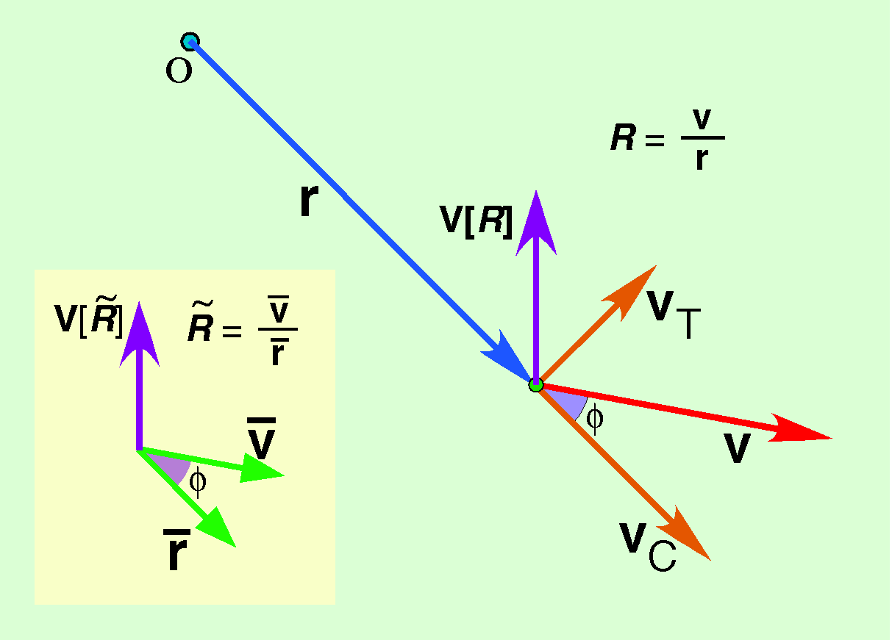

The ratio of the direction of the velocity to the direction of the radial vector
An object with a mass of lies at a point that is at a location relative to a reference point, , and it is moving with a velocity . We start by computing the unit vector and magnitude of each parameter.
We may compute the ratio of the direction of the velocity to the direction of the radius, which is . It has a vector and an angle .
The directions and define a plane. The vector of , , is a perpendicular to that plane and is the angular excursion that turns into .
It is important for understanding what follows to differentiate between quaternions, which are written bolded and in italics, vectors, which are just bolded, and scalars, which are neither bolded nor in italics. So, is the vector of the quaternion and is its angle, which is a scalar. Of course, scalars and vectors are special instances of quaternions, but since they combine in different ways, it is convenient to differentiate them. In addition, the practice of symbolically differentiating between the types of entities forces a more careful consideration of what is being said. Being forced to consider what form the elements of an expression take prevents many potential logical errors.

Ratio of the velocity to the radial vector from the origin
Note that the ratio quaternion may also be the unit quaternion of the ratio of the velocity to the radial displacement, , which may be the simpler, more direct, way of calculating it.

The tangential and centrifugal components of the velocity
From the unit vector, , we can construct two rotation quaternions, one with an angle of 90° ( radians) and one with an angle of 0° (0 radians).
The rotation, , gives the tangential component of the velocity and the rotation, , gives the centrifugal component. From an examination of the above illustration, one can easily write down the expressions for the two velocities.

Linear momenta
If the mass of the object is , then the tangential momentum of the object relative to the center of rotation is the mass times the tangential velocity and the centrifugal momentum is the mass times the centrifugal velocity. The linear momentum is the mass times the velocity. Note that the linear momentum is the sum of the tangential and centrifugal momenta.
Although the linear momentum is the product of a quaternion and a vector, the result is a vector, because the vector of the quaternion is perpendicular to the rotating vector. Consequently, the linear momentum is a non-orientable vector if the radial vector is a non-orientable vector. The radial vector is the difference between two locations, therefore is not intrinsically orientable. Linear momentum has the same direction as its velocity and it is proportional to the mass and speed of the moving object. We will find that angular momentum is a quaternion vector that does have an intrinsic orientation.

A simple example
This leads to a counter-intuitive, but observationally substantiated situation. Assume that the mass is rotating on a circular trajectory about a reference point.
Linear momentum is an expression of the effort that it would take to stop the movement, its inertia. Inertia is proportional to the amount of material present and to the speed at which it is moving, therefore to momentum. The tangential momentum is how much of that momentum is directed along a trajectory that is perpendicular to the radial vector from the point of reference to the moving mass. The centrifugal momentum is the effort that would be required to keep the mass from moving radially. If we were to instantaneously break the physical connection between the mass and the reference point, it would move away from the reference point with a momentum equal to the centrifugal momentum. Note that the total linear momentum is a conserved quantity in systems that are not subject to external forces, but, neither of the component momenta are conserved and their values are functions of the location of the reference point.
There are circumstances in which the component linear momenta may be informative. If the reference point is on the axis of rotation for a bone, then the centrifugal momentum is an expression of how much the rotation tends to distract or compress the joint and the circumferential momentum is an expression of the energy of the rotation. Time differentials of linear momenta are forces.
This implies Newton’s first law of mechanics. If is zero, that is, there is no external force, then, there can be no change in momentum, meaning that the object must continue in the same direction at the same speed. That includes the situation when the object is not moving ().
Let us consider a system in which a mass is rotating about a fixed reference point at a constant velocity. Then the position of the point can be written as a function of time and its velocity readily computed, by taking the derivative of its location.
It follows that rate of change of the velocity is directed in the opposite direction to the radial vector or the tether.
In a frictionless system, the mass will continue to spin indefinitely, unless the tether is cut, in which case, it will travel away from the central fixation, while continuing in the direction that it had at the instant of the disconnection. In this case, the linear momentum, which is equal to the tangential momentum, changes periodically. There is no external application of force, but the momentum is periodic. There is a periodic internal application of force that moves the circling mass out of a straight trajectory.

Angular momentum
The angular momentum is the vector interval from the reference point to the point mass times the tangential momentum.
Since the angular momentum is a product of vectors, it is a quaternion. However, since the tangential velocity is by definition perpendicular to the radial vector, the quaternion is a vector, a quaternion vector, which means that it is orientable. It not only has a direction and magnitude, but also a sense, that is, a direction of rotation about its axis. Angular momentum, , is a quaternion vector, times times the mass of the moving particle, where and may be quaternion vectors or standard non-orientable vectors. It is perpendicular to the plane defined by the radial and velocity vectors and turns to . It is proportional to the mass of the particle, the distance from the origin to the mass particle, and the velocity of the particle.

Angular momentum versus linear momentum and their conservation
Angular momentum is a different type of entity than a linear momentum. We can see that in the fact that a non-orientable vector may represent linear momentum and angular momentum requires an orientable vector. Linear momentum is an expression of the inertia of an object. It is the effort required to bring a moving mass to rest in the assumed frame of reference. It expresses the amount of effort required and the direction in which it must be applied. The change in linear momentum that an object experiences is the effort that must be done to bring about the change. Angular momentum also embodies an effort, but it is the effort to rotate a body. It is in essence the law of levers. The longer the lever arm, the greater the mass, or the greater the velocity, the more effort it takes to stop the rotation. When we use levers, we try to match two lever arms so that the impressed force is such that their angular momenta are equal.
The angular momentum vector is perpendicular to the plane in which the movement is occurring and its magnitude is proportional to the effort to the effort needed to stop the rotation. It also specifies the direction in which the effort must be exerted by its direction. It is a vector that has direction, magnitude and sense. That is to say it is orientable. Linear momentum is expressed in kilogram-meters per second and angular momentum is expressed in kilogram-meters squared per second.
A reason that we care about both linear and angular momentum is that they are both conserved in a closed system. If there are no external forces, then the velocities may be shifted between the components of the system, but the sums of both types of momentum over all of the components must remain the same magnitude and in the same direction. If the connection between the circling mass and the center of rotation were cut instantaneously, the mass would continue indefinitely in the direction that it is going the moment of the cut. That would satisfy both conservation laws because the velocity remains the same and the perpendicular to the velocity is constant, therefore the product of the radial vector and the velocity will be constant.
The two conservation laws set constraints upon the possible outcomes of events in closed systems. They also allow us to shift our point of view in useful ways that often clarify a situation or allow us to express the description of an event in different ways that are equivalent, but often give insight into the nature of the event. We will spend most of the remainder of this essay considering such transformations.

Angular momentum versus linear momentum and their conservation
Angular momentum is a different type of entity than a linear momentum. We can see that in the fact that a non-orientable vector may represent linear momentum and angular momentum requires an orientable vector. Linear momentum is an expression of the inertia of an object. It is the effort required to bring a moving mass to rest in the assumed frame of reference. It expresses the amount of effort required and the direction in which it must be applied. The change in linear momentum that an object experiences is the effort that must be done to bring about the change. Angular momentum also embodies an effort, but it is the effort to rotate a body. It is in essence the law of levers. The longer the lever arm, the greater the mass, or the greater the velocity, the more effort it takes to stop the rotation. When we use levers, we try to match two lever arms so that the impressed force is such that their angular momenta are equal. The angular momentum vector is perpendicular to the plane in which the movement is occurring and its magnitude is proportional to the effort to the effort needed to stop the rotation. It also specifies the direction in which the effort must be exerted by its direction. It is a vector that has direction, magnitude and sense. That is to say it is orientable. Linear momentum is expressed in kilogram meters per second and angular momentum is expressed in kilogram meters squared per second.
A reason that we care about both linear and angular momentum is that they are both conserved in a closed system. If there are no external forces, then the velocities may be shifted between the components of the system, but the sums of both types of momentum over all of the components must remain the same magnitude. If the connection between the circling mass and the center of rotation were cut instantaneously, the mass would continue indefinitely in the direction that it is going the moment of the cut. That would satisfy both conservation laws because the velocity remains the same and the perpendicular to the velocity is constant, therefore the product of the radial vector and the velocity will be constant.
The two conservation laws set constraints upon the possible outcomes of events in closed systems. They also allow us to shift our point of view in useful ways that often clarify a situation or allow us to express the description of an event in different ways that are equivalent, but often give insight into the nature of the event. We will spend most of the remainder of this essay considering such transformations.

A simple example
Consider a simple example, where a mass is rotating along a circular trajectory about the reference point. We can write the description of the trajectory as a function of time.
From these relations we can readily compute the ratio of the velocity to the location.
We can see that this is a correct expression for the ratio just by inspection. It follows that the tangential velocity is and the centrifugal velocity is 0. The linear momentum is , which is also the tangential momentum.
The angular momentum follows from its definition.
The angular momentum is perpendicular to the plane of the location and velocity and it is proportional to the mass, the angular velocity, and the square of the distance from the reference point to the mass point. Doubling the radial arm quadruples the angular momentum.

The rates of change of linear and angular momentum
It is an experimental observation that a force applied to a rigid body may be moved along its line of action without changing it rotatory action on the rigid body. That means that there is a radial vector, , that is perpendicular to the line of action for a velocity, unless the line of action passes through the origin of the radial vector. Consequently, we can compute the ratio of to , , and the expression for the angular momentum becomes simpler.
That leaves us with the problem of finding . It lies in the plane of and and it is rotated relative to by the negative of minus the angle between and , .

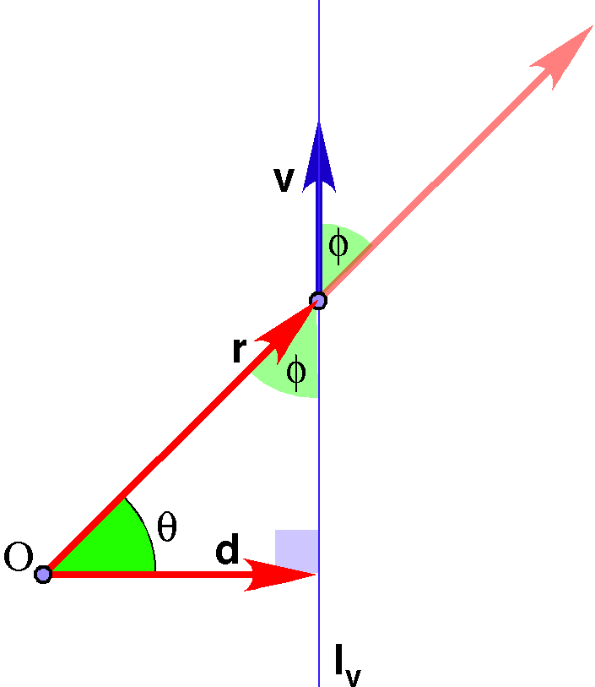
Then, the radius is obtained by rotating through and taking the vector of the quaternion.
We can see that moving the force along its line of action will not change the moment about the point because the is the scalar factor in both forms of the expression.

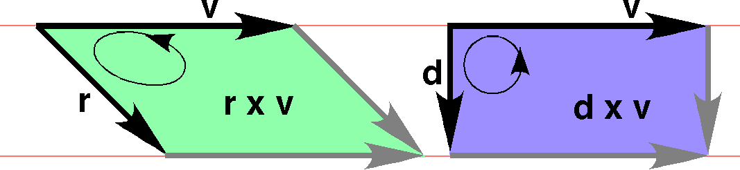

In both cases we are effectively using a cross product and the magnitude of the cross product may be interpreted as the area of the parallelogram that has the two vectors as its sides. In moving the force vector along its line of action we are effectively shifting a parallelogram that lies between two lines so that it is a rectangle. The two cross products are represented in the above figure as oriented areas. It is easily appreciated that the areas of the two cross products are the same. The two oriented areas are in the same plane, so, the perpendiculars to the areas are in the same direction.

The move to forces and torques
If we return to our simple example, it is straightforward to compute the force that is acting on the mass to hold it in a circular orbit. Force is the time derivative of the linear momentum. We have computed the linear momentum and we assume that the mass is constant, so the derivative of the velocity is the critical parameter.
The force is directed in the direction opposite the radial vector and it is proportional to the mass, the distance between the central reference point and the mass point, and the square of the angular velocity. The force is entirely centripetal, that is pulling the mass towards the central reference point, and no force is required to move the mass along its circular course.
If the trajectory of the mass is not circular, then there will be a tangential force. We can see that because the ratio vector would have a scalar component since the angle between the radial vector and the velocity vector would not be a right angle (), therefore the ratio of the velocity to the radial vector would be a quaternion with both a vector part and a scalar part. The velocity will have components parallel and perpendicular to the radial vector.
Another way to view the situation is to consider a force or collection of forces that act upon a rigid object. Most placements of the force(s) will cause the object to rotate and translate to a new location. We must choose a reference point. It may be a pivot point in a joint, a center of mass or an arbitrary point. Its location is denoted by O. The point of application of the force F is r from the reference point. The force may be resolved into a force that is perpendicular to the radial vector in the plane defined by the radial and force vectors, the tangential force (), and a force that is in the direction of the radial vector, the centrifugal force (). The force will rotate the rigid body about O and the force will draw the body in the direction of the radial vector. We have effectively computed these vectors in the section dealing with the resolution of velocities.

Torque Vectors and Torque Quaternions
Torque is the rotatory effort being applied relative to a reference point in a rigid body. It resembles angular momentum in that it is a vector quantity that is proportional to the displacement from the reference point to the point of application of the force and to the magnitude of the force. In vector analysis it is expressed as the cross-product of the radial displacement times the force. It may also be expressed as the differential of the angular momentum.

Actually, those two definitions are not actually the same quantity if is a function of time. Therefore let us consider the definition of torque in some more detail. We will start with some examples to get a feel for the way forces and torques behave.

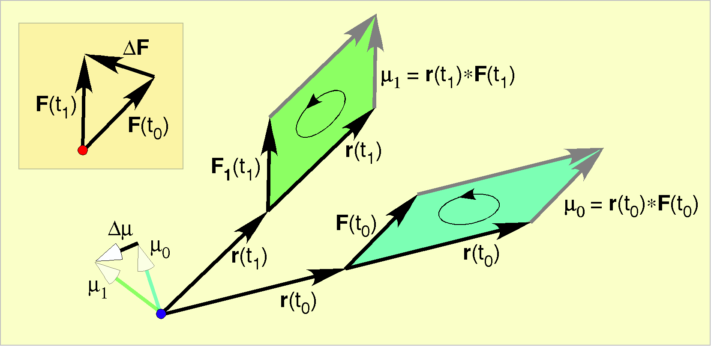

An example: uniform rotatory movement
For uniform rotatory movement about a fixed point, we can write the expression for the radial vector as a function of time and the velocity and acceleration follow directly from that description.
It follows that the ratio quaternion is the mass times the acceleration, divided by the radial vector.
In this instance, the velocity is always perpendicular to the radial vector, so and we can write the expression for the angular momentum and differentiate it to obtain the torque.
The angular momentum is constant, therefore, the torque is zero. It does not take any additional effort to keep the mass circling once it has been placed in orbit about the center of rotation.

An example: non-uniform rotatory movement
Now that we have set out the form of the analysis, let us consider a slightly more complex situation, where the movement is not circular or of uniform speed. The locations lie on an elliptical trajectory that may move out of a plane. It may rise and fall relative to the plane as one goes around the ellipse. The location, velocity and acceleration are as follows.
It follows that the ratio quaternion is the mass times the acceleration, divided by the radial vector.
If we multiply this ratio times the radial vector the result is the total force vector.
If movement is entirely in a single plane and circular , then the force is the same as was computed for the uniform circular movement.
If the movement is in a single plane, but elliptical, then the total force is somewhat more complex. It is a little counter-intuitive that despite the elliptical orbit, where the moving mass slows and speeds up at different parts of the orbit, the force that holds it on trajectory is a constant central force. Of course that is true because planets in the solar system follow elliptical orbits and they are held by a constant central force, namely the gravitational force between the mass of the sun and their mass.
For both of these the force is directed in the opposite direction to the radial vector. The situation for the full example is not as simple, but it is similar in that the force is in the same general direction. If the angular velocity of the third component, , is the same as the angular velocity of the other directions, , then the force vector would be in the direction opposite to the radial vector. The ratio of the direction of the force to the direction of the radius is given by the following expression.
The relationship between the force vector and the radial vector is somewhat complex. The vector that turns the radial vector into the force vector is always in the i,j-plane and it is perpendicular to the radius vector. We know that the vector component is perpendicular to the radius because of exchanging of the sine and cosine functions in the vector. This relationship is illustrated in the following figure. The horizontal ellipse is the excursion of the radius vectors and the vertical ellipse is the excursion of its perpendicular. In the ratio of the force to the radius, the ellipse is multiplied by a constant () and a variable function of time (), but that does not change the direction of the turning quaternion’s vector. It does affect the angular excursion of the radial vector necessary to align it with the force vector.

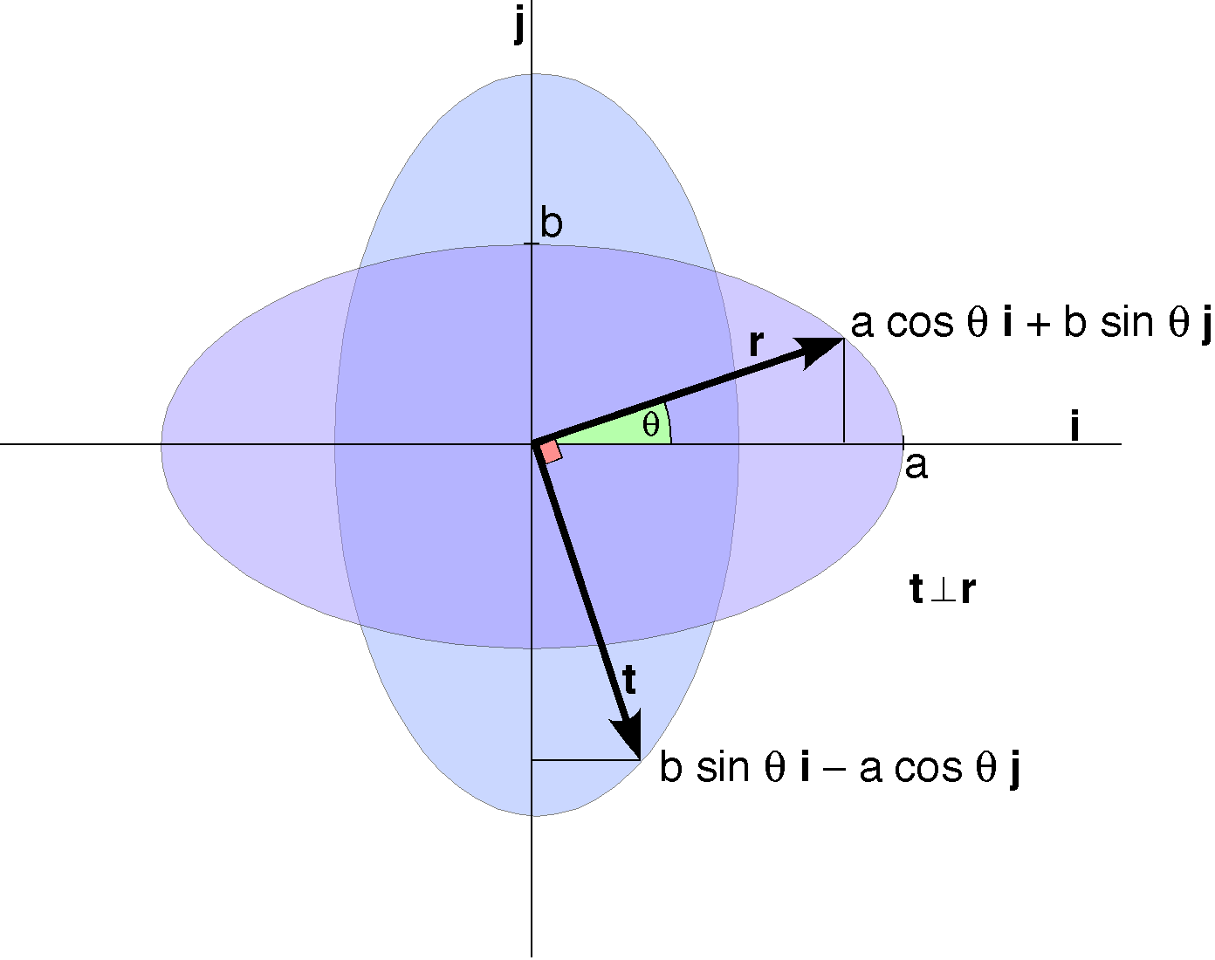

Calculation of the torques for the second example
The torques are computed as follows for each case. When the trajectory is circular, then the torque is zero, as was computed.
When the trajectory is elliptical and confined to a single plane then the angular momentum is the product of the mass times the vector part of the product of the radial vector times the velocity vector.
As stated above for the central force that holds planets on their elliptical orbits, there is no torque for an elliptical orbit, because the angular momentum is a constant vector, even though the mass changes speed as it moves around its orbit.
Clearly the torque moves in a circle in the plane of the elliptical movement, but it cycles at a rate that is the sum of the rates for the elliptical component and the oscillation above and below the plane. This arrangement is too complicated to be readily visualized. Fortunately, this complexity is not typical of anatomical movements.
An example that is more representative of an anatomical movement is a pendulum. Let us consider a periodic pendular movement as a third example.

Pendular example
Consider a joint in which the armature swings back and forth along a circular trajectory, but at a rate that varies sinusoidally. In particular, the pendulum swings in the i,j – plane about the origin, with lever arm of one unit. It swings through a maximal angular excursion of with an angular velocity of . Consequently it swings from to and back in one unit of time. We can write down it temporal course fairly easily and all else follows from that decription.
The angular momentum is in-phase with the pendulum and the torque is shifted 90° out of phase. The angular momentum is maximal at and , but in opposite directions. It is minimal at and , when it switches polarity. The torque is proportional to the mass, the maximal excursion and the rate of the swinging and it points in a direction perpendicular to the plane of the pendular movement.

Force couples
As with velocity, a force can be moved along its line of action without fundamentally changing its effect on the rotation of the rigid body, therefore we can rewrite the expression for angular momentum.
The radial component becomes shorter but the force becomes proportionately greater so the product is same. The angular moment is the turning capacity of the force at its current point of application relative to the reference point. We can make the concept more flexible by introducing the concept of a force couple. If two equal, but opposite forces are applied at points separated by an interval d, then the moment of the force couple is the moment.

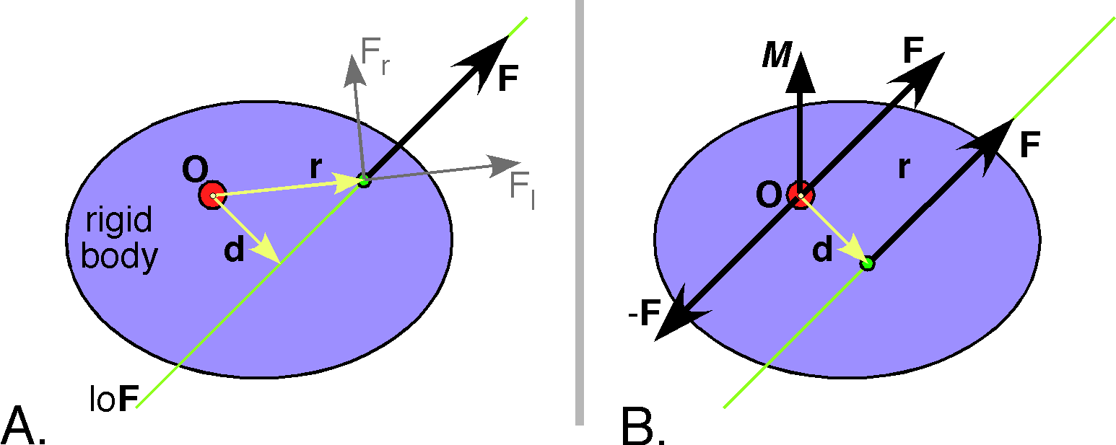

As discussed above, the moment is the product of two vectors, therefore a quaternion, but since the vectors are perpendicular, it is a vector, so it is a quaternion vector.
Force couples are essentially equivalent to the laws of levers. If we have a reference point, , then the force couple is the turning effort upon a rigid body relative to the reference point. Three situations are illustrated in the following figure. In each case the net angular momentum about the reference point is the same. In the first situation, on the left, the forces are applied symmetrically to either side of the origin, so that is each is appliedway from the origin and both forces will tend to rotate the rigid body counterclockwise. The resultant of the two forces is the sum of the two torques, . In the second situation, in the middle, one of the forces is applied to the origin, therefore does not produce any torque. The other force is displaced from the reference point so the torque is the same, . In the third situation, both forces are applied to the same side of the reference point, therefore the rigid body would rotate about a different point if it were able to do so. If the pivot point is at , then the two forces tend to move the rigid body in opposite directions. However, the net effect is the same, . In addition to these types of variation, the force couple is unchanged if the distance between the points of force application is reduced or expanded as long as the magnitude of the force in concurrently raised or lowered by the same proportion.
Force couples rotate the object but do not translate it. Consequently, the moment of the force couple is the amount of turning capacity due to the force. A useful feature of force couples is that their moments are free vectors, that is, vectors that do not have a particular location. So we can move them as necessary as long as we keep the same moment. The moment does define the plane and direction of the rotation, that is, the plane and sense of the quaternion vector.

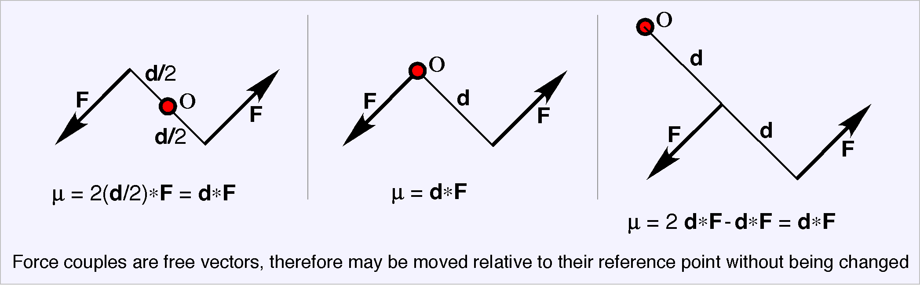

Equivalent systems of forces
Since equal and opposite forces applied to the same point will have a net force of zero, we can apply the force F and its negative to the reference point without changing the mechanical situation for the rigid body. That was done in panel B for the figure above. However, we can rearrange our interpretation and consider the negative force vector as the other half of a force couple that has one force vector displaced d from the reference point. The other force vector applied at O will now translate the rigid body in the direction of F but not rotate it.
So, it is possible to replace a single force acting at a point on a rigid body with a force couple, which rotates the rigid body, and a force acting at the reference point, which translates the rigid body without rotating it. The torque of the force couple and the translating force are always perpendicular for any single force.
The advantage of this arrangement becomes apparent when we wish to examine the consequences of applying several forces to different parts of the rigid body. A torque/force pair can be generated for each force so that the torques all reference the same point in the body and all the forces pull from that point. The forces and torques add vectorially with the others of the same type so that we obtain a force acting at the reference point and a torque for a force couple acting about that point. However, unlike the case for individual forces, the force vector and the torque are generally not perpendicular when combining a number of forces acting at different points on the rigid body. Still, we have reduced a set of forces to a single force and a torque.
Forces are vectors and torques are quaternions. Both may be added to others of the same kind, but they may not be added to each other. The differences are subtle, but important. A force can be represented by a right quaternion. That is a quaternion that may be expressed as a ratio of two vectors at right angles to each other, but a force is indistinguishable from its reflection. Torques are also right quaternions, the ratios of two vectors separated by an angular excursion of radians, but their sense of rotation is quite specific, so that the reflection of a torque is different from the original torque. One is a right-handed rotation and the other is a left-handed rotation. Still, both forces and torques add vectorially.
If multiple forces act together at a point, then the net force is the vector sum of the component forces, which is a force. This rule is well established by experimental observation.
If we have two torques acting at the same point, then the net result is the vector sum of their two quaternions. That is obviously true when they are acting about the same or opposite axes of rotation. The total turning effort is the scalar sum of the magnitudes of the turning efforts about that axis of rotation. It is less clear that when the two turning efforts are acting in different directions that the combined effort is about an axis between the two component axes. Since an object can more in only one direction at any given time, there must be a single axis of rotation and it is not in the direction of either of the two components.

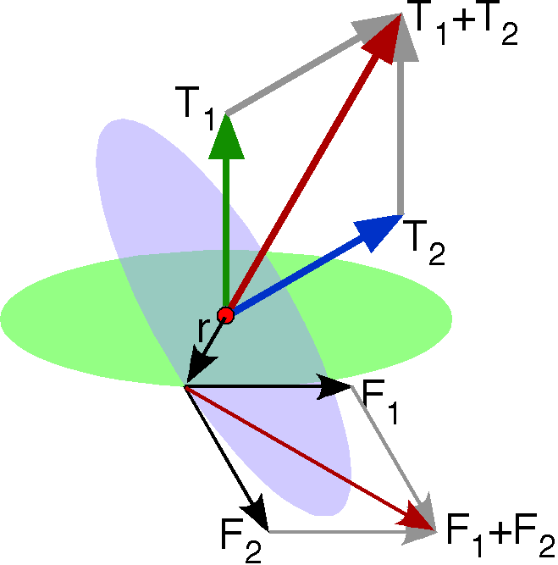

The above figure is a demonstration that torques to add vectorially. We have two torques, and , which are not aligned. Since torque is a radial displacement times a force, we can express the torque as a force acting in the plane perpendicular to the torque vector times a force in that plane. Each torque has its own plane and the two planes intersect in a line that is the ratio of the two planes. Therefore, we can take our radial displacement to be a unit vector in the direction of the intersection and the force to be a force of appropriate magnitude in each plane. The result is two forces acting at a point and we can sum those forces to obtain an equivalent force that acts in an intermediate direction. This is just the run for adding forces. But that combination force, acting at the radial displacement of the component torques, will generate a torque that is the vector sum of the component torques. By this means, we can sum any two torques with a common reference point and by induction any set of torques acting at a common locus. Consequently, torques sum vectorially.

It should be stressed that this argument depends on the two torques having a common reference point, on being a unit vector, and upon the force vectors being perpendicular to the unit radial displacement. We have constructed an equivalent system that has nice properties. Torques do not add vectorially if the do not have a common reference point, but we can compute an equivalent system in which they do have a common reference point, therefore it is always possible to add torques.

Computing torques at other locations, moving the point of reference

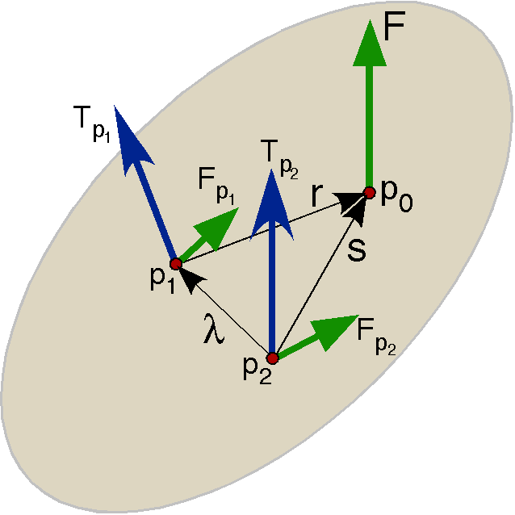

When two torques are not referenced to the same point then we can move them to a common reference point. The torques added are not those given, but their equivalents when referenced to the common locus. If we know the value of a torque referenced to a point and we wish to compute its value referenced to point , we subtract the torque referenced to that would be obtained by applying the force at from its torque referenced at . That is illustrated in the above figure when we have a force applied at the point . By definition the torque relative to point is , but we know the torque at and the displacement from to , which is .
More generally, if we have a number of forces that are applied to various points on a rigid body, then we can extend the above argument to the equivalent force and torque.
The final relationship says that if we know the equivalent force and torque at a point, we may compute the force and torque at another point that lie from the reference point. That is a remarkable simplification of the system.

The force/torque pair of a combination of forces will generally not be mutually perpendicular
If all the forces are applied at a single point, then there will be no torque, since they are all pulling radially. If all of the force vectors lie in a single plane, then they will all have torques in the same direction or its negative, which are both perpendicular to the plane that contains the force vectors. Consequently, the force and torque are perpendicular and the pair can be reduced to single force in the plane, but displaced from the reference point (see the next section). Finally, if all the applied forces are applied in a single direction or its negative, then they will all have their torques in the same plane, which is perpendicular to the directions of the force vectors. The sum of the torques will be in the same plane, therefore, it must be perpendicular to the sum of the force vectors. Otherwise, the torque and force of a combination of forces applied to a rigid body will not be mutually perpendicular without very special balancing of their magnitudes to make it so.
The next step would to be to try to convert the force/torque pair to a single force applied at some point on the rigid body. To do that, we need one more tool, the consequences of moving the reference point.

Reducing a force/force couple pair to a single force
We start with a set of forces applied at the points and referenced to the point. After processing as described above, we will have a mutually orthogonal force, , and force couple torque, , at point that is formally equivalent to the set of applied forces. We can compute the couple that would result if we shift the reference point to a different location displaced from . We did that above. The linear force is not changed by displacement, therefore, it remains . The torque is the torque at plus the torque from applying at from .

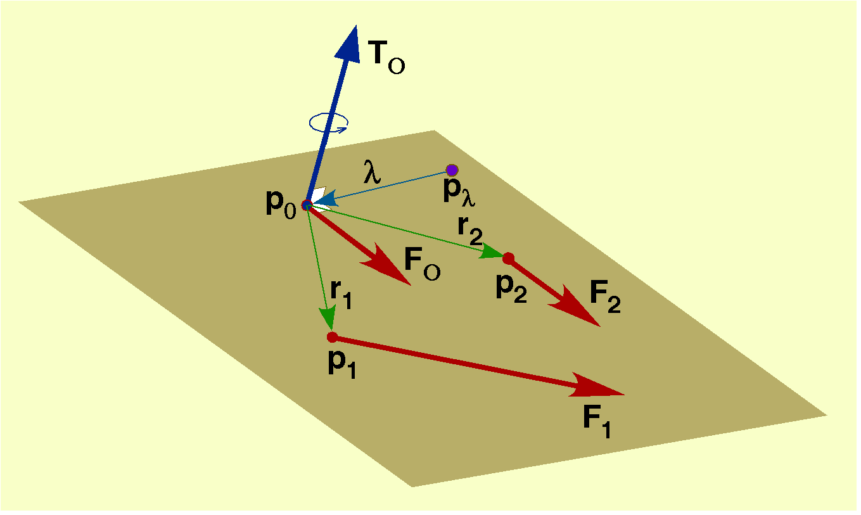

It follows that if we choose the offset so that , then the force/torque pair is replaced by an arrangement where there is only a force and that force negates the action of the force/torque at . That is, the force produces the same amount of torque as exists at . The rotation about by the force applied at is equivalent to the sum of all the forces applied to the rigid body. So the system of forces is reduced to a single equivalent force applied to a particular point on the rigid body.
We still need to compute the value of . Clearly, the displacements are in the plane perpendicular to the torque’s vector. Otherwise, the torque vectors that cancel cannot point in opposite directions. Secondly, the displacement is most usefully chosen to be perpendicular to the force vector because then . That direction can be readily computed by computing the ratio of the plane of the torque to the plane of the force. The ratio of those planes is their intersection. We can determine the magnitude of the displacement, , by taking the ratio of the torque to the force vector.
This is a remarkably simple result. The system reduced to a single force that is equivalent to the force/torque pair is the system that displaces the force from the reference point by the negative of the ratio of the torque to the force. Note that we still are referenced to a point.
There is nothing in this argument that depends upon the orthogonality of the torque and the force so we can extend it to the general case where the torque vector is not perpendicular to the force vector. Then the displacement is chosen to lie in the plane that is perpendicular to the force vector and in the plane that is the perpendicular to the torque vector, which means that it lies in the intersection of the two planes and the ratio of two planes is their intersection. So the displacement is the ratio of the two vectors.
The force applied at is formally and physically equivalent to the force/torque pair applied at , when referenced to . The reference to the origin of the system, , is critical to the interpretation of torque, which is always in reference to a location.

Wrenches and their Pitches
When a number of forces are applied to a rigid body at a number of points that are not coplanar, then the net result is almost always a force/force couple pair in which the force and torque vectors are not mutually orthogonal. The object is moving linearly in one direction and rotating in a plane that is not perpendicular to that direction of movement. When that occurs, it is not possible to reduce the system to a single force acting at a point. There is an irreducible torque. However, we can simplify the system to a force and a torque that is in the same direction. Such a combined vector pair is called a wrench. For an excellent introduction to this material in a vector analysis framework see Beer and Johnston (Beer and Johnston Jr 1990).
We do not see a great deal about wrenches these days, but they were of great interest in the late 1800’s and early 1900’s. They turn up in the advanced analysis of mechanical systems. They are related to screws, which are the movement version of the same process, a concurrent rotation about an axis of advancement. We consider that type of movement elsewhere.
Let us now consider how one obtains a wrench as a simplification of a system of forces acting on an object. The mechanical situation is a rigid body that is being moved by multiple forces that do not act in a common direction or in a common plane. We have shown that such a system may be simplified to a force, , and a torque, , acting at a reference point, . As stated above, the force vector and the torque vector will not generally be mutually perpendicular. We have also seen that we can effectively eliminate a torque perpendicular to the force vector by moving the point of application of the force some distance along a vector that is perpendicular to both the force and torque vectors. The applied force generates the same torque about the reference point.
We cannot remove torque that is not perpendicular to the force vector by this means. However, we can split the torque into a component that is perpendicular to the force vector, , and a torque that is in the same direction, . The torque that is perpendicular, , can be embedded in a displacement of the point of application of the force, , leaving the torque in the direction of the force vector, .
Let us start with the force, , and the torque . We can compute the unit vector of the ratio of to , . Let the angle of the ratio be . Then we can write the expressions for the components of as a function of the ratio of to , , which is a quaternion.

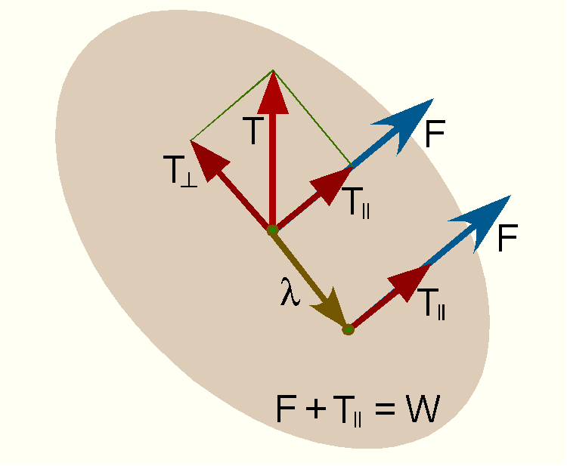
A knowledge of the force and the components of the torque perpendicular to it allows one to compute the distance that one needs to go along to apply the force so as to generate the same torque.
The parallel torque can be moved with the force. It is the turning effort in the plane of the force, that is in the plan perpendicular to the force.
Although wrenches do not figure prominently in modern treatments of mechanics, they were well known in the late 1800’s (Joly 1905). At that time it was common practice to speak of the pitch of the screw or the wrench. As it happens the pitch of the wrench is the amount of turning in the plane perpendicular to the force vector (parallel torque) for a given amount of force. If we express the pitch by the symbol , then the scalar is the ratio of the magnitude of the torque parallel to the force to the magnitude of the force. Since the torque and the force are in the same direction, their ratio is a scalar and that scalar is the pitch of the wrench.
This leads to an interesting relationship. The ratio of the torque to the force for a system of forces acting on a rigid object is the sum of the offset or lever arm and the pitch, which is a quaternion.

Recapitulation and a More General Solution
We started with a very general situation, where we had a rigid body that is being acted upon by a number of forces that are applied at various point on or within the object. For instance, the object might be a bone that is being pulled on by a set of muscles attached at several insertions, plus the ligaments that bind the bone to another bone, the force of gravity acting at the center of mass for the bone, and the reaction forces in the joint that resist its compression or distraction.
Forces add vectorially so one can compute a resultant force that may formally replace the various forces acting on the bone. Torques also add vectorially. Consequently, we can choose a reasonable reference point, such as a point on the axis of rotation for the joint, and compute the torque generated by each force in reference to that reference point. While the torque for any force is always perpendicular to the plane defined by the force vector and the radial vector from the reference point to the point of application of the force, when we add the forces and the torques, the resultant force, $F$, and torque, $T$, will not generally be perpendicular.

We have seen that it is possible to resolve the torque into two components, one perpendicular to the resultant force vector ($T_{\hat{}}$) and one parallel to it (). Let those torque vectors be called the perpendicular torque and the parallel torque, respectively. We can create an equivalent mechanical system with the torque being generated by the force ($F$) displaced $l$ from the reference point. It follows from the definition of torque that the torque is the radial displacement times the force vector in such a system, that is the lever arm times the force acting on the lever arm. Therefore, the lever arm for rotation in the plane of the torque perpendicular to the force vector is the ratio of the perpendicular torque to the force.
In this system, the force causes the rigid body to rotate in the plane that contains the force vector, , and the displacement vector, , while being translated in the direction of the force vector.
However, we still have a torque that is parallel to the resultant force vector, the twist that accompanies the translation, the wrench. The wrench rotates the rigid body about the axis of the force vector as it translates the object. The relative proportions of rotation and translation are expressed in the pitch of the wrench.
Let us consider how we might further generalize this analysis and perhaps simplify it in the process by replacing the force/torque pair with a single force. To start, we resolve the torque into two components, as has already been done. But, in addition, we consider the implications of the parallel torque. As a consequence we will be able to move directly to an equivalent mechanical system that has a single force.
The following figure illustrates the situation where the torque and force are not mutually orthogonal. A force is combined with a torque that lies at an angle of to the force vector. The torque is resolved into a perpendicular torque, , and a parallel torque, . The perpendicular torque can be replaced with a displacement of the force vector from the reference point for the force torque pair. Consequently, the displaced force has the same vector value as the original force, . This is essentially the analysis that is spelled out above. The new step is to note that a force vector at the same location may also replace the parallel torque. The new force vector is perpendicular to the plane defined by and and its magnitude is to the magnitude of the parallel force as the magnitude of is to the magnitude of .

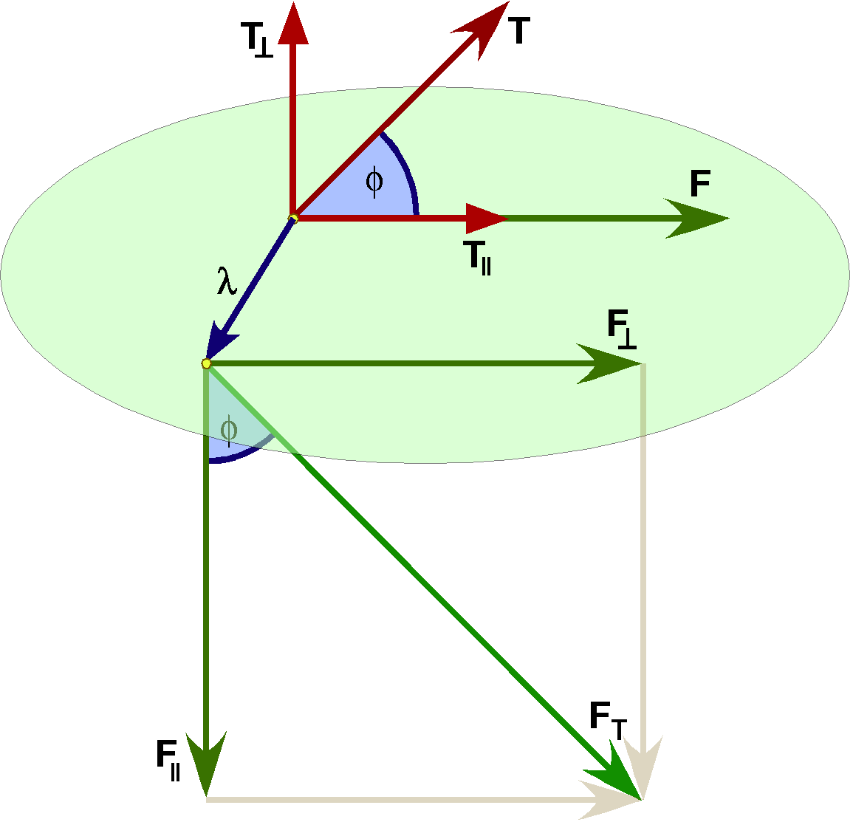

The parallel torque force does not advance the object in the direction of the force vector, but it does rotate it in the plane perpendicular to the force vector. We have two forces acting at a common point, therefore we can add them vectorially. The result is the force . However, it is apparent that the force is simply the force in the plane of the torque that satisfies the relationship implicit in the definition of a torque.
We have taken advantage of the fact that is in fact a quaternion, although we have treated it as a vector up to this point. It rotates the torque vector through 90° and re-scales it to the appropriate length. This expression is in fact more general and simpler than the analysis that led to a wrench. It moves directly from the force and torque to the radial displacement and force that will give the same mechanical outcome. It is more general in that is not a unique value. We can redefine it as follows.
The product in the numerator rotates the torque vector through 90° in the direction opposite to the rotation from the force vector to the torque vector and the scalar in the denominator scales the force to be the inverse of the ratio of the magnitude of the tensor to the magnitude of the force, that is the inverse of the generalized pitch.

An example of distributed forces that create a wrench
Consider a set of four forces that are applied at where each force is perpendicular to the coordinate axis and tilted in the direction of . The net effect of such an arrangement is a torque about the origin and a force in the direction of .

In the above illustration, the vectors are 0.2 units long in the -plane and one unit long in the direction of . Consequently, the resultant force is 0.4 units in the direction of and the resultant torque is 0.8 units, also in the direction of . This arrangement is clearly a wrench in that the torque and force vectors are in the same direction. Also, because of the symmetry of the arrangement it is clear that one can replace the wrench with a single vector at a unit distance from the origin that is directed 0.8 units tangent to a unit circle in the -plane and 0.4 units in the direction of , if the rotation is constrained to occur about the origin. We are not really replacing the four vectors with a single force vector, but with a force couple where one of the vectors is at the origin. The simplification is not as intuitive as the wrench interpretation, which leads directly to a force pulling the object in the direction of the axis while the object is being spun about that axis. A point on the object will follow a screw trajectory.

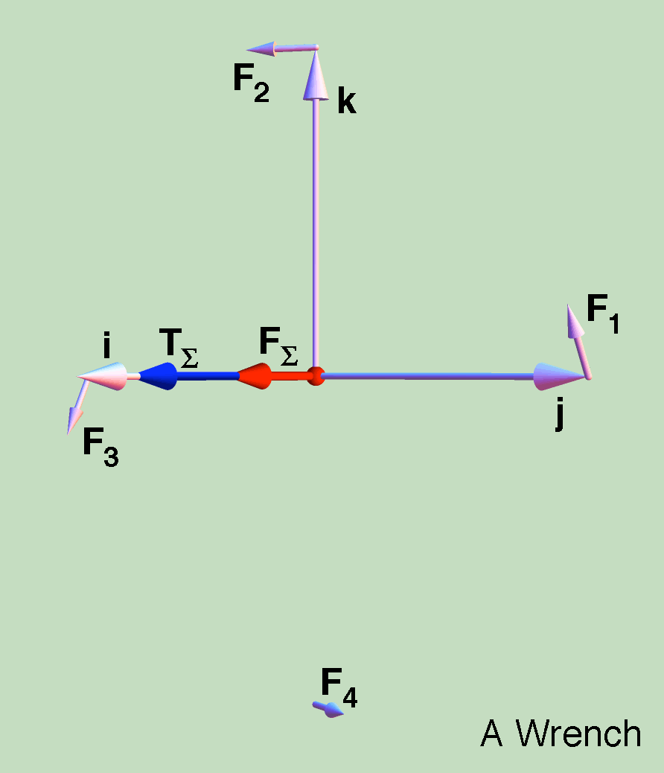

Joints generally resist substantial translations, because they are an inefficient way of achieving movement, therefore, the force component is apt to be the component that is resisted by compression or distraction of the structures of the joint. Compression is absorbed by cartilage and distraction is usually absorbed by ligaments or muscles. Rotation may also be resisted by joint structures, so that the joint is constrained to move in a particular plane.

References

