Movements of a Circular Canal
When a semicircular canal accelerates, the fluid within it tends to move in the opposite direction as it lags or leads the canal, because of inertial drag. This section considers how fluid moves within a ring in a number of situations where the ring is rotating. The general situation will be described first and then a number of sample situations or increasing complexity will be considered computationally.

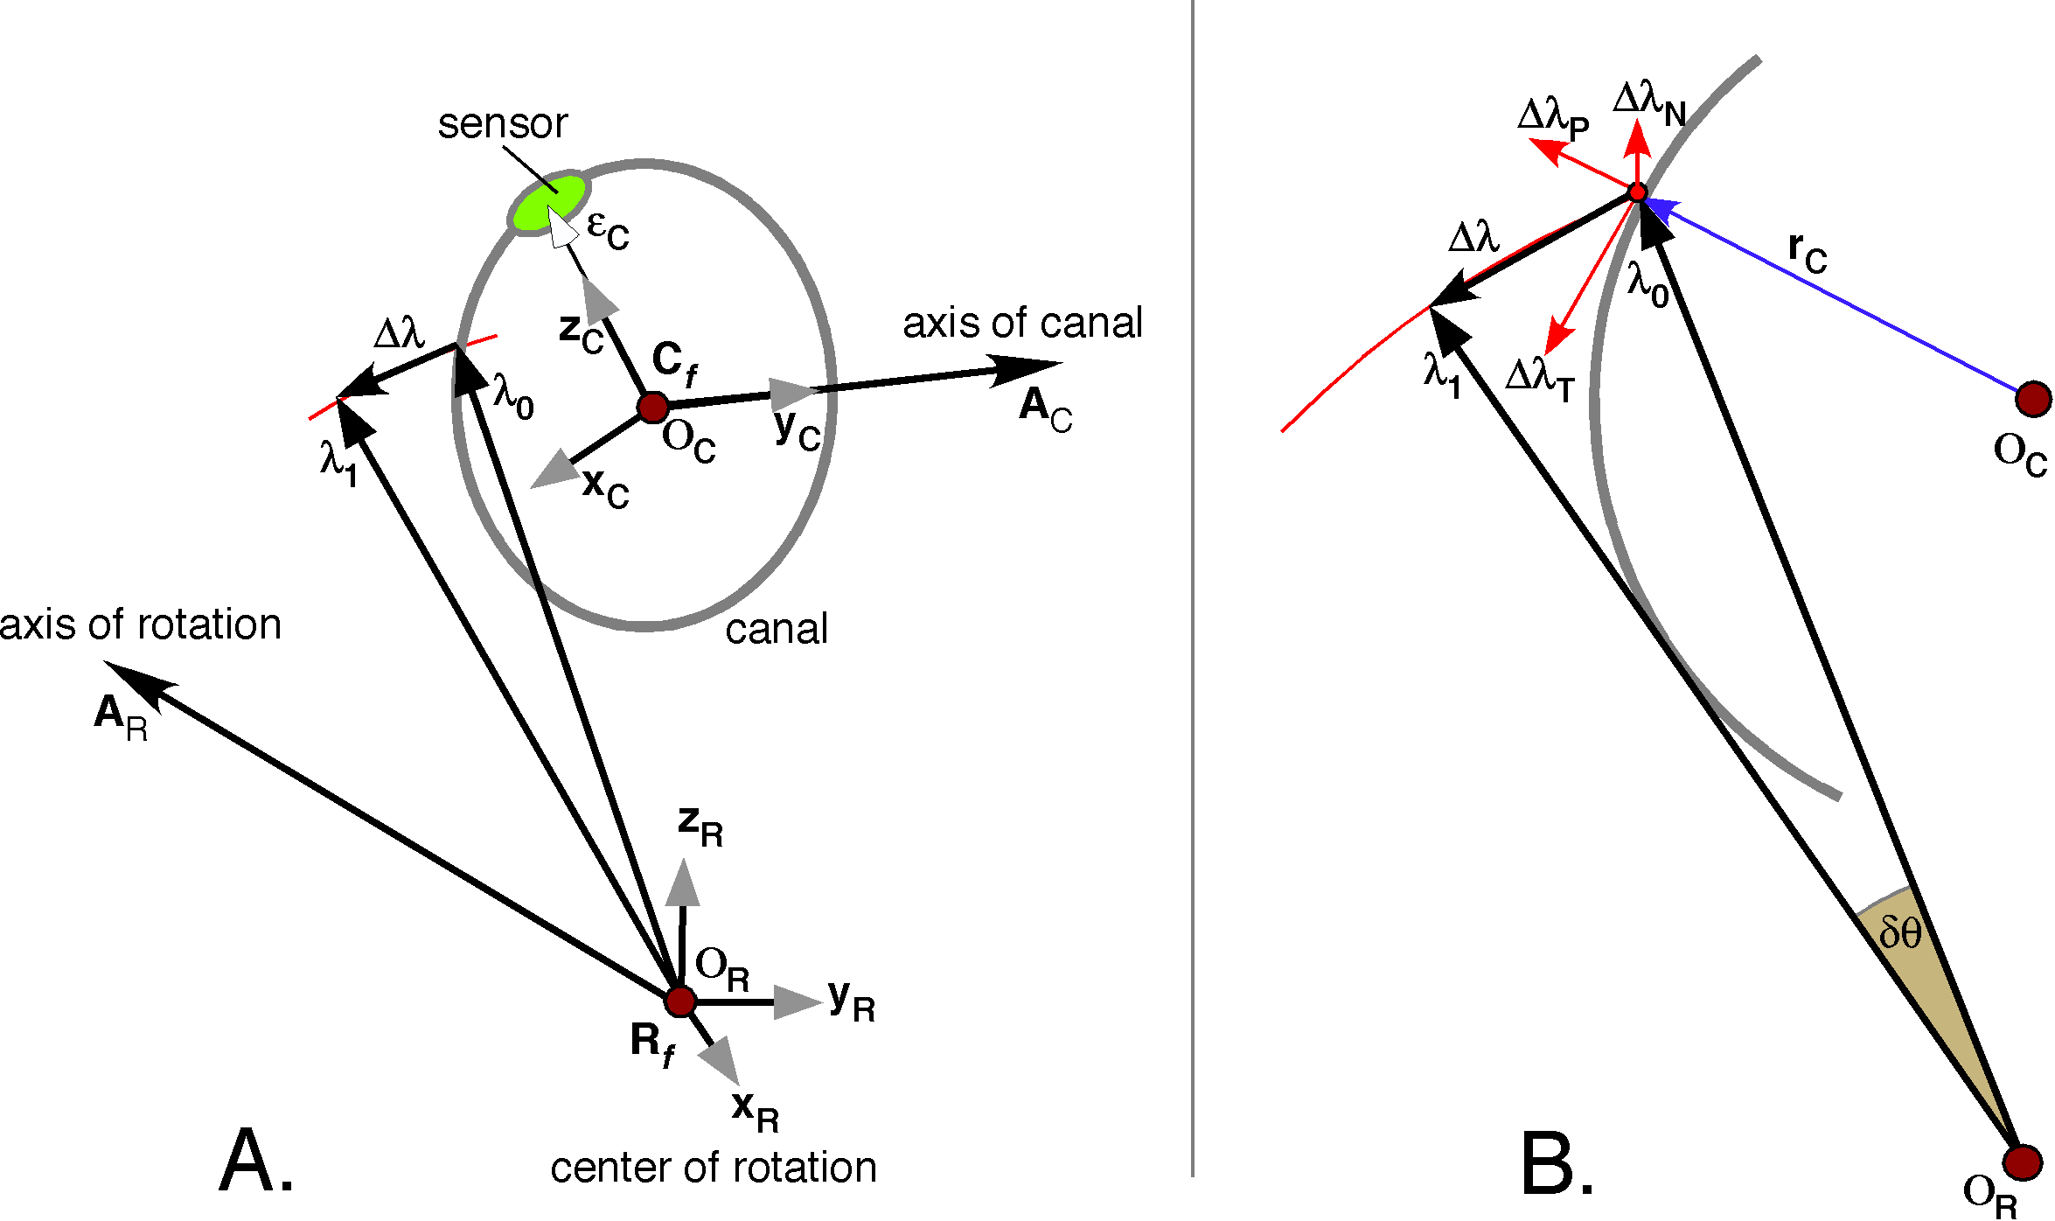

A general scheme for the analysis of fluid motion in a circular ring. The ring is rotated about an axis of rotation that does not lie in the sensory region and the inertial drag upon the fluid in the canal causes the fluid to move within the ring.
The general situation is illustrated in the following figure. There are two frames of reference, one attached to the center of rotation () and one attached to a ring (). The center of rotation has a location, , and an orientation frame of three vectors that reference it to the head or universal space or some other convenient coordinate system {}. There is an axis of rotation for the canal, , which will be taken to be the perpendicular to the canal plane that leads to increased activity in the sensory epithelium when the canal is rotated about it. It will generally be assumed that the movement is in a right-handed coordinate system. The framed vector for the canal will have a location, , and a frame of reference, {}, where the first basis vector, , points to the direction of the optimal acceleration for the sensory epithelium, the second basis vector, , points in the direction of the axis of rotation and the third basis vector, , will point towards the sensor. There is an extension vector from the center of the canal to the sensor, . That extension vector is important to what follows, because we will select points in the canal by rotating the vector around the axis of the canal. The radial vector, , extends from the center of rotation to the canal, where it meets a vector drawn from the center of rotation to the same point in the canal, . That point is rotated through a small angular excursion, , about the axis of rotation and it comes to a new point at the end of the vector . The linear excursion of that point in the canal is . The displacement may be resolved into three mutually orthogonal displacement vectors. Since we are interested in the movement of fluid in the canal, the axes of the displacement are defined relative to the canal. One axis is perpendicular to the canal in the plane of the canal, , therefore it is in the direction of the radial vector to the point, . A second is perpendicular to the canal in the direction of the axis of the canal, , therefore in the direction of the axis of the canal, . The third, , is in the direction of the ratio of the first to the second and therefore it is in the direction of the tangent to the canal. Although the basis vectors are listed in this order, they will be written in the order , so that In that order, they form a right-handed coordinate system. Once we have these basis vectors, we can calculate the components of the displacement by taking the dot products of each basis vector with the displacement vector. From that information one can move fairly directly to the forces acting on the fluid at the selected point in the canal. The force is the second derivative of the displacement with respect to time. It is in the opposite direction of the displacement and proportional to the rate of rotation. We now need to get down to the nitty-gritty of the calculation.
There are several rotations that occur about vectors, so let us set up the following convention. If a rotation occurs about a vector, let the quaternion that expresses that rotation be written as . The italic and bold formal indicates that it is a quaternion and the bar indicates that it is a unit quaternion. Similarly, the bar above the symbol for a vector indicates that it is a unit vector.
To simplify the calculations, let us assume that the center of rotation is at and the basis vectors for the center of rotation frame are . Doing so does not affect the generalizability of the calculations and it simplifies the symbolism. Then the center of the ring is at and the radius of the ring is . The axis of the ring is . If we take the center of the sensor to be at zero on the ring, then we can express the sampled point in the ring as a rotation of the extension vector from the center of rotation to the sensor, .
The vector from the center of rotation to the selected point is the point minus the center, which, because of the assumptions listed above, is the value of the selected point.
If the canal is rotated through a small angular excursion, , then the new locations of the point will be and we can compute the change in location for the sampled point.
The new location of the selected point is and the displacement is the difference between the locations of the sampled point before and after the rotation.
The components of the displacement are the dot or scalar products of the displacement with the local basis vectors for the canal.
It should be noted that the rotation will also change the orientation and location of the canal, therefore one must recalculate the framed vector for the canal.
However, returning to the component displacement vectors, the calculated quantity is a displacement and we are interested in acceleration. We could compute the rate of change of the displacement per unit time and then compute the components or we can treat each component separately. The result is the same if we stick to rotations about fixed centers of rotation. Any of the vectors may be expressed as a vector in the plane of the change. We parameterize the plane with two mutually orthogonal vectors, and express the displacement as a sum of the projections of on to and . The velocity of the displacement is perpendicular to the displacement and proportional to the magnitude of the angular excursion per unit time. Then one can differentiate again to obtain the acceleration and the result is that the acceleration is in the opposite direction of the displacement and proportional to the square of the rate of angular displacement per unit time.
Forces that are in the directions of the perpendicular or the normal vectors will not affect the sensor, because they will not move fluid around the ring of the canal. Therefore, we are most interested in the magnitudes of the forces that are tangential to the ring, which are proportional to . While we may eventually be interested in the actual magnitudes of the forces generated in the canal, for the time being we are only interested in relative magnitudes.
At this point we will begin examining a number of progressively more complex situations to get some sense of the consequences of rotations on the signals generated by canals. The first situation is very simple, if not very realistic in life. It is assumed that the center of rotation is at the center or the circular canal and the axis of rotation is aligned with the axis of the canal. The situation is very symmetrical so we can examine one segment of the ring and deduce the action occurring in all segments.

F = ma
If a mass moves at a constant velocity in a straight line, then no force is required for it continue in the same manner, leaving aside frictional forces for the time being. However, if the mass accelerates or decelerates or if it moves in a curvilinear trajectory, then there must have been a force applied to cause the change and the mass will exert equal and opposite forces upon the agent responsible for the change. The magnitude of the force will be proportional to the quantity of the mass and the acceleration that it experiences.

A uniformly rotating circular ring with its axis of rotation through the center of the ring, aligned with the axis of the ring
If we take the origin of our coordinates to be the center of the ring, where the axis of rotation intersects the plane of the ring, then the position of a segment of the ring may be described as a constant radius that rotates at a constant angular velocity in the plane of the ring. For simplicity, let the radius be unity and the angular velocity be one cycle per second.
The velocity vector of the moving segment is tangential to the ring and orthogonal to the position vector.
A short time later the segment of the ring has rotated a small distance around the axis of rotation and the velocity vector is the same magnitude, but directed in a slightly different direction. The change in the velocity with respect to time is the acceleration.
Notice that the acceleration vector is the same as the position vector except for being multiplied by a negative constant. Since the position vector is perpendicular to the ring in the plane of the ring, the acceleration vector is also perpendicular to the ring and in the plane of the ring. This corresponds to our physical intuition that the uniformly spinning ring where the axis of rotation is through the center of rotation and perpendicular to the plane of the ring will experience a constant centrifugal force on the outer surface of the ring.

An accelerating rotating circular ring with the axis of rotation through the center of the ring and aligned with the axis of the ring
If the ring in our first example is changing the speed with which it is rotating, then the situation is slightly more complex. The position vector is a variable function of time; therefore, the derivative with respect to time is not a constant.
The velocity vector of the moving segment is tangential to the ring and orthogonal to the position vector.
The velocity is proportional to the derivative of the angular speed. So far, the situation is only moderately different from that for uniform rotation of the ring. The acceleration is notably different.
In this situation, it is clear that the force can be resolved into two vectors. The first, , is like in the first example, with constant speed of rotation. It is directed perpendicular to the ring, in the plane of the ring and it is proportional to the square of the angular velocity. The second vector, , is tangential to the ring, therefore is a force that would cause deflection of a partition transverse to the circumferential axis of the ring. Consequently, a structure like the semicircular ducts might be sensitive to changes in head velocity, but not to uniform head rotation.
If the displacement varies sinusoidally with time (), then the outward pressure is greatest when the velocity is greatest and the circumferential pressure is greatest when the displacement is greatest.

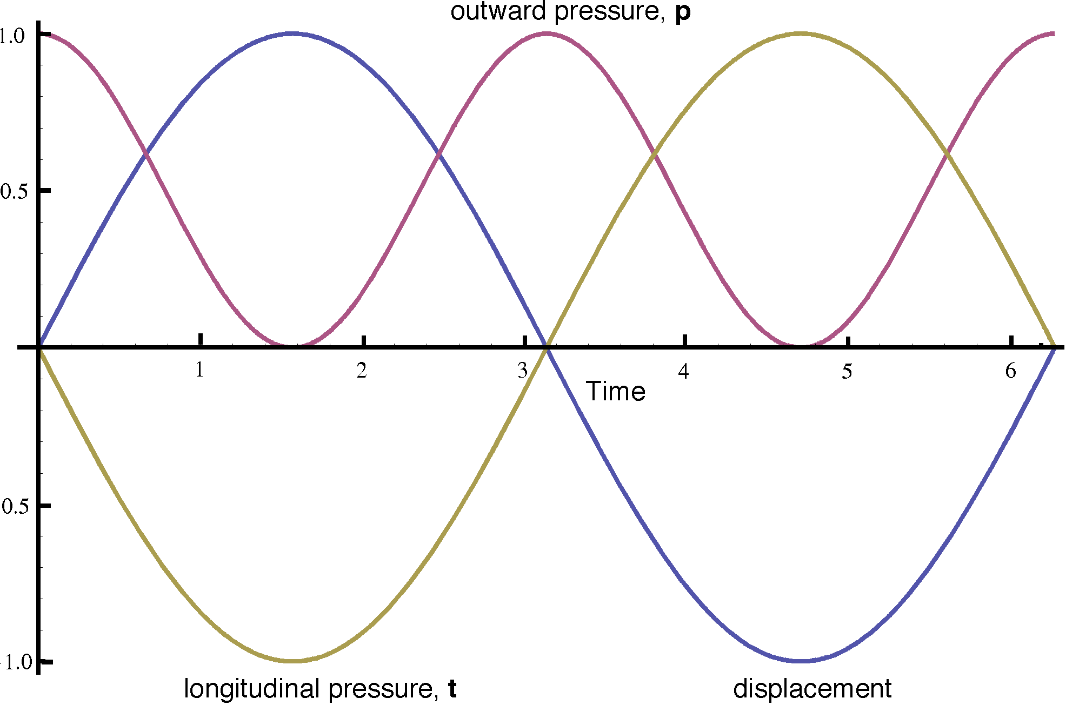

We will move to a more realistic model, but first let us consider another situation, where the rotation is not about the perpendicular axis through the center of the ring. Let the axis of rotation be in the plane of the canal and parallel with the sensitive axis of the sensor. In this situation the distribution of pressures is not radially symmetrical, so we will need to look at the distribution of pressure as a function of angular distance from the sensor.
Let us put the situation in the format that was introduced above to set up for the more complex situations where the mathematics is more difficult. We start with the ring in the i,k-plane, centered on the origin, which is also the center of rotation. The axis of rotation is in the same direction as the axis of the canal, both in the direction of the j axis. The selected point is the extension vector of the frame of the canal that extends from the center of the canal to the sensor, , rotated through an angle of and it is denoted by . The rotation of the canal about the axis of rotation is and it moves the selected point to . The excursion of the selected point is .

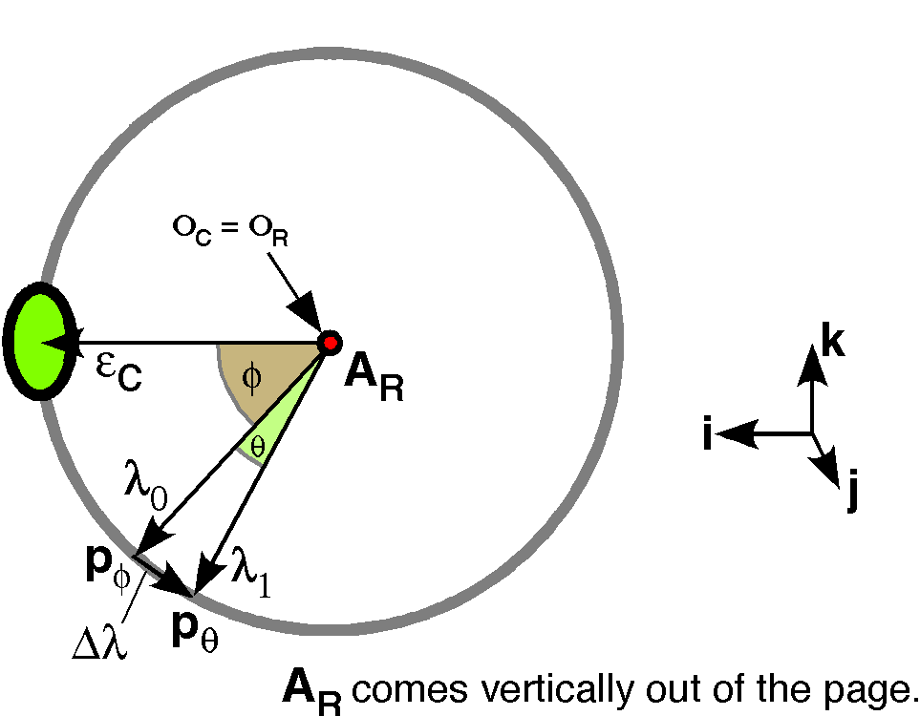

We can write down the expression for the various elements of the situation by inspection of the diagram. The new location follows from the anatomical description of the rotation. Then it is a simple matter to compute the displacement of the selected point in the ring and derive an expression for the displacement that simplifies to a description in accord with our intuition about the situation.

The final result says that the displacement is approximately orthogonal to the radial vector, which means that the acceleration term is almost totally circumferential around the ring, independent of the point chosen. This is the same result as we obtained by the first method.
It should be noted that what is being assessed is the change in velocity of ring rotation. If the ring continues to rotate at a constant velocity, then the fluid within it will be brought up to speed with the ring, because of friction within the fluid and between the fluid and the wall of the ring and because there is a partition across the ring that is somewhat distensible, but will not allow fluid to flow around the ring. Consequently, the fluid displacement is really a change in fluid velocity and the ring is reacting to the acceleration of the fluid.

Ring spinning about an axis through the ring

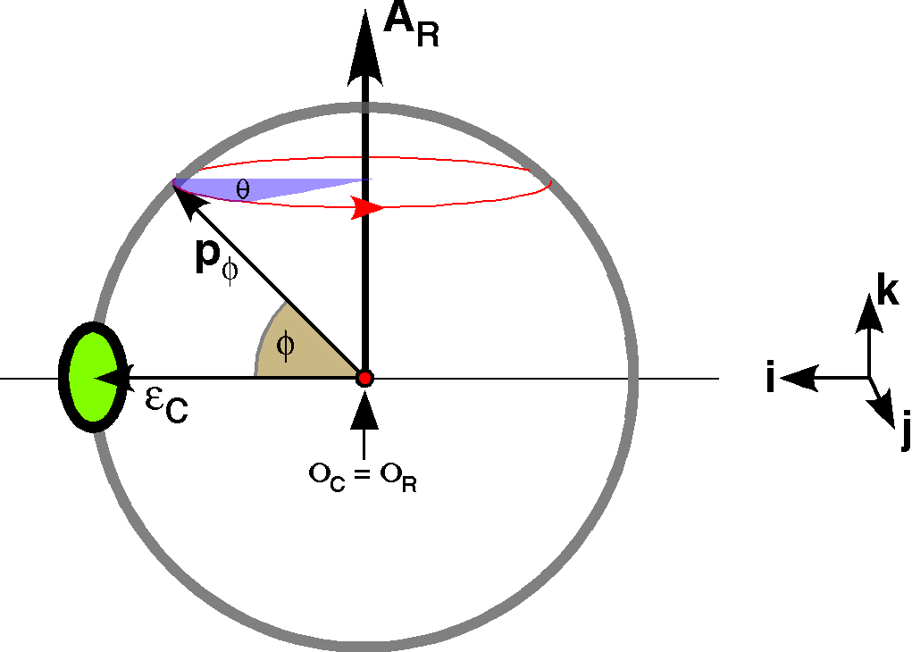

Let the center of rotation be the center of the ring and let it be perpendicular to the extension vector from the center of the ring to the sensor, . Then the selected point in the ring is . For convenience, let the ring lie in the i,k-plane, so the quaternion of the rotation is with a vector of k and the extension vector is i. The axis of the canal is . We can then begin calculating the excursion of the selected point.
The movement is confined to the plane of the rotation. However, the magnitude of is assumed to be small, approaching zero, therefore, is nearly one and the movement of the fluid in the canal is essentially perpendicular to the lateral wall of the canal. The magnitude of the force is proportional to the . So, it is maximal in the mid-ring and small at the top and bottom of the ring. It is in opposite directions on the two sides of the ring, as one would expect from the geometry of the situation. There is no circumferential movement, therefore, this type of rotation would not stimulate the receptor.

Rotation about an eccentric center of rotation, in the plane of the canal
Next, consider the situation where the canal is rotating about a center of rotation that is outside the ring, but the axis of rotation is aligned with the axis of the canal. We would expect this situation to be quite effective in stimulating the canal, but the forces should be a function of the point chosen in the ring.
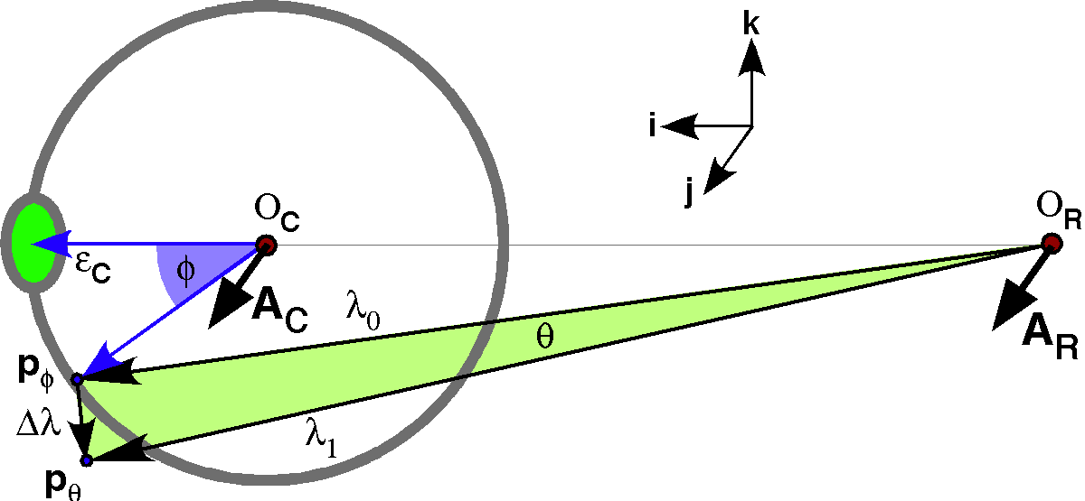

Let the canal lie in the i,k-plane and the axis of the canal lie at the origin and directed along the j axis. The extension vector from the center of the canal to the sensor, , is i. The selected point in the ring is and it is rotated about the center of rotation at to obtain the new location, . The location of the center of rotation will be three radii from the center of the ring and the axis of rotation is parallel to the axis of the ring. The difference in location due to the rotation is . In this situation, it will be necessary to compute the vectors for the selected point so that may be projected on the unit vectors of the basis, to obtain the relative amounts of acceleration along the canal and perpendicular to it.
We can see by examining the illustration that the movement will tend to be at a substantial angle to the ring at both the top and the bottom of the ring and fairly parallel at the two sides of the ring especially at the sensor when the arrangement is it being most distant from the center of rotation. We can also see that the circumferential accelerations in the part of the ring more proximal to the center of rotation will tend to push the fluid in the opposite direction to the direction induced in the more distal parts of the ring. We would expect the more distal acceleration to be greater, because of the greater linear excursion with the same angular excursion. Having made these observations, let us consider the calculation of the displacements.
This expression for the displacement of the selected point is sufficiently complex that one is probably far better off going with numerical methods. First we calculate the displacement of the selected points as a function of their location on the ring. The next figure shows the displacement in the direction of the axis and in the direction of the axis. The rotation is 0.05 radians which is slightly less than 2.9°. We can see that the greatest displacements in the direction, relative to the movement of the ring as a whole, are at the most distal and most proximal parts of the ring with respect to the center of rotation. In the direction the greatest displacements are at the midpoints between those two poles and they are also about 0.05 times the radius.

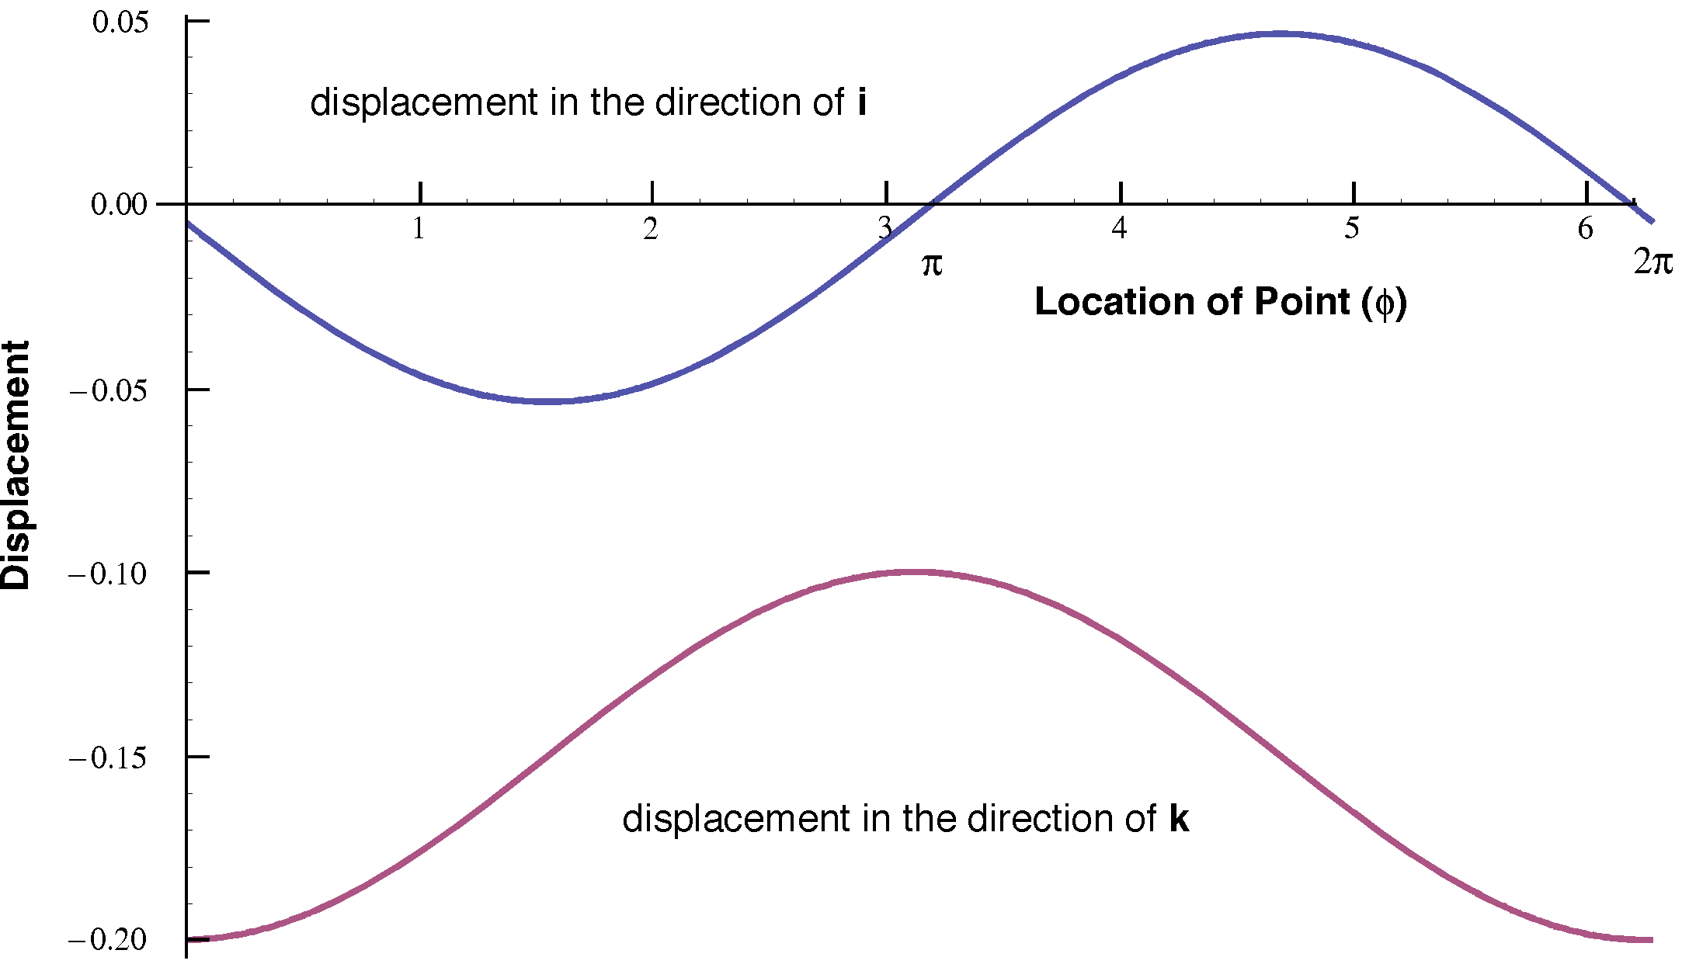

We know from the expression for the displacement that the functions are approximately a sine and cosine function, so it is likely that the circumferential displacement may be almost constant. There is a phase shift in the curve for displacement in the direction. However, when the total displacement is plotted, we find that the amount of displacement is a cosine-like function of location. It is maximal at the most distal part of the ring and minimal in the location closest to the center of rotation. That is what we would expect from the structure of the situation. Because the distal point is about twice as far from the center of rotation, it travels about twice as far with the same angular excursion.

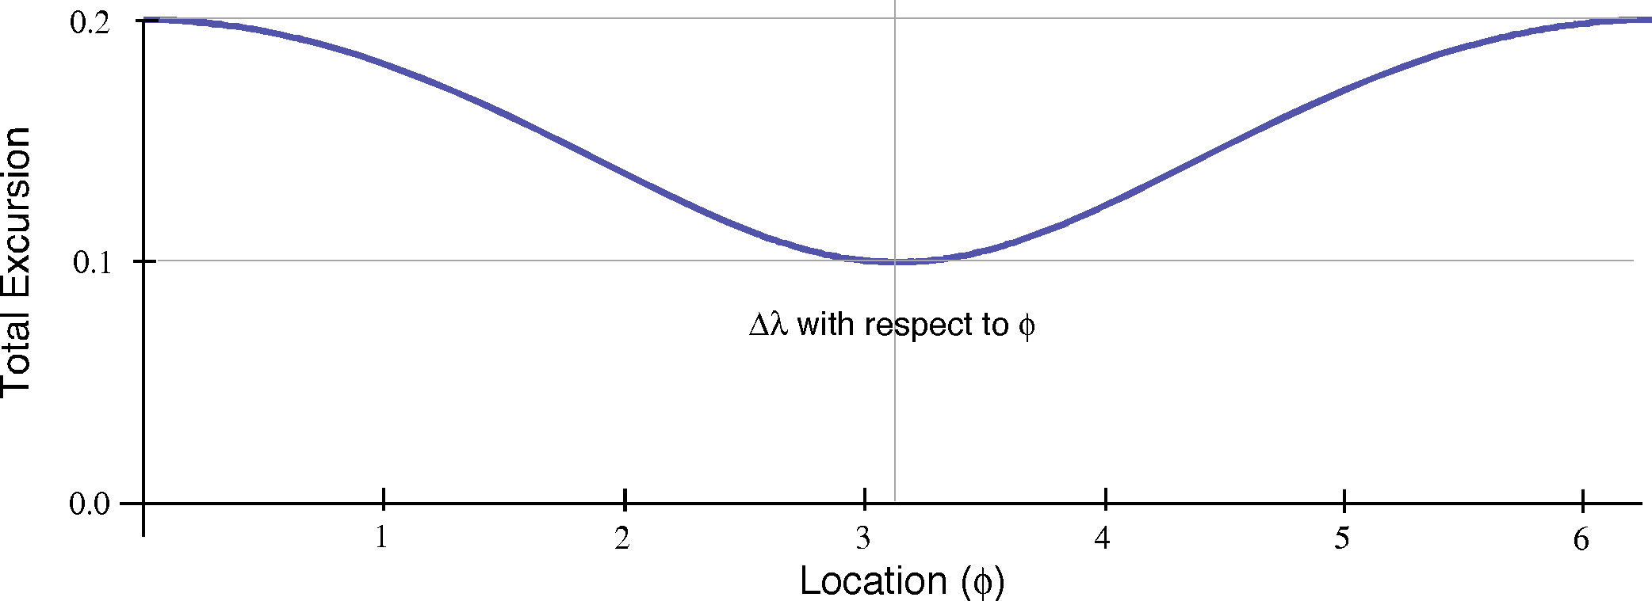

We can examine that by computing the projections of the displacement upon tangential and radial unit vectors. That has been done here by taking the ratio of the displacement to the unit vector tangential to the ring and to a radial unit vector. The tensor or magnitude of the ratio is the magnitude of the displacement, which is plotted immediately above. The scalar of the ratio quaternions may be computed and they are the relative magnitudes of the projections of the displacement on each reference vector for that location. The sum of the squares of the values for each location will be unity. The relative radial flow is clearly warped from a sinusoidal function and the relative tangential flow is similarly warped, being narrower in the proximal part of the ring than in the distal part.

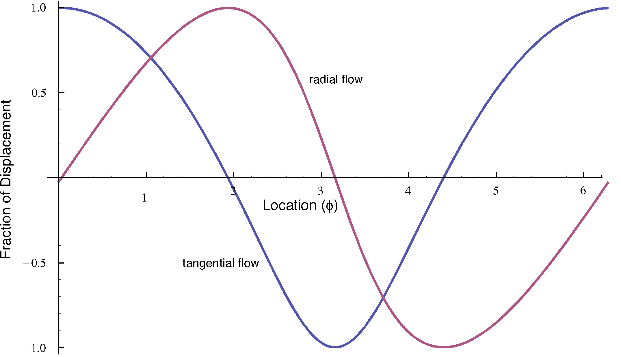

The curves for the angles between the displacement vector and the local reference vectors is approximately saw-tooth, but with some curvature that causes the curves to deviate from straight lines. They are also phase-shifted relative to each other.

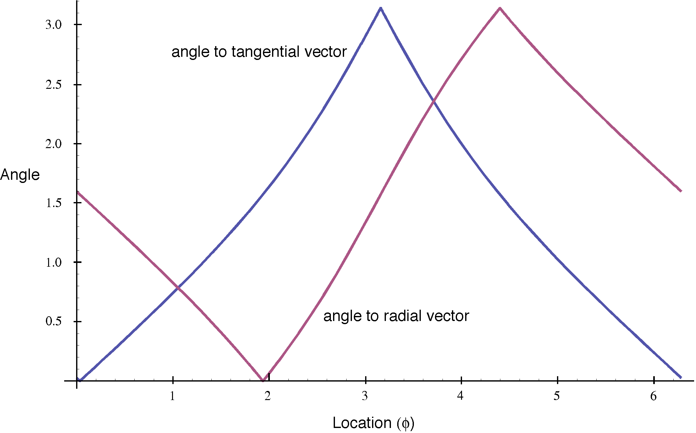

When we multiply the relative amount of flow at each location by the absolute amount of flow, to obtain the actual amount of flow, then the curves become symmetrical nearly sine and cosine functions. The radial flow is nearly sinusoidal and symmetrical for flow to the exterior of the canal on one side and flow towards the outside of the canal on the other side. That is intuitively what we would expect from the geometry of the situation. The circumferential flow is not symmetrical. For the distal part of the ring the flow is greater than for the proximal part and the flow is in the opposite direction for the most proximal part of the ring. In a ring of uniform caliber, there will be a preponderance of flow in one direction, the direction of flow in the distal part of the ring. If one plots the function on the same plot, there is a very small discrepancy between it and the curve of the tangential flow, but it turns out to be very good approximation to the flow distribution. That is good because it implies that we can assume a fairly simple relationship between angular excursion and net flow in a tube.

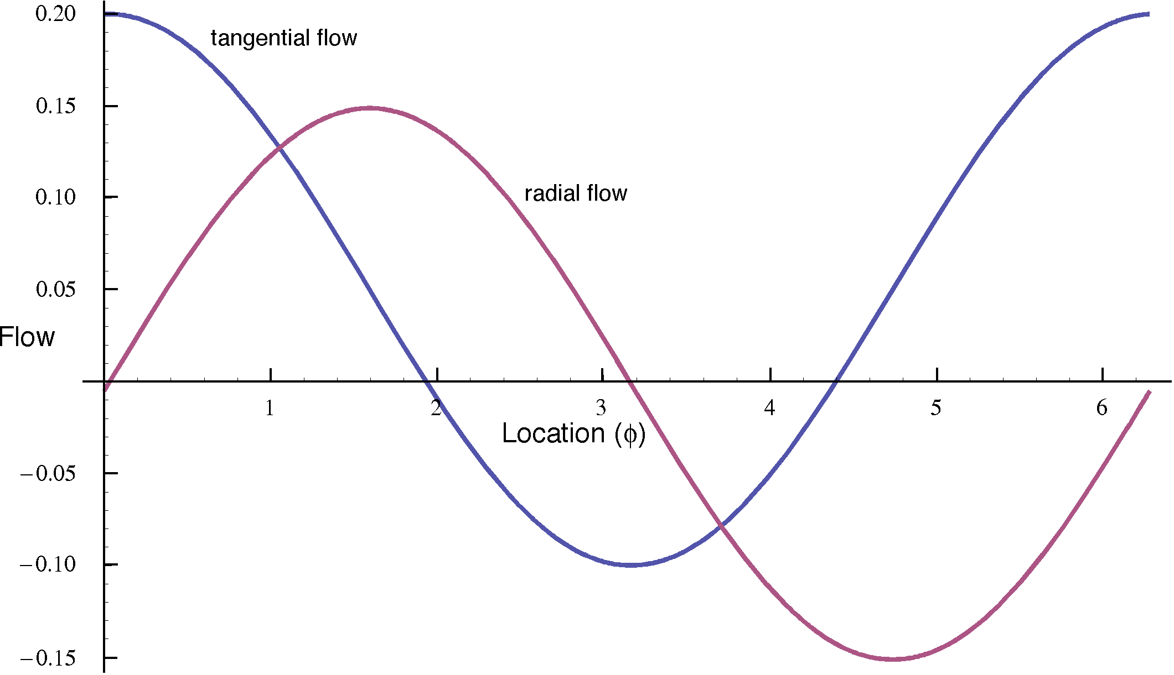

In the next figure the profiles for a series of situations are plotted together to illustrate how the tangential and radial flows depend on the distance from the center of rotation to the center of the ring. The number beside the curve indicates the distance between the centers, in ring radii. The curves from the above calculations are indicated by the number 3. All the curves of a type intersect at two points. That value is the angular excursion of the ring rotation chosen for the calculation. When the movement excursion is 0.05 radians, the tangential displacements have a common intersection 0.05 radians above the zero axis. For the radial displacements, the intersects lie on the horizontal axis through zero displacement. The curves are very close to cosine and sine waves so that there is a small asymmetry for tangential displacements, which means that there is a small bias for fluid movement in the ring in a direction opposite to the direction of ring rotation.

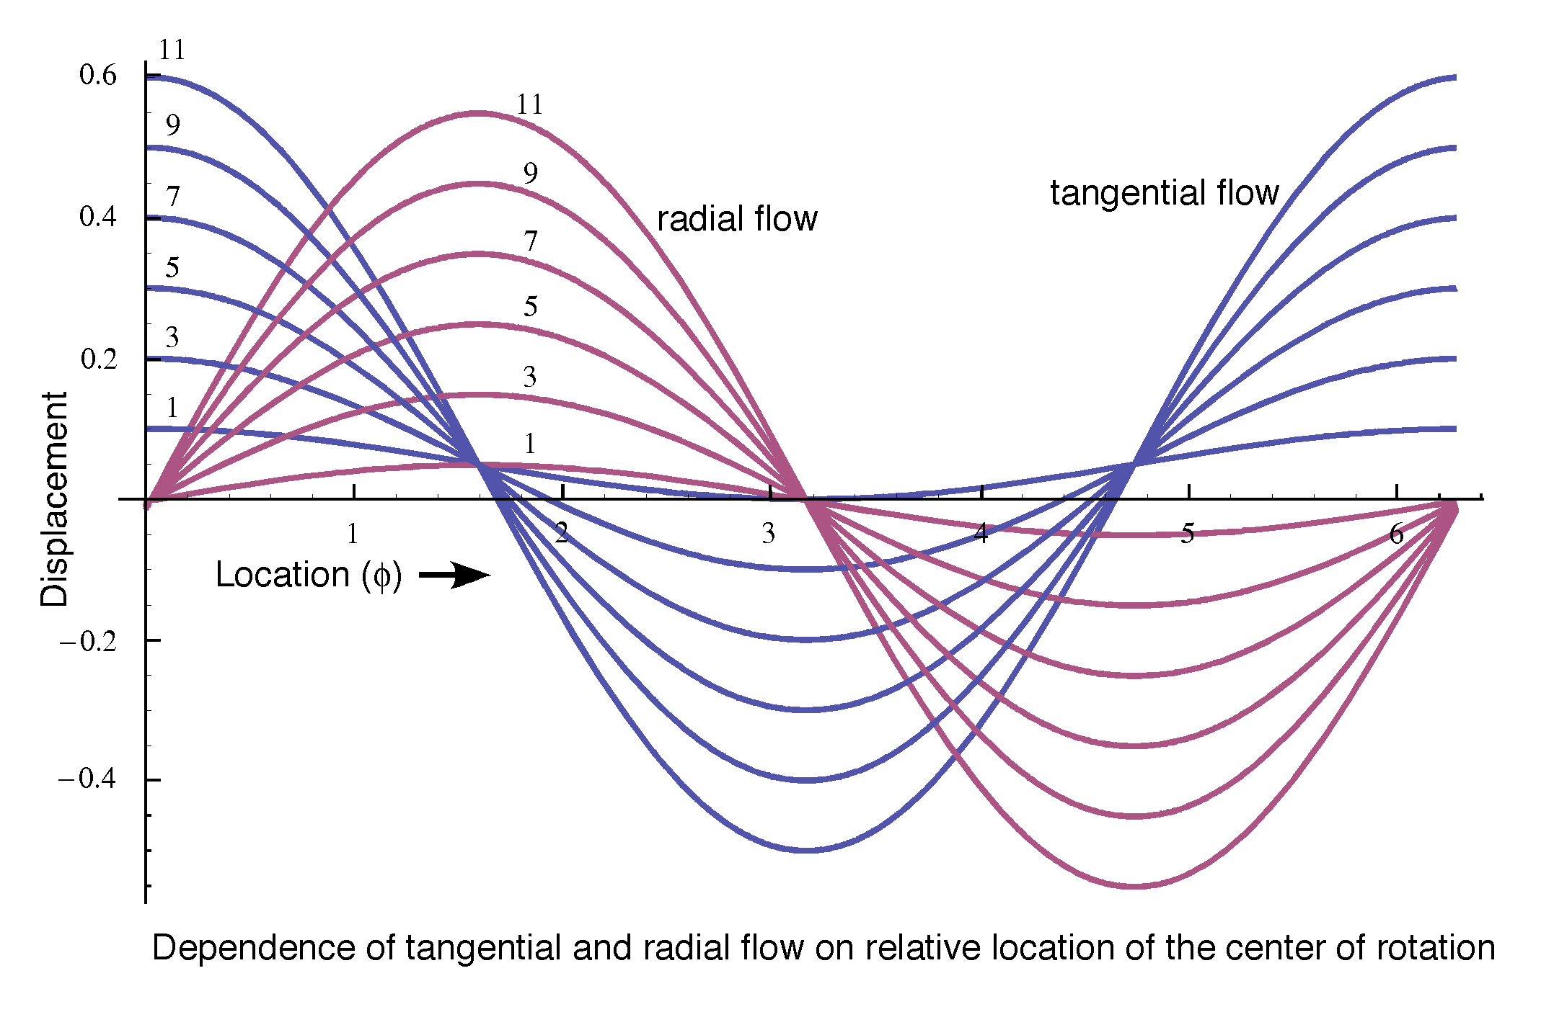

The geometry of the situation was chosen so that the sensor was at the part of the ring that is maximally stimulated by the rotation because the force to move the fluid in the direction opposite the rotation is greatest in the part of the ring opposite the center of rotation. The calculations so far seem to indicate that the location of the sensor would effect the signal the sensor would give with a given rotation. If we assume that the forces average, which is most likely since the fluid is virtually incompressible at the pressures that occur in a semicircular canal. Then the effect of a rotation would be to cause the fluid to move in one direction, the direction dictated by the pressures in the most distal part of the ring.
The net pressure in the ring may be related to the integral of the forces generated throughout the ring, which is the area between the curve and the horizontal axis. We have found that the pressure profile for circumferential movement is of the form , therefore the integral will be depend only on the offset, . The k is a constant, which would be the sensor output when there is no movement. In the vestibular system there is a baseline discharge rate about which the discharge rate varies, so both positive and negative displacements a will register.
The overall signal that is sensed by the ring is the angular excursion. Theoretically, there would be more distortion if we use large angular excursions, but we can view a large angular excursion as a series of small excursions, each of which is quite small. In that case there is little deviation from a sine or cosine function.
If the movement is happening at a particular speed, then the angular excursion per unit time will be translated into a displacement per unit time or an angular velocity. It is the change in velocity that generates forces that tend to displace the fluid. If a ring travels in a straight line with constant speed, the fluid in the ring travels with the ring and there is no force. If the speed of the ring changes or the direction of its movement changes, then there is a change in velocity and the fluid has an inertial drag, which generates reaction forces of fluid movement. Therefore, the pressure on the cupula will be a linear function of the change in the head’s angular velocity.
The average circumferential displacement is a linear function of the magnitude of the rotational excursion if the ring is rotating about an axis that is parallel with the axis of the ring. That is remarkable, because it says that the push on the cupular partition is simply related to the head movement, independent of the center of rotation. Even though the semicircular canals move through much more distance when the head is moved from the waist than from the neck, the canals will sense both movements as being the same if the angular excursion is the same and the time to complete the movement is the same. The local forces at points in the ring will be much greater in the first situation, moving from the waist, but the average force moving fluid around the ring is the same.

Rotations about the axes of rotation near the axis of the ring
The next few section it will be shown that rotations in planes perpendicular to the plane of the ring cause no overall circumferential fluid movement, because the average displacement around the ring is zero. So, circumferential movement in a ring is due to rotation in a plane near that of the ring. We will briefly consider that relationship in the next couple sections.
Now, we turn to rotations about axes that are tilted with respect to the axis of the ring. In the following figure, the center of rotation is displaced three ring radii in the direction of the axis and three radii in the direction of the axis. The axis of rotation is initially parallel to the axis of the ring (0°). Then the direction of the axis of rotation is moved in five steps to point in the direction of the center of the ring. In the most tilted instance, the ring is tilted 45° with respect to the axis of rotation (45°).

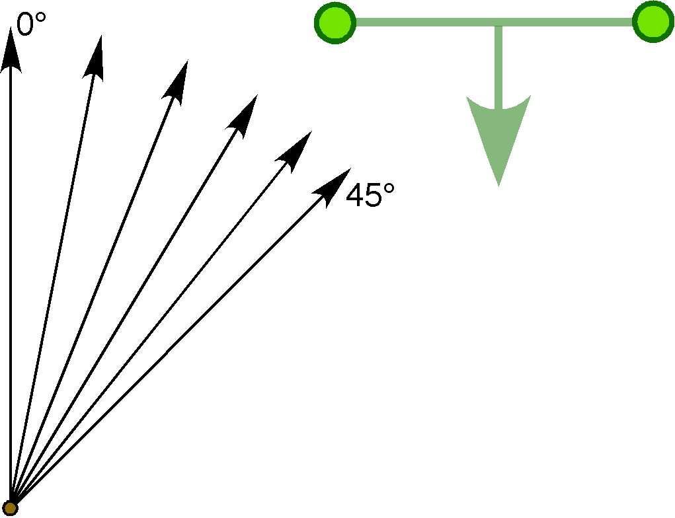
A ring (green) is rotated about an eccentric center of rotation (brown circle) with a number of different axes of rotation ranging from perpendicular to the plane of the ring (0°) to a 45° angle to the plane of the ring.

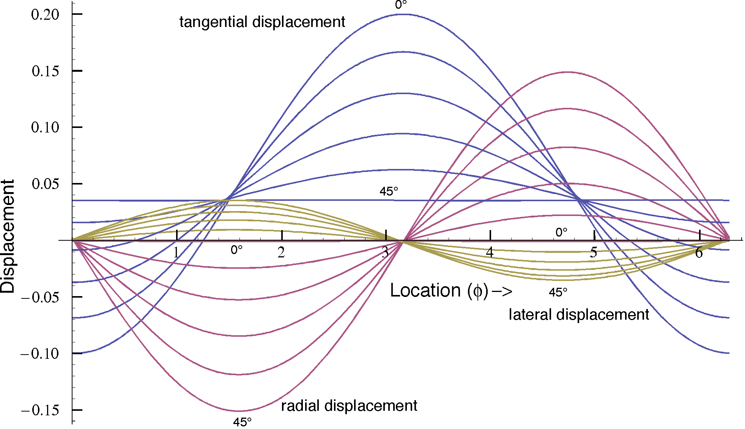

When the axis of rotation is parallel to the axis of the ring all of the displacement is circumferential and the average is proportional to the angular excursion of the rotation, but the displacement varies sinusoidally around the ring. When the axis of rotation is a 45° angle to the ring, but through the ring the circumferential displacement is constant around the ring, but there is a substantial displacement towards the wall of the ring that varies sinusoidally with location, being greatest at the poles of the ring, the leading a trailing parts of the ring. Note that since the lateral and radial displacements co-vary, the displacement is neither radial nor lateral, but oblique, more radial than lateral.
It is also interesting that the tangential displacement curves do not cross at a common point. That reflects that the middle value of the curves shifts with angle. When the axis of rotation is perpendicular to the ring, the middle value is the magnitude of the angular excursion of the rotation and when it is a 45° angle, it appears to be about the angular excursion times the cosine of 45°. Consequently, the average displacement in a rotating ring is an index of both the angular excursion and of the inclination of the ring to the axis of rotation.

Rotations in which the ring is tilted to the axis of rotation, but there is some rotation in the plane of the ring.
The previous situation was complicated by two things happening at once. The axis of rotation was moving closer to the center of the ring at the same time as it was changing it angle with respect to the plane of the ring. Let us now eliminate the first factor by examining the situation where all the axes of rotation are through the center of the ring, but they differ with respect to their tilt. When the ring is perpendicular to the axis of rotation and the axis of rotation in through the center of the ring, we have the initial situation considered above and all of the displacement is circumferential. The tangential displacement is 0.05 radians, the same as the total displacement of the ring about its center. The displacement is the same in all parts of the ring so the curve is a straight line or a constant value. As the axis is tilted more with respect to the plane of the canal (10° through 90°), the amount of tangential displacement becomes less until there is no tangential displacement of average (90°), because the ring is rotating about an axis through the center of the ring that lies in the plane of the ring. It is spinning like a coin spinning on it edge. There is some sinusoidal variation in the profiles for tilted axes of rotation, because some parts of the ring are further from the axis of rotation than other parts. The magnitude of that variation increases with greater tilt.

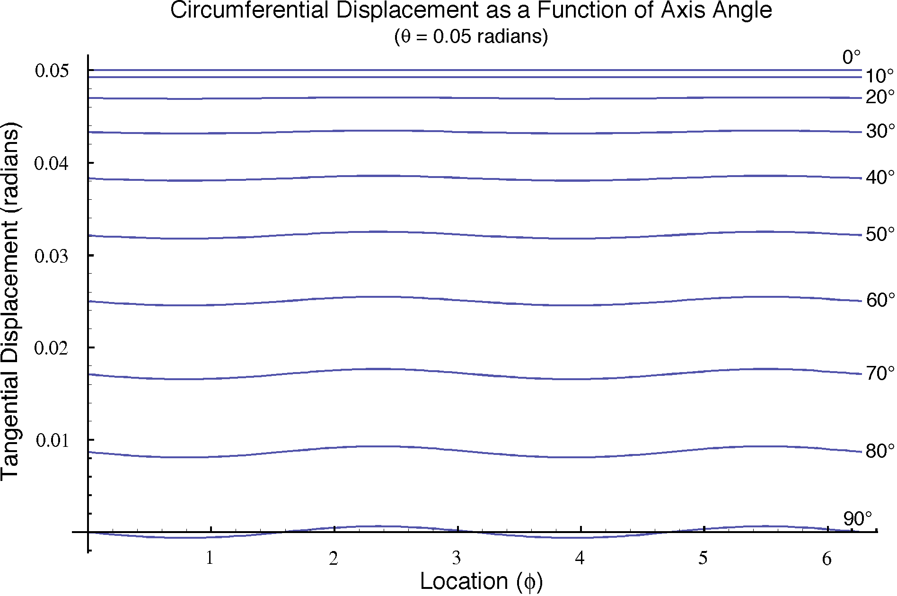

Still, the variation is much smaller than the mean value for all but the 90° tilt example. For every other example, there is a non-zero average for the profile and the area between the profile and the zero axis is greater for less tilt. It works out that the magnitude of the average tangential displacement is proportional to the cosine of the angle of the tilt. So we can elaborate on the expression developed from the first situation and say that the response, , is proportional to the rate of change of rotation, angular acceleration, , and the cosine of the tilt between the axis of the canal and the axis of rotation, .
That relationship indicates that we cannot tell from one sample of a response to a movement to what extent the ring is accelerating () and to what extent it is tilted relative to the axis of rotation ().
Returning to the previous section, we can now say that the curves for tangential displacement did not cross at a single point because the average values of the responses were different in response to the different tilts with respect to the plane of the ring.

Rotations in which the ring moves in direction of its axis
More briefly, we can consider the displacements that occur when the ring moves about an axis that lies outside the ring in the plane of the ring and the ring moves in the direction of the axis of the canal. It moves face-on. We would expect the main displacement to be against the lateral wall of the canal. The next figure illustrates the displacements relative to the local coordinate system, that is radially, tangentially and laterally or orthogonal to the ring plane. The calculations were essentially as in the last situation, except that the center of rotation is displaced along the axis for 1, 3, 5, 7, 9, and 11 radii, and the rotation is about an axis of rotation parallel to the axis.

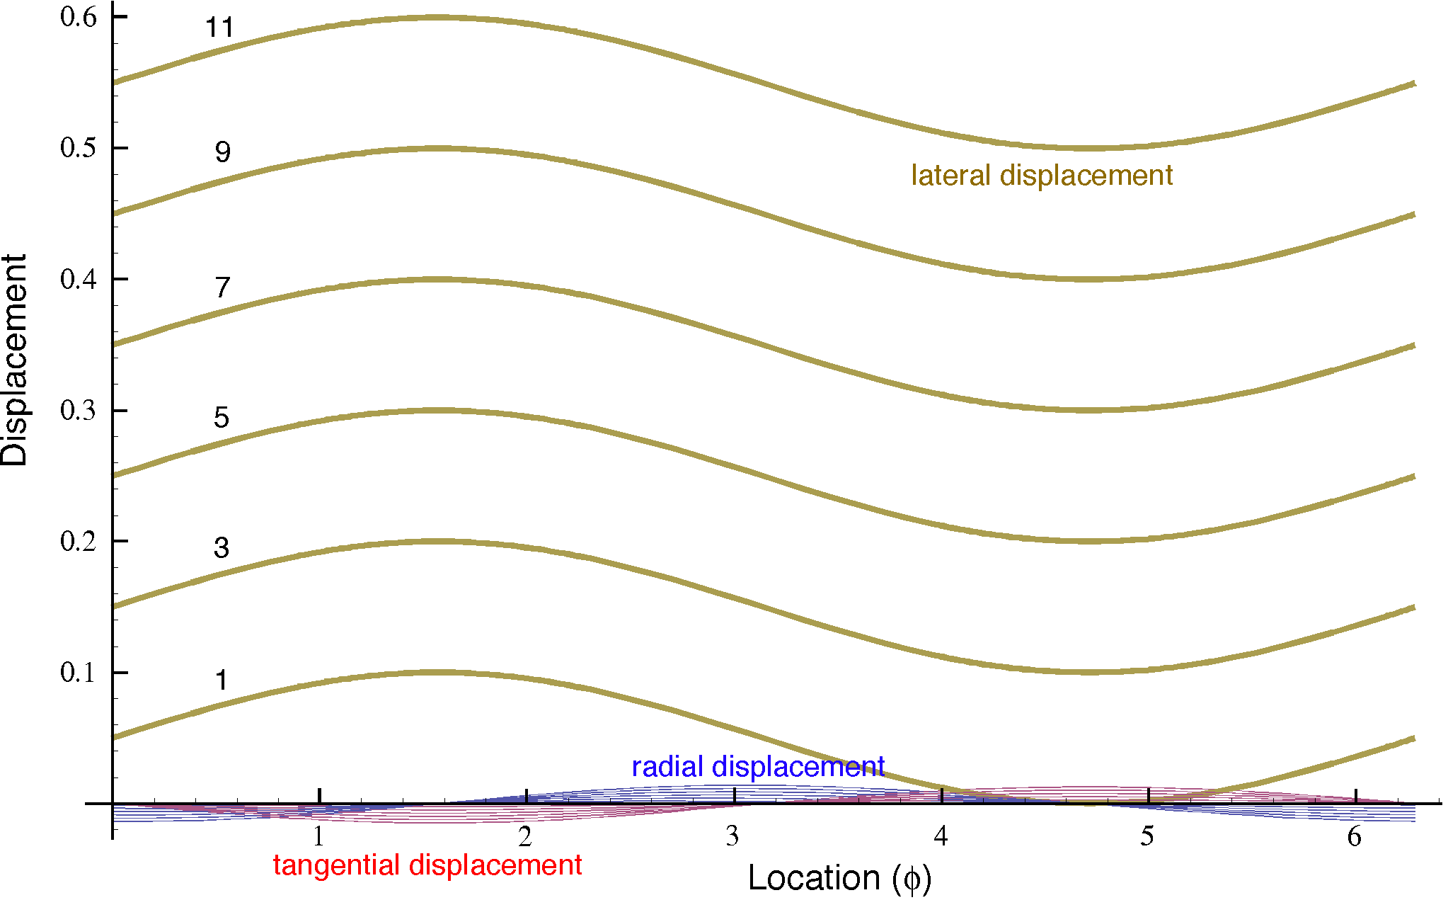
As expected, the major displacement is in a direction orthogonal to the canal plane or against the lateral wall of the ring. The amount of displacement is proportional to the distance from the center of rotation to the center of the ring. The sinusoidal variation is due to the more proximal locations traveling less distance than the more distal locations.
There is also some displacement in the radial direction at the more distal and proximal locations. That is centripetal displacement due to movement in a circle, so that the fluid seems to be drawn towards the center of rotation because of it deviation from a straight trajectory.
There is also some tangential displacement, for the same reason as the radial displacements, but it is greatest at the middle of the ring, where the fluid tends to flow along the tube towards the distal part of the ring. The displacement is balanced on the two sides, or opposite in direction, so there is no net movement when integrated over the whole ring.
Both the radial and the tangential displacements are sinusoidal about no displacement, so that there is no net tangential displacement, but there would be a force on the outer wall of the distal ring and the inner wall of the proximal ring, which would tend to push the ring distally as one would expect of a swinging ring.

Spinning about an axis in the plane of the ring
Another possible way of rotating the ring is to spin it about and axis that passes through the middle of the ring in the plane of the ring. It would be spinning like a top or a penny spinning on its edge. The displacements would be fairly straightforward. They would be against the lateral walls of the ring, in opposite directions on the two sides of the axis of rotation and zero where the axis passes through the ring. There would also be a radial displacement towards the center of the ring because the fluid would deviate from a straight trajectory. Calculations with the model indicate that the lateral displacements are orders of magnitude greater than the radial displacement for small angular excursions. There would be no tangential displacement, because the fluid at any location will be moving in a circular trajectory in a plane perpendicular to the plane of the ring.

Conical swings about an axis parallel to the plane of the ring
A more interesting excursion is when the ring is swinging about an axis that is not through the ring, but parallel to the plane of the ring, that is experiencing a conical rotation. Many of the movements of the head will produce such a trajectory for the semicircular canals. For instance, moving one’s head back and forth in a horizontal plane, as when shaking it to signify ‘no’ or disagreement would cause all of the canals to experience a conical rotation. In that particular instance, the only canal that has a plane that comes close to containing a vertical vector is the anterior canal. The posterior canal is in roughly the same situation. The horizontal canal would roughly approximate another type of conical swing where the center of rotation is not in the plane of the canal, but the axis of rotation is in the direction of the axis of the canal, that is formally equivalent to the first situation considered, because we can find a point on the axis of rotation that is in the plane of the canal.
In the next section, we will consider the special case of the axis of rotation parallel to the ring plane, but not in it, and then move on to the general case of a conical rotation. That is the situation most like normal movements of semicircular canals.

What happens when the tube is not of uniform caliber?
The assumption of a tube of uniform caliber has given us some insights into the movements of fluid in a ring, it is not very like the anatomy of semicircular canals. The semicircular canals are only partial rings, about two-thirds of a circle with the ampulla at one end. Both ends of the canal are joined to the utricle, which is a comparatively large amorphous chamber. The diameter of the duct part of a canal is about a quarter to a third that of that of the ampulla and the ampulla is much smaller than the utricle. We would expect comparatively little resistance to fluid flow in the utricle or the ampulla, compared to the resistance to flow in the duct. For laminar fluid flow in a circular tube, resistance is proportional to the fourth power of the radius of the tube, which means that the resistance to fluid flow in the duct is about two orders of magnitude greater than the resistance in the ampulla and even greater relative to the utricle. These structural considerations mean the fluid dynamics in the vicinity of an ampulla are like that of a hypodermic syringe with a long needle on it. The pressure needed to move the plunger in the barrel is much greater with the needle attached than it is without it. In much the same way, a force that tries to move fluid from an ampulla into the adjacent duct will meet a substantial resistance to flow that depends upon the viscosity of the fluid, the length of the tube, and the diameter of the tube.
The duct acts as a damper on the system. The same process would work in the opposite direction. Fluid movement from the duct through the ampulla and into the utricle would encounter a drag retarding movement through the duct. The retarding force would be proportional to the velocity of fluid movement and opposite the direction of the force trying to move the fluid through the ampulla. This damping is a good feature to have in such a system because it tends to prevent large movements of the fluid in the canal. The ampulla is sealed off by the cupula and the cupula is distensible, but optimally only within narrow range. Too much unopposed force tending to move fluid around the canal would tear the cupula from its attachments to the wall of the ampulla and the crista ampullae. The cupula will act as a spring in that fluid movements will cause it to billow, like a sail in the wind. However, that distortion will resist further distortion, presumably in a manner roughly proportional to the amount of displacement, . Ideally, we want a brief transient delay as the canal changes the rate at which it rotates and a rapid acceleration of the fluid within the canal to the new velocity.
There is an additional component acting to control fluid movements. The duct of a semicircular canal does not have a circular cross-section. It is elliptical, with an approximately 2:1 ratio of axes. That means that it can accommodate a bit more fluid if there is greater internal pressure and it can become flatter if the internal pressure drops. That may be an important mechanism if the movements of fluid into and out of the ampulla. As fluid is forced into the ampulla by greater pressure on the utricular side of the cupula, the cupula billows, thereby forcing fluid from the duct side of the ampulla into the duct. The duct offers resistance to fluid movement, but the fluid can be accommodated by rounding of the duct. If there is a sustained acceleration, then the duct can bleed the excess fluid through the duct and into the utricle. With fluid movements in the opposite direction, the duct side of the ampulla can draw fluid from the duct by allowing the duct to flatten a bit. This mechanism would also seem to work as a spring and, in the short term, one would expect the fluid stored in the duct distortion to be proportional to the amount of fluid that has moved into or out of the duct. More stored fluid would stretch the duct more and create a greater restoring force, .
In fact, the anatomy is even stranger in that the needle extends back to end in the chamber of the syringe.

