The Functional Anatomy of the Semicircular Canals in Man

Anatomy of the Semicircular Canals
The semicircular canals are generally described as a set of mutually perpendicular membranous rings that meet in a dilated expansion called the utricle. The anterior and posterior canals are approximately vertical with each canal at an approximately 45° angle to the midsagittal plane and the lateral canal approximately horizontal, which is why it is also called the horizontal canal. The planes of the canals form an array similar to the corner of a box that is rotated 45° out of the sagittal plane.

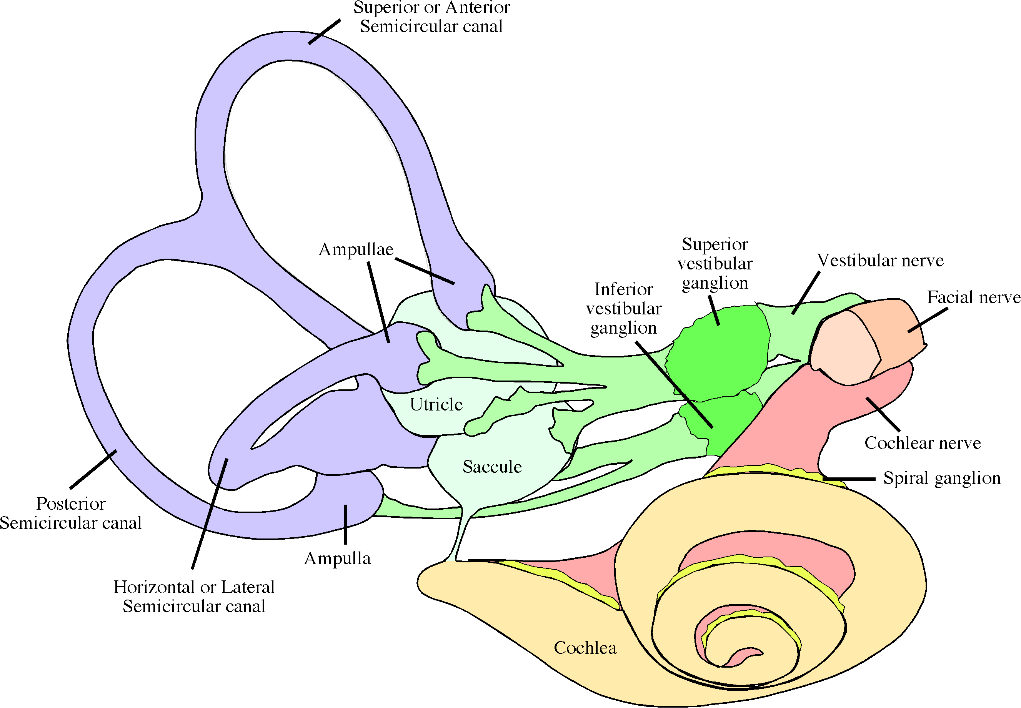

The vestibular part of the membranous labyrinth is composed of the utricle and saccule and three roughly mutually perpendicular semicircular canals. The semicircular canals arise from and end in the utricle. One end of each canal has a dilation called an ampulla, which contains the sensory epithelia for rotational acceleration. The utricle and saccule each contain a sensory epithelium for linear acceleration.
The semicircular canals lie in a similarly shaped bony chamber called the bony labyrinth, which also has a cochlea and three semicircular canals. The canals, along with the utricle and saccule and the scala media of the cochlea and the endolymphatic duct form a complex membranous structure called the membranous labyrinth. The scala media is attached to the walls of the bony cochlea and the membranous semicircular canals lie within the bony semicircular canals. The utricle and saccule lie in the vestibule of the bony labyrinth.
The membranous labyrinth is filled with an ionic solution called endolymph and surrounded by another ionic fluid called perilymph. The different ionic compositions of the two fluids are important for the correct operation of the hair cells. Both fluids are approximately the same density and viscosity as water.
The vestibular parts of the membranous labyrinth, the saccule and utricle and the three semicircular canals are suspended in the bony labyrinth by thin connective tissue trabeculae, so that the membranous labyrinth is floating in the bony labyrinth, but retrained from large movements within the bony chamber. The arrangement is like a water-filled balloon floating in a substantially larger pool of water, held in place by many thin elastic bands.
The cross-sectional radius of the membranous semicircular canal is about one-third that of the bony labyrinth and it is modestly flattened so that the canal has an elliptical cross-section. The elliptical cross-section means that the canal can expand in volume readily, simply by assuming a more circular cross-section. A circle has a greater area than an ellipse with the same circumference.
At one end of each canal, just before it meets the utricle, the membranous semicircular canal dilates into a bulbous ending called the ampulla of the canal. The ampulla has about three times the radial cross-section of the remainder of the canal. The ampulla has a transverse ridge, called the crista ampullae, that contains sensory hair cells oriented so as to respond head movements in the plane of the canal. Surmounting the crista ampullae and separating the ampulla into two spaces is a gelatinous membrane called the cupula.

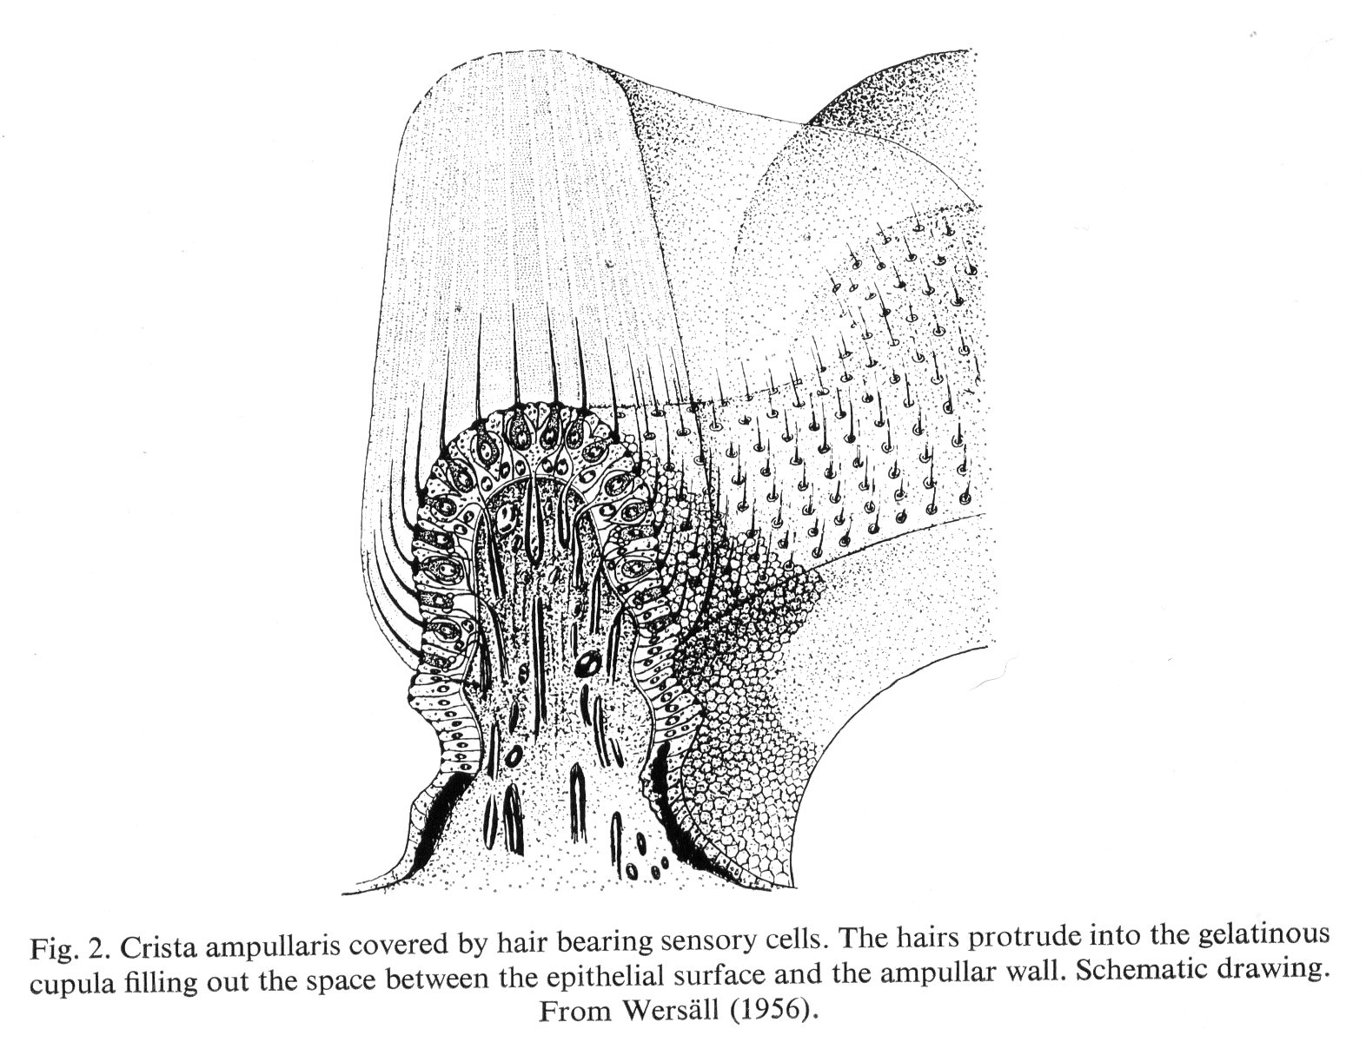

Nerves and blood vessels that pass into the base of the crista supply the sensory epithelium of the crista ampullae. Consequently each canal has its own nerve and the different nerves combine with each other and the nerves from the maculae in the utricle and saccule to form first a superior and inferior branch and then the vestibular nerve. The vestibular nerve runs in the internal auditory meatus with the cochlear nerve and the facial-intermediate nerve. The proximity of these nerves in the narrow passage of the internal auditory meatus means that they are often compromised together by mass lesions such as edema and tumors.

Rotations of the Head Stimulate the Semicircular Canals
Rotation of the head in the plane of a canal causes a slight lag in the flow of the endolymphatic fluid within the canals because of its inertia. The forces involved are much the same as you experience when you are in a car that accelerates or decelerated or turns a corner. Your body would continue in the same direction at the same speed except that it is compelled to change its velocity by your seat pressing on your body. In a semicircular canal, it is the walls of the membranous canal and ultimately the bony canal that compel movement. The fluid can also move around the canal if there is not a wall to force it in the new direction or at the new speed. Lagging fluid moving within the membranous canal ultimately displaces cupula of the ampulla, causing it to billow like a sail in a breeze. As the cupula billows in the displaced endolymphatic fluid, the cilia of the embedded hair cells are displaced.
Displacement of the many stereocilia of a hair cell towards the single kinocilium at the margin of the cluster of stereocilia will cause channels to open, leading to a depolarization of the hair cell. Displacement in the opposite direction will hyperpolarize the hair cell. In any given crista ampullae all the hair cells are oriented so that their kinocilia lie to the same side of their cluster of stereocilia. In the ampulla of the horizontal canal, the stereocilia are arranged so that displacement of the cupula towards the utricle will cause excitation. In the anterior and posterior canals it is displacement away from the utricle that is excitatory.
Each canal has a dilation at one end where it meets the utricle. That dilation, called the ampulla has a transverse ridge, called the crista ampullae, that contains a population of embedded hair cells, all oriented so that displacement of the hairs in one direction elicits depolarization of the hair cells and movement in the opposite direction causes hyperpolarization. The crista ampullae is surmounted by a gelatinous membrane, called the cupula, which seals off the ampulla. Movements of the fluid in a semicircular canal causes the cupula to billow, like a sail in a breeze, and the shearing force exerted upon the embedded stereocilia and kinocila of the hair cells causes more or less neurotransmitter to be released on to the terminal processes of the sensory neurons of the vestibular nerve. The result is a fluctuating discharge in the vestibular sensory neurons that is proportional to the displacements of the cupula.
Rotation in one direction will cause the discharge rates to increase and rotation in the opposite direction will cause them to decrease. Rotation in planes that are oblique to the canal plane will have less and less effect, until rotations in a plane perpendicular to the canal plane will not modify activity in the canal’s hair cells. Since there are three canals that are approximately perpendicular to each other, one would expect that rotations of the head in any direction will stimulate at least one canal and most often multiple canals.
The mirror symmetrical arrangement of the canals on the two sides of the head means that any rotation will stimulate canals on both sides of the head. The two sets of canals are set so that the two horizontal canals respond to rotations in opposite directions. The anterior canal on one side is approximately aligned with the posterior canal on the opposite side so rotations in certain oblique planes will affect a canal on one side and the other canal on the opposite side. For instance, rotating the head so that the nose moves down and to the side will increase activity in the opposite anterior canal and decrease activity in the posterior canal on the same side.

The Value of Normal Vectors
We will consider the sensitivities of the semicircular canals in terms of vectors that are orthogonal to the planes of the canals. This approach is generally considered more difficult that using the planes of the canal themselves, but, with a little practice, one soon realizes that normal vectors are easier to understand, because they lack the ambiguity intrinsic to the planar approach and the magnitude and direction of a vector is easier to picture than the orientation of a plane. In practice, it will be convenient to move back and forth between the two descriptions of the canals. After all, the planes are what we see when we look at the canals and rotation in the plane of the canal is intuitively clear, if difficult to quantify. Oriented surfaces are about as difficult for most people to understand as vectors, but that is what one must use to model the semicircular canals. Oriented surfaces are formally equivalent to quaternion vectors.
If we consider the sensitivity of the anterior canal, a canal at a roughly 45° angle to a sagittal plane, movements that cause the ampulla to move anteriorly will excite hair cells in the crista ampullae of the canal. The optimal axis of rotation for the canal will be perpendicular to the plane of the canal. For the right anterior canal, the axis or rotation is directed towards the opposite side at a roughly 45° angle to the sagittal plane, nearly confined to a horizontal plane. Consequently, rotations of the head about that axis will excite the canal.
Briefly consider the movements of the nose and ear during optimal movements for exciting the anterior canal, where the axis passes through or near the semicircular canal. The nose moves down and towards the opposite side from the canal, while the ear moves down and towards the same side. This disparity is due to the geometry of the head and it is only an apparent difference. If the axis of rotation is set higher, then both the nose and the ear move to the opposite side and, if it is set lower, they both move to the same side. Clearly referencing the optimal movement to the plane of the canal and landmarks of the head is intrinsically ambiguous. The situation is similar to the difference between swing and spin. What you see depends upon your point of reference. That ambiguity is removed if one uses the axis of rotation and each of the above outcomes flows directly from an understanding of the axis of rotation and the anatomy of the head relative to the axis of rotation.

Normal Vectors for the Planes of the Canals Lead to their Optimal Axes of Rotation
Each canal has two, oppositely directed, normal vectors which are perpendicular to the plane of the canal and which can be an optimal axis of rotation. Semicircular canals are stimulated by angular momentum and angular momentum is expressed by a vector perpendicular to the plane of rotation, that is, the plane defined by the movement vector and a vector that extends perpendicularly from the axis of rotation to the moving mass. For the most effective stimulation of a semicircular canal the center of rotation is on an axis of rotation perpendicular to the plane of the canal where it penetrates the plane of the canal. Therefore, either normal vector to a canal is potentially the optimal axis of rotation for the canal. However, rotation in one direction will depolarize the hair cells in the canal’s ampulla and rotation in the opposite direction will hyperpolarize them. If we choose the optimal axis of rotation to be the canal that depolarized the canal’s hair cells, then there is a unique axis.

Planes to Normal Vectors
If one has a plane that includes the origin, it may be described by an expression like the following.
The are constants and the x, y, and z are variables. Normally, the plane is written in the form of the second expression, but the basis vectors in the first expression are implied. They are made explicit here, because they are relevant to the calculation of the normal vector to the plane.
If we express the plane in this format, then it is apparent that a plane is the set of vectors for which the sum of their coefficients is zero. The orientation of the plane is determined by the relative values of the constants. The ratios of the constants are the critical factor. The absolute values are largely irrelevant as long as the ratios are maintained. For that reason one can always write the expression for a plane so that the sum of the constant coefficients is one. The reason that one might wish to do so arises from the following argument.
We can readily calculate two vectors that lie in the plane by setting the coefficient of k equal to zero and setting the coefficient of j equal to zero.
Then the normal vector to the plane is the vector of the ratio of these two vectors in the plane. We can take the ratio of the second to the first or the first to the second.
If we compute the ratio of the second to the first, then we get a vector that extends in one direction relative to the plane and if we compute the other ratio, then the vector points in the opposite direction. These are the two normal vectors to the plane. Also note that the coefficients of the orthogonal vectors are the same as for the plane, give or take a negative sign and the fact that the normal vectors are expressed as unit vectors. If the coefficients of the plane are normalized so that the sum of the squares of the coefficients is 1.0 then the normal to the plane has the same coefficients as the plane.
Because of this relationship between the expressions for a plane and its unit normal vectors, we can take descriptions of the canal planes and immediately write down the expressions for the axes of rotation for the canals.

The Actual Optimal Axes of Rotation for Human Semicircular Canals
Blanks et al. (1975) measured the planes of the semicircular canals in ten skulls of a mixture of races and they expressed the planes of the canals as the regressions of all of the canals of a given type. We can directly convert their expression for the regression plane into the axes of rotation for each canal type. For the canals on the right side the values were as follows.

Horizontal canal | C_{HR} | 0.365 i + 0.158 j − 0.905 k
Anterior canal | C_{AR} | 0.652 i + 0.753 j + 0.17 k
Posterior canal | C_{PR} | 0.757 i – 0.561 j + 0.320 k

To get the values for the canals on the left side, we need only reverse the values for the j terms.

Horizontal canal | C_{HR} | 0.365 i − 0.158 j − 0.905 k
Anterior canal | C_{AR} | 0.652 i − 0.753 j + 0.17 k
Posterior canal | C_{PR} | 0.757 i + 0.561 j + 0.320 k

However, a little thought and experimentation will convince you that the values as written are for movements relative to a left-handed coordinate system. To render them into a right handed coordinate system one must reverse the values for all the components of the left-handed expressions. So the final values for the left-handed canals are as follows.

Horizontal canal | C_{HR} | − 0.365 i + 0.158 j + 0.905 k
Anterior canal | C_{AR} | − 0.652 i + 0.753 j − 0.17 k
Posterior canal | C_{PR} | − 0.757 i − 0.561 j − 0.320 k

Visual Representations of the Canal Axes
It is much easier to think about the canal axes when one has a graphical representation. To that end, this section considers a number of images that represent the canal axes as vectors. In the first figure the canal axes for the semicircular canals on the right side of the head are represented as viewed from two viewpoints. The left panel is an oblique view from the left and above the horizontal plane and the right panel is the same axes viewed from directly in front of the head and slightly above the horizontal plane. Three mutually orthogonal blue vectors indicate the axes of the head. The i axis points directly anteriorly. The j and k axes point directly laterally and directly vertically, respectively.
One can see that the horizontal canal axis is vertically directed with a modest anterior and lateral tilt. Its total tilt from vertical is 23.7°; it tilts 10° laterally and 22° anteriorly. The anterior canal has an axis that crosses the midline at a roughly 45° angle to a sagittal plane, actually 49.11° to the contralateral side a sagittal plane. It is nearly confined to a horizontal plane, being 1° below the horizontal plane. The posterior canal axis is directed anteriorly and laterally at about 45° to a sagittal plane and it rises vertically at a modest angle. Its is 40.47° from the anterior axis (i), 36.54° from a sagittal plane, and 18.76° above a horizontal plane through its origin.
All these measurements are relative to the Reid stereotaxic coordinates in which the horizontal plane passes through the centers of the external auditory canals and the inferior margins of the orbits. They would be slightly different in the Frankfurt coordinates, which use the superior margins of the external auditory canals (Blanks, et al., ’75).
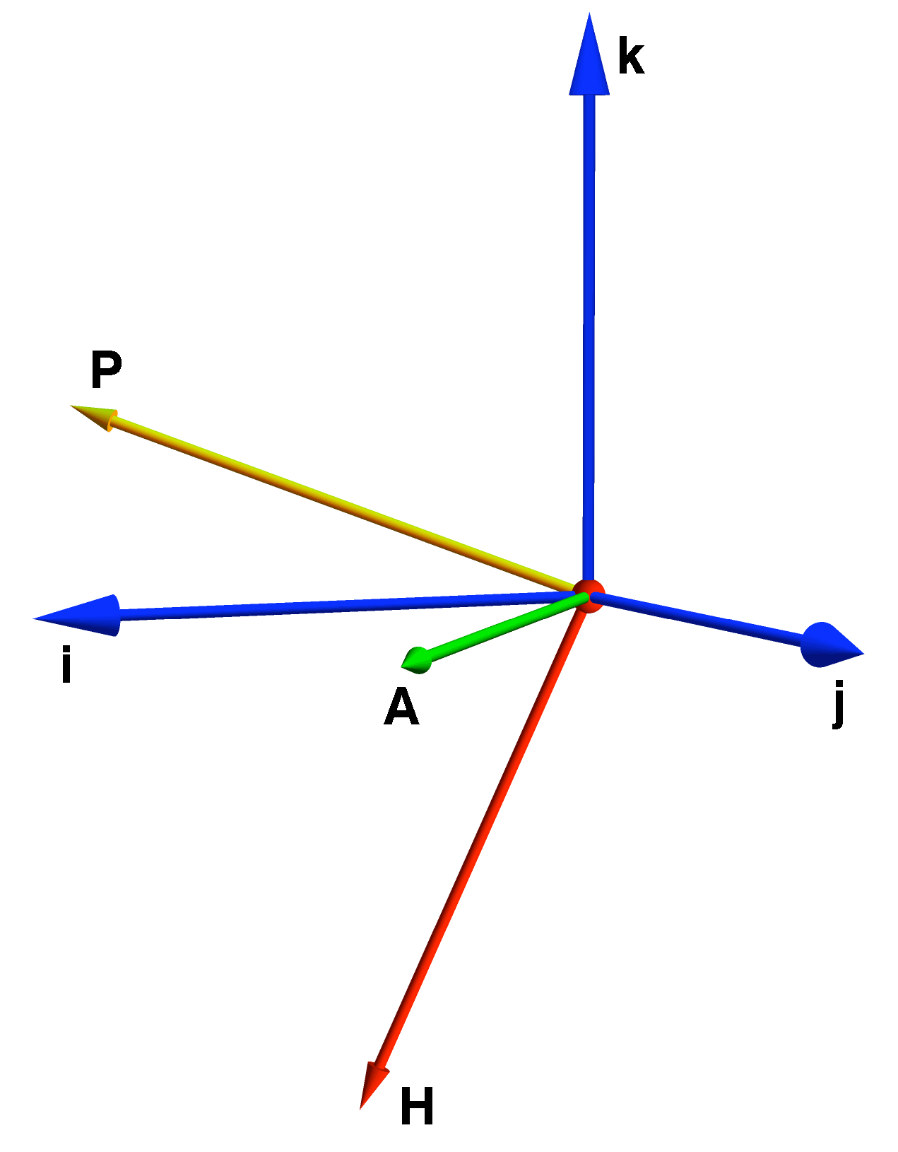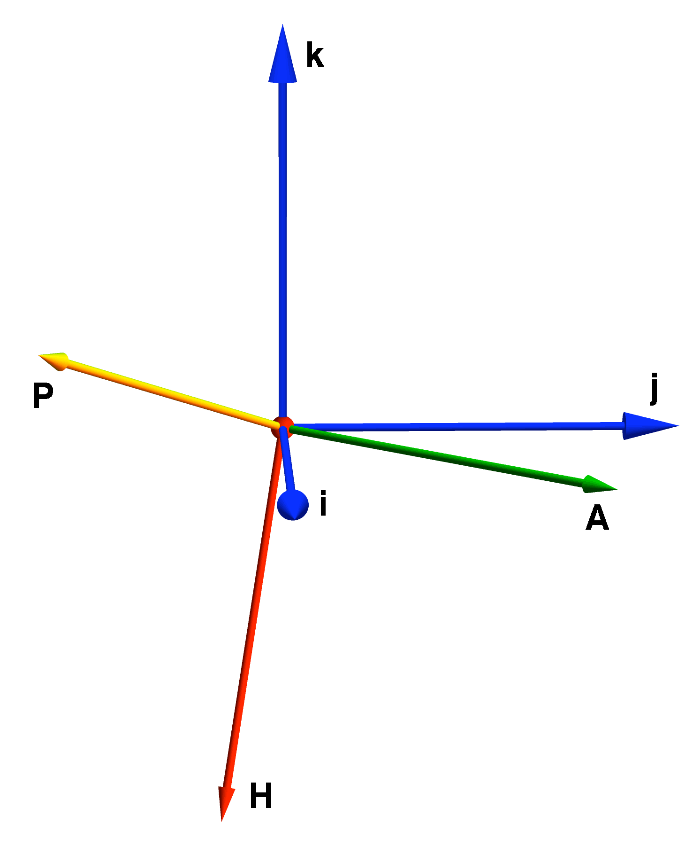

The right semicircular canal axes viewed from the left and anterior (left panel) and from in front and slightly above the horizontal plane (right panel). The basis vectors are aligned with the anterior axis (i), the left lateral axis (j), and the vertical axis (k) of the Reid stereotaxic system (Blanks et al, ’75). The canals axes are labeled with H for the horizontal canal, A for the anterior canal, and P for the posterior canal. These conventions apply to all of the following figures unless stated otherwise.

The next task is to represent the relationships between the canal axes on the two sides of the head. In the next figure the right canal axes have been reflected in a sagittal plane, because the canals on the two sides of the head are approximately mirror reflections of each other. That representation is quite intuitive in that one set of canal axes is simply the reflection of the other set. Unfortunately, reflection also flips the coordinate system. A bit of thought and experimentation will reveal that the axes on the left side are appropriate only if one uses one’s left hand to express the rotation. They are in a left-handed coordinate system, while the axes on the right side are in a right-handed coordinate system. Consequently, we need to convert one or the other set into the other coordinate system in order to compute with them.
We will consider the reflection of the right canal axes in a bit, but there are some points that can be drawn from this representation that are not as easily appreciate in a consistent single-handed representation. The two anterior canal axes cross in the midline and they lie in a plane that is nearly parallel with the horizontal plane. They are nearly orthogonal to each other, which means that the canals lie at approximately a 45° angle to a sagittal plane and nearly vertical. The posterior canal axes are at approximately a right angle to the anterior canal axes, actually 89.58° in the horizontal plane and 86.20° in the plane that contains both axes, which means that the posterior canal planes are nearly perpendicular to the anterior canal planes. The posterior canal axes are tilted up, meaning that the canals are tilted posteriorly at their dorsal margin relative to their ventral margin. The horizontal canals are approximately horizontal, because their axes are predominantly vertically directed, but they are tilted up and anteriorly along their anterior margin relative to their posterior margin. That means that they do not have a common axis, so there is no rotation that is optimal for both canals, but the best compromise is obtained by tilting the head forward until both axes lie in a coronal plane. That inclination is generally said to be about 30°, nose down from standard position, but the data considered here would suggest that it should be more like 22°.

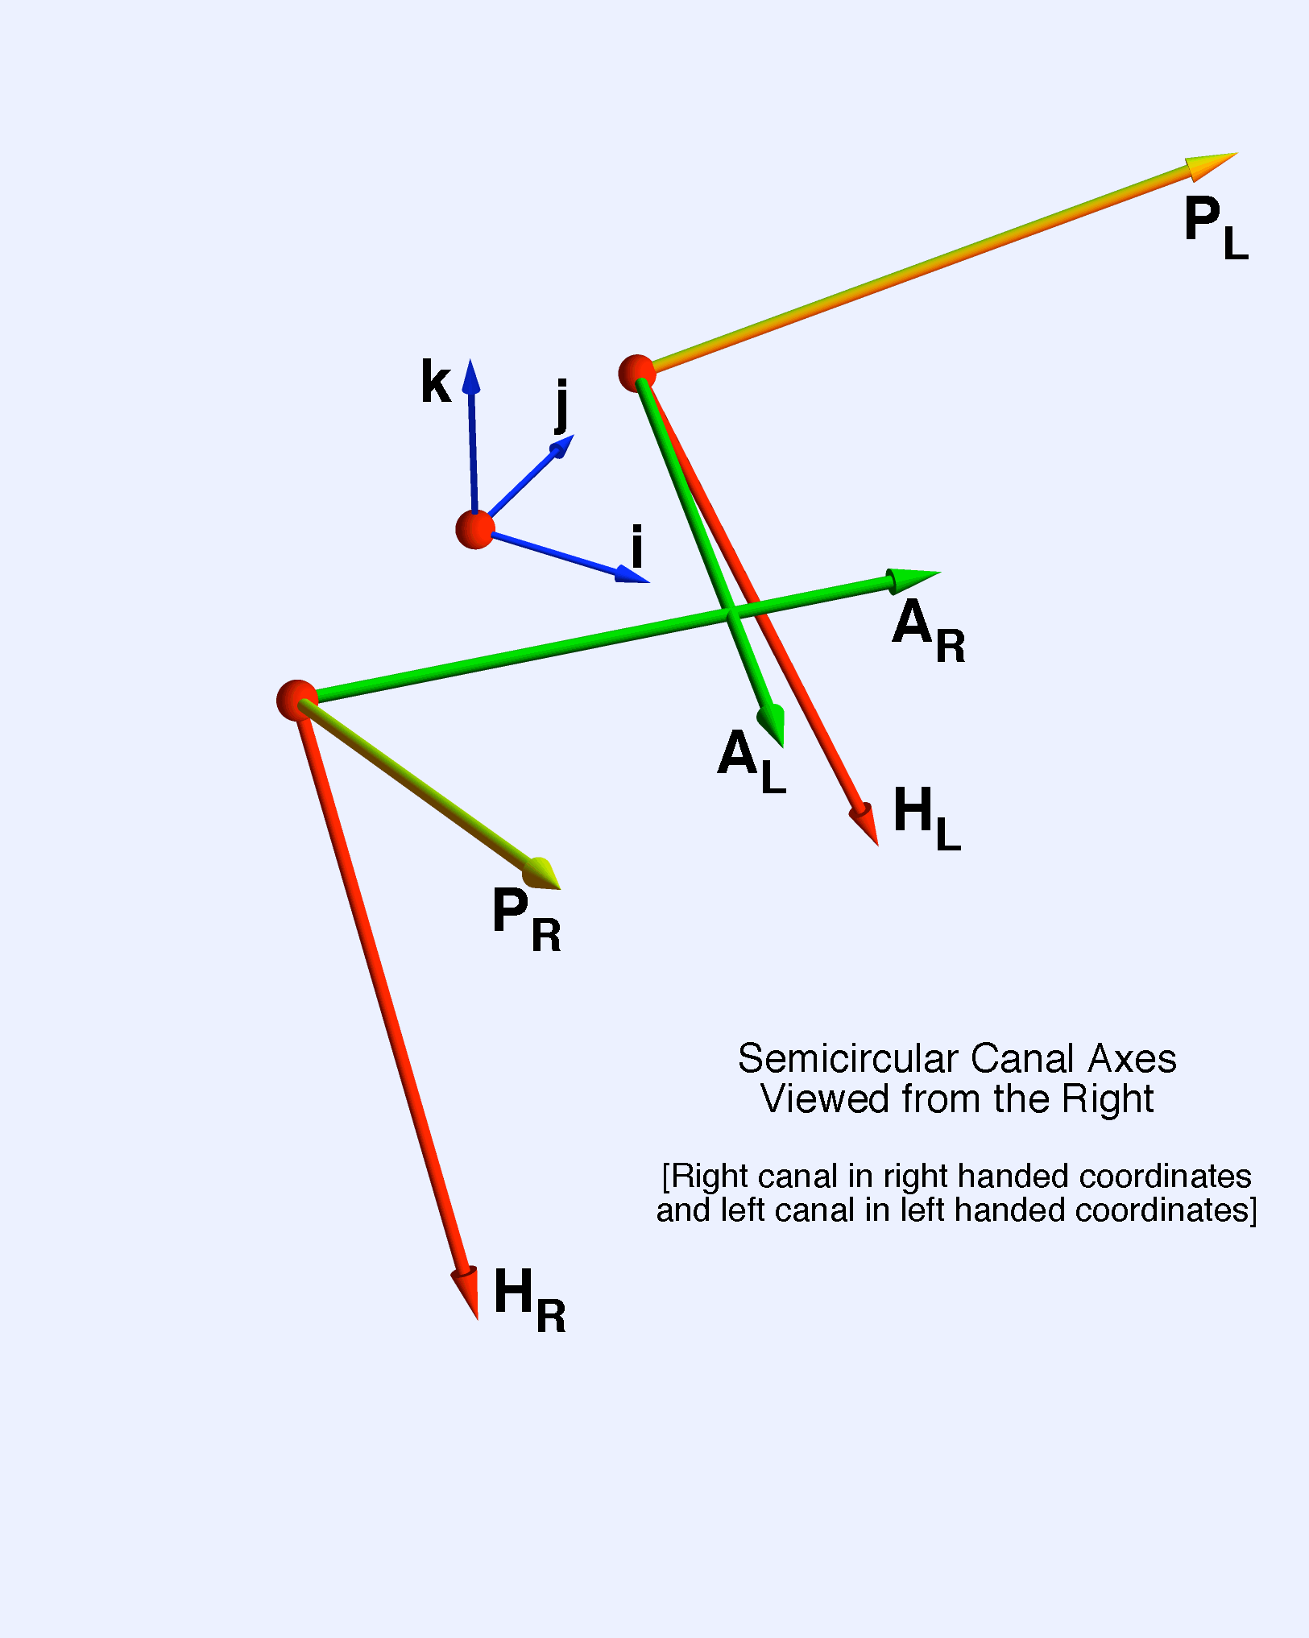

The right and left canal axes with the right canal axes reflected across the midline. This is an intuitive representation, but a little experimentation will reveal that the left side axes work only if one uses one’s left hand to indicate the movement, that is they are in a left-handed coordinate system while the ones on the right are in a right-handed coordinate system. The right canal axes have an R as a subscript and the left canal axes have an L.

The next figure is similar to the last figure except that the canal planes have been represented by circular discs that are perpendicular to the axes of rotation. The centers of the canal axes have also been moved a bit further apart so that the anterior canal axes do not overlap and the basis vectors are clearly visible. There is no proper separation for the two sets of canal axes and there is no need for the canal axes to have a common center. They are vectors and so are free to move as is convenient as long as they maintain their direction and magnitude. Actually, they are quaternion vectors, so it is important to keep their orientation or sense as well, but they have no location, so their placement is largely arbitrary. In this case, the elements have been grouped and placed so as to facilitate an appreciation of the orientation of the canal axes and planes.
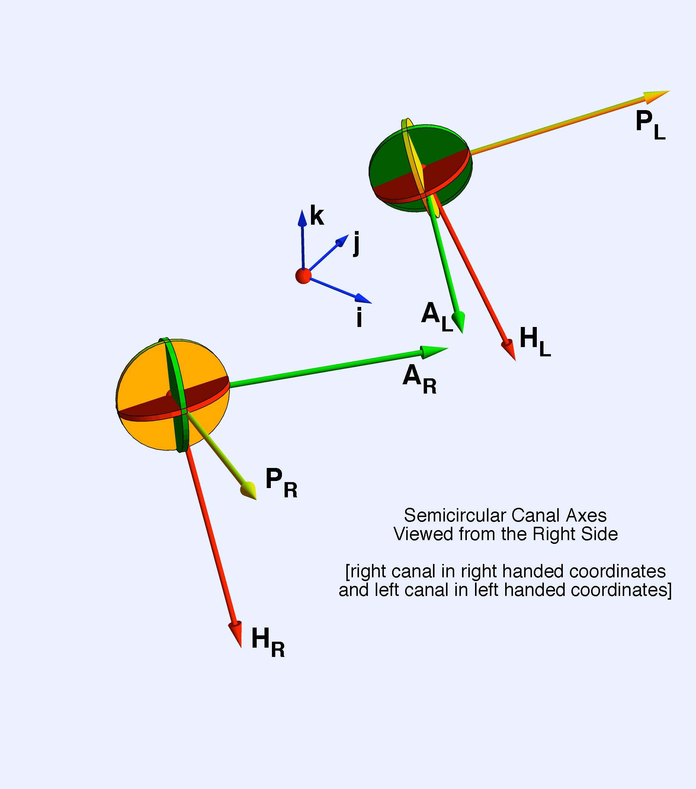
The reflected canal axes are drawn with the planes of the canals indicated by circular discs and the canal centers moved further apart, so that the anterior canal axes do not overlap. The same reservations apply to this representation as for the previous figure. One can see that the canal axes do not leave through the intersections of the discs, which indicates that the canals are not actually orthogonal, although they are approximately so.

As stated above, the canal axes in the previous two figures are in two different coordinate systems, which aids in understanding the relationships between the canals on the two sides of the head, but they will rapidly get one in trouble if one tries to compute with them. A bit of experimentation will lead one to the canal axes in a right-handed coordinate system that correspond to those illustrated in the last two figures. The correct reflection of the right canal axes is indicated in the following figure and the three that follow it. The reflected axes do not look much like a mirror reflection, but if one plays with the image by rotating it and by making the indicated gestures, it becomes apparent that it is a true representation of the reflected right canal axes.

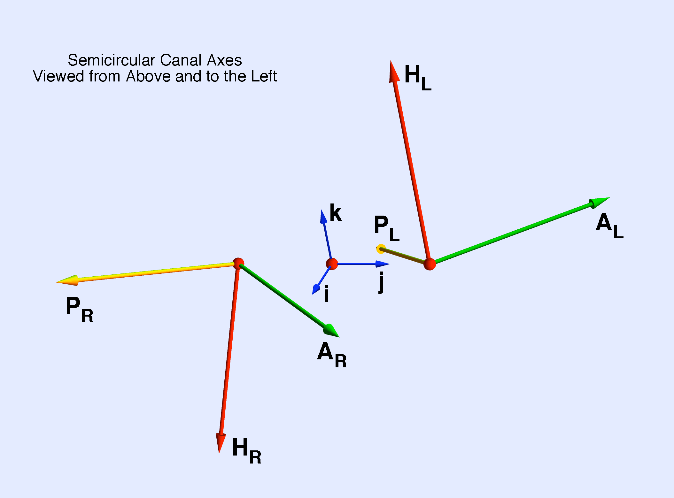

The canal axes expressed in right-handed coordinate system. The left canal axes are rendered in terms of a right handed coordinate system. Consequently, the left canal axes are the reflection of the right canal axes across the midline. This representation is not as intuitive as a simple mirror reflection, but it is more appropriate for calculations.

As with the reflection that changed the handedness of the canal axes, one can see that the three canals on one side are approximately mutually perpendicular, but deviate from perpendicular by a readily detected amount. The vertical canals only approximately align with the matching canal on the opposite side (right posterior with left anterior and right anterior with left posterior). The horizontal canals are only approximately aligned and each is tilted anteriorly and laterally to the same side. Because the canal axes are quaternion vectors they have magnitude, direction, and orientation. Because they are quaternion vectors, their mirror reflections are distinctly different appearing vectors.
The next three figures show the same canal axes from a number of special viewpoints. The first is from a point directly anterior to the canals. The canal axes look very asymmetrical, but it you take the negative of each of the canal axes, then you will have a set of axes that are a mirror reflection of the axes for the opposite semicircular canals. When viewed directly from the side, the axes collapse into a single center, because the two centers are aligned. There is much more symmetry in that view, since each axis points in the opposite direction as the same canal axis on the opposite side. When viewed from directly above there is also more apparent symmetry, but it is more like symmetry through the center point of the basis vectors, rather than mirror symmetry. Closer inspection reveals that the symmetry is only approximate and it is broken in many ways.
The symmetry of the two sets of canal axes is a more subtle symmetry than one normally perceives, but they are truly symmetrical because they are transformed into each other with only a reversal of signs for the directional components. We also know that the representations are reflections of anatomical structures that are symmetrical across the midsagittal plane.

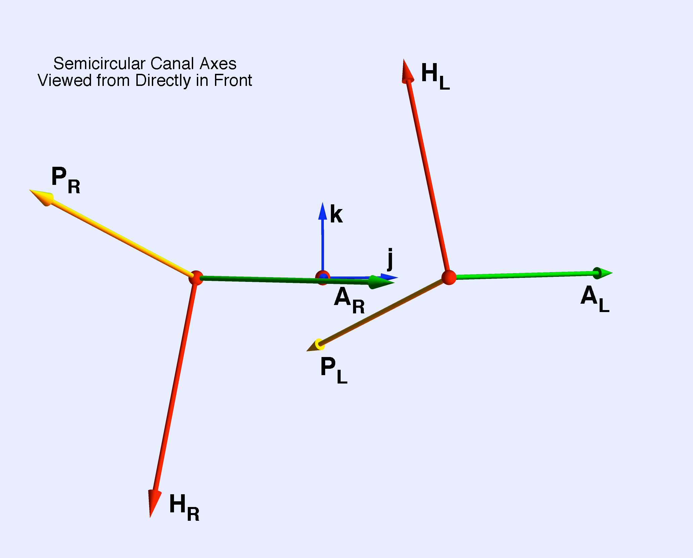

The same canal axes viewed from directly anterior. This view makes it easier to appreciate that the anterior canal axes are almost in a horizontal plane. The horizontal canal axes are laterally directed and the posterior canal axes have a substantial inclination to the horizontal plane. The vertical canals are clearly not aligned in the coronal plane and the horizontal canals have opposite tilts.

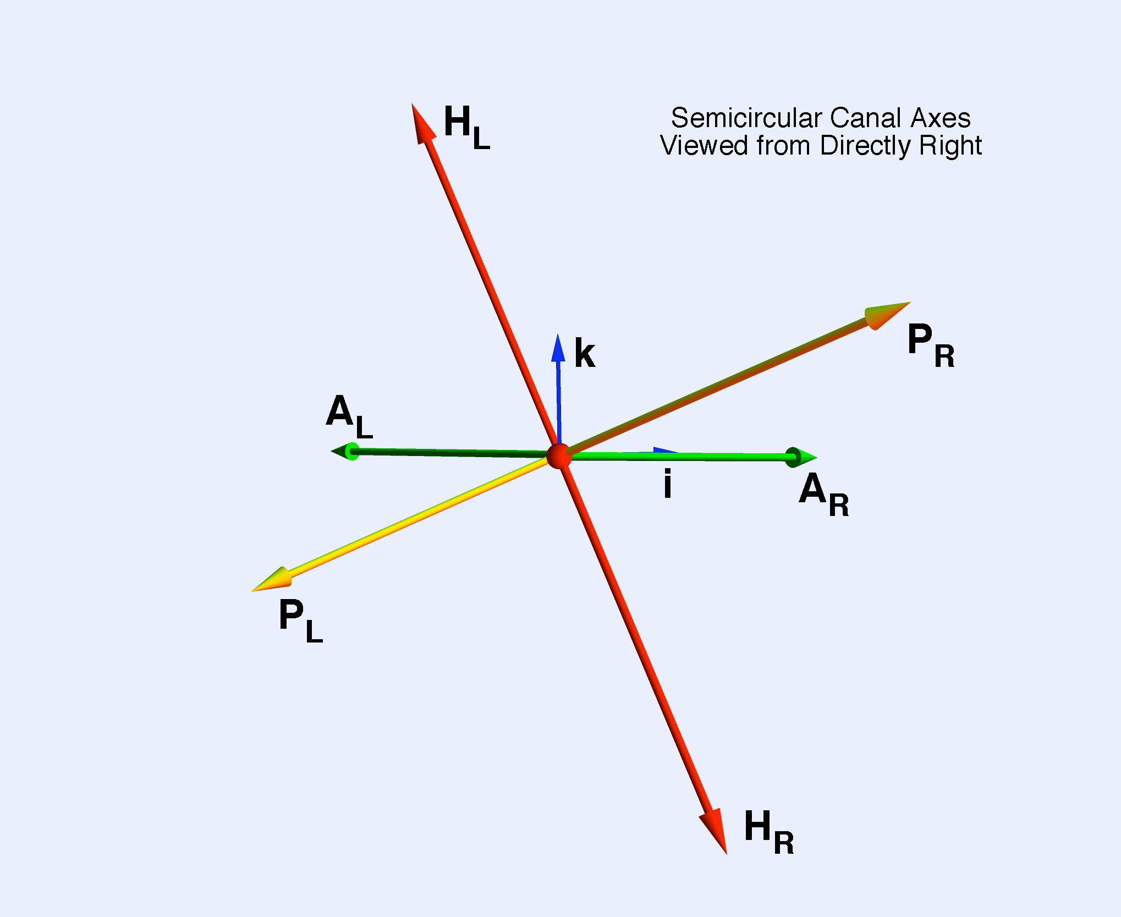

The same canal axes viewed from directly laterally. In this view, one can see that the right land left canal axes are oppositely directed in the sagittal plane. That is not true of the coronal plane (see previous figure). The underlying symmetry is most obvious from this viewpoint.

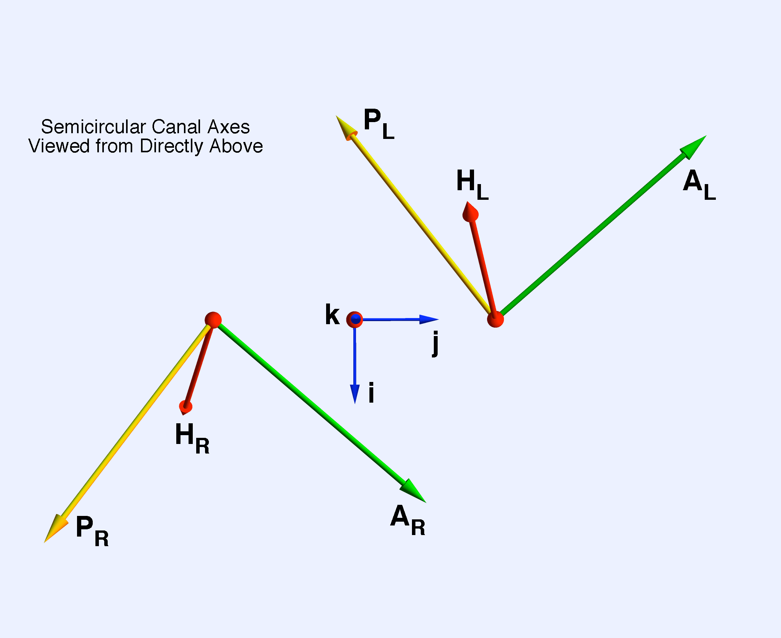

The same canal axes viewed from directly above. One can see that the right anterior and the left posterior canals are not actually aligned in the horizontal plane although they are approximately aligned.

Angles Between the Canals
Given the plane and normal vectors of the canals, one can readily compute the relative orientations of the canals. The ratio of two planes is their intersection, which is also the ratio of their normal vectors. We can simply compute the ratios of the canal axes and obtain the angular excursions and the axes of the intersection. The following table summarizes the results of a number of such calculations.

Canals | Ratio | Angle | Intersection | Blanks et al. ‘75
Horizontal  to  Anterior |  | 112.216°
Horizontal  to  Posterior |  | 95.948°
Anterior  to  Posterior |  | 86.2003°
Right Posterior to  Left Anterior |  | 23.2833°
Right Anterior  to  Left Posterior |  | 23.2833°
Right Horizontal  to  Left Horizontal |  | 18.3942°

Non-optimal Rotations
Most movements will not be about an optimal canal axis for any canal and no rotation can be optimal for all the canals, because they have different canal axes. That is fundamentally why there are multiple canals, so that any head rotation can be sensed by at least one canal. We now consider how the different canals sense a given rotation.
The magnitude of response in a canal is proportional to the projection of the axis of the rotation on the canal axis. If both axes point in the same direction, then the response to the rotation will be maximal for that rotation. If they are perpendicular, then the response in the canal will be nil. If they point in opposite directions, the response will be minimal. In brief, the response is a canal will be proportional to the dot or scalar product of the canal axis with the axis of rotation. Each vestibular afferent was a substantial resting discharge rate () which may decrease as well as increase in response to head rotation. Also, the proportionality factor for response versus movement amplitude () is different for different afferents and possibly for different canals. If the axis of the n’th canal is and the axis of rotation for the rotation is , then the response for the canal is something like the following.
The canal axis is a unit vector, so, the response is a vector in the direction of the canal axis that varies about the resting rate to an extent proportional to the magnitude of the movement, the proportionality factor, and the projection of the axis of rotation upon the canal axis. Each canal extracts a different image of the movement and it is the consensus of the canals that determines the brains image of the movement. The consensus is not necessarily the same at all central locations, because a different array of afferents may end in different targets, but one presumes that the differences are compensated for by internal circuits so that the effective image of the movement is much the same at all targets. Therefore, there are grounds for assuming a summation of the canal inputs is a fairly useful indication of the information flowing into the brainstem in the vestibular nerves.
In this expression the summation is over canals, although one could view it as a summation over canal afferents. Note that information is a vector. It has magnitude and direction. The rate of change of information may be a quaternion, because it may be expressed as a ratio of vectors.
If the nervous system responds to the movement, then it needs to know the current direction of the movement and its rate of change with respect to time.

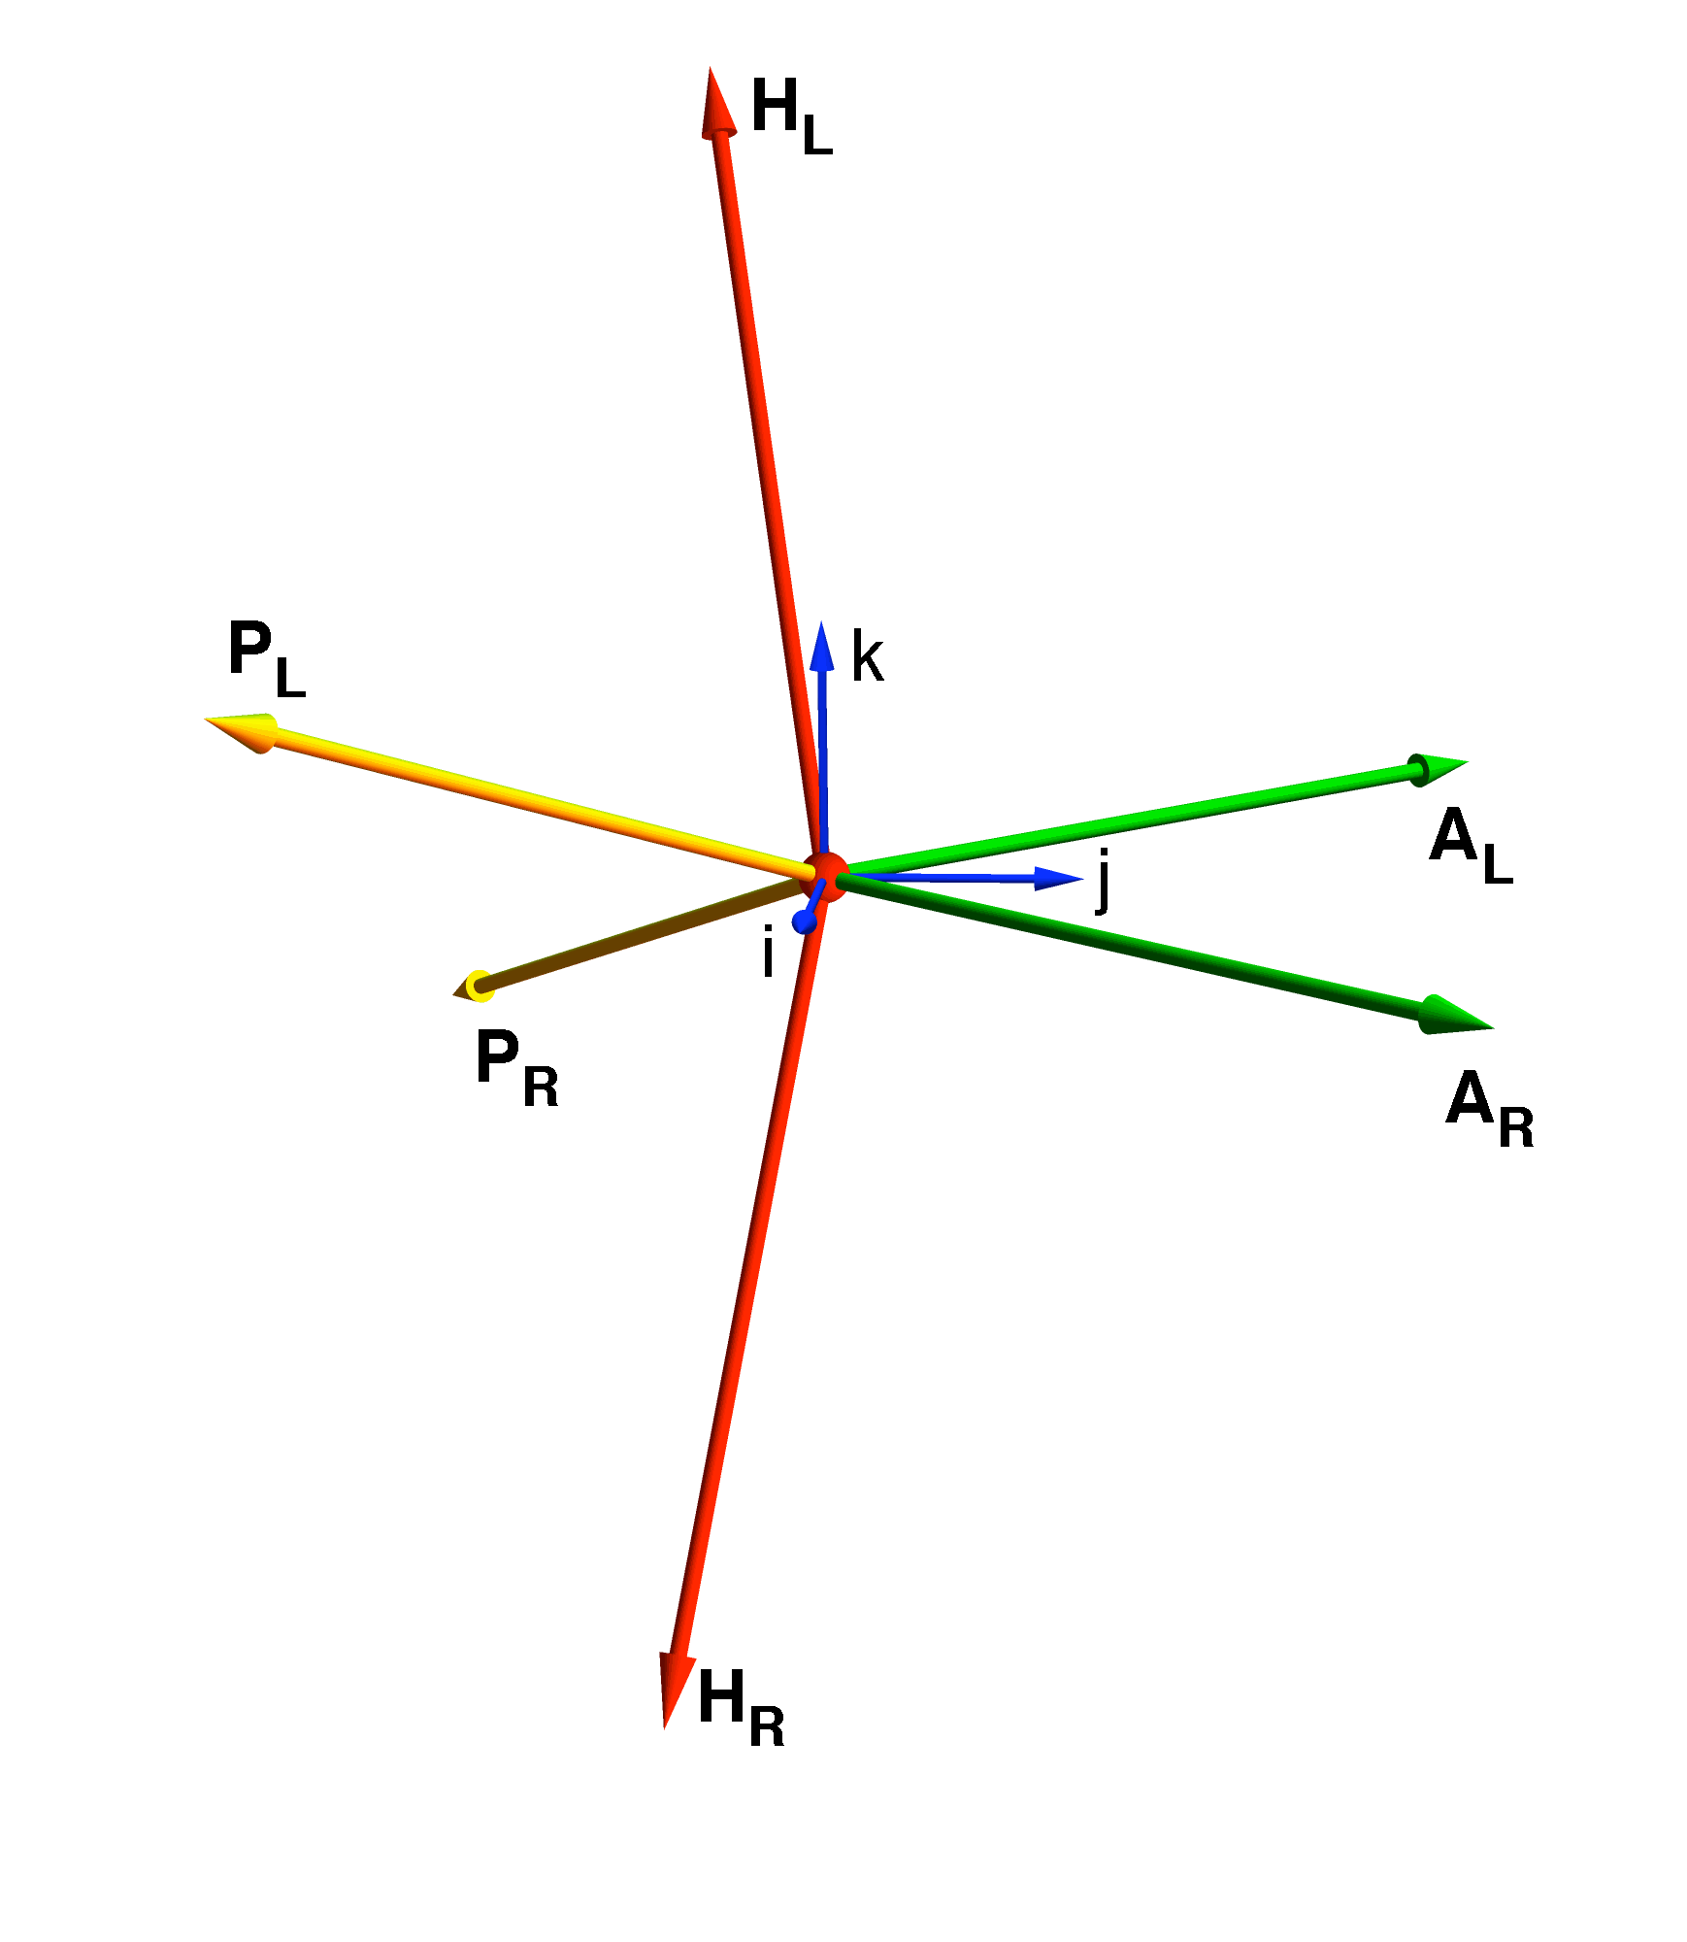

All the canal axes are drawn from a common center and viewed from the left front, above the horizontal plane. It is readily seen that the alignments that are generally assumed when sketching the actions of the canals individually and collectively are not actually valid, but this discrepancy is not a particular problem when modeling the semicircular canals.

The Vestibular Signal

The Hypodermic/Hydraulic Model of the Semicircular Canal Dynamics
Cupula as a diaphragm between a large, low resistance, chamber and a small, high resistance, chamber
The conformational change of the flattened semicircular duct as a short time constant capacitance/spring.
Short duration signals affect primarily the capacitance
Long duration signals affect the resistive elements

The Model of the Dynamic Vestibular Response
The dynamic vestibular response behaves like a second degree differential equation with a very short time constant (~1/100 sec) and a long time constant (20-30 sec).
The stimulus is almost certainly rotational head movements, which cause angular acceleration.
The short-term response mimics the angular velocity, which is taken to indicate a mechanical integration.
The long-term response is characterized by an adaptive return to baseline in the presence of a sustained constant angular velocity.
The model is generally characterized by a driving function that is a torque, therefore proportional to the second derivative of an angular displacement. The semicircular duct responds with an inertial drag from the fluid within the duct, resistance to flow of the fluid because of viscosity (proportional to first derivative of angular displacement), and distortion of the cupular membrane as it resists the relative displacement of the fluid (proportional to angular displacement). To this one might add the distortion of the duct itself as it tries to accommodate the back flow, which is proportional to fluid displacement or angular displacement.
The semicircular duct is quite narrow, which results in a substantial resistance to flow along its axis, and it is flattened, which means that has a cross-sectional area that is less than maximal for its circumference. If it is necessary for fluid to flow through the duct, there will be a resistance that will be partially offset by outwardly directed pressure on the duct walls, which will cause the duct to become more circular in cross-section. This conformational change will act as a capacitive or spring element.
A pressure difference across the cupula will cause the cupula to billow like a sail in a breeze. Since the cupula is elastic, it will provide a restorative force that resists fluid flow and returns the fluid to status quo if it is displaced. Most head movements are apt to be of short duration and moderate speed. Under those conditions there is probably very little movement of the cupula and it acts as a linear capacitive element.
As the cupula billows it produces a transient pressure changes in the ampulla and the proximal duct. These are partially absorbed by fluid flow through the duct and partially by changing the duct’s cross-sectional shape to accommodate more or less fluid. The resistance to fluid flow through the duct is proportional to the velocity of flow. The distension/compression of the duct is proportional to the amount of fluid flow.
Because of the much greater resistance of the duct to fluid flow, one can open the circuit and to the first approximation model the cupular-duct dynamics as two chambers with an elastic diaphragm between. On one side there is low resistance to flow and a large reservoir of fluid. On the other side is a high resistance to flow and a small volume of fluid. The driving force is the pressure at the utriculo-ampullary junction, F_{u}. The magnitude of the force is proportional to the rate of angular displacement in a manner that depends on the axis and direction of rotation, the location, orientation, and cross-section of the junction. The amount of fluid flow will be proportional to the driving force, V = F_{u} * R. The cupular membrane is distorted by the fluid displacement, V, and it generates a restoring force proportional to the amount of distortion. In addition, the compression or rarefaction of the fluid on the duct side of the cupula will cause conformational changes in the duct and will cause fluid flow through the duct. The conformational changes will be small and therefore linearly related to the volume displaced. The flow through the duct will be laminar, therefore proportional to the rate of change of the volume displaced.
The forces on the cupula will be balanced so we can write a number of expressions
Let $V$ represent the displaced volume. On the utricular side of the cupula there is a force $F_{u}$ that causes a flow through a resistance $R_{u}$.
$$F_{u}=R_{u}∗\frac{\text{dV}}{\text{dt}}Û\frac{\text{dV}}{\text{dt}}=\frac{F_{u}}{R_{u}}$$
The elastic force, $F_{c}$, from distortion of the cupula is linearly related to the displaced volume
$$F_{c}=c_{u}∗V$$
The duct force is composed of the conformational distortion, $F_{d}$, and the resistance to flow, $F_{r}$. The conformational distortion is proportional to the displaced volume for small volumes.
The flow resistance is proportional to the rate of change of the displaced volume or the flow.
$$F_{r}=R_{d}∗\frac{\text{dV}}{\text{dt}}$$
If the duct is fed back to the large reservoir then there will be a different force applied to its distal end, $F_{t}$.
$$F_{r}−F_{t}=R_{d}∗\frac{\text{dV}}{\text{dt}}⇒F_{r}=R_{d}∗\frac{\text{dV}}{\text{dt}}+F_{t}$$
The two forces that impinge upon the ends of the semicircular ducts, $F_{u}{\text{ and F}}_{t}$, are dependent upon the geometry of the system and the manner in which it moves.

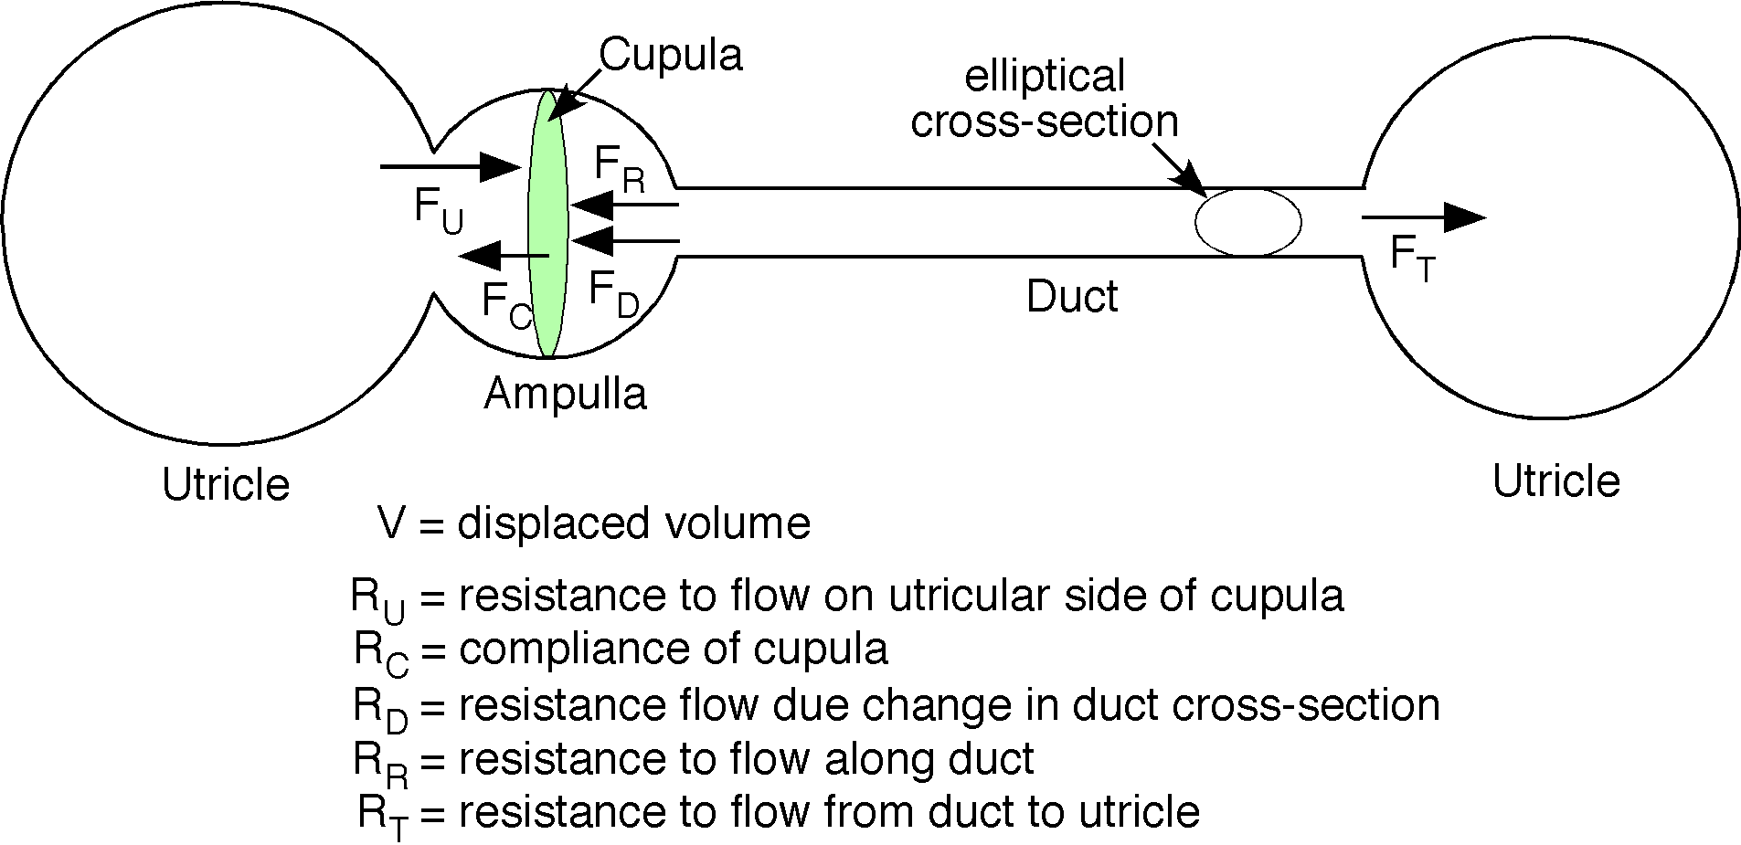

The Alignment of the Canals with the Foramen Magnum
The torsion pendulum model assumes that rotations occur around the center of the ring, but they almost never do so. If they did for one semicircular duct, then they would not for any other duct.
An axis drawn from the foramen magnum to the semicircular canals would be roughly orthogonal to the posterior canal, roughly in the plane of the anterior canal and roughly in the plane of the horizontal canal.
The positioning of the cupula at the utriculo-ampullary junction may important to the changes that occur in the cupula.

More Detail of Anatomy of Semicircular Canal With Functional Implications

Schematic of a Semicircular Canal with Frame of Reference
The sensory apparatus for a semicircular canal is located in the ampulla, so, it is movements of the ampulla that are most relevant to the stimulation of a canal. For that reason it makes sense to place the framework for describing the canal at the ampulla. The framework will be a standard frame of reference. The location of the ampulla, , is the first frame vector. It will be defined relative to a central origin, , and frame of reference, . The extension vector, , is reserved for a convenient measurement and it may be multiple vectors if need be. The orientation for the canal will be the three vectors . The first orientation vector is the axis of rotation for the canal. Rotation about that axis will optimally stimulate the canal. The second orientation vector is in the direction that will in which cupular movement will maximally stimulate the hair cells for that canal. It is opposite the direction in which ampullary movement will maximally depolarize the hair cells in the crista ampullae. The third axis is the product of the first orientation vector times the second orientation vector. It completes a right-handed coordinate system.

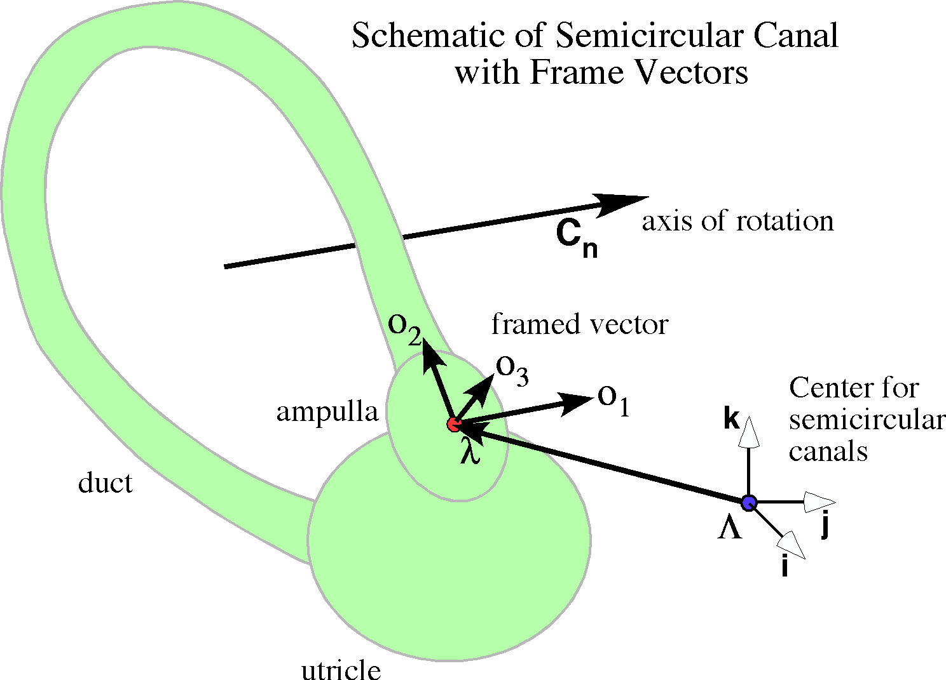

The framed vector for a canal is anchored at the ampulla and its orientation reflects the movements that maximally stimulate the ampulla.
Movements in the direction of or will not change the discharge rate in the ampullary nerve. Rotations about either of those axes will maximally stimulate the canals as will rotations about any axis that may be expressed as a combination of those two vectors. Movements in the direction of will maximally stimulate the canal and rotations about that vector will not change the membrane potentials of the hair cells. Movement in the opposite direction will maximally reduce the discharge rate in the canals nerve. The next step is to define the consequences of rotations that are not in the above categories, that is, to solve for the general case.

The Pattern of Excitation in a Canal Hair Cell as a Function of Movement Direction
Canal afferents have a rest discharge rate that may increase or decrease, depending on the direction of head movement. Let that rate be . Then the increase or decrease with movement is dependent upon how the movement lies with respect to the axis from the stereocilia to the kinocilium of the hair cells. In semicircular canals, all the hair cells have a common axis although the saddle shape of the crista ampullae means that the actual direction is variable. Presumably, it is the shearing force of the cupula on the hair cell cilia that determines the displacement of the hairs. The cupula is normally caused to billow by the pressure of the endolymph pressing on the broad surfaces of the cupula, so the shear is across the crista. Consequently, we would expect the activation of the hair cells to reflect the pressure differential across the cupula, so that we can choose the direction orthogonal to the cupula and crista as the direction of movement that will optimally stimulate hair cells. That pressure differential will depend on the angle between the movement direction and the optimal direction in a way that is close to the cosine of the angle. If the movement direction is and the optimal direction is , then the effective stimulus magnitude is , where is the magnitude of the acceleration, is a unit vector in the direction of the movement, and is the unit vector in the direction of optimal stimulation. Consequently, the response would have the following form.
The magnitude of the movement has been separated from the direction to illustrate that they enter into the response in different ways, but there is no reason one might not have used a vector of variable magnitude, such as . Then the expression would be simply . The form of this expression is an epicycloid that resembles a cardioid.

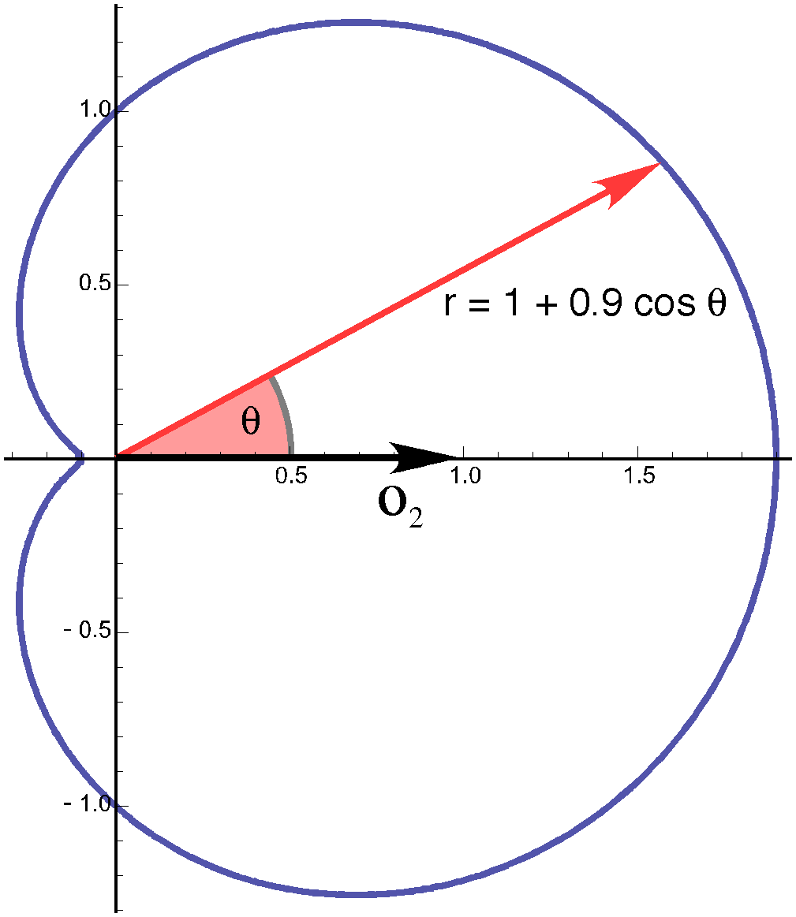
If we plot the responses for a series of accelerations ranging from no movement to a movement that completely suppresses the vestibular afferents activity. Then the response curves look like the following figure. The red curve is with minimal movement and the blue curve is with sufficient acceleration to completely suppress the activity when it is in the direction opposite the direction of optimal responsiveness.

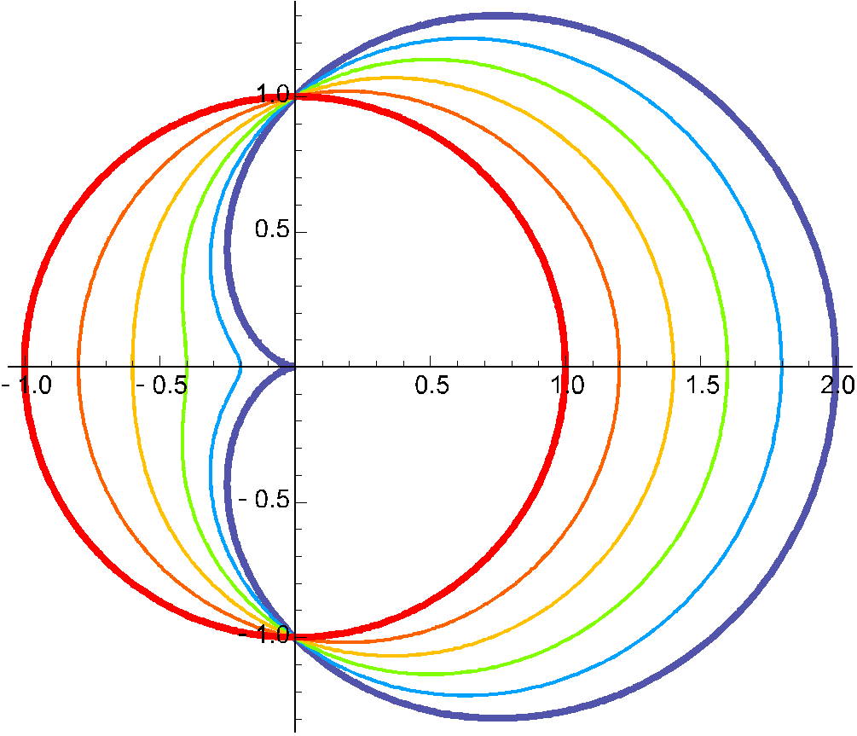
The responses to movements of an ampulla will be maximal when it is in the direction of , minimal when in the opposite direction and nil when in the plane perpendicular to the axis. So, each canal has a response surface that is like those drawn above, but rotated about the horizontal axis. If we assume similar response curves for each canal, then we can read off the magnitudes of the responses in the different canals by computing the angle between the acceleration vector and the canal axis and plotting the radial vector at that angle. Where the vector intersects the surface of the appropriate acceleration the length of the vector will be the magnitude of the response. Because to the canals are approximately perpendicular, rotations about the axis of one canal will give a maximal response for that canal a near minimal response for its opposite on the other side of the head and near baseline responses in the other canals. The near baseline responses will be antagonistic in the central brainstem circuits therefore will approximately cancel each other while the maximal and minimal responses will show a near maximal difference.

