Building a Neck and Watching It Move:
Anatomical Foundations for the Description of
Movements in the Cervical Spine

Thomas Langer
The Program
One of the best ways to understand how the neck moves is build one and watch it move. To build a neck one must look very carefully at how a neck is put together, try to determine which attributes are essential features of a neck, which are features of a particular neck, but may be altered without major changes in its movements, and which are dispensable. When building a neck it is convenient to standardize the components as much as possible, to reduce the number of variables that have to be controlled. In the following, the neck will be constructed of three elements; an atlas, an axis, and a lower cervical vertebra. In addition, we need to incorporate the occiput into the descriptions of the upper cervical spine, since it forms a complex joint with the atlas and axis. However, we will need only the occipital condyles and the supporting bone for our construction. The atlas and rostral half of the axis are very different from the remainder of the cervical spine and from each other, therefore we need a different set of rules for each. The caudal half of the axis and the remaining five cervical vertebrae are similar enough to be described by a single set of rules without critically distorting the analysis. If we describe the neck assembly adequately, it should be possible to change the rules at a later date and examine the consequences upon movement.
The model of the neck is constructed by first setting down a set of anatomical observations that describe the relevant attributes of the cervical vertebrae and the relations between them and converting them into quantitative expressions that can be programmed and manipulated in a computer. The output of the model will generally be a three-dimensional image or a collection of images. However, since the model is quantitative, it is also possible to obtain quantitative measurements.

Conceptual Tools
Two novel mathematical concepts will be used to construct the model and compute solutions. These are the use of quaternion analysis to model rotations in three-dimensional space and the use of framed vectors to code three-dimensional orientable objects. The properties and manipulation of these mathematical entities have been treated in detail elsewhere.

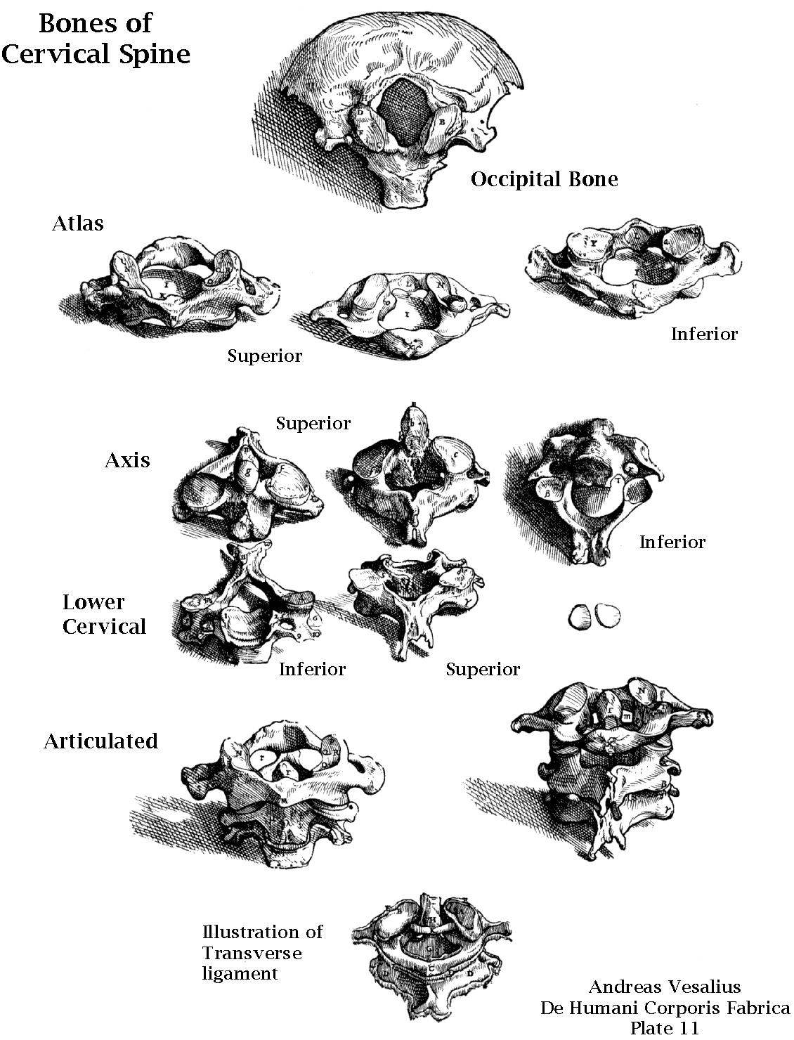
The Cervical Vertebrae from On the Fabric of the Human Body (De Humani Corporis Fabrica) Chapter 15, On the Vertebrae of the Neck or Cervix. Plate 11.
A quaternion may be interpreted as the ratio of two spatial vectors. Consequently, rotations in three-dimensional space may be expressed as rotations about an axis of rotation, which is the vector of the quaternion (v), through an angular excursion, which is the angle of the quaternion (θ). A rotation quaternion, R, may be expressed as:
$$R=\text{cos}q+\text{sin}q∗v$$
All anatomical objects are orientable, meaning that they have a particular orientation in space and any simple movement other than a 360° rotation in a single plane will change that orientation. For instance, your hand has a definite dorsal and ventral surface, medial and lateral aspects, and proximal and distal parts. You can tell your right hand from your left hand and you can tell if your hand has been rotated in any direction. Your hand is orientable.

The Problem
The cervical vertebrae are all orientable objects with definite locations in space and movements of the neck are the concatenation of subsidiary rotatory movements of the vertebrae about particular axes of rotation. The burden of the results in this paper are descriptions that can be re-interpreted as quantitative descriptions of the cervical vertebrae and incorporated in models of the cervical spine. Other papers consider particular problems that may be addressed in the model that will be developed here. We will describe the anatomical features of the cervical vertebrae and the manner in which they are interconnected and move relative to each other within the cervical spine.
Materials
Most of the following is based upon the examination of three dried skeletal cervical spines and a few dozen random cervical vertebrae collected over the years from partial sets of bones and cadaveric material. The individual bones give some indication of the range of possible shapes and sizes and the articulated spines give an indication of the interrelationships in a set of bones from a single individual. The intent of the study was to determine the normative structure of cervical vertebrae, determine to what extent one is justified in using a standard structure for all of the lower cervical vertebrae, and to obtain quantitative descriptions of the cervical vertebrae that could be used to model the spine

Statistics for the Lower Cervical Vertebrae: Actual Measurements

 |  | Average Actual Values for 3 cervical spines
 | Body |  | C2 | C3 | C4 | C5 | C6 | C7 | T1 | Average
 |  | Depth | 1.38 | 1.43 | 1.41 | 1.42 | 1.46 | 1.42 | 1.43 | 1.42
 |  | Width | 1.89 | 1.80 | 1.90 | 1.95 | 2.19 | 2.49 | 2.68 | 2.04
 |  | Height | 1.33 | 0.97 | 0.94 | 1.03 | 1.06 | 1.24 | 1.42 | 1.10
 | Superior Disc
 |  | Disc Width |  | 1.30 | 1.31 | 1.47 | 1.50 | 1.78 | 2.28 | 1.47
 |  | Uncinate Width |  | 2.01 | 1.99 | 2.14 | 2.32 | 2.52 |  | 2.20
 | Inferior Disc
 |  | Disc Width | 1.38 | 1.38 | 1.49 | 1.57 | 1.88 | 2.02 | 2.25 | 1.62
 | Vertebral
 |  | Width | 4.61 | 4.48 | 4.59 | 4.41 | 5.11 | 5.82 | 6.45 | 4.84
 |  | Depth | 4.24 | 3.86 | 3.62 | 3.73 | 4.54 | 5.24 | 5.27 | 4.21
 | Foramina
 |  | Medial/Lateral | 2.97 | 2.89 | 2.84 | 3.28 | 3.25 | 3.46 |  | 3.11
 |  | Width | 0.64 | 0.55 | 0.40 | 0.53 | 0.51 | 0.56 |  | 0.53
 |  | Depth | 0.52 | 0.44 | 0.37 | 0.44 | 0.40 | 0.43 |  | 0.37
 | Superior Facet
 |  | Depth |  | 1.12 | 1.01 | 0.98 | 0.89 | 0.92 | 0.88 | 0.98
 |  | Width |  | 0.95 | 0.99 | 1.07 | 1.17 | 1.30 | 1.12 | 1.10
 |  | Angle |  | 50.00 | 55.00 | 50.00 | 53.33 | 61.67 | 55.00 | 54.00
 | Inferior Facet
 |  | Depth | 1.41 | 1.06 | 0.99 | 0.93 | 0.91 | 1.04 |  | 1.06
 |  | Width | 1.00 | 0.98 | 1.04 | 1.28 | 1.27 | 1.40 |  | 1.16
 |  | Angle | 46.67 | 45.00 | 50.00 | 51.67 | 53.33 | 40.00 |  | 47.78
 | Canal
 |  | Width | 2.11 | 2.05 | 2.12 | 2.21 | 2.29 | 2.09 | 1.80 | 2.15
 |  | Depth | 1.43 | 1.34 | 1.30 | 1.26 | 1.27 | 1.30 | 1.33 | 1.31

The actual measurements, in centimeters and degrees, for a number of structural features of the cervical vertebrae in three cervical spines. The spines were chosen to be typical but different from each other. The data was collected to ascertain the normal structure of cervical vertebrae, rather than the full range or unusual variants. These values were compared with many other individual vertebrae to insure that they were not misrepresentative of the full range of possibilities.

Statistics for the Lower Cervical Vertebrae: Scaled Measurements

 |  | Scaled Average Values for 3 cervical spines
 | Body |  | C2 | C3 | C4 | C5 | C6 | C7 | T1 | Average
 |  | Depth | 1.00 | 1.00 | 1.00 | 1.00 | 1.00 | 1.00 | 1.00 | 1.00
 |  | Width | 1.37 | 1.26 | 1.35 | 1.37 | 1.50 | 1.75 | 1.87 | 1.43
 |  | Height | 0.97 | 0.68 | 0.67 | 0.72 | 0.73 | 0.88 | 1.00 | 0.77
 | Superior Disc
 |  | Disc Width |  | 0.91 | 0.93 | 1.04 | 1.03 | 1.26 | 1.60 | 1.03
 |  | Uncinate Width |  | 1.41 | 1.41 | 1.51 | 1.59 | 1.78 |  | 1.54
 | Inferior Disc
 |  | Disc Width | 1.00 | 0.97 | 1.06 | 1.10 | 1.29 | 1.42 | 1.57 | 1.14
 | Vertebral
 |  | Width | 3.34 | 3.13 | 3.26 | 3.10 | 3.50 | 4.10 | 4.51 | 3.40
 |  | Depth | 3.07 | 2.70 | 2.57 | 2.63 | 3.11 | 3.69 | 3.68 | 2.96
 | Foramina
 |  | Medial/Lateral | 2.15 | 2.02 | 2.01 | 2.31 | 2.23 | 2.43 |  | 2.19
 |  | Width | 0.46 | 0.39 | 0.28 | 0.38 | 0.35 | 0.39 |  | 0.38
 |  | Depth | 0.38 | 0.31 | 0.26 | 0.31 | 0.27 | 0.31 |  | 0.26
 | Superior Facet
 |  | Depth |  | 0.78 | 0.72 | 0.69 | 0.61 | 0.65 | 0.62 | 0.69
 |  | Width |  | 0.67 | 0.70 | 0.75 | 0.80 | 0.92 | 0.79 | 0.77
 |  | Angle |  | 50.00 | 55.00 | 50.00 | 53.33 | 61.67 | 55.00 | 54.00
 | Inferior Facet
 |  | Depth | 1.02 | 0.74 | 0.70 | 0.66 | 0.62 | 0.73 |  | 0.75
 |  | Width | 0.72 | 0.69 | 0.74 | 0.90 | 0.87 | 0.99 |  | 0.82
 |  | Angle | 46.67 | 45.00 | 50.00 | 51.67 | 53.33 | 40.00 |  | 47.78
 | Canal
 |  | Width | 1.53 | 1.43 | 1.51 | 1.56 | 1.57 | 1.47 | 1.26 | 1.51
 |  | Depth | 1.03 | 0.93 | 0.92 | 0.88 | 0.87 | 0.92 | 0.93 | 0.93

The measurements scaled to the depth of the vertebral body for each vertebra for a number of structural features of the cervical vertebrae in three cervical spines. This is the same data as in the previous figure, but re-scaled to remove the influence of overall variation between the cervical spines. The goal was to obtain representative measurements for a standard cervical vertebra and to examine the systematic differences between different levels of the spine.
Some measurements from diagnostic imaging and dissections are cited for the interpretation of the data from the bones, but this material is not considered in detail here. X-ray images, CAT scans, MRI images, and serial sections of cadaveric material all give insight into the structure of live cervical spines. They also give an indication of the normal variation between spines. Here we use the data mostly to determine the spacing and relative placement of the vertebrae.
The Structure of Cervical Vertebrae
It is easiest to start with the typical lower cervical vertebra and then to consider the special structure of the atlas and axis. There are differences between the vertebrae in the lower cervical spine (caudal C2 through rostral T1), but the vertebrae are remarkably alike in many of the ways that will be relevant here. Therefore, we start with the general features and progress to the specific differences.

Observations on the Lower Cervical Spine Vertebrae
The vertebra will be divided into several parts for the purposes of description. These are: 1.) the superior and inferior surfaces of the vertebral body, 2.) the transverse processes and the foraminae within them that transmit the vertebral arteries and veins and the autonomic plexus that runs with the arteries, 3.) the superior and inferior articular facets or zygapophyseal joints, joined by the bony articular pillar, and 4.) the laminae and spine, which constitute the posterior part of the vertebra.
When one looks at random samples of lower cervical vertebrae, drawn from different individuals, it is striking how much variation in size and configuration is observed. While the form remains much the same, the details may vary substantially, even on the two sides of a single vertebra. However, within a single cervical spine there is a remarkable consistency in some features. It is those features that remain much the same that will be considered below.
Because of the large variation in size from individual to individual and the consistency within an individual and because much of the data used does not come with an attached scale, it is often convenient to scale measurements to a standard feature that can be readily measured. To that end, the depth of a cervical vertebra, the distance between its anterior and posterior faces in the midline, is used as the unit of measure. While this distance varies a bit from vertebra to vertebra, it does tend to be about the same for all the lower cervical vertebrae in a single individual. In different situations, different indices may be used, because they are more convenient, but it is usually easy to convert between the reference values.

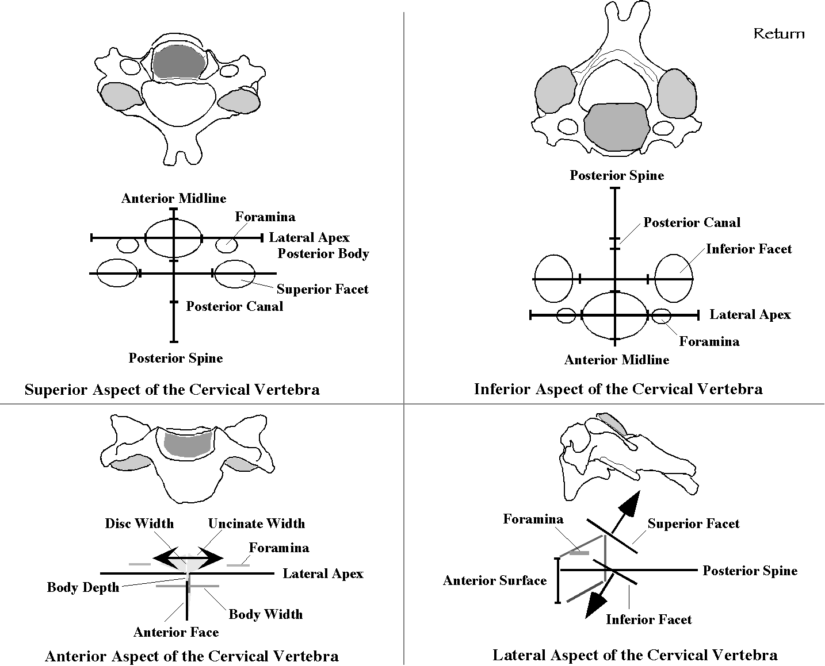
The panels illustrate the appearance of a standard cervical vertebra: in terms of drawings of a particular vertebra, in the upper part of the panel, and in terms of the measurements from many vertebrae, in the lower part of each panel. The diagrammatic representation in the lower parts of the panels is the basis for the computer models.

The shapes of the vertebral bodies of all the cervical vertebrae in an individual tend to be similar. The width of the body, from side to side, is usually about 5/4 to 3/2 times the depth and the thickness, from rostral to caudal, is from about 2/3rds to 3/4ths the depth. The more rostral vertebrae tend to be thinner and narrower than the more caudal vertebrae. These variations are comparatively minor and one would expect that the exact dimensions of the vertebral bodies to be of minor importance, since size varies so much between cervical spines. If we are going to represent all the lower cervical vertebrae by a single form, then it might have a vertebral body 1 unit deep, 1.35 units wide, and 0.8 units thick, where a unit is defined to be the depth of the vertebral body.

Superior and Inferior Surfaces of the Vertebral Body
The superior face of the vertebral body is generally flat and it may be tilted up as much as 20°, i.e. the posterior margin more rostral than the anterior margin. The lateral margins in a mature spine have substantial flanges, called uncinate processes, which rise from the posterior part of the superior surface to a sharp superior margin. In a live spine, these lie lateral to the intervertebral disc and they may function much like synovial joints; their surfaces are smooth as with a synovial joint. The uncinate processes do not extend much beyond the midpoint of the superior surface, so they are not a part of the anterior part of the intervertebral joint. It is speculated that the uncinate processes restrict lateral translation and rotation in the joint, but they are perfectly placed to guide flexion/extension and the combined lateral rotation/sideflexion that is characteristic of lower cervical vertebrae (see below).
From midsagittal MRI images of the cervical spine, it is possible to measure the relative amounts of the spine that are taken up by the vertebral bodies and the intervertebral discs. The discs occupy about one-third of the cervical spine’s length. Typically, uncinate processes are about the same height as the disc, so that successive vertebrae just engage at the uncinate processes. If one examines the inferior surface of the vertebral body, it is generally quite clear that the lateral margin of the inferior surface is also smooth and tilted to face laterally so as to abut upon the superior part of the uncinate processes of the subjacent vertebra. The amount of the inferior surface of the vertebral body that is roughened to engage the intervertebral disc is almost identical with the amount of the superior surface on the subjacent vertebra that is roughened.
The disc bearing area is about 0.9 units wide and the distance between the superior edges of the uncinate processes is about 1.35 units, which is essentially the same as the width of the vertebral body.
In many vertebrae, one can see that the anterior margin of the superior and inferior surfaces of the vertebral body are raised and smoothed as occurs when a ligament attaches. Similar raised borders are present along the posterior margin as well. This is in accord with recent observations of the structure of cervical discs. The cervical spine apparently starts with discs similar to those in the lumbar spine, but, unlike lumbar discs, the annulus fibrosus changes as the spine matures and it comes to form a crescentic fibrous band along the anterior margins of the superior and inferior surfaces. There is also a thin fibrous band along the posterior margins of the disc as well, but largely confined to the more medial part to the disc. Much of the remaining space is occupied by a fibrocartilaginous matrix that resembles the nucleus pulposus in being a firm soap-like gel, but apparently firmer than the nucleus pulposus. As the intervertebral disc matures it often develops horizontal fissures that extend in from the lateral margins of the disc and may render it into two plastic discs that move upon each other. The lateral recesses, adjacent to the uncinate processes, are thought to contain a lubricating fluid, which makes the uncinate processes similar to a synovial joint. If this fluid is present, then it may also extend between the two discal plates and lubricate their movements as well. With just the elements so far considered, the intervertebral joints would be unstable. Apparently, the anterior and posterior longitudinal ligaments are more developed, to act as restraints upon movement. It is also likely that the muscles that surround the spine are restraints upon movement.
If the vertebral body is taken to be 0.8 units thick and the intervertebral disc is taken to be a third of the spine (0.4 units), then the vertebral unit (1.2 units) may be taken to be the vertebral body and 0.2 units of intervertebral disc in both the superior and the inferior joints.
The inferior surface is distinctive in that it is cylindrically concave, superiorly. This is due to a straight and sharp posterior margin that extends more caudally than the center of the vertebral body and an anterior beak that may extend caudally to cover much of the intervertebral disc.
This configuration suggests that the upper vertebra of a pair is able to rotate about a transverse axis that lies in the body of the subjacent vertebra. Just looking at the evolute of the inferior surface would suggest that the axis of rotation lies in the upper part of the subjacent vertebral body. Measurements of the actual instantaneous axes of rotation (IAR) for flexion/extension indicate that they lie in different parts of subjacent vertebra at different levels of the cervical spine, but generally in the anterior upper part of the subjacent vertebra.
When the upper surface is tilted anteriorly, it is observed that the plane that contains the posterior margin of the inferior surface and the tip of the anterior beak is tilted about the same amount. The tilting tends to be greatest in the upper half of the lower cervical spine, especially the C2/C3 joint.
In general, the superior and inferior surfaces of a particular vertebra are roughly parallel. The superior and inferior surfaces are aligned with each other so that the anterior and posterior faces of the vertebrae are parallel and vertical when the vertebra is in neutral position. Neutral position is the orientation that places the ring of the vertebra in a horizontal plane. This is an anatomical neutral position. In the body, the vertebra may be tilted up or down, depending upon its position in the cervical spine and the configuration of the neck. In the spine, that position when the neck is at rest in the midline is also neutral position, but a functional neutral position. The description that follows assumes that the vertebra is in the anatomical neutral position. In the anatomical neutral position, the superior surface lies directly above the inferior surface. The superior and inferior faces of the vertebral body are much the same shape, so, the vertebral body is much like a section of vertical right cylinder.

Transverse Foramina
The broadest part of the vertebra is usually through the transverse processes. Most cervical vertebrae are about 3.5 units wide. The range is from a bit more that three units to a bit more than 4 units. Vertebrae C2, C3, C4, and C5 tend to be narrower than C6 and C7.
The transverse processes extend from the posterior part of the vertebral body, lateral to the uncinate processes. The anterior ramus of the transverse process arises about midway between the anterior and posterior limits of the vertebral body. It extends directly laterally or slightly anteriorly as one moves laterally. It is about the same height as the lateral wall of the vertebra in its medial margin and tapers to a narrow blade laterally. At its lateral extreme, it forms an enlargement, the anterior tubercle, that acts as an anchor for muscles
The posterior process arises from the pedicle of the vertebra. The pedicle extends from the posterior vertebral body back and laterally at an angle of about 30° to the coronal plane. The posterior processes of the transverse process extends from directly laterally up to about 30° anteriorly. It also ends in an enlargement, the posterior tubercle, that is an anchor for muscles. The anterior tubercle is about even with the middle of the vertebral body and the posterior tubercle is in a coronal plane through a point about 3/4th the way to the posterior surface.
Between the anterior and posterior rami of the transverse process is a trough or gutter. The exiting cervical spinal nerves run in this gutter and pass posterior to the ascending vertebral arteries. As it runs laterally, the gutter within the transverse process tilts inferiorly at about 20° to 30°. The inferior surface of the gutter may extend horizontally from the vertebral body or may also tilt inferiorly.
Within the transverse process, at the junction of the pedicle with the anterior and posterior processes of the transverse process, is a passage that allows the vertebral arteries to pass rostrally through the transverse processes of the cervical spine. It is called the transverse foramina. The vertebral vein and autonomic axons also run through these channels with the vertebral arteries. These transverse foraminae lie about level with a horizontal plane through the vertebral body a bit below the superior surface.
If the center of the vertebral body is taken as the center of the local coordinate system, with the positive x coordinate axis being directly anterior, the positive y coordinates being to the left, and the positive z coordinates being vertically up, then the foramina lies about 0.3 units superior and 0.75 units laterally in the coronal plane about midway between the center and the posterior surface of the vertebral body {-0.25, 0.75, 0.3}.
The foramen is usually elliptical and, on average, it would be about 0.3 units wide and 0.25 units deep. The rostrocaudal location of the foramina varies from vertebra to vertebra, from about the level of the superior surface to the level of the inferior surface, however, it usually lateral to the upper half of the cell body. The superior surface would be 0.4 units superior to the origin and the inferior surface would be 0.4 units inferior.

Zygapophyseal Facet Joints
Immediately posterior to the transverse process is the articular pillar. It is a cylindrical mass that is capped superiorly by the superior facet and inferiorly by the inferior facet. The superior facet lies directly superior to the inferior facet. The areas of the facets are about the same for the forces due to the head are passed directly through the pillar.
The facets are elliptical, but often approximately circular. Averages of measurements from the cervical facets in three spines give dimensions of 0.66 by 0.75 for the superior facet and 0.7 by 0.66 for the inferior facets. Circular facets with a diameter of 0.7 units would be a reasonable representation of both sets of facets. In the more rostral vertebrae the facets joints tend to be oblong with the long axis running anterior to posterior. In the more caudal vertebrae the facets tend to be oblong with the long axis running medially to laterally.
The facets are tilted so that they lie in a plane that is tilted about 45° to the horizontal and coronal planes, with the anterior margin of the facet superior to the posterior margin. The degree of tilt varies from vertebra to vertebra and from spine to spine. It may even be substantially different for the facets on opposite sides of the same vertebra. Most facets are tilted between 30° and 60°, with the most frequent measurements being around 45°. While most of the facets lie flat in the tilted plane, some may also be tilted a bit medially or laterally, less than 20°. There does not seem to be any consistent pattern as to which are tilted medially and which laterally. In fact, opposite facets on the same vertebra may be oppositely tilted.
The facets lie lateral and posterior to the vertebral bodies. On average, they extend anterior and medially enough to slightly overlap the vertebral body along the sagittal and transverse axes. As a result of this arrangement, the support surface for the cervical spine is about one and a half times the dimension of the vertebral body in both directions in the horizontal pane. In terms of the base of support, it is about two and a quarter times the area of the superior or inferior surfaces of the vertebral body.
On average, the center of the superior articular facet lies about level with the superior surface of the vertebral body and the center of the inferior articular facet lies slightly superior to the inferior surface of the vertebral body. The more caudal cervical vertebrae tend to have the superior facet a bit more superior. This is in part due to the anterior/posterior narrowing of the superior facets in the more caudal vertebrae, so they do not extend as far caudally. The superior tip of the anterior margin of the superior articular facet lies closer to the posterior margin of the vertebral body at higher spinal levels. For C6 and C7 the superior facet is substantially more rostral and caudal . Similarly the inferior facets shift from being below the cell body (C2) to being centered upon the inferior surface of the vertebral body (C7).

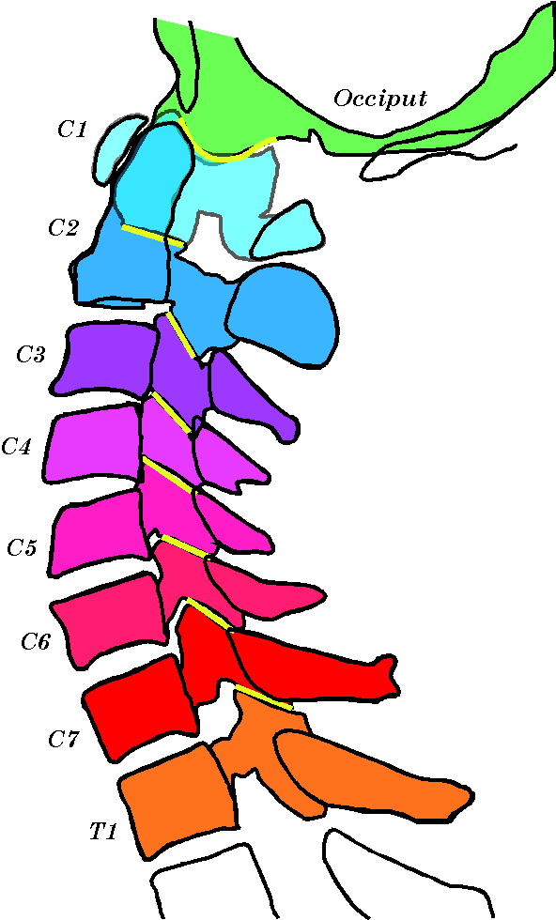

Cross-sections of cervical spine from midline (vertebral bodies and spines) and lateral (articular pillars) sections of cadaveric material. Note the relative locations of the vertebral bodies and the facet joints. Similar relations can be seen in xrays, CAT scans, and MRI images.
On average, the center of the superior facet is about {-1.1, ±1.0, 0.4} and the center of the inferior facet is about {-1.1, ±1.0, -0.3}. Each is tilted up about 45° and each is roughly circular with a radius of 0.35 units.
There is usually a narrow cleft between the anterior face of the inferior facet and the posterior ramus of the transverse process. The posterior ramus of the transverse process may extend inferiorly enough to lie immediately anterior to the inferior facet. In that location, it is situated so that the superior facet of the subjacent vertebra might impact upon the transverse process when the superjacent vertebra is in endrange extension. In a dry skeleton, the anterior margin of the superior articular process generally rests in the narrow groove between the inferior articular process and the transverse process. However, in life, the intervertebral disc is probably thick enough to separate the two vertebrae enough for the superior articular process to pass just inferior to the transverse process of the superjacent vertebra.

Laminae
The laminae arise from the articular pillar and extend approximately horizontally to converge in the midline, at the base of the vertebral spine. The laminae form the majority of the posterior part of the vertebra. The angle at which they meet is between 90° and 120°, so, together with the articular pillars and the posterior aspect of the vertebral body, they form a roughly triangular vertebral canal. The canal is widest at the pedicles, about 1.5 units, slightly more than the vertebral body’s width. The distance between the posterior midline of the vertebra and the junction of the laminae is about 1.0 unit (between 0.9 and 1.1 units). Consequently, the junction of the laminae and the spine is about 2 units posterior to the anterior midline of the vertebra or at -1.5 units in the local coordinate system. The midpoint of the junction is at {-1.5, 0.0, 0.0}. The lamina is about 7/10^{ths} the height of the vertebral body and the laminae tilt about 45° medially. There is usually a small gap between the successive laminae.
The junction of the laminae and the vertebral spine is important in that it appears the extension is most often limited by impaction between the laminae of successive vertebrae at this junction. The bottom of the lamina of the superjacent vertebra comes into contact with the top of the junction in the subjacent vertebra.
The shape and size of the vertebral canal is consistent throughout the cervical spine, up to the atlas, where it expands substantially. Therefore, the laminar junctions are also consistently placed.

Spinous Processes
The consistency of the placement of the laminar junctions is somewhat obscured by the variability of the vertebral spinal processes. The extent of the spinous processes is the most variable feature of the cervical vertebrae. The atlas has no spine, only a posterior tubercle. The axis has a modest spine and C3 almost no spine, but then the next few vertebrae have gradually longer spines as one approaches the thoracic spine. The spine of C7 is usually the vertebra prominens, which is a clinical landmark.
Many of the intermediate cervical vertebrae have bifid spines. The vertebra prominens is usually not bifid, but it has a rostrocaudally flattened enlargement on its tip

Intervertebral Disc
The intervertebral disc is not a part of the dried skeleton and it is probably somewhat distorted by the fixation procedures used to preserve cadavers, so, it can be difficult to obtain reliable measurements of the disc. However, diagnostic imaging methods can be used to obtain some measurements. Perhaps one of the most useful of these images is the midsagittal MRI. Measuring the profiles in such an image indicates that the cervical discs constitute about a third of the lower cervical spine. This is about the same ratio as in the lumbar spine. Both regions are substantially more mobile than the thoracic spine, where the ratio is substantially less.
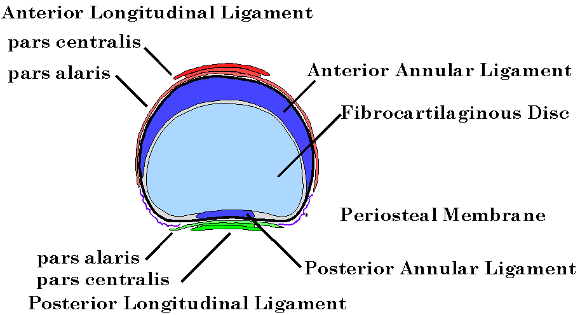
Diagram of the cervical vertebral disc. The annulus fibrosus is reduced to a semicircular anterior ligament and the nucleus pulposus is a fibrocartilaginous disc.
When the thickness of the disc is calculated, it turns out to be about 0.4 units, which is about the height of the uncinate processes. Consequently, the vertebrae are separated by a disc so that the lateral margins of the inferior vertebral surface just engage the tips of the uncinate processes when the neck is in neutral position. This may be seen in AP plane x-ray images.
The situation is complicated a bit by the fact that the anterior beak on the inferior aspect of the vertebra extends over a substantial part of the disc anteriorly. The posterior inferior margin of the beak that is smoother than the remainder of the inferior surface and the smooth region extends posteriorly to meet the smooth surfaces on the lateral aspect of the vertebral body that engage the uncinate processes. Recent studies have shown that, in mature cervical spines, this rim is the site of the annulus fibrosus attachment.
The remainder of the space between successive vertebrae is occupied by the matrix that would correspond to the nucleus pulposus in the lumbar spine, but it is a fibrocartilaginous plate or plates, depending upon the amount of horizontal fissuring. Unlike the lumbar spine, the cervical discs generally develop horizontal fissures that extend in from the lateral margins of the disc and may meet in the midline, dividing the disc into two plates that could slide upon each other. These plates have been described as soap-like in cadaveric material. This is taken to mean like hard soap such as used to wash one’s hands. If the plates are like soap, then there is probably some give to them, so that they might be compressed and return to their original shape. The presence of fluid in the joint that is like synovial fluid would suggest that such compression and relaxation may help to nourish the disc plates, as it does hyaline cartilage in synovial joints.

Movements
The movements in the cervical spine will be considered in detail elsewhere, but a few words will be devoted to the basics of the movements here, since the analysis is derived primarily from a model of a cervical vertebra that is constructed from this anatomical data. There are basically two types of movement that occur in the lower cervical spine. Most of the other possible movements are essentially play in the joints. Which may be important is some situations, but are not central to the analysis.
The first type of movement that occurs in the cervical spine is flexion/extension. To avoid having to use that conjunction every time to refer to these movements the combined movement will be called salaam. Flexion is positive salaam and extension is negative salaam.
Salaam is about a transverse axis that passes through the subjacent vertebral body. It is probably partially guided by the uncinate processes, which force the movement to be in the sagittal plane. During salaam, the facet joints slide vertically, so that the inferior facets of the superjacent vertebra move superiorly and anteriorly upon the superior facets of the subjacent vertebra to produce flexion.
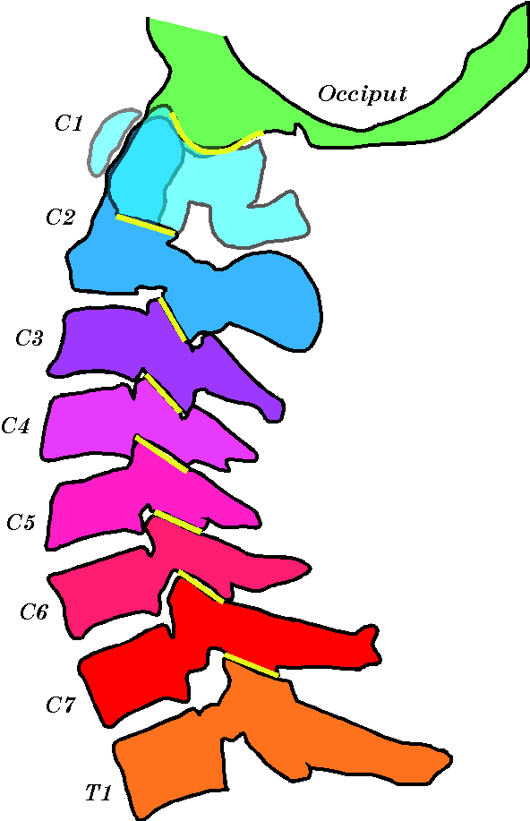
The neck bones in profile. The vertebrae are reconstructed from a series of parasagittal sections of the neck.
Flexion is probably limited by the anterior and posterior longitudinal ligaments and the anterior crescent of fibrocartilage in the disc. The anterior ligamentous structures will tend to tether the vertebral body from moving too far forward and tend to drive the posterior part of the joint apart. However, that separation is limited by the posterior longitudinal ligament and the interspinous and supraspinous ligaments associated with the vertebral spines. There is a possibility of impaction between the anterior beak and the superior surface of the subjacent vertebra, but that is not likely to occur normally.
Extension is a rocking posteriorly and caudally that causes the facets to slide together. It is apparently limited by impaction between the facets at their posterior margins, by impaction of the junctions of the laminae and by tethering by the crescent of anterior fibrocartilage at the anterior margins of the vertebral bodies.
The other primary movement between lower cervical vertebrae is an oblique rotation about an axis perpendicular to the facet joints. Since the facet joints lie in a plane that is tilted about 45° relative to the horizontal plane, the axis of rotation is at a 45° angle to the vertebral body in the midsagittal plane. The movement must happen in the intervertebral disc and since the anterior margin is tethered by the fibrocartilage in the annulus, the movement is most apt to occur in the anterior part of the joint. This means that the posterior part of the disc will experience a rocking movement in which the superjacent vertebral body rides up on one uncinate process and down on the other, like one bowl rotating within another. It is noteworthy that the uncinate processes are well placed to guide the oblique rotatory movement.
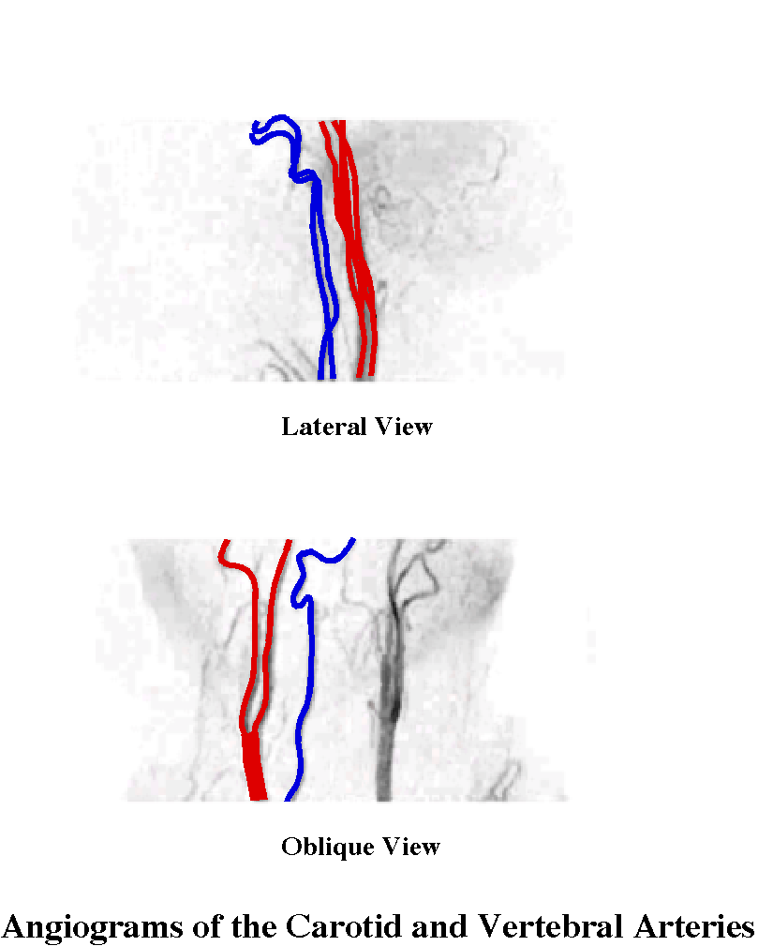

Vertebral Arteries
A feature of the cervical spine in life that cannot be studied directly in the dried skeleton is the passage of the vertebral artery up through the transverse processes. However, its course has milestones along the way that we can examine. The transverse foraminae mark the passage of the vertebral arteries at regular intervals and they are eminently examinable. When measurements are made of the locations and sizes of the transverse foraminae, the numbers turn out to be remarkably consistent from vertebra to vertebral in a single cervical spine. Consequently, the vertebral arteries pass directly from vertebra to vertebra up the neck. In angiograms, the artery does not have discernable discontinuities at the transverse foraminae.
The location of the vertebral arteries places them close to the axes of rotation in the cervical spine (see below). For flexion/extension [salaam] the arteries are like a stripe on the side of a flexible tube. Anterior to the stripe, the distances between points are reduced and posterior to the stripe they are increased as the tube flexes. At the lateral margin of the tube, the distances are unchanged. Therefore, the placement of the vertebral arteries is such as to produce minimal strain with salaam movements.
The other movements that occur in the cervical spine are about an inclined axis that is perpendicular to the plane of the facet joints. The effect of these movements is to tilt the vertebra to the side and rotate it about a vertical axis. These movements will move the successive transverse processes apart. The question is how much, which will be the subject of much calculation, but a crude direct measurement in a dried skeleton suggests that it will be on the order of a 5% increase in length. This is possible because the vertebral arteries are as close as possible to the center of rotation, short of running through the vertebral bodies.

Observations on the Axis and Atlas Vertebrae of the Cervical Spine

Overview:
The axis is the transition between the lower cervical spine and the upper cervical spine. Its inferior surface is in many respects like a lower cervical spine vertebra in that it has a cylindrically concave surface, inferior facets that lie in a plane tilted 45° anterior to the coronal plane, and a short bifid spine. There is an intervertebral disc between the second and third cervical vertebrae. The superior surface of the axis is very differently arranged, because of its role in the axial-atlanto-occipital joint complex. Perhaps most noteworthy is the prominent odontoid process or dens, but the superior articular facets are also very anteriorly placed, just to either side of the dens. The superior facets are laterally tilted, so that they form sloping shoulders for the atlas to rest upon.
The vertebral artery passes just lateral to the posterior part of the vertebral body, so it passes just inferior to the superior articular processes then turns abruptly beneath the superior facet and runs laterally and slightly posterior, to exit the vertebra at its most lateral point. The artery will pass rostrally and a bit more lateral, to reach the transverse foramina of the atlas.
The apex of the dens extends just above the rostral aspect of the anterior arch of the atlas. The anterior facet of the dens articulates with the posterior facet on the anterior arch of the atlas.
The atlas is a ring of bone, with two articular pillars in the anterior part of the ring. The anterior arch is short, just a bit wider than the dens of the axis, and the posterior arch is the entire posterior half of the ring. The articular facets lie in the anterior half of the ring, laterally, so that the anterior face of the vertebra is very broad and fairly flat. The inferior facets are approximately circular, but the superior facets are elliptical with the long axis directed caudally and laterally at an angle of about 30° to the sagittal plane. Both sets of facets are angled so as to face medially so compression through the atlas will tend to drive the articular pillars laterally, that is, apart.
The transverse processes are lateral to the articulations. Unlike in most of the cervical spine, the anterior ramus is thick and the posterior ramus is thin. The vertebral artery passes through a foramina in the transverse process and then turns abruptly to pass horizontally around the posterior aspect of the superior articular facet. The most lateral part of the atlas is the tip of the transverse processes and the atlas is the broadest of all the cervical vertebrae.
Axis

Inferior Discal Surface
The body of the axis tends to be slightly narrower and thinner than the more caudal cervical vertebrae. Its inferior surface is like other lower cervical vertebrae in being cylindrically concave, with the axis of the cylinder being transverse. The discal surface is about as wide as it is deep. The anterior beak is pronounced and the posterior aspect of the beak is smooth, but marked by the insertion of the annulus fibrosus attachment.

The Statistics for the Atlas and Axis Vertebrae

 | Average Actual Values |  |  |  | Scaled to Axis Depth
Atlas |  |  |  | Atlas
 | Width | 6.22 |  |  | Width | 4.50
 | Depth | 3.87 |  |  | Depth | 2.80
 | Foramina | 4.95 |  |  | Foramina | 3.59
 | Superior Facet Depth | 1.98 |  |  | Superior Facet Depth | 1.44
 | Superior Facet Width | 1.18 |  |  | Superior Facet Width | 0.86
 | Inferior Facet Depth | 1.48 |  |  | Inferior Facet Depth | 1.07
 | Inferior Facet Width | 1.42 |  |  | Inferior Facet Width | 1.03
 | Inferior Facet Angle | 30.00 |  |  | Inferior Facet Angle | 30.00
 | Anterior Gap | 1.47 |  |  | Anterior Gap | 1.06
 | Dens Depth | 1.00 |  |  | Dens Depth | 0.72
Axis |  |  |  | Axis
 | Dens Depth | 0.97 |  |  | Dens Depth | 0.70
 | Dens Width | 0.83 |  |  | Dens Width | 0.60
 | Dens Height | 1.37 |  |  | Dens Height | 0.99
 | Superior Facet Depth | 1.58 |  |  | Superior Facet Depth | 1.15
 | Superior Facet Width | 1.52 |  |  | Superior Facet Width | 1.10
 | Superior Facet Angle | 25.00 |  |  | Superior Facet Angle | 18.12
 | Foramina | 4.17 |  |  | Foramina | 3.02
 | Vertebral Separation | 1.15 |  |  | Vertebral Separation | 0.83
 | Vertebral Shift | 0.39 |  |  | Vertebral Shift | 0.28
 | Degrees Shift | 18.81 |  |  | Degrees Shift | 18.81
The structure of the atlas and axis vertebrae is particular to each, so they are listed individually. The statistics are derived from the same spines as the lower cervical data and the remarks made above apply here as well. The format here is simpler, since each bone is different from the other. The actual measurements are in centimeters and degrees.
The posterior margin of the inferior surface has a straight sharp edge. As with the inferior surfaces at other levels, the lateral margins of the inferior surface of the axis has smooth rim that is continuous with the articular surfaces for the articulation with the uncinate processes of C3. The inferior surface lies directly caudal to the superior surface.

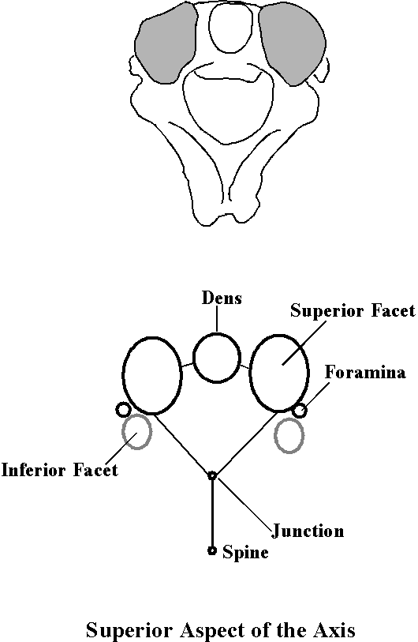

The Superior Surface [dens, odontoid process]
The anterior 2/3^{rds} of the superior surface is occupied by the odontoid process or dens, a bony “tooth” that stands about as tall as the vertebral body (1.0 units tall), but is 0.7 units deep and 0.66 units wide at its widest point. The anterior face of the dens rises directly from the anterior aspect of the vertebral body. It appears slightly recessed because it originates from the anterior tubercle at the junction of the vertebral body and the odontoid process. The tubercle is an attachment site for the anterior longitudinal ligament.
The dens has a modestly tapered waist as it arises from the vertebral body, flares briefly on its posterior and/or lateral aspects and then tapers quickly to an apex. Most of the anterior aspect of the dens is taken up by the articular surface for the anterior atlantoaxial joint. The waisted region of the posterior aspect is occupied by the articular surface for the interface between the transverse ligament and the dens.
The apex of the dens is smoothed for the attachments of the apical and alar ligaments. It is roughly pyramidal with the posterior faces pointing posteriorly, laterally and superiorly. Its slope is about 45° relative to the horizontal plane.

Transverse Foramina
The transverse foramina lie in a modified structure that acts as the foundation for the superior articular surface. The anterior ramus extends directly laterally or slightly anterior to the coronal plane and the posterior ramus projects posteriorly at about a 45° angle, in the horizontal plane. The two processes fuse laterally and form a process that extends a short distance beyond the lateral margin of the superior articular surface. It is the most lateral part of the axis vertebra, about 1.6 units lateral to the midline.
The superior joint facet forms a roof that completely covers the transverse process, so the vertebral artery passes up under the superior articular surface and then turns abruptly laterally. The arterial passage extends rostrally for about three-quarters of the height of the axis vertebral body, turns abruptly and passes posteriorly and laterally, at about a 45° angle to the sagittal plane. The vertebral artery leaves the bone at its most lateral point, just caudal to the posterior half of the lateral margin of the superior articular surface, about 1.5 units lateral to the midline. As it leaves, it is running horizontally and it must turn about 90° to run rostrally again. As a consequence, the vertebral artery makes two right angle turns in a short segment of the artery, less than one centimeter. The entrance to the foramina is elliptical with the long axis transverse; about 1.5 to 2 times wider than the depth. The lateral opening of the arterial passage is approximately circular and laterally directed. Sometimes there is a modest posterior orientation [~30°] as well.

Superior Facet Joints
Unlike in the lower cervical vertebrae, the superior articular surface does not lie directly superior to the inferior articular surface. The superior facets lie anterior to the inferior facets, directly lateral to the dens and above the transverse processes. They do not extend quite as far medial as the lateral margin of the dens. They are nearly flat and lie in a plane perpendicular to the coronal plane, tilted about 30° laterally, so that they form sloping shoulders for the atlas to rest upon. The facets are roughly circular (1.15 by 1.10 units). The superior articular facets engage the inferior facets of the atlas and allow the atlas to rotate about a vertical axis though the odontoid process. Their location relative to the dens is such that the atlas rides upon the axis like two inverted funnels, one inside the other, with their spouts aligned at the dens.

Inferior Facet Joints
The inferior facets are similar to those of the lower cervical vertebrae. They lie directly posterior to the transverse processes and do not extend as far medial as the lateral margin of the body. The slope of the facets may be as much as 60° to the horizontal plane, facing forward, but they are usually closer to 45°. The areas of the facets are roughly elliptical with the long axis oriented slightly anterior in the coronal plane. The center of the inferior articular joint lies about the level of the highest point of the inferior surface of the body of the vertebra.
As in lower cervical vertebrae, anterior margin of the inferior facet is separated from the posterior transverse process by a narrow, but deep, groove.

Laminae
The laminae extend approximately horizontally from the articular pillar and at an angle of about 45° to the sagittal plane, so they meet at a roughly 90° to 120° angle at the base of the vertebral spine. They are a little less thick than the vertebral body, so, there may be a gap between them and the laminae of C3. There is a substantial gap between the laminae of C2 and the posterior arch of C1. As in the lower cervical spine, the laminae slope posteriorly as one progresses inferiorly, so that the blades are tilted at about 45° at the junction between the two laminae and the base of the spine. Extension may be limited by impaction between the laminar junctions of C2 and C3.

Spine
The spine is bifid and extends a short distance posteriorly from the junction with the two laminae. Generally, extension is not limited by the impaction of the dorsal tips of the spines. The spine on C3 is usually much shorter than that on C2. The total depth of the axis, from the anterior midline of the vertebral body to the tip of the spine, is about 3 units.

Intervertebral Disc
There is no intervertebral disc between the atlas and the axis. The disc between C2 and C3 is about a third of the cervical spine height, measured in the mid-sagittal plane. The disc is about the same height as the uncinate processes of the subjacent vertebra. The axis sits with its lateral margins in contact with the crests of the subjacent vertebra’s uncinate processes. The ventral beak of the caudal surface overlies a substantial portion of the disc, when viewed from the front. As related in the section on lower cervical vertebrae, cervical discs are very different than lumbar discs in mature spines.

Movements
The movements in the inferior joints are much as in other lower cervical spine joints. That is salaam and oblique rotation about an axis perpendicular to the plane of the facet joints.
The major movement in the atlanto-axial joint is rotation about an axis through the center of the odontoid process. The movement is constrained by the transverse ligament and restricted by the alar ligaments. Rotation is supported by the atlas riding upon the superior facets like a funnel over another funnel. The total movement is about 45° in both directions, which is about the extent of the articular surfaces; much more rotation would allow the atlanto-axial joint to sublux.
Flexion is a minor movement in the atlantoaxial joint and it occurs about an axis through the shaft of the odontoid process. Supraspinal and interspinal ligaments and the posterior neck muscles are probably restrictions on flexion. In addition, the posterior longitudinal ligament is also a potential restriction on flexion. Extension is also a minor movement in this joint. Sideflexion is prevented by the placement of the superior articular facets immediately lateral to the dens.

Atlas

Anterior Arch
There is no vertebral body, only a flattened segment of bone that binds the two articular pillars together, the anterior arch. The posterior aspect of the arch is smooth, for the articulation with the anterior aspect of the dens.

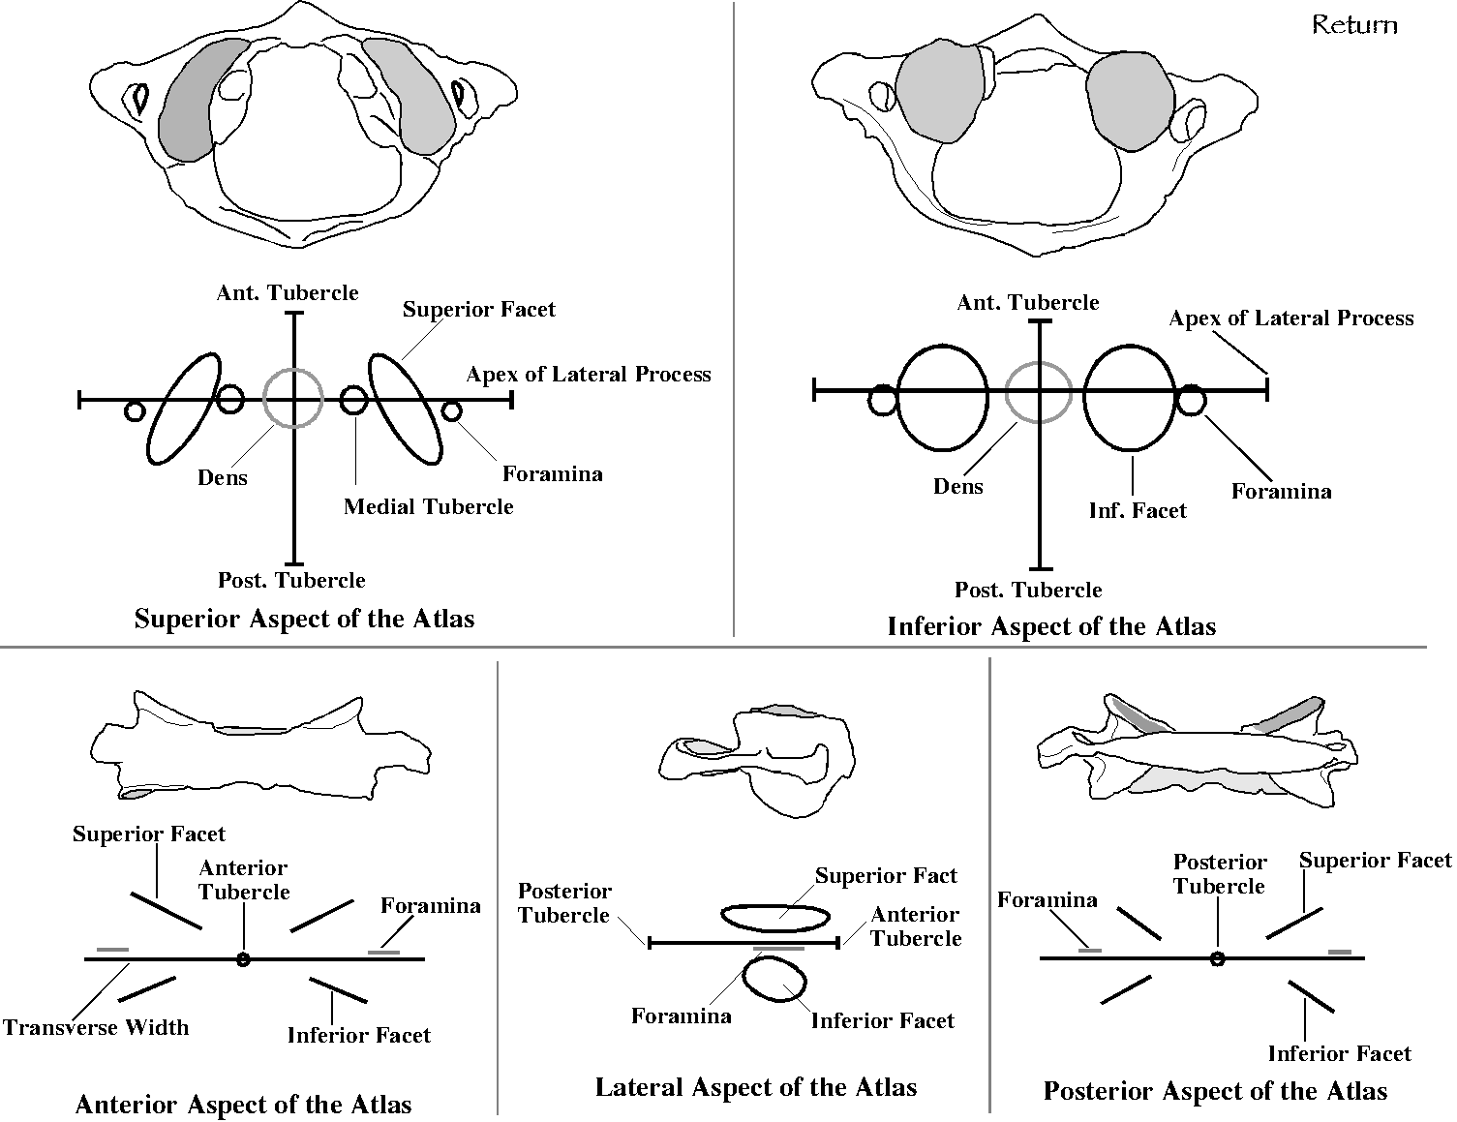
The atlas as viewed from several perspectives. The upper part of each panel is a drawing of a particular atlas and the lower panel is an abstraction of the data form the set of measured bones.
The medial aspects of the articular pillars have small smooth tubercles to which the transverse ligament attaches. These face directly medial. There is also a prominent tubercle on the inferior aspect of the anterior arch, in the midline. The gap between the two articular pillars is about 1 unit, whereas the dens is about 2/3rds of a unit. If the dens is placed in the anterior gap, its center lies about 0.75 units posterior to the anterior tubercle on the anterior arch.

Posterior Arch
The posterior arch extends approximately horizontally from the articular pillar to form a thin ring in the horizontal plane that is centered about midway between the articular facets. It encloses a broad, roughly trapezoidal, foramina.
The width of the atlas is about 4.5 units and the depth about 3 units. This makes it much broader than other cervical vertebrae and about as deep.

Spine
There is no spine, but there is a tubercle on the posterior aspect of the midline of the posterior arch. The tubercle is a site of ligamentous attachments.

Transverse Foramina
The transverse foraminae lie lateral to the posterior half of the superior articular surface. The anterior ramus is thick and it comes off the anterior surface of the articular pillar, while the posterior ramus is thin and it forms a narrow strut to the most anterior part of the posterior arch. The two processes fuse laterally and form a process that extends a short distance beyond the lateral margin of the superior articular surface. This bony strut is the most lateral part of the atlas vertebra, about 2.25 units lateral to the midline.
The arterial passage is a narrow ring of bone. The artery passes through the ring and immediately turns posteriorly to wrap around the posterior aspect of the superior articular process. The foramen is roughly elliptical with the long axis sagittal; about 1.5 to 2 times deeper than the width. The opening lies immediately below the lateral margin of the superior articular facets, in their posterior half.

Inferior Facet Joints
These facet joints lie directly medial to the transverse processes and lateral to the space that is occupied in life by the dens. The slope of the facets is about 30° to the horizontal plane, facing medially. They rest upon the similarly sloped superior articular facets of the axis vertebra. The areas of the facets are about equal and roughly circular, with a diameter of about 1 unit. The anterior margins of the facets lie in line with the anterior surface of the anterior arch. The center of the inferior articular joint lies in a coronal plane near the center of the dens.

Superior Facet Joints
The superior facet joints lie lateral to the dens, directly superior to the inferior facets. Their anterior half is directly lateral to the dens and their posterior half extends posterior to it. The superior facets are modestly concave with an elliptical shape. Their long axes directed posteriorly and laterally at about a 45° angle to the sagittal plane. The depth of the articular surface is about 1.45 units and its width about 0.9 units. The facet is cylindrically curved so that it has an axis of rotation that lies at about a 45° angle anterior to the coronal plane and tilted up about 45°.
The superior articular facets engage the condylar facets of the occiput and allow the occiput to rotate about a transverse axis within the skull. This configuration encourages rotation in the sagittal plane and very little in other planes. Rotation about a sagittal axis may be possible by gliding the condyles medially and laterally.

Movements
The major movement in the atlanto-axial joint is rotation about an axis through the center of the odontoid process. The movement is constrained by the transverse ligament and restricted by the alar ligaments. Lateral rotation is achieved by the atlas riding upon the superior facets of the axis, like a funnel over another funnel. The total movement is about 45° in both directions. That is also about the extent of the articular surfaces; much more would allow the atlanto-axial joint to sublux.
Movement between the atlas and occiput is mostly salaam (~15° to 25°) with small amounts of sideflexion (~ 5°) and even smaller amounts of rotation about the odontoid process.
Movements in the axial-atlanto-occipital assembly are linked by the alar and transverse ligaments, so that movements between each pair of bones affects the movements between the other two bones. The assembly allows unusually large sagittal and lateral rotation movements , but little side flexion.

Discussion
There is much more that could be said about the anatomy of the cervical spine, but the above descriptions will be useful in constructing a model of the cervical spine for the purposes of calculation. As stated at the outset, the cervical spine has two distinctly different parts; the axio-atlanto-occipital assembly (AAOA) and the lower cervical spine. The AAOA is a complex joint that involves three bones and at least five joint surfaces. It includes the superior part of the axis, the atlas, and the occipital condyles. The lower cervical spine includes the inferior part of the axis, the superior part of the first thoracic vertebra, and all the cervical vertebrae between. The two parts are mechanically linked in the axis vertebra, which participates in both.

Lower Cervical Spine
The lower cervical spine is constituted of seven similar units that are much the same width, depth, and thickness, have the same types of joints between the vertebral bodies and between the articular facets, and that move in much the same way. There are individual variations, but, initially, it helps comprehension to treat all the vertebra units as the same. Once we have some understanding of the basic implications of that structure, then we can explore the effects of varying it.
The basic structure for a lower cervical vertebra is a vertebral body that is 1.0 unit deep, 1.5 units wide, and 0.8 units thick. The vertebral bodies are separated by an intervertebral disc about 0.4 units thick and a little less wide and deep than the vertebral body. The discs are slightly thicker anteriorly than they are posteriorly so that successive vertebrae are tilted relative to each other by about 6° on average.
We will not incorporate them initially, but the uncinate processes will have to be examined. We note that they engage the superjacent inferior vertebral surface in a live spine. It is also noteworthy that mature cervical intervertebral discs are quite different from lumbar discs and it will be necessary to examine the implications of the actual anatomy.
The articular pillar of the cervical spine is interrupted by synovial joints in which the articular facets are tilted about 45° anterior to the coronal plane and superior to the horizontal plane. These joints are located posterior (-1.1 unit) and lateral (± 1.0 units) to the vertebral body and the center of the superior facet is at about the level of the superior surface of the vertebral body (+0.4 units), while the center of the inferior facet is slightly above the level of the inferior surface (-0.3 units). This arrangement leaves room for the cartilages of the zygapophyseal joints.
The junction of the two laminae and the vertebral spine lies about 1.5 units posterior to the center of the vertebral body. This is relevant, because these junctions may well abut upon each other and act as a bony restriction on extension.
The vertebral arteries pass up through the cervical spine by passing through a series of foraminae in the transverse foraminae of the cervical vertebrae. These foraminae lie immediately lateral to the posterior half of the vertebral body, which places their center about 0.25 units posterior, 0.75 units lateral, and 0.3 units superior to the center of the vertebral body.
There are two types of movement between lower cervical vertebrae; salaam and oblique rotation. Salaam, which is a term for both flexion and extension, is about a transverse axis, {0.0, 1.0, 0.0}. The oblique rotations are a combination of sideflexion and lateral rotation that occurs about an oblique axis in the midsagittal plane, {-0.71, 0.0, +0.71}. The value 0.71 is an approximation to the $\sqrt{2}$, which is the cosine and sine of 45°. What will not be specified here and which are critical to the movements of the cervical spine are the locations of the axes of rotation relative the vertebra for each of the cervical vertebra. That information is obtained by observing actual cervical movements and computing the instantaneous axis of rotation for each movement. It will be found that good approximations to the observed locations of the axes of rotation may be deduced from the anatomy.

AAOA
The axis is the foundation for the upper cervical assembly. Its location and orientation in space is usually a consequence of the movements in the lower cervical spine. In the upper cervical assembly, the axis is fundamentally a pivot about which the atlas and occiput rotates. The center of the rotation is the central vertical axis of the odontoid process, located about 0.25 units posterior to the center of the axis vertebral body. The axis of rotation is {0.0, 0.0, 1.0}. The atlas rides upon the shoulders of the axis, formed by the superior facets, which are tilted 30° laterally so that the facets face superiorly and laterally.
The dens of the axis is tethered to the occiput by the apical and alar ligaments that attach to its apex and the inner margins of the foramen magnum. The alar ligaments have a major role in the dynamics of the upper assembly, particularly in linking the movements in the atlantoaxial joint and the atlanto-occipital joint.
The atlas is fundamentally a link between the upper part of the assembly and the lower part. In the lower, atlantoaxial joint, its movements are principally lateral rotation and in the upper, atlanto-occipital, joint, they are principally salaam. There are a few degrees of sideflexion in the upper part of the assembly and a few degrees of salaam in the lower part. Although these are small, they may be important in restricting the principal movements.
The superior articular facets are located anteriorly, about 0.5 units posterior to the center of the axis vertebral body and extending from about the anterior surface of the axial body to about 1.5 units posterior. Kapandji argues that the curvature of the superior facets is approximately correct to consider the occiput as being like a sphere that is sliding upon the interior surface of another sphere, where the point of contact is anterior to the center of the spheres.

