A Model for the Study of Movements of the Lower Cervical Spine

Thomas Langer
The movements of the lower cervical spine are complex even though they are almost entirely of two types. All of the lower cervical vertebrae (inferior C2 through C7) are similar in their size and shape. So much so, that it is possible to use the same basic measurements for each with minor changes in a few features. There are differences that differentiate the upper three from the lower three elements, so, it is common to divide the lower spine into two parts a middle cervical spine and a lower cervical spine. The principal difference that will affect this analysis is that the axes of rotation for the movements vary from vertebra to vertebra (Kapandji 1974). There are two types of movement that occur in the lower cervical spine: 1.) flexion/extension, about a transverse axis and 2.) sideflexion/lateral rotation about an oblique axis in the sagittal plane. It is this latter type of movement that makes the cervical movements complex, because it forces the movement to occur in a plane that is not one of the orthogonal planes of movement and not aligned with the standard orientations of the vertebrae or of the head or of the neck. Consequently, the oblique rotation causes movement in non-cardinal directions.
Quaternion analysis removes much of the computational difficulty associated with non-orthogonal movements, but it will still produce results that are difficult to conceptualize, especially when concatenated by combining the movements of the entire lower cervical spine. Therefore, we will approach the problem through a series of progressive steps that build upon the earlier analysis. We will start with single vertebrae and the movements that occur between pairs of vertebrae, then advance to the concatenation of a series of similar functional units. Finally, we will consider the consequences of the differences in axes of rotation at different levels.

The Anatomy of a Typical Cervical Vertebra
The first two cervical vertebrae are atypical in a number of ways, which have profound implications for the manner in which movements occur between them and the skull. The remaining cervical vertebrae are similar in their size and shape [(Williams, Bannister et al. 1995)]. The seventh cervical vertebra is moderately different from the others in that it has a longer, non-bifid spine, more posteriorly placed transverse processes and a larger size overall. It is in many ways transitional between the typical cervical vertebra and the typical thoracic vertebra. Still the differences are probably not markedly different. The significant differences for movement are more apt to be the directions of the axes of rotation.

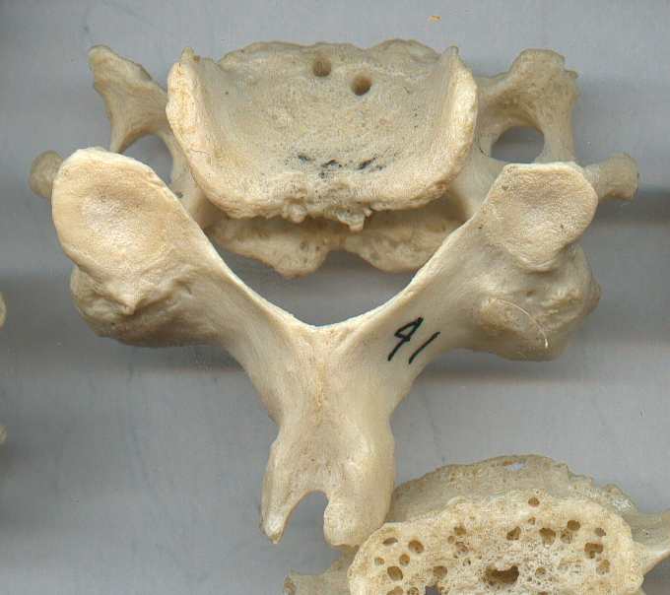
A cervical vertebra viewed from the back.
The Vertebral Body: A typical cervical vertebra is composed of a body that is much like other vertebral bodies except for being smaller than at other levels and having raised edges in mature spines. These take several forms. Along the lateral margins of the vertebral body, the superior surface develops parasagittal ridges that form synovial joints with the recessed lateral margins of the inferior surface of the superjacent cervical vertebra. These synovial joints are called uncinate joints. These unciform processes may act as a restraint upon sideflexion. It has also been speculated that they may represent an ongoing evolution towards a more ball and socket like configuration in mature spines (Penning 1989). The uncinate processes tend to be present only in the posterior part of the superior surface. Cervical vertebrae which may be more mobile than other vertebrae, because of horizontal fissuring of the intervertebral disc.
The anterior margin of the superior surface of the vertebral body is slightly raised into a thickening ledge. The anterior margin of the inferior surface is extended inferiorly into a “beak” that partially covers the intervertebral disc. It is possible that the impingement of the beak upon the ledge of the subjacent vertebra is one of the restraints upon cervical flexion. However, other anatomical constraints may come into play earlier in flexion.
The Intervertebral Disc: It is important to remember that the bony vertebral bodies are separated by comparatively thick intervertebral discs. If we make the distance from the superior surface of one vertebra to the superior margin of the subjacent vertebra equal to a distance of 1.0, then the vertebral body occupies seven-tenths of that interval and the intervertebral disc occupies the remaining three-tenths. This is comparable to the ratio in the lumbar spine, where there is also considerable movement between the vertebrae.
The intervertebral disc is the most important ligament in guiding and restricting movement between the cervical vertebrae. The fibrous structure of the disc allows the superjacent vertebra to translate forward and back and from side to side, but only to a certain extent. As it translates it also tilts, so the net effect is to produce a rotation about an axis of rotation.
The Pedicles and Transverse Processes: The posterior arch of the vertebra is made up of the pedicles, the articular processes, the laminae, and the spine. In the cervical spine, the pedicles are short and extend into a laterally directed transverse process, which arises from the lateral wall of the vertebral body and the articular pillars. The transverse process extends anteriorly and laterally at an angle of about 60° to the sagittal plane. It has raised margins anteriorly and posteriorly, that form a gutter, which is tilted about 15° inferiorly as it extends laterally. The elevated margins end in the anterior and posterior tubercles, which are the attachment sites for anterior cervical muscles. The gutter surrounds and supports the cervical spinal nerves. In the middle portion of the transverse process is a hole, the transverse foramina, which allows the passage of the vertebral vessels and their accompanying sympathetic nerves. Perhaps most importantly, the vertebral artery generally passes through the transverse foraminae of vertebrae C1 through C6. Thus the cervical spinal nerves exit the spinal canal between the pedicles, pass anterior to the vertebral artery, and along the gutter to leave between the two tubercles at the end of the process, which form the cervical and brachial plexus between the scalene muscles.
The Articular Pillar: The facet joints for the cervical vertebrae form a sequence of bony segments posterior and lateral to the vertebral bodies. The superior and inferior articular facets are nearly directly superior and inferior to each other. The center of the superior facet lies about even with the superior surface of the vertebral body and the center of the inferior facet lies about even with the inferior surface of the vertebral body. Consequently, the facet joints are roughly aligned with the intervertebral discs. This varies to some extent with vertebral level and from spine to spine. In some x-ray images there is a substantial deviation from this pattern.
The placement of the facet joint relative to the vertebral body is probably not as important as the angle that the plane of the facets makes with the horizontal plane of the vertebral body. The facet joints lie in or very near a single oblique plane that is tilted about 45°anterior with respect to a horizontal plane through the vertebral body. Those for the middle cervical vertebrae tend to be a bit less than 45°, that is, more horizontal, and the lower vertebrae tend to be more vertically oriented. Once again, when comparing x-ray images or looking a individual skeletons, it is clear that the angulation of the facets is subject to substantial individual variation.
It is seldom noted, but the anterior rim of the superior facet of the inferior vertebra extends up into the notch formed by the transverse process of the superior vertebra as it extends anteriorly and inferiorly from the pedicle. This relationship is important in restricting extension of the cervical spine. When the superior vertebra moves posteriorly and inferiorly in extension, the notch abuts upon the anterior margin of the superior facet. Consequently, cervical extension is limited by a bone on bone contact. There is a possibility of the superior vertebra rocking up a short distance on the anterior margin of the superior facet, but one would expect the tethering of the anterior part of the intervertebral disc and abutment between the superior facet and the inferior facet of the superjacent vertebrae to normally prevent that action. Flexion is theoretically much less restrained, because it opens the intervals between the vertebrae, so it may be depend more on restraint by the tethering of the intervertebral disc and the ligaments and muscles.
The Laminae and Spine: The articular pillars are joined by the laminae of both sides, which meet in the midline to form the spine. The spines generally extend directly posterior to the vertebral body, although it tends to taper inferiorly, so that the bifid terminus is about level with the inferior surface of the vertebral body. The spinous process of the axis is prominent and it extends about as far posteriorly as the spines for C3 and C4. The spines of C5, C6, and C7 become increasingly more prominent. As the neck is extended, the collisions between the vertebral spines at their roots, where they meet the laminae, may be a limiting factor.

Dimensions and Locations of Landmarks for Lower Cervical Vertebrae
If we measure the vertebrae in the lower cervical spine, it becomes apparent that several of the landmarks are remarkably consistent from vertebra to vertebra (Langer). For modeling the lower cervical vertebrae (C3 – C7) we can use a standard shape as the vertebral configuration. To standardize the measurements from a number of sources, the distance from the anterior midline to the posterior midline of the vertebral body is taken to be one unit. The measurements are approximately as follows:
Center of vertebral body ={0.0, 0.0, 0.0}
Superior surface = {0.0, 0.0, 0.4}
Inferior surface = {0.0, 0.0, -0.4}
Posterior midline of vertebral body = {-0.5, 0.0, 0.0}
Anterior midline of vertebral body = {0.5, 0.0, 0.0}
The ratio of the vertebral body’s dimensions are approximately: r:s:t = 1.0 : 1.4 : 0.7
The intervertebral disc is about 0.4 units thick.
Tip of spinal process = {-2.2, 0.0, 0.0}; the t coordinate (rostral/caudal axis) is variable, for the C7 vertebra it may be (–1.5 to – 2.0 units)
The centers of the facets are about even with the superior and inferior faces of the vertebral body, which would make them something like –
Superior facet = {-1.1, ±1.0, +0.4}
Inferior facet = {-1.1, ±1.0, -0.3}
The transverse foraminae are slightly behind the center of the vertebral body and level with the vertical midpoint of the vertebral body, therefore its location is something like –
Transverse foraminae = {-0.25, 0.75, 0.3}

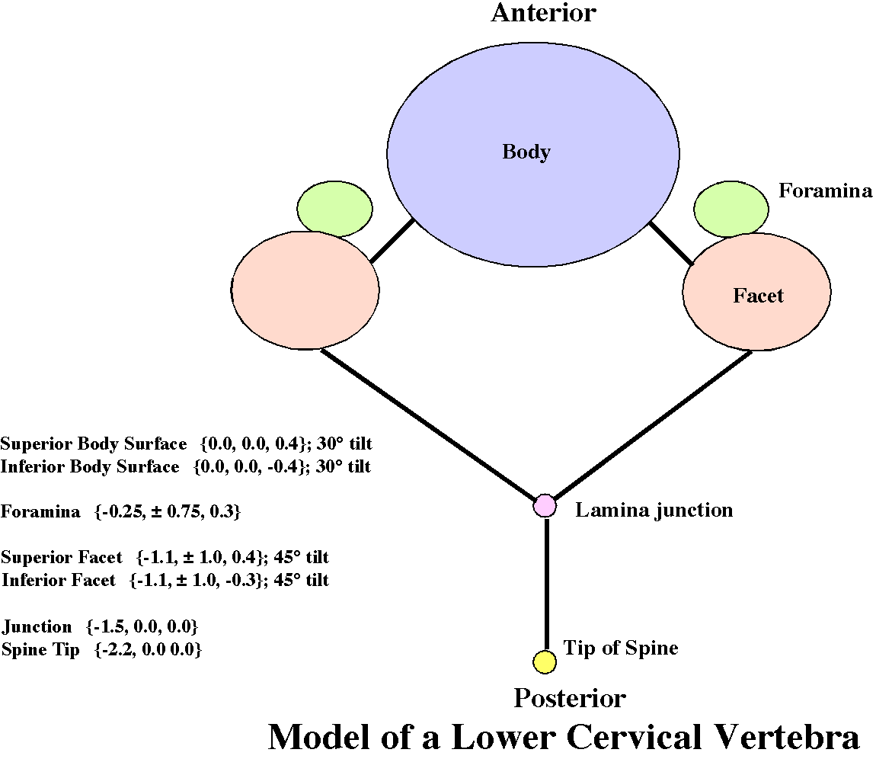

A Diagrammatic Summary of the Model Cervical Vertebra

Movements and Axes of Rotation
There are two basic types of movements that occur in the lower cervical spine. Both are guided by the conformation of the articular facets. These are flexion/extension, in which both facets glide in the same direction, and lateral rotation/side flexion, in which one facet moves superiorly while the other is moving inferiorly.
The examination of images from a number of sources, including x-rays and MRI images indicate that there is a substantial amount of anatomical variation from individual to individual. Many of the drawings in atlases are clearly at odds with the details of the x-rays and MRI’s. The radiographic images indicate that there is a modest anterior curvature to the anterior aspect of the cervical spine leading to the upper cervical vertebral bodies being nearly horizontal, while the lower cervical vertebrae are tilted down in the sagittal plane.

Lateral Rotation/Side Flexion
The values for the tilt of the vertebral bodies and the angles between the anterior axis of the vertebra and the axis of the lateral rotation/side rotation are collected in the following tables. All values are in degrees and positive values indicate angular excursion in a superior direction. The data was collected from several published illustrations. The sources used were a sagittal plane x-ray of the neck (figure 6.95) and a midsagittal MRI (figure 6.96C) in the thirty-eighth edition of Gray’s Anatomy (Williams, Bannister et al. 1995), a sagittal plane x-ray in the ninth edition of Grant’s Atlas of Anatomy (figure 4.13) (Agur 1991), drawing of the cervical spine, viewed laterally, in Netter’s Atlas of Human Anatomy, (Plate 13) (Netter 1989), and a diagram in Kapandji’s The Physiology of the Joints, Volume III, the Cervical Vertebral Column (figure 50) (Kapandji 1974). The x-rays were judged to be best evidence in that they illustrated real necks in neutral position. The drawing were most easily measured, because the joint planes were clearly indicated. Generally, the joint planes were clear in the x-rays, but there was more room for interpretation.
Measurements of Vertebral Body Tilt
 | Gray’s X-Ray | Grant’s X-Ray | Netter | Kanpandji | Gray’s MRI
Tilt C2 | 7 | 12 | 12 | 6 | 5
Tilt C3 | 0 | 0 | 0 | 0 | 0
Tilt C4 | -7 | -12 | -12 | -6 | -6
Tilt C5 | -9 | -15 | -15 | -14 | -12
Tilt C6 | 12 | -22 | -22 | -13 | -18
Tilt C7 | -23 | -23 | -23 | -14 | -25
Tilt T1 |  | -16 | -16 | -15 | -33
It was generally observed that the third cervical vertebra tended to be oriented nearly horizontally and the second and fourth vertebrae were tilted about equally up and down, respectively. The amount of the tilt was between 5° and 12°. The remaining cervical vertebrae are generally progressively more tilted, usually with the C7 vertebral body tilted about 25° anteriorly. The drawing in Kapandji appears to have an unusually flattened cervical curvature when compared to almost any other source of information. The MRI was the best source for defining the vertebral bodies and there was a progression of about 6° per vertebra. Consequently, a reasonably representative model for the cervical spine might start with the atlas tilted up about 6° and each successive vertebra tilted an additional 6° down.
Measurements of Sagittal Rotation Axis
 | Gray’s X-Ray | Grant’s X-Ray | Netter | Kanpandji
C2 | 55 | 31 | 20 | 55
C3 | 45 | 33 | 25 | 55
C4 | 48 | 43 | 23 | 55
C5 | 53 | 52 | 35 | 57
C6 | 56 | 46 | 52 | 45
C7 | 70 | 48 | 55 | 50
The planes of the facet joints were measured relative to the anterior axis of the vertebra or the horizontal plane. Again, Kapandji’s diagram is at a variance with the other data. The other sources indicate that there is a trend to have greater angles in successively lower vertebrae. The actual values are subject to substantial variation, which may reflect actual variation between individuals. It may be interesting to look at how the amount of inclination of the axis affects the overall movement and how it interacts with the tilt of the vertebra. It would appear that the angle between the axis of rotation and the posterior axis of the vertebra may be anywhere between 20° and 70°, but the usual values are in the middle third of the angle between the posterior axis and the vertical axis of the vertebra (30° to 60°). A good place to start might be 45° of elevation. That angle gives the greatest amount of concurrent spin and swing with a rotation. {see paper on the relationships between tilt of the orientation frame and the relative amounts of spin and swing} When it comes to differentiating the movements at different levels of the spine, the lower facet joints tend to be more steeply inclined relative to the horizontal plane of the vertebra. Using the data from the x-ray images, the average angle for the upper three facets is 42.5° and for the lower three facets is 54.2°, so setting them to 45° and 55°, respectively, would not be too far off.
Sideflexion and lateral rotation (roll and turn) are smaller in the lower cervical spine than flexion/extension (White and Panjabi 1990), but the oblique movement is a combined movement, so we would expect a combination of the ranges of sideflexion and lateral rotation to be the appropriate measurement of the amount of oblique movement. In addition, the measurements of roll and turn are only for one side, so one has to double the numbers to obtain the full range. Lateral flexion or sideflexion is greatest in the upper cervical spine and lateral rotation is maximal in the middle levels. In the joints to either side of C4 (C3/C4 and C4/C5) the lateral flexion is estimated to be slightly more than 10°. In the C2/C3 joint, it is about 10°. In the successively more caudal joints the range declines; C5/C6 ~ 8°, C6/C7 ~ 7°, and C7/T1 ~ 4°. Lateral rotation is about 7° in all the joints other than the first (C2/C3 ~3°) and the last (C7/T1 ~ 2°). Adding these ranges up, one obtains about 50° of side flexion and about 35° of lateral rotation. The great majority of the sideflexion and about half of the lateral rotation in the neck occurs in the lower cervical spine. Most of the lateral rotation for the entire neck, about 45° to either side, occurs in a single joint, the atlanto-axial joint. The first two cervical joints add only about 10° of additional sideflexion. They may allow as much and 25° of flexion or extension, or about 50° total.
It should be stressed that there is considerable variation in the reports of movements in the cervical spine. Part to this may be due to normal variation, part is due to the different methods used to measure it, and part is because it is very difficult to make these measurements. Another factor is that the measurements are being forced to fit a model of the neck that measures movement in three orthogonal cardinal directions. That is not how the neck moves. Because there is a complex interaction between the measured movements in the cardinal planes, it may become difficult to sort out what is actually occurring.
In this essay, the details of the movement amplitudes are not critically important. The emphasis is upon the general principles that govern the patterns of movements in the cervical spine. Still, it would be useful to have the magnitudes of the movements at least approximately correct.

Flexion/Extension
Flexion/extension is a gliding motion in which the inferior facet of the superior vertebra slides, superiorly and anteriorly to produce flexion, or inferiorly and posteriorly, to produce extension. In both of these movements both superior facets slide in the same direction. The movement is said to be partially restricted by the uncinate facets, which prevent lateral sliding, although it is potentially possible for the facet joints to glide obliquely. The axis of rotation for flexion and extension is a transverse line that lies through the body of the subjacent vertebra. The location at which the axis of rotation intersects the vertebral body apparently varies with the facet that is being examined. For the upper facets, the axis lies in the inferior and posterior part of the subjacent vertebral body, while for the lower vertebrae it lies superior and anterior (Kapandji 1974; Penning 1989; Panjabi, Dvorak et al. 1998). One can see this difference readily when playing with a set of cervical vertebrae. The sagittal movements between the upper vertebrae (inferior C2 through superior C5) are most naturally an anterior gliding movement, with a longer radius of rotation; those between the lower vertebrae (inferior C5 through superior T1) are more of a rocking motion, about an axis just below the superior surface of the subjacent vertebra. A further complication is that the locations of the transverse axes of rotation may vary throughout the sagittal rotation. Initially, we can start with an axis approximately through the center of the vertebral body and then explore the effects of moving it away from the center in various directions.
Flexion and extension are basically gliding movements at the facets. In flexion, both facets of the superior vertebra slide superiorly and anteriorly upon the facets of the inferior vertebra. In extension, the relative movements are reversed. If there were no intervertebral discs, then the movements would cause the vertebrae to move further apart and to shift anteriorly during flexion, like an extensible ladder being opened to reach a roof. However, the disc is stretched by the gliding motion in flexion and it tethers the superior vertebra to the inferior vertebra, forcing the superior vertebra to rock forward upon the disc if the elements of the articular pillar are going to rise to their maximal extent. This rocking motion will compress the anterior portion of the disc and stretch the posterior portion. Therefore, flexion is limited by the tensile strain in the posterior disc and compression of the anterior disc.
In extension, the movement tends to bring the two vertebrae closer together, but to shift the superior vertebra posteriorly over the inferior vertebra. In this movement the tethering of the disc will act to prevent the posterior shift, but since the approximation of the vertebrae reduces the distance between the vertebrae it allows more posterior displacement before the fibrous part of the disc is maximally stretched. Because of the nucleus pulposus, the anterior disc fibers are stretched as the superior vertebra rocks posteriorly over the nucleus. In extension, the movement may be limited by the tensile strain in the anterior portion of the disc, by abutment of the superior facet upon the inferior facet, or by the inferior aspect root of the superior vertebra’s pedicle and transverse process abutting upon the superior aspect of the inferior vertebra’s superior facet. The importance of the disc in restricting movement may be seen in individuals that have had injuries that rupture the disc. The movement is what would be expected if there were no tethering (Nordin and Frankel 1989), p. 218.
In the middle levels of the lower cervical spine, especially at the level of C5, the total excursion in flexion/extension is about 20° in each intervertebral space (C4/C5 and C5/C6). In the adjacent spaces (C3/C4 and C6/C7) the total range is about 15°. In the last two intervertebral spaces (C2/C3 and C7/T1) the range is estimated to be about 10°. Adding all these together, one obtains a total excursion of about 90° of flexion/extension. The great majority of flexion/extension in the neck occurs in the lower cervical spine. Kapandji (Kapandji 1974) estimates a range of 100° of flexion/extension in the lower cervical spine, based upon x-rays. The overall ranges of flexion and extension in the lower cervical spine indicate that there is about half again as much extension as there is flexion (40% flexion, 60% extension) (Kapandji 1974). The individual joint ranges cited are comparable to those given by White, Panjabi, and others (White and Panjabi 1990; Panjabi, Dvorak et al. 1998). The high mobility in mid-cervical joints is reflected in the amount of degenerative change observed. It is highest for C5 and declines as one proceeds both rostrally and caudally (Milne 1991).

Quantitative Morphology and Kinematics of the Cervical Spine
Up to this point, the emphasis has been upon presenting the basic anatomy of the cervical spine and reviewing the published numbers for ranges of movement in the various joints. However, if we are to understand the movements of the neck, it will be necessary to synthesize this information into a consistent model that incorporates the known facts and allows one to ask quantitative questions and obtain quantitative answers. Often the quantitative answer is an image, rather than a set of numbers, because it is easier to understand images and images are closer to a mathematics of the anatomical structures than single numbers, or even arrays of numbers, would be. However, one requires very quantitative answers for the computer to draw an image that reflects reality.
Starting in the next section, a model of the cervical spine will be introduced that is based upon the descriptions given above. Initially, it will use identical units that have the average attributes of the cervical vertebrae. Subsequently, it will be possible to introduce the local variations that are typical of actual spines and examine the consequences of varying the locations and axes of rotation of joints. Often equally informative, it is possible to create spines that could never exist, but have attributes that illustrate the rationale for the actual anatomy or highlight aspects of the biomechanics that one might not appreciate otherwise.

Quantitative Morphology and Kinematics of the Cervical Spine
In the last section the basic anatomy of the cervical spine was reviewed with the intent of determining the principal features of that portion of the spine and the types of movements that occur between the vertebrae. An attempt was made to obtain representative measurements of the principle features and the principal movements. It was noted that, with the exception of the atlas and axis, the cervical vertebrae were similar in size and shape; so one could start with a standard unit, replicated six times and stacked in a consistent manner to obtain a reasonable first approximation to a model of the lower cervical spine. It was also noted that there are differences between the three most rostral elements of the chain and the three most caudal elements. These differences can be incorporated in the model to obtain a more detailed match between the model and actual cervical spines.
In this section, a model of the cervical spine will be introduced that is based upon these descriptions. Initially, the cervical vertebrae are identical units that have the average attributes of the cervical vertebrae. Subsequently, the local variations that are typical of actual spines are introduced and the consequences of varying the locations and axes of rotation of joints are examined. Clearly, the model is not a true representation of the actual cervical spine, but then there is a great deal of variation between individual spines and, at this point, the emphasis is being placed on determining the general attributes of movements in the lower cervical spine.

A Model of the Lower Cervical Spine
Initially, this discussion will be primarily concerned with developing the framework of a biomechanical model that will allow easy modification, as the need arises, and which will allow us to study the major attributes of the biomechanics of the region. Therefore, the model will start with six vertebral units that are anatomically similar. Their main difference will be their location and orientation in space. Later, the angle that the axis of rotation for sideflexion/lateral rotation makes with respect to the orientation of the vertebra will be varied and the locations of the axes of rotation for sagittal rotation will be moved.
This model was constructed in Mathematica as an interactive text and program that allows one to follow the construction of the model and the use of the model to examine a number of questions relating to the kinematics of the cervical spine. Portions of the text and program functions are included here to illustrate the elements of the model. To fully understand the model it is necessary to actually play with the program.

Calculation of the model
Introduction: The Basic Assumptions
The lower cervical spine is a chain of seven concatenated bones, C2 through T1. For C2, it is only the inferior part of the bone that is typical of the lower cervical spine. The superior aspect has a very atypical structure and it is part of the upper cervical assembly, which also includes the atlas and the base of the occiput as elements. The first thoracic vertebra is not a cervical vertebra and it has a number of structural differences from the cervical spine, not the least of them being that it has an attached rib. However, it is included in the following analysis as a foundation for the cervical spine. C7 and T1 are larger than typical lower cervical vertebrae and the transverse foraminae of C7 are also substantially more posteriorly placed than those in the other cervical vertebrae. There are many other more subtle differences between the cervical vertebrae that allow one to differentiate them, but for the purposes of the model it will be assumed that the bones are all alike in their general structure, unless specified otherwise. However, the mathematical structure has been built into the model to give each vertebra and each joint different attributes, if desired.
The purpose of the model, at this point, is to examine the consequences of the types of movements that occur in the cervical spine, when applied repeatedly in a chain of bones. Consequently, a simpler format works well. One is less apt to become consumed by the minutia of the cervical anatomy, before there is a context in which to evaluate them.
A cervical vertebra is composed of a body, a neural arch with a spine, and a lateral process that contains the transverse foraminae. The vertebral body is an ovoid column with the relative proportions 1.0:1.4: 0.7 for the anterior/posterior (r), medial/lateral (s), and superior/inferior (t) axes, respectively. The vertebral bodies are separated by intervertebral discs that are about 0.3 to the vertebral bodies 0.7 of vertical height. Consequently a vertebral unit, which may include a vertebra and a disc or a vertebra and two half discs, is about 1 unit tall.
The articular pillar has superior and inferior facets that are anteriorly tilted about 45° to the coronal and horizontal planes of the vertebra. All intervertebral movements occur approximately in that plane. When the superior facets side superiorly on the inferior facets, the tethering by the intervertebral disc causes the superior vertebral body to flex forward upon the inferior vertebral body. Conversely, when both superior facets slide inferiorly upon the inferior facets, the superior vertebra extends posteriorly relative to the inferior vertebra. These are not large movements. It would appear that they are about 5° to 10° in each direction. The range of motion for flexion tends to be greater than that for extension. The middle joints, above and below C5, have largest range (~20°), the adjacent joints are intermediate (~15°), and the most superior and inferior joints have the least range (~10°).

Sagittal Movements
The restriction to sagittal movement is going to be least for movements that shear through the intervertebral discs. Therefore, the center of rotation should lie upon a line perpendicular to the plane of the facets and on a line that passes perpendicular to the horizontal plane of the disc. Since the model assumes that the plane of the facets lies at a 45° angle to the coronal plane, which contains the perpendicular to the disc, and measurements of several vertebrae place the centers of the facet joints about 0.7 units posterior to the center of the vertebral body and about level with center of the disc. These arguments indicate that the center of rotation should lie about 0.7 units inferior to the center of the disc or 1.2 units inferior to the center of the vertebral body. The axis of rotation is a sagittal axis though that point. In actual anatomical specimens the center of rotation will be variable, even during the course of the movements, but this calculation gives us a starting point for a reasonable location for the center of rotation for sagittal movements.
Measurements from x-rays of necks that have been moved through the sagittal range of motion indicate that this analysis applies to the upper cervical vertebrae, where the center of rotation is 1.0 to 1.5 units below and 0.2 to 0.5 units posterior to the center of the moving vertebra. The lower vertebrae act more as if the superior vertebra were rocking on the nucleus pulposus and the center of rotation lies though the superior part of the subjacent vertebral body, closer to 0.6 - 0.7 units below the center of the moving vertebra (White and Panjabi 1990), Figure 4-9.
This variation in the location of the axis of rotation is in the direction that one would expect, because the inferior vertebrae have facet joints that are more vertically oriented relative to a horizontal plane through the vertebral body. The perpendicular to the plane of the facet joints will intersect a perpendicular to the horizontal plane closer to the superior vertebra. Also, if the facet joint is placed more superior to the intervertebral disc then the intersection will lie more superior. The examination of multiple x-ray images and spinal skeletons would seem to indicate that the facet joint is more superiorly placed in the lowest cervical joints. This is a point that should be explored in detailed studies of many cervical x-rays.

Oblique Movements
The other type of movement between cervical vertebrae is a rotatory movement in which one superior facet glides superiorly while the other glides inferiorly upon the inferior facets. This means that the axis of rotation is perpendicular to the plane of the facet joints. Once again, the movement is restricted by the tethering of the intervertebral discs. To make the movement as large as possible the axis of rotation must pass through the center of the intervertebral disc. Consequently, the axis of rotation lies approximately at a 45° angle to the coronal plane, extending from anterior and inferior to posterior and superior, and the center of rotation is the center of the intervertebral disc. There are some indications that the lateral and posterior parts of the cervical discs are normally fissured in adult spinal columns. This allows the vertebrae to rotate more freely upon each other, especially when the axis of rotation is oblique to the disc. If this is so, then one might expect the center of rotation in the disc to be shifted anteriorly, where there is apt to be the greatest amount of tethering. This is apt to be a small difference from the center of the disc, so one would not expect a striking difference between the movements with the axis through the center of the disc and movements with it about 0.1 to 0.2 units more anteriorly. The greater implication of the fissuring is that the oblique movements are apt to have greater excursions than one might anticipate if the disc were intact.

The Basic Model
These observations lead to a reasonably simple model for movement in the lower cervical spine. One starts with a set of identical vertebrae with bodies about a unit thick, 1.4 units wide, and 0.8 units tall. They are separated by discs that are about 0.4 units tall. They can rotate about two axes; a sagittal axis and an oblique axis. The sagittal axis passes through a center of rotation about 1.2 units inferior to the center of the vertebral body and the oblique axis passes through the center of the disc at a 45° angle in the sagittal plane.
By making the vertebrae identical other than their location and orientation, it is possible to concentrate upon the implications of their structure and how their basic movements interact to create more complex movements in all three dimensions. In particular, the oblique movements produce a compound movement that occurs in all three cardinal planes.

Graphic Functions Used in the Program:
To illustrate the configuration of the cervical spine it is convenient to have a simplified image of the vertebra that can act as a stand-in in the images. The program defines functions for a simple torus that can be used to represent the vertebral body and a disc that can be used to represent the facets. The shape of the torus may be changed, if need be, but it has been set at the relative dimensions of the cervical vertebral body. The disc is a very flat ellipsoid. RotateBody is the interface that allows one to call the function to create a torus in the appropriate location and orientation. It uses a rotation quaternion that has been previously defined and stored in the variable rotationQuaternion. The function moveVertebra performs the same operation for the combined vertebral body and four facets.

Initialization of the Framed Vectors

Initialization of the Joint Excursions

jointAngles: An Array of Joint Excursions
Atlas | jointAngles[[1]]={1, 0, 0};
Axis/C2 | jointAngles[[2]]={2, 5, 10};
C3 | jointAngles[[3]]={3, 7.5,10};
C4 | jointAngles[[4]]={4, 10, 10};
C5 | jointAngles[[5]]={5, 10, 10};
C6 | jointAngles[[6]]={6, 7.5, 10};
C7 | jointAngles[[7]]={7, 5, 10};
T1 | jointAngles[[8]]={8, 0, 0};
The rotation in each of the joints of the lower cervical spine are tabulated in the above table of jointAngles[[ ]]. The format is: first, the vertebra number; second, the angular excursion of the sagittal movement; third, the angular excursion of the oblique rotation. In the illustrated example, there is 10° of oblique rotation at each level of the lower cervical spine. There is 10° sagittal rotation the superior and inferior facet joints of C5, 7.5° of flexion in the next joints in both directions and 5° of flexion in the most superior and inferior joints. Normally, this array is the principal element of the model that is changed between calculations.
There are entries for the first cervical vertebra (1), but it is not used in the calculations. The entries for the first thoracic vertebra (8) are similarly ignored. These values may enter into other calculations. For instance, the flexion/ extension parameter for C1 may refer to the movement that occurs about a transverse axis through the middle third of the odontoid process, and the sideflexion/lateral rotation may be used for the lateral rotation about a vertical axis through the odontoid process. the values for T1 may be used to tilt the entire neck, by tilting the entire body.

Initialization of the Vertebral Elements

center of cervical spine
c3Frame0[[1]] = Quaternion[0.0, 0.0, 0.0, 0.0];
center of sagittal rotation:1.2 vertebral bodies below center of body
c3Frame0[[2]] = Quaternion[0.0, 0.0, 0.0, -1.2];
axis of rotation for sagittal rotation
c3Frame0[[3]] = Quaternion[0.0, 0.0, 1.0, 0.0];
center of sideflexion/lateral rotation: center of subjacent disk
c3Frame0[[4]] = Quaternion[0.0, 0.0, 0.0, -0.50];
axis of rotation for sideflexion/lateral rotation
c3Frame0[[5]] = Quaternion[0.0, - Cos[π/4], 0.0, Sin[π/4]];
frame of reference
c3Frame0[[6]] = Quaternion[0.0, 1.0, 0.0, 0.0];
c3Frame0[[7]] = Quaternion[0.0, 0.0, 1.0, 0.0];
c3Frame0[[8]] = Quaternion[0.0, 0.0, 0.0, 1.0];
The framed vectors for the lower six cervical vertebrae and first thoracic vertebra are defined and initialized with zero's. The standard vertebra is defined for C3, c3Frame0. All the other vertebrae are the third cervical vertebra rotated and translated in space. At first, the third cervical vertebra is taken as the reference, because it is horizontal in neutral position. Later, the reference is the first thoracic vertebra, because it is taken as the foundation of the neck and it does not move in the calculations. It could be moved, if desired, because the mathematical structure is included to do so.
Each framed vector is an ordered set of eight quaternions. The quaternions are all actually vectors, but it makes it easier to perform the calculations if we use the more general form of the vector, a quaternion vector, with a null scalar component

The Neutral Position and Orientation of the Archetype Element
The center for the archetype is taken to be a hypothetical point at the middle of the vertebral body. The anterior/posterior width of the vertebral body is 1.0 units. The width of the body is about 1.2 units. The height of the body is about 0.8 units
The center of the vertebra, [[ 1 ]], is taken to lie at {0, 0, 0}.
The center of sagittal rotation, [[ 2 ]], is taken to be at the intersection of the line perpendicular to the inferior facet and a line perpendicular to the inferior surface of the vertebra. The inclination of the inferior facet is being taken to be at 45° to the horizontal plane, running inferior and anterior. The facet joint is taken to lie 0.7 units posterior in a horizontal plane through the center of the disk, or about 0.5 units below the center of the vertebra. The intersection of the two lines would be about 1.2 units inferior to the center of the vertebra (0.5 from vertebral center to center of disc and 0.7 from center of disc to intersection point). The rotation axis, [[ 3 ]], is sagittal, therefore it is a unit vector in the direction of the lateral component of the frame of reference.
The center of rotation for the sideflexion/lateral rotation, [[ 4 ]], passes through the center of the disk that is inferior to the moving vertebra, 0.5 units inferior to the center of the vertebra. It is perpendicular to the plane of the inferior facet of the vertebra. The angle of the rotation axis is at a 45° angle to the horizontal plane, [[ 5 ]], a unit vector in the mid-sagittal plane of the vertebra.
The neutral orientation, [[ 6, 7, 8 ]], is aligned with the standard universal coordinates.
In a right-handed system, positive sagittal rotation will be flexion and positive sideflexion/lateral rotation will carry the anterior face of the body to the left, posteriorly, and inferiorly.
Once created in the framed vector for the third cervical vertebra, the archetype is transferred to a general framed vector that can be used as a reference for all of the calculations, cFrame. If one wishes to change the archetype, this is where it is done. When it becomes desirable to make the different vertebrae behave differently, because of different anatomy, it would be at this point that the changes are made, prior to the rotation and translocation of the vertebra.

Calculating the Positions and Orientations of the Cervical Vertebrae
The next step is to calculate the positions and orientations of the remaining vertebrae. In doing so, it is assumed that the C2 vertebra is tilted an 6° up from the C3 vertebra, C4 is tilted 6° down and each successive vertebra is tilted an additional 6° down. This means that there will be a total of 36° difference between the horizontal plane of C2 and the horizontal plane of T1. T1 will be anteriorly tilted about 30° relative to horizontal. Normally, this will be a fixed position and orientation, since the T1 vertebra is not moved in the calculations. Since we keep the same facet angles, at least initially, there will be a 30° difference in the axes for sideflexion/lateral rotation for C2 versus C7.
The calculation of the individual vertebrae involves rotating the archetypal vertebra though the appropriate sagittal angle, using a rotation quaternion with an angle that is the appropriate multiple of 6° and a vector that lies along the transverse axis through the center of the vertebra, and then translating it to the appropriate location. There are linkages at junction points. Junction points are located 0.5 units superior and inferior to the center of the vertebra, in the center of the intervening disc. Two adjacent vertebrae meet in a junction point. The superior junction point of the inferior vertebra is the inferior junction point of the superior vertebra.

Switching the Point of Reference to the Center of the T1 Vertebral Body
At this point, the positions and orientations of cervical vertebrae C2 to T1 have been entered, assuming a common structure. The values obtained are in reasonable agreement with MRI and x-ray images. The T1 vertebra is assumed to be fixed for the purposes of the model, therefore it is convenient to express the other vertebral positions in terms of its location. There are three vectors in each framed vector that depend upon absolute location, the first, second and fourth. Therefore, for each framed vector the value in t1Frame0[[1]] is subtracted from the current values in vectors [[ 1 ]], [[ 2 ]] and [[ 4 ]].

Calculate the location and configuration of the vertebrae.
At this point, the arrangement of the cervical vertebrae has been computed, for all the joints in neutral position. The next program segment computes the consequences of the rotation of C2 upon the location and orientation of C2, then the consequences of the rotations of C3 upon C2 and C3 and then the consequences of the rotations of C4 upon C2, C3, and C4, and so on until C7. It is the heart of the model in that it takes the basic anatomical structure and applies the rotations tabulated in the jointAngles array to each vertebra, to obtain the final configuration of the lower cervical spine.

Completion of the Calculation of the Arrangement of the Neck Vertebrae
At this point, the calculation of the arrangement of the vertebrae in the lower cervical spine has been completed. Unfortunately, it is expressed as a set of framed vectors, which are generally difficult to visualize as such. To help with the visualization there are two program segments that convert the framed vectors into images that are more user friendly. The first plots a set of tori that approximate the dimensions of the vertebral bodies at separations that approximate the discs. The second plots the vertebral body images as in the first program segment, but also plots the facet joints as a set of four flattened ellipsoidal discs.

Plot the Vertebrae.
The final segment of the core program computes the rotation quaternion for each vertebra and then feeds that transform to the rotateBody or moveVertebra function, which computes the image of the vertebra. After all the images are computed, they are displayed in a common framework to give an image of the cervical spine. An example of such an image is shown below. To help with the perception of orientation, slits have been cut in the anterior midline and the horizontal meridian.
This is the basic program to compute the configuration of the cervical spine, subject to specific amounts of rotation in each joint. Naturally, once it is possible to do that , one is in a position to analyze the effects of such rotations upon the overall configuration of the cervical spine and upon the location and orientation of the individual vertebrae. These considerations are developed in other essays.
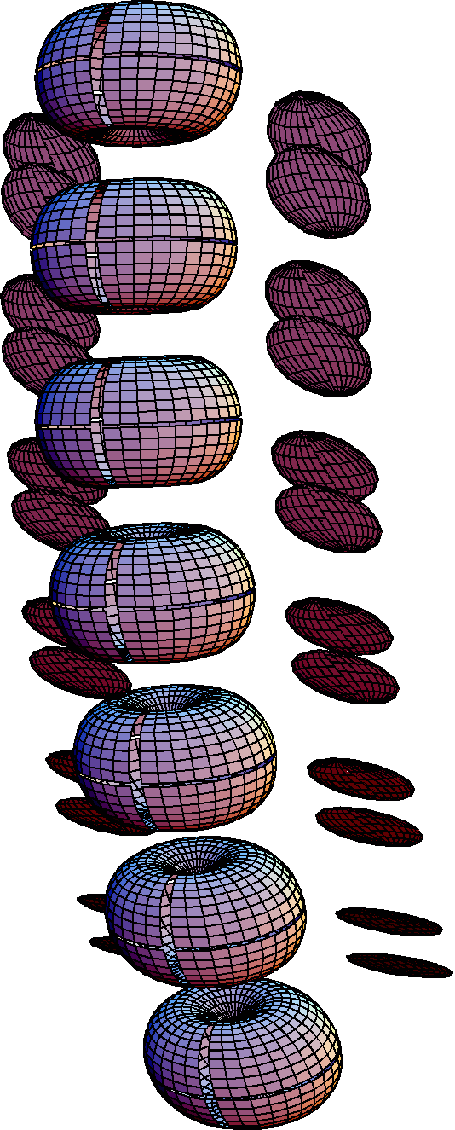

An example of a plot of the cervical spinal cord in neutral position. The vertebral bodies are drawn as fat tori with the appropriate shape and dimensions and the facet joints are represented by flat discs.

Bibliography
Agur, A. M. R. (1991). Grant's Atlas of Anatomy. Baltimore, MD, Williams & Wilkins.
Kapandji, I. A. (1974). The Physiology of the Joints. Annotated diagrams of the mechanics of the human joints. New York, Churchill Livingstone.
Milne, N. (1991). "The role of zagapophyseal joint orientation and uncinate processes in controlling motion in the cervical spine." J. Anat. 178: 189.
Netter, F. H. (1989). Atlas of Human Anatomy. Summit, NJ, CIBA-Geigy Corporation.
Nordin, M. and V. H. Frankel (1989). Basic Biomechanics of the Musculoskeletal System. Philadelphia, Lea & Febiger.
Panjabi, M. M., J. Dvorak, et al. (1998). Cervical Spine Kinematics and Clinical Instability. The Cervical Spine. T. C. S. R. S. E. Committee. Philadelpia, Lippincott - Raven: 53 - 78.
Penning, L. (1989). Functional Anatomy of Joints and Discs. The Cervical Spine. T. C. S. R. S. E. Committee. Philadelphia, J.B. Lippincott: 33 - 56.
White, A. A. and M. M. Panjabi (1990). Clinical Biomechanics of the Spine. Philadelphia, J.B. Lippincott.
Williams, P. L., L. H. Bannister, et al. (1995). Gray's Anatomy. The Anatomical Basis of Medicine and Surgery. New York, Churchill Livingstone.

