Movements in Artificial Necks

Thomas Langer

Introduction
Given an anatomical description of the shapes and spatial inter-relationships between the bones of the neck, it is comparatively easy to express these features as a set of symbolic expressions that can be manipulated to determine how the neck moves. If quantitative values are plugged into the variables in the expressions, then quantitative descriptions of the movements can be obtained. The morphological and kinematic constraints in the human neck have been considered elsewhere (Langer #1) and the construction of a model has been described in some detail (Langer #2). In this paper we will examine the implications of these observations and the resulting model.
The necks that will be considered here are artificial in that they are logical constructs that encapsulate the main anatomical features of the human cervical spine. They are simplified in various ways to simplify the analysis. The main simplification used in the artificial necks is that all the vertebrae are similar. This simplification is close to the actual situation in human necks (Langer, ). When the range of motion and the axis of rotation differs in each joint, it is very difficult to sort out what attributes of the joints are responsible for the different features of the movements. By using similar vertebrae throughout, it is possible to examine the effects of concatenating multiple joints that operate on the same principles. In artificial necks, we can isolate the relationships and study their attributes by systematically varying the anatomical parameters.
The model used here can incorporate most of the variation in an actual neck, but considering all of that variation at once makes the results too complex to comprehend and most of it is irrelevant to the general features of the neck’s movements. Therefore, it has been eliminated for now. On the other hand, with the model it is possible to consider necks that do not occur, such as straight necks and necks that are kyphotic, rather than lordotic. Although such necks do not occur in humans, analysis of their features often gives insight into why actual necks are formed as they are and why they move as they do.

Comparing Necks
Often, calculations lead to two or more versions of a neck, usually before and after a movement. How can we compare the versions of the neck? There are multiple ways. One can generate three-dimensional images of the neck. Such images are routinely constructed by the model used here and these images are often used as illustrations. Such images allow us to use our considerable visual processing skills to assess the changes, which provides a fast, powerful, deeply intuitive comparison. However, one often needs to obtain quantitative assessments. Such assessments allow one to sort out the components of the change and show how each contributes to the overall movement. It is difficult to obtain this type of information just by visual inspection.
Once one starts trying to make quantitative comparisons, it rapidly becomes apparent that such comparisons are difficult to make. What you see often depends upon your viewpoint. For instance, if we consider the movements of the lower cervical spine relative to the first thoracic vertebra the descriptions of the movements are often quite different from those for the same movements viewed by an individual watching the neck move. For instance, a movement that is entirely lateral rotation with respect to T1 will appear to be a mixture of lateral rotation, sideflexion, and flexion when observed by an outside examiner (see Results). Both are equally valid interpretations and either may be cited, depending upon the points being addressed.
While we have to accept that context determines our interpretation of movement, we can try to remove context as much as possible and express the fundamental attributes of the movement in a manner that is independent of the context. However, there is a price to be paid in doing so. The contextual descriptions are highly intuitive; when we remove the context, the concepts and descriptions become much less intuitive. This is like the theory of general relativity, which is expressed in differential geometry and tensor analysis. These tools greatly increase the power of the analysis by making it free of any particular coordinate system, but they are concepts that require considerable study and practice to understand.
In the following, we will start with images, then consider contextual analysis, and finally move to a more abstract level of analysis that allows us to make more exact and detailed comparisons, independent of any particular coordinate system.

Materials and Methods
The construction of the model that is used here, for the calculation of movements in the lower cervical spine, is considered elsewhere. The anatomy of the neck is described and measurements of various features of the cervical vertebrae are tabulated (Langer #1), then the logical statements derived from the anatomy are formulated and combined into a program in Mathematica (Langer #2). A version of the program has also been described.
In this paper, that program is used to compute the configuration of the neck and the changes it undergoes with particular sets of individual joint movements. These configurations are usually presented as three-dimensional images that use symbolic forms for representing the parts of the vertebrae. A fat torus is used to represent the vertebral body. The dimensions of the torus are approximately the same as an average lower cervical vertebral body. These tori have been separated by the thickness of an intervertebral disc. The zygapophyseal facets are represented as flat circular ellipsoids that are appropriately centered and tilted to lie in the planes of the bony surfaces of the facet joints. The program computes the three-dimensional configuration of the lower cervical spine and presents a two-dimensional image of the spine from a particular viewpoint. The perspective correction in the illustrations make it easier to perceive the conformation of the neck, but make measurements from the figures inconsistent.

Computing Ratios Relative to Standard Orientations
In understanding the movements of the neck, one of the problems is that each movement is a concatenation of several movements. What happens at C2 is a consequence of movements between C2 and C3, but also of movements between C3 and C4 and between C4 and C5, and so on. Often we are concerned only with what is happening to C2 and we can lump all the movements together. We can reduce the comparison to a set of statements about each vertebra in isolation. It turns out that there are different ways that one can do this. We will consider a couple of these.
These measurements are the ratios of the individual vertebral orientations to a standard orientation, which is the usual way of defining an orientation. In normal anatomical description we speak of a bone being internally rotated or anteriorly tilted and assume that the reader knows the standard to which we are comparing the current orientation. In standard referenced ratios there is always an explicit standard orientation.
First, one can compute the orientation of the vertebra with respect to the first thoracic vertebra. The first thoracic vertebra is taken as the foundation of the neck and thus is a reference point for the movements of the cervical vertebrae. Having computed the configuration of the neck, one can ask how the T1 vertebra would have to be moved to align it with each of the cervical vertebrae. For instance, in neutral position, the C4 vertebra may be extended about 24° relative to T1. After a movement it may also be laterally rotated and sideflexed. The calculation of the relative orientation is straightforward. One takes the ratio of the vertebra’s frame of reference to the frame of reference of T1. The ratio is a quaternion, but the results can be expressed as a set of standard rotations. The total rotation is the angle of the quaternion, the angle through which the T1 vertebra must move to come into alignment with the vertebra being considered. Rather than write the vector of the quaternion, that is, the axis about which the rotation occurs, the movement can be expressed as roll, salaam, and turn. These are canonical rotations in which the total rotation is fractionated into three projections upon the coronal, sagittal, and horizontal planes. Roll is projected on a coronal plane, salaam is projected upon a sagittal plane, and turn upon a horizontal plane.
The same type of calculation can be done using the universal frame of reference for the body as the standard orientation. The universal coordinates are the usual cardinal directions, with the axes being the perpendiculars to the coronal, sagittal, and horizontal planes of the body. This will be our usual context for visualizing and describing the orientation of an anatomical structure, unless some other standard is specified.
While the C4 vertebra is extended relative to T1, T1 is normally flexed forward about 30° relative to the coronal plane of the body. So, in the frame of reference of the body, C4 is flexed forward about 6° when the neck is in neutral position. Consequently, the C4 vertebra is extended in one frame of reference and flexed in another. This is comparatively easy to see, because both interpretations leave the vertebra in the same plane, however, in other positions the vertebra may just be laterally rotated relative to T1, but it is sideflexed and laterally rotated relative to the universal coordinates (see below). We will generally find that while a vertebra is both sideflexed and laterally rotated in both frames of reference, it is not rotated to the same degree or proportionately in each. Because the cervical spine is lordotic, the same rotation in different joints may appear to produce proportionately more lateral rotation or sideflexion at some levels than it does at other levels.

Roll, Salaam, and Turn
The usual convention in these essays is to call the three axes of the orientation frame r, s, and t, much as one might use x, y, and z for the universal coordinate system. To make it easier to remember which movement is associated with each axis the movements are named to reflect the consequence of rotation about the axis. Rotation about the r axis, which is generally the axis that extends anteriorly, is called roll. It is comparable to sideflexion in anatomical terms. Rotation about the s axis, which is generally the transverse axis, is movement in the sagittal plane. Such movements might be called sagittal movements or flexion/extension, but there is not a commonly used, simple, generic, term that means movement into either flexion or extension, like sideflexion, which can be to the right or the left. To fill that gap, I have adopted the word salaam for moving in the sagittal plane. While to make a salaam is traditionally to bend forward, it might also include the return. In any case, it starts with the letter ‘s’ and it is in the correct direction. Finally, to rotate about the t axis is usually to rotate about a vertical axis or to turn from side to side, therefore it has been called turn. Turn corresponds to the anatomical term rotation, or more definitively lateral rotation, since all these movement are rotations. In summation, the rotations about the r, s, and t axes are roll, salaam, and turn, respectively.
It is worth pausing to specify the meaning of the measurements of roll, salaam, and turn. All three are embedded in the rotation quaternion that transforms the orientation of a standard frame of reference, such as the T1 vertebra into the orientation of one of the lower cervical vertebrae. The total rotation is the arc cosine of the scalar term of the rotation quaternion and the roll, salaam, and turn are the magnitudes of the i, j, and k components of the unit vector of the quaternion times the total rotation excursion, respectively. They are, in effect, the projection of the movement upon three orthogonal planes: the coronal, sagittal, and horizontal planes of the universal coordinate system.

The Calculation of Ratios of Neck Configurations
The last way of comparing necks does not assume that there is a fixed standard, although we have to assume a particular basis coordinate system if we are going to express the results in vector components. The difference from the standard referenced ratios is that each vertebra is compared to its state prior to the transformation. The axes and centers of rotation are computed for every vertebra, comparing its configuration after the movement to its configuration prior to the movement.
It should be noted that we use movement as a metaphor for a transformation. There need not actually be movement between the two configurations and, if there is, it need not follow the computed trajectory. We may compare a neck in neutral position with one that is in endrange flexion without it actually going through the movement and if it does pass between the two configurations it may well have passed through a sideflexed configuration on the way. This method of comparison is relatively context free, which is its prime advantage, but it is less intuitive, which is a disadvantage.
Computing the axis of rotation is comparatively simple in that we divide a frame of reference after a movement (f₁) by the frame before the movement (f₀). This is actually what is done in the other two methods, except the reference frame, f₀, is a standard frame of reference like the orientation of T1 or the universal frame of reference. Here the reference frame is the orientation of each vertebra prior to the movement. The axis of rotation is the vector of the quaternion, $Q_{\text{Rot}}$, that is the ratio of the frames of reference.
Finding the center of rotation is a more difficult proposition. We know that it lies in the plane perpendicular to the axis of rotation that contains the location of the vertebra prior to the movement. We can compute the new location assuming that the rotation is the one that transforms the frame of reference prior to movement into the frame after movement. Therefore, we have to find a point in that plane that is equidistant from both points, such that a circular arc about that point will pass through both locations. Therefore, it must lie on a line that passes midway between the two locations. We also know the angle that the vertebra moves through as it passes between its two terminal locations, because it is the angle of the rotation quaternion, $α$, that was obtained as the ratio of the two frames of reference. So we determine the midpoint between the two locations and proceed along it until we find a point, $p_{C}$, that is the apex of an isosceles triangle that has the locations at either end of its base and the angle of the rotation quaternion as its apical angle.

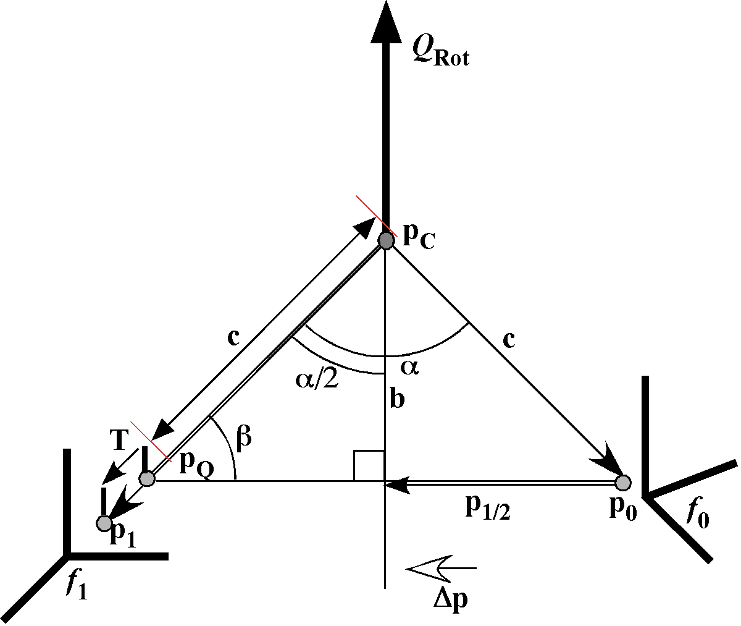
Diagram of Calculation of Center of Rotation. The center of rotation and axis of rotation are computed from the initial and final frames of reference (f₀ and f₁) and the initial and final locations (p₀ and p₁) of the vertebra.
This analysis assumes that the transformation is entirely due to a single circular arc about a fixed center of rotation. In fact, when we are concatenating several rotations, the overall movement is not necessarily a simple circular arc, even though all the components are simple rotations. It may be more convenient to express the movements as a combination of a rotation and a translation, which will be called a compound movement.
It is possible that there is no rotation about the computed axis of rotation that that will carry the initial location, prior to the movement, into the final location, after the movement. In such cases, there must be a translation parallel to the axis of rotation, called the axial translation, that projects the final location into the plane of the initial location.
If we project the final location into the plane of rotation that contains the initial location, then it is always possible to express the transformation as a single circular rotation about a center of rotation in the plane. However, it may be known that the center of rotation lies in a particular plane that intersects the plane of rotation, such as the midsagittal plane. In that case, the center of rotation must lie on the line of intersection for the two planes. It is fairly simple to rotate the center of rotation for the rotation-only solution into the line of intersection, but it means that there has to be a translation that occurs in the plane of rotation, called the planar translation. The total translation is the vector sum of the axial and planar translations.
Consequently any movement may be expressed as a combination of a rotation and a translation. The full analysis that leads to such a solution is far from simple, therefore it is fully treated in a separate essay (Langer, ). Comparison of neck configurations in terms of combined movements is deferred to another paper (Langer, ). In this paper we will consider the first two methods of comparison, movements in reference to T1 and movments in reference tot he universal body coordinates.

Results

Interactions Between Neutral Configurations and Oblique Rotations
There are a number of questions that arise once one has a model that computes movements of the neck. These include the effects of concatenating the oblique movements. If we look at the movements between successive vertebrae, then it is evident that the flexion/extension or salaam movements are simply additive, when considering the orientation of the vertebra. On the other hand, the oblique movements combine in complex ways with each other and with salaam.

General Observations
There are a number of observations that are readily made from trying a few movement combinations. They are stated here and illustrated in the following analysis.
1.) First, the total amount of rotation, the angle of the rotation quaternion, adds linearly; the component rotations (roll, salaam, and turn) do not.
2.) Salaam is much less affected by the oblique movements than roll or turn. Although the axis of rotation is at a 45° angle to the horizontal plane, therefore midway between the axes for roll and turn, it produces substantially more turn than roll.
3.) The relative amounts of roll and turn depend upon the amount of flexion or extension in the neck.
4.) The measured amount of roll, salaam, and turn depend upon the frame of reference, therefore they are not fundamental attributes of the movement. However, they are the way in which one tends to see the movement.
First, we will briefly consider artificial, but simple, spines that are straight. They are simple enough that we can develop some feeling for the nature of the changes that occur during movements before taking on more natural, but more complex, examples.

Oblique Rotations in the Straight Vertical Spine
In order to understand the interplay between the lateral rotation and the sideflexion components of the oblique rotation, it helps to start with an artificial neck configuration that is chosen to simplify the anatomy. For the time being, assume that the lower cervical spine is straight and vertical in neutral position. If 10° of oblique rotation with an axis of rotation inclined 45° above the horizontal plane of the vertebra, in the midsagittal plane, occurs in each joint, then the angular excursions are as given in the following table.

Straight Vertical Spine
Relative to T1
 | Total | Roll | Salaam | Turn
C2 | 60.00 | - 42.43 | 0.0 | 42.43
C3 | 50.00 | - 35.36 | 0.0 | 35.36
C4 | 40.00 | - 28.28 | 0.0 | 28.28
C5 | 30.00 | - 21.21 | 0.0 | 21.21
C6 | 20.00 | - 14.14 | 0.0 | 14.14
C7 | 10.00 | - 7.07 | 0.0 | 7.07
T1 | 0 | 0 | 0 | 0
The angle of the rotation quaternion (Total) is consistently the number of joints away from T1 times 10°. This resolves into equal, but opposite roll and turn excursions. There is no salaam component. The sum of the squares of the roll and turn angular excursions is the square of the total angular excursion.
$${\text{total}}^{2}={\text{roll}}^{2}+{\text{turn}}^{2}$$

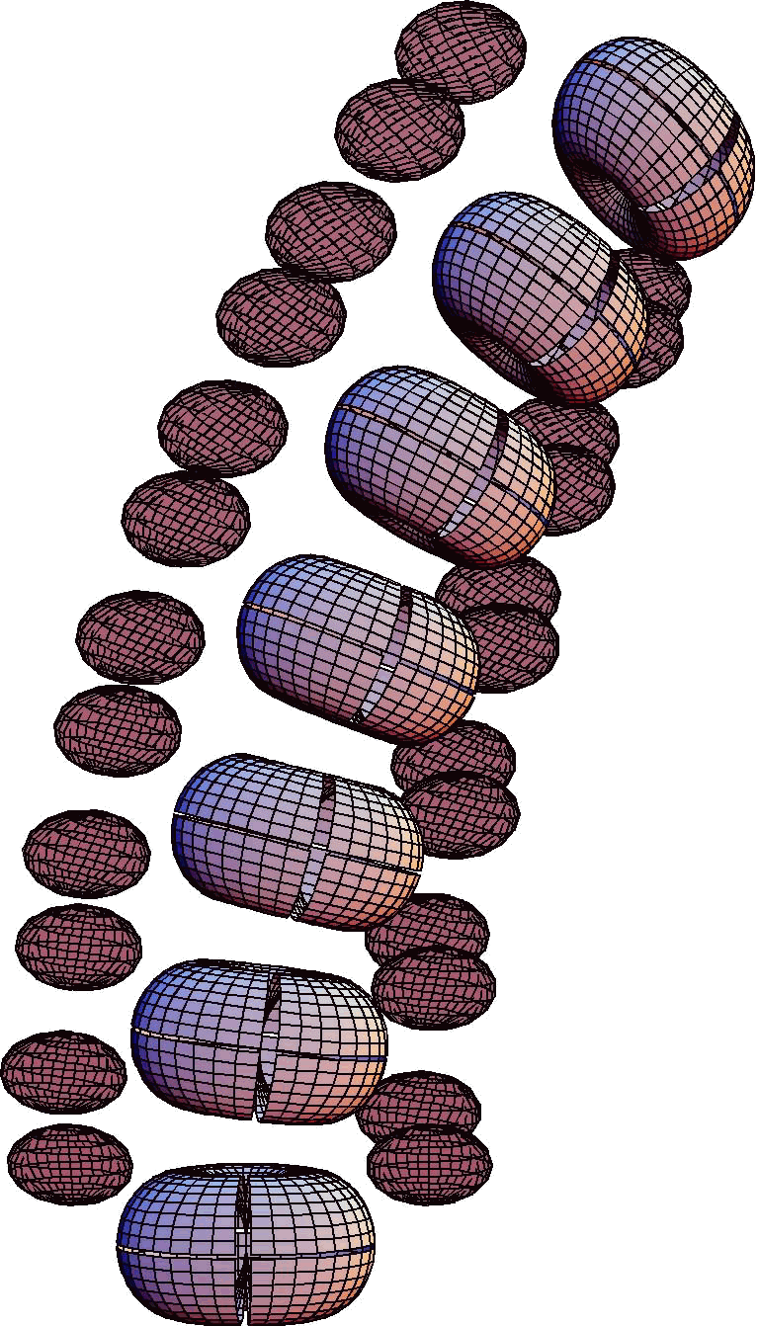
A straight vertical spine with 10° oblique rotation between each pair of vertebrae. The vertebral bodies sideflex and laterally rotate equally in each joint. Each vertebral body is represented by a fat broad torus with a vertical slit in the anterior midline and a horizontal slit in the horizontal plane, midway between the superior and inferior surfaces. The zygapophyseal joints are represented by flat circular disks. The intervertebral discs are represented by the gaps between the vertebral “bodies”. The relative dimensions and relative placements of the vertebral body, the intervertebral disc and the facet joints are set to match the average values for actual cervical vertebrae.
The C2 vertebra is rotated 42.43° to the left and sideflexed 42.43° to the left. Positive turn is to the left, but positive roll is to the right. This is consistent within a right-handed coordinate system, which is what is assumed here. Since the spine was vertical prior to the movement, these numbers are also the observed rotations of the neck in the universal coordinate system.

If we take the straight vertical spine as the reference neck and the straight spine after 10° oblique rotation in each joint as the test spine, then the difference between the two spines is as follows.
The C2 vertebra is located at {0.0, 0.0, 6.6} in the straight neck when it is in neutral position and at {-0.59, 2.25, 6.01} when it is obliquely rotated 10° in each joint. Therefore, there was a moderate amount of posterior shift (0.59 units), a substantial amount of side shift (2.25 units), and a moderate vertical shortening (0.59 units). A unit is the distance from the anterior midline of the vertebral body to the posterior midline.

Oblique Rotations in the Straight 30° Anteriorly Tilted Spine
If, instead of being vertical, the spine is straight, but tilted 30° anteriorly, then the roll and turn may or may not be equal, depending upon the point of view. The values for rotation in the frame of reference for the T1 vertebra are the same as in the previous example, as one would expect, since the situation is exactly the same in that frame of reference. While there is no salaam, the C2 vertebra is drawn slightly posteriorly relative to its original coronal plane, as was the case in the straight vertical spine.
Relative to T1 Vertebra
 | Straight Spine Tilted 30° Anterior
 | Total | Roll | Salaam | Turn
C2 | 60.00 | - 42.43 | 0.0 | 42.43
C3 | 50.00 | - 35.36 | 0.0 | 35.36
C4 | 40.00 | - 28.28 | 0.0 | 28.28
C5 | 30.00 | - 21.21 | 0.0 | 21.21
C6 | 20.00 | - 14.14 | 0.0 | 14.14
C7 | 10.00 | - 7.01 | 0.0 | 7.01
T1 | 0 | 0 | 0 | 0
The amounts of roll and spin relative to the body frame of reference are not equal. For C2 the amount of turn is 1.73 times the amount of roll (52.51° versus - 30.32°). Both increase roughly linearly with the number of intervening vertebrae. The total rotation in moving from the universal frame of reference to the vertebral orientation, 66.45°, is more than ten times the number of joints, but the baseline rotation is 30°, so the change in C2 is 36.45°, which is substantially less than the amount of rotation in the intervertebral joints, that is, 60°.

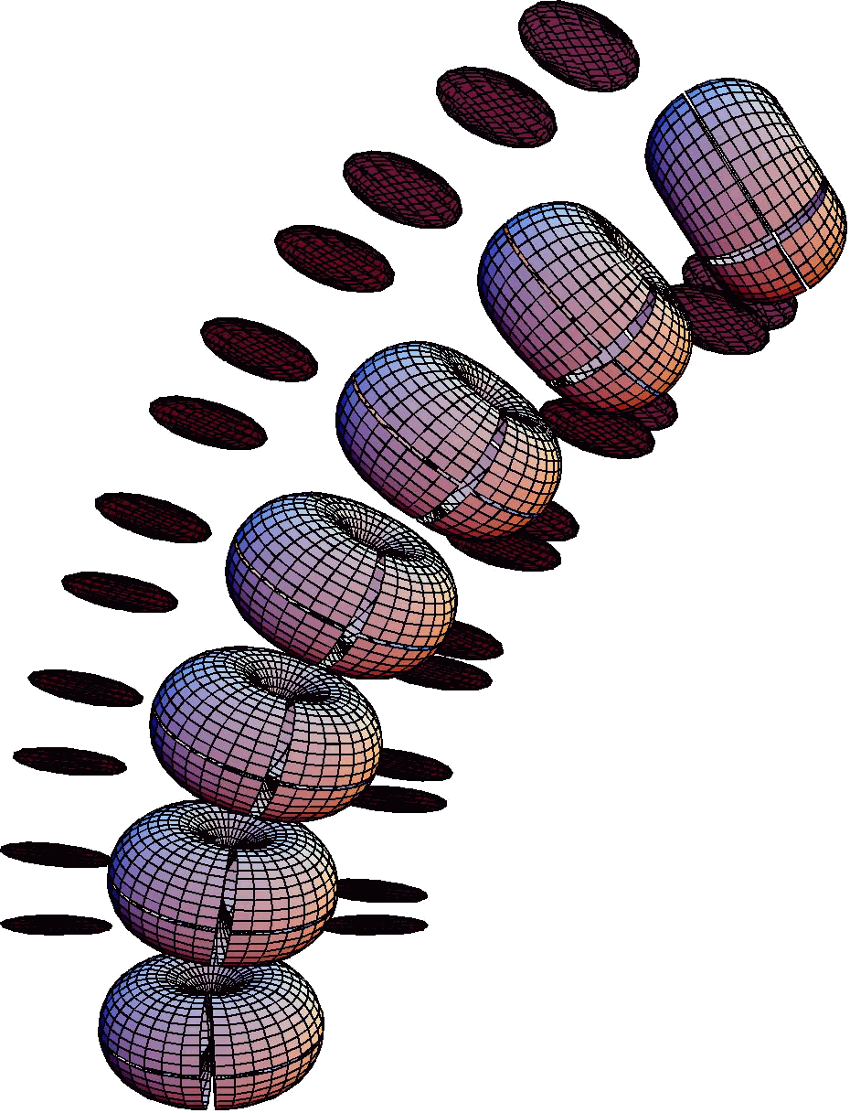
Uniform 10° oblique rotation in an anteriorly tilted straight spine. Prior to the movement, the spine is straight and tilted 30° anteriorly. During the movement, there is 10° of left oblique rotation in each joint, occurring about an axis tilted 45° posterior relative to a perpendicular to the superior surface of the vertebral body. All the conventions about the representation of the vertebral body and facet joints are the same as in the previous figure.
In the body frame of reference, there is a small amount of salaam, 2.82° in C2 relative to T1. If there is no oblique rotation in this anteriorly tilted straight spine, then there is a constant 30° of anterior tilt for every vertebra in the neck. The absolute amount of salaam with oblique rotation is small, compared to the amounts of turn and roll, but the rate at which the salaam is decreasing is becoming greater with each joint.
Relative to Universal Coordinates
 | Straight Spine Tilted 30° Anterior
 | Total | Roll | Salaam | Turn
C2 | 66.45 | - 30.32 | 27.18 | 52.51
C3 | 57.81 | - 25.27 | 28.05 | 43.77
C4 | 49.63 | - 20.22 | 28.76 | 35.03
C5 | 42.18 | - 15.17 | 29.30 | 26.27
C6 | 35.93 | - 10.11 | 29.69 | 17.52
C7 | 31.59 | - 5.06 | 29.92 | 8.76
T1 | 30 | 0 | 30 | 0
Note that the relation between the total rotation and the component rotations is a generalization of the relation noted in the first example.
$${\text{total}}^{2}={\text{roll}}^{2}+{\text{salaam}}^{2}+{\text{turn}}^{2}$$
This relationship is implicit in the definitions of the various types of rotation. However, it is still a useful relationship to keep in mind, because it defined the non-linearity of the rotations.
The C2 vertebra is located at {3.30, 0.00, 5.72} in neutral position and at {2.49, 2.25, 5.50} in full oblique rotation, with 10° rotation in each joint. The neck between the C2 and T1 vertebrae has become 0.22 units shorter. The net effect of the oblique rotations is to draw C2 about 1.01 units posterior, 2.25 units laterally, and 0.22 units inferior to its position in neutral position. This is a total excursion of 2.47 units, which is about the depth of a cervical vertebra.

Oblique Rotations in the Straight 45° Anteriorly Tilted Spine (Figure 3)
The straight spine that is tilted 45° anteriorly is a particularly simple spine for present purposes. All of the rotatory movement is about vertical axes for oblique rotation. The vertebrae swing laterally in the same horizontal plane.
The amounts of roll and spin increase linearly with the number of joints involved. Therefore, the amount of roll and turn that occur between T1 and C2 is six times the amount between T1 and C7. This is also true for the movements viewed in the body frame of reference, except that the sizes of the steps are different. The relative amounts of roll and turn are different as well

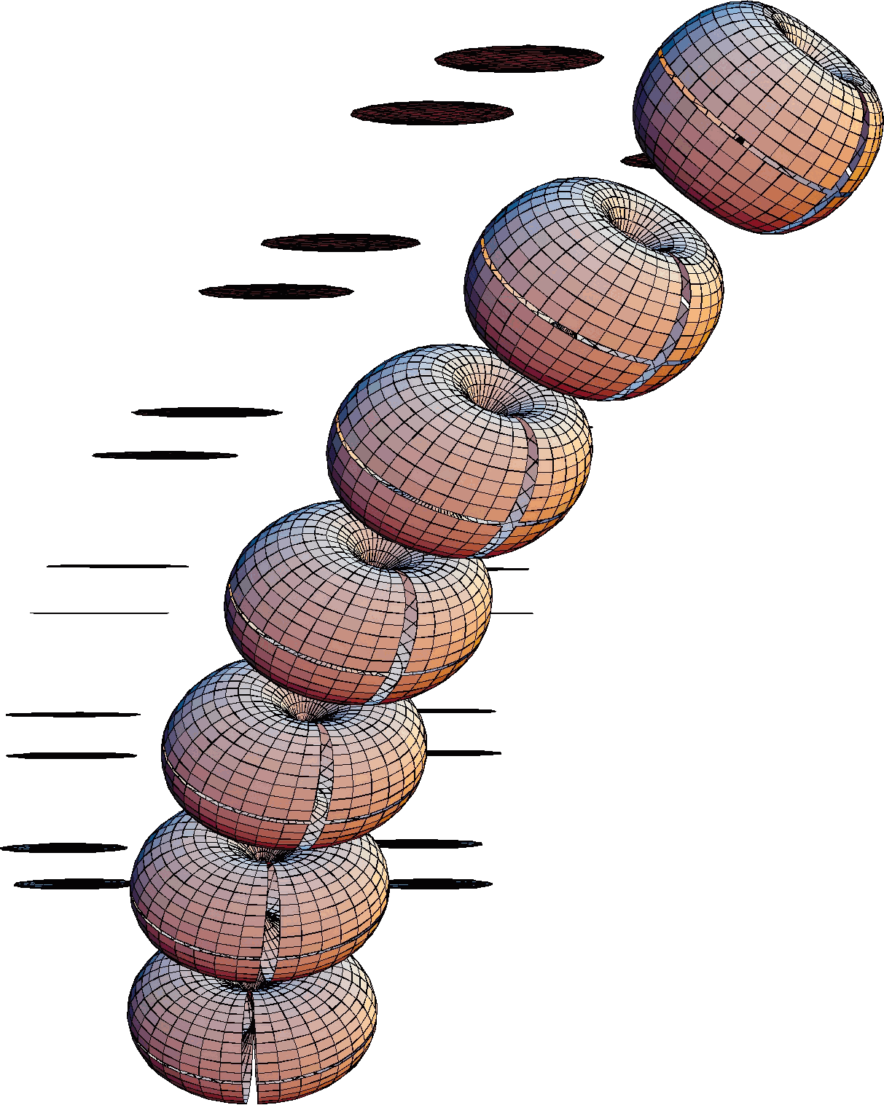
Straight spine tilted 45° anteriorly, 10° of oblique rotation in each intervertebral joint. The straight artificial neck is tilted 45° anteriorly so that the oblique axis of rotation for the intervertebral joints are vertical, in the midline. This means that the vertebrae make pure turning movements in the universal coordinate system.
In the body frame of reference, there is a moderate amount of salaam, 4.27° of extension at C2. With no oblique rotation in this anteriorly tilted straight spine there is a constant 45° of anterior tilt for every vertebra in the neck. The absolute amount of salaam with oblique rotation is small, compared to the amounts of turn and roll, but the rate at which the salaam is decreasing is becoming greater with each joint.
The turn is 2.41 times the roll (56.77 versus –23.51). There is substantially less roll and moderately less turn than in the straight neck tilted 30° anteriorly. In part this is due to the greater salaam from the neck being more anteriorly tilted, but there is definitely less roll as well.
The C2 vertebra is located at {4.67, 0.00, 4.67} in neutral position and at {3.83, 2.25, 4.67} in full oblique rotation, with 10° rotation in each joint. The net effect of the oblique rotations is to draw C2 0.84 units posterior, 2.25 units laterally, and 0.00 units inferior to its position in neutral position. This is a total excursion of 2.40 units.
Relative to T1 Vertebra
 | Straight Spine Tilted 45° Anterior
 | Total | Roll | Salaam | Turn
C2 | 60.00 | - 42.43 | 0.0 | 42.43
C3 | 50.00 | - 35.36 | 0.0 | 35.36
C4 | 40.00 | - 28.28 | 0.0 | 28.28
C5 | 30.00 | - 21.21 | 0.0 | 21.21
C6 | 20.00 | - 14.14 | 0.0 | 14.14
C7 | 10.00 | - 7.07 | 0.0 | 7.07
T1 | 0 | 0 | 0 | 0

Relative to Universal Coordinates
 | Straight Spine Tilted 45° Anterior
 | Total | Roll | Salaam | Turn
C2 | 73.72 | - 23.51 | 40.73 | 56.77
C3 | 66.28 | - 19.60 | 42.05 | 47.34
C4 | 59.51 | - 15.69 | 43.12 | 37.89
C5 | 53.65 | - 11.78 | 43.95 | 28.43
C6 | 49.03 | - 7.85 | 44.53 | 18.96
C7 | 46.04 | - 3.93 | 44.88 | 9.48
T1 | 45 | 0 | 45 | 0

Natural Spines
We now consider a different series of spines. Straight spines were considered first because they are simple and yet they exhibit non-linear behavior. It is possible to get a sense of the nature of the oblique rotations where there are no intrinsic, structural, rotations in the spine. However, straight spines are not realistic. We are most concerned with understanding what is happening in necks like those that actually occur in humans. Therefore, we now turn to the consideration of such normally curved spines.
The remaining spines to be considered are arched like actual anatomical spines. Most of the them will be fairly close to the lordotic configurations that are observed in skeletons and imaging studies. There will be a few brief comments upon movements in kyphotic cervical spines.

Normally Curved Symmetrical Cervical Spine
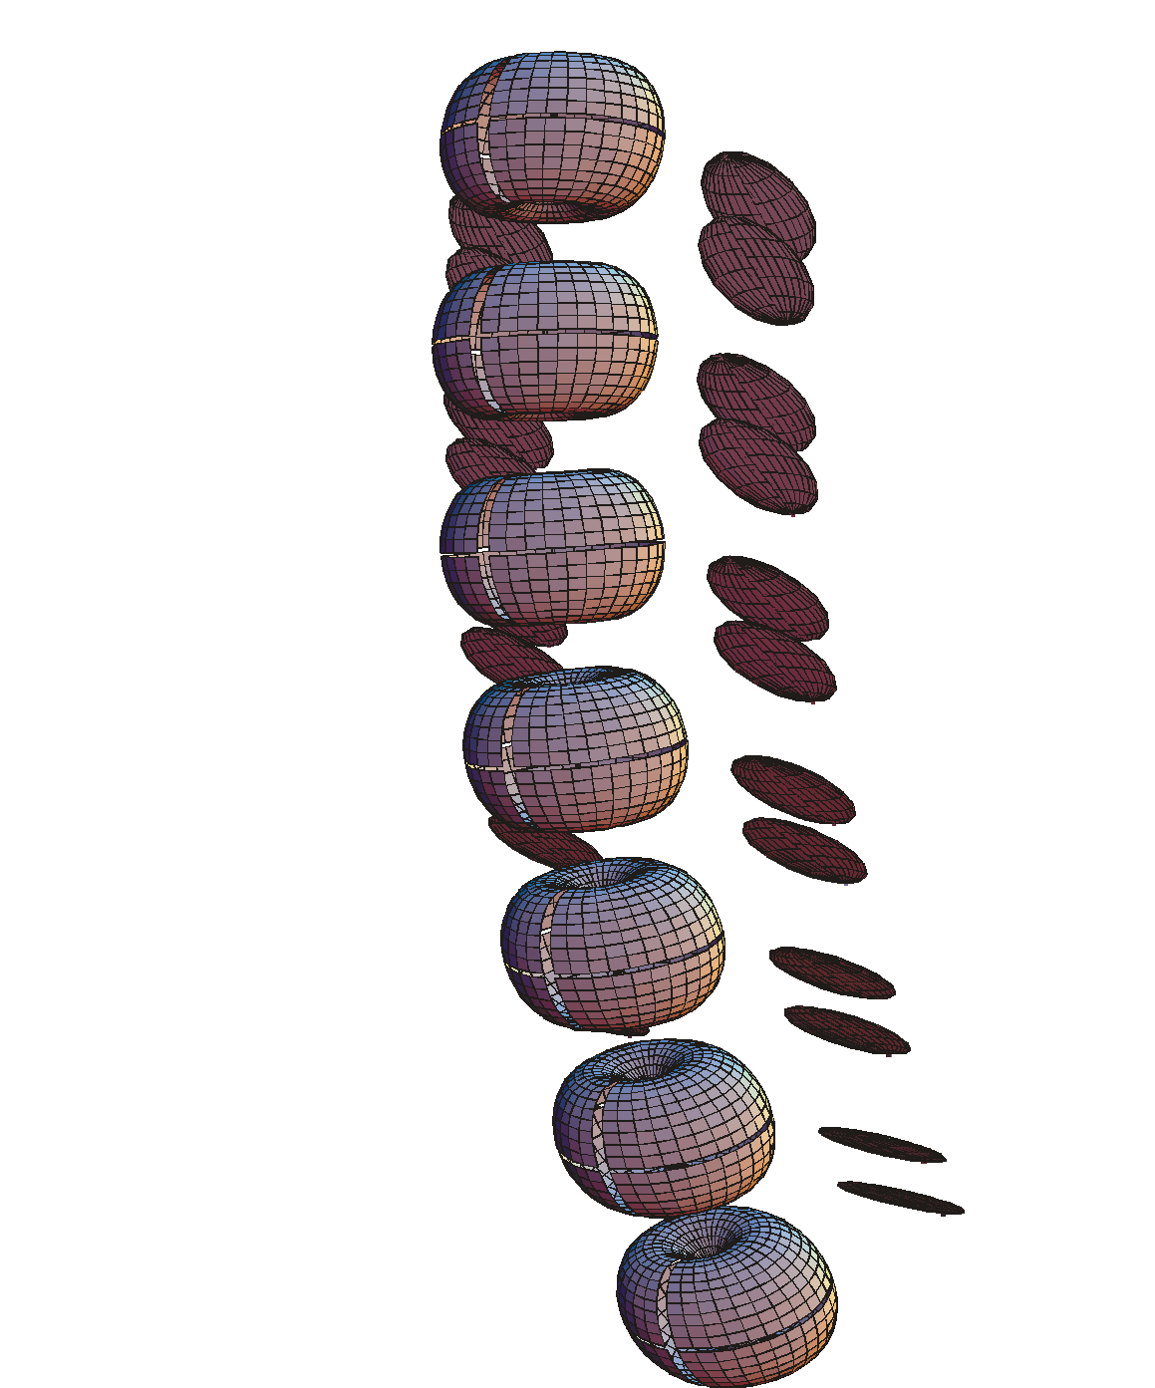
Normally curved cervical spine in neutral position, viewed from left and front. Each vertebrae is tilted 6° posteriorly relative to the subjacent vertebra, with the T1 vertebra anteriorly tilted 30° relative to the horizontal plane. This causes the C3 vertebra to be horizontal and the C2 vertebra to be posteriorly tilted 6°.
In a normally curved symmetrical spine each vertebra is extended, on average, about 6° relative to its immediately subjacent neighbor (Langer #1). As a shorthand, we will call these actual or normally curved spines, even though they are only similar to anatomical spines. In neutral position, the rotations between vertebrae are entirely due to the anatomical configuration. The rotation is entirely salaam. The amount of salaam is the posterior tilt between vertebrae, 6°, times the number of joints between T1 and the vertebra. Therefore, in a normally curved spine, the C2 vertebra is extended 36° relative to T1. T1 is anteriorly rotated 30° relative to the horizontal plane. The total rotation is equal to the salaam, which entirely extension, therefore negative salaam. There is no roll or turn.
Since the T1 vertebra is normally tilted 30° anteriorly (into flexion, positive), the C2 vertebra is tilted 6° posteriorly (into extension, negative) in the universal coordinates frame of reference. The other vertebrae are in flexion (T1 to C4) or horizontal (C2).
These numbers are a reasonable fit to anatomical spines as they appear in x-ray images, CAT scans, and MRI images. In such images, C3 is usually closest to horizontal and T1 is tilted about 30° anterior. The tilts of the other vertebrae are variable from image to image, but if we smooth the total curvature evenly over the entire lower cervical spine, then the profile will be fairly close to the values given in these two tables.
Normally Curved Symmetrical Spine in Neutral Position
Referred to T1
 | Total | Roll | Salaam | Turn
C2 | 36.0 | 0.0 | - 36.0 | 0.0
C3 | 30.0 | 0.0 | - 30.0 | 0.0
C4 | 24.0 | 0.0 | - 24.0 | 0.0
C5 | 18.0 | 0.0 | - 18.0 | 0.0
C6 | 12.0 | 0.0 | - 12.0 | 0.0
C7 | 6.0 | 0.0 | - 6.0 | 0.0
T1 | 0 | 0 | 0 | 0
Now that the orientations are known for neutral position, this is the standard with which to compare the rotated necks with normal curvature. In the following, either this version of the neck or one taken to end-range in some direction will generally be the reference configuration for comparing necks.

Normally Curved Symmetrical Spine in Neutral Position
Referred to Universal Coordinates
 | Total | Roll | Salaam | Turn
C2 | 6.0 | 0.0 | - 6.0 | 0.0
C3 | 0.0 | 0.0 | - 0.0 | 0.0
C4 | 6.0 | 0.0 | 6.0 | 0.0
C5 | 12.0 | 0.0 | 12.0 | 0.0
C6 | 18.0 | 0.0 | 18.0 | 0.0
C7 | 24.0 | 0.0 | 24.0 | 0.0
T1 | 30.0 | 0 | 30.0 | 0
Up to this point, we have not considered flexion or extension in the spine other than that due to the anatomical curvature in neutral position. Now we will consider the effects of rotation in the intervertebral joints. There are varying numbers on the amounts of flexion and extension that occur in the intervertebral joints of the cervical spine. The literature has widely divergent values for the amounts of movement in the different intervertebral joints (refs). It is difficult to sort out any particular values as being clearly more reliable than others. It may well be that there is substantial variation from individual to individual. However, there does seem to be a consensus that there is the most movement in the joints immediately above and below the C5 vertebra and the ranges of motion become less as one progresses in either direction from there. Reasonable numbers seem to be 10° in each direction in the joints to either side of C5, 7.5° in the adjacent joints, and 5° in the most distant joints, therefore those number will be used as the norm. Unless specified to be otherwise, those will be the values used for normally curved spines. The same numbers will be used for salaam and oblique movements. Consequently, we would expect about 90° of salaam and oblique movement from side to side. This seems to be appropriate for an average individual.
There may be a tendency for the facets of the more superior cervical vertebrae to be less tilted relative to the horizontal plane of the vertebra. Again, there is little consistency in this variable, therefore 45° of tilt will be used as the normal anatomical configuration, unless stated otherwise. It is easily seen that tilting the facet joints more steeply will cause the oblique rotation to give more roll and less tilt and less steeply inclined facet joints will move the balance in the opposite direction. Therefore, if the inferior joints are more steeply inclined, they will produce relatively more lateral rotation and the superior joints will produce relatively more sideflexion. However, it remains to be established that these differences are consistently present. In general, the effect of oblique rotation in the naturally curved spine will be to produce more turn than roll, in the reference frame of the T1 vertebra (see below).

Full Flexion in Naturally Curved Spines

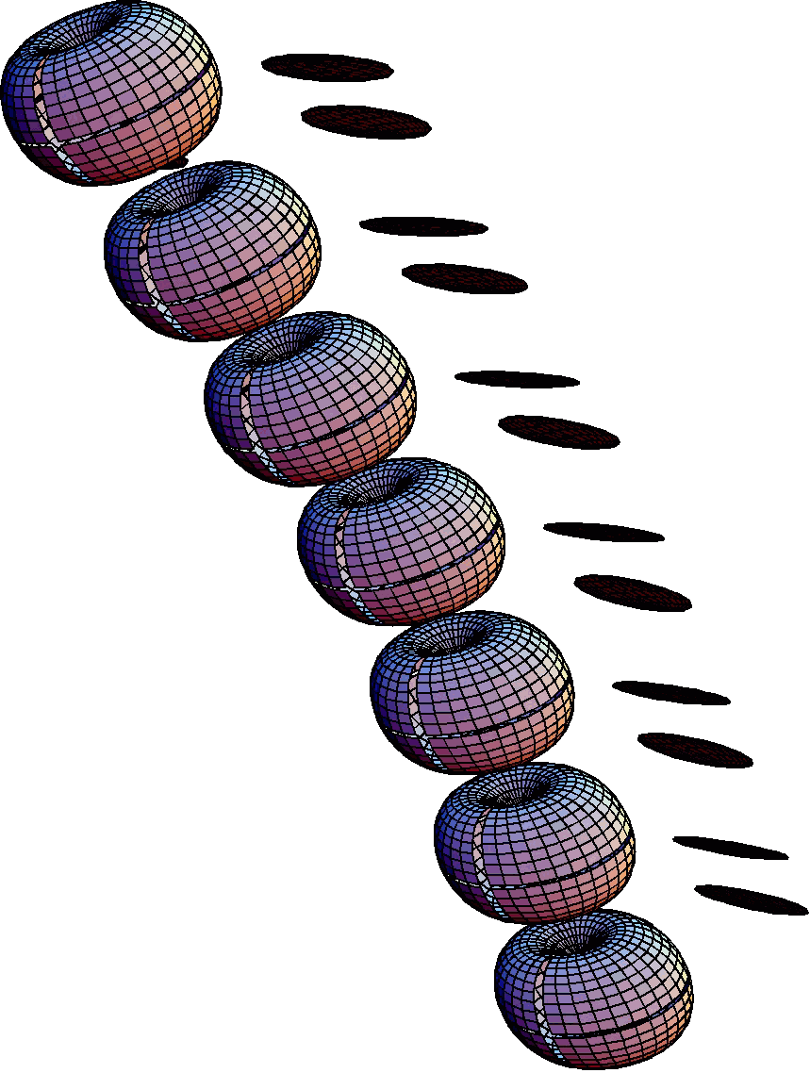
Fully flexed normally curved cervical spine. The spine was in normal neutral position before flexion occurred in each and every intervertebral joint. The spine is viewed from the left and front.
When the cervical spine is flexed to the endranges of its joints, it becomes approximately straight in its lower portion (T1 to C6), has a substantial increase in flexion at the level of C5 and then becomes nearly flat again. This is reflected in the model as well. The C6 and C7 are almost directly in line with T1, then C5 is tilted 4.5° anteriorly and C4 is 8.5°, but C3 and C2 are 10° and 9 ° anteriorly tilted. These values are simply 30° greater in the universal coordinates.
This is about what one would expect. Salaam only affects the sagittal orientation of the vertebrae and it combines linearly. In full flexion, one would expect the C2 vertebra to be anteriorly tilted about 40°, relative to the horizontal plane of the body.
The C2 vertebra is located at {1.35, 0.00, 6.34} in neutral position and at {3.99, 0.00, 5.25} in full flexion rotation, with the normal distribution of flexion rotation in each joint. The net effect of the flexion rotations is to draw the C2 vertebra 2.64 units anterior and 1.09 units inferior to its position in neutral position. This is a total excursion of 2.86 units, entirely in the midsagittal plane.
Normally Curved Spine in Full Flexion
Referred to T1
 | Total | Roll | Salaam | Turn
C2 | 9 | 0.0 | 9 | 0.0
C3 | 10 | 0.0 | 10 | 0.0
C4 | 8.5 | 0.0 | 8.5 | 0.0
C5 | 4.5 | 0.0 | 4.5 | 0.0
C6 | 0.5 | 0.0 | 0.5 | 0.0
C7 | 1.0 | 0.0 | -1.0 | 0.0
T1 | 0 | 0 | 0 | 0

Full Extension in Naturally Curved Spines
When the cervical spine is extended to the endranges of its joints, it becomes very curved. C2 is extended about 81° relative to T1 and in the universal coordinate system it is still tilted into about 51° of extension. In extension, the natural extension of the spine is added to the extension of the movement to produce 11° to 16° of extension in every joint.
Normally Curved Spine in Full Extension
Referred to T1
 | Total | Roll | Salaam | Turn
C2 | 81 | 0.0 | - 81 | 0.0
C3 | 70 | 0.0 | - 70 | 0.0
C4 | 56.5 | 0.0 | - 56.5 | 0.0
C5 | 40.5 | 0.0 | - 40.5 | 0.0
C6 | 24.5 | 0.0 | - 24.5 | 0.0
C7 | 11.0 | 0.0 | - 11.0 | 0.0
T1 | 0 | 0 | 0 | 0
Considering the conformation of the cervical spine in body related coordinates, the lower portion of the spine remains slightly flexed, but at the level of C5 the spine is extended and it rapidly extends over 45°. In actual, spines the amount of extension may be less, because it has been noted that the amount of flexion in the cervical spine tends to be greater than the extension at most levels.
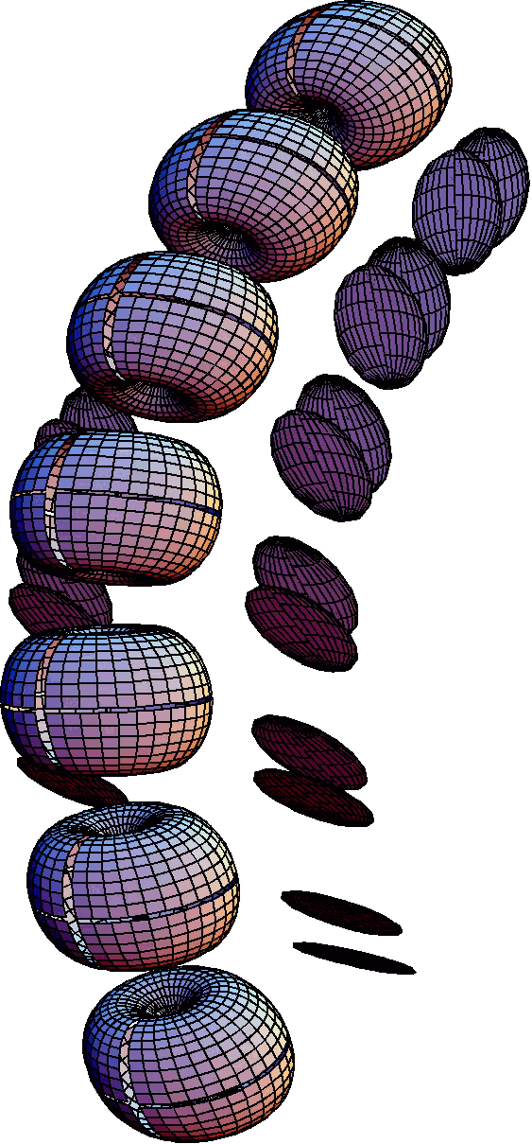
Fully extended normally curved cervical spine. The normally curved spine is extended in each and every intervertebral joint by the standard amounts. The C2 vertebra is extended about 51° in universal coordinates and by 81° relative to T1.
Naturally Curved Spine in Full Extension
Referred to Universal Coordinates
 | Total | Roll | Salaam | Turn
C2 | 51 | 0.0 | -51 | 0.0
C3 | 40 | 0.0 | -40 | 0.0
C4 | 26.5 | 0.0 | -26.5 | 0.0
C5 | 10.5 | 0.0 | -10.5 | 0.0
C6 | 5.5 | 0.0 | 5.5 | 0.0
C7 | 19 | 0.0 | 19 | 0.0
T1 | 30 | 0 | 30 | 0
The C2 vertebra is located at {1.35, 0.00, 6.34} in neutral position and at {-1.36, 0.00, 5.74} in full extension, with the normal distribution of extension in each joint. The net effect of the extension rotations is to draw the C2 vertebra 2.71 units posterior and 0.60 units inferior to its position in neutral position. This gives a total excursion of 2.76 units.

Oblique Rotation from Neutral Position in Normally Curved Spines
If the cervical spine is in neutral position and the maximal oblique rotation is produced in each joint then the result is much as in the following tables. There is very little change in the salaam relative to T1; at most a fraction of a degree. There is slightly less turn than there is roll. The roll and turn have opposite signs, but are in the same direction, according to standard naming conventions. Both increase by progressively greater amounts until C4 and then by progressively smaller amounts. This is due to the different size rotations in the joints. If we compute the values with the same rotation in each joint, then the differences between vertebrae are almost identical.
Normally Curved Spine in Full Oblique Rotation from Neutral Position
Referred to T1
 | Total | Roll | Salaam | Turn
C2 | 57.60 | - 33.58 | - 35.71 | 30.24
C3 | 49.98 | - 30.32 | - 29.84 | 26.23
C4 | 40.38 | - 24.79 | - 23.92 | 21.08
C5 | 28.80 | - 17.08 | - 17.96 | 14.67
C6 | 17.32 | - 9.38 | - 11.99 | 8.27
C7 | 7.81 | - 3.72 | - 6.00 | 3.35
T1 | 0 | 0 | 0 | 0
Initially, the fact that the sum of the various component rotations is greater than the total rotation is difficult to understand. The acute observer may note that the sum of the squares of the component rotations is equal to the square of the total rotation.
Total² = Roll² + Salaam² +Turn²
Note that the rotations include the conformational rotations and the intervertebral joint rotations. This is partly due to the definitions of the rotations, but a very real phenomenon.
When viewed from the perspective of the body’s orientation, the amount of roll in the movement of each vertebra is substantially less, while the amount of turn increases substantially. These differences are large enough to reverse the relationship. There is considerably more turn than roll when viewed from the point of view of the universal coordinates. There is also a modest increase in the extension.
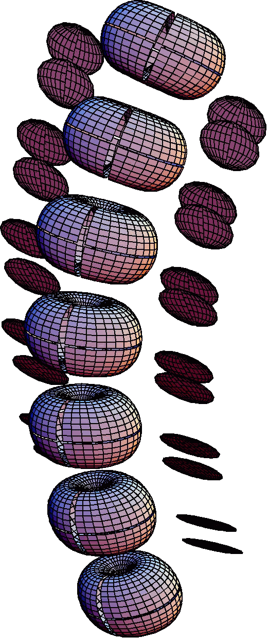
Normally curved spine with full oblique rotation in each and every intervertebral joint. The oblique rotation varies from joint to joint, but the magnitude of the rotation is the maximum assigned to that joint. The point of view is the same as in the previous two figures.
This difference between points of view is different from that which occurred with straight spines and with salaam in normally curved spines. In those instances, the values in the universal coordinates were obtained from the values in the T1 coordinates by adding a number to each value. In this spine, the polarity of the relationship has reversed. There is also not a simple relationship between the amounts of salaam in the two points of view.
The C2 vertebra is located at {1.35, 0.00, 6.34} in neutral position and at {0.96, 1.46, 6.12} in full oblique rotation, with the normal distribution of oblique rotation in each joint. The net effect of the oblique rotations is to draw the C2 vertebra 0.39 units posterior, 1.46 units laterally, and 0.22 units inferior to its position in neutral position. The total excursion is 1.53 units of which the lateral component is by far the largest.
Normally Curved Spine in Full Oblique Rotation from Neutral Position
Referred to Universal Coordinates
 | Total | Roll | Salaam | Turn
C2 | 45.03 | - 24.21 | - 7.26 | 37.27
C3 | 39.64 | - 22.24 | - 1.05 | 32.79
C4 | 32.74 | -18.36 | 5.28 | 26.59
C5 | 25.30 | - 12.67 | 11.65 | 18.55
C6 | 21.85 | - 6.94 | 17.89 | 10.44
C7 | 24.51 | - 2.74 | 23.98 | 4.22
T1 | 30 | 0 | 30 | 0
This completes the single movement scenarios. The next two section considers two artificial, but interesting situations that illustrate the dependence of turn and roll upon the context, then the following sections consider what occurs when two types of movements are combined. For instance how does the neck’s configuration change when it is flexed and obliquely rotated.

Oblique Rotations in Reverse Curved Symmetrical Cervical Spine
It is of only academic interest, but we can also look at the effect of making the curvature of the spine opposite to its normal extended configuration. We start with each vertebra tilted 6° into flexion relative to the subjacent vertebra, then, with the same lateral rotation as in the previous situation, the pattern of rotations is reversed relative to the normally curved spine. The total rotation is the same but in the opposite direction. The total rotation for C2 with no oblique rotation in its joints is 36° of flexion, relative to T1. Here, after the oblique rotations in the individual joints, it is flexed 35.71°. There is a larger turn component than roll, but they are still of opposite sign. Translating this into anatomical nomenclature, the C2 vertebra is sideflexed 30.24° to the left and laterally rotated 33.58° to the left. The salaam is into flexion.
The same simple reversal does not occur in the universal coordinates. Comparison with the values in the previous example will show that the numbers are very different for the flexed spine.
This is an extreme and artificial case, but it illustrates a general principle. The more the neck is extended, the greater the fraction of the movement that is going to be roll and the less that is going to be turn. As the neck is flexed, the balance shifts towards equality of the two component rotations and then greater turn than roll.
Reverse Curved Symmetrical Spine with 10° Oblique Rotations
With respect to T1
 | Total | Roll | Salaam | Turn
C2 | 57.60 | - 30.24 | 35.71 | 33.58
C3 | 49.98 | - 26.23 | 29.84 | 30.32
C4 | 40.38 | - 21.08 | 23.92 | 24.79
C5 | 28.82 | - 14.67 | 17.96 | 17.08
C6 | 17.32 | - 8.27 | 11.99 | 9.38
C7 | 7.81 | - 3.34 | 6.00 | 3.72
T1 | 0 | 0 | 0 | 0

Reverse Curved Spine in Full Oblique Rotation
Referred to Universal Coordinates
 | Total | Roll | Salaam | Turn
C2 | 79.45 | - 21.33 | 64.06 | 41.86
C3 | 71.76 | - 18.10 | 58.55 | 37.34
C4 | 62.78 | - 14.36 | 53.08 | 30.29
C5 | 52.87 | - 10.00 | 47.56 | 20.81
C6 | 43.77 | - 5.68 | 41.86 | 11.44
C7 | 36.33 | - 2.31 | 35.98 | 4.53
T1 | 30 | 0 | 30 | 0

Oblique Rotations in a Symmetrical Cervical Spine with Inverted Facet Joints
It will not be dealt with here in any detail, but if we reverse the tilt of the facet joints, so that their axis of rotation runs from inferior and posterior to superior and anterior, then the roll and turn components have the same sign, or opposite directions in the conventional naming system. The basis for the coupling of the roll and turn is the relationship between the frame of reference and the axis of rotation. If the axis of rotation is parallel with the r axis, then there is roll without turn and if the axis of rotation is parallel with the t axis, then there is turn without roll, there is no conjoint movement. If the axis of rotation is tilted so that its projection on the t axis is negative, then the roll and turn will have same sign. If the rotation axis is tilted so that its t axis projection is positive, they will have opposite signs. The same movement may have either interpretation, depending on how the frame of reference is chosen. In other words, turn and roll are not fundamental attributes of the movement, because they are contingent upon the frame of reference, which is arbitrary, although often set by convention.

Full Oblique Rotation with Full Flexion in Normally Curved Spines
It is possible to look at what occurs when there is rotation about both axes of rotation. To start, consider the situation in which the neck is taken into full flexion, as it was above, then additional rotation occurs about the oblique axis. The calculation can be refined later, if need be. For both rotations in the intervertebral joints, the maximal movement is as above, that is {5.0, 7.5, 10.0, 10.0, 7.5, 5.0} for C2/C3 through C7/T1.
Normally Curved Spine in Full Oblique Rotation and Full Flexion
Referred to T1
 | Total | Roll | Salaam | Turn
C2 | 45.87 | - 31.19 | 9.20 | 32.35
C3 | 41.23 | - 28.20 | 10.14 | 28.30
C4 | 33.58 | - 23.07 | 8.59 | 22.84
C5 | 22.94 | - 15.98 | 4.54 | 15.82
C6 | 12.51 | - 8.89 | 0.51 | 8.78
C7 | 5.10 | - 3.57 | -0.99 | 3.50
T1 | 0 | 0 | 0 | 0
When viewed from the perspective of the T1’s orientation, the amount of roll is approximately equal to the amount of turn. Salaam is approximately what was observed in the fully flexed naturally curved spine. However, when viewed from the perspective of the body’s coordinate system the turn becomes about twice as much as the roll. The change in salaam is 1.48° less than for flexion alone, therefore the oblique rotation produces a modest extension.
This situation leads to a configuration that is rather like the sum of the two separate movements. Perhaps this is because the flexion brings the spine into a configuration that is almost straight, as in one of the first few examples, where the straight spine was tilted 30° anterior.
There are two different references that might be of interest in this situation: the changes relative to the configuration in neutral position and the changes relative to the end positions for single types of rotations. We will start with comparisons to the configuration in neutral.
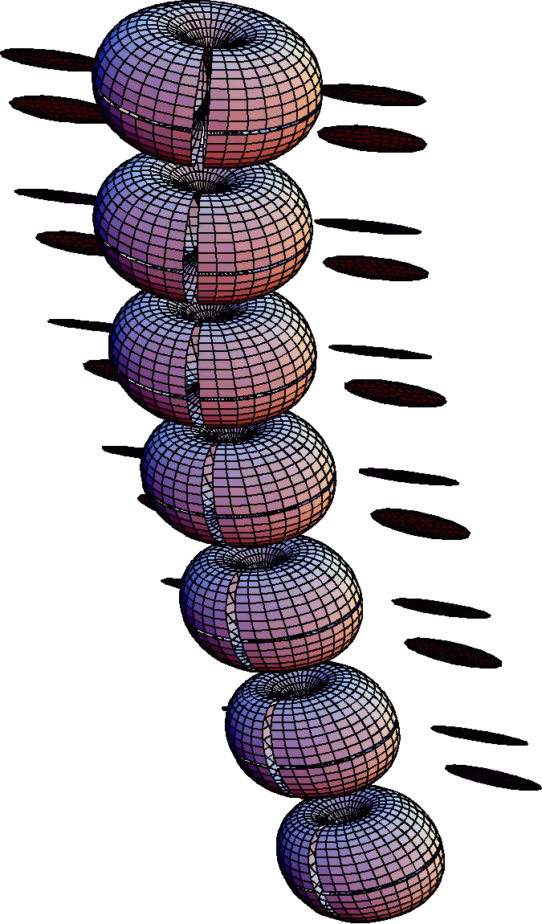
Normally curved spine in full flexion and oblique rotation. The movements in each intervertebral joint has been taken to its maximum in both flexion and left oblique rotation. The point of view is as in all the previous normally curved spines. Note that the spine is nearly straight and the lateral rotation of C2 is just short of 45°, while it is tilted much less.

Normally Curved Spine in Full Oblique Rotation and Full Flexion
Referred to Universal Coordinates
 | Total | Roll | Salaam | Turn
C2 | 59.24 | - 22.15 | 37.62 | 40.04
C3 | 56.30 | - 20.29 | 38.89 | 35.30
C4 | 50.19 | - 16.67 | 37.77 | 28.54
C5 | 41.07 | - 11.52 | 34.15 | 19.70
C6 | 32.91 | - 6.39 | 30.39 | 10.91
C7 | 29.42 | - 2.56 | 28.98 | 4.35
T1 | 30 | 0 | 30 | 0
Fully flexed and obliquely rotated versus neutral position:
The C2 vertebra is located at {1.35, 0.00, 6.34} in neutral position and at {3.45, 1.95, 5.13} after full flexion and full oblique rotation, with the normal distribution of oblique rotation and flexion in each joint. The net effect of the combined rotations is to draw the C2 vertebra 2.10 units anterior, 1.95 units laterally, and 1.21 units inferiorly. This is a total excursion of 3.11 units.
Fully flexed and obliquely rotated versus fully flexed position:
Another difference that we might consider is the difference between the fully flexed neck and the flexed and obliquely rotated neck. Let us consider this difference.
The C2 vertebra is located at {3.99, 0.00, 5.25} in full flexion and at {3.45, 1.95, 5.13} after full flexion and full oblique rotation, with the normal distribution of oblique rotation and flexion in each joint. The net effect of the combined rotations is to draw the C2 vertebra 0.54 units anterior, 1.95 units laterally, and 0.12 units inferior to its position in a fully flexed configuration. This is a total excursion of 2.03 units, which is largely lateral translation.

Centers of Rotation:
Normally curved spine in full flexion versus full flexion and oblique rotation

 | x | y | z
C2 | 1.63 | 0.51 | 4.85
C3 | 1.30 | 0.37 | 4.09
C4 | 0.95 | 0.24 | 3.33
C5 | 0.60 | 0.12 | 2.55
C6 | 0.36 | 0.04 | 1.69
C7 | 0.17 | 0.01 | 0.84

Full Oblique Rotation with Full Extension in Normally Curved Spines
At the opposite extreme from the last configuration is full oblique rotation from a fully extended position. The pattern of rotation is given in the following table.
When viewed from the perspective of the T1’s orientation, the amount of roll is substantially more than the amount of turn, more than when full oblique rotation occurred with full flexion. The roll of C2 relative to T1 was –31.19 in flexion/oblique rotation versus –35.94 in extension/oblique rotation. Salaam is about what was observed in the fully extended naturally curved spine.
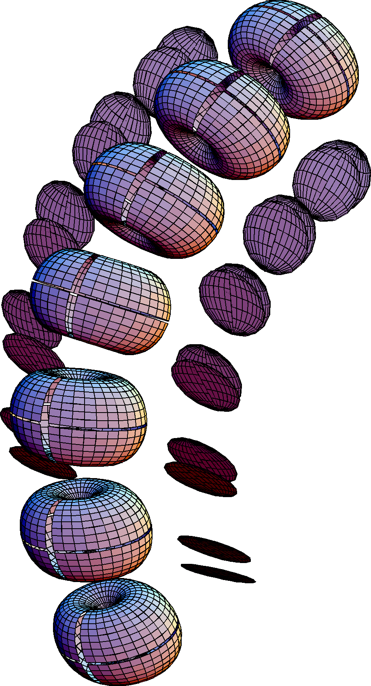
Fully extended and obliquely rotated normally curved cervical spine. Each vertebrae is rotated as usual for each intervertebral joint.
When viewed from the perspective of the body’s coordinate system, the roll becomes substantially less and the turn is much more. They almost reverse their values in the Ti frame of reference. The salaam is much less, but essentially the same as for extension alone.

Normally Curved Spine in Full Oblique Rotation and Full Extension
Referred to T1
 | Total | Roll | Salaam | Turn
C2 | 92.59 | - 35.94 | - 80.62 | 27.95
C3 | 80.56 | - 32.30 | - 69.81 | 23.94
C4 | 65.13 | - 26.32 | - 56.42 | 19.11
C5 | 46.30 | - 18.06 | - 40.46 | 13.41
C6 | 27.49 | - 9.84 | - 24.48 | 7.73
C7 | 12.08 | - 3.86 | - 10.99 | 3.19
T1 | 0 | 0 | 0 | 0

Normally Curved Spine in Full Oblique Rotation and Full Extension
Referred to Universal Coordinates
 | Total | Roll | Salaam | Turn
C2 | 67.73 | - 26.07 | - 52.17 | 34.45
C3 | 56.25 | - 23.94 | - 41.01 | 30.16
C4 | 41.62 | - 19.82 | - 27.21 | 24.47
C5 | 24.58 | - 13.70 | - 10.84 | 17.29
C6 | 13.54 | - 7.45 | 5.40 | 9.94
C7 | 19.64 | - 2.92 | 18.99 | 4.09
T1 | 30 | 0 | 30 | 0
Fully extended and obliquely rotated versus neutral position:
The C2 vertebra is located at {1.35, 0.00, 6.34} in neutral position and at {-1.57, 0.85, 5.50} after full extension and full oblique rotation, with the usual distribution of oblique rotation and extension in each joint. The net effect of the combined rotations is to draw the C2 vertebra 2.92 units posterior, 0.85 units laterally, and 0.84 units inferiorly. This is a total excursion of 3.16 units, much of which is posterior shift.
Fully extended and obliquely rotated versus fully extended position:
We now turn to the difference between the fully extended neck and the fully extended and fully obliquely rotated neck. The C2 vertebra is located at {-1.36, 0.00, 5.73} in full extension and at {-1.57, 0.85, 5.50} after full extension and full oblique rotation, with the usual distribution of oblique rotation and extension in each joint. The net effect of the combined rotations is to draw the C2 vertebra 0.21 units posterior, 0.85 units laterally, and 0.22 units inferior to its position in full extension. This is a total excursion of 0.90 units, largely lateral displacement. This is a smaller movement than usual for these extreme positions.
The addition of oblique rotation to full extension does not move the C2 vertebra as far as in flexion and it tends to cause more roll than turn, so that the neck turns more in on itself than occurs in other positions.

Discussion
A model created from a quantitative description of the lower cervical spine has considerable power in the examination of neck movements. First, we can create three-dimensional images of the neck elements with the neck with any set of joint excursions. By rotating the image, one can obtain very good visual impression of how the elements lie relative to each other and how the individual movements concatenate to produce substantial changes in the orientation of the C2 vertebra, which is the foundation for the upper joint assembly and the head. Second, we can compute the numerical values of the orientation of the neck elements in any frame of reference. In this paper, the T1 vertebra and the universal coordinate system of the body have been used as reference frames. It was observed that what one sees, in terms of sideflexion, flexion/extension, and lateral rotation is contingent upon one’s point of view. This approach is very informative, but one tends to drown in information. Consequently, we will try to extract a few general points in the following sections.
The lower cervical spine presents an interesting challenge to understanding its kinematics, because, even though all of its vertebrae have roughly the same morphology and there are only two major axes of rotation in its intervertebral joints, the shape of the vertebrae are complex and the two rotation axes are not orthogonal. The shapes of the vertebrae can be readily abstracted, as has been done in this paper. For the most part, there are two features that are relevant to the kinematics; the vertebral body and the zygapophyseal facet joints. If we are interested in muscles, then we might add their attachment sites, and if we are interested in the vertebral artery, we can add the transverse foraminae. There are many other anatomical features, but, to a large extent, they primarily restrict the rotation axes, rather than determine their directions. We incorporate their contributions by setting the rotation axes to particular values and the joint excursions to certain ranges.
The rotation axes are transverse, for salaam, and oblique, for a combination of roll and turn. Each affects the movements of the cervical spine in different characteristic ways.
It turns out that salaam in isolation is straightforward. The movement is all in the same plane and the only complication comes in how concatenation of the salaam movements causes the higher cervical vertebrae to act as if they were moving from an axis more posterior and inferior than the actual location of their individual axes of motion.
The principal variation in the transverse axes is the point at which they intersect the spine. It appears from radiological studies that the upper cervical vertebrae salaam about an axis placed in the posterior part of the subjacent vertebra, about the level of the center of the vertebral body, but varying substantially in the exact location. In the lower cervical spine, the instantaneous axis of rotation tends to lie high in the subjacent vertebral body, just below the superior surface of the vertebra. It turns out that for present purposes the exact location of the axis of rotation is largely irrelevant. If one runs the model with different locations there are small differences in the physical location of the vertebrae, but the orientations are unchanged. In other words, the forms of the movements are not contingent upon the exact locations of the transverse axes of rotation.
Oblique rotations are more complex, because the resulting movement does not lie in a cardinal plane, therefore it takes on attributes of both roll and turn. In addition, a spine with oblique rotation moves the vertebrae out of a single plane so its movements interact non-linearly. For instance, the sum of the turn and roll is more that the magnitude of the oblique rotation that produced them. If the vertebra is not oriented with its axes aligned with the cardinal axes of the frame of reference, then there may be cross-talk between the types of rotation. For instance, the oblique rotations also produce small amounts of salaam.
If there is only salaam in the spine, either as part of its configuration in neutral position or due to movement in the sagittal plane, then the movements of the vertebrae are all coplanar. There is a shift of the center of rotation with concatenation, but the rotation is planar or pure swing. Any oblique rotation will produce a conical rotation. Concatenation moves the effective center and axis of rotation away from the centers and axes of rotations of the individual vertebrae.

Points of View
One of the central observations of this analysis is that the nature of the movement depends upon the point of view. Three points of view were considered, two in this essay and the third in a separate essay.
The descriptions of movements relative to the frame of reference of T1 indicate the manner in which the vertebrae move relative to each other. In that point of view if the same rotations occur in all the joints, then the movement description is the same, independent of the tilt of the spine. For instance, the full oblique rotation in every joint of a straight spine gave the same results for all the straight spines. In this respect the T1 frame of reference is telling us something fundamental about the movements.
The universal coordinates frame of reference is also fundamental. It tells us what the effect of the movement is relative to the outside world. This system is considered in a separate essay. In this frame of reference, it matters how much the neck is tilted forwards. If one is to properly engage with the world, then one will have to consider how the movement appears in the universal coordinates. However, the amounts of sideflexion and lateral rotation may be quite different in the universal coordinates than in the frame of reference for T1. This is not a problem, because sideflexion, lateral rotation and flexion/extension are not fundamental attributes of moving objects. They are intuitive and convenient ways of describing movement in a particular context.
There is a third point of view in which there is not a single frame of reference, but movement is related to the actual movements experienced by the individual vertebrae. It is in this self referent frame of reference that it becomes apparent that the same movement concatenated through a chain of identical units will produce quite different effects for the individual elements of the chain, depending upon where they lie in the chain. While we have to settle upon a particular coordinate system for the actual calculations, this point of view is not tied to any particular frame. It is the most informative, but, in some ways, the most demanding to understand.

Conical rotations from combinations of salaam and oblique
When we combine the movements by allowing some movement about both axes of movement, then the resulting movement is not a simple combination of the two separate movements. Moving the neck into flexion flattens the excursion of the oblique movement, while performing the same oblique rotation in extension turns it in on itself. Similarly, if the neck is sideflexed then rotations about the transverse axis will no longer be in a cardinal plane, therefore they will no longer be seen as pure swing, but as a conical rotation. It will generate roll and turn as well as salaam.

Nonlinearity and Neural Control
The effect of a given movement will depend upon the anatomical configuration of the mechanical chain in which it lies at the time that the movement is initiated. This presents an interesting problem in neural control. First of all, the system is fairly nonlinear within its normal ranges, second, the local effect of a single intervertebral movement will depend on the state of the local vertebrae at that time, and, third, the effects of a local movement will propagate throughout the chain. All of these factors make neural control a very complicated process.
The same local movement may have different global consequences, depending on where in the chain it occurs. At C7, the movement is a rocking movement and at C2, it is a conical swing with translation. Another way of saying this is that concatenation is non-linear, therefore the neural control of concatenated chains of joints must be non-linear.
If both ends of a concatenated chain are potentially free, then the consequences of a movement may be very different, depending on which end is fixed or if an intermediate link is fixed. This is well known and recognized. It is further complicated by the fact that we live with the ever present gravity, which changes the muscle forces depending on the orientation of the body and the spine. Further, if the control system solves the static situation for the muscle forces needed to sustain a posture, it still has to solve the greater problem of moving between postures in a wide variety of velocities and accelerations, dependent upon the context.
In the neck, moving relative to T1, movements happen more caudal and posterior in the chain than the vertebrae that are moving. This is a consequence of the fact that movements propagate through a chain. One can not specify the movement without taking a global perspective. One can not specify the length of a given muscle and bring about an effect. Even a small set of muscle lengths will not suffice. One must specify the state of all the muscles that participate in the movement.
At a very fundamental level, it is clear that the nervous system does not compute the entire muscle solution for every movement prior to the movement. There must be, and demonstrably is, a great deal of feedback from the muscles and joints and from the outside world through the eyes and vestibular apparatus. In addition, there are probably neural circuits that effectively operate as a look-up table for the muscle lengths that produce a given posture. These circuits are probably trained and maintained by past experience. Such a neural network type solution is very efficient and fast and it requires minimal understanding of the mathematical structure of the problem to be effective. Nonlinear problems are no more difficult than linear problems in such as system.

Joint Restrictions
One of the reasons that we wish to understand the movements of the neck is to understand the reasons for and the consequences of pathology. In necks with frozen joints or restricted joints the consequences propagate through the chain and may produce much more restriction than one would expect from the amount of movement in the joint. This is easily seen, if we consider the consequences of freezing the C7/T1 joint. Doing so effectively shortens the neck by one vertebra, and makes the C2 vertebra act as if it were the C3 vertebra. Restriction in the middle vertebrae will have a disproportionate effect, because they have more movement that those above and below them. We will not consider these situations here, but the model would be an effective means of studying the consequences of biomechanical problems.

The Construction of Movements
As stated above, the nervous system probably effectively uses a look-up table to determine how to perform a particular movement when the movement is within or near its normal parameters. However, it is possible that it may calculate new movement trajectories when it encounters unusual constraints, such as muscle spasm or injury. In a more theoretical frame of mind, one might ask if it is possible to compute a trajectory, given the endpoints? Can we solve for a particular movement between two configurations?
It is clear that there is not a unique trajectory in multi-joint systems. This can be seen by imagining the following scenario. The hand is held in a particular orientation with the hand close to the shoulder, then, the hand is moved to a new location, maintaining the orientation of the hand. There are many ways in which the rest of the arm may move and still maintain the orientation of the hand, such as with elbow down or with elbow up. Therefore, there is not a unique movement. Other parameters have to be set to determine a single trajectory.
On the other hand, if you try the movement described in the previous paragraph you will quickly discover that there is a definite set of solutions. So there are constraints upon movement, mostly due to anatomy. Your joints move in certain ways and within certain limits. Therefore there are definite solutions and the problem becomes defining the set of solutions rather than finding a particular solution.
This brings up further questions. Is there a most efficient movement? Is there a restraint like Listing’s plane for eye movements? Listing’s plane is the plane in which the axis of rotation for a saccadic eye movement must lie in order to move from gaze A to gaze B without introducing spin relative to neutral gaze. It turns out that the Listing’s plane trajectory causes the eye muscle lengths vector to travel in the static gaze surface (Langer, #3). Is there a comparable restraint on limb and vertebral movements? It would be based on some concept of efficiency.
There are more and less efficient ways of movement. We recognize them intuitively. One of the attributes of beautiful movement, as in dance, is its efficiency, even when it is stylized to be complex. Inefficient movement, such as that in those with brain lesions and dysfunctions, strikes us as ugly and inappropriate. We can often recognize an individual with neurological dysfunction, such as alcohol intoxication, within a fraction of a second by his movements, because they do not meet the optimization criteria of normal movement.
There are obviously many satisfactory solutions to the problem of movement. We each find our own solutions, based on our own anatomy, nervous systems, and experience. You can identify many individuals that you know by their gait or the way they perform certain actions, that is by their solutions of those problems. On the other hand, one may use different solutions in different situations. How you walk may differ, depending upon your state of mind, your physical condition, and the conditions under which the action is occurring. Whether you are happy or sad, rested or tired, on ice or gravel will change your walk.
Consequently, another direction that one might proceed from this work is to look at the problem of finding movement trajectories from known constraints. A process rather like constructing and solving differential equations.

In summation
In this essay, the model developed from the anatomical structure of the lower cervical spine has been used to examine a series of movement scenarios. The movement of the neck is constrained by the anatomy of the vertebrae and the two axes of rotation in the intervertebral joints.
It was found that salaam alone is a fairly simple movement in that changes in orientation add linearly, but still nonlinear in that concatenation causes the effective center and axis of rotation to shift relative to the moving vertebrae. Oblique rotations cause the vertebrae to experience sideflexion and lateral rotation to varying degrees, depending upon the direction of the axis of rotation and the vertebra’s location in the mechanical chain of linkages. Once again, the effective center and axis of rotation for a vertebra is contingent upon its place in the chain. When movements about both axes of rotation are combined, the resultant movements are not the simple addition of the individual movements.
There are multiple legitimate and useful points of view for interpreting movements, but what is seen depends upon the frame of reference that one assumes. While sideflexion, flexion, extension, and lateral rotation are natural and intuitive ways to describe anatomical movement, they are contingent upon one’s point of view and assumptions about the orientation of the vertebra. Their magnitudes are not fundamental attributes of the moving object.
References
Langer, T. {1} 2004 Anatomical Foundations for the Description of Movements in the Cervical Spine. Website
Langer, T. {2} 2004 Quantitative Morphology and Kinematics of the Cervical Spine. Website
Langer, T. {3} 2004 Spin Neutrality and Saccadic Trajectories. Website

