Centers of Rotation and Translation in the Cervical Spine

Thomas Langer

Introduction

Upper versus Lower Cervical Spine
The elements of the cervical spine are remarkably similar from the base of C2 to the upper part of T1. The part of the cervical spine betweenC2 and T1 will be called the lower cervical spine, to differentiate it from the axial-atlanto-occipital complex that forms the upper cervical spine and differs in many ways from the lower cervical spine in its anatomy and mechanics. The upper cervical spine is basically a gimbal joint that incorporates the upper part of the C2 vertebra (axis), the entire C1 vertebra (atlas), and the condyles of occipital bone. It carries the head primarily into lateral rotation, flexion, and extension. The lower cervical spine is a concatenation of similar elements that carry the head into flexion and extension and into a combination of sideflexion/lateral rotation that will be called oblique rotation. These two types of rotation can be combined to carry the head into a wide range of orientations. This paper begins to address those movements of the lower cervical spine.
All the lower cervical vertebrae are similar in size and shape, from the caudal part of C2 to the upper part of T1, so we can assume similar structures for all of the vertebrae without seriously compromising a model of the lower cervical spine. The detailed anatomy of the cervical vertebrae have been described elsewhere (ref.: Langer, Anatomy of Cervical Vertebrae) For our purposes, the lower cervical spine can be reduced to a stacked series of vertebral bodies, each extended about 6° relative to the subjacent vertebra, separated by discs that occupy about 30% of the spine in a midsagittal section.

Roll, Salaam and Turn
Let us pause briefly to introduce some nomenclature. Flexion and extension combined will be called salaam, much as we group right and left sideflexion and right and left lateral rotation together as sideflexion and lateral rotation. Occasionally, sideflexion will be called roll and lateral rotation will be called turn. Part of the reason for this terminology is that the movements of the cervical vertebrae are measured relative to an orthogonal coordinate system in which the axes are labeled r, s, and t. Roll is a rotation about the r axis, which extends ventrally or anterior; salaam is rotation about the s axis, which extends laterally; and turn is a rotation about the t axis, which extends rostrally or superiorly. To roll one’s head is to tilt it from side to side, salaam is to nod, and turn is to look from side to side.

There are Two Axes of Rotation for Lower Cervical Vertebrae
Movement in the lower cervical spine presents some difficulty for understanding because the two axes of rotation, salaam and oblique rotation, are not orthogonal and one of them, the oblique axis changes inclination with spinal level. There are also interactions between the two axes as the neck moves. These features do not make the analysis any more computationally difficult when using the analytic tools used here, but the movements may be harder to visualize.
Each vertebral body has facets that articulate with the complementary facets of the superjacent and subjacent vertebrae. The facet joints in actual cervical spines are variable in their orientation, but they generally lie in a plane tilted about 45° ventrally, midway between a coronal plane and a horizontal plane. The plane slants from rostral and ventral to caudal and dorsal. The lower cervical vertebrae are tethered along their anterior margin, by the annulus fibrosus, and in the posterior midline of the body, by the posterior longitudinal ligament (ref.). Consequently, they restrict lateral movement between the cervical vertebrae to rotation about an axis tilted about 45° ventrally in the midsagittal plane. Consequently, the rotation about this axis is a combination of roll and turn.
The actual inclination of the bony facets is variable between 30° and 60° of ventral tilt and they may have some medial or lateral inclination as well. There does not appear to be a consistent pattern to these variants and substantial differences are frequently found between facets, even on the same vertebra. Consequently, the model used here assumed that all facet joints are tilted 45° ventrally, unless specified to be different. The mean, median, and mode of the distribution are all about 45° of inclination. Movements in this tilted plane are called oblique movements, because they are a combination of sideflexion and lateral rotation.
The axis of rotation for oblique movements is taken to pass through the center of the intervertebral space. This is because the anatomy of the intervertebral disc is such that the strain in the joint is minimal when the rotation occurs about such an axis (ref.: Langer, Strains in intervertebral discs).
The axis of rotation for salaam movements is thought to pass through the subjacent vertebra. This is because the moving vertebra rocks forward and back with a small gliding movement. This is possible because the vertebra’s facet joints slide up and forward and down and back to guide the movement. Therefore, the radii of the rotation must be approximately perpendicular to the plane of the facet joint and perpendicular to the horizontal plane of the intervertebral disc. X-ray studies seem to indicate that the centers of rotation for individual joints are located in the subjacent vertebral body, generally between 1/3 and 2/3 of the distance from the superior surface to the inferior surface. Again the actual location is variable, but assuming that the center of rotation passes through the center of the subjacent vertebra will not be seriously wrong for any joint. Unless stated otherwise, that is the assumption in the calculations described here.
One way in which cervical vertebrae consistently differ is in the relative placement of the facets relative to the intervertebral joints. At C2, the inferior facet is below the level of the intervertebral joint and in progressively lower cervical joints the facets shift progressively further above the level of the intervertebral joint. The relationship of the level and inclination of the inferior facet joint and the inferior surface of the vertebra are probably important in determining the axis of rotation for the vertebra. Note, however, the inferior surfaces of the vertebrae are convex rostrally and the superior surface of the subjacent vertebra is approximately flat in its central part so the salaam movement is largely a rocking movement.
These are the essential features of the model discussed here. Details are described elsewhere (ref. Langer, Model of Lower Cervical Spine). When one spends time trying various values of the centers of rotation for the individual vertebrae in the model, it becomes apparent that the general outcome does not depend upon the precise values of the centers or the inclinations of the facets. This is not surprising when one looks carefully at a number of spinal columns. There is considerable variation from spine to spine and even within a single spine and yet they all move much the same way. For present purposes a fairly simple configuration is probably adequate in that we are interested in the broad strokes of the movements. Much of the following analysis is with spines that are deliberately wrong, to simplify the analysis. Once we have laid down the broad strokes. we can return to fill in some of the fine detail.

Centers of Rotation
The anatomy and biomechanics described so far relate to the individual vertebrae and their joints. Such information is the stuff of which the model is constructed, but what is of greater interest is how the neck moves. The actual configurations of the computed spines are obtained by entering the oblique and salaam joint excursions for each joint and letting the computer calculate the consequences of all the movements in combination. We have a starting configuration and a final configuration and we want a description of how the neck moves from the starting configuration to the final configuration. Movies may be made of the movement, which give a visual impression of the movement, but what we will consider here is how the movement may be resolved into a combination of a rotation and a translation, what is called a compound movement (ref.: Langer, Analysis of Compound Movements). In effect, we compute the ratio of the final configuration to the initial configuration (ref.: Langer, Ratios of Structures).
Initially, we consider artificial necks in which all the joints move in the same manner. This is so that we can determine what attributes of the movement are due to various anatomical attributes. Once, we understand such uniform necks, we can consider the movements in natural necks, in which the amount and character of rotation varies from joint to joint.
The basic approach to the comparison of the neck in two different configurations is to ask how each vertebra moves between its location and orientation prior to the movement and its location and orientation after the movement. The movement may be entirely translation, meaning that the orientation of the vertebra does not change. The movement may be entirely rotation, meaning that the change in both orientation and location is consistent with a rotation about a single axis of rotation. The movement may be a combination of a rotation and a translation, meaning that there is no single axis rotation that will transform the initial orientation and location into the final orientation and location.
When we specify a translation, it should be the most direct trajectory between the two configurations. A rotation should be the smallest angular excursion consistent with the movement. For compound movements, there generally is not a unique rotation and translation that will produce the effect. However, if one has additional information, such as that the movement started in the midsagittal plane, then it is often possible to find a unique combination of rotation and translation that are consistent with the changes in location and orientation.
The detail of how one computes the center of rotation and translation of a compound movement are described in detail elsewhere (ref.: Langer, Analysis of Compound Movements). Basically it involves the following steps.
1.) Determining the axis of rotation and the angular excursion from the ratio of the orientations prior to and after the movement.
2.) Computing the axial translation, that is, the translation in the direction of the axis of the rotation, which is fairly straightforward.
3.) The axial translation is subtracted from the final position to give a movement entirely in a plane perpendicular the axis of rotation. The total translation is the sum of the axial and planr translations.
4.) Since we know the angular excursion and the difference between the initial and final positions in the plane of the rotation, we can compute the point on the perpendicular bisector of the difference between the positions that will give the proper angular excursion for rotations from the initial to the final position. That point is the center of rotation, assuming that the movement in the plane of rotation is entirely due to rotation.
At that point we know a combination of a rotation and a translation that will transform the initial location and orientation to the final location and orientation. However, there are an infinite number of equally valid solutions in which the movement in the plane of the rotation may be divided into a rotation and a translation in the plane of the rotation. If we know more about the movement, it may be possible to find a single solution. Much of what follows is in situations in which it is known that the movement started in the midsagittal plane and there is an unique solution.

Methods
The computation in this analysis was performed using a model of the lower cervical spine described elsewhere (ref. Langer, Model of Lower Cervical Spine). In addition, following the calculation of the configuration of the lower cervical spine prior the movement and after the movement, the configurations were compared by taking the ratio of each vertebra’s location and orientation before and after the movement using the analysis described elsewhere (ref.: Langer, Analysis of Compound Movements). Unless stated otherwise the starting position was neural position, with all the vertebrae centered in the mid-sagittal plane and each vertebra extended 6° relative to the subjacent vertebra. The T1 vertebra was tilted 30° ventrally. There are also some calculations performed with straight spines and an un-tilted T1 vertebra.
Many of the calculations were done with equal movements in each joint. While this is not how the neck normally moves, it does reduce the number of variables to a point where we can sort out what attributes of the anatomy are responsible for the attributes of the movement. Calculations were also done in spines in which there is more movement in the middle joints than at the extremes, which is more physiological.
The results of the calculations are often presented as plots of the centers of rotation for the vertebrae. Because we are starting from neutral position, they all lie in the midsagittal plane.

Results

Rotations from Neutral Position
In the first figure, the centers of rotation for a number of movements from neutral position have been plotted. Superimposed on the plot is an image of the spine in neutral position to give some idea of how the centers of rotation lie relative to the spine. The vertebral bodies are represented by fat tori and the articular facets are represented by flat plates. The large red asterisks indicate the centers of the vertebral bodies.
When the movement is the same oblique rotation in every joint, the centers of rotation are located in the clusters of points that are connected by the blue broken line. Each cluster includes centers of rotation for 1°, 5°, and 10° of oblique rotation. While there is some variation, clearly all the centers of rotation are very tightly clustered. For the C7/T1 joint, the most caudal cluster, the center of rotation is close to the center of the vertebra, actually within the vertebral body. When comparing the C2 vertebra before and after an oblique rotation of the neck, the centers of rotation lie a substantial distance caudal and inferior to the C2 vertebral body, near the tip of the C3 vertebral spine.

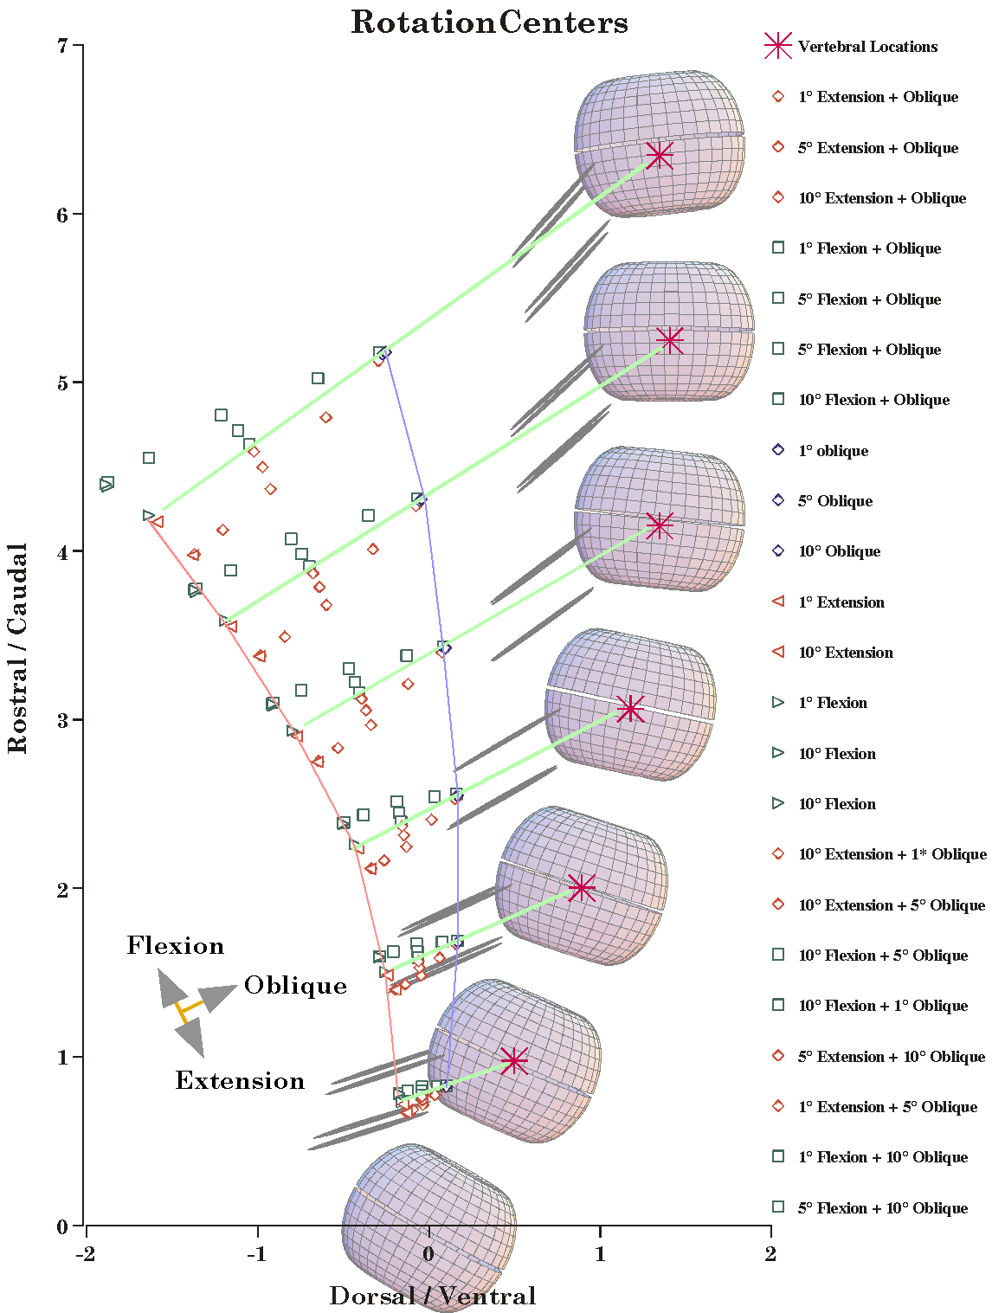
The Centers of Rotation for Uniform Movements in a Normal Lower Cervical Spine. The centers of rotation in the midsagittal plane are plotted relative to the centers of the vertebrae (large red asterisks). The broken blue line connects the centers of rotation for oblique rotation and the broken red line connects the centers of rotation for small salaam movements. See text for details.
If the movement is flexion or extension, then the centers of rotation lie more dorsal and caudal. The centers of rotation for salaam are the most dorsal points in the plot. They lie near the broken red line. Unlike oblique rotation, the points are not tightly clustered. They spread along a line that is roughly aligned with the red line segments. For small excursions (1°) the points lie close to a line from the center of the vertebra through the points for purely oblique movements. Let that line be designated as the center line for the vertebra. Larger excursions (5° and 10°) have centers of rotation further from the center line. Flexion moves the center of rotation rostrally and dorsally; extension moves it caudally and ventrally.
For rotations that are equal parts salaam and oblique rotation, the centers of rotation lie about midway between the centers for salaam and for oblique rotation. They are also spread out along a axis roughly perpendicular to the center line. Larger excursions cause the centers of rotation to be further from the line.
A few calculations were done with combined salaam and oblique rotation in different proportions and the centers of rotation are displaced as one would expect. Proportionately greater oblique rotation moves the center toward the vertebral body, more salaam moves it away. Flexion moves it rostrally and extension moves it caudally.
Since 10° is about as large as any movement that occurs in the lower cervical spine, the plotted points probably enclose the area where one might reasonably expect to find centers of rotation in the lower cervical spine. For each joint, the distribution of centers of rotation occupies a roughly triangular area with curvilinear upper and lower margins. The dorsal base of the triangle is also curvilinear, but it switches from bulging out in the more caudal joints to sucking in a bit at the C2/C3 joint. The area of the distribution increases dramatically for more rostral joints.

Rotation Centers for Pure Salaam
The centers of rotation for salaam in figure 1 are actually not pure salaam. Either a hundredth or a thousandth of a degree of oblique rotation is added to each flexion and extension. It turns out that the size of the oblique component does not change the center of rotation significantly, as long as it is small. Adding the oblique rotation forces a solution that is consistent with oblique rotation, without causing appreciable displacement of the center of rotation from what would be expected from salaam alone. The reason for adding the trace of oblique rotation is that pure salaam leads to an alternate solution for the center of rotation. While the computed centers of rotation for pure salaam are valid solutions, they are discontinuous with all other solutions. They do not allow for oblique rotation.
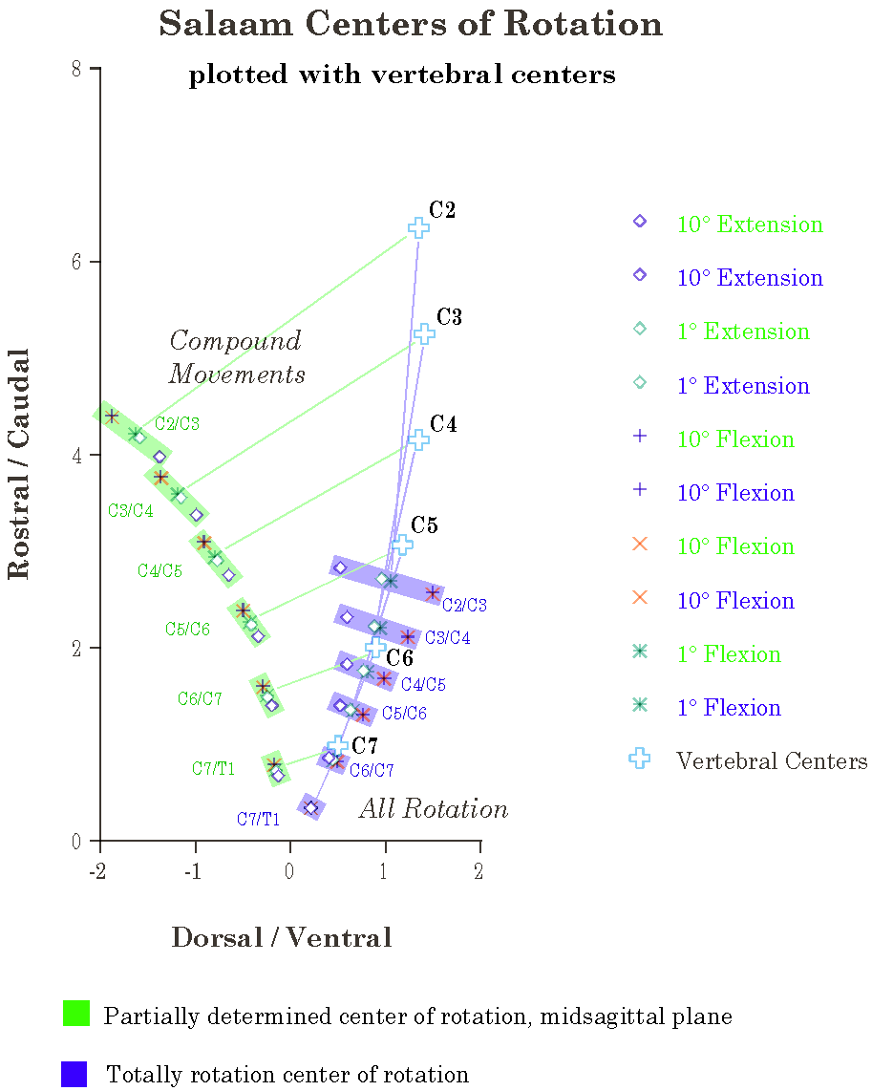
Centers of Rotation When the Movement is Salaam With Slight Obliquity. The centers of rotation in the blue streaks are for rotation-only solutions. The centers in the green streaks are the equivalent compound movement solutions. The rotation-only solutions extend dorsal (extension) and ventral (flexion) to the axis of the vertebral bodies. They are distributed caudally in the vertebral column. The transformation associated with the compound movement solution rotates and translates the centers of rotation.
Since pure salaam is confined to the midsagittal plane, it is also appropriate to use the rotation only solution for the centers of rotation. Those centers are illustrated in the second figure. They lie near the vertical axis of the lower cervical spine, with the centers for flexion ventral to the axis and the centers for extension dorsal to the axis.
The centers of rotation alone lie very low in the spine. The centers for the C2/C3 joint lie caudal to the center of the C5 vertebra. The transformation that moves the center of rotation of oblique and combined movements into the midsagittal plane rotates and translates the centers for salaam into the configuration illustrated in the first figure, where they are consistent with all other movements.
There are all rotation solutions for oblique and combined movements, but the centers of rotation spread out of the midsagittal plane in a curvilinear array that intersects the midsagittal plane as indicated by the points in the blue bands in the above figure.
The centers for all rotation solutions for salaam appear to lie in a straight line, as far as can be told from the use of a straightedge. There is a slight bending of the line in the midsagittal solution. The transformation rotates and translates the points in a consistent, but non-linear manner.

Straight Spines
The calculations represented in figure 1 are artificial in that they assume the same rotation in every joint and, in the case of the 10° rotations, they may exceed the normal range of movement in many of the joints. The next set of calculations are even more artificial in that we assume a straight neck. However, simplifying allows one to see how the anatomy influences the movement.
In a straight neck the pattern of centers of rotation is similar except that the line that connects the centers of rotation for oblique rotations is a straight line. The centers of rotation for salaam and combined movement are nearly straight, but bowed slightly towards the vertebral body centers at the middle levels, meaning that the centers are placed slightly dorsal from where one would expect to find them based on more caudal joints. The spread of the points with salaam is still not orthogonal to the center lines. The spread for salaam has the flexion points more dorsal than the extension centers. The combined movements with equal salaam and oblique rotation have a distribution of centers of rotation that is curvilinear.
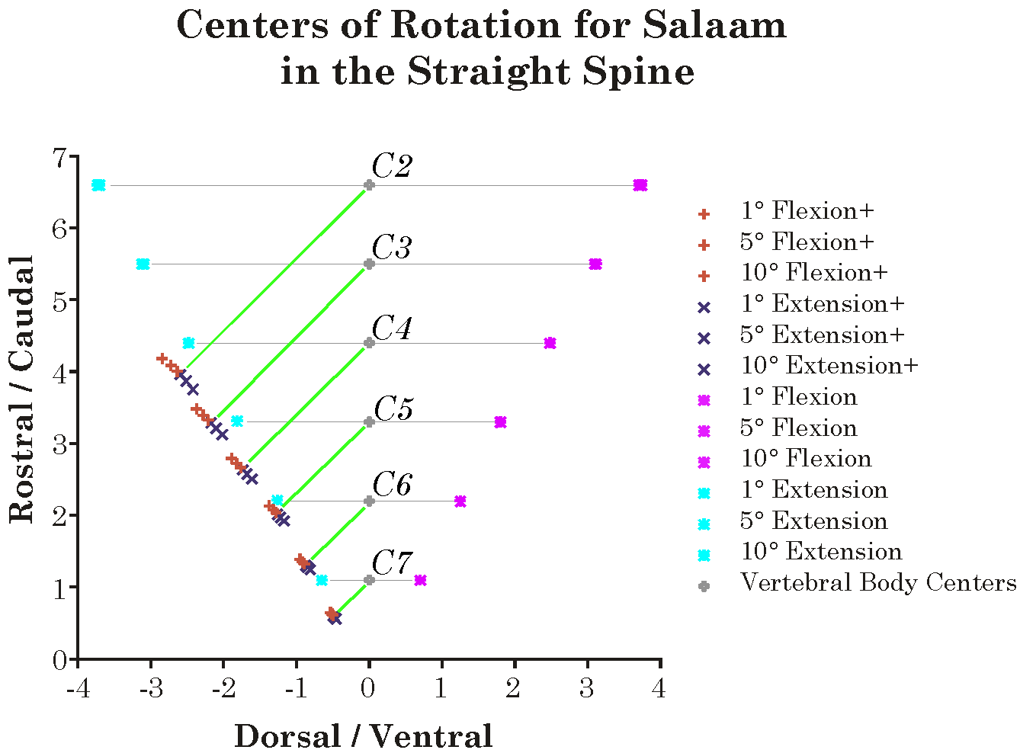
Centers of Rotation for the Straight Spine. In the straight spine, the vertebrae form a vertical spine. There are two solutions for the centers of rotation. The first set (Flexion+ and Extension +) have a very small obliquity in addition to the salaam movement. Their centers of rotation are comparable to those for other movements. The other set have no obliquity and they are directly dorsal and ventral to the centers of the vertebrae in a linear array that extends away from the spine at more rostral levels.
The center lines are all at a 45° angle from vertical, which means they are at a 45° angle to the vertical axis of the vertebra. In the normally curved spine, the angle of the central line to the vertical axis of the vertebra is 45° for C7/T1 and increases to 60° for C2/C3. It adds about 3° for each successive joint.
If the extension between vertebrae is set to 10°, rather than 6°, then the angle between the vertical axis of C7 and its center line is still 45°, but the difference between successive center lines is 5°. It would appear that the C7 center line is set by the obliquity of the oblique axis of rotation, in these cases set to 45°, and the steps between center lines is half the extension between successive vertebrae.

Directions of Center Lines Relative to the Vertebral Vertical and the Universal Vertical

Center line | Angle to Vertebral Vertical (degrees) | Angle to Universal Vertical (degrees)
C2 on C3 | 60 | 54
C3 on C4 | 57 | 57
C4 on C5 | 54 | 60
C5 on C6 | 51 | 63
C6 on C7 | 48 | 66
C7 on T1 | 45 | 69
We can check the dependence upon the oblique axis of rotation by changing it and re-computing the center lines for the usual configuration with 6° of extension. The obliquity of the oblique axis was set to 60° and the C7 center line was 60° from the vertical axis of the vertebra. The steps were 3°, as with the normal spine. Several other choices of obliquity for the oblique axis give much the same result. The inclination of the C7 center line is equal to the obliquity of the facets and the step change between center lines is half the extension between successive vertebrae.

Rotation-only Salaam Movements
In the straight spine the salaam only movements have centers of rotation that lie directly ventral (flexion) and directly dorsal (extension) to the centers of the vertebrae. The centers are on a straight lines at about a 30° angle to the vertical axis. The addition of a miniscule amount of oblique rotation (0.001°) forces the solution to include the possibility of oblique rotations and the centers are as described above. The salaam-only solution gives the same centers of rotation almost independent of the size of the rotation. There is a small variation at the most rostral levels of the spine. The salaam + oblique solutions are spread out. It was noted above that the rotation-only solutions were also spread out as a function of rotation size.

The Translation Component
As part of the calculation of the center of rotation there is commonly a translation as well as a rotation. Most movements that carry a vertebra out of the midsagittal plane will introduce a translation in the plane of the rotation. In the previous sections it was shown that even compound movements in the midsagittal plane introduce translations. In fact, the translations for extension are comparatively large ones.

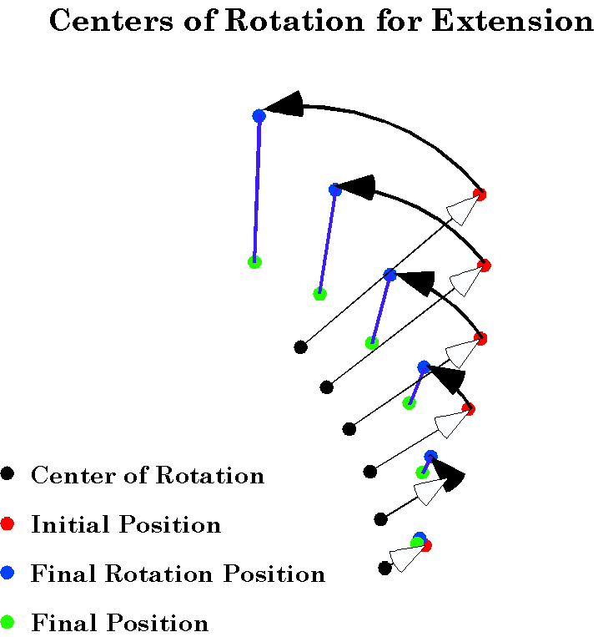
The Compound Movement Components of Extension from Neutral Position. The compound movement that yields a 10° extension in every joint is composed of a rotation (black arrow arcs) and translations (blue lines).
The above figure illustrates the rotations and translations for 10° of extension in every joint. Note that the translations are substantial for such movements. In fact, the translations are generally greater for salaam than for oblique or combined movements. As stated above that is largely due to the necessity of maintaining the possibility of oblique rotation. The rotation only salaam movements have no translation, by definition. Curiously, the pure salaam combined movements have even larger translations than salaam with slight obliquity.
In flexion, there are large translations in the midsagittal plane, 3.83 units for C2 with 10° of flexion. For 1° of flexion there is proportionately less, 0.32 units at C2. Flexion does not cause axial translation. That is expected, since the axis of rotation is perpendicular to the midsagittal plane.
Extension is similar except that there is substantially less translation in the plane of rotation, 2.42 units at C2, and proportionately more at small amplitudes of rotation, 0.31 units with 1° of rotation. There is no axial translation, for the same reasons as for flexion.
With oblique rotation, there is minimal axial translation at C2, 0.002 units with 10° of oblique rotation in every joint. Planar translation is also comparatively small, as well, 0.28 units at C2 after 10° of oblique rotation in every joint. There is essentially no translation with 1° of oblique rotation, 0.0029 units at C2.
When there is a combination of salaam and oblique rotation, then there is an intermediate amount of translation, but there is more axial translation. For 10° of flexion and 10° of oblique rotation in each joint, there is 3.89 units of planar translation and 0.34 units of axial translation. Since these are orthogonal to each other, the total translation is 3.94 units. Similarly, for 10° of extension and 10° if oblique rotation in every joint, the axial translation is 0.31 units and the planar translation is 1.76 units, for a total translation of 1.84 units of translation. That is substantially less than for 10° if extension alone.
The ratio between the amount of axial and planar translation is not constant from level to level. For extension, the relative amounts of planar and axial translation is about 10 to 1 for the more caudal joints, but drops to about 6 to 1 for the two most rostral joints. Similar calculations for different combinations of salaam and oblique rotation do not reveal a simple relationship between the axial and planar translations at different levels of the spine. The amount of axial translation is always substantially less than the amount of planar translation.

Non-uniform Movement in the Lower Cervical Spine
Indications from imaging studies are that the amount of movement in the intervertebral joints of the lower cervical spine depends upon the level considered. The greatest movement occurs to either side of the C5 vertebra and progressively less is allowed in each successive intervertebral joint as one moves either rostrally or caudally. In modeling the lower cervical spine, the movements have been divided as follows:

Joint Level | Salaam | Oblique
C2/C3 | 5° | 5°
C3/C4 | 7.5° | 7.5°
C4/C5 | 10° | 10°
C5/C6 | 10° | 10°
C6/C7 | 7.5° | 7.5°
C7/T1 | 5° | 5°
Actual necks may differ from this arrangement, but it gives a realistic looking spine in all configurations. Small variations from this pattern will probably have minimal effect upon the features of the neck’s movements that are considered here. For succinctness of description, the above distribution of movements among the joints of the lower cervical spine will be called natural movement. Uniform movement is used to mean the situation where the same movement occurs in every joint.
When natural movement occurs in the extension and oblique directions, then the centers of rotation are displaced relative to their positions in any uniform movement. Unexpectedly, the differences are greatest for the middle vertebrae. At the most rostral and most caudal levels, the center of rotation is close to the centers for the uniform movements.

Summary
This paper has considered a number of problems in the description of the combined movements of the lower cervical spine. It is just a start in that direction and it is not clear that it is a profitable direction in which to proceed. The division of the movements into rotational and translational components is in many respects artificial, much like the division of movements into the cardinal movements of flexion/extension, sideflexion, and lateral rotation.

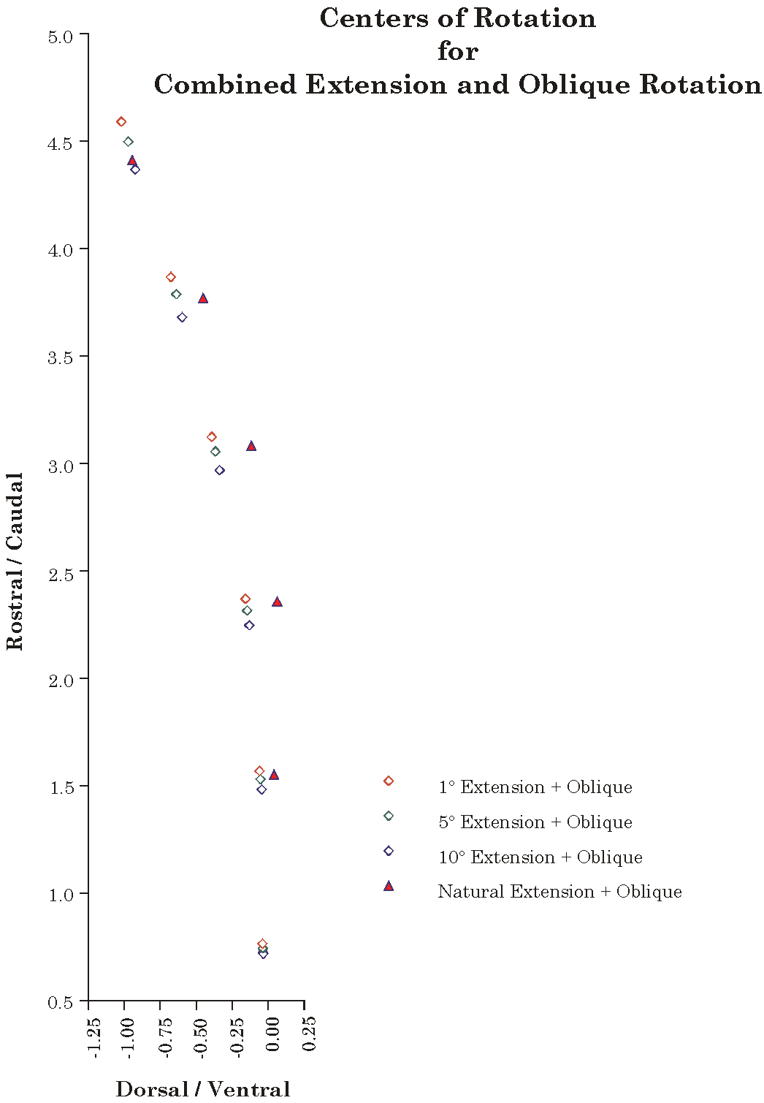
Comparison of Natural Movements versus Uniform Movements. When the movement in the joints varies from joint to joint, the centers of rotation are displaced ventrally.
The process does capture certain elements of the movements and allows one to compare movements of different types on a common framework. However, the question remains of whether constraining the centers of rotation to the midsagittal plane is valid. If one is examining movements to or from configurations other than neutral position, then the center of rotation would have to lie in another plane. Still, there is a possibility that a regularity much like Listing’s plane for eye movements may be developed for other movements and an approach involving compound movements may be the means of describing the movements.
The use of fractionation of movements is largely to help to convey the nature of the movements to others and to develop a means of encapsulating the movements in a quantitative form that may be manipulated. The true description is naturally that given by the full model. As indicated by some of the parenthetical remarks in the text, these movements have been examined in a more free-form analysis, directly from the output of the model and the character of the movements may be seen in many ways. For instance, the rotation-only solutions for the centers of rotation of oblique and combined movements takes one off into curvilinear trajectories that pass though the midsagittal plane only for pure salaam movements.
There is still a great deal of room for experimentation with the model of the lower cervical spine. It may be some time before we settle on a set of measurements that convey the attributes that seem most relevant to the movements of the neck. Presently, the model is useful as a rich source of ideas about how the anatomy of an assemblage may be reflected in the movements of its components and of the assemblage as a whole. It is often helpful in understanding the basis of a movement if one can study situations that do not occur in life, such as straight necks and necks that have the same movement in each joint. That is possible only in models such as the one used here, where one can reach in a tweak the structure in various ways and examine the consequences of the changes.

