Why does sideflexion increase ipsilateral vertebral artery occlusion with contralateral atlanto-axial rotation?

Thomas Langer

Introduction
When the head and neck are placed in the premanipulative position for C1/C2 mobilization, that is, passively sideflexed with the atlas manually rotated in the contralateral direction, the artery that lies in the direction of the sideflexion generally experiences more occlusion than in any of the standard vertebral artery stress tests [Arnold, 2003]. Reduced blood flow or arterial occulsion is almost certainly an indicator of stress in the vertebral artery, especially when produced by stretching the artery. Compared with the standard stress tests, the premanipulative hold is most stressful position. These observations lead naturally to the question that heads this essay. Answering that question is the principal goal of this paper. It will be argued that the relaxation of the alar ligament by the sideflexion is the critical factor in allowing the stretching that occludes the vertebral artery.
One may start by noting that the critical stress is most apt to occur in the C1/C2 segment of the vertebral artery and the largest movement in the atlanto-axial joint is lateral rotation, which far exceeds movement at any other spinal level [Levangie, 2001 #10; Nordin, 1989 #13]. It causes crimping, stretching, flattening, and pinching of the vertebral artery at that level [Langer, 2004 #23]. Therefore, it is probably increased lateral rotation that is responsible for the strikingly reduced blood flow with contralateral rotation in ipsilateral sideflexion.

Why the alar ligament?
Movements in the atlanto-axial joint are almost entirely restricted to an axis of rotation that passes vertically through the odontoid process, therefore, it is likely that the increased stress is due to the relaxation of the restraints upon lateral rotation. Rupture of an alar ligament allows 30% more contralateral lateral rotation in that joint [Dvorak, 1988 #5], therefore, probably the alar ligaments that are restricting contralateral lateral rotation. Consequently, the first place to look for relaxation of restraints upon lateral rotation in the C1/C2 joint is reduction of the distance between the attachments of the alar ligaments.

Anatomy of the alar ligaments
Alar ligaments may have several parts. The thickest and longest part is the thick bands that pass between the odontoid process and the foramen magnum. They pass about 11 millimeters horizontally and laterally from the longitudinally ovoid flattening of the posterolateral aspect of the odontoid process to the roughened inner margin of the foramen magnum, medial to the occipital condyles [Williams, 1995 #17]. Measurements of the distance between the two occipital attachment sites in several skulls give a consistent 2 centimeters. The odontoid process is about a centimeter wide and the odontoid attachment sites for the alar ligaments are about two to three millimeters to either side of the midline. These numbers indicate that a ligament that is about 11 centimeters long bridges a gap that is about seven centimeters wide, in neutral position. Therefore, the ligament will allow the gap to increase to about 50% more than its width in neutral position.
There are often additional short bands (~3 millimeters long) of the alar ligaments that extend from the anterior inferior margin of the odontoid attachment to the lateral masses of the atlas, where they attach anterior to the transverse ligament. These ligaments do not appear to restrict normal lateral rotation of the atlas upon the axis. Finally, a few fibers in the alar ligaments may extend over the apex of the odontoid process to attach to the anterior arch of the atlas. The last two ligaments are not apt to be affected by sideflexion, since the atlas does not sideflex to any appreciable extent upon the axis. If it did, these attachments are very near the potential axis of rotation, therefore would not be significantly affected. That leaves the major band of the alar ligaments, the part that bridges the gap between the axis and the occiput, as the prime agent preventing undue stress upon the vertebral arteries.

The AAOA Joints
The alar ligaments pass from the axis to the occiput, leaving the atlas free to move as needed in the two intervening joint complexes. Superiorly, the atlas is the foundation for the atlanto-occipital joint and inferiorly it rotates upon the axis in the atlanto-axial joints. Its role in the each joint complex is quite different from that in the other.
In the atlanto-occipital joint, the atlas is the base that the occiput moves upon. The joint is compound with two separate joint spaces, one to either side of the vertebral canal. Because of the shapes of the occipital condyles and the superior articular facets of the atlas, the principal movement in the joint is in the sagittal plane, that is, flexion and extension. It is hard to find consistent numbers for the amount of flexion and extension in the atlanto-occipital joint. They may be highly individual, depending upon the normal rest position and the anatomy of the region for each person. The total range is usually set at about 15° to 25°. In addition, there is a small amount of sideflexion and lateral rotation in the joint. Once again the ranges vary from study to study. They range from 3° to slightly more than 5° of rotation. It is common observation that there is substantially less play in the joint and the entire AAOA joint complex when the head is in endrange flexion or extension. These are called the "close-packed positions".
The atlanto-axial joint is also compound, being composed of a median joint and two lateral joints. The median joint has two parts, one that lies between the anterior surface of the dens and the posterior surface of the anterior arch of the atlas and a second that lies between the posterior surface of the dens and the transverse ligament. This joint restricts the odontoid process to a space formed by the anterior arch of the atlas, anteriorly, the two lateral masses of the atlas, laterally, and the transverse ligament, posteriorly. The transverse ligament bridges the gap between the two lateral masses. The second component of the atlanto-axial joint is two lateral joints, between the inferior facets of the atlas and the superior facets of the axis. These joints are almost planar, but tilted so that the lateral margins lie inferior to the medial margins. The joints are effectively two segments of interlocked cones, like one funnel inside another. In addition to their sloping shoulders, the bony elements of the lateral joints are slightly convex in a sagittal plane and slightly concave in a coronal plane. Still, when viewed face-on in an x-ray image, the most striking attribute of the lateral joints are their obliquity.
Because of the configurations of the atlanto-axial joints, the principal movement in the joint is lateral rotation about a vertical axis through the odontoid process. There is some play in the joints that will allow a small amount of sagittal movement, about an axis through the dens and, also, about an axis though the center of the vertebral canal. The former produces a rocking movement and the latter, a sliding movement, in the median atlanto-axial joint. These sagittal movements will be ignored from here on.
It is often argued that there is a small amount of approximation between the atlas and the axis as they approach the endranges of lateral rotation. This is thought to be due to their superiorly directed convexity in the sagittal plane. Estimates are that the distance between the atlas and axis may be as much as 3 to 4 millimeters less at the end of range. The gap between the two vertebrae can be computed from x-ray images and it is probably between 2 and 3.5 millimeters in neutral position ( from Grants's Atlas[Fig. 4.16] and Grays Anatomy [Fig. 6.96 ]), therefore it is hard to see how 3 to 4 millimeters of approximation by compression is possible. It more likely comes from the cones that approximate the joint surfaces being elliptical in cross-section, broadest when in neutral position. The following model will also generally ignore the approximation of the atlas and the axis.

Role of the Alar Ligaments in the AAOA
The alar ligaments are the limiting constraint upon lateral rotation in the atlanto-axial joint. Rupture of an alar ligament allows about 30% more contralateral rotation in that joint (Dvorak and Panjabi, `87). The normal range of lateral rotation is about 45° to either side, therefore, with a ruptured alar ligament it would be about 60°. At that point the restraint is probably from structures other than the alar ligaments, such as abutment or capsular or longitudinal ligament strain, or muscle strain. This is a functionally important constraint, because at 60° of lateral rotation the posterior arch of the atlas is beginning to impinge upon the spinal cord.
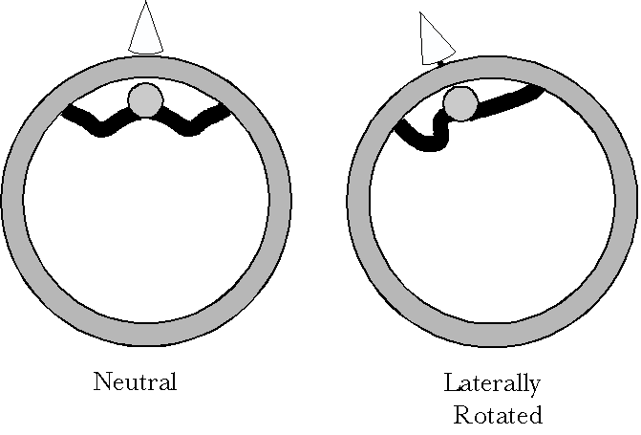
Left lateral rotation increase the right alar gap and reduces the left alar gap.
With ipsilateral rotation of the atlas upon the axis, the occipital end of the alar ligament is moving posterior to the odontoid process and the odontoid attachment of the alar ligament is posterior to the axis of rotation, therefore the distance between the two attachments is decreasing, so, the alar ligament is not an effective restraint upon ipsilateral rotation.
In contralateral rotation, the situation is reversed. The odontoid attachment is posterior to the axis of rotation, but the occipital attachment is moving anterior to it, so the ligament wraps around the superior end of the dens. This effectively increases the gap between the two ends of the ligament and must ultimately reach the point where the ligament is taut and will not stretch further.
It would appear that there is an interplay between the point of attachment of the alar ligament to the inner margins of the occipital condyles and the length of the ligament. Moving the attachment site posteriorly will increase the excursion before the ligament begins to wrap around the odontoid process. Also, making the ligament more lax will allow more rotation before the ligament becomes taut.

The Alar Ligament and Sagittal Movements in the Atlanto-occipital Joint
Where the alar ligament attaches to the occiput may be important to its participation in flexion and extension in the atlanto-occipital joint The site of attachment, some distance away from the center of rotation for the occiput, causes occipital attachment site to travel as the sagittal rotation occurs. The attachment of the alar ligament is such that it will travel posteriorly with flexion and anteriorly with extension. These movements will tend to increase the gap between the two ends of the alar ligament.
The gaps when the occiput is in neutral position allow both ligaments to be relaxed. In that position, there will be greater lateral rotation in the atlanto-axial joint and more rotatory play in the atlanto-occipital joint. That is, it should be possible to sideflex and/or rotate the occiput upon the atlas. As the head is flexed or extended, the gap between the attachments of the ligament will increase, eventually causing the alar ligament to become taut. In those positions, there should be no rotatory play in the joint and also no contralateral rotation. In effect, moving the head into endrange flexion or extension pulls the three bones into a compact, unitary array, which moves as a unit.
The occipital placement of the alar ligament will determine the relative amounts of flexion and extension in the atlanto-occipital joint. Placing it more anterior will reduce flexion and increase extension and placing it more posterior will reduce extension and increase flexion. Placing the occipital attachment further from the center of rotation will decrease total excursion and closer will increase it.

Sideflexion of the Occiput
Sideflexion of the head will approximate the medial margin of the foramen magnum to the odontoid process, on the side where the margin is moving medially . Normally, occipital sideflexion is a very small movement. Dvorak estimated it to be about 3°, but that was under voluntary control [Dvorak, 1988 #5]. With manual overpressure and with the atlanto-occipital joint near neutral position, it is possible that the available movement is greater. When the atlas is manually rotated upon the axis, the atlanto-occipital joint is generally locked in sideflexion, so that the head can be used to help control the movement of the atlas into lateral rotation. A five degree rotation of a 40 millimeter long armature will move it 3.5 millimeters. Therefore, sideflexing the occiput 5° will decrease the gap between the dens and the medial margin of the occipital condyles about that distance on the side where the occiput is approaching the dens. It will increase it an equal amount on the opposite side. That is about all the slack available in the alar ligament.
It is found that when an alar ligament is ruptured, the increase in lateral rotation is towards the contralateral side. Consequently, with relaxation of an alar ligament, we would expect that there could be a greater contralaterally directed lateral rotation. Contralateral lateral rotation is the most stressful of the cardinal or combined movements of the head and neck for the vertebral artery [Langer, 2004]. Increasing its range it would increase the stress upon the vertebral artery.

The Role of the Alar Ligaments in AAOA Movements
The transverse ligament is important in that it holds the dens in the notch between the lateral masses of the atlas and prevents the atlas from slipping anteriorly upon the axis. The anterior and posterior longitudinal ligaments and their extensions into the craniovertebral junction may offer some binding of the vertebral elements into an assemblage, but, because of the unusually large amounts of movement in these linkages, the ligaments probably do not become restrictive until the movements go well beyond normal range. The posterior atlanto-occipital and atlanto-axial membranes close the vertebral canal, but as with many of the other ligaments and capsules in this region, they are adapted to allow large excursion movements.
The alar ligaments seem to be the exception. They do allow large movements, but, largely due to their location, near the centers of rotation. They also seem to restrict movement in each joint and in the complex as a whole. They provide a cross-interaction, so large movements in one joint will reduce movement in the other. At the extremes of flexion and extension, there is little lateral rotation and at the extremes of lateral rotation, there is little flexion or extension. By compressing the joints, the alar ligaments reduce the play in the cranio-vertebral assembly.

Quantification: Using the Model of the AAOA
Up to this point the analysis is just a likely story, based on the known anatomy and plausible hand-waving. It is now necessary to translate the anatomy into a form that can be quantitatively manipulated to determine if the scenario presented here is consistent with the anatomy. To explore the anatomical logic, the anatomy has been expressed as a set of framed vectors and quaternions that model the movements of the AAOA [Langer, 2004]. This model is now applied to the particular question under consideration here; the role of the alar ligaments in the restriction of lateral rotation in the atlanto-axial joint.

Methods

Introduction to AAOA Model
The details of the model used to compute the movements of the axial-atlanto-occipital assembly have been given elsewhere [Langer, 2004]. Only the essential elements of the model are reviewed here.
There are three orientable elements in the upper cervical assembly: the occiput, the atlas, and the axis. They all have single centers of rotation in this model. The axis is the platform for the assembly and it may move about any or all of three orthogonal rotation axes, because of its location at the superior end of the lower cervical spine. Its rotation quaternion lies in the center of its vertebral foramen and rotations are entered as three rotations: flexion/extension (~ 45° in both directions from neutral position), sideflexion (~ 90°, bilaterally), and lateral rotation (~ 45°, bilaterally), combined mathematically to form a single rotation quaternion.
The atlas has a single axis of rotation, about a vertical axis through the odontoid process, which allows about 45° of lateral rotation to both sides. There are additional small rotations: flexion/extension (~10°) about a transverse axis through the head of the odontoid process, a helical screwing movement associated with lateral rotation (~3-4 mm vertical excursion), but these are ignored here.
The movements of the occiput upon the atlas are considered to occur about three orthogonal axes that have a common point of intersection within the skull. The flexion/extension movement about a transverse axis has the greatest excursion (~15° - 25° total). Sideflexion may be as much as 5° to either side and lateral rotation may be 7° to either side. Lateral rotation may be a more complex movement than considered here, involving two component rotations about different axes of rotation. The second, smaller, lateral rotation, which occurs about the dens, is not treated here.
These parameters are the basic model that is used for the computations of the movements that occur in the axial-atlanto-occipital assembly (AAOA).

The Neutral Position and Orientation of the Elements
The center for the assembly is taken to be a hypothetical point about the middle of the vertebral canal at the level of the body of the atlas. That point is called the Q-point. All measurements are scaled to the anterior/posterior depth of the atlas. The anterior/posterior extent of the atlas is 2 units or 40 millimeters. The Q-point lies midway between the two limits.
The framed vector for the atlas has six component vectors. The center of the atlas [1] is taken to lie a quarter unit superior to the Q-point. The center of rotation [2] is taken to be through the middle of the odontoid process, about a half unit from the anterior limit, in the horizontal plane of the Q-point. The rotation axis [3] is vertical. The neutral orientation [4, 5, 6] is aligned with the standard universal coordinates for the body (anterior, left lateral, and superior).
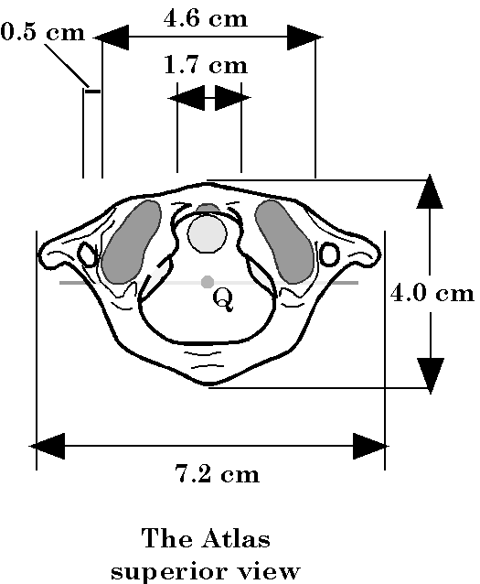
Dimensions of a typical atlas vertebra. The Q point is the center of the coordinate system used in the model.
The framed vector for the axis also has six component vectors. The center of the axis [1] is taken to lie a half unit inferior to the Q-point. The center of rotation [2] is taken to be through the center of the axis. The rotation axis [3] is initially vertical, but it may be in any direction within the anatomical limits. The neutral orientation [4, 5, 6] is aligned with the standard universal coordinates for the body.
The framed vector for the occiput has eight component vectors, because it has three orthogonal axes of rotation. The center of the occiput [1] is taken to lie two units superior to the Q-point. The center of rotation [2] is taken to be at the center of the occiput. The rotation axes are transverse [3], sagittal [4], and vertical [5]. The neutral orientation [6, 7, 8] is aligned with the standard universal coordinates for the body.

The Calculation
All the models used were programmed in Mathematica and most of the data from the calculations was plotted in that software environment. The conversion between the units used for the AAOA model, which is expressed in multiples of the distance between the anterior and posterior tubercles of the atlas, and actual measurements in millimeters is based on measurements of several atlas vertebrae. Those measurements are summarized in the above figure.
The movements of the occiput, atlas, and axis relative to each other are incorporated in a Mathematica function. The new configuration is computed by calculating the rotation quaternions at the centers of rotation for the individual elements. First the rotation of the occiput is computed and applied to the occiput, then the rotation of the atlas is computed and applied first to the atlas and then to the occiput. Finally the transformation of the axis is computed and passed back up the assembly to the atlas and occiput. Each rotation propagates through the chain of bones.
The gap between the two attachments of the alar ligaments are computed in a second function that invokes the first function to obtain the configuration of the AAOA. The aspects of the calculations that are passed in this model are the frames of reference for each vertebra. From the frame it is straight-forward to compute the locations of the attachments of the alar ligaments in space. From their locations it is easy to calculate the gap between the ends of the ligaments and determine if it exceeds the length of the ligament.
It is possible to alter the functions to explore the consequences of different anatomical relationships between the elements. In the present context, the locations of the attachment sites for the alar ligament can be altered to look at the effect upon the movements in the AAOA. However, the values are usually chosen so that the alar ligament extends directly lateral in a horizontal plane.

Results

The Alar Ligaments
The alar ligament extends between the posterior aspect of the dens and the medial margin of the occipital condyles (following figure). As it does so, it lies almost directly horizontal and lateral. It may run slightly superior as it extends laterally and there may be some anterior or posterior displacement as well.
The alar ligament's attachments upon the posterior aspect of the dens are to a longitudinally ovoid depression to either side of the midline, about 1 to 5 millimeters lateral to the midline. The odontoid process is about 1 centimeter wide and 1 centimeter thick. It is somewhat flattened at the insertions for the alar ligaments, so the posterior surface is roughly triangular in cross-section. the odontoid process extends superiorly from the body of the axis for about 1.7 centimeters, so that its superior tip extends slightly above the anterior arch of the atlas. That means that the alar ligaments take origin from the dens about 15 millimeters superior to the Q point.
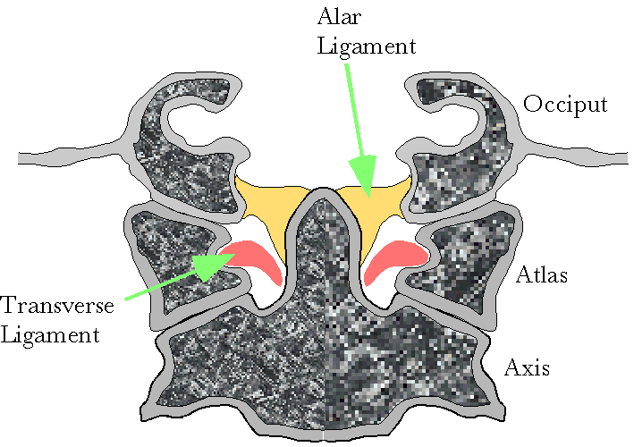
The alar ligament extends from the posterior lateral aspect of the dens to the inner margin of the occipital condyles. Usually is extends laterally and slightly superiorly from the dens to the occiput.
The occipital condyles rest upon the superior articular facets of the atlas and are roughly co-extensive with them when the head is in neutral position. The lateral insertion of the alar ligaments lies medial to the occipital condyles, about a centimeter from the midline. It may be identified by an irregular depression on the inside margin of the foramen magnum. The curvature of the condyles is such that the axes of rotation for sagittal, rolling, and turning movements all intersect in a point about 40 millimeters superior to the Q point in neutral position. This may be subject to variation between individuals.
The alar ligaments are lax when the occiput is in neutral position and they become taut as it approaches endrange extension or flexion. It will be assumed that the length of the alar ligaments is about 11 millimeters ( Grays Anatomy, p. 522). This also may be variable from person to person.
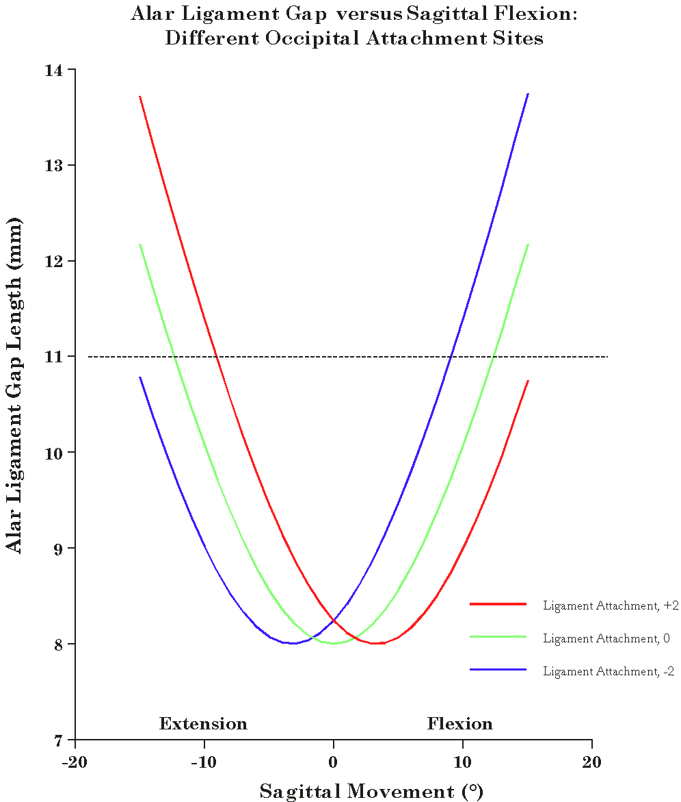
The placement of the alar ligament insertion into the inner margin of the occipital condyle will affect the relative amounts of flexion and extension. The horizontal line at 11 millimeters of alar gap indicates the point at which the alar ligament becomes taut.

Sagittal Rotation in the Atlanto-occipital Joint
With the model, one can compute the amount of sagittal rotation that is possible before the ligaments become taut. Substitution of a variety of values in the parameter for sagittal rotation indicates that about 12° in each direction is possible before the ligament length exceeds 11 millimeters (,green line). While that was not built into the model explicitly, it is in agreement with the actual observation that the total range is about 15 to 25 degrees. Placing the occipital attachment 2 millimeters more anterior reduces the extension to 9° and increases the flexion to 15° (red line). Moving it 2 millimeters further posterior increases the extension to 15° and decreases the flexion to 9° (blue line). Making the alar ligaments extend 5 millimeters superiorly as they run laterally reduces the range, to 9° in each direction or a total of 18°. One can readily appreciate that an AAOA with a superiorly directed alar ligament would tend to draw the occiput and atlas together as they approached end range of flexion or extension, because one would get slightly more range by drawing the dens up towards the occiput and making the alar ligament more horizontal. Note that both ligaments are affected comparably with sagittal movements in the atlanto-occipital joint.

Coronal Rotation in the Atlanto-occipital Joint
A second way that the occiput can move upon the atlas is sideflexion. It turns out that this is very relevant to understanding the effectiveness of the premanipulative hold in obstructing blood flow in the vertebral arteries. Therefore, let us look briefly at the consequences of sideflexion in the atlanto-occipital joint.
If the occiput is sideflexed 3°, then the ipsilateral gap for the alar ligament goes from about 8 millimeters to about 6 millimeters and the contralateral gap becomes almost 10 millimeters. If we play with the sideflexion until the contralateral gap is 11 millimeters, that is the ligament is taut, then the ipsilateral gap is 5 millimeters. Normal sideflexion is estimated to be about 3°, but that is voluntary sideflexion. If the occiput is passively sideflexed until the joint is locked, then it is quite possible that the movement is nearer 5°. If the head is sideflexed in the atlanto-occipital joint and then laterally rotated contralaterally in the atlanto-axial joint, then it is possible for it to rotate substantially further before the alar ligament becomes taut. This will be considered below.

Horizontal Rotation in the Atlanto-occipital Joint
The next step is to modify the program segment to allow one to compute an array of alar ligament gap lengths for different amounts of lateral rotation in the atlanto-axial joints. It is possible to voluntarily laterally rotate one's occiput in the atlanto-occipital joint, probably by about 5 to 6 degrees in either direction, however, this movement is much less than occurs in the atlanto-axial joint, which is about 45° in either direction. In most ways the atlanto-occipital rotation is like that in the atlanto-axial joint. The two rotations are additive so the sum of both determines the limits of lateral rotation. What occurs in one joint complex, correspondingly reduces or increases what can occur in the other.

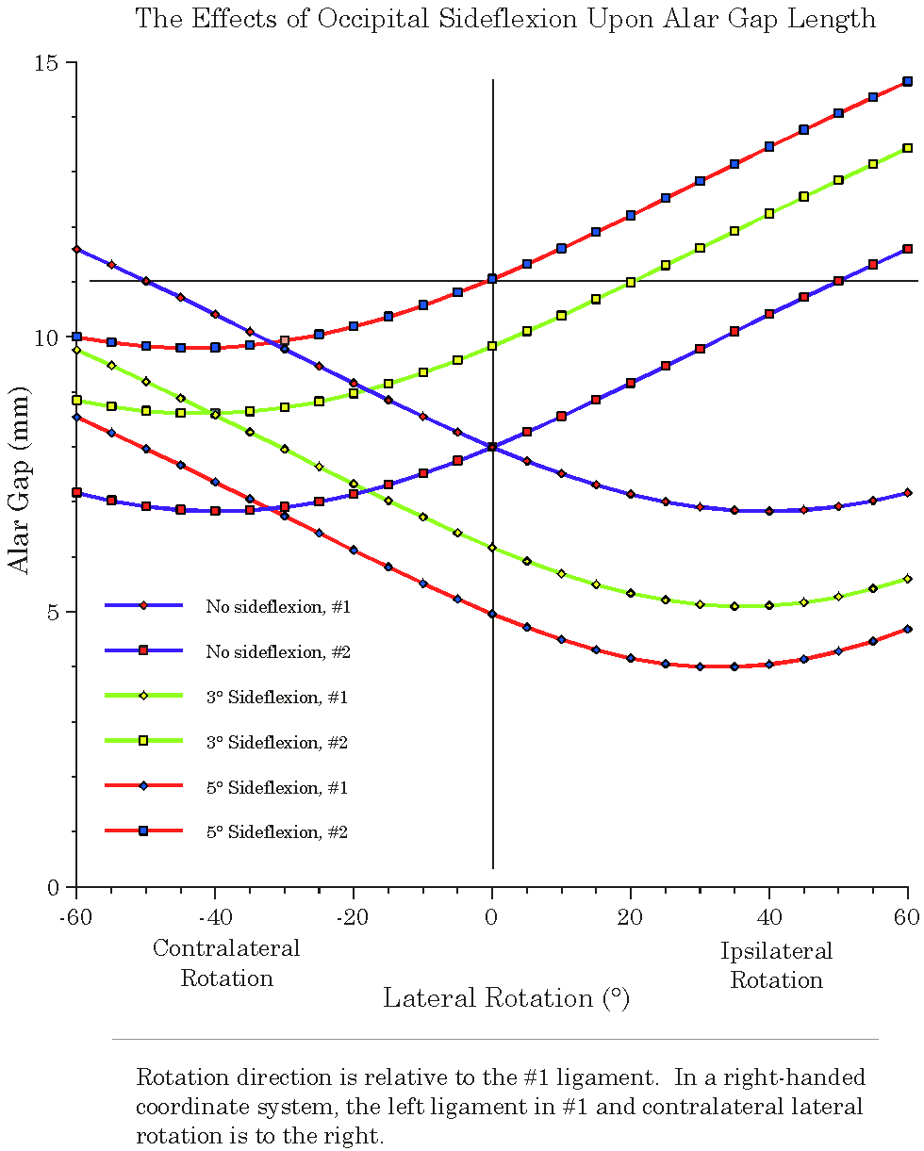
Sideflexion in the atlanto-occipital joint causes restriction of lateral rotation in the atlanto-axial joint. Rotation towards the direction of the sideflexion is reduced because of increasing of the contralateral alar gap.

Lateral Rotation in the Atlanto-axial Joint
First, consider the changes that occur in the gap between the ends of the alar ligament when the lateral rotation is performed with the atlanto-occipital joint in neural position (blue lines). With no rotation, the two ligaments are lax, with the gaps both 8 millimeters. As the atlas rotates contralaterally upon the axis (negative angles), the gap increases until at about 50° it is equal to the length of the alar ligament and the rotation would be halted by the taut ligament. If the atlas is rotating to the right, then it is the left ligament that will restrict rotation (blue line with circles). As the atlas rotates ipsilaterally (positive angles) the gap becomes smaller and so further laxity occurs in the ligament. Once the movement exceeds about 40°, the gap begins to increase again, but the contralateral ligament will stop the movement in the next few degrees in any case, so the alar ligaments do not restrict ipsilateral lateral rotation. Even if the contralateral ligament were to rupture, the ipsilateral ligament will still be lax at 60° of rotation, which is where lateral rotation stops, for other reasons.

Lateral Rotation in the Atlanto-axial joint With Sideflexion in the Atlanto-occipital Joint
If the occiput is sideflexed about 3° in the atlanto-occipital joint, it reduces the gap on one side and increases it on the other (green lines). On the side with the reduced gap, contralateral lateral rotation is not restricted by the alar ligament (green lines with diamonds). Curiously, the ligament on the side with the increased gap, which normally does not restrict the rotation, may become the limiting ligament, even though it is initially made more lax by the contralateral rotation.
Sideflexing the occiput definitely blocks ipsilateral rotation, because the ligament on the side with the increased gap, the contralateral ligament, is starting from a greater gap in neutral rotation, If the occiput has been taken to the end of ipsilateral sideflexion, then it should not be possible to laterally rotate the atlas ipsilaterally upon the axis (red line with boxes).
The increase in lateral rotation when the head is tilted can be experienced by first turning one's head as far as possible with the alignment of the occiput in neutral, then try the same movement with your occiput sideflexed. There should be an appreciable increase in range.
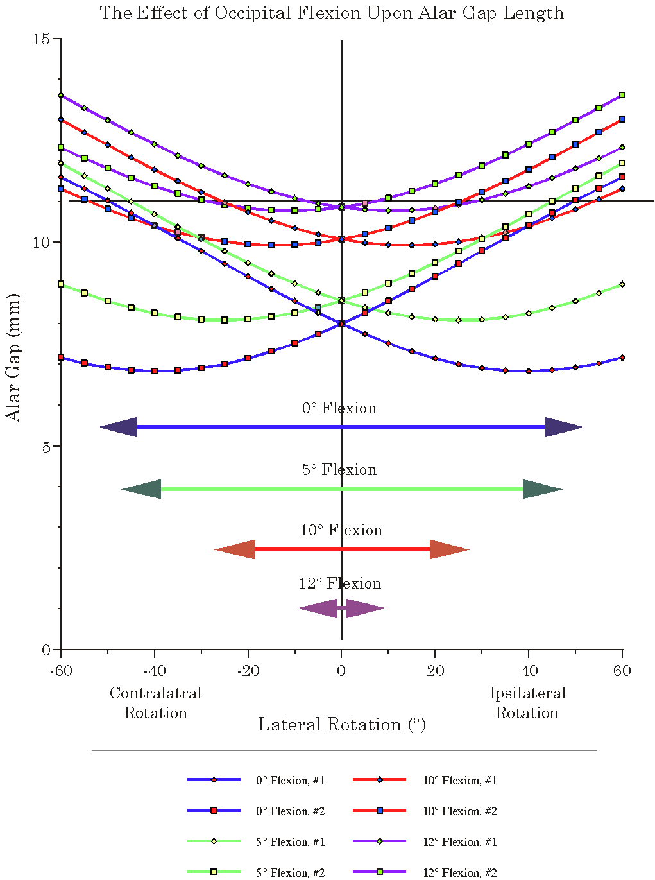
Flexion (or extension) causes a reduction in the maximal amount of lateral rotation.

Lateral Rotation in Atlanto-axial Joint With Sagittal Rotation in Atlanto-occipital Joint
If the occiput is moved into either flexion or extension, then the range of lateral rotation in the atlanto-axial joint is reduced (above figure). With no sagittal movement, the range of lateral rotation is 45-50° in either direction (blue lines). Placing the occiput in 5° of extension reduces the range to slightly less than 40° of contralateral rotation in either direction. With 10° of occipital extension, there is about 15° of lateral rotation. Flexion is less constraining. With 5° of occipital flexion there is still 45° of lateral rotation in both directions (green lines) and with 10° of occipital flexion there is still 25° of lateral rotation (orange lines). However, by slightly over 12° of flexion or extension (12.3°), there is no lateral rotation available in the atlanto-axial joint (purple lines).

Lateral Rotation with Sagittal and Coronal Rotations in the Atlanto-occipital Joint
If the occiput is rotated sagittally and sideflexed, then the ligaments are shortened enough to provide a restraint upon lateral rotation contralateral to the shortened ligament (Figure 6). For example, flexing the occiput 10° will reduce the available sideflexion to 2° and the contralateral lateral rotation to 35°. The movement is stopped by the contralateral ligament, the one that crosses the greater gap.

Summary of the Results of the Computation
The calculations relative to the alar ligaments allow one to set the configuration of the bones in the AAOA and then compute the interval between the ends of the alar ligament. By doing so, it is possible to determine how the various parameters of the AAOA configuration affect the amount of available range for rotation if the alar ligament is the restrictive agent. It indicates that tilting the head into sideflexion releases the atlanto-axial joint to rotate further into contralateral rotation, while reducing the ipsilateral rotation. If the head is sideflexed to the right, then it decreases the gap for the alar ligament on the right and increases the gap on the left. The right ligament is less restrictive of lateral rotation to the left, but the left ligament reduces lateral rotation to the right and it may, with large right sideflexion be a braking agent for left lateral rotation.

Discussion

Movements in the AAOA and stress in the vertebral arteries
Because they bridges both joints, the alar ligaments act to correlate the movements in the two joint complexes of the upper cervical spine. Moving away from neutral position with sagittal movement in the atlanto-occipital joint reduces the amount of available lateral rotation in the atlanto-axial joint and vice versa. Also, allowing lateral rotation in the atlanto-occipital joint will accordingly reduce or increase the amount of lateral rotation in the atlanto-axial joint. This may be relevant in that rotating the head 40° laterally to the right by moving the occiput will produce about 5° of rotation in the AO joint and 35° of rotation in the AA joint. On the other hand, if the rotation is produced by moving the atlas, the full 40° will occur in the AA joint. When one does the vertebral artery stress test by extending the upper neck and rotating the head to the side, the rotation in the AO joint reduces the ipsilateral lateral rotation in the AA joint, therefore, there is less stress in the C1/C2 segment the vertebral artery, compared with the same lateral rotation if the lateral rotation is imposed at the atlas.
If a lateral rotation is performed, starting with the head in neutral position, then about 5° of the rotation occurs in the AO joint and the rest in the AA joint. Further stress may be imposed in the C1/C2 segment of the vertebral artery if the movement is imposed at the atlas, because the head will tend to lag the atlas, which means that there is a 5° contralateral rotation in the AO joint, which will allow an additional 5° of lateral rotation in the AA joint.
Normally, when moving from neutral position or any position in which the head is not sideflexed in the AO joint, the amount of contralateral lateral rotation is restricted by the alar ligament. However, if the head is sideflexed in the AO joint, the gap bridged by the alar ligament is shortened, thereby allowing substantially more contralateral lateral rotation. As little as 3° of sideflexion may completely remove the constraint. This is potentially a serious situation, because contralateral lateral rotation is more stressful than ipsilateral lateral rotation, sideflexion in the AO joint allows substantially greater contralateral lateral rotation, and if the movement is being driven from the atlas, the head will tend to lag, which will allow even more lateral rotation. If one was to set out to find a position that would maximally stress the vertebral artery, it would be had to beat contralateral rotation of the atlas upon the axis with the head in ipsilateral sideflexion.

The axio-atlanto-occipital assembly model
When one plays with the model of the effect of movements in the AAOA upon the alar gap, it comes home very forcefully that the three bones and two joint complexes that participate in it are a single complex mechanism. What happens to each element propagates through the full assembly. There is a complete interdependence between the various possible movements. One can not fully understand one movement without considering all of the others.
The model allows one to do experiments that are not possible in actual necks; first of all because one does not have the control or the means of observing the movements of the individual parts, but also because one can isolate the effects of anatomical features and biomechanical relationships in the model. The model allows one to ask quantitative questions and obtain quantitative answers. One can explore the consequences of a more anterior or posterior attachment of the ligament, of the rupture of a ligament, of fractures, and of differences in the anatomy of the region.
The particular extension of the AAOA model that is explored here indicates that the alar ligament is a critical element is the control of the upper cervical spine. It also accounts for many of the observations made in the clinical study of the effects of the vertebral artery stress tests.

