Movements of the Upper Cervical Assembly:
A Model of the Axio-atlanto-occipital Assembly

Thomas P. Langer
The axio-atlanto-occipital assembly (AAOA) or upper cervical assembly is a complex joint assembly between the cervical spine and the skull. Its role is probably primarily to act as a buffer between the head and the body, which allows each to move without forcing the other to participate. Anyone who has had a stiff neck rapidly comes to appreciate the benefits of such an interface. Our daily activity tends to largely involve movement such as walking or running where the body is moving in complex ways, but we wish to keep our eyes aligned with the horizon, or activities where our body is stationary, but we are scanning our visual world, reading, driving, conversing. While there is movement of both ends of the linkage as a part of any ordinary movement, the head and body move synergistically, but largely independently. In order to achieve this relative isolation, the upper neck is mechanically organized much like a gimbal joint.
Gimbals are used to mount compasses on ships, so that as the ship moves in rough seas, the plane of the compass remains parallel with the horizon. Similarly, as we move in walking and running our eyes remain approximately horizontal. The ship’s gimbal has two concentric rings. The neck has at least three axes of rotation, but only two of them have substantial ranges of motion.

Movements of the Cervical Spine and Strains in the Vertebral Artery
Recent work by our group has been concerned with the validity of the stress tests used to scan for vertebral artery compromise prior to cervical manipulation. We found that there are significant strains upon the vertebral artery only when the head and neck are placed in certain endrange positions and that many of the supposed stress tests only minimally strain the vertebral artery (Arnold, Bourassa, et al. 2003). There was apparently more strain in the vertebral arteries in full contralateral lateral rotation than in lateral rotation combined with extension and traction or in full de Kleyn’s position, where the head neck and shoulders are suspended over the end of the table and the neck is taken to its limits of extension and lateral rotation with some added traction. The most stressful position for the vertebral arteries seems to be full contralateral rotation of the atlas upon the axis when the occiput has been sideflexed upon the atlas. In order to determine why the vertebral arteries were apparently more strained in full lateral rotation than in what appeared to be much more stressful positions, we have examined the movements of the cervical spine. In this paper, we have modeled the movements of the upper cervical assembly, which involves the atlanto-occipital and atlanto-axial joints and the participating bones. The movements of the bones are the primary focus in this paper and other papers (Langer 2003) examine the consequences for the vertebral artery.
It has been observed that nearly all cases of vertebro-basilar cerebrovascular accidents associated with rapid head movements occur in the segment of the vertebral artery between the atlas and the axis (Bladin and Merory 1975; Norris, Beletsky et al. 2000). Consequently, it behooves us to look carefully at the anatomy of the vertebral arteries and the cervical spine in this region and sort out the distortions that the vertebral arteries experience with normal and abnormal head and neck movements.

Anatomy of the Upper Cervical Spine
The base of the skull and the first two cervical vertebrae form a special mechanical assembly for guiding movements of the head (Williams, Bannister et al. 1995). Movement occurs in two specialized joints: 1). the joint between the occipital condyles and the superior articular facets of the atlas, the atlanto-occipital joint, and 2). the three component articulations between the dens and superior articular facets of the axis and the anterior arch and inferior facets of the atlas, the atlanto-axial joint.
The anatomy of the bones and joints in the upper cervical assembly place constraints upon the movements that are allowed to occur between the cervical spine and the head. The elongation of the occipital condyles and the superior facets of the atlas in the anterior-posterior direction means that movements in the joint are largely constrained to those that occur in the sagittal plane; that is flexion and extension. There is a small amount of play in the joint that allows a few degrees of rotation about an anterior-posterior axis, that is, sideflexion. This movement is probably restrained principally by the alar ligaments, which are pulled taut by side flexion. There is also a possibility of some rotation about a vertical axis that passes approximately through the intersection of the axes for flexion and sideflexion, but that movement is comparatively small (Kapandji 1974; Levangie and Norkin 2001), again, probably restricted principally by ligaments. Consequently, the atlanto-occipital joint is an ellipsoidal joint in which the axes are directed medial-laterally and anterior-posteriorly relative to the atlas. The principal axis is the transverse axis, for sagittal movements.
The articulation between the atlas and the axis is such that the atlas is constrained to rotate about the vertical axis of the dens, which is approximately perpendicular to its horizontal plane. The lateral articulations are thought to serve as a nearly flat surface that supports the axis while it rotates. It has been argued that there is a slight spiraling motion between the two vertebrae that may cause them to move closer as they approach the endrange of lateral rotation (Kapandji 1974). As with the atlanto-occipital joint, there is enough play in the joint to allow about 10° of anterior/posterior tilting about an transverse axis through the odontoid process,
We will develop these anatomical points in substantially more detail as we develop the details of the model, but first it is necessary to briefly introduce several concepts that form the basis of our approach. These have to do with the nature of gimbals and the fundamentals of quaternion analysis.
Illustration of a Gimbal. The smallest ring is suspended in the array in such a manner that it can assume a wide range of orientations by rotation about the two horizontal axes, and , and the vertical axis . It can also remain horizontal when its support shifts about it.

Gimbal Joints
The organization of the superior cervical joint assembly is many ways like that of a gimbal. A gimbal is constructed so that by allowing rotation of separate elements relative to each other the net effect is to maintain one element in a particular orientation relative to some reference direction. For instance, by mounting a compass in a gimbal it may be kept horizontal relative to gravity while the boat that carries it swings about in the course of moving through a rough sea.
The movements in a gimbal assembly are different from those that occur in an assembly such as the eye. The eye may potentially rotate about any axis of rotation that passes through the center of the eye. It is, in effect, a universal joint. The observation that normal eye movements occur only about axes that are constrained to a single plane is noteworthy because it is not a mechanical constraint, but dictated by a functional need (Tweed and Vilis 1987; Langer 2004a; Langer 2004b; Langer 2004c). In the gimbal assembly, there are three axes of rotation, but they are not interchangeable. One axis, which here will be taken to be the support axis ($Q_{V}$), is different from the other two, floating, axes ($Q_{\text{h1}}\text{ and }Q_{\text{h2}}$), in that it can potentially lie at any angle and it acts as the support for the gimbal. The vector components of the other two axes are constrained by their attachments to the support ring and each other. These attachments fix the axes of rotation and they travel with their supports. It is noteworthy that the two floating rings cannot fully compensate for the movements of the support ring. For instance, on the ship, the gimbal can keep the compass horizontal, but the orientation of the compass in the horizontal plane is determined by the compass support. This is an advantage for the ships compass, because we want it to reflect the orientation of the ship, but it might be a problem in other systems. In the case of the upper cervical assembly, the restricted movement is sideflexion, while nodding and looking from side to side are relatively large free movements.

Approximation of the Upper Cervical Spine by a Traveling Axes Model
In the case of the head-neck system, the atlas is a natural point of reference since the three principal axes are nearly fixed relative to it. Because the axes of rotation travel with the atlas, we compute the changes of the atlas orientation and thus the changes in the axes of rotation in the universal coordinate system.
The movements that the atlas can experience are as follows:
1.) The atlas rotates about the dens, that is about a vertical or longitudinal axis. There is also a small element of rotation about a transverse axis through the center of the odontoid process, which allows the atlas to tilt about 10° in the sagittal plane upon the axis. This second movement is probably related to the play in the joint and is not a normal voluntary movement.
2.) The vertical axis through the axis, is part of the orientation of the axis, which may be tilted and/or translated by movements of the remainder of the cervical spine, thereby causing movements of the atlas.
3.) The atlas may move anterior and posterior upon the occipital condyles, that is about a transverse axis. The transverse axis of rotation is located superior to the plane of the atlas.
4.) The atlas may swing from side to side upon the occipital condyles, that is about a sagittal axis. The sagittal axis of rotation is also located superior to the plane of the atlas and it lies in approximately the same horizontal plane as the anterior-posterior axis. This is a small movement.
5.) The atlas may rotate upon the occipital condyles about a longitudinal axis. The longitudinal or vertical axis of rotation may pass through the center of the vertebral canal or through the dens of the axis. In fact, the axis may shift rather abruptly between these two locations as the alar ligaments become taut or relax. The centered axis lies in approximately the same coronal plane as the transverse axis and the same sagittal plane as the sagittal axis.
Any of these rotations may be combined with translation, but translation is not a substantial component of movement in the upper cervical assembly. These rotations and translations all occur concurrently.
In the lower cervical spine, the greatest movements are sideflexion and flexion/extension. These affect the orientation of the atlas, which is the foundation of the upper cervical assembly. About half of the lateral rotation in the neck occurs in the lower cervical spine (~ 45°) and about half occurs in the atlanto-axial joint. Flexion and extension are also approximately equally divided between the upper and lower neck. Consequently, the orientation of the axis vertebra in space is subject to considerable variation. It can be side-flexed as much as 90°, rotated up to about 45° to either side of the midline, and flexed and extended about 90° in total. There is substantial variation between studies in how much of the neck’s range of motion occurs in the upper cervical spine and how much in the lower (Kapandji 1974; White and Panjabi 1978; Williams, Bannister et al. 1995; Levangie and Norkin 2001).
In summary, the upper cervical assembly has two major axes of rotation: a vertical axis through the odontoid process, for the atlanto-axial joint, and a transverse axis, for the atlanto-occipital joint. There are minor axes for other rotations, so the analogy with a gimbal joint is not perfect. In addition, unlike the gimbal, endrange movements about one axis of rotation may reduce the amount of available rotation about the other axes. In some instances, endrange movements even shift the location and orientation of an axis of rotation, by causing an abutment.

A Sample Calculation
In a gimbal joint, movement about one axis will change the orientation of the other axes. The main challenge in understanding the movements of a gimbal-like joint lies in dealing with the changes that occur in one axis as rotations occur about other axes. For all but the most trivial cases, it is virtually impossible to accurately characterize the combined movements produced by movements in all three axes without computation. To compute one must have a set of rules and tools that model the movements. In the following example, we show how a simple movement may be expressed as a calculation.
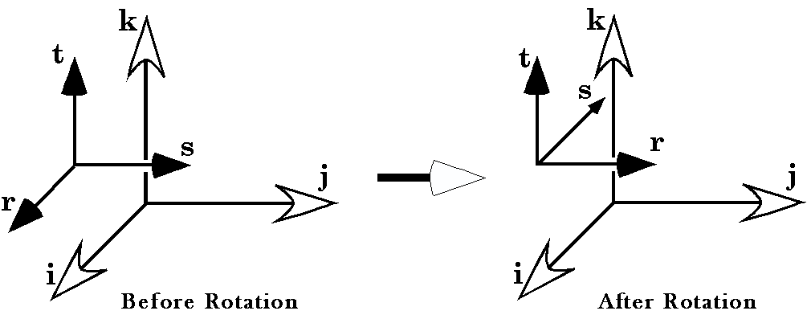
To illustrate this interdependence, let us start with a simple gimbal system. The axes of the frame of reference are r, s, and t and the axes of the universal coordinate system are i, j, and k. In neutral position, the vertical axis,$t$, is aligned with the k axis. The sagittal axis, $r$, is aligned with the i axis and the transverse axis, $s$, is aligned with the j axis. Now suppose that the system is rotated about the vertical axis by + 90°. It is easily verified that this makes the sagittal axis, r, align with the j axis and the transverse axis, s, is now aligned with the -i axis.

Quaternions
It can be shown that if the axis of a rotation, $R$, is aligned with the vector $v$ and the rotation is through an angle $j$, then a structure aligned with the vector $α$ will be changed into the vector $α^{'}$ by the rotation $R$, where $α^{'}$ is given by the following expression.
$$α^{'}=r∗α∗r^{−1}\text{,where }r=\text{cos}\frac{j}{2}+\text{sin}\frac{j}{2}∗v\text{.}$$
The variable r is a quaternion, which is a hypercomplex number that is the sum of a scalar and a vector. Quaternions behave much like other algebraic numbers except that the vector is expressed as a sum of three different imaginary numbers, corresponding to the three coordinate axes. The basis vectors are i, j, and k. A vector is expressed as a sum of real multiples of these basis vectors, so a vector that extends two units anterior, three units lateral, and five units superior would be written as:
$$v=2i+3j+5k\text{.}$$
The unusual feature of quaternions is that since i, j, and k are three different imaginary numbers their products are as follows.
$$\begin{aligned}i∗i=j∗j=k∗k\text{=-}1 \\ i∗\text{j=k, j}∗\text{k=i, k}∗\text{i=j} \\ j∗\text{i=-k, k}∗\text{j=-i, i}∗\text{k=-j}\text{.}\end{aligned}$$
The bases are imaginary numbers because their squares are equal to –1; they are different because the product of any two is the third, and the order of multiplication is relevant. As strange as this may seem, they are precisely the attributes needed to model rotations in three dimensions.
Armed with this knowledge it is now possible to set up and solve the expression for the given movement. We compress the calculation by treating the three axes together as a column matrix.
$$f=\left\{\begin{matrix}r \\ s \\ t\end{matrix}\right\}=\left\{\begin{matrix}i \\ j \\ k\end{matrix}\right\}$$
The rotation is given by the expression
$$R=\text{cos}\frac{p}{2}+\text{sin}\frac{p}{2}kÛr=\text{cos}\frac{p}{4}+\text{sin}\frac{p}{4}k=\frac{1}{\sqrt{2}}+\frac{k}{\sqrt{2}}$$
The inverse of the quaternion is given by the expression
$$r^{−1}=\text{cos}\frac{p}{4}−\text{sin}\frac{p}{4}k=\frac{1}{\sqrt{2}}−\frac{k}{\sqrt{2}}$$
The rest is simply algebra, being careful to keep the order of the products.
$$f^{'}=\left[\frac{1}{\sqrt{2}}+\frac{k}{\sqrt{2}}\right]∗\left\{\begin{matrix}i \\ j \\ k\end{matrix}\right\}∗\left[\frac{1}{\sqrt{2}}−\frac{k}{\sqrt{2}}\right]=\left\{\begin{matrix}j \\ −i \\ k\end{matrix}\right\}$$
This is precisely, what we reasoned from visualizing the rotation. So far, it has not been worth the effort of using quaternion analysis, but if we make the question a little more complex, then it becomes apparent that a formal structure is needed to express the rotation.

The Interdependence of Traveling Axes
With the system in its initial state, $f=\left\{r,s,t\right\}=\left\{i,j,k\right\}$, a rotation through an angular excursion of $q$, about the transverse axis, would be expressed by -

We can check this by setting $q=\text{90}°$. Doing the calculation, we obtain $f^{'}=\left\{−\text{k,}\text{j,}i\right\}$. In words, the vertical axis is directed anteriorly, the sagittal axis is directed inferiorly, and the transverse axis is still transverse.
After the rotation of 90° about the vertical axis, the transverse axis was pointing posteriorly. Now, if we follow that rotation by a rotation about the transverse axis, $\bar{s}\text{=-}i$, then the new orientation is given by -

Now, we apply the same process to the frame of reference, and then we can write out the expression in unbarred coordinates.

Note that the moving armature and the axis about which it rotates have been transformed by the same rotation about the vertical axis.
This simple situation leads to a fairly complex expression, but still an interpretable expression. If we introduce all the degrees of freedom in a gimbal joint, the expression of the solution rapidly passes beyond ready comprehension, therefore it is advisable to quickly move to computer calculators and models to deal with the kinematics of the joints.

Traveling Axes of Rotation
The quantitative approach just illustrated utilizes the concept of travelling frames of reference. It is a natural approach for gimbal-like joints, because each movement is most readily and logically expressed as a movement about a particular axis, but the orientation of that axis is a function of movements about other axes.
There are advantages to using an approach, which utilizes traveling frames of reference. Perhaps the greatest advantage is that the order of the calculations is reversible. Flexion of the elbow is always fundamentally the same movement, whether the shoulder is in neutral position, flexed, abducted, or rotated. When using traveling axes, changing the order of a series of movements about different joints does not change the final outcome. Flexing the elbow and then the shoulder leads to the same final position as first flexing the shoulder and then the elbow. The details of the calculation are quite different, but the final result is the same.
Because of the geometry of a gimbal-like joint, it may be treated as a collection of separate joints or joint elements. The first element is the vertical or support element, the element that holds the other elements. In the neck, it would be the cervical spine up to the axis. The other elements are the atlanto-axial joint and the atlanto-occipital joint.

Calculation of the Orientation of Frames of References

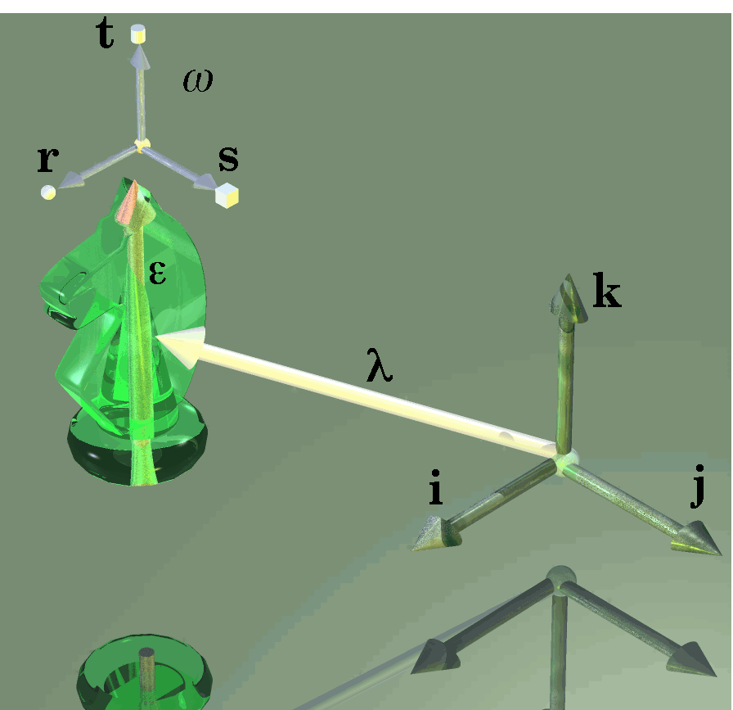
Framed vectors are arrays of three type of vectors. The location vector, λ, is the placement of the object relative to the origin of a coordinate system {i, j, k}. The extension vector, ε, is an attribute of the structure of the object, in this case its height. The frame of reference, ω, is a set of three vectors, {r, s, t}, that specify the orientation of the object.

Framed Vectors
The model used in this paper is based on the manipulation of framed vectors, associated with the vertebrae, by rotations about a set of axes of rotation. A framed vector is a collection of vectors that characterize the location, extension, and orientation of a moving rigid body. The framed vector for a vertebra might have 1.) a location vector, from the origin of the universal coordinate system to the location of some feature of the vertebra, 2.) an extension vector or vectors, between two features of the vertebra that are relevant to its size and shape, and 3). A frame of reference, for the vertebra. The frame of reference is a set of three vectors that lie in particular directions relative to the vertebra. For instance, one might choose a sagittal vector that extends perpendicular to the anterior surface of the vertebra, a vertical or longitudinal vector, that extends perpendicular to the superior surface of the vertebra, and a transverse vector that extends perpendicular to the other two.
It is sufficient that the three vectors in the frame of reference be independent, that is, none of the vectors can be expressed as a linear combination of the other two, therefore they are not coplanar. However, the frame of reference tends to be most useful if it is composed of three orthogonal unit vectors. It also tends to most convenient for understanding the consequences of movements if one chooses them to correspond to anatomically interesting features of the vertebra.
Note that there are two different possible orderings for the frame of reference. If one places one’s right thumb so that it points in the direction of the positive sagittal vector then, if rotation of the positive transverse axis through 90° in the direction that the fingers curl will bring it into alignment with the positive vertical axis, then the frame of reference is said to be right-handed. If using the left hand produces the alignment, then the frame of reference is said to be left-handed. One may choose to use either system, depending on the situation, but once chosen all the results are contingent upon that choice. You must stay in the same system when interpreting the results.
This set of five vectors is the standard form for a framed vector in that it codifies the necessary information for understanding movements of a rigid body. However, it is often convenient to add one or more additional vectors to encapsulate all the features that one wishes to monitor. For instance, one might have several extension vectors to follow how various points on the vertebra, such as the facets and the spine, move in space. It is possible that one would use an entire array of vectors that describe the shape of the vertebra. Alternatively, one might use multiple location vectors to different features of the vertebra. Generally, one would not use multiple frames of reference, but it easy to envision how doing so might give useful information.
The location vector, extension vector, and frame of reference are modified in different ways by movement, therefore it is necessary to combine them in different ways with the quaternions that represent rotations.

Structural elements
We normally start from the support element and work our way through the joint elements. We assume that there is a neutral state for the system and we can write the expressions for the orientation of all of the elements of the joint in that position.
$$\begin{aligned}f_{E}=\text{framed vector for the environment}; \\ f_{1}={\text{framed vector for the 1}}^{\text{st}}\text{ element}; \\ f_{2}={\text{framed vector for the 2}}^{\text{nd }}\text{ element}; \\ f_{3}={\text{framed vector for the 3}}^{\text{rd}}\text{ element}; \\ f_{T}=\text{framed vector for the test object};\end{aligned}$$
The environment is the context within which the joint is moving. For the upper cervical spine, it may be the third cervical vertebra or even the axis. In many analyses, the environment will be the universal coordinate system for the body. For instance, anterior, lateral, and superior frame of reference vectors and the location of the axis vertebral body in space.
The test object is the object that we are monitoring for location and orientation. In the upper neck system, it might be the skull. Often it is the element of the system that we are studying as a reference for the entire system.
There are a number of possible mathematical structures that one might superimpose on the upper cervical joint assembly. Which one is used would depend on what information is available and what information is sought from the model. If we are primarily interested in the moving elements, then we might modify the standard framed vector by adding a second extension vector $\left(ρ\right)$, which is aligned with the axis of rotation. The location vector $\left(λ\right)$ would point to the center of the element, the first extension vector $\left(e\right)$ might extend from the center of the element to the axis of rotation, and the second extension vector would be the axis of rotation. The frame of reference $\left(w=\left\{e_{1},e_{2},e_{3}\right\}\right)$ would be the frame for the element.
We will generally not be reconstructing the objects, but it should be possible, in principle, to do so, if necessary. For instance, one might describe a ring centered upon the center and in the plane of the first and second elements of the orientation frame of reference as follows.
$$\begin{aligned}p_{i}=λ_{C}+β∗\left(\text{cos}j_{i}∗e_{1}+\text{sin}j_{i}∗e_{2}+d_{i}∗e_{3}\right),\text{where the framed vector is } \\ f_{C}=\left\{λ_{C},e_{C},ρ_{C},e_{1},e_{2},e_{3}\right\}\text{, and }β\text{is a scale factor}\text{.}\end{aligned}$$

Methods
The calculations described in the Results Section were programmed in Mathematica Version 5. A collection of special functions were written to define framed vectors, frames of reference, and the operations that can performed upon them using quaternion analysis. The basic quaternion functions are in the standard add-on package Algebra `Quaternions`. The framework of the program is as described for the sample program in the Results.

Results

The Basic Format of the Analysis
Studies of the upper neck indicate that there are three orthogonal axes of movement for the atlanto-occipital joint that come near to intersecting in a common point (Kapandji 1974; Williams, Bannister et al. 1995; Levangie and Norkin 2001). The discrepancies are small relative to the dimensions of the head and thorax so it is reasonable to assume a common intersection for the purposes of a first analysis. Where questions depend on a very precise definition of the axes of rotation, it is relatively easy to go back into the model, make the changes, and re-run the calculations. The advantage of assuming a common intersection for all of the axes of the atlanto-occipital joint is that it simplifies many of the equations and the logic of the analysis
Most of the axes of rotation are not known with any greater precision than that used in the model. Perhaps the observations arising from these calculations will stimulate measurements that are more precise. On the other hand, the available precision is about a good as it gets for this type of measurement in a group of individuals. When examining bones taken from a variety of individuals, it is clear that there is considerable variation from spine to spine, therefore there may be little benefit in trying to achieve great precision, since it is apt to be empty precision.
For each structural element in the AAOA, we create a framed vector that has a standard set of components. The first component is the locus of the element ($λ$), which we are taking to be the center of the element. The second component is a center of rotation for the element ($d$). The center of rotation is a point upon the axis of rotation. If there is more than one direction of rotation, then there may be more than one center of rotation. For instance, if flexion occurs about one axis and lateral rotation occurs about another that may not intersect that for flexion. We will assume a common intersection of the three orthogonal axes of rotation of the occiput upon the atlas, therefore there will be a common center of rotation for all three axes of rotation. The third component of the framed vector is a vector parallel with the axis of rotation ($ρ$), that is, it is the direction of the axis of rotation. They are arranged so that the first is the offset of the axis of rotation, that is the chosen center of rotation, and the second is the axis of rotation. The last component f the framed vector is an array of three vectors that codes the orientation of the element ($w=\left\{e_{1},e_{2},e_{3}\right\}$). The set of axes used to code orientation is arbitrary, but it is usually convenient to choose them so that one can relate the anatomy of the structure to the orientation. For instance, the orientation of the skull is most logically related to the alignment of the eyes and/or the semicircular canals, since those are structures that the nervous system probably monitors for alignment.
These six vectors form the standard framed vector for the following analysis, but it may be convenient to extract certain of the components for parts of the analysis or to double up some of the elements where the structural element moves in different ways at different times. We will examine the consequences of rotations in the AAOA, by examining the results of manipulating these framed vectors that abstract the individual elements.

A Sketch of the Anatomy of the AAOA
There are three atlantoaxial joints; an atlanto-odontoid or median atlanto-axial joint between the anterior surface of the odontoid process and the posterior aspect of the anterior arch of the atlas and bilateral lateral atlanto-axial joints between the lateral facets (Williams, Bannister et al. 1995). The odontoid surface is biconvex and the atlas surface biconcave, but elongated along the mediolateral axis. The posterior aspect of the odontoid process is crossed by the transverse ligament that passes from a tubercle on one side to the matching tubercle on the opposite side of the anterior arch of the atlas, connecting the lateral masses of the atlas. The odontoid process is often tilted, most often posteriorly (up to 14°), but sometimes anteriorly or laterally (up to 10°). The transverse ligament restrains the odontoid process from separating from the anterior arch of the atlas, allowing it rotation only about its long axis, like a peg in a socket. There is probably room for a comparatively small amount of flexion/extension of the atlas upon the axis (possibly as much as 10°, (Nordin and Frankel 1989).
The principal movement between the atlas and the axis is rotation about a vertical axis that passes through the odontoid process. If we make the anteroposterior width of the atlas two units then the axis of rotation is about a quarter of the distance along the median line, measured from the anterior arch, or 1/2 unit from the anterior surface of the anterior arch and from the center of the vertebral canal. The vertical curvature of the atlanto-odontoid articular surface is such that it approximates a segment of a circle that has its center about midway along the distance between the anterior and posterior limits of the axis, which is also about the mid-point of the vertebral canal. While there is probably comparatively little flexion and extension in the atlanto-axial assembly this point is of interest because it lies directly inferior to the center of rotation for the occiput upon the atlas when the head is in neutral position. Using the symbol used for this point in Kapandji’s monograph (Kapandji 1974), this point will called the Q point. It roughly corresponds to the center of curvature for the vertical median articular facet of the odontoid process, but we will redefine it to be the median mid-point of the vertebral canal at the level of the middle of the odontoid facet.
The lateral atlanto-axial joints are roughly like two cylinders abutting upon each other along their longitudinal axes. With the cartilage that covers the joints, they are nearly planar, but the underlying bony articulation is slightly concave along the mediolateral axis and slightly convex perpendicular to that axis. When the atlas is centered over the axis and the joint is in neutral position, the separation between the atlas and axis is maximal. This means that the joint has maximal potential energy in neutral position, therefore there should be a modest drive towards rotation between the atlas and the axis. As the atlas rotates about the odontoid process the lateral facets slide on each other so that the superior facet descends about 3-4 millimeters as it swings medially. One superior facet will descend anteriorly and the opposite one will descend posteriorly. The overall trajectory is a shallow helix. The net effect is to bring the atlas and axis slightly closer together as they rotate relative to each other. There may be a slight relaxation of the structures that pass between the two bones, but such relaxation as occurs is probably lost in the much greater shearing movement due to the rotation about the vertical axis. Overall, it is likely that rotation produces a screwing home effect, making the atlanto-axial assembly more of a single fixed unit when rotated to its end of range for lateral rotation. Overall, the curvature of the joint surfaces is probably a minor factor in the movements of the assembly.
There is a possibility of a modest flexion/extension, movement of the atlas upon the axis, in which case both superior facets would ride posteriorly and slightly inferior upon the convex inferior facets. It appears that the center for this rotation passes through the center of the odontoid process (Kapandji 1974). Again, this is probably a minor factor, more joint play than actual deliberate movement.
The amount of rotation in the atlantoaxial joints is an average of 41.5° with a range of 29° to 54° (Dvorak, Schneider et al. 1988). This means about 45° in either direction, for a total of about 90° of rotation. The movement seems to be restricted by the alar ligaments, because rupture of one of them will result in a unilateral increase in ROM towards the opposite side.
If we abstract the axis and atlas as rings of unit radius, then the atlas is about 0.25 units superior to the Q point and the axis is about 0.5 units inferior. Both are roughly centered upon the vertical axis through the Q point. Measurements and data cited in Grays’s Anatomy indicate that the unit of measure used here is roughly 12 millimeters or about a half inch. The atlas is 2 units deep, from the anterior tubercle to the posterior tubercle. The units used here are different from those tabulated elsewhere, that are based on the average depth of the cervical vertebral bodies. These units are roughly twice those units.
There are two atlanto-occipital joints, symmetrically to either side of the midline, between the superior articular facets of the atlas and the occipital condyles. They are elongated and they converge anteriorly so that their axes would intersect some distance anterior to the anterior arch of the atlas. All or the great majority of the superior articular facets of the atlas lie anterior to the middle of the atlas. They are mechanically linked so that there is effectively a single joint. Their placement and inclination is such as to make them segments of a sphere that has its center superiorly, within the skull. Again, if we normalize the measurements to the radius of the atlas, then the center of the sphere of rotation for the atlanto-occipital joints lies about 2 units directly superior to the Q point for the atlanto-odontoid joint, when the head is in neutral position. Sideflexion of the skull is about an axis that passes approximately through the center of rotation for flexion and extension. Therefore, we can place the center of the occiput of the skull at a distance of 2 units superior to our reference point.
There is a small amount of lateral rotation in the atlanto-occipital joint, which is about an axis centered in the vertebral canal, so it tends to cause the atlanto-occipital facets to shear. This shear is said to tighten the atlanto-occipital ligament, which then becomes the center of rotation. The new center of rotation, produced as the ligament becomes taut, causes the posterior occiput to swing in the same direction as it was traveling, but about a more anterior axis of rotation. This shifts the center of the atlas a small distance in the direction of the posterior occiput’s excursion. There is also a small sideflexion to the side towards which the posterior occiput is traveling. Therefore, a rotation of the chin to the left will cause a small displacement of the effective center of rotation to the right of the midline and a small right sideflexion. While it is a small movement, this curiosity may be of interest for later analysis, after dealing with the big movements.
Measurements of the ROM of the occiput upon the atlas in the various directions gives a range of 16.8° to 20.8° of flexion/extension (Johnson, Hart et al. 1977), there is less than 3° of lateral flexion, and 5.7° of rotation (Dvorak, Schneider et al. 1988). Nordin and Frankel claim that there is no lateral rotation (Nordin and Frankel 1989). Measurements of the atlanto-occipital flexion extend from 10° to 30°, but 20° is probably a normal flexion ROM.
About 10-30° of flexion/extension occurs in the axio-atlanto-occipital assembly and the rest (~100°) in the remainder of the cervical spine. Most of the lateral flexion (~90° to each side) occurs in the C3-C7 cervical spine. Approximately half of the lateral rotation occurs in the AAOA and half in the lower cervical spine.

The Neutral Position Frames of Reference
Now that we have sketched the pertinent anatomy of the assembly, let us convert it into a set of framed vectors for analysis. The null point will be taken to be the Q point and the universal coordinate system will be chosen so that the anterior sagittal axis is i, the left transverse axis is j and the superior vertical axis is k. The odontoid process is centered a half a unit anterior to the Q point (λ), in the median plane. The neutral orientation is the universal frame. The axis of rotation (ρ) is a vertical axis through its center (δ).
$$f_{\text{odontoid}}=\left[\begin{matrix}λ \\ d \\ ρ \\ e_{1} \\ e_{2} \\ e_{3}\end{matrix}\right]=\left[\begin{matrix}0\text{.}5 & 0\text{.}0 & 0\text{.}0 \\ 0\text{.}5 & 0\text{.}0 & 0\text{.}0 \\ 0\text{.}0 & 0\text{.}0 & 1\text{.}0 \\ 1\text{.}0 & 0\text{.}0 & 0\text{.}0 \\ 0\text{.}0 & 1\text{.}0 & 0\text{.}0 \\ 0\text{.}0 & 0\text{.}0 & 1\text{.}0\end{matrix}\right]$$
The atlas is represented by a framed vector for the ring of bone that is centered on the vertebral canal, about a quarter unit superior to the Q point. Its center of rotation is the center of the odontoid process and its axis of rotation is a vertical unit vector.
$$f_{\text{atlas}}=\left[\begin{matrix}λ \\ d \\ ρ \\ e_{1} \\ e_{2} \\ e_{3}\end{matrix}\right]=\left[\begin{matrix}0\text{.}0 & 0\text{.}0 & 0\text{.}\text{25} \\ 0\text{.}5 & 0\text{.}0 & 0\text{.}0 \\ 0\text{.}0 & 0\text{.}0 & 1\text{.}0 \\ 1\text{.}0 & 0\text{.}0 & 0\text{.}0 \\ 0\text{.}0 & 1\text{.}0 & 0\text{.}0 \\ 0\text{.}0 & 0\text{.}0 & 1\text{.}0\end{matrix}\right]$$
The axis is similar, except in being about a half unit ventral to the Q point. We take its axis of rotation to lie through the center of the ring. The axis of rotation in the framed vector is the vertical axis, but it might equally well be the transverse axis or the sagittal axis. The axis is arbitrary because the center of rotation is for the orientation of the axis due to the cumulative effect of the lower cervical spine.
$$f_{\text{axis}}=\left[\begin{matrix}λ \\ d \\ ρ \\ e_{1} \\ e_{2} \\ e_{3}\end{matrix}\right]=\left[\begin{matrix}0\text{.}0 & 0\text{.}0 & −0\text{.}5 \\ 0\text{.}0 & 0\text{.}0 & −0\text{.}5 \\ 0\text{.}0 & 0\text{.}0 & 1\text{.}0 \\ 1\text{.}0 & 0\text{.}0 & 0\text{.}0 \\ 0\text{.}0 & 1\text{.}0 & 0\text{.}0 \\ 0\text{.}0 & 0\text{.}0 & 1\text{.}0\end{matrix}\right]$$
The occiput in neutral position is similar, but it is two units above the Q point and it has three possible axes of rotation, which we list in order of decreasing range of motion (t – transverse; s – sagittal; v – vertical). The location of the occiput is discretionary. It has been taken to be a ring about the center of rotation.
$$f_{\text{occiput}}=\left[\begin{matrix}λ \\ d \\ ρ_{t} \\ ρ_{s} \\ ρ_{r} \\ e_{1} \\ e_{2} \\ e_{3}\end{matrix}\right]=\left[\begin{matrix}0\text{.}0 & 0\text{.}0 & 2\text{.}0 \\ 0\text{.}0 & 0\text{.}0 & 2\text{.}0 \\ 0\text{.}0 & 1\text{.}0 & 0\text{.}0 \\ 1\text{.}0 & 0\text{.}0 & 0\text{.}0 \\ 0\text{.}0 & 0\text{.}0 & 1\text{.}0 \\ 1\text{.}0 & 0\text{.}0 & 0\text{.}0 \\ 0\text{.}0 & 1\text{.}0 & 0\text{.}0 \\ 0\text{.}0 & 0\text{.}0 & 1\text{.}0\end{matrix}\right]$$
These abstract descriptions of the various elements in the AAOA are simple in neutral position, but they will rapidly loose their apparent simplicity when we begin to manipulate them.

A Sample Movement
Normally, the calculation of the placement and orientation of the bones in the AAOA would be done by a Mathematica program, but we step through the process in a simple example to illustrate the process. For now, we will stick with the major movements attributed to each joint and look at a movement in which the atlas laterally rotates 30° on the axis and the occiput tilts forward 15°. The calculation is simpler if we start from the top and work our way down.

Rotation of the Occiput Due to Rotation in the Atlanto-occipital Joint
Flexion of the occiput occurs about the transverse axis of rotation in the framed vector for the occiput, $ρ_{t}$. The center of the occiput was chosen to be the intersection of the three axes of rotation so the center of rotation is the same as the center of the occiput. The rotation quaternion for a flexion of 15° is given by the following expression.
$$Q_{F}=\text{cos}β+\text{sin}β∗ρ_{t}=\text{cos}\text{15}\text{°+}\text{sin}\text{15}\text{°*}ρ_{t}{Ûq}_{F}=\text{cos}7\text{.}5\text{°+}\text{sin}7\text{.}5\text{°*}ρ_{t}$$
$$q_{F}=0\text{.}\text{99144}+0\text{.}\text{13053}j$$
The distance between the center of the occiput and the axis of rotation is $λ−d=0\text{.}0$, therefore, the center of the occiput is not moved by the flexion. The transverse axis of rotation is not changed by the flexion about the axis.
$$ρ_{t}^{'}=q_{F}∗ρ_{t}∗q_{F}^{−1}=ρ_{t}$$
The other two rotation axes are changed.
$$\begin{aligned}ρ_{s}^{'}=q_{F}∗ρ_{s}∗q_{F}^{−1}=\left(\text{cos}\frac{β}{2}+\text{sin}\frac{β}{2}∗j\right)∗i∗\left(\text{cos}\frac{β}{2}−\text{sin}\frac{β}{2}∗j\right) \\ \text{cos}β∗i−\text{sin}β∗k=\text{cos}\text{15}\text{°*}i−\text{sin}\text{15}\text{°*}k=0\text{.}\text{96593}∗i−0\text{.}\text{25882}∗k\end{aligned}$$
$$\begin{aligned}ρ_{r}^{'}=q_{F}∗ρ_{r}∗q_{F}^{−1}=\left(\text{cos}\frac{β}{2}+\text{sin}\frac{β}{2}∗j\right)∗k∗\left(\text{cos}\frac{β}{2}−\text{sin}\frac{β}{2}∗j\right) \\ \text{sin}β∗i+\text{cos}β∗k=\text{sin}\text{15}\text{°*}i+\text{cos}\text{15}\text{°*}k=0\text{.}\text{25882}∗i+0\text{.}\text{96593}∗k\end{aligned}$$
We have actually calculated the new frame of reference as we computed the new axes of rotation, so it is possible to write it down without further ado.
$$\begin{aligned}w_{\text{occiput}}=\left[\begin{matrix}\text{cos}β & 0\text{.}0 & −\text{sin}β \\ 0\text{.}0 & 1\text{.}0 & 0\text{.}0 \\ \text{sin}β & 0\text{.}0 & \text{cos}β\end{matrix}\right] \\ \left[\begin{matrix}0\text{.}\text{9653} & 0\text{.}0 & −0\text{.}\text{25882} \\ 0\text{.}0 & 1\text{.}0 & 0\text{.}0 \\ 0\text{.}\text{25882} & 0\text{.}0 & 0\text{.}\text{9653}\end{matrix}\right]\end{aligned}$$

Rotation of the Atlas Due to Rotation in the Atlanto-axial Joints
None of the other frames of reference is changed by the flexion in the atlanto-occipital joint, therefore it is possible to move on to the lateral rotation. The axis of rotation is through the center of the odontoid process so there is an offset for the atlas and the occiput. The quaternion for a 30° left lateral rotation is given by the following expression.
$$Q_{R}=\text{cos}α+\text{sin}α∗ρ_{o}=\text{cos}\text{30}\text{°+}\text{sin}\text{30}\text{°*}ρ_{o}{Ûq}_{R}=\text{cos}\text{15}\text{°+}\text{sin}\text{15}\text{°*}ρ_{o}$$
$$q_{R}=0\text{.}\text{9653}+0\text{.}\text{25882}k$$
The center of rotation for the atlas is 0.5 units anteriorly along the sagittal axis of the vertebra. The center of the atlas is elevated 0.25 units above the Q point, which is the origin of the coordinate system for these calculations. The vector that connects the center of rotation for the atlas to the center of the atlas is $λ−d\text{=-}0\text{.}5∗i+0\text{.}\text{25}∗k$. The location for the center of the atlas in the coordinate system centered upon the center of rotation after the 30° lateral rotation is computed as follows. However, this vector extends from the center of rotation, but we want it is the universal coordinates, so we must add the value for the center of rotation to obtain the atlas position in the universal coordinates.
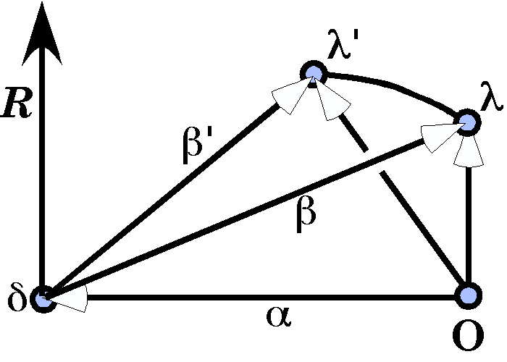
$$\begin{aligned}β=\left(λ−O\right)+\left(O−d\right)=λ−d, \\ β^{'}=q_{R}∗β∗q_{R}^{−1}, \\ λ^{'}=β^{'}−α=β^{'}−d\text{.}\end{aligned}$$

$$\begin{aligned}λ_{\text{atlas}}^{'}=q_{R}∗\left(λ_{\text{atlas}}−d_{\text{atlas}}\right)∗q_{R}^{−1}+d_{\text{atlas}} \\ \left(\text{cos}\frac{α}{2}+\text{sin}\frac{α}{2}∗k\right)∗\left(e_{\text{At}}∗i+m_{\text{At}}∗k\right)∗\left(\text{cos}\frac{α}{2}−\text{sin}\frac{α}{2}∗k\right)+e_{\text{At}} \\ \left(\text{cos}\text{15}\text{°+}\text{sin}\text{15}\text{°*}k\right)∗\left(−0\text{.}5i+0\text{.}\text{25}k\right)∗\left(\text{cos}\text{15}\text{°-}\text{sin}\text{15}\text{°*}k\right)+0\text{.}5i \\ \left(0\text{.}\text{9653}+0\text{.}\text{25882}∗k\right)∗\left(−0\text{.}5i+0\text{.}\text{25}k\right)∗\left(0\text{.}\text{9653}−0\text{.}\text{25882}∗k\right)+0\text{.}5i \\ \text{=-}e_{\text{At}}∗\text{cos}α∗i−e_{\text{At}}∗\text{sin}α∗j+m_{\text{At}}∗k+e_{\text{At}}∗i \\ \text{=-}0\text{.}5∗\text{cos}\text{30}\text{°*}i−0\text{.}5∗\text{sin}\text{30}\text{°*}j+0\text{.}\text{25}∗k+0\text{.}5i \\ \text{=-}0\text{.}\text{4330}∗i−0\text{.}\text{2500}∗j+0\text{.}\text{2500}∗k\text{++}0\text{.}5i \\ 0\text{.}\text{0670}∗i−0\text{.}\text{2500}∗j+0\text{.}\text{2500}∗k\text{.}\end{aligned}$$
The main effect is to shift the center of the axis about a quarter of a unit laterally. For rotations of much more than 45°, there would be a danger of impingement of the spinal cord between the axis and the atlas. This may be why lateral rotation is generally limited to an excursion of about 45°.
The axis of rotation is not changed by rotation about itself. The frame of reference is not affected by the offset, but it is affected by the rotation.
$$\begin{aligned}w_{\text{atlas}}^{'}=q_{R}∗w_{\text{atlas}}∗q_{R}^{−1} \\ \left(\text{cos}\frac{α}{2}+\text{sin}\frac{α}{2}∗k\right)∗\left[\begin{matrix}1 & 0 & 0 \\ 0 & 1 & 0 \\ 0 & 0 & 1\end{matrix}\right]∗\left[\begin{matrix}i \\ j \\ k\end{matrix}\right]∗\left(\text{cos}\frac{α}{2}−\text{sin}\frac{α}{2}∗k\right) \\ \left(\text{cos}\text{15}\text{°+}\text{sin}\text{15}\text{°*}k\right)∗\left[\begin{matrix}i & 0 & 0 \\ 0 & j & 0 \\ 0 & 0 & k\end{matrix}\right]∗\left(\text{cos}\text{15}\text{°-}\text{sin}\text{15}\text{°*}k\right) \\ \left[\begin{matrix}\text{cos}αi & \text{sin}αj & 0 \\ −\text{sin}αi & \text{cos}αj & 0 \\ 0 & 0 & 1\text{.}0\end{matrix}\right]=\left[\begin{matrix}\text{cos}\text{30}°i & \text{sin}\text{30}°j & 0 \\ −\text{sin}\text{30}°i & \text{cos}\text{30}°j & 0 \\ 0 & 0 & 1\end{matrix}\right]=\left[\begin{matrix}0\text{.}\text{86603}i & 0\text{.}\text{50000}j & 0 \\ −0\text{.}\text{50000}i & 0\text{.}\text{86603}j & 0 \\ 0 & 0 & 1\end{matrix}\right]\end{aligned}$$
The net effect is to rotate the frame of reference in the horizontal plane.

Rotation of the Occiput Due to Rotation in the Atlanto-axial Joints
The rotation quaternion for the occiput is the same as that just used, $Q_{R}{Ûq}_{R}$, because it is the same rotation, just applied to a different element. The center of rotation is the same as for the atlas rotations. First, we compute the difference between the center of the occiput and the center of rotation and the consequence of the rotation of the atlas.
$$\begin{aligned}{\left(λ_{\text{occiput}}^{'}−d_{\text{atlas}}\right)}^{¢}=q_{R}∗\left(λ_{\text{occiput}}^{'}−d_{\text{atlas}}\right)∗q_{R}^{−1} \\ \left(\text{cos}\frac{α}{2}+\text{sin}\frac{α}{2}∗k\right)∗\left(−e_{O}∗i+m_{O}∗k\right)∗\left(\text{cos}\frac{α}{2}−\text{sin}\frac{α}{2}∗k\right) \\ \left(\text{cos}\text{15}\text{°+}\text{sin}\text{15}\text{°*}k\right)∗\left(−0\text{.}5i+2\text{.}0k\right)∗\left(\text{cos}\text{15}\text{°-}\text{sin}\text{15}\text{°*}k\right) \\ \text{=-}e_{O}∗\text{cos}α∗i−e_{O}∗\text{sin}α∗j+m_{O}∗k \\ \text{=-}0\text{.}5∗\text{cos}\text{30}\text{°*}i−0\text{.}5∗\text{sin}\text{30}\text{°*}j+2\text{.}0∗k \\ \text{=-}0\text{.}\text{4330}∗i−0\text{.}\text{2500}∗j+2\text{.}0∗k\end{aligned}$$
Now the rotated difference vector must be added to the locus of the center of rotation.
$$\begin{aligned}λ_{\text{occiput}}^{''}={\left(λ_{\text{occiput}}^{'}−d_{\text{atlas}}\right)}^{¢}+d_{\text{atlas}} \\ \left(−0\text{.}\text{4330}∗i−0\text{.}\text{2500}∗j+2\text{.}0∗k\right)+0\text{.}\text{500}∗i \\ 0\text{.}\text{0670}∗i−0\text{.}\text{2500}∗j+2\text{.}0∗k\end{aligned}$$
We now turn to the orientation of the occiput
$$\begin{aligned}w_{\text{occiput}}^{''}=q_{R}∗w_{\text{occiput}}^{'}∗q_{R}^{−1} \\ \left(\text{cos}\frac{α}{2}+\text{sin}\frac{α}{2}∗k\right)∗\left[\begin{matrix}\text{cos}βi & 0\text{.}0 & −\text{sin}βk \\ 0\text{.}0 & 1\text{.}0j & 0 \\ \text{sin}βi & 0 & \text{cos}βk\end{matrix}\right]∗\left(\text{cos}\frac{α}{2}−\text{sin}\frac{α}{2}∗k\right) \\ \left[\begin{matrix}\text{cos}α\text{cos}βi & \text{sin}α\text{cos}βj & −\text{sin}αk \\ −\text{sin}αi & \text{cos}αj & 0 \\ \text{cos}α\text{sin}βi & \text{sin}α\text{sin}βj & \text{cos}βk\end{matrix}\right]=\left[\begin{matrix}\text{cos}\text{30}°\text{cos}\text{15}°i & \text{sin}\text{30}°\text{cos}\text{15}°j & −\text{sin}\text{15}°k \\ −\text{sin}\text{30}°i & \text{cos}\text{30}°j & 0 \\ \text{cos}\text{30}°\text{sin}\text{15}°i & \text{sin}\text{30}°\text{sin}\text{15}°j & \text{cos}\text{15}°k\end{matrix}\right] \\ \left[\begin{matrix}0\text{.}\text{83652}i & 0\text{.}\text{48296}j & −0\text{.}\text{25882}k \\ −0\text{.}\text{50000}i & 0\text{.}\text{86603}j & 0k \\ 0\text{.}\text{22414}i & 0\text{.}\text{12941}j & 0\text{.}\text{96593}k\end{matrix}\right]\end{aligned}$$
In summary, we have computed the locations and orientations of the atlas and occiput when there is a 15° flexion in the atlanto-occipital joint and 30° lateral rotation in the atlanto-axial joint.

The Axial Contribution
We have assumed that the axis is lying in neutral position. However, the axis is the transition element between the usual cervical vertebrae in the lower cervical spine and the AAOA. The superficial part of the axis is specialized to support the atlas and act as a pivot for rotations of the head. The inferior surface is much like the remainder of the cervical vertebrae in terms of the intervertebral disc and the uncinate processes, anteriorly, and the orientation of the facet joints, posteriorly. The lower cervical spine will be considered elsewhere. At this point, it is all lumped together and the second cervical vertebra, the axis, may move into a wide range of possible orientations by the actions of the lower cervical spine. These shifts of orientation will be expressed by the quaternion $Q_{C}$.
$$Q_{C}=\text{cos}g+\text{sin}g\left(h_{i}∗i+h_{j}∗j+h_{k}∗k\right){Ûq}_{C}=\text{cos}\frac{g}{2}+\text{sin}\frac{g}{2}\left(h_{i}∗i+h_{j}∗j+h_{k}∗k\right)$$
The unit vector of the quaternion may be in a wide range of directions. If the lower neck is sideflexed 45° and rotated 30°, then the unit vector of the rotation quaternion is as follows.
$$\begin{aligned}q_{\text{neck}}=q_{\text{rotation}}∗q_{\text{sideflex}} \\ \left(\text{cos}\frac{j}{2}+\text{sin}\frac{j}{2}∗k\right)∗\left(\text{cos}\frac{J}{2}+\text{sin}\frac{J}{2}∗i\right) \\ \left(\text{cos}\text{15}\text{°+}\text{sin}\text{15}\text{°*}k\right)∗\left(\text{cos}\text{22}\text{.}5\text{°+}\text{sin}\text{22}\text{.}5\text{°*}i\right) \\ \text{cos}\frac{j}{2}∗\text{cos}\frac{J}{2}+\text{cos}\frac{j}{2}∗\text{sin}\frac{J}{2}∗i+\text{sin}\frac{j}{2}∗\text{sin}\frac{J}{2}∗j+\text{sin}\frac{j}{2}∗\text{cos}\frac{J}{2}∗k \\ \text{cos}\text{15}\text{°*}\text{cos}\text{22}\text{.}5\text{°+}\text{cos}\text{15}\text{°*}\text{sin}\text{22}\text{.}5\text{°*}i+\text{sin}\text{15}\text{°*}\text{sin}\text{22}\text{.}5\text{°*}j+\text{sin}\text{15}\text{°*}\text{cos}\text{22}\text{.}5\text{°*}k \\ 0\text{.}\text{89240}+0\text{.}\text{36964}i+0\text{.}\text{09905}j+0\text{.}\text{23911}k\end{aligned}$$
If we convert to standard format, the result is as follows.
$$q_{C}=\text{cos}\text{26}\text{.}\text{82}\text{°+}\text{sin}\text{26}\text{.}\text{82}\text{°*}\left(0\text{.}\text{81916}∗i+0\text{.}\text{21950}∗j+0\text{.}\text{52990}∗k\right)$$
Since we are rotating the axis vertebra as a whole, we will assume that the axis of rotation is through the center of the vertebra. The new orientation of the axis can be computed readily as follows.
$$\begin{aligned}w_{\text{Axis}}^{'}=q_{\text{neck}}∗\left[\begin{matrix}i & 0 & 0 \\ 0 & j & 0 \\ 0 & 0 & k\end{matrix}\right]∗q_{\text{neck}}^{−1}=\left[\begin{matrix}\text{cos}ji & \text{sin}jj & 0\text{.}0 \\ −\text{sin}j∗\text{cos}Ji & \text{cos}j∗\text{cos}Jj & \text{sin}Jk \\ \text{sin}j∗\text{sin}Ji & −\text{cos}j∗\text{sin}Jj & \text{cos}Jk\end{matrix}\right] \\ \left[\begin{matrix}\text{cos}\text{30}°i & \text{sin}\text{30}°j & 0\text{.}0 \\ −\text{sin}\text{30}\text{°*}\text{cos}\text{45}°i & \text{cos}\text{30}\text{°*}\text{cos}\text{45}°j & \text{sin}\text{45}°k \\ \text{sin}\text{30}\text{°*}\text{sin}\text{45}°i & −\text{cos}\text{30}\text{°*}\text{sin}\text{45}°j & \text{cos}\text{45}°k\end{matrix}\right] \\ \left[\begin{matrix}0\text{.}\text{86603}i & 0\text{.}\text{50000}j & 0\text{.}0k \\ −0\text{.}\text{35355}i & 0\text{.}\text{61237}j & 0\text{.}\text{70711}k \\ 0\text{.}\text{35355}i & −0\text{.}\text{61237}j & 0\text{.}\text{70711}k\end{matrix}\right]\end{aligned}$$
The axis of rotation is the same as the t component of the orientation.
$$\begin{aligned}ρ_{\text{Axis}}^{'}=\text{sin}j∗\text{sin}J∗i−\text{cos}j∗\text{sin}J∗j+\text{cos}J∗k \\ 0\text{.}\text{35355}∗i−0\text{.}\text{61237}∗j+0\text{.}\text{70711}∗k\end{aligned}$$
It is also straightforward to compute the new location vector of the axis vertebra.
$$\begin{aligned}{\left(λ_{\text{Axis}}−d_{\text{Axis}}\right)}^{¢}=q_{\text{Neck}}∗\left(λ_{\text{Axis}}−d_{\text{Axis}}\right)∗q_{\text{Neck}}^{−1} \\ q_{\text{Neck}}∗0∗q_{\text{Neck}}^{−1} \\ 0\text{.}0\end{aligned}$$
$$λ_{\text{Axis}}^{'}={\left(λ_{\text{Axis}}−d_{\text{Axis}}\right)}^{¢}+d_{\text{Axis}}=0\text{.}0−0\text{.}\text{50}∗k\text{=-}0\text{.}\text{50}∗k$$
We can collect all these results together and write the transformed framed vector for the axis as follows.
$$f_{\text{axis}}=\left[\begin{matrix}λ \\ d \\ ρ \\ e_{1} \\ e_{2} \\ e_{3}\end{matrix}\right]=\left[\begin{matrix}0\text{.}\text{000}i & 0\text{.}\text{000}j & −0\text{.}\text{500}k \\ 0\text{.}\text{000}i & 0\text{.}\text{000}j & −0\text{.}\text{500}k \\ 0\text{.}\text{354}i & −0\text{.}\text{612}j & 0\text{.}\text{707}k \\ 0\text{.}\text{866}i & 0\text{.}\text{500}j & 0\text{.}\text{000}k \\ −0\text{.}\text{354}i & 0\text{.}\text{612}j & 0\text{.}\text{707}k \\ 0\text{.}\text{354}i & −0\text{.}\text{612}j & 0\text{.}\text{707}k\end{matrix}\right]$$
The same calculations can be done for the atlas and the occiput and the results are as follows.
$$\begin{aligned}f_{\text{Atlas}}\left(q_{\text{Neck}},q_{R}\right)=q_{\text{Neck}}∗f_{\text{Atlas}}\left(q_{R}\right)∗q_{\text{Neck}}^{−1} \\ \left[\begin{matrix}λ \\ d \\ ρ \\ e_{1} \\ e_{2} \\ e_{3}\end{matrix}\right]=q_{\text{Neck}}∗\left[\begin{matrix}0\text{.}\text{06700}i & −0\text{.}\text{2500}j & 0\text{.}\text{2500}k \\ 0\text{.}\text{5000}i & 0\text{.}\text{0000}j & 0\text{.}\text{0000}k \\ 0\text{.}\text{0000}i & 0\text{.}\text{0000}j & 1\text{.}\text{0000}k \\ 0\text{.}\text{8660}i & 0\text{.}\text{5000}j & 0\text{.}\text{0000}k \\ −0\text{.}\text{5000}i & 0\text{.}\text{8660}j & 0\text{.}\text{0000}k \\ 0\text{.}\text{0000}i & 0\text{.}\text{0000}j & 1\text{.}\text{0000}k\end{matrix}\right]∗q_{\text{Neck}}^{−1}=\left[\begin{matrix}0\text{.}\text{2652}i & −0\text{.}\text{4593}j & 0\text{.}\text{0303}k \\ 0\text{.}\text{6098}i & −0\text{.}\text{0562}j & −0\text{.}\text{1464}k \\ 0\text{.}\text{3536}i & −0\text{.}\text{6124}j & 0\text{.}\text{7071}k \\ 0\text{.}\text{5732}i & 0\text{.}\text{7392}j & 0\text{.}\text{3536}k \\ −0\text{.}\text{7391}i & 0\text{.}\text{2803}j & 0\text{.}\text{6124}k \\ 0\text{.}\text{3536}i & −0\text{.}\text{6124}j & 0\text{.}\text{7071}k\end{matrix}\right]\end{aligned}$$

$$\begin{aligned}f_{\text{Occiput}}\left(q_{\text{Neck}},q_{R},q_{F}\right)=q_{\text{Neck}}∗f_{\text{Occiput}}\left(q_{R},q_{F}\right)∗q_{\text{Neck}}^{−1} \\ \left[\begin{matrix}λ \\ d \\ ρ_{t} \\ ρ_{s} \\ ρ_{r} \\ e_{1} \\ e_{2} \\ e_{3}\end{matrix}\right]=q_{\text{Neck}}∗\left[\begin{matrix}0\text{.}\text{0670}i & −0\text{.}\text{2500}j & 2\text{.}\text{0000}k \\ 0\text{.}\text{0670}i & −0\text{.}\text{2500}j & 2\text{.}\text{000}k \\ −0\text{.}\text{5000}i & 0\text{.}\text{8660}j & 0\text{.}\text{0000}k \\ 0\text{.}\text{8366}i & 0\text{.}\text{4830}j & −0\text{.}\text{2588}k \\ 0\text{.}\text{2241}i & 0\text{.}\text{1294}j & 0\text{.}\text{9659}k \\ 0\text{.}\text{8366}i & 0\text{.}\text{4830}j & −0\text{.}\text{2588}k \\ −0\text{.}\text{5000}i & 0\text{.}\text{8660}j & 0\text{.}\text{0000}k \\ 0\text{.}\text{2241}i & 0\text{.}\text{1294}j & 0\text{.}\text{9659}k\end{matrix}\right]∗q_{\text{Neck}}^{−1}=\left[\begin{matrix}0\text{.}\text{8839}i & −1\text{.}\text{5309}j & 1\text{.}\text{2677}k \\ 0\text{.}\text{8839}i & 1\text{.}\text{5309}j & −1\text{.}\text{2677}k \\ −0\text{.}\text{7392}i & 0\text{.}\text{2803}j & 0\text{.}\text{6124}k \\ 0\text{.}\text{4622}i & 0\text{.}\text{8725}j & −0\text{.}\text{1585}k \\ 0\text{.}\text{4899}i & −0\text{.}\text{4002}j & 0\text{.}\text{7745}k \\ 0\text{.}\text{4622}i & 0\text{.}\text{8725}j & −0\text{.}\text{1585}k \\ −0\text{.}\text{7392}i & 0\text{.}\text{2803}j & 0\text{.}\text{6124}k \\ 0\text{.}\text{4899}i & −0\text{.}\text{4002}j & 0\text{.}\text{7745}k\end{matrix}\right]\end{aligned}$$
When we are dealing with movements in multiple joints, it becomes considerably more efficient to use quaternion calculators and programmed models to obtain results. In the above calculations, the analytical solution was derived to show how to do it and to show the nature of the relationships between the various elements in the framed vectors. Normally, it is too labor intensive to compute these solutions by hand, largely because it is so easy to reverse the order of the terms and produce erroneous results. Consequently, this work is done with a computer programmed to do quaternion mathematics.

Constructing Images of the Objects
If we have functions to clothe the framed vectors with images of the vertebrae, then we could re-create their image from the framed vectors that have just been computed. For instance, if the image were a ring, it might be written as follows.
$$X_{K}=λ_{K}+k_{K}\left(\text{cos}α+\text{sin}α∗e_{\text{3K}}\right)∗e_{1_{K}};0≤α≤2p,k=\text{radius}$$
This expression states to move to the center$\left(λ\right)$of the K’th object and then rotate a vector $\left(e_{1}\right)$ of length $k$ about that center in the plane perpendicular to the third element of the vertebra’s orientation frame of reference $\left(e_{3}\right)$ through an angular excursion of $2p$ radians. The rotating vector traces out a circle centered upon the center of the K’th object.
If we want it to be a torus, then we can draw a series of circles about the curve that has just been defined.
$$\begin{aligned}X_{K}=λ_{K}+k_{K}\left(\text{cos}α+\text{sin}α∗e_{\text{3K}}\right)∗e_{1_{K}}+ν_{K}\left(\text{cos}β+\text{sin}β∗{\hat{e}}_{\text{2K}}\right)∗e_{1_{K}}; \\ 0≤β≤2p,ν=\text{radius of torus}, \\ {\hat{e}}_{\text{2K}}=\left(\text{cos}α+\text{sin}α∗e_{\text{3K}}\right)∗e_{2_{K}}\end{aligned}$$
This expression says that, for every element of the circle just described, construct the tangential to the circle $\left({\hat{e}}_{2}\right)$ and the radial vector, which is multiplied by the scalar $ν$, and then rotate the radial vector about the circle through an angular excursion of $2p$ radians.
It is also easy to plot the axes of rotation in their correct location. The location of the N’th axis of rotation for the K’th object is given by the following relationship.
$$s_{\text{N,K}}=λ_{K}+d_{\text{N,K}}$$
The direction of the N’th axis of rotation is $ρ_{\text{N,K}}$.

Simplified Images
Simplified images are illustrated in the following figure. The pinched region is the lateral extreme of the ring, approximately at the locations of the transverse foraminae for the vertebrae. The first plot is with the vertebrae aligned in neutral position with the model facing to the right. The rings are at the level of the axis, the atlas and the occiput at the level of the common center of rotation for the atlanto-occipital joint. The radii of the rings are 1.0, 1.2, and 2.0 respectively. These were chosen because the radii of the axis and atlas rings place the pinched regions about as far laterally as their transverse foraminae. The ring for the occiput is centered upon the pivot point for its movements upon the atlanto-occipital joint. The anterior median part of the ring is approximately at the junction of the vertebral arteries, to form the basilar artery.
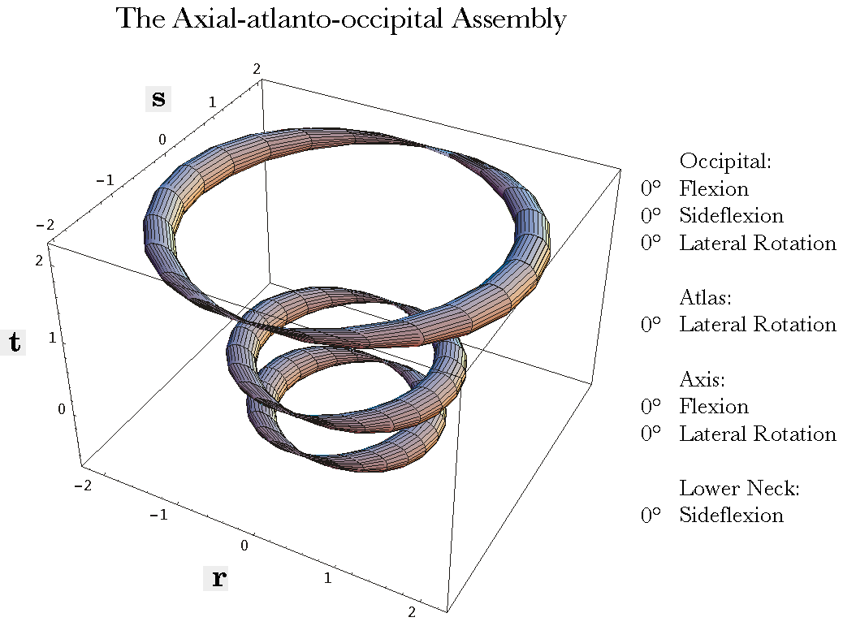
The AAOA in neutral position. The three rings represent the occiput, atlas, and axis, progressing from the top to the bottom. The pinched parts of the lower rings are the locations of the transverse foraminae in the atlas and axis. The anterior midpoint of the top ring, {r, s, t} = {2.0, 0.0, 2.0}, is approximately the location of the junction of the two vertebral arteries to form the basilar artery.
The second panel of the figure shows the configuration of the components after the axis has been rotated 45° laterally and 45° anteriorly, the atlas has been laterally rotated 20° and the occiput flexed 20°. One can choose any combination of the available ranges of motion and view the configuration of the elements of the AAOA.
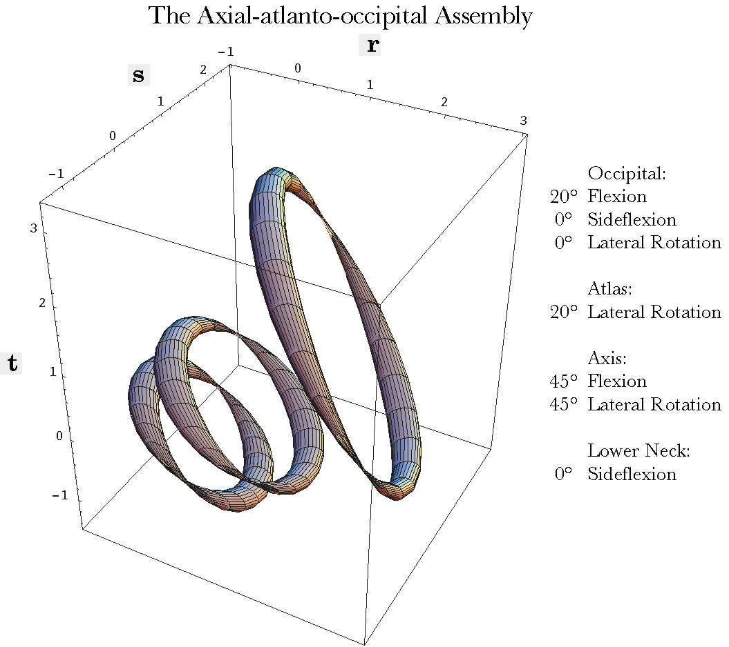
The AAOA after a combined movement of all three elements. The occiput is flexed 20° on the atlas, the atlas rotated 20° on the axis, and the axis rotated 45° to the left and tilted 45° anterior. All the conventions are as in the previous figure.
Rings have been used here because they do not obscure each other, as full representations of the bony elements would. However, one can enter as much detail as one likes as long as it is expressed in terms of the basis vectors of the frame of reference and the center of the element. One can choose to plot the facet joints and study their relationships as the vertebrae move or study the muscle and/or the ligament attachments and compute their axes of tension and lengths. In the following paper, we consider the shear placed upon the vertebral artery as it extends between the transverse foraminae of the atlas and the axis.
It turns out that the main limitation in performing these calculations is obtaining good quantitative data. A certain amount of data can be obtained from atlases and published x-rays and MRI’s, but much of the data has to be collected from anatomical specimens.

A Biomechanical-Cardiovascular Problem
The vertebral artery passes just posterior to the superior articular facets of the atlas and then through the foramen magnum to the medulla oblongata of the brainstem. At the superior end of the medulla the two vertebra arteries fuse to form the basilar artery. There is some controversy on whether the vertebral arteries are sufficiently stretched by the movements in the atlanto-occipital joint to compromise flow in the arteries. We can begin to answer that question by looking at how much distance lies between the posterior margin of the superior articular facet and the basilar artery when the head is taken through a full range of motion.

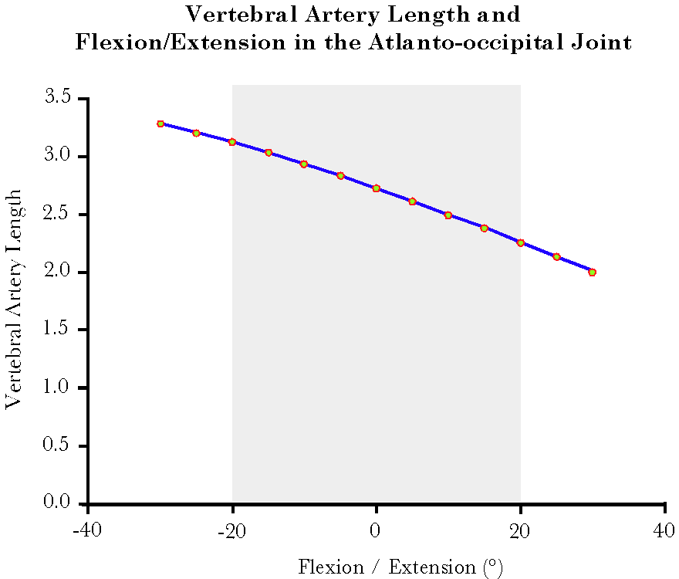
The foramen for the vertebral artery lies in the posterior atlanto-occipital membrane about 3/4 of a unit lateral to the center of the atlas and slightly above its horizontal meridian, say 0.3 units superior to the Q point. That will give it the location vector –
$λ_{V}\text{ =}λ_{\text{Atlas}}\text{+0}\text{.}\text{75}∗e_{\text{2;Atlas}}\text{ +0}\text{.}\text{05}∗e_{\text{3;Atlas}}=\left\{0\text{.}\text{0, 0}\text{.}\text{75, 0}\text{.}\text{30}\right\}\text{ in neutral}\text{.}$
The point at which the vertebral arteries join to form the basilar artery is more difficult to determine, but it would appear to be about the longitudinal level of the common center of rotation for the atlanto-occipital joint and about two units anterior to that point, in the midline. That would give it a location vector of about -
$λ_{B}\text{ =}λ_{\text{Occ}}\text{+2}\text{.}0∗e_{1_{\text{;Occ}}}\text{ =}\left\{2\text{.}\text{0, 0}\text{.}\text{0, 2}\text{.}0\right\}\text{ in neutral}\text{.}$
The distance that the vertebral artery spans is the difference between these two loci.
$$D_{\text{Vertebral}}=λ_{B}−λ_{V}$$
The first location travels with the atlas and the second travels with the occiput. If we perform the calculation of the alignment in neutral position, then the distance between the two loci is 2.73 units in neutral, as one can determine by vector subtraction. If the neck is flexed 20° then the distance between the two loci is 2.26 units and if it is extended 20° then it is 3.13. The relationship is plotted in the above chart. The increase in distance between the two points is a little less that 15%. At 15° extension the change is about 11.5%.

Discussion
The upper cervical joint assembly is a mechanically complex region of the spine with a number of special features that make its actions different from the rest of the spine. Both major joints are compound joints with unusually large ranges of motion. It does not have intervertebral discs and the facet joints are unique in the spine. The three bony elements have complex shapes and unusual alignment. The ligaments associated with this assemblage are also complex and unique to the region. At the same time, it has definite axes of rotation that make it straightforward to model in the first approximation. The model presented here is a framework within which one can ask quantitative questions and obtain quantitative answers. It is easily modified to introduce additional axes of rotation and special features that one wishes to track as the assembly moves.
This basic framework can be used to study a number of biomechanical questions related to manual therapy and cervical pathology. The advantage of a model such is this is that one can modify the various parameters and quantitatively examine how those differences may affect the biomechanics of the system. In other papers, the implications of the large ROM in the atlanto-axial joint are examined from the point of view of strains in the vertebral artery. Having solved for the average anatomy, one can then ask how the situation changes when the breadth and height of the vertebrae change, how the placement of the transverse foraminae relative to the axis of rotation change the strains, or how the ligamentous and/or muscular restrictions place more or less strain on the arteries. Often, the analysis leads to looking at the anatomy and physiology more closely, because it raises issues that were not considered previously.

Models Based on Quaternion Analysis
The model introduced here is in many ways remarkably simple. It reduces to a small set of equations. The equations are straightforward statements of the anatomical relationships that exist in the joint. Anatomical object are expressed as framed vectors and rotations as quaternions. The framed vectors are generally a direct expression of the pertinent anatomy, where the object is located, how it is distributed in space, and how it is oriented. The rotation is contingent upon the axis of rotation, the angular excursion, and the center of rotation. The equations can generally be written down by inspection, with a little thought. In this sense, the development of a model is very intuitive. Usually, the hardest part of the process is finding reliable numbers, because anatomy is generally not done quantitatively.
Once the descriptive expression has been created, there will be three types of equations because there are three types of vectors involved, which transform differently with movement. The simplest are these in the frame of reference. The new orientation is simply the rotation, R, operating on the basis vectors according to Euler’s formula.
$$e^{'}=r∗e∗r^{−1};r=R,\text{ with half the angle}\text{.}$$
Extension is potentially more complex, because re-scaling changes extension whereas it does not change orientation, but changes in size are not common in anatomical movements. It generally turns out that extension can be treated like orientation. In fact, it frequently turns out that the extension vector is simply a multiple of one of the orientation vectors and the same calculation used for the frame of reference also yields the new extension vector as well. The location vector is most difficult because it is necessary to shift the coordinate system from the origin of the system to the center of rotation, compute the transformation produced by the rotation and then shift the coordinate system back to the origin.
$$λ'=r∗\left(λ−h\right)∗r^{−1}+h;h=\text{center of rotation}$$
The center of the moving object and the center of rotation are both location vectors.
With these differences in mind, the transformation produced by a rotation is expressed simply as a product of a rotation quaternion and the object upon which it is working.
$$f^{'}=r∗f∗r^{−1}$$
What makes the upper cervical assembly model a bit more complex is that we are concatenating three rotations. The results of the first transformation are the object of a second transformation and so forth. The effects of each transformation are propagated through the system of linkages.
Once one has computed the transformations ($T$) due to a set of rotations in a linked system, it is usually easy to compute a great many other attributes of the components with minimal effort. If the attribute of the object, $α$, is expressed as function of the object’s location ($λ$), extension ($d$), and orientation ($w$), then one has only to substitute the new values in the descriptors.
$$α\left(λ,d,w\right)\vec{T}α^{'}\left(λ^{'},d^{'},w^{'}\right)$$
For instance, when computing the distance traversed by the vertebral artery within the subarachnoid space, the locations of the two ends were expressed relative to the occiput and the atlas in neutral position, the linkage was transformed by different amounts of flexion and extension in the atlanto-occipital joint, and the new values for the location and orientation vectors were substituted into the same expressions.

Summary
The movements of the axio-atlanto-occipital assembly (AAOA) are readily described in a formalism that grows out of quaternion analysis. The known anatomical features of the region may be translated directly into descriptive expressions that may be manipulated logically to obtain descriptions of complex, multi-joint, movements of the bony elements in the assemblage. With this logical model of the AAOA, it is possible to ask quantitative questions and obtain quantitative answers. The model has been realized in a short Mathematica program that allows one to specify the parameters of the movements in the various joints and generate a visual image of the alignments of the component elements. This model serves as a foundation for the examination of the strains produced in the C1/C2 segment of the vertebral arteries as lateral rotation occurs in the atlanto-axial joint.

Bibliography
Note: references with manuscript sources appear as links elsewhere on this website.
Arnold, C, R. Bourassa, T. Langer, and G. Stoneham (2003) Doppler studies evaluating the effect of a physical therapy screening protocol on vertebral artery blood flow, Manual Therapy, 9/1: 13-21.
Bladin, P. F. and J. Merory (1975). “Mechanisms in cerebral lesions in trauma to high cervical portion of the vertebral artery--rotation injury.” Proc Aust Assoc Neurol 12: 35-41.
Dvorak, J., E. Schneider, et al. (1988). “Biomechanics of the craniocervical region: the alar and transverse ligaments.” J Orthop Res 6: 452-461.
Johnson, R. M., D. L. Hart, et al. (1977). “Cervical orthoses: a study comparing their effectiveness in restricting cervical motion in normal subjects.” J Bone Jt Surg 59A: 332-339.
Kapandji, I. A. (1974). The Physiology of the Joints. Annotated diagrams of the mechanics of the human joints. New York, Churchill Livingstone.
Langer, T. (2002). “The movements produced by the extrinsic eye muscles: Sling model.” manuscript.
Langer, T. (2002). “The movements produced by the extrinsic eye muscles: Traditional model.” manuscript.
Langer, T. (2002). “Saccades are the most efficient trajectories for eye movements.” manuscript.
Langer, T. (2002). “Strain in the vertebral arteries due to movements of the upper cervical joint assembly.” manuscript.
Levangie, P. K. and C. C. Norkin (2001). Joint Structure and Function. A Comprehensive Analysis. Philadelphia, F. A. Davis Company.
Nordin, M. and V. H. Frankel (1989). Basic Biomechanics of the Musculoskeletal System. Philadelphia, Lea & Febiger.
Norris, J., V. Beletsky, et al. (2000). “Sudden neck movement and cervical artery dissection. Canadian Stroke Consortium.” CMAJ 163:(1): 38-40.
Tweed, D. and T. Vilis (1987). “Implications of rotational kinematics for the oculomotor system in three dimensions.” J Neurophysiol 58(4): 832-49.
White, A. A. and M. M. Panjabi (1978). Clinical Biomechanics of the Spine. Philadelphia, J. B. Lippincott.
Williams, P. L., L. H. Bannister, et al. (1995). Gray's Anatomy. The Anatomical Basis of Medicine and Surgery. New York, Churchill Livingstone.

