Dependence of Vertebral and Carotid Artery Flow Upon Vertebral Artery Stress Tests and Premanipulative Holds

Arnold, C.¹, Bourassa, R. ², Langer, T. ³ & Stoneham, G. ⁴

1 Cathy M. Arnold, M.Sc. Assistant Professor, School of Physical Therapy, University of Saskatchewan
2 Richard J. Bourassa, M.Sc., Clinical Professor, School of Physical Therapy, University of Saskatchewan
3 Thomas Langer Ph.D., Lecturer, Dept. of Anatomy and Cell Biology, College of Medicine, University of Saskatchewan
4 Grant Stoneham, MD., Assistant Professor, Dept. of Medical Imaging, College of Medicine, University of Saskatchewan

Introduction
This study examines a few variants from a previous study of the response of vertebral artery blood flow to a series of stress test maneuvers (Arnold, et al, 2004 a,b). In that study, it was observed that most stress tests positions had no consistent effect upon vertebral artery blood flow. The only exceptions were a cessation of blood flow with full lateral rotation, seen in few individuals, and cessation or major reduction of blood flow in a over half the subjects when their C1/C2 joint was placed in a premanipulative hold position for lateral rotation of the atlas upon the axis. There was some question of whether the results were particular to the therapist doing the tests, whether the order of the tests was a factor, and whether the level of the manipulative hold was critical to the result. To try to address these questions, a number of subjects from the previous study were re-examined in a situation where the order of the tests were shuffled, the tests were performed by two therapists, Richard and Denise, and the premanipulative hold was performed at the C1/C2 joint and C5/C6. Only the tests that were most effective in producing change were done. All the subjects were individuals that responded in the previous testing, about a year previously.
While watching these experiments, the most impressive effect of the mobilizations was the major reductions in vertebral artery blood flow during certain of the premanipulative holds, when performed by Richard. This remains the principal finding of the study. In particular, with sideflexion and contralateral rotation either in the premanipulative hold for atlanto-axial manipulation or as part of the lock for the C5/C6 extension manipulation, there was a substantial reduction of peak systolic flow rate and often a complete cessation of diastolic flow. This occurred only when Richard performed the maneuver. Statistical analysis indicates that the same effect occurred with Denise, but it was more subtle. It is the artery that lies contralateral to the direction of the rotation which experiences the reduction in flow.
In addition, there were also subtle increases in resistance to blood flow in the carotid arteries during the maneuvers. There were some other minor effects that are suggestive, but only suggestive.
During the second set of measurements in neutral position, after Richard and before Denise, there was a tendency to lower vertebral artery flow velocities in both peak systolic and end diastolic phases. After Denise there was a greater than average flow in both phases.
The results of these studies are briefly described here and the findings are considered in relation to the anatomy of the neck in the premanipulative holds. It is argued that the critical feature of the holds for the reduction of blood flow is the few degrees of sideflexion that reduces the gap for the alar ligament on the ipsilateral side, thereby removing the restraint upon contralateral rotation. The additional contralateral rotation is sufficient to crimp the vertebral artery as it passes between the axis and the atlas.
Data Collection and Processing
The data consists of 418 samples collected in 7 individuals. There were four types of sampled positions: neutral, full lateral rotation to the right or left, premanipulative hold for a right or left rotatory manipulation of the atlanto-axial joint, and premanipulative hold for an extension manipulation of the right or left C5/C6 facet joint. Samples were take in neutral position prior to any maneuvers (N1), between testers (N2), and after both testers had finished (N3). In every position, there was sampling of both the right and the left vertebral artery and carotid artery. The vertebral arteries were sampled at mid-cervical levels. An effort was made to sample the internal carotid, but sometimes the bifurcation occurred too high to visualize the internal carotid much above the bulb. Each maneuver was performed by each of two testers, Richard (R) and Denise (D).
Each subject was allowed to rest in supine for 10 minutes prior to all measurements, to allow their circulation to equilibrate. A measurement of blood flow in both vertebral arteries and both carotids was collected prior to any movements of the head or neck. The Richard placed the head an neck in a each of the test positions, in random order, according to a schedule that was arranged prior to all testing of the subjects. Samples of blood flow in both vertebral and both carotid arteries were collected in each position. Following all of Richard’s tests, the subject again lay in supine for about 10 minutes and a second set of measurements were collected in neutral position. Then, Denise took the subject through all of the tests in the same order and velocity was measured as in the first set of tests. The subject again rested for a few minutes and the same velocity measurements were collected in the same order in neutral position.
If you take 6 maneuver positions times two sampled arteries times two sides times 7 subjects times two testers plus three tests in neutral times two sampled arteries times two sides times 7 subjects, you get 420 samples. The discrepancy is due to not doing the initial carotid measurements in neutral position for one test subject.
For every sample, we measured peak systolic flow (P), end diastolic flow (D), and computed resistance (R). The resistance is the difference between peak systolic flow and end diastolic flow over peak systolic flow.
$$R=\frac{P−D}{P}$$
If blood flow ceases during diastole then the ratio is 1.0, so a resistance of 1.0 indicates that the flow was occluded for a part of the pulse cycle.
After the sample collection, the mean values for the three parameters in neutral were computed for each test subject by adding together all three values for each artery and computing the mean value for each artery on each side.
$$\bar{V}=\frac{1}{N}\sum_{\text{n=1}}^{N}{V_{n}};{\text{ where V}}_{n}\text{ is a parameter, in neutral}\text{.}$$
Then, the other maneuver samples were normalized by subtracting the sample value from the mean value in neutral position for that artery, dividing by the mean value and expressing the fraction as a percentage. By this means the percent change in peak systolic flow rate (%P), in end diastolic flow rate (%D), and in resistance were computed (%R).
$$\text{\%V}=\frac{V−\bar{V}}{\bar{V}}∗\text{100\% for V=P, D, R}$$
Consequently, there were six numerical variables for each sample or 2,508 sample points for analysis.
There were a number of questions that we wished to address and different groupings were relevant to each question. The data was analyzed by dividing it into progressively finer groups to determine what divisions isolated the data with responses that were clearly different from the norm. The norm was generally taken to be the average blood flow in neutral position. When examining individual subjects, it was their average blood flow in neutral that was used as the norm.
Analysis

Vertebral Artery Data

Average Values for All the Vertebral Artery Data
If we consider all of the measurements from the vertebral artery samples, the values for the standard variables are as in Table 1. These values are for the entire data set for the vertebral arteries. Therefore, it includes the data from neutral position and all the maneuvers of both testers..

All Samples From Vertebral Artery (N = 210)
 | Mean | Standard Deviation | Standard Error
P | 46.50 | 15.12 | 1.04
D | 14.67 | 7.07 | 0.49
R | 0.70 | 0.11 | 0.007
%P | -0.18 | 28.89 | 1.99
%D | -4.31 | 43.31 | 2.99
%R | 5.80 | 16.81 | 1.16

Table 1. Mean and variation for all vertebral artery samples. The abbreviations are as follows: P – peak systolic velocity, D – end diastolic velocity, R – arterial resistance, %P – percent change in peak systolic velocity relative to the average for the three samples taken in neutral, %D – the same ratio for end diastolic velocity, %R – the same ratio for vertebral artery resistance.
The distributions of the basic parameters are summarized in Figure 1. The darker green areas mark the same set of samples in each case. They are the samples in the highest group of resistance measurements, the samples in which there was cessation of blood flow. Those tests tended to be the tests with the lowest peak systolic and end diastolic blood flow, the greatest negative change in peak systolic and end diastolic blood flow and the greatest increase in resistance. The box plots are for the data in the adjacent distributions. The box encloses the median and the upper and lower quartiles. Outliers are indicated by the blue dots. There is clearly a set of samples that are markedly different from the usual. They will be willowed out as we consider subsets of this data.
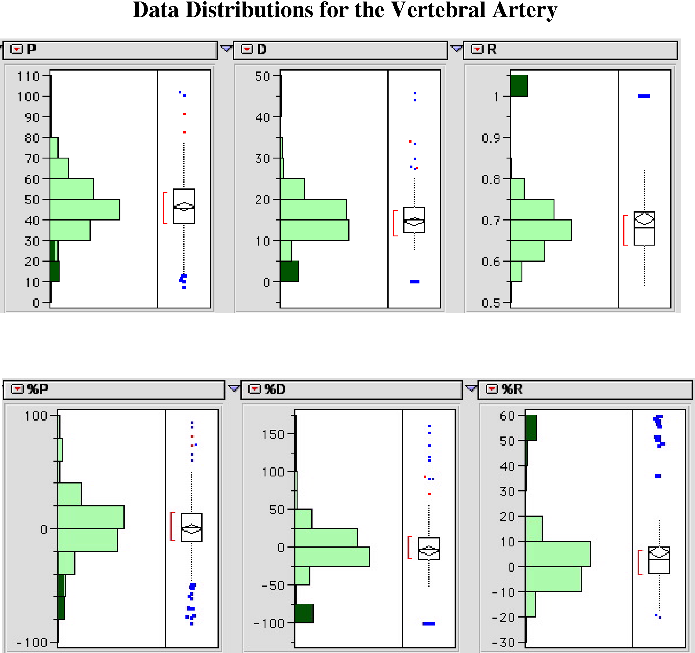
Figure 1. The distributions of the measured and calculated parameters from all the measurements. The symbolic conventions are as in Table 1.
Average Values for the Vertebral Artery Data Collected in Neutral Position
The values for the samples taken in neutral position are collected in Table 2. Comparison of these first two tables will reveal that the means of the distributions for peak systolic flow, P, and end diastolic flow, D, during all samples are statistically equal to the values for the measurements in neutral (P > 97.5%) and the mean for the resistance, R, is statistically different (P >97.5%) with the mean for the whole sampled set, being greater than that for neutral position.
All Neutral Samples (N = 42)
 | Mean | Standard Deviation | Standard Error
P | 46.86 | 15.45 | 1.48
D | 15.45 | 3.33 | 0.51
R | 0.67 | 0.04 | 0.007
%P | 0.00 | 8.67 | 1.34
%D | 0.00 | 9.12 | 1.41
%R | 0.00 | 4.83 | 0.75

Table 2. The mean and variation for all measurements collected in neutral position. These samples were taken prior to all testing, between sets of tests, and after all testing. The conventions are the same as in Table 1.
The means for the percent change values is zero for the samples taken in neutral position. It would appear that the mean %P and mean %D for the full sample set are statistically equal to that in neutral, but the %R is statistically greater than zero. Consequently, both tables suggest that resistance to flow is modestly increased by the maneuvers. There are weak indications that the peak systolic and end diastolic flows may decrease, but these relations need to be examined in more defined sets.

Does Blood Flow change during the Course of the Testing?
One of the questions that needs to be addressed is whether the background flow rates change systematically during the course of the sampling. To address this we might look at how the mean varies between tests. The following three tables are for the individual tests in neutral position. N1 is the test prior to any testing, N2 is the test between testers, and N3 is the test after both testers. The percent changes are all relative to the full set of three tests in neutral position.
N1 (N = 14)
 | Mean | Standard Deviation | Standard Error
P | 47.51 | 10.84 | 2.90
D | 15.85 | 3.42 | 0.92
R | 0.66 | 0.05 | 0.01
%P | 1.19 | 10.29 | 2.75
%D | 2.41 | 7.78 | 2.08
%R | -1.26 | 5.45 | 1.46

N2 (N = 14)
 | Mean | Standard Deviation | Standard Error
P | 46.23 | 10.29 | 2.75
D | 14.48 | 3.22 | 0.86
R | 0.68 | 0.04 | 0.01
%P | -1.52 | 8.82 | 2.36
%D | -6.19 | 7.87 | 2.10
%R | 2.66 | 4.03 | 1.08

N3 (N = 14)
 | Mean | Standard Deviation | Standard Error
P | 46.85 | 8.22 | 2.20
D | 16.04 | 3.37 | 0.90
R | 0.66 | 0.04 | 0.01
%P | 0.33 | 7.03 | 1.88
%D | 3.78 | 8.77 | 2.34
%R | -1.40 | 4.03 | 1.08

Tables 3. The values for vertebral blood flow during the rest periods prior to testing (N1), between testing sessions(N2), and after testing (N3). The conventions are as in Table 1.
There is an indication that the resistance is elevated in the middle test, between testers. This may be due to the slight decrease in average peak systolic flow and the larger decrease in the average end diastolic flow. There is also an increase is percent change in resistance. This a small effect, probably not clinically relevant, but definitely present. It may or may not be related to the effects that will be described below for Richard’s testing.

Samples from the vertebral artery during testing
Next, consider the comparable values in the data sets for Richard and Denise alone. The distributions are just the samples when one or the other tester was actually maneuvering the head and neck. These values in Denise’s data (Table 4) are essentially the same as for neutral position. At least in the aggregate, there is no effect of maneuvers. To dissect the data it is necessary to look at Richard’s data to see where a difference from neutral might appear.

All Samples From Denise (N = 42)
 | Mean | Standard Deviation | Standard Error
P | 46.86 | 9.62 | 1.48
D | 15.46 | 3.33 | 0.51
R | 0.67 | 0.04 | 0.01
%P | -0.00 | 8.67 | 1.34
%D | 0.00 | 9.12 | 1.41
%R | -0.00 | 4.83 | 0.75

Table 4. Vertebral artery samples during testing by Denise. The conventions are as in Table1.
Clearly, Richard’s sampling is quite different from Denise’s. While mean peak systolic velocity (P) is slightly less, the dispersion is more than twice as great. Mean end diastolic velocity (D) is less and the dispersion is more than three times as great. The resistance (R) is more than 10% higher and the dispersion is almost four times as great. This indicates that though both peak systolic velocity and end diastolic velocity drop, the latter drops proportionately more. The average percent change in peak systolic velocity (%P) is substantial, but not significantly different from zero, because of the wide variance. Not only does the mean drop, due to negative values, but there are more large positive values as well. The dispersion is almost five fold that of Denise. For percent change in end diastolic velocity (%D) the drop is greater and the dispersion is over seven fold that of Denise’s samples. The percent change in resistance (%R) is very much greater than zero and the dispersion is about five fold that of Denise’s data.

All Samples From Richard (N = 42)
 | Mean | Standard Deviation | Standard Error
P | 44.42 | 19.24 | 2.11
D | 13.59 | 10.04 | 1.10
R | 0.75 | 0.15 | 0.02
%P | -4.36 | 39.75 | 4.37
%D | -10.48 | 64.69 | 7.10
%R | 12.38 | 24.22 | 2.66

Table 4. Vertebral artery samples during testing by Richard. Conventions as in Table1.
The Distribution’s Structure
To see why Richard’s data is so far from the samples in neutral position, we need to return to the distributions of all the sample data (Figure 1). The box-plots are particularly informative. There is a solid body of data that lies in the central region of the distributions, which determines the median, mean, quartiles and whiskers of the box plot. Based upon the majority of the samples most of the data should fall within the range of the whiskers. However, there are substantial populations of outliers at both ends of the distribution. We are particularly interested in those that indicate compromise of the vertebral circulation, but both sets need to be considered.
If we examine the distribution of D, it is clear that most values fall within the whiskers of the box plot, but a population of outliers is located at the zero flow extreme of the distribution, well separated from the rest of the population. The separation allows us to select those samples that have a cessation of flow during diastole. They are indicated by the darker green bar at the end of the frequency plot. What is interesting though is that the same samples are indicated by the dark green portions of the other frequency distributions. In the peak systolic flow plot all the samples are at the low end of the frequency distribution. Therefore, the occulsion caused the peak flow to decrease as well. In the plots for resistance the same samples are all in the bar for R = 1.0, which we would expect since the definition of R makes R equal to 1.0 if and only if D = 0.0. The percent change in peak systolic blood flow reflects the same pattern as the peak systolic blood flow plot, indicating that is genuine decreases in blood flow rather than slow flow vessels being more susceptible to occulsion. The percent change in end diastolic blood flow has the same characteristics and it implies that the occulsion is a general response to the maneuver. Finally, the percent change in resistance plots show that there are two populations of sample points. The upper group is the samples that are highlighted. The 20 highlighted samples are listed in Table 5.

Richard’s Vertebral Artery Data
All the samples are in Richard’s set and all are premanipulative positions, half the atlanto-axial manipulations and half the lower cervical spine manipulations. For the atlanto-axial premanipulative hold, the direction of the manipulation is opposite to the side of the artery that is occluded. In the lower cervical spine, it is the opposite and both have the same directional designation. The difference is an artifact of the naming system. For both manipulations, the head is sideflexed to the side of the occluded artery and the atlas is rotated away from the occluded artery. Consequently, the same mechanism is probably responsible in both premanipulative holds.
The order is the place in the sequence at which the test was actually performed. The possible values are 2 to 7, because the first neutral sample is always number 1 and the second is always number 8. As can be readily seen, all the possible values occur so it is unlikely that the order in which the tests are done is relevant. If anything, being the last of the three tests reduces the frequency of occlusion. All but one of the subjects tested showed occlusion in at least one artery, most had occulsion in both arteries. One subject did not have any occlusion and one had it only on the left side.
Outlier Samples
Test | Sample Artery | Order | Subject
RAA | L | 2 | Ca
RAA | L | 2 | To
RAA | L | 2 | Ke
RAA | L | 6 | Bo
RAA | L | 4 | Ta
RAA | L | 6 | Car
LAA | R | 3 | Ca
LAA | R | 3 | To
LAA | R | 3 | Ke
LAA | R | 5 | Ta
R56 | R | 4 | Ca
R56 | R | 4 | To
R56 | R | 4 | Ke
R56 | R | 2 | Car
L56 | L | 5 | Ca
L56 | L | 5 | To
L56 | L | 5 | Ke
L56 | L | 3 | Bo
L56 | L | 7 | Ta
L56 | L | 3 | Car

Table 5. The samples in which there was complete cessation of blood flow during the diastolic phase. The first column is the test. If the first letter is R then the rotation was to the right, if it is L , then it was to the left. AA designates the atlanto-axial premanipulative hold and 56 indicates that the test was the C5/C6 extension premanipulative hold. The sampled artery was either the Right (R) or the left (L) artery. Order refers to the place of the test in the testing sequence. There were seven subjects, six of them had occlusion on at least one side. In five, both sides were occluded.

Does Denise’s vertebral artery data show the same effect?
Nothing as definitive as full occulsion was obtained by Denise during her maneuvers. However, we now know which tests might be expected to show an effect of the maneuvers and therefore can examine them particularly. The question that is being asked is whether there is a tendency for decreased flow and/or increased resistance in those tests in which the head is sideflexed towards and laterally rotated away from the sampled artery. The results from Denise’s data are summarized in the following table.

Number of Negative Changes
 | %P | %D | %R
Crossed
Rotation | 10 | 10 | 7
Atlanto-axial | 7 | 10 | 3
C5/C6 | 4 | 8 | 3
Uncrossed
Rotation | 8 | 8 | 7
Atlanto-axial | 4 | 7 | 6
C5/C6 | 8 | 8 | 7

Table 6. The distribution of samples in which there was a decrease in blood flow. All the numbers are out of 14 possible samples.
There were 14 tests in each category (7 subjects times 2 sides). If about half of the tests showed an increase and half showed a decrease, then we can be fairly sure that there is no effect. If only one or two were positive or negative and all the rest had the opposite sign, then we can be fairly sure that there was a strong effect. If we compute the probabilities of obtaining N tests with negative change and the remainder with a positive change, then the values are as in Table 7.
If there were 3 or less, or 11 or more, that were negative, then the probability of it being due to chance variation is less than 0.029. There are two situations in which only three of the tests were negative, for percent change in resistance with the atlantoaxial premanipulative hold and with the C5/C6 premanipulative hold, when the sideflexion was towards the sampled artery. These observations are consistent with what was seen in Richard’s data. Therefore, there is a comparable trend in Denise’s data, but it shows only for resistance, which seems to be the most sensitive measure of altered blood flow.
Binomial Distribution for 14 Samples
N | Probability | Cumulative
0 | 0.0000610352 | 0.0000610352
1 | 0.000854492 | 0.000915527
2 | 0.0055542 | 0.00646973
3 | 0.0222168 | 0.0286865
4 | 0.0610962 | 0.0897827
5 | 0.122192 | 0.211975
6 | 0.183289 | 0.395264
7 | 0.209473 | 0.604736
8 | 0.183289 | 0.788025
9 | 0.122192 | 0.910217
10 | 0.0610962 | 0.971313
11 | 0.0222168 | 0.99353
12 | 0.0055542 | 0.999084
13 | 0.000854492 | 0.999939
14 | 0.0000610352 | 1.00

Table 7. The binomial probabilities of different numbers of outcomes. Both the probability density and the cumulative probabilities are provided. One would not expect 3or less or 11 or more, at a 6% confidence level. If there is no effect of the testing on blood flow, then one would usually expect 7±2 tests with increases or decreases in flow.

The High Outliers
As was noted above, there were also a number of outliers that were above the upper whisker in several plots. When we select them and trace them to their sources, we find a situation generally opposite to that for the low outliers. When we select the high outliers in the percent change in peak systolic velocity plot, then two were Denise’s and six are Richard’s. Both of Denise’s were from left rotation, one on the right side and the other on the left, in two different individuals. Richard’s data was from the premanipulative holds. Three of the samples were from each premanipulative hold. The relationship is the opposite from the low outliers. The greatest increases in peak systolic velocity were when the sampled artery was opposite the direction of the sideflexion and on the side towards which lateral rotation was occurring.
Carotid Artery Data
The data from the carotid artery samples is more easily dealt with in that there were no striking responses to the maneuvers of either Richard or Denise. The distributions are compact with almost no outliers and the few that do occur have no consistent pattern. The basic statistics are as follows.
All Samples From Carotid Artery (N = 208)
 | Mean | Standard Deviation | Standard Error
P | 72.40 | 18.44 | 1.29
D | 23.44 | 5.96 | 0.41
R | 0.67 | 0.06 | 0.004
%P | 11.49 | 22.47 | 1.56
%D | -3.20 | 20.77 | 1.44
%R | 7.70 | 10.62 | 0.74

Figure 8. The sample means and variation for all samples from the carotid arteries. The distributions are more compact than those for the vertebral arteries, which would argue less perturbation from the testing.
The comparable figures for the samples taken from neutral are as follows.
All Samples From Carotid Artery in Neutral Position (N = 40)
 | Mean | Standard Deviation | Standard Error
P | 65.96 | 16.39 | 2.59
D | 24.72 | 6.18 | 0.98
R | 0.63 | 0.06 | 0.009
%P | -0.00 | 13.43 | 2.12
%D | 0.00 | 13.30 | 2.10
%R | 0.00 | 6.80 | 1.07

Figure 9. The sample means and variation for all samples from the carotid arteries while in neutral position. The distributions are compact than those for the vertebral arteries, which would argue less perturbation from the testing.
The individual tests in neutral are generally statistically indistinguishable from the average of all the tests in neutral. There is however a curious trend in the %R measurements. All but one of the %R values in the first sample in neutral are positive and the mean is statistically greater than 0.00. For the second test in neutral, it is all but three that are positive, but the mean is statistically equal to zero at the 95% level of confidence. The final test in neutral is nine out of fourteen negative changes and the mean is indistinguishable from zero at the 95% level of confidence.
Comparison of the statistics for all the samples versus the samples in neutral indicate that the samples during maneuvers of the head and neck have increased peak systolic flow, increased resistance to flow and probably decreased end diastolic flow. Therefore, it is worth looking at the data for the maneuvers to determine where this difference is occurring.
Richard’s Samples From Carotid Artery (N = 84)
 | Mean | Standard Deviation | Standard Error
P | 75.64 | 21.69 | 2.37
D | 23.45 | 6.32 | 0.69
R | 0.68 | 0.06 | 0.006
%P | 16.25 | 25.80 | 2.81
%D | -3.15 | 22.83 | 2.49
%R | 9.81 | 10.47 | 1.14

Table 10. The collected data from all tests by Richard. The mean percent change in peak systolic velocity and resistance are clearly significantly different from neutral.
The statistics for Richard and Denise individually are summarized in the following tables (Tables 10 and 11). The shifts are most clear and most likely due to the maneuvers in the percent change data. There is a clear increase in the mean peak systolic blood flow and an ambiguous decrease in the mean end diastolic blood velocity. Overall, there is a very clear increase in mean resistance to blood flow. This effect appears to be evenly distributed over the lateral rotations, atlanto-axial premanipulative holds and the C5/C6 premanipulative holds. In Denise’s data, there is no apparent pattern to which hold, which direction of hold, or which tested artery is involved. In Richard’s data, all but one of the samples with large increases was for sampling the right artery. Otherwise, there was no apparent dependence upon the hold used or the direction of the hold.
Denise’s Samples From Carotid Artery (N = 84)
 | Mean | Standard Deviation | Standard Error
P | 72.22 | 15.50 | 1.69
D | 22.81 | 5.43 | 0.59
R | 0.68 | 0.06 | 0.006
%P | 12.20 | 20.52 | 2.24
%D | -4.78 | 21.53 | 2.35
%R | 9.26 | 10.69 | 1.17

Table 11. The collected data from all tests by Denise. The mean percent change in peak systolic velocity and resistance are clearly significantly different from neutral.

Differences between the responses in the two arterial systems
There is a subtle, but interesting difference in the %R responses in the vertebral arteries versus the carotid arteries. The increase in the vertebral artery was for the most part accompanied by a decrease in the peak systolic velocity, but an even greater decrease in the end systolic velocity. In fact, blood flow ceased during diastole. By contrast, the increase in %R in the carotid artery was accompanied by an increase in peak systolic and small decrease in end diastolic velocity. Both indicate an increase in resistance to flow somewhere distal to the sampled region, but the nature of the increase is different.
If there is a small increase in resistance then it takes more pressure to push the blood through the resistance, therefore, the flow during diastole is reduced a bit, but energy is stored in the elastic elements of the circulatory vessels and the peak systolic flow increases, because of increased pressure. This is the situation in the carotid artery data.
If the distal resistance to flow increases enough, then the pressure during diastole is not sufficient to push through the resistance and blood flow ceases. Despite the stored energy and increased driving pressures, the resistance to flow impedes the flow enough to reduce the velocity of the blood during systole. This is the situation in the vertebral artery data.

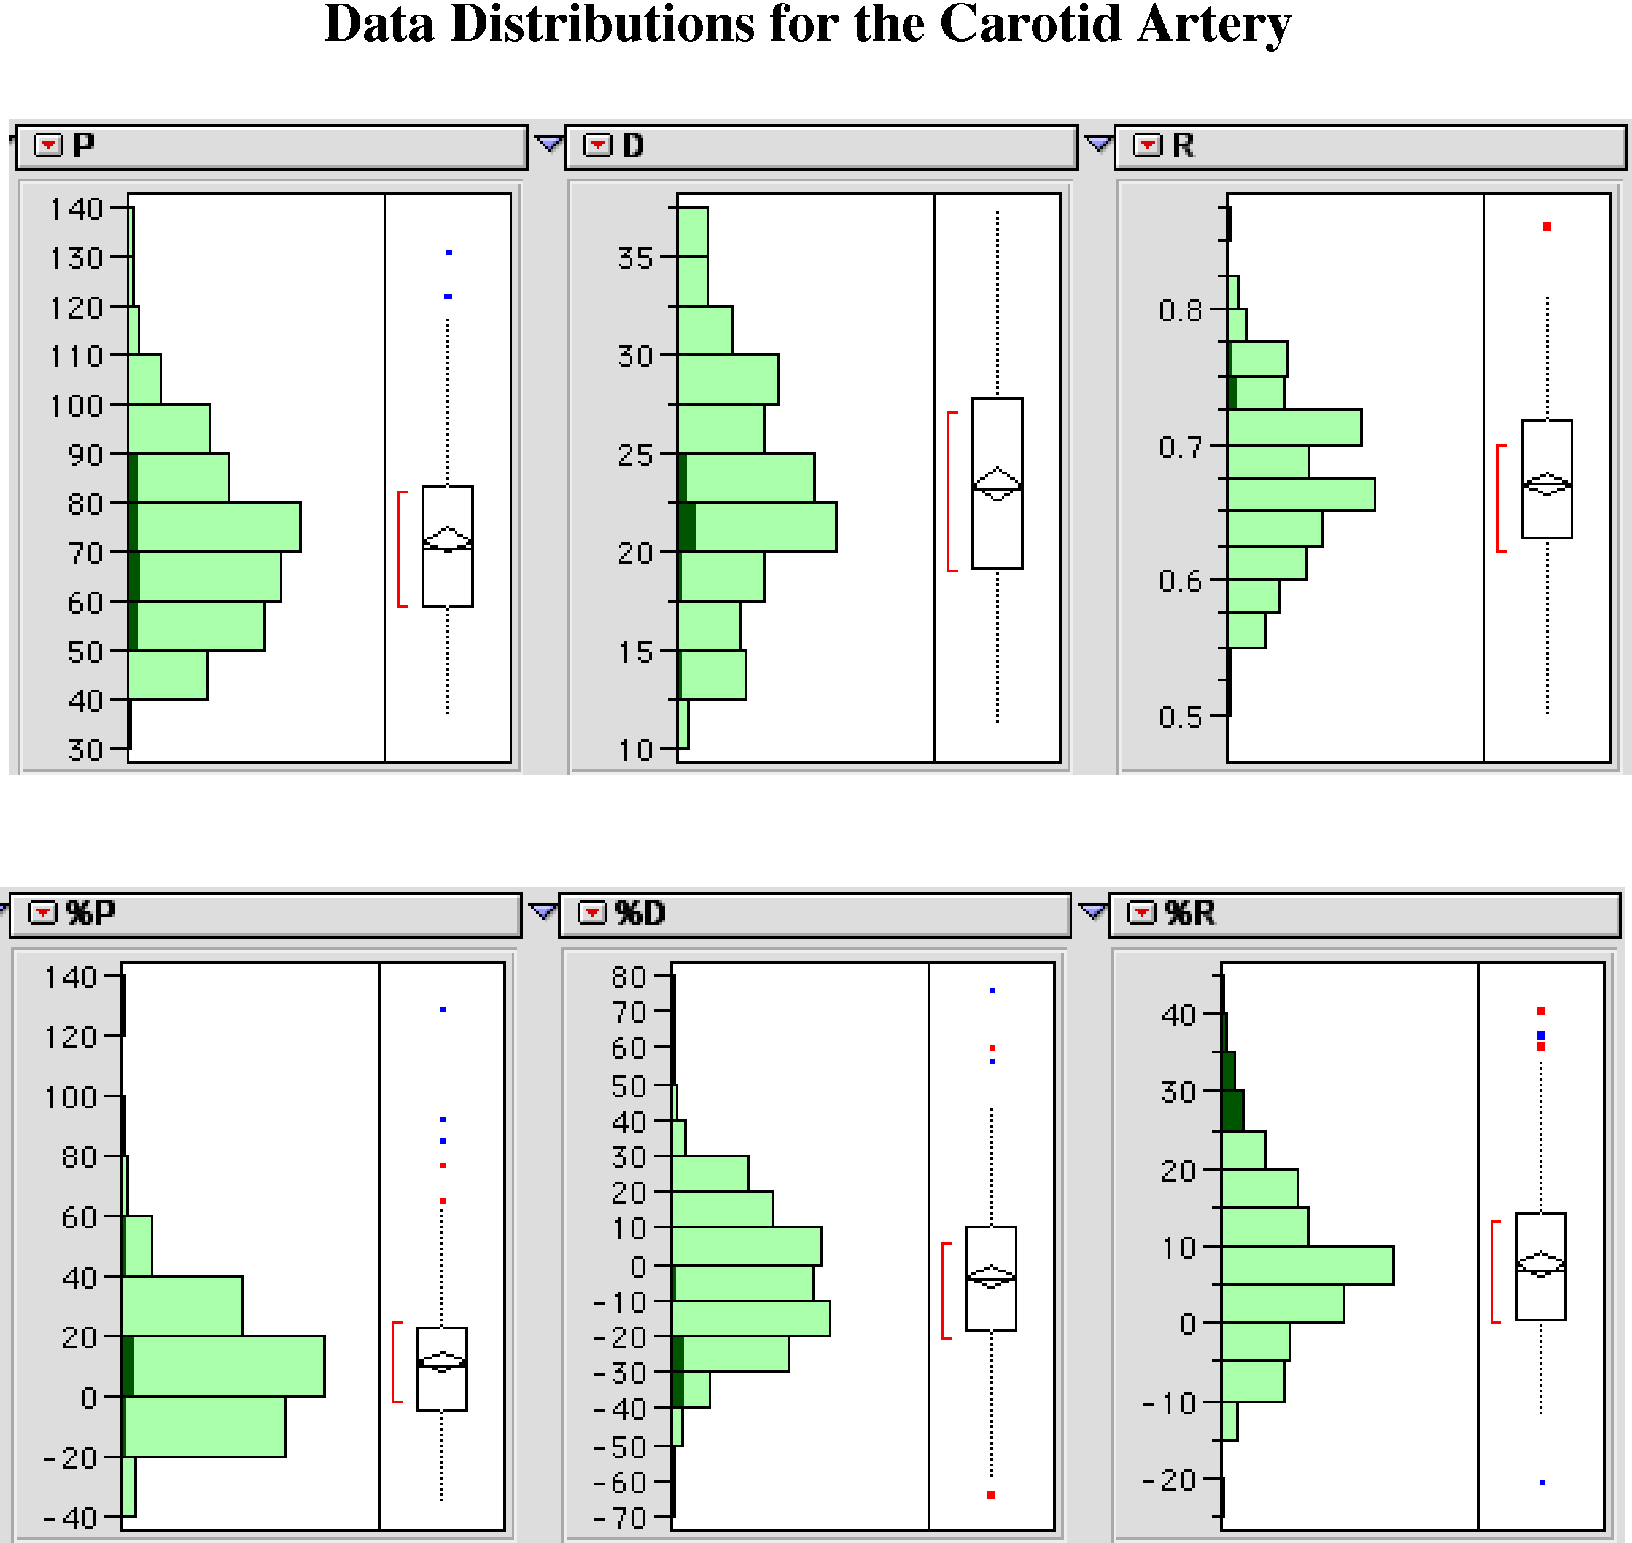

Figure 2. The distribution of blood flow in all samples from the carotid arteries. The darker green samples are selected from those with the greatest increase in resistance.
If the resistance to flow increases even more, then the blood cannot flow through the vessel and there would not be any blood flow in either systole or diastole. This did not occur in these experiments, but it did happen a few times in the first set of experiments.
Consequently, we are seeing a moderate increase in distal resistance for the carotid arteries for sporadic samples, with little apparent relation to the maneuver being performed, but there is a clear pattern to the greater distal resistances seen by the vertebral arteries. The resistance seen in the vertebral artery is related to the head being ipsilaterally sideflexed and contralaterally laterally rotated.
Overview
There are several points that may be made about the data obtained in these experiments.
1.) The results confirm the original observation that the premanipulative hold for atlanto-axial manipulation is a powerful impediment to blood flow in the artery contralateral to the direction of the mobilization. However, these experiments indicate that the technique used may be a significant factor as well. The effect was much less apparent in Denise’s hands. This is the most striking conclusion from the present data. The effect did not appear to depend on the order in which the maneuvers were performed.
2.) The present data does not confirm the original observation that there are individuals in whom full contralateral rotation of the neck obstructs blood flow. Those individuals that had cessation of blood flow in full lateral rotation in the original series did not exhibit that behavior in this series. This is almost certainly due to better ultrasound technique, possibly due to the use of a more sophisticated machine.
3.) There is a less marked increase in distal resistance to blood flow in some of the samples from the carotid artery. This is more of a statistical phenomenon at this point and there is not a clear relation to any particular maneuver. The effect is real, but the reason for it is obscure.
4.) There was a subtle, but real difference between the samples taken in neutral position prior to any maneuvers, between testers, and after all maneuvers. The last test in neutral seems to be closest to the average in neutral. For Richard, there was an increased resistance to flow in the vertebral arteries after the maneuvers. The resistance in the carotid arteries is greatest prior to the maneuvers, less between testers, and least after all the maneuvers. At this point, these observations are basically interesting observations; there is little that we can do with them.
As limited as this series was, it has provided a number of useful points to ponder and largely confirmed the original data. It may also point the way to further questions related to medical practice and our understanding of the anatomy of the neck and of the cerebral circulation.

