Blood Flow in the Vertebral Arteries When Strained by
Lateral Rotation in the Upper Cervical Spine

Thomas Langer

Introduction
The segment of the vertebral arteries that passes between the transverse processes of the first two cervical vertebrae is particularly prone to injury with rapid head movements and the majority of strokes involving the posterior circulation were found to be due to injury at the C1/C2 level of the vertebral arteries [Bladin, 1975 #18; Norris, 2000 #19]. It is thought that the reason for the susceptibility of this portion of the artery is the very substantial range of motion in the atlanto-axial joint. Normal lateral rotation in that joint is about 45° to either side, or 90° total excursion [Levangie, 2001 #10]. That amount of movement is apt to place strains upon the vertebral arteries and, secondarily, to compromise blood flow. Conversely, markedly reduced blood flow may be an indication that there are major strains in the vertebral artery.
The motivation for this work came from a study that monitored the blood flow in the vertebral arteries with Duplex Doppler ultrasound while the head and neck were being mobilized into an series of endrange positions normally used to test for the competence of the vertebro-basilar circulation [Arnold, et al., 2004]. Contralateral lateral rotation proved more apt to reduce blood flow than ipsilateral lateral rotation, lateral rotation with extension and traction, or even de Kleyn’s position, which involves suspending the head, neck, and shoulders off the end of the table, taking the head and neck into maximal extension and lateral rotation and adding overpressure. In a subsequent study, with a more advanced ultrasound machine, it was found that full lateral rotation generally did not occlude the vertebral artery (Langer et al., 2004). However, in both studies, by far the most stressful position for the vertebral arteries, as indicated by reduced blood flow, was a pre-manipulative hold for an atlanto-axial manipulation, in which the neck is sideflexed to one side and the atlas is manually laterally rotated upon the axis so that it rotates away from the side of the sideflexion. It reduces blood flow in a majority of individuals and will often completely occlude the vertebral artery for at least a part of the pulse cycle.
These observations prompted questions as to the causes of the reduced blood flow. To address these questions it was necessary to look carefully at what the bones in the upper cervical spine were doing during these movements and how those movements might strain the vertebral arteries. To that end, a model was constructed that allows one to compute the alignments of the vertebrae and the occiput for any specific set of movements in the joints of the region [Langer, 2004]. That model was the foundation of another model that allowed one to compute the strains in an elastic tube that was distorted by off-center rotations like the C1/C2 section of the vertebral artery experiences when the atlas is laterally rotated upon the axis [Langer, 2004]. In this paper, the model is extended to examine the changes in blood flow that would be expected with the computed stains in the vertebral artery. It is assumed that flow in the vertebral arteries is laminar and that the vertebral arteries behave like elastic tubes. The emphasis is upon determining what distortions of the vertebral arteries are most apt to make major changes in the resistance to blood flow in the artery.

Methods
In this paper, the axis vertebra is taken as fixed and the principal rotation is lateral rotation in the atlanto-axial joint. There are no movements in the atlanto-occipital joint. The implications of concurrent rotations in both joints are explored in another paper [Langer, 2004]. The only movement in the atlanto-axial joint is lateral rotation about a longitudinal axis through the odontoid process, unless stated otherwise. The main feature extracted from the model of the configuration of the bony elements in the craniovertebral junction [Langer, 2004] was the locations of the transverse foraminae. For the purposes of the model, it is generally assumed that the vertebral arteries run directly from the transverse foramina of the axis to the transverse foramina of the atlas [Langer, 2004].
In this paper, the flow though the artery was computed, assuming laminar flow. The flow rate is generally referenced to the flow in a circular tube with a standard radius, usually set equal to 1.0. The other flow parameters are set so that flow through a tube of radius of 1.0 gives a flow of 1.0. In other words, the results of the analysis are expressed as relative flows.
All the modeling described in the results was done with programs written in Mathematica, Version 4. Most of the figures were generated in that program as well.

Results

Flow in Circular Tubes
There is a great deal of theoretical analysis on the fluid mechanics of flow in tubes with circular cross-sections [Henke, 1966; Nakayama, 1999]. The behavior of incompressible fluids is described by the Navier–Stokes partial differential equation that can be solved in special cases, such as flow in circular tubes. The solution for circular pipes is called the Hagen-Poiseuille formula. It is written as follows.
$$\begin{aligned}Q\text{=-}\frac{{pr}^{4}}{8m}\frac{\text{dp}}{\text{dx}};\text{where }Q\text{ is flow rate, r is the radius, }m\text{ is viscosity, and} \\ \frac{\text{dp}}{\text{dx}}\text{ is the rate of change of pressure with respect to distance along the tube}\text{.}\end{aligned}$$
A striking attribute of this expression is the dependence of flow volume upon the fourth power of the radius. This means that small changes in the radius will cause large changes in the flow, all else being equal. The only other attribute that is apt to change is the pressure differential and it affects the flow linearly. Consequently, flow can be a very sensitive indicator of changes in the caliber of a vessel, especially where we can assume that pressure is constant or consistent from pulse to pulse. A change of 20% in the radius will cause a 50% increase or decrease in flow rate. A 50% change in the radius of the vessel will cause the flow to increase five-fold or decrease to about 6% of the baseline flow.
One of the consequences of the calculations that were presented in the paper dealing with the stains in the vertebral artery with twisting at the atlanto-axial joint, is that the C1/C2 segment of the vertebral artery is probably seldom circular. We assume that flow in tubes with elliptical cross-sections is still approximately proportional to the fourth power of their radius, however, the actual relationship is more difficult to compute.

Flow Through an Elliptical Tube
In order to compute the flow through the tube it is necessary to determine how the shape and size of an elliptical tube affects the flow. This can be investigated by simple numerical methods. The starting point is that laminar flow is dependent upon the distance between the wall of the tube and the point at which the flow is being measured. Therefore, the tube cross-section is divided into a series of very thin elliptical rings that are constant distances from the tube wall. In a circular tube, these would be equally spaced concentric circles. In an elliptical tube the shape changes as one progresses centrally, until the most central ellipses are flat and aligned with the major axis of the vessel’s elliptical cross-section. Given the major (b) and minor (a) axes of an ellipse, one can compute its area, $A=p\text{ab}$.
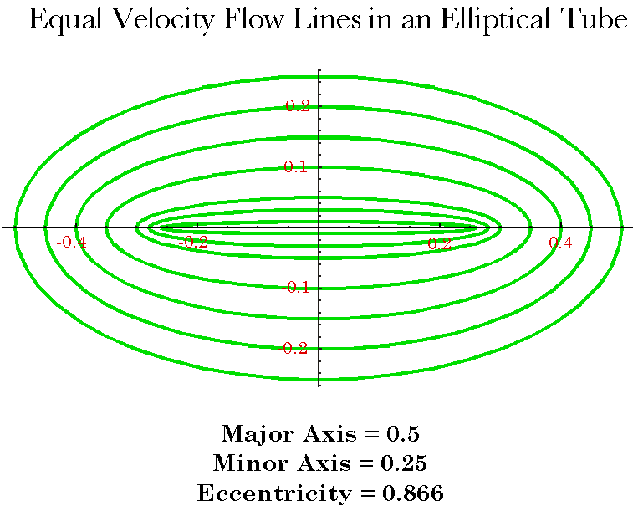
Figure 1. Elliptical sections of constant velocity in an elliptical tube cross-section. In the actual calculation, there are about 100 concentric rings.
Each thin elliptical ring has an approximately constant flow velocity, therefore the flow volume through each ring is the flow velocity that distance from the wall of the tube times the area of the ring. The sum of the flow volumes for all the rings is the total flow through the tube. The area of each ring is the area of the ellipse that forms its outer boundary minus the area of the ellipse that forms its inner boundary.
What remains to be determined is the flow rate in each ring. This relationship comes out of the Navier-Stokes Equation and takes the following form, if $\text{©a©}$ is the minor axis and x is the distance from the wall of the tube.
$$Q\left(x\right)\text{=-}\frac{1}{8m}x\left(x−a\right)\frac{\text{dp}}{\text{dx}}$$
If $d$is the width of a ring, then the flow is given by the following expression.
$$\begin{aligned}Q=\sum_{n=1}^{n=N}{{DA}_{n}}∗Q\left(nd\right),\text{ where N}d\text{=a,} \\ DA=p\left[\left(a−\left(n−1\right)d\right)\left(b−\left(n−1\right)d\right)\right]−p\left[\left(a−nd\right)\left(b−nd\right)\right] \\ p\left[\left(a+b\right)d+\left(1−\text{2n}\right)d^{2}\right], \\ Q\left(nd\right)\text{=-}k∗nd\left(nd−2a\right)\text{.}\end{aligned}$$
The constant, k, in the flow term is chosen so that a circular pipe with a radius of 1.0 will give a flow of 1.0. It was found that if 100 concentric rings were used for the calculation, then the computed flow was the same as when 200 or 300 rings were used, therefore the calculations used 100 rings as the standard. Much less than 100 rings yielded different values depending upon the number of rings.
We can check that this approach yields reasonable results by substituting the parameters for a circular tube. If the parameters for a circular cross-section are substituted into the formula and it is integrated over the variable x, then the calculation yields the correct expression for flow in a circular pipe.
The next step was to compute the flow for a range of elliptical cross-sections ranging from a circle to an ellipse that had a minor axis that was one twentieth of the major axis, keeping the minor axis constant at 1.0. The curve is plotted in Figure 2 (blue) along with the curve for flows through circular tubes with radii equal to the minor axis of the ellipse (green).
The flow through the elliptical tubes is greater than the flow through the circular tube with a radius equal to the minor axis of the ellipse, but has much the same shape. Both drop very quickly with decreasing cross-section. By the point that the elliptical cross-section has a minor axis half of its major axis, the flow has dropped to slightly less than 15% of the flow in a circular tube of radius equal to the major axis of the ellipse. A circular tube with a radius equal to the minor axis of the elliptical tube would have a flow that was slightly more than 6% of that through the circular tube with radius of 1.0. In most situations, the twisting of the tube reduces both axes of the ellipse, so, most flows through though tubes twisted as by lateral rotation in the atlanto-axial joint will lie between the two illustrated curves.

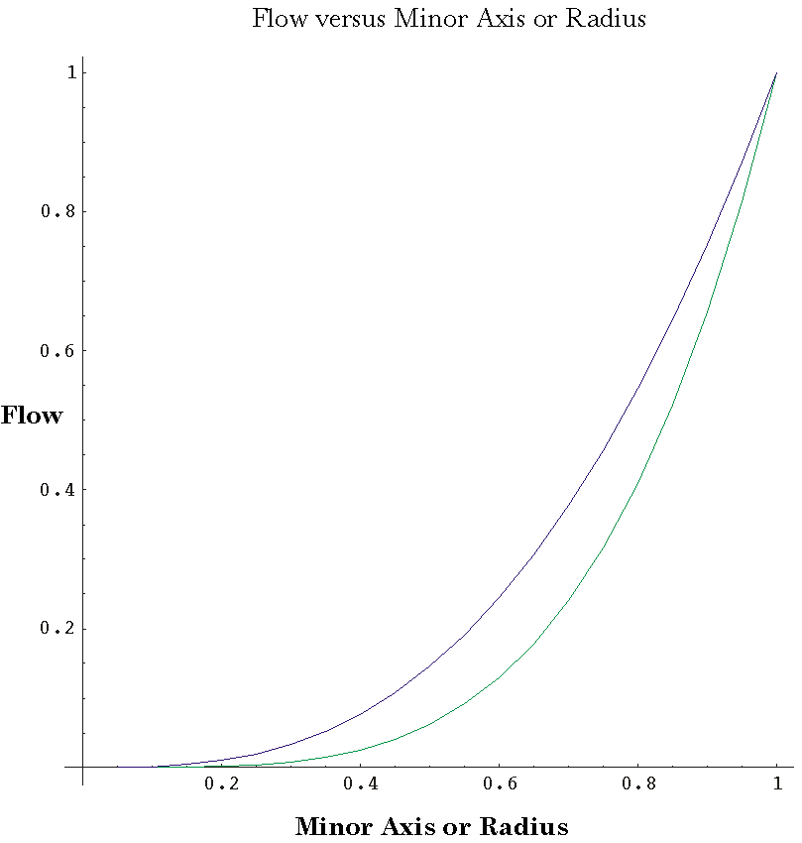
Figure 2. Flow versus minor axis of elliptical tube with constant major axis. The blue line shows the relationship for tubes in which the minor axis is varied from 5% to 100% of the major axis. The green line shows the flow for circular tubes with radii equal to the minor radius of the elliptical tube.

Conductance and Resistance to Flow
At this point, it is possible to define a conductance for a segment of the tube. This was done using the flow through a circular tube with a radius of one unit and a length of one as the unit of flow. The flow through any elliptical tube may be computed and the ratio of the flow in the elliptical tube to that in the reference tube is the conductance.
The C1/C2 segment of the vertebral artery has been modeled by an elastic tube that is twisted by the rotation of the atlas about the odontoid process (Langer, 2004). This model tube has been sliced into 30 transverse segments. It is possible to compute the conductance to fluid flow in each segment. The segments are effectively a set of serial resistances, where the resistance of a segment is the inverse of its conductance. The total resistance to flow through the tube is the sum of the resistances of the individual segments.
There remains one additional point that has to be considered. When the tube is distorted by the rotation at the odontoid process, not only is it flattened and pinched, but it is also stretched. The individual segments are longer. This must also be factored into the calculation. Therefore, if the flow through the n’th segment of the tube is $Q_{n}$and $Q_{U}$ is the flow through a unit tube, then the resistance of the entire tube is expressed by the following relations.
$$\begin{aligned}\text{Segmental conductance},g_{n}=\frac{Q_{n}}{Q_{U}}; \\ \text{Segmental resistance, }ρ_{n}=\frac{1}{g_{n}}; \\ \text{Total resistance},R_{T}=\sum_{\text{n=1}}^{\text{n=N}}{ρ_{n}∗\frac{λ_{n}}{λ_{0}}}; \\ λ_{n}=\text{length of n©th segment}; \\ λ_{0}=\text{neutral length of segment}\text{.}\end{aligned}$$
This leads directly to the flow through the tube, expressed as the ratio of the flow divided by the flow through a circular tube of unit radius of the same length as the distance between the transverse processes in neutral position. In other words, the flow is the relative amount of flow, rather than an absolute measurement, but all the computed flows are referred to the same reference flow.
The flow through the twisted tube is proportional to the ratio of the pressure differential across the C1/C2 segment to the total resistance of the segment.
$$Q=k∗\frac{DP}{R_{T}};k=\text{constant}$$
The flow through each segment of the tube is the same as the flow through the entire tube, therefore it is possible to compute the pressure differential across each segment of the tube.
$${DP}_{n}=Q∗\frac{ρ_{n}}{R_{T}}$$
The resistance and pressure gradients in the twisted tube can be plotted as a function of distance along the tube. The distributions of these quantities change as the tube is distorted by rotation and by crimping. The next couple of sections deal with these distributions.

The Major and Minor Axes and the Eccentricity as a Function of Tube Section: Dependence of Flow and Pressure on the Anatomical Attributes of the Tube
It is possible to synthesize all the components that have been defined up to this point into a single calculation and determine how the shape of the twisted tube varies with distance along the tube and how that affects the resistance to flow and the pressure differential along the tube. In addition, it is possible to look at how these segmental resistances influence the total flow through the section of tube. At this point, we will consider the situation where the ends of the tube remain circular. In the next section, we will consider how crimping of the tube affects flow.

Uncrimped tubes
In a tube that has been twisted as the vertebral artery would be by rotation about the odontoid process, there is a complex shift in the shape of the tube. These have been described in an accompanying paper [Langer, 2004]. Briefly, the shape of the tube is elongated, flattened, and pinched.
The flow through the tube is dependent upon the tube’s shape. As the tube’s cross-section becomes smaller in both dimensions, the resistance to flow increases and the pressure differential necessary to maintain the flow increases. However, there must be a monotonic drop in pressure as one progresses distally.
When the tube is twisted as the vertebral artery would be by 45° of contralateral rotation about the odontoid process, the shape and flow parameters are like those illustrated in Figure 3. Both the major and minor axes become shorter as one progresses away from the foraminae. The minor axis is about 60 to 62% of its original length, the major axis stays about 92 to 98% of its original length. Both are minimal in the middle sections. The slight increase in length for the middle segments is apparently due to the discrete sampling of the perimeter of the cross-sections. Both axes are more affected proximally than distally in that they are shorter in the proximal, smaller numbered, sections than in the comparable distal segments. The tube becomes slightly more rounded in the middle cross-sections.
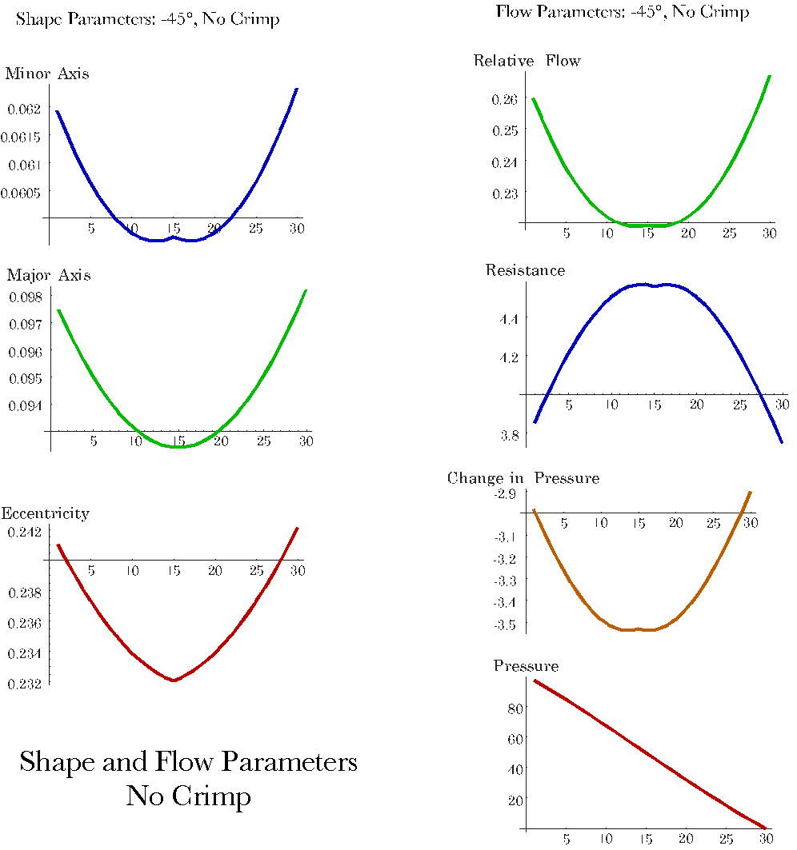
Figure 3. The shape and flow parameters of a circular tube that has been twisted 45° contralaterally. The minor axis, major axis and eccentricity of the cross-sections are roughly symmetrical about minimal values in the middle of the tube. The relative flow is the conductance for each segment of the tube and resistance is its inverse. Change in pressure is the pressure differential across the cross-section segment and the pressure profile is the percent drop in pressure as a function of distance along the tube.
The shape changes along the tube are reflected in changes in the flow parameters. The conductance (relative flow) follows the changes in the axes of the cross-sections. It varies from about 22% to about 27% of reference flow. Resistance is the inverse of the conductance, therefore it becomes maximal in the middle cross-sections. The pressure differential is related to the resistance to flow, but it varies moderately along the tube, so the pressure profile is nearly linear. It has a slight upward convexity.

Crimping
The analysis to this point has assumed that the vessel remains circular as it passes through the transverse foraminae. For small lateral rotations in the atlanto-axial joint, this is probably a reasonable assumption, but if the rotation is enough that it is stretching the vessel, then there is almost certainly crimping as the vessel runs over the bony margins of the holes. Consequently, the next step is to look at how crimping changes the shape of the vessel and the flow through it.
The details of how crimping affects the shape of the tube are given elsewhere [Langer, 2004]. Briefly, the tube is still elongated, flattened, and pinched, but the locations of the minimal diameters shifts along the tube, depending upon the location and magnitude of the crimping. With proximal crimping alone, the minimal minor axis is shifted proximally and the minimal major axis is shifted distally. The opposite pattern occurs with distal crimping. By 45° of twist, the minimas are located at opposite ends of the tube and the parameters vary monotonically with distance along the tube. The eccentricity is maximal at the crimped end and it decreases monotonically as one progresses towards the opposite end. That is the tube becomes more round, which is what one expects.
When both ends are crimped, the situation may be more complex, depending upon the amount of crimp. Here, we explore the effects of symmetrical 50% crimps. A 50% crimp means that the minor axis is half the radius of the round tube which was crimped. The minima for the minor axis is shifted about half way to the proximal end. The major axis is maximal proximally and it decreases monotonically with distance distally. The eccentricity is greatest at the proximal end and it decreases monotonically with distal distance in the tube.
As might be expected, for endrange twists, the conductance is minimal and the resistance is maximal at the crimped end of the tube. There is three-fold difference in the magnitudes of both parameters between the ends of the tube and they are always less than the values in the uncrimped tube. The differential pressure profile is monotonic with the greatest pressure differential at the crimped end of the tube.
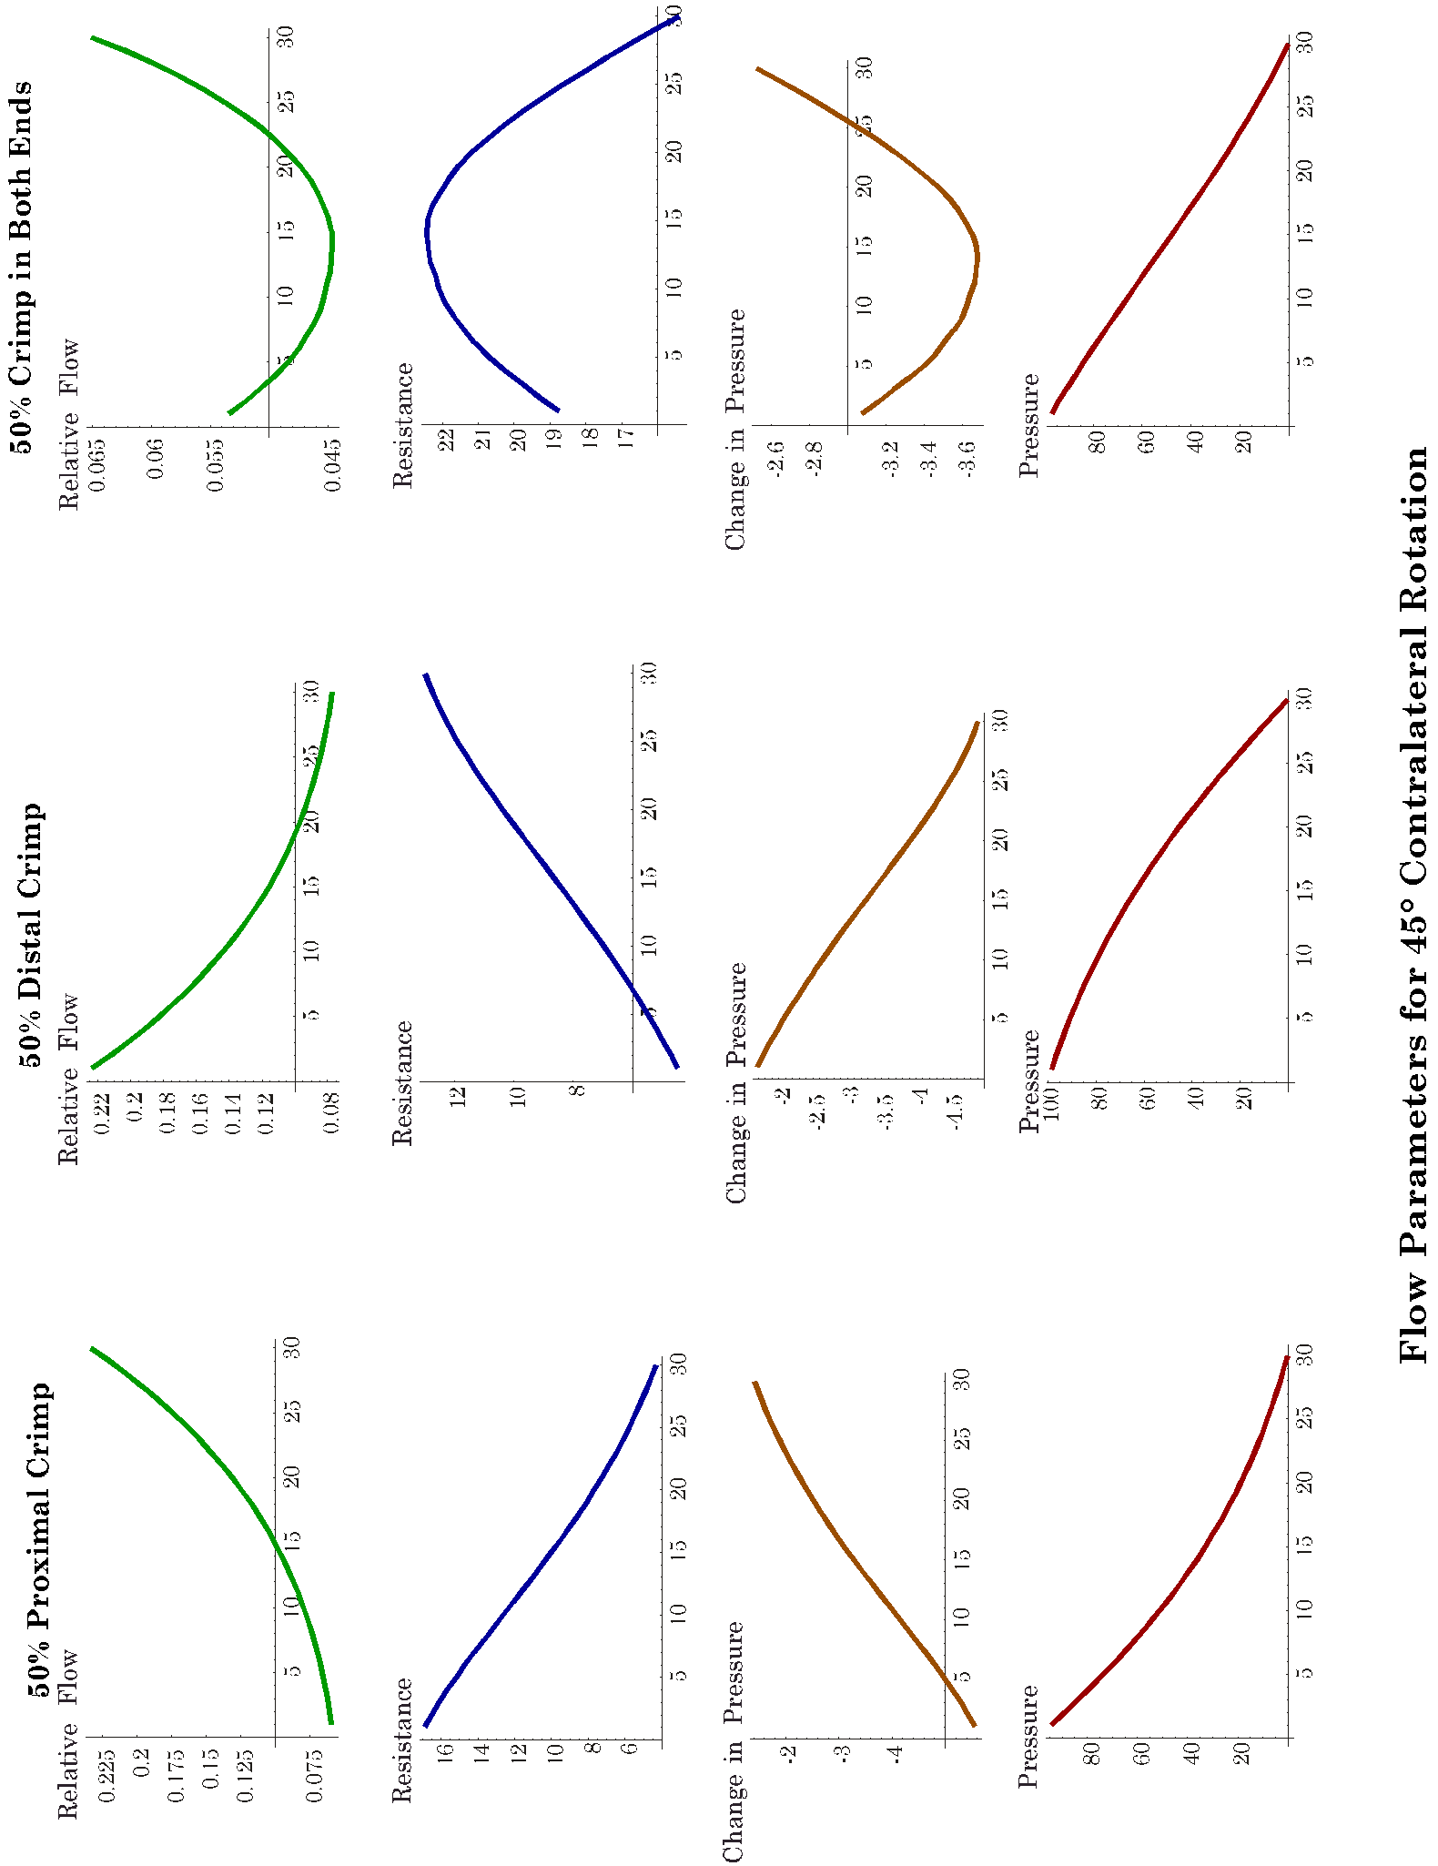
Figure 4. Flow and pressure parameters versus segment for twisted tubes with crimping. The flow and pressure parameters are illustrated for tubes that have a 50% crimp proximally, distally, and at both ends of the tube. The twist is that which would be generated in a vertebral artery by rotating the atlas 45° contralaterally about the odontoid process. The flow and pressure parameters illustrated are the same as in Figure 3.
Unlike the uncrimped tube, where there was comparatively little variation along the tube, the pressure differential varies by a factor of five from one end of the tube to the other. In tubes with proximal crimps, this leads to a marked concave upward bowing of the pressure profile and with a distal crimp there is a marked convex upward bowing.
If there is a crimp at both ends, then the profiles look much like those for an uncrimped tube, except that the minima are displaced proximally. The magnitude of the resistance is substantially greater than for an uncrimped tube. While the maximal resistance in the uncrimped tube was about 4.6, the maximal resistance in the tube crimped 50% at both ends is about 23. The pressure profile is similar to that in the uncrimped tube, because the distribution is dependent upon the relative magnitudes of the resistances in the various segments of the tube and not on their absolute values.

Flow versus twist
The next step is to ask how these twists and crimps influence the total flow through the tube. The resistance to flow has been examined in twisted circular tubes as the amount of twist was increased from neutral to 60° in either direction. The distribution is a slightly lopsided U-shape, low and flat near neutral position, but rising rapidly once the twist is greater than 20° in either direction. In neutral position the resistance is approximately 1.0, and at 45° rotation it is about six times baseline.
If there is a 50% proximal crimp, then the shape of the curve is very similar except the resistance in neutral position is about 2 times baseline and it rises to 14 times baseline, with 45° rotation. Normally, there would not be a crimp for twists near neutral position, so the values in that region are not realistic in the present context. However, it is possible that if one were looking at the effects of an osteophyte pressing upon the vessel wall such values would be appropriate. With a 50% distal crimp, the situation is similar, except the curve is more symmetrical and the resistance is about 13.5 times baseline for rotation of 45° in either direction.

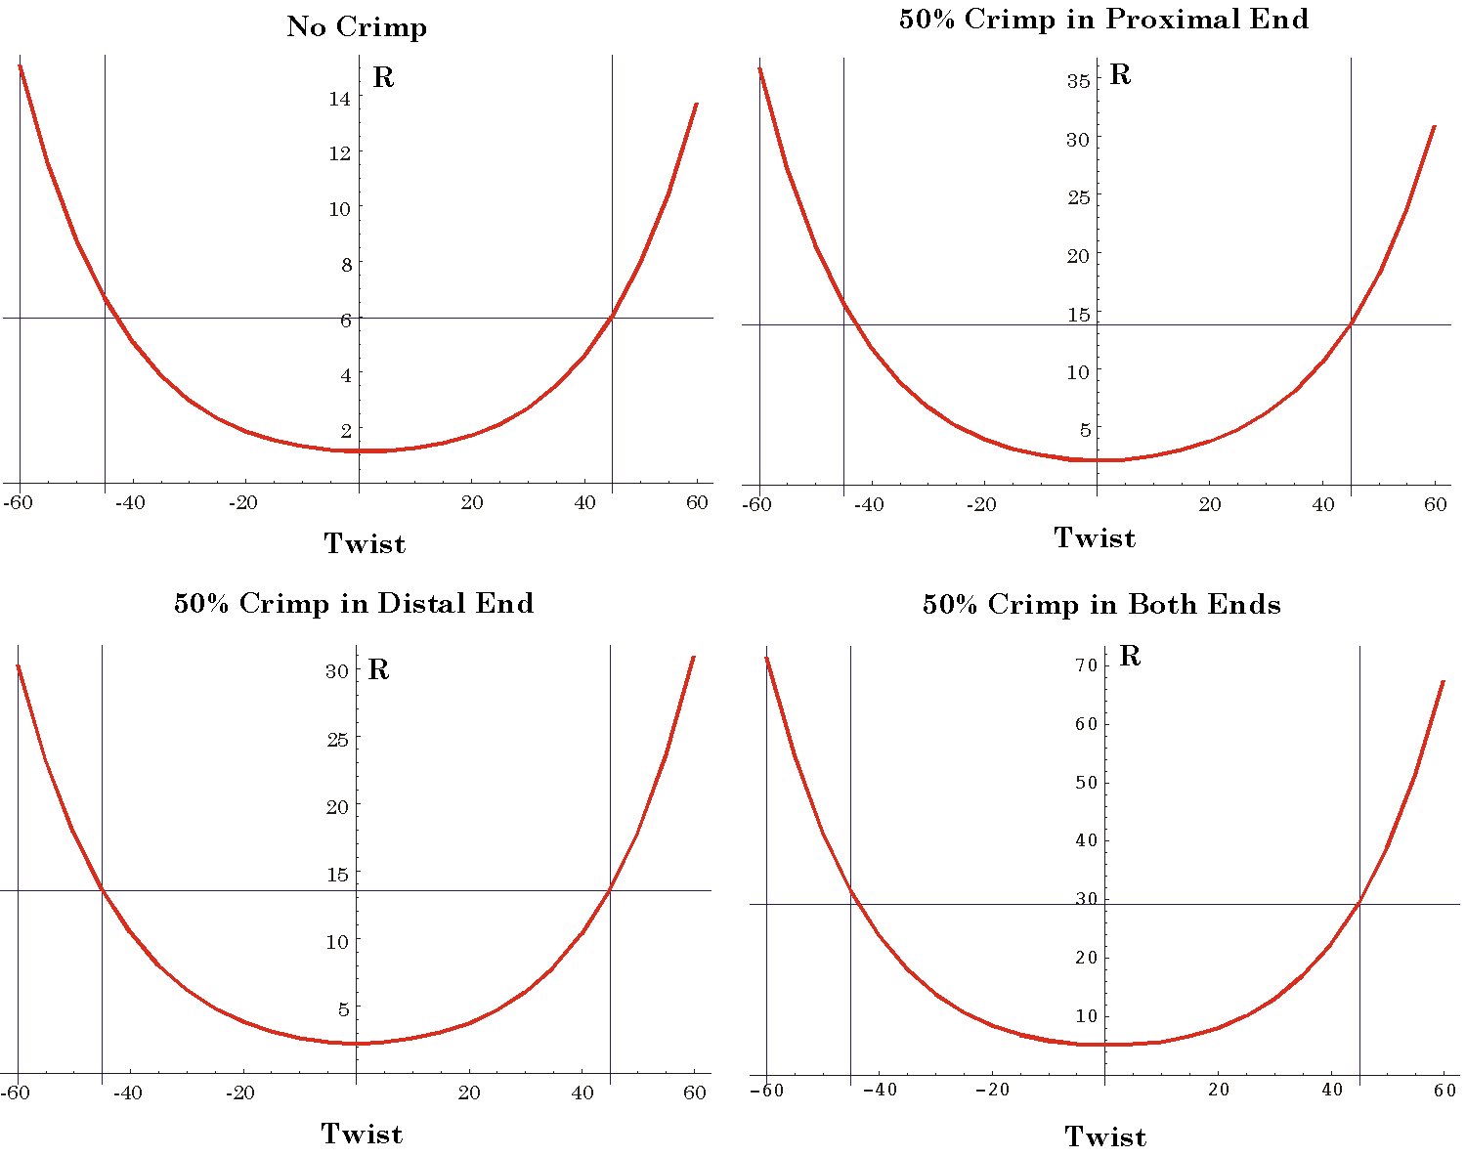
Figure 5. Segmental resistance in twisted tubes with crimping versus twist. The total resistance for the C1/C2 segment is plotted versus twist for excursions from 60° ipsilaterally to 60° contralaterally. The calculations have been illustrated when there is no crimp, when there is a 50% crimp at one end or the other, and when there is a 50% crimp at both ends of the tube. Note that the resistance scales are different in the plots.
For 50% crimps in both ends of the tube, the resistance reaches 30 times baseline for 45° rotation. Therefore, for 50% crimps the effects of the two crimps is roughly additive. While the shapes of the different curves appear the same in the four panels of Figure 5, the resistance scales are substantially different. If all four curves were plotted on the same set of axes it is apparent that the curve for crimping at both ends rises much quicker than that for no crimp, about five times faster.

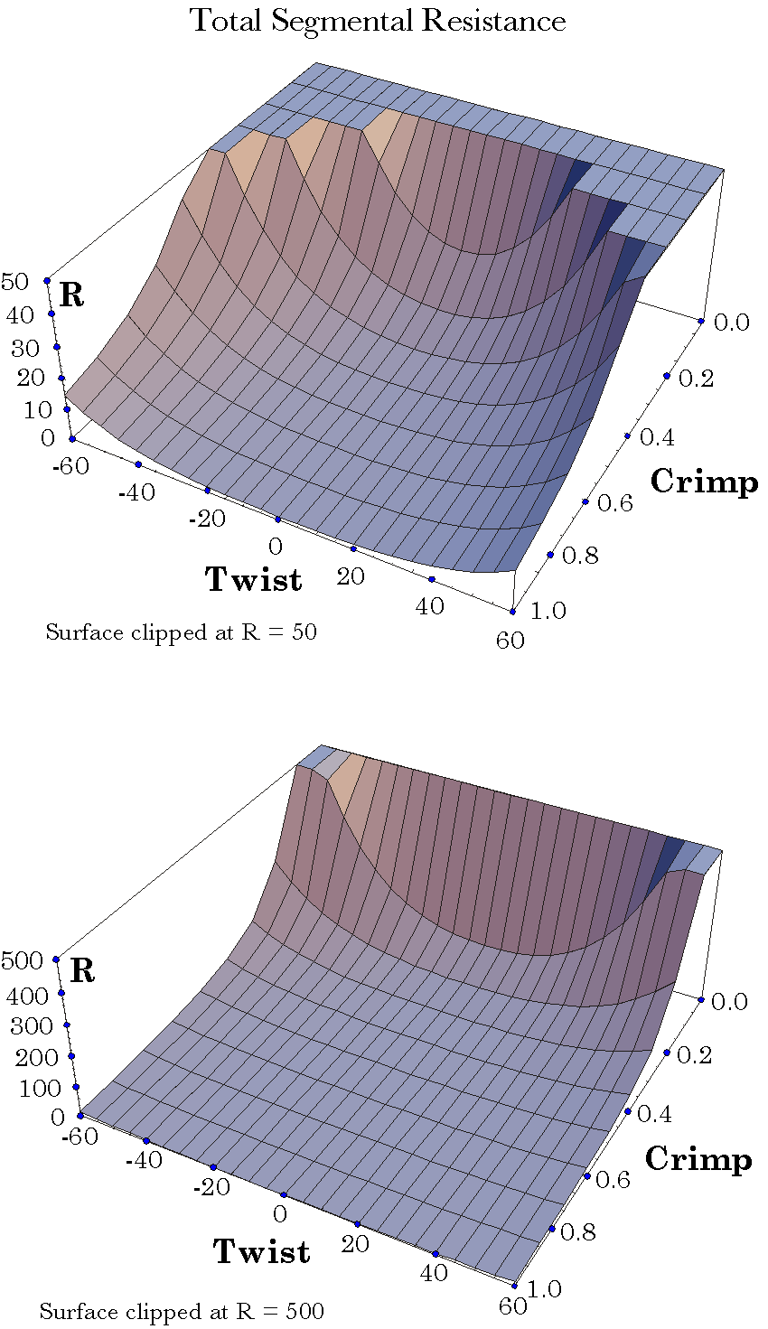
Figure 6. Segmental resistance in twisted tubes with crimping versus lateral rotation and crimp. The total resistance to flow in tubes, twisted as the vertebral artery is twisted by rotation of the atlas upon the axis, is plotted as a function of the amount of contralateral or ipsilateral rotation and as a function of the amount of crimp applied symmetrically to both ends of the tube.

Flow versus Crimp
Finally, the question arises as to how the amount of crimp affects the amount of resistance to flow. The resistances to flow with various amounts of crimp were computed for 60° of contralateral rotation to 60° of ipsilateral rotation (Figure 6). Up to about 50% crimp has a modest effect and the crimp effects add approximately linearly. For greater amounts of crimping, the resistance to flow increased dramatically and the combined effects of crimps at both ends of the tube are far greater than the sum of the effects of each crimp alone. Computed values for 90% crimp are hundreds to thousands of times baseline. Almost certainly, by the time the resistance reaches those kind of values, the effects have become non-linear, a laminar flow model is not justified, and there is a cessation of flow.
In Figure 6, the surface for total resistance in the C1/C2 segment has been plotted against twist and crimp. In the upper panel, the surface has been cut off at a resistance 50 times baseline and in the lower panel the cutoff has been set at 500 times baseline. One can readily see that the surface becomes much steeper as the crimp increases. By the time the minor axis is crimped to about 50% of its original value, the resistance at 45° of rotation is approaching 50 ties baseline flow, which probably means that the flow has probably effectively ceased. The further reduction of the minor axis, by crimping, or the further rotation of the atlas upon the axis will both cause a steep increase in the resistance to flow through the tube. Chances are that both happen together as the head is rotated into endrange lateral rotation and over-pressure applied.

Discussion

The Anatomical Factors that Cause Changes in Flow
The purpose of the foregoing exercise was to determine which factors are most apt to affect blood flow in a vertebral artery as the atlanto-axial joint approaches full lateral rotation. To that end, the changes in conformation were computed and the consequences on blood flow were estimated by assuming laminar flow within the altered vessel shape. In general, the vessel is modestly changed by small rotations, < 20°. We would expect little change in this region anyway, because the slack in the vessel as it traversed the C1/C2 gap would be enough that the vessel would not become taut. As the rotation increases beyond 20°, the resistance to flow increases rapidly until it may be more than five times greater in an uncrimped vessel at full rotation, 45°.
However, it is unlikely that the vessel would be uncrimped at full rotation and crimping is very effective in reducing blood flow, especially if it is at both ends of the vessel segment. Therefore, it is likely that the most critical factor in changing blood flow in the vertebral arteries when the head is rotated is the compression of the artery as it passes over the bony margins of the foraminae. The increase in resistance as the crimping exceeds about 50% is such that the flow rapidly decreases to levels where it is probably non-laminar and non-linear, leading to intermittent cessation of flow.
The amount of crimping is going to be a function of the amount of slack in the vessel in the C1/C2 segment and the range of motion in the atlanto-axial joint. Both of these factors are subject to considerable individual variation and it may be that variation that determines how an individual will react to mobilization of the upper cervical spine.
In considering the crimping of the vessels, it must be remembered that the vertebral arteries are full of blood and that blood is under substantial pressure. The internal pressure is going to work to reduce the crimping and the crimping is going to increase the pressure in the segment of the artery just proximal to the crimp. In addition, blood pressure fluctuates through the pulse cycle. Consequently, the dynamics at the C1/C2 segment are apt to become complex as the flow becomes restricted. Modeling that process is not going to be particularly effective until there is good data on the actual flow in a number of well studied individuals in which we know their anatomy in some detail and have detailed flow data.

Pathological Anatomy and Flow
All of the modeling in this paper is based upon normal anatomy of the region. This was for two reasons, first, we were trying to explain the finding in normal subjects and, second, we were developing tools that would allow us to explore the implications of pathological anatomy, but in a situation where the anatomy is standard.
The anatomy may become pathological in many ways. Some are external, like osteophytes pressing upon the vessel or fractures of the dens or ligament ruptures, which shift the axis of rotation and/or the range of movement. There are also internal changes like plaque, thrombi, or tears that change the shape of the vessel and alter the stress in its walls. The tools developed so far may be helpful in sorting out the principal consequences of these pathologies, but with suitable alteration of the model, they may allow analysis that is even more detailed.

Bibliography
Arnold, C., R. Bourassa, T. Langer, and G. Stoneham. (2004). “Doppler studies evlauating the effect of a physical therapy screening protocol on vertebral artery blood flow.” Manual Therapy 9: 13-21.
Bladin, P. F. and J. Merory (1975). “Mechanisms in cerebral lesions in trauma to high cervical portion of the vertebral artery--rotation injury.” Proc Aust Assoc Neurol 12: 35-41.
Hamilton, W. R. and C. J. Joly (1869). Elements of quaternions. New York,, Chelsea Pub. Co.
Hardy, A. S. (1881). Elements of quaternions. Boston,, Ginn Heath & co.
Joly, C. J. (1905). A Manual of Quaternions. London, Macmillan and Co. Ltd.
Kapandji, I. A. (1974). The Physiology of the Joints. Annotated diagrams of the mechanics of the human joints. New York, Churchill Livingstone.
Kuipers, J. B. (1999). Quaternions and Rotation Sequences: A Primer with Applications. Princeton, New Jersey, Princeton University Press.
Langer, T. (2004). “The movements of the upper cervical joint assembly.”.
Langer, T. P. (2004). “The sensitivity of blood flow in the vertebral arteries to the biomechanics of the upper cervical spine.”.
Langer, T. P. (2004). “Flow changes associated with strain in the vertebral artery due to lateral rotation in the atlanto-axial joint.”
Langer, T. P. (2004). “A model of the biomechanical configuration of the upper cervical spine.”.
Levangie, P. K. and C. C. Norkin (2001). Joint Structure and Function. A Comphrehensive Analysis. Philadelphia, F. A. Davis Company.
Norris, J., V. Beletsky, et al. (2000). “Sudden neck movement and cervical artery dissection. Canadian Stroke Consortium.” CMAJ 163:(1): 38-40.
Williams, P. L., L. H. Bannister, et al. (1995). Gray's Anatomy. The Anatomical Basis of Medicine and Surgery. New York, Churchill Livingstone.

