Anatomical Descriptions That Compute Functional Attributes

Goal: To write a description of an anatomical structure that leads directly to the calculation of its functional attributes. For instance, an anatomical description of a joint may embody its range of motion or a description of the muscles and ligaments around a joint yields the relationships between muscle length and joint configuration. The functions of interest are expressed in terms of movements. The movement may be an internal motion, such as strain, or and external motion, such as ranges of motion and movement trajectories.

The Concept of Placement of Anatomical Objects
At the foundation of this analysis is the fact that anatomical structures are orientable. They may be described so that their arrangement in space and relative to space are unambiguously determined. A right hand can be differentiated from a left hand and the spatial location and orientation of either can be completely specified.
Anatomical description is expressed in terms of location, extension, and orientation. Each of these attributes has a precise meaning, a manner of specification, and definite rules for its manipulation during movements of all types.
Location is where the object is in space. Generally, it is specified for some particular point in the object, such as a bony prominence or the center of a joint. Location is changed by translation, rotation, and re-scaling. It is expressed as a vector relative to an origin.
Orientation is how an object is aligned with its surroundings. It is expressed as three mutually orthogonal unit vectors that form a basis. Such a set of orientation vectors is called a frame of reference. Orientation is changed by rotation, but not by translation or re-scaling.
Orientation can be specified by only two quaternion vectors, with a prior agreement about the handedness of the coordinate system. The third vector can always be computed as the ratio of the other two unit vectors, if one knows which way the ratio is to be assessed.
Location does not have orientation and orientation does not have location. While all the elements are vectors and they may be expressed in terms of a common set of coordinates, they occupy different spaces.
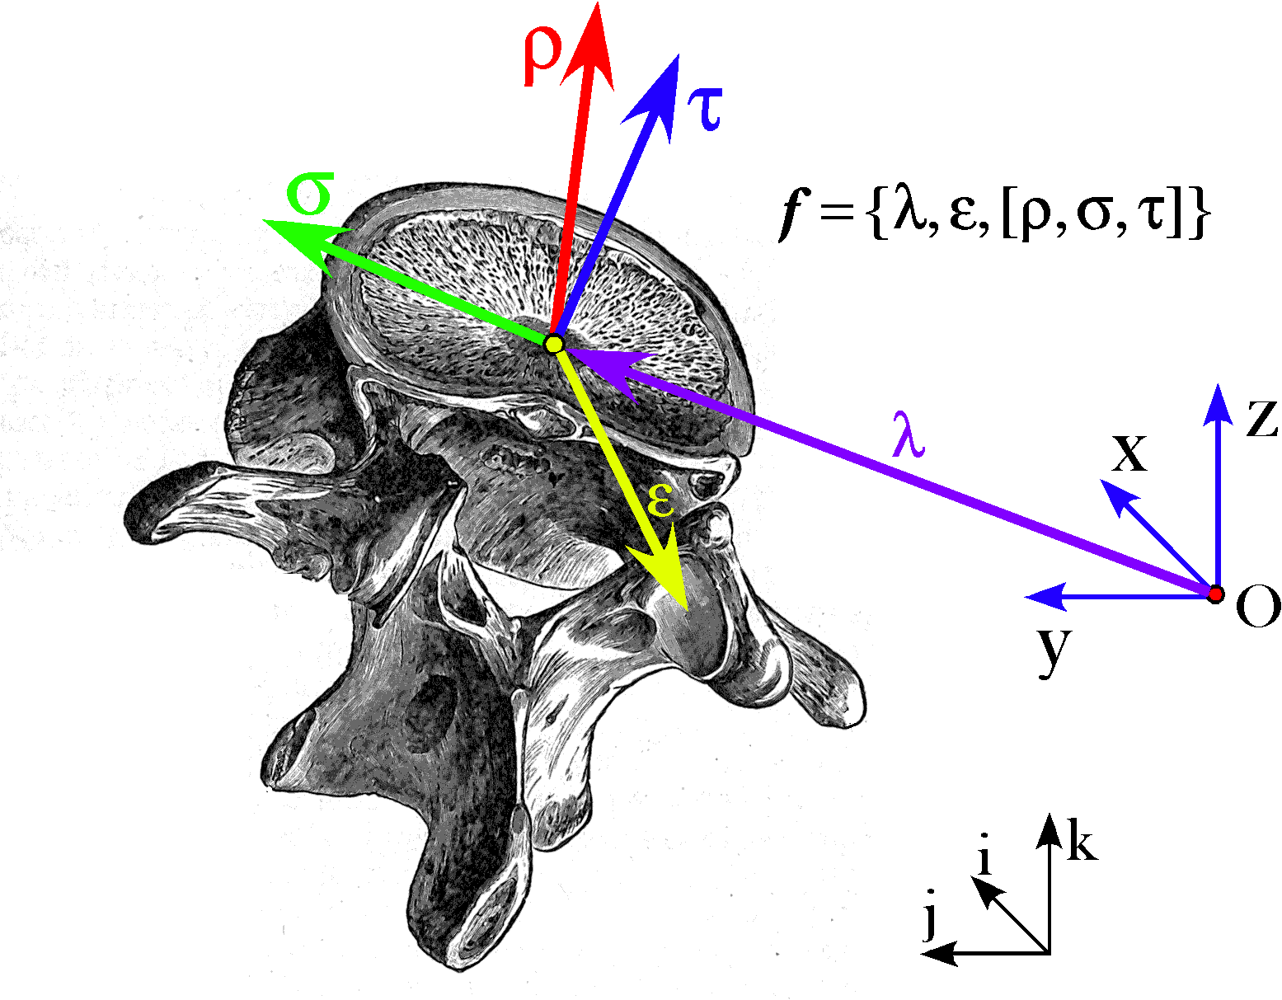
The lumbar vertebra is described by a framed vector, , where the location, λ, is relative to an origin, O, the extension from the location of the vertebra to the right facet joint is ε, and the frame of reference for the orientation is given by the ordered set of vectors [ρ, σ, τ]. All of the vectors of the framed vector and the coordinates of the space {x, y, z} may be defined in terms of the basis vectors {i, j, k}.
Extension is the internal organization of an object, its length, depth, and width relative to some reference point, usually the object’s location. While extension shares attributes with location and orientation and can be expressed in terms of locations and in terms of orientation, it is different from both. An object’s shape and/or conformation of its internal landmarks can be expressed by a set of extension vectors. Extension is changed by rotation and re-scaling, but not by translation.
Placement is the term used to indicate both the location of an anatomical object and its orientation. Any non-null movement changes placement.
In addition to placement, an anatomical object may have extension. Placement and extension may be expressed as a framed vector. A framed vector is a location vector, a set of extension vectors, and a frame of reference for the orientation. However, it is a loosely defined entity that can change to meet almost all situations for description.

The Concept of Joints
We develop a concept of joints, a concept similar in its usual usage, but with a more general meaning. Some of the objects studied as examples of joints are not usually called joints. For instance, the eye in its orbital socket will be a particularly useful joint for exploring a number of lines of reasoning and developing some analytic methods.

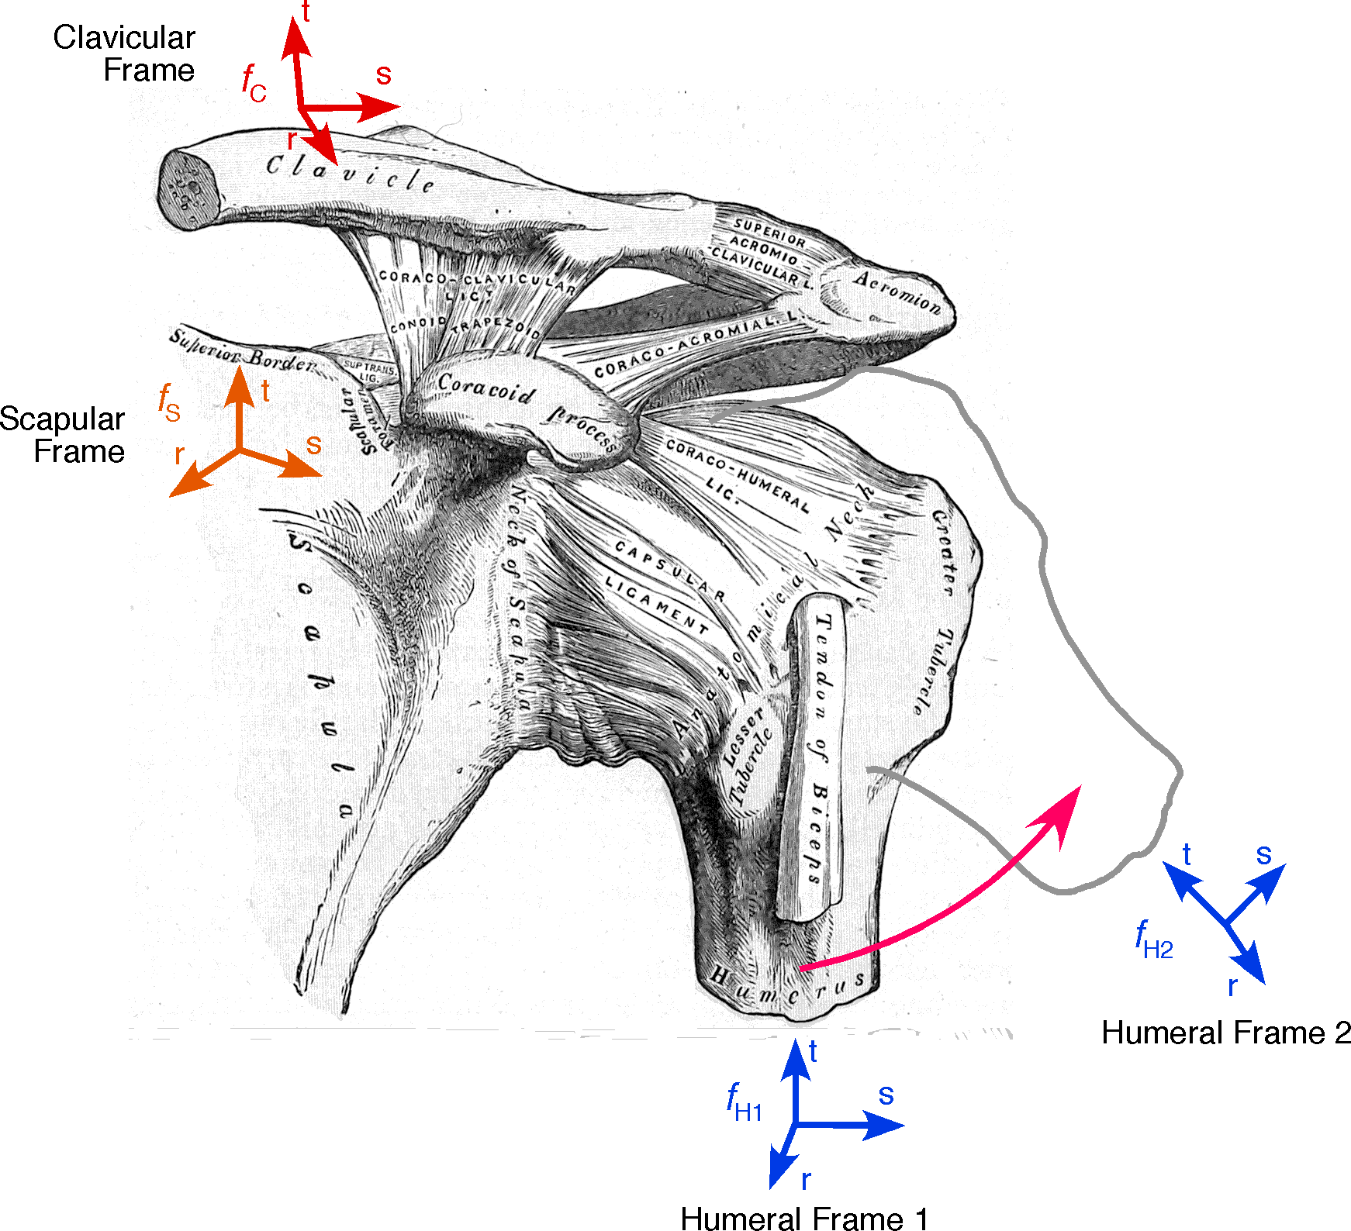
A joint is a junction of two orientable elements with a common axis of rotation. The joint is defined by a transformation between the orientation of the pre-joint element and the post-joint element (Scapular Frame and Humeral Frame 1). There is also a transformation between a joint element before moving and after moving (Humeral Frame 1 and Humeral Frame 2). Both types of transformations may be expressed as a rotation about an axis of rotation, therefore they can be expressed by a quaternion. To fully define the joint it is also necessary to compute the location of the axis of rotation. That is a somewhat more complex calculation that requires finding the axis of rotation that also transforms the location of the moving element before the movement into its location after the movement.
Usually the location of a functional joint is its axis of rotation, which is seldom in the anatomical joint. It is often within one of the moving anatomical objects that form the joint. However, in multi-joint systems, like the cervical spine, the location of the functional joint may be outside all of the constituent elements.

The Concept of Quaternions
In general, the ratio of two frames of reference is a quaternion. This is equivalent to saying that the ratio of two orientations is a rotation. It is also the case that the ratio of two oriented planes in their intersection, which is a quaternion.
A change of placement cannot always be expressed as a quaternion, but it may be expressed as a combination of a translation and a rotation, therefore by a fixed vector and a quaternion. Such movements are called compound movements.
A quaternion is a hypercomplex number, like a complex number, but with three imaginary components, i, j, and k. It is written as follows, all the coefficients being real numbers.
Quaternions add and multiply algebraically with the caveat that i, j, and k are three different imaginary numbers that multiply as follows.
Despite the weirdness of number composed of three different imaginary numbers and a real number, quaternions turn out to be ideal for the description of rotations in three-dimensional space. The three orthogonal directions of space are labeled with the three imaginary numbers so that vectors formed by combining multiples of those three imaginary numbers are vectors in the space.
It is worth noting that quaternions include real numbers, that is, the scalar of a quaternion, and complex numbers and they add vectors, that is, quaternions with a null scalar. The concept of vectors started with quaternions and it was simplified when vector analysis was created. Quaternion vectors are subtly different from vector analysis vectors, which means that there are some things that can be done with quaternion vectors that are not legal with vector analysis vectors. One of the most powerful concepts of quaternion analysis is the ratio of two vectors. It underlies almost everything that is presented here.

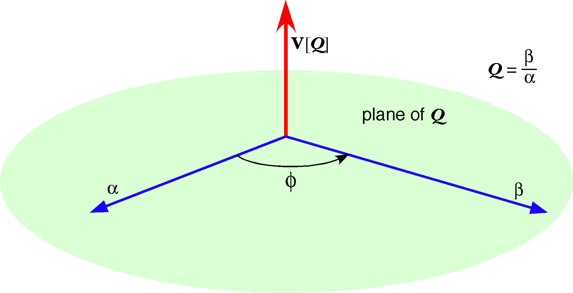
The ratio of two vectors is a quaternion
It is convenient to operationally define a quaternion as the ratio of two vectors. The vector of a quaternion is the vector perpendicular to the plane that contains the two vectors that points in the direction of the thumb on a right hand that has the fingers curled in the direction that carries the denominator of the ratio into the numerator. The tensor of a quaternion is the ratio of the length of the numerator to the length of the denominator. The angle of a quaternion is the angular excursion from the denominator to the numerator. The unit vector of the quaternion is the direction of an axis of rotation. The angle of the quaternion is the angular excursion of a rotation about that vector. The tensor of the quaternion is a re-scaling .
If a quaternion is defined in a space with the basis vectors {i, j, k} then the quaternion may be written as follows.
It follows from its definition of a quaternion that the quaternion operating upon the vector is the vector .
The cosine term is the scalar of the quaternion, . It is a real number.
The sine term is the vector of the quaternion, , and it may be expressed as a sum of multiples of the basis vectors.
This means that the quaternion may be written in the following form.
This will be called the rectangular form of the quaternion and the expression in terms of a tensor, angle, and unit vector will be the trigonometric form. As with complex numbers, the two forms are useful in different contexts, so each will be used frequently and interchangeably. Also, as with complex numbers, there is an exponential form, but there will be little occasion to sue it.

Conical Rotations
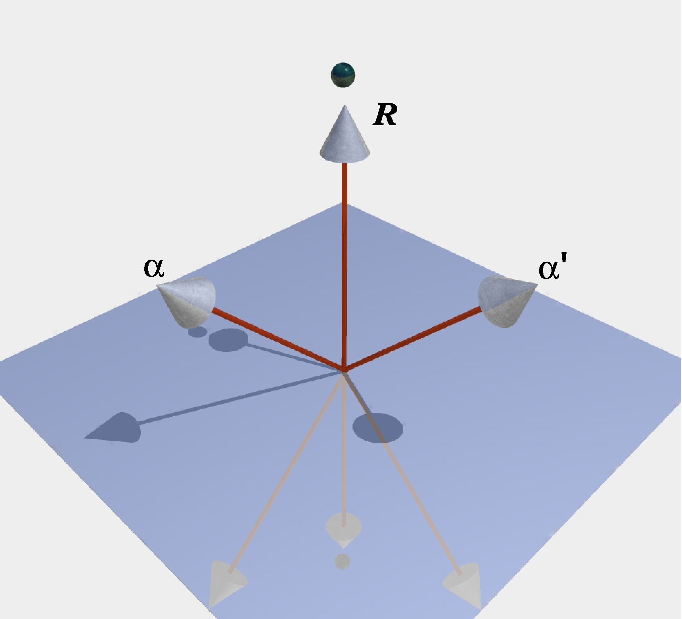
Rotation of the vector α around the vector of the quaternion R sweeps out a conical surface to yield the vector α’.
The power of quaternions is that any vector rotated about an arbitrary axis of rotation through an angular excursion is equal to the following expression.
Such a rotation is called a conical rotation because the rotating vector sweeps out a conical surface. Conical rotations are the more usual type of rotation in most contexts, because if the axis of rotation and the rotating vector are chosen at random, the chances of their beng orthogonal are essentially nil.
Still, there are situations in which the definition of a quaternion as the ratio of two vectors, both orthogonal to the vector of the quaternion, will be extremely useful. For instance, when computing the ratio of two orientations it is necessary to break the operation down into two component rotations, each of which is precisely the ratio of two vectors in a plane.

Anatomical Descriptions That Embody Functional Consequences
These are the concepts that form the foundation for anatomical descriptions that compute functional implications. The placements and extensions of anatomical objects are expressed as framed vectors that express the relevant attributes of an anatomical object or objects. Often, we are interested in describing multi-joint systems in which there are multiple elements that have definite constraints upon their movements because of the geometry of the joints that join them. We can express each of these objects and the relations between them in a concise language that embodies the information and the operations that are required to compute the movements that may occur in the system.
Although a detailed exact calculation of the consequences of the anatomy may be computationally complex, the concepts that are developed here can be used in an intuitive, qualitative, manner to address many questions with no calculation at all or simple back of the envelope types of estimation.
It may be noted that no actual calculations have been presented here. To do so effectively requires a bit more background, but all the necessary foundations are laid out elsewhere along with a great many applications.

