Muscle Set Surfaces as a Function of Joint Anatomy

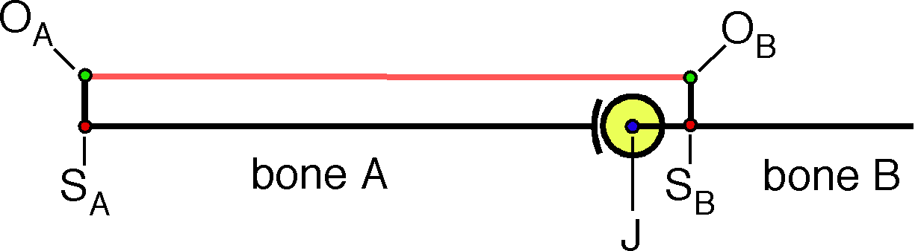
Let us envision a generalized joint, as illustrated in the above figure. It is a universal joint with a spherical joint surface, so that all types of movements are potentially possible, rather like the shoulder and hip joints. Most joints are not that free. In fact, the hip and shoulder joints are not as free to move. However, we can consider most joints as special cases of this general joint.
We introduce a muscle that connects two bony offsets, one on each bone (O_{A} on bone A and O_{B} on bone B). The offsets are attached to the bones are S_{A} and S_{B}, respectively. The functional joint, J, is located at the center of the spherical facet. The value of each of these points is a variable and specific ranges of values are characteristic of a particular type of joint. The geometry of a joint determines the special features of that joint. A large part of the fascination in studying joint lies in seeing how their geometry determines their functional character. A detailed consideration of the many possible variants is not appropriate here, because relationships between joint anatomy and joint function are complex, but a few specific examples of different types of joints will be considered below.
Our present objective is to illustrate how a muscle set surface may be computed for a set of muscles crossing a joint. To start, we need to describe the anatomy with a set of framed vectors. The first defines the three points that are illustrated on bone A along with a frame of reference for that bone. It contains a location for the bone, L_{A}, and an attachment site, S_{A}, of the offset, O_{A}. For Bone B we will use the location of the functional joint, J, as the location of the bone.

Muscle length is . It is the dependent variable of the muscle set surface. As described earlier in this chapter, the muscle moment is the ratio of the origin to the insertion, relative to the joint. In this instance, the muscle moment and its unit vector are as follows.
The axis of rotation for the muscle at the joint, , is the second element of the frame of reference for the muscle relative to the joint. The first element is the unit vector in the direction of the muscle, . The third element of the frame of reference, the perpendicular to the muscle from the joint, is the ratio of these two unit vectors.

Frame of Reference for a Bone Relative to a Muscle Attachment

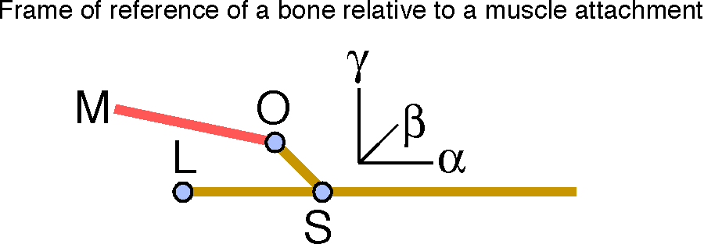

The frame of the bone relative to a muscle (M) is an ordered set of three unit vectors: 1.) in the direction of the bone shaft (α), 2.) in the direction of the axis of rotation from the bone shaft to the muscle attachment (β), and 3.) in the direction of the perpendicular from the bone shaft to the muscle attachment (γ).
In this system, let us define the direction of a bone as the unit vector in the direction of the root of the offset. In a multi-muscle system, we would have to decide on a common direction for all the muscles, but any direction that is picked may be expressed as a simple ratio to a particular direction and the root of the offset has been chosen to lie on the ‘shaft’ of the bone in the model that we are considering here. The placement of a bone will be its location and its orientation, which will be set to include the direction of the bone, the axis of rotation from the bone to the offset, and the perpendicular direction from the shaft of the bone to the offset. In the current model, the frame of reference for a bone will be three ordered vectors.
The first component is the direction of the bone, the second is the plane of the muscle attachment relative to the bone, and the third is the perpendicular direction of the muscle attachment relative to the bone.

The Muscle Set Surface is an Invariant
The muscle set surface is an invariant for the geometry of a joint/muscle system. It may be expressed in a form that does not depend upon the particular placement of the system because one can always rotate and translate the joint configuration so that one bone, say bone A, is in a standard location and orientation and then the same transformation applied to the moving bone, bone B, will bring it along in its original relation to bone A. All possible configurations of bones A and B can be realized in such a standardized musculoskeletal system. It is a canonical image of the system.
In such a canonical system, a muscle set surface can be expressed with complete generality as function of joint movements relative to a neutral placement. Muscle length is not affected by moving the system into a standard form, because internal spatial relationships are unchanged by a rotation of the system as a whole. On the other hand, muscle length varies as a function of movements from a neutral placement of the joint, irrespective of the orientation of the musculoskeletal system as a whole.
Since the movement will be the same for all muscles crossing the joint, the complete muscle set surface may be computed and plotted against the same independent variables. The complete muscle set surface is the combination of the collection of individual muscle set surfaces.
Note that muscle force is not an invariant. The muscle set for a shoulder remains the same irrespective of the orientation of the shoulder, but the forces needed to hold shoulder in a configuration may be very different, depending upon the orientation of the shoulder. The set of muscle forces required to abduct one’s shoulder 90° in standing is quite different from set of muscle forces needed to perform the same movement when lying on one’s side or back. The set of muscle forces is clearly not an invariant for the geometry of a joint/muscle system.

The Calculation of Muscle Set Surfaces
We will now consider a small number of examples of the calculation of a muscle set surface for a single muscle, plotted against relative bone placement in a joint that the muscle crosses. We will consider two simple muscle configurations and then a more complex muscle configuration, with multiple components that act differently, but in a coordinated fashion.
In each case the calculation is essentially the same. The location of the muscle insertion for neutral placement, O_{I} , relative to the functional joint, J, is computed.
The muscle insertion is rotated about the longitudinal axis of bone B, through an angle , and then about a transverse axis perpendicular to the longitudinal axis that will cause bone B to flex or extend upon bone A, through an angle . In kinesiological terminology, the moving bone spins about its longitudinal axis through an angle of and then swings about a transverse axis that moves with the bone, though an angle of . The initial transverse axis is perpendicular to the plane of the muscle and the bone, the axis of the frame of reference for the bone relative to the muscle attachment.

The muscle vector, , is the difference between the new location of the muscle insertion and the location of the muscle origin. It is the length of that is plotted versus the placement of bone B.
Rotating bone B about its longitudinal axis once more, after the computed movement, will alter the placement of bone B by changing its orientation. However, that option will not be used here. Therefore, the placement will have its orientation determined by the location and the orientation will have null spin relative to neutral placement. The advantage for present purposes is that placement has only two dimensions, allowing us to plot the muscle set surfaces as two-dimensional surfaces in a three-dimensional space.
There are other options for creating an array of placements of bone B. The one sketched here will give an array that is like the lines of longitude and latitude on a globe. In fact all of the surfaces plotted below are for a hemisphere of movement. This system seems to be a natural array for a universal joint. Other, more restricted, joints might warrant a different type of array. In which case, the rotation quaternions might be constructed differently.

A Long Muscle With Its Insertion Near the Joint

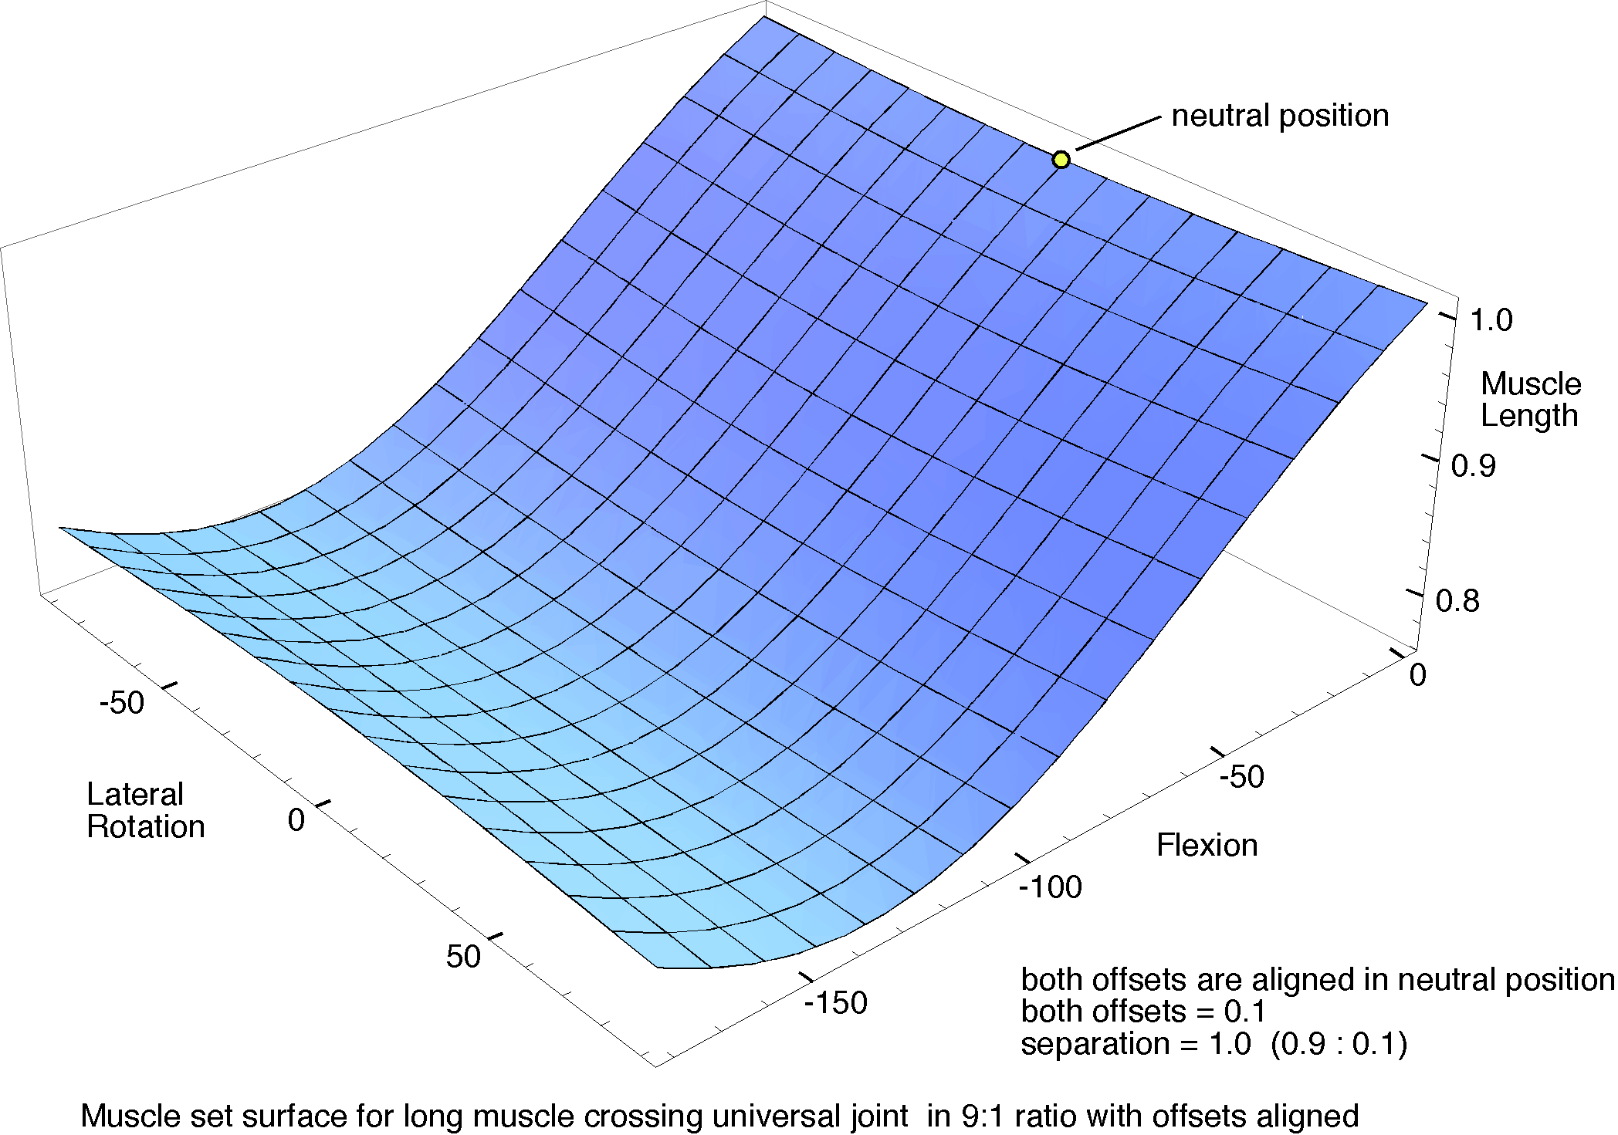
The muscle extends from an origin near the proximal end of bone A to an insertion near the joint on bone B. Both offsets are aligned in neutral position.
For a first example, consider a muscle like that illustrated above to illustrate the concept of a generalized universal joint, where the origin is far from the joint and the insertion is near it. In particular, let the origin be 0.2 units from the proximal end of bone A, on an offset of 0.1 units off the axis of the bone, and let the insertion be 0.1 units distal to the universal joint in bone B with an offset of 0.1 units in the same direction as the offset on bone A. The joint is constructed to have a radius of curvature of 0.1 units. Consequently, in neutral configuration the muscle has a length of 1.0 units.
The muscle set surface is fairly simple. There is small concavity in the surface centered upon neutral position. As bone B is laterally rotated through 90° in either direction, there is a subtle lengthening of the muscle, so muscle contraction will have a modest tendency to bring the two offsets into alignment. However, the much greater tendency with shortening of the muscle will be to flex the joint until it is bent about 130°, beyond which the muscle will become longer with further flexion and the moving bone will tend to roll laterally. This behavior accords with our intuitive impression of what such muscles do.
This arrangement seems to be well designed for situations where a large joint excursion into flexion or extension is required. It gives large movements with modest amounts of muscle contraction. All the flexion movements converge on a common placement, just as the lines of longitude converge upon the poles.

A Short Muscle With Its Origin and Insertion Near the Joint
In a second example, the muscle origin is moved distally until it lies just proximal to the universal joint and the muscle insertion lies just distal to the joint and rotated laterally through 90°. The proximal offset is 0.1 units from the axis of the bone and the distal offset is 0.2 units. In words, the muscle wraps about a quarter of the way around the joint.

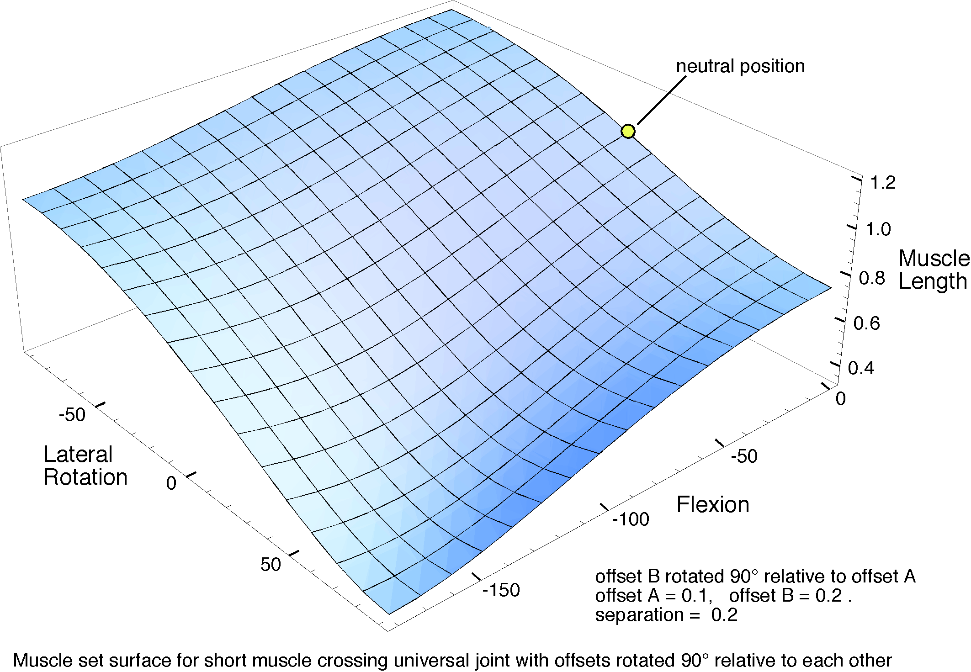
The muscle set surface for a muscle that crosses the universal joint diagonally between an origin and insertion where both are close to the joint.
As one might expect, the muscle becomes longer as the joint is rotated so as to increase the angle between the offsets and it shortens when the angle is reduced until they are aligned. Flexing the joint also reduced the length of the muscle, but generally not as quickly. Muscle contraction that produces a rotation that brings the offsets into alignment and flexes the joint is the movement that causes the greatest shortening of the muscle. However, the extent to which the muscle can bring about that movement is restricted by the gap between the insertions when the offsets are aligned being smaller than the muscle can achieve. The maximal contraction of a muscle from greatest to shortest length is probably 50%. That means that the muscle cannot move into the nearest corner of the surface in the illustration, because the gap is on the order of 40% of that in neutral position and the muscle must be able to become longer than it is in neutral configuration if the joint is able to turn laterally in the direction that opens the angle between the offsets. Consequently, only that part of the surface that lies above 0.6 is likely to occur in a real system and the range may be substantially less.
As a result of these considerations, such muscles will tend to be important for laterally rotating a joint. They are most stretched and shortened by such movements and they are comparatively insensitive to flexion and extension. In this particular geometry, the amount of flexion is comparable to the amount of lateral rotation with muscle shortening.

A Deltoid-like Muscle
Next, consider a muscle that is in many ways like the deltoid muscle of the shoulder. We will consider the muscle in terms of three component muscle descriptions that represent different aspects of the muscle. The first component, the middle component, extends from an offset that directly overhangs the joint to an insertion some distance down the shaft of bone B. The joint is considered to be in neutral position when bone B is extended 90° relative to bone A. The other two components of the muscle differ in having their origins anterior and posterior to the joint as well as proximal to the joint. One might imagine the offset from bone A to have the shape of a horseshoe lying in a horizontal plane above the joint. The insertion for all three components of the muscle will be at the same point on bone B.

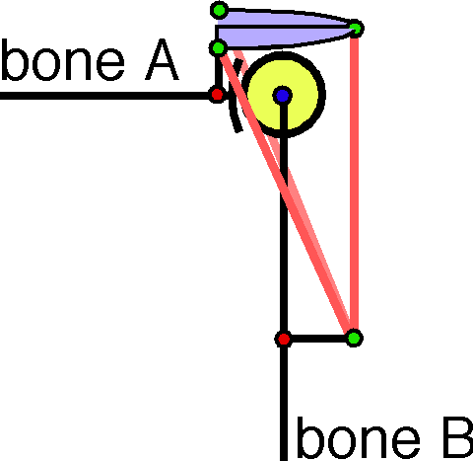
A deltoid-like muscle takes its origin from an offset ring above the joint and it inserts into the shaft of the moving bone. Three muscle components are drawn: one at the apex of the offset that runs directly down, one that takes origin anteriorly and one that takes origin posteriorly. They have a common insertion.
Bone B is rotated about its long axis through a series of angular excursions from -90° to +90° and then about an axis perpendicular to the plane that contains the shaft of the bone and the offset, again through a series of angular excursions from -90° to +90°. In each location bone B could be again rotated about its shaft, to give a variety of orientations, but that movement tends to have only a small effect on muscle length, so it is not been explored here.
In the following calculations, if the functional joint is taken to be the origin of the coordinate system, then the origins and insertion of the three components are taken to be at the following locations.

The values are approximations from actual shoulder joints, where the radius of curvature for the spherical facet is set equal to 0.1 units. One usually obtains the best results when using the values approximately equal to actual anatomical values, because they usually give the best compromise of all the possible values. By choosing values that differ from the anatomical values, one can often discover why the anatomical values are what they are.
The following figure shows the geometrical relations of the first component of the muscle. It resembles the first illustration of this section, that for a long muscle that just crosses the joint, but it is different in a number of interesting ways.

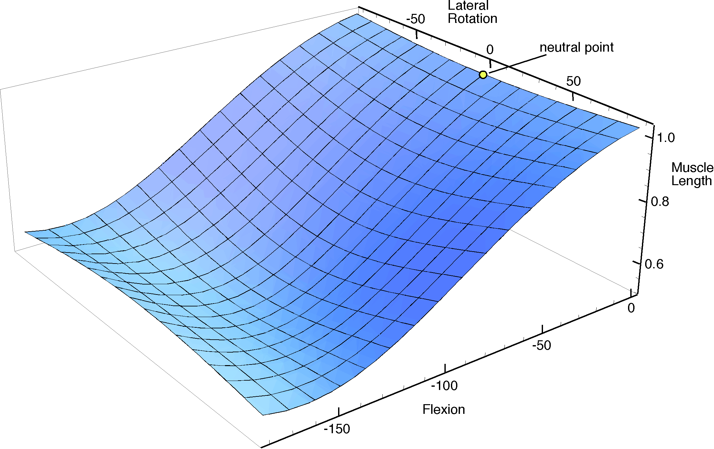

Muscle set surface for the middle component of a deltoid-like muscle where the neutral point is chosen with the arm pendant.
Rotation about the long axis of bone B in a pendant position leads to minor lengthening of the muscle so contraction of the muscle will tend to move the bones towards neutral configuration. That effect is more pronounced as bone B is abducted (moving towards the left in the illustrated surface). The trend is reversed when there is more that 150° of extension, however, anatomical joints would not normally support that much extension. In actual glenohumeral joints, the range of abduction is on the order of 60° to 90° of abduction and the range of medial and lateral rotation are usually less than 90° from neutral placement (Kapandji).
The more pronounced geometrical relationship is the change in muscle length as the bone B is elevated. The return on contraction becomes less as the joint approaches 150° of elevation, but it remains the dominant consequence of muscle contraction throughout the entire physiological range. Consequently, the contraction of the central component of this deltoid-like muscle, working alone, tends to lift the arm directly laterally. All the contraction vectors are directed towards the central meridian through neutral placement and elevation.
That raises the question of what one gains by having the anterior and posterior components of the muscle. Because their arrangement is symmetrical with respect to the bones their muscle set surfaces are also symmetrical.

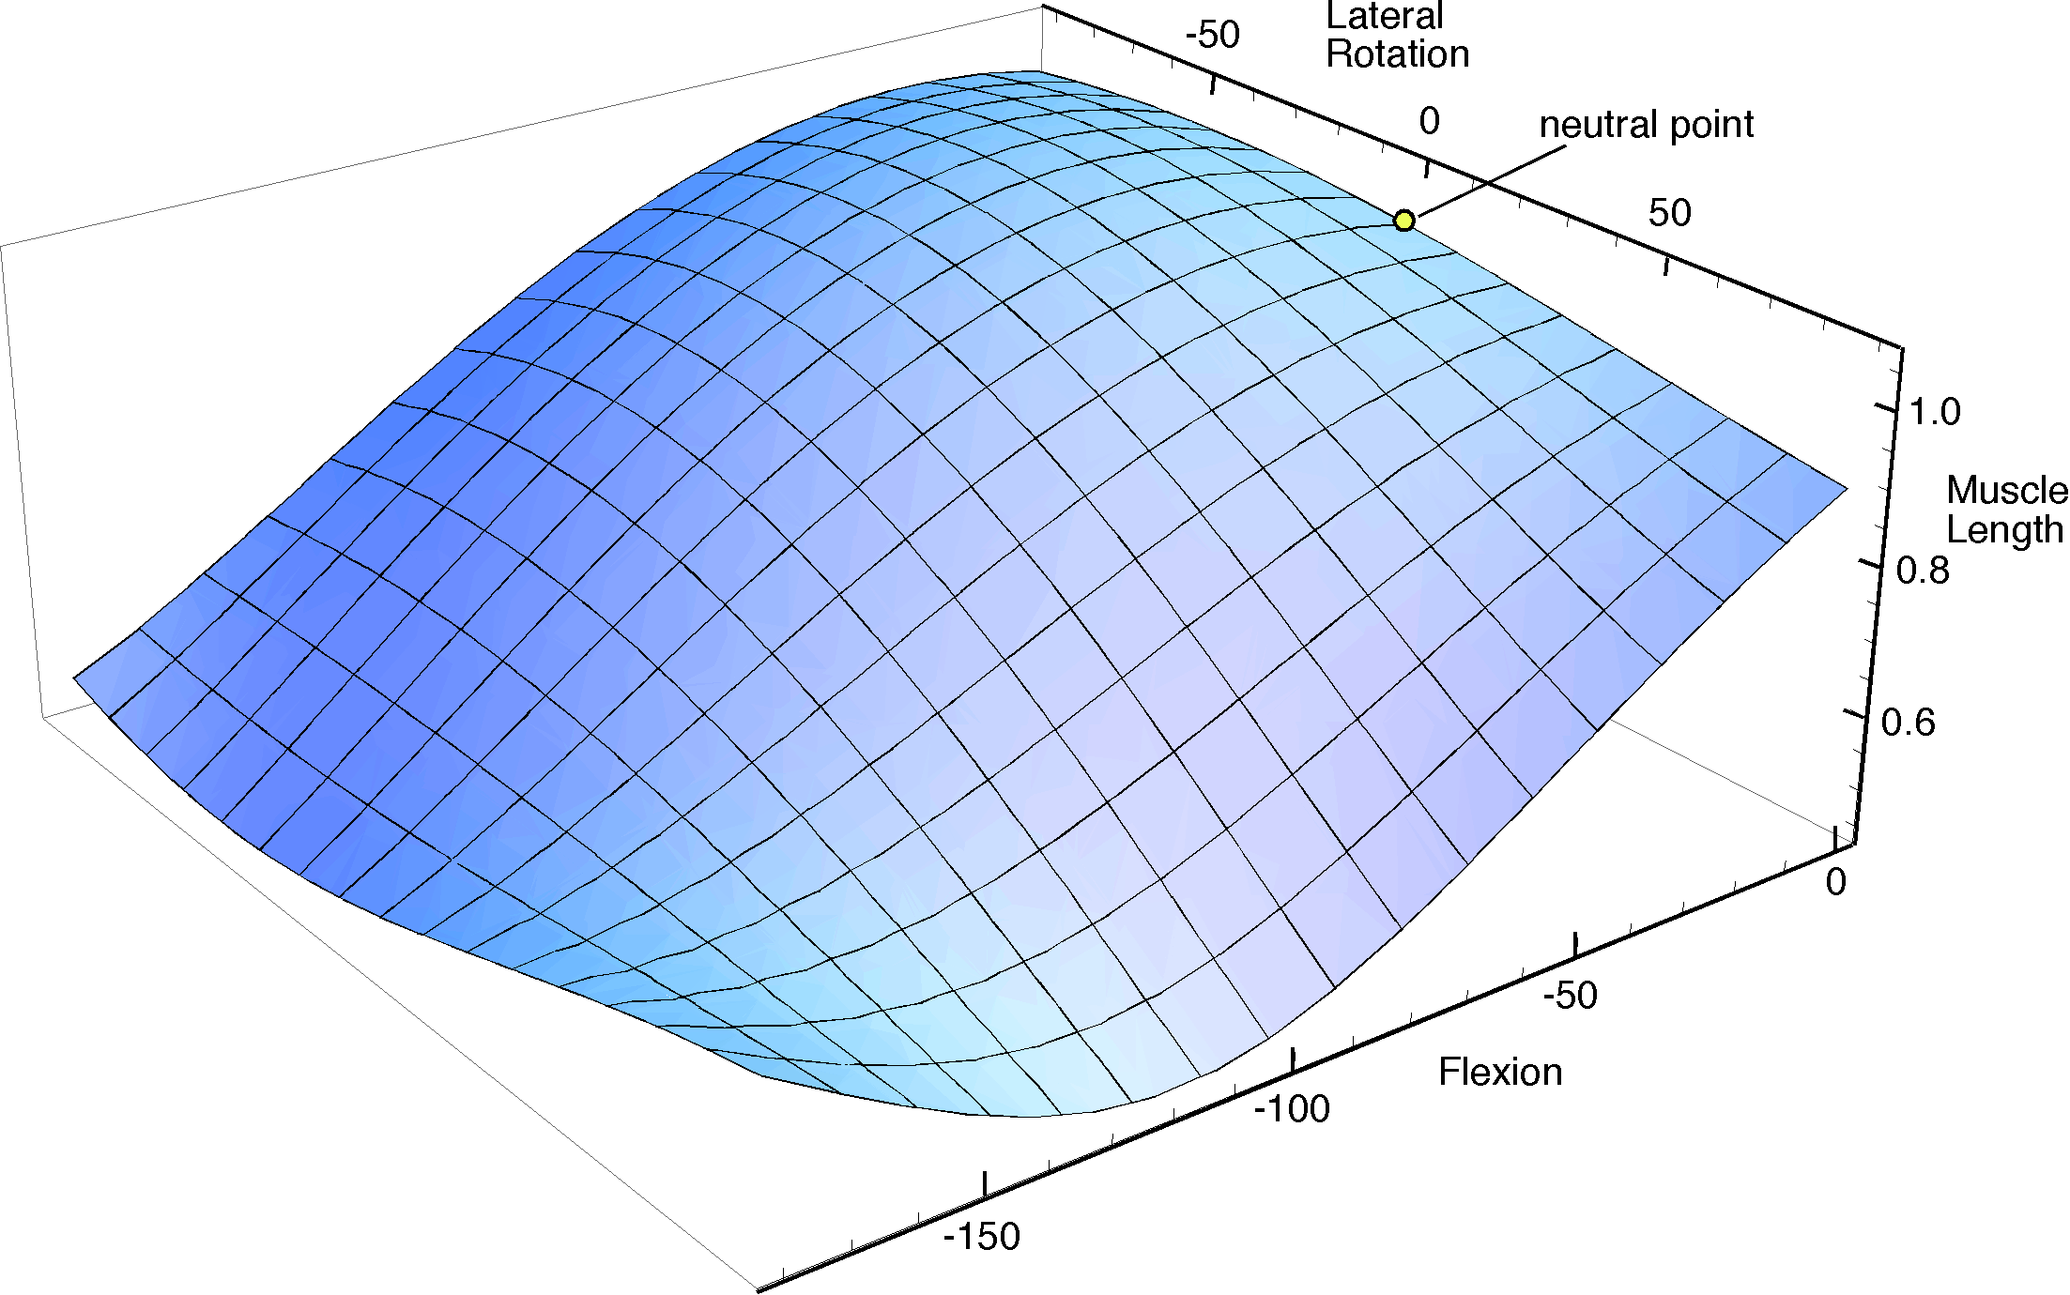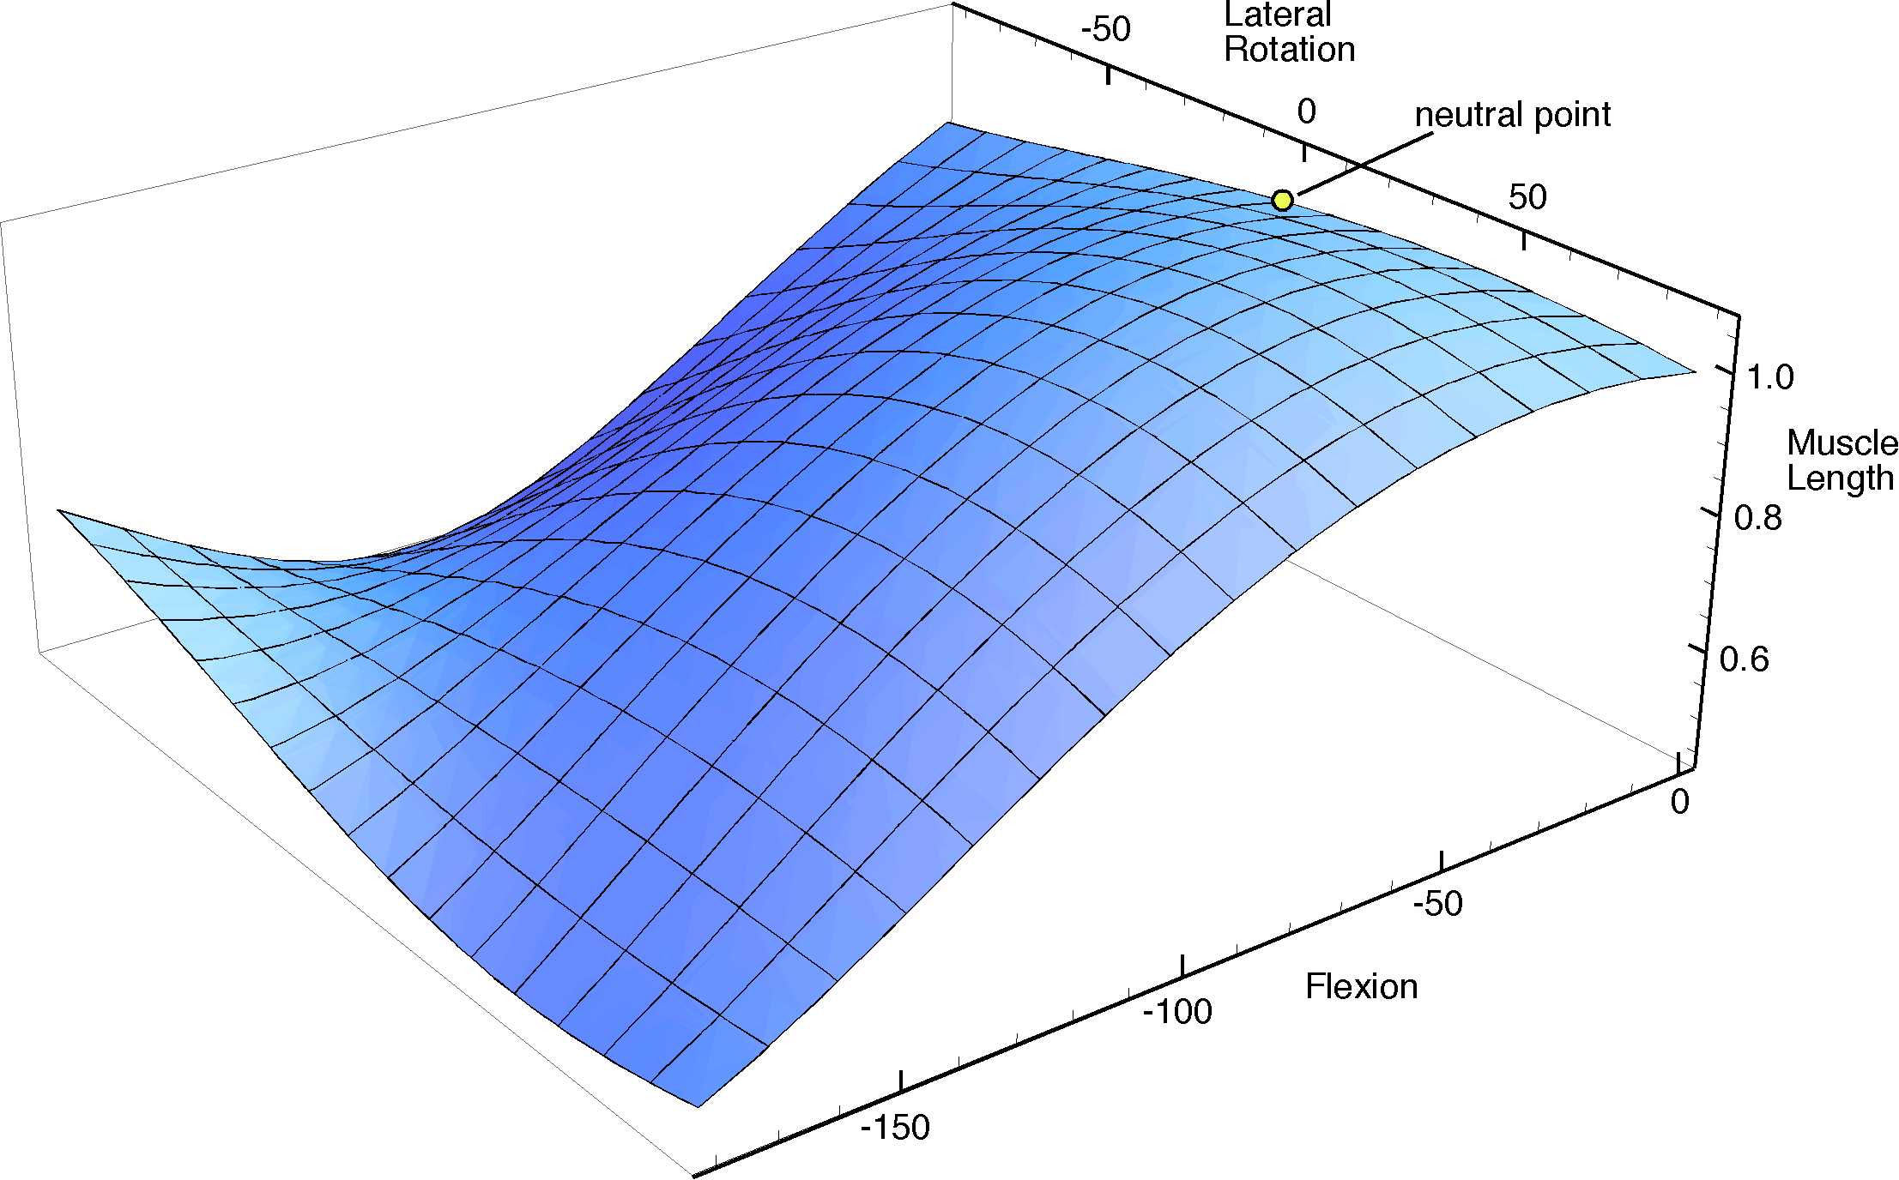

Muscle set surfaces for the anterior and posterior components of the deltoid-like muscle constrain the ability of a bone to move in the opposite direction and pull it towards the same direction at the origin. These two surfaces are mirror reflections of each other in the coronal plane through neutral placement.
The anterior and posterior components are more directed at bringing bone B forwards and backwards. Rotation of the bone about its long axis will moderately lengthen a muscle for rotation in one direction and shorten it for rotation in the opposite direction. When the bone is rotated so as to lengthen the muscle, the muscle is not very effective in elevating the bone until it is already elevated about 50°. On the other hand, when the bone is rotated so as to shorten the muscle length, the further shortening of the muscle will work to further rotate it about its axis in the same direction and to elevate it. Since portions of the muscle take origin anteriorly and portions take origin posteriorly, there is an effective aid to elevation in all directions. The portion of the muscle that is contracting will act to pull the moving bone further in the same direction. By resisting lengthening, an eccentric part of the muscle may prevent movements from moving into a substantial portion of the potential movement range. Consequently, these components may act as brakes upon movements in the direction away from their original placement.

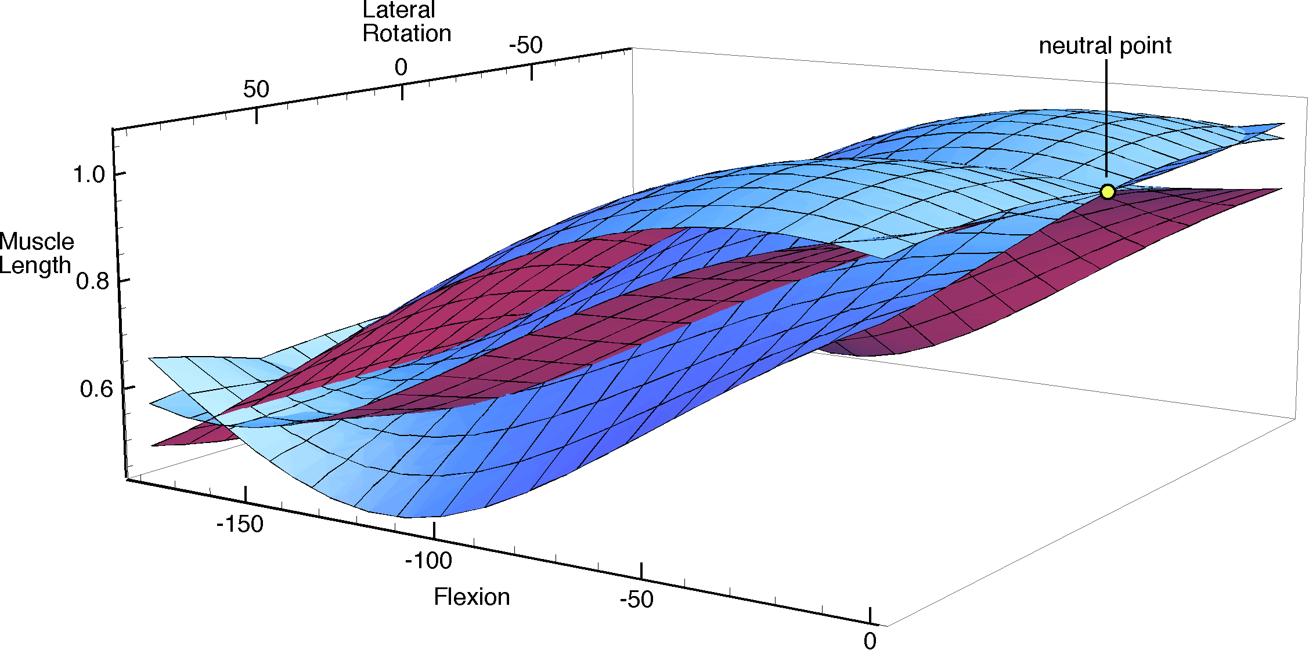
The three component muscle set surfaces considered above are plotted together and viewed from a different viewpoint.
The muscle set surface for a deltoid like muscle is complex. In the above figure the three surfaces that were considered individually are plotted in the same coordinate system to illustrate their differences and how they might work cooperatively in the control of the joint. In fact, the complete muscle set surface for the deltoid-like muscle is a stack of such surfaces, a sheave, as it were. In the figure, we see two end sheets and the median sheet in the sheave. In addition, as mentioned above, there are other options for orientation at each location of the bone, so each of these surfaces would extend into a third placement dimension, rotation about the axis of the bone. So the true surfaces are actually volumes in a four-dimensional space. Those volumes would have a three-dimensional mesh, like the lines drawn on the surfaces that are illustrated here, so that one would follow definite paths through the volume surface as the placement changed along meridians of location and orientation.
Such surfaces are complex. In most instances, three or more dimensions of placement as well as the muscle lengths for several muscles or muscle components. They are usually beyond our ability to readily visualize or comprehend in their entirety. However, with judicious simplification, one can often learn interesting things about how a muscle functions, how its geometrical anatomy influences its functioning, and why the muscle takes the form that it does. There is not space here to delve deeply into these ideas, but they warrant a separate consideration at greater length, elsewhere.

