How Ligaments Restrict Movement
Tethering may simply prevent bones from moving more than a certain distance apart, that is, to restrict active or passive translation. For instance, if a joint is distracted by pulling on one of its bones while stabilizing the other, then the separation is ultimately limited by the ligaments. The cruciate ligaments in the knee joint operate largely by restricting anterior posterior translation of the femur upon the tibial plateau, but the consequence is mostly to restrict rotation in the joint. The role of most ligaments is to restrain rotation, because that is largely what joint are about.
If rotation occurs, then the ends of a ligament linking the bones will move relative to each other. The gap between the ligament attachments may increase or decrease in a manner that depends upon the geometry of the joint. When the bones move so as to stretch the ligament, then the maximal separation is the length of the ligament. That is the ligament’s principal constraint upon movement. When the ligaments are maximally stretched there is usually an abutment between the two bones that fixes the joint in the sense that it cannot move any further in that direction. In this way, tethering and abutments often operate together. For instance, in the following figure, bone 1 and bone 2 have rotated about axes perpendicular to the page until they are stopped by their abutment.

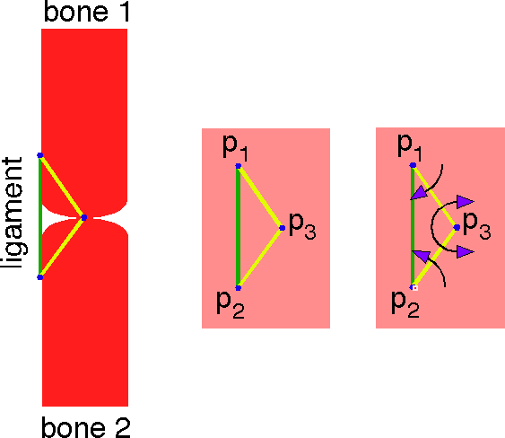
A tethering ligament and abutment is abstracted to a triangle with three pivot points. The joint is locked by the rotations indicated by the purple-headed arrows.
There are three loci critical to the fixation of the joint, the two attachments of the ligament (p₁ and p₂) and the abutment (p₃). This arrangement may be abstracted as three linked points. Each point is a potential pivot point. The attached bone can pivot about its ligamentous attachment and the two bones can pivot about the point at their mutual contact. We will say that such a joint is locked in that it can move no further in the direction that it followed into the lock. It can still move in many other directions.
The fact that the three points form a triangle is important, because triangles with sides of fixed length are rigid. Such triangles are uniquely determined. There is no other triangle that has the same three sides. That would not be true of a rectangle, which can be sheared without changing the lengths of the sides. In everyday life, the rigidity of triangles is the principle of structural trusses, which are used to build structures that need to be rigid, like roofs and bridges.
The triangular arrangement of the three critical loci is also important because it determines what movements can occur in the joint. For instance, the third panel in the above figure indicates the directions of rotation that lock the joint. At point 1 the axis of rotation is into the page and point 2 it is out of the page. The two torques at the abutment are equal and opposite to those at the ligament attachments. Nothing is moving, so the joint is locked, but only for movements that are in the indicated directions. Obviously, rotation in the opposite direction will unlock the joint and it turns out that many other rotations are also permitted. For instance, rotation about the axis of the ligament is permitted and rotation about a horizontal axis through a ligament attachment is also permitted. In this instance, with a little reflection, one can see that the set of rotation axes for the permitted rotations occupy a hemisphere in the direction opposite to the direction of the axis of rotation for the locking rotation. Consequently, there are a great many rotations that will unlock the joint.

The Formal Constraints Upon Movement
To discuss the permitted axes of rotation formally, it is convenient to generalize the description of a joint limited by a ligament and an abutment. Let us start with two bones that are linked by a ligament. The ligament attaches at points p₁ and p₂ and it has a maximal length of κ. The points ι₁ and ι₂ lie in the articular surfaces of bones 1 and 2, respectively. If a rotation is indicated by the symbol , then a rotation is permitted if the following conditions are satisfied.
The first two expressions simply say that a ligament cannot be longer than its maximal length and bones cannot overlap (there is no point that lies in both bones). The next four lines say that there can be no part of the moving surface that lies within any other bone after the rotation.
The local surface geometry determines the allowed rotations. That is partially because the local geometry determines the center of rotation for the surfaces. Commonly, at least one of the surfaces is convex as with a sphere, an ellipse, or a cylinder and the local curvature has a center of rotation that is the effective center of rotation for that surface. In the knee joint, the condyles are each like an ellipsoid and lying side-by-side as they do, they enforce an axis of rotation that lies some distance superior to the condylar surfaces, within the femur. The menisci reinforce and amplify shallow depressions in the tibial facet that help to guide the movements of the femur upon the tibia, but they would not be very effective without the guidance of the ligaments the lie about and within the joint. Let us consider a situation similar to the medial and lateral collateral ligaments.
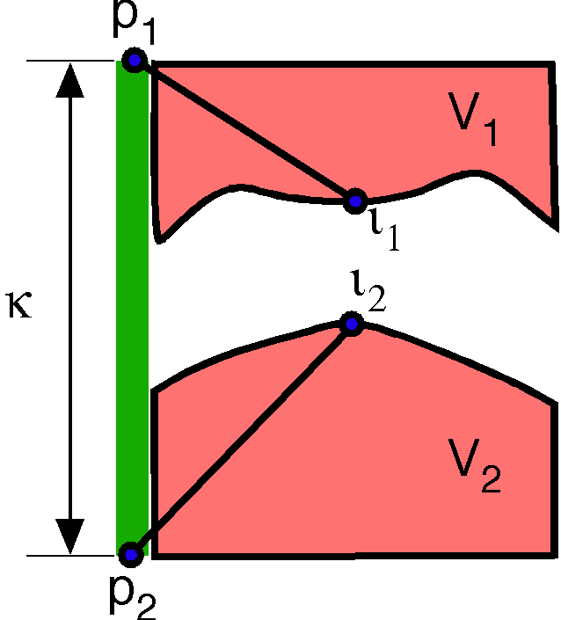
The joint is limited by a ligament with a maximal length of κ and attachment sites p₁ and p₂. The two points ι₁ and ι₂ are in the surfaces of bone 1 and bone 2, respectively, which occupy the volumes V₁ and V₂.
A single ligament is not particularly restrictive, because of the many ways in which the joint may move without violating the conditions laid out above. Two ligaments force the permitted movements to satisfy two sets of constraints, which may greatly reduce the options.

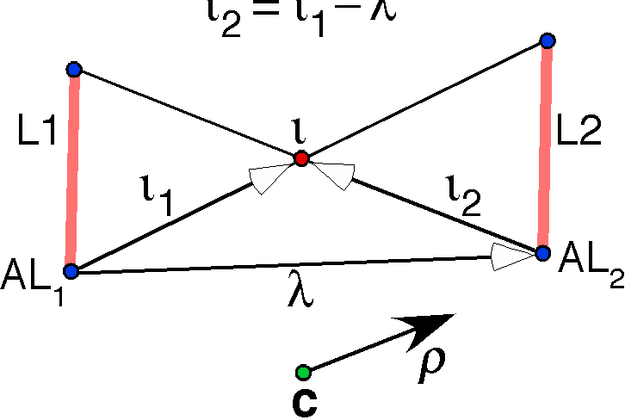
Consider the following situation. Two ligaments are set to ether side of a joint so that they are parallel and they have a common abutment. Let them be designated as L1 and L2 and let them have the common abutment . There is a fixed relationship between the ligamentous attachments to a bone and the abutment point for that bone. Let the vector from the attachment of L1 to the attachment of L2 be . We write the location of the abutment in a common coordinate system centered upon the attachment for L1. For an arbitrary rotation, , the new location of the abutment point () is given by two expressions.
The only rotation that satisfies both conditions is about an axis () in the direction of the vector that joins the attachment points (). Clearly, the ligaments have a substantial role in restricting movement. If the ligaments are not maximally stretched, then there is more room for variation in the axis of the rotation. However, most ligaments are situated so that the gap that they span varies little in length. And the gap is normally close to the maximal length of the ligament.

Ligament Arcs and Center of Rotation Arcs
Ligaments restrict movement in joints by only allowing movements that do not produce a gap between their attachments that exceeds the maximal length of the ligament. That mean that that, if we fix one end to the ligament, then all permissible movements keep the other end of the ligament within the arc generated by swinging the maximal gap about the fixed attachment. That will be called the ligament arc.
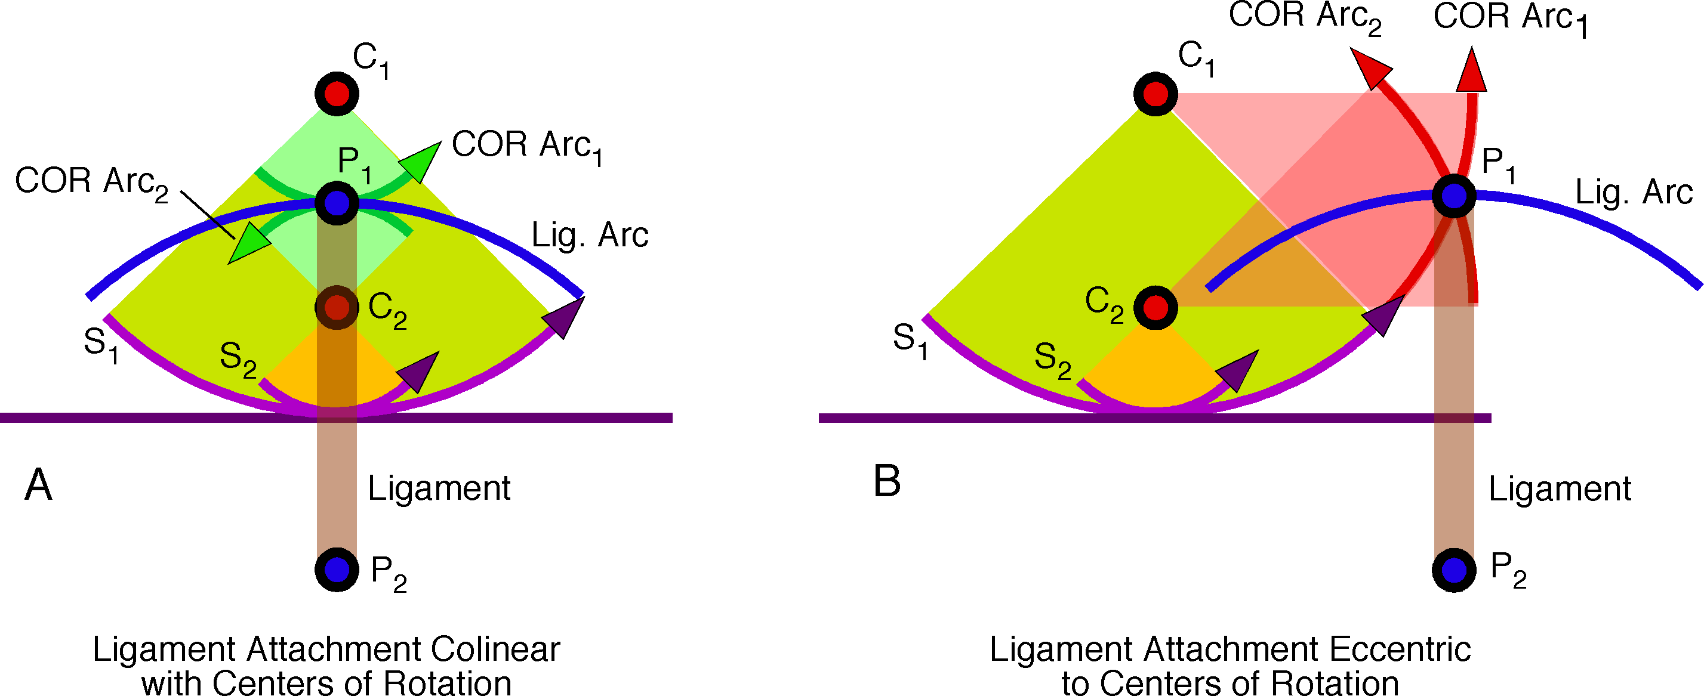

The movements of the mobile end of a ligament are examined when the center of rotation of the moving bone is collinear with the ligament and when it is eccentrically placed. Only cases where the center of rotation lies on the same side of the joint as the moving bone are illustrated. P₁ and P₂ are the attachment sites for the ligament. The ligament arc is the arc that the moving attachment traces when the ligament is maximally stretched. All permissible movements leave the moving attachment with that arc. C₁ and C₂ are possible centers of rotation. S₁ and S₂ are the arcs of the surfaces that would have the same center of rotation. Movements about each center of rotation will cause the mobile attachment to follow another arc, which is its center of rotation arc (COR arc). The COR arcs are drawn for a maximally stretched ligament.
As the bones move by rotating about a center of rotation, the mobile ligament attachment is also moved. If the center of rotation lies between the two ligament attachments (C₂ in the following figure), then the ligament is swung on an arc that that has a shorter radius of curvature than the ligament arc. That means the there is no restriction on the movement due to the ligament. The arc followed by the ligament attachment will be called the center of rotation arc (COR arc).
As the center of rotation approaches the stable attachment, the COR arc will approach the radius of curvature of the ligament arc. If the axis of rotation passes through the stable attachment and it is perpendicular to the long axis of the ligament, then the COR arc will be coincident with the ligament arc for a fully stretched ligament. If there is slack in the ligament, then the two arcs will be concentric.
In the above figure, the center of rotation is constrained to lie in the moving bone, because the supporting bone has a flat surface. Consequently, the case of a center of rotation in the stable bone is not illustrated.

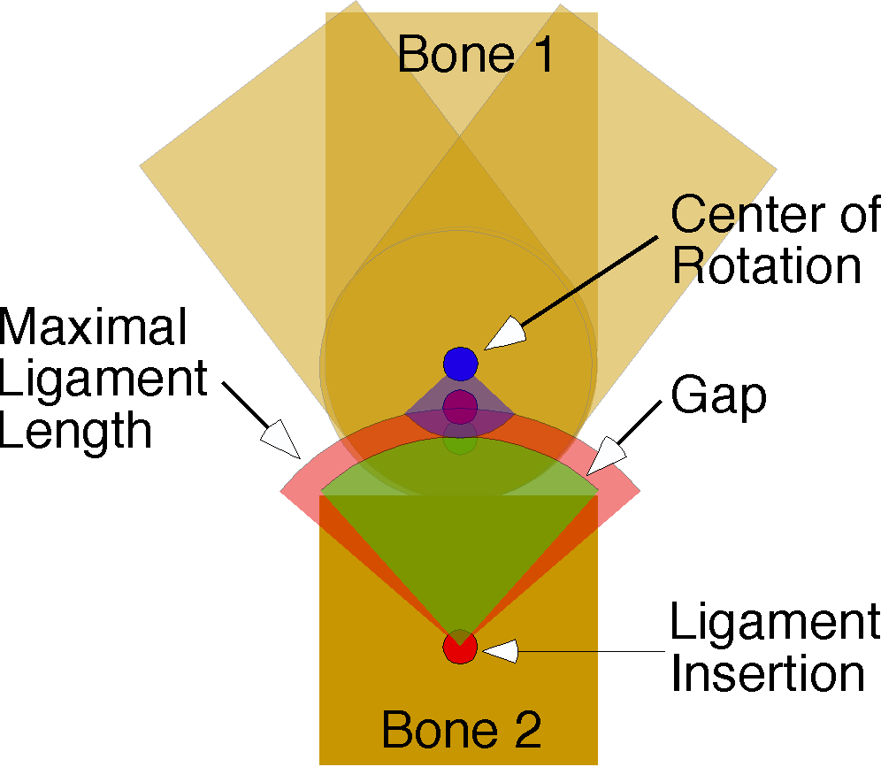
The permissible movement is the excursion between the actual gap (Gap) and the maximal gap (Maximal Ligament Length). The location of the mobile ligament insertion in neutral position is the green dot, but the maximal ligament length is the red dot and its arc. The center of rotation is the blue dot. The permissible angular excursion is the blue arc. Bone 1 is drawn in neutral position and the two extreme positions.
If the center of rotation lies beyond the stable attachment of the ligament, then the radius of curvature of the arc of the mobile attachment is greater than that of the ligament arc and the arc is flatter. If the ligament is not stretched to its maximal length, then movement is possible until the center of rotation arc intersects the ligament arc. That excursion may be substantial since the arc is going to be comparatively flat and it takes an almost tangential approach to the ligament arc.
In general, ligaments allow the most movement in directions perpendicular to the long axis of the ligament. So, one can often deduce the permitted or favored movements for a ligament by constructing the spherical shell with its center at the stable attachment site.
If the center of rotation of the bone carrying the mobile ligament attachment is beyond the mobile attachment, then the center of rotation arc is curved in the opposite direction. That means that unless there is some slack in the ligament, the bone will not be able to rotate. If there is slack, then the rotation will occur until the center of rotation arc intersects the ligament arc.
If the center of rotation is not in the plane of the ligament attachments, then the situation changes in an interesting way. There is a direction of rotation that allows the joint to open and a direction of rotation that will lock the joint. The direction of rotation that allows the joint to open depends on which side of the ligament the center of rotation lies. In the illustration, rotation about an axis that comes perpendicularly out of the page will tighten the joint. However, if we move C₂ to the other side of the ligament, then the joint will open with the same rotation.

An Example: The Collateral Ligaments of the Knee
The knee is a complex joint with many interacting components that constrain it to move in particular ways. We will not consider all of the features of the knee at this point, but it does provide an interesting context in which to explore some of the ideas that have just been introduced.

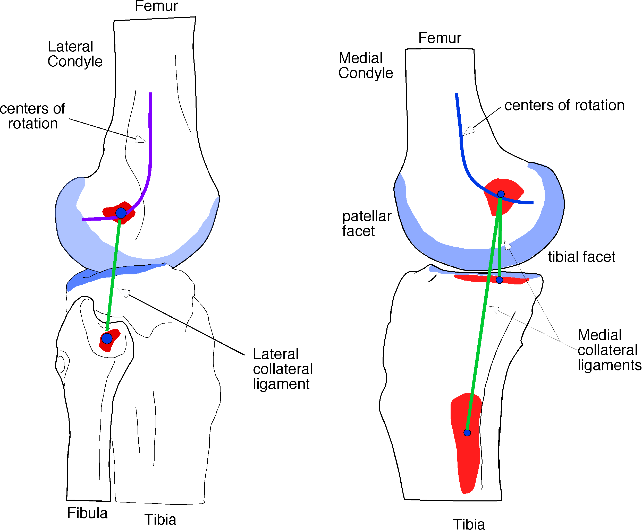

Drawing of the knee joint viewed from laterally and medially, showing the bones and the collateral ligaments and the approximate trajectories of the centers of rotation.
The two bony elements of the knee are the distal end of the femur and the proximal end of the tibia. The tibial condyles are relatively flat, but with a slight elliptical depression for the medial facet and a saddle-shaped surface for the lateral facet. The lateral facet is concave in the medial-lateral axis and slightly convex in the anterior-posterior axis. The medial condyle is more elliptical and longer. The flatness of the tibial facets is partially compensated for by the menisci that fit between the femoral and tibial surfaces, providing moveable sockets for the femoral condyles to sit in.
The femoral condyles are most relevant to our purposes, because they are strongly curved and their shape reflects the mechanics of the joint. The joint surface on the distal femur takes the form of two ellipsoidal condyles with the long axes directed anterior-posterior and convergent anteriorly.
The articular surface is actually two joint surfaces. On the anterior face of the femoral condyles is a single surface with medial and lateral elevations that articulates with the posterior surface of the patella. That part of the joint will not be relevant to what follows.

The posterior half of the condyles is split by a deep cleft, so that there are two separate articular surfaces. The two condyles are similar, but not identical. For instance, the medial condyle is larger. The condyles are ellipsoidal, but with a curvature that flattens as one approaches the anterior part of the tibial articular surface. Posteriorly, the articular surface wraps around to cover the posterior aspect of the condyle, so that the knee can flex through more than 90°. Passive flexion is estimated to be about 160°, active flexion more like 120-140°, depending on the orientation of the hip joint and the amount of muscle that comes between the femur and tibia.
Because of the variation in curvature of the femoral condyles, the center of rotation changes as the joint flexes and extends. In the following figure, the tracks of the centers of rotation are sketched against the anatomy. For flexed postures the centers of rotation lie posteriorly and near the articular surface, but as the joint nears full extension the center of rotation shifts anteriorly and sharply superior.

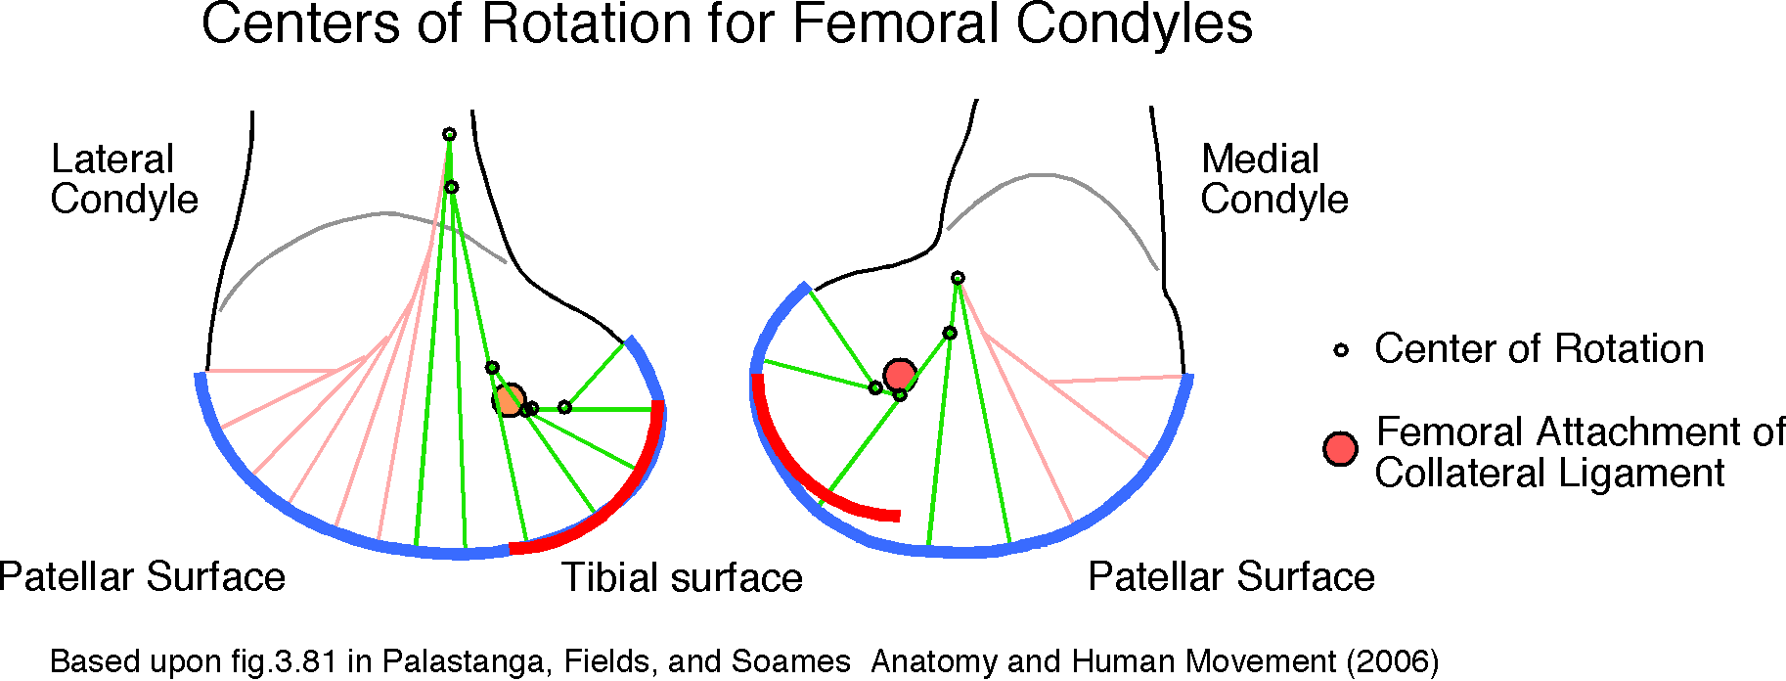

The figure also shows the locations and distributions of the attachments for the medial and lateral collateral ligaments. The green lines indicate the locations of the ligaments. Both ligaments are nearly vertical and attached posteriorly on the femoral condyles. The trajectory of centers of rotation passes across both proximal attachment sites.
In the above figure the pertinent features of the femoral condyles have been abstracted. The centers of rotation are approximated by drawing a series of perpendiculars to the articular surfaces. Where adjacent lines meet is a reasonable estimate of the center of rotation for the part of the articular surface that lies between the perpendicular lines. The centers of rotation cluster near the proximal attachment sites for both collateral ligaments when considering the posterior part of the surface, the part that comes into play with large flexion movements. As the knee is extended, the centers of rotation move anteriorly and up the shaft of the femur.
The red curves are segments of a circle centered upon the ligament attachment site, with a radius equal to the distance to the most posterior aspect of the condyle. Both surfaces have an approximately circular sagittal cross-section. The medial condyle is relatively deeper than the lateral condyle.
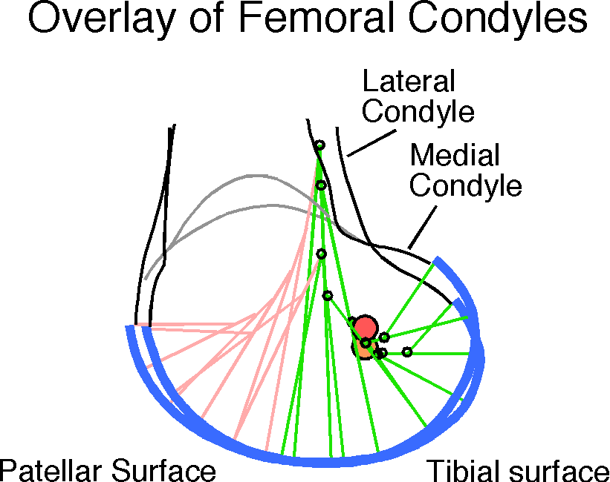
If we superimpose the two profiles, the two condyles can be seen to be remarkably similar. The attachment sites for the collateral ligaments are approximately aligned and the centers of rotation are clustered along a common trajectory. There are differences and they are relvant for the locking of the knee when it enters terminal extension and rotates slightly on a longitudinal axis, but, to the first approximation, we have two rockers that rotate about a common, approximately horizontal, axis. The axis of rotation is set by the centers of rotation, which all cluster around the proximal ligament attachments. In flexion, the relative placements of the centers of rotation and the ligament attachments indicates that the ligaments are unlikely to restrict movement, but they may guide it, by preventing rotations that deviate significantly from an axis through the proximal ligament attachments. As the joint approaches full extension, the centers of rotation move away from the ligament attachment sites and anteriorly. As you can easily see, rotations about those centers of rotation into extension (axis of rotation perpendicularly out of the page) will cause the attachment site to move proximally, that is, stretch the ligaments. Consequently, the collateral ligaments restrain movement into extension and they do so as the knee approaches full extension. Also, because the point of contact lies anterior to the ligament attachments, there is an abutment due to the ligaments being maximally stretched and the femur being unable to move any further into extension.
It should be noted that there are a number of other ligaments that reinforce the restriction. One way to get around the restriction might be to slip the femur posteriorly, so that the abutment lies in the same vertical plane as the ligaments. That is prevented by the need to make the ligaments longer to do so. First, moving the femur back would make the ligaments oblique, therefore longer. Secondly, the socket on the medial side is concave so moving the medial condyle posterior will move it up that slope and further from the distal ligament attachment. However, both of those restrictions may be overcome by stretching the collateral ligaments. Another restriction is the anterior cruciate ligament, which extends from the anterior margin of the tibial plateau to the posterior medial aspect of the lateral femoral condyle. Moving the femur posteriorly will strain that ligament and so the anterior cruciate ligament restrains extension. In a fully extended knee the femur cannot move further posterior, because, to do so would strain the cruciate ligament in the direction where they have the least give, along the longitudinal axis of the ligament. We will briefly consider the geometry of the cruciate ligaments in the next section. Finally, the posterior part of the joint capsule that overlays the posterior parts of the femoral condyles is thickened so that at full extension it is pulled taut and will not allow the femoral condyles to move more superiorly. The cruciate ligaments and the posterior joint capsule are different than the collateral ligament in that they do not guide the movement through its full excursion, but check it at its extreme.

The Cruciate Ligaments
The cruciate ligaments lie in the center of the knee joint and as their names imply they cross each other. The anterior cruciate is attached to the anterior end of the elevation between the tibial condyles and it reaches posteriorly and superiorly to attach to the medial aspect of the lateral condyle, just above the articular cartilage. The posterior cruciate ligament attaches to the posterior rim of the tiba, between the tibial condyles and stretches anteriorly and superiorly to attach to the lateral aspect of the medial condyle, just posterior to the cartilage of the patellar facet. Their approximate locations have been drawn on the medial view of the knee joint.
When the knee is flexed, the center of rotation is near the posterior attachment of the anterior cruciate ligament, probably a bit closer to the tibial surface than the center of rotation. That might cause problems because the COR arc is orthogonal to the ligament arc, but the movement into flexion makes the gap between the attachments of the anterior cruciate ligament much shorter than the maximal ligament length, so the anterior cruciate ligament does not constrain movement. Flexion carries the posterior cruciate ligament into a more vertical orientation, so it may be stretched, but, since greater than 90° of knee flexion is routine, the ligament is normally long enough and so placed that its attachments do not separate by more than the maximal length of the ligament. However, the ligament may contribute to the posterior shift of the femur upon the tibial plateau as the knee goes into flexion. A posterior shift would bring the two attachments closer together. Since the centers of rotation in flexion are between the two attachments, the COR arc will have a smaller radius of curvature and therefore the ligament will not be significantly stretched by either flexion or extension.
Extension is more interesting because the cruciate ligaments are important elements in the fixation of the knee. The situation in endrange extension is illustrated above. The gap between the attachments of the anterior cruciate ligament is near or at its maximum. Consequently, the ligament will pull the femur anteriorly and inferiorly. Further extension will further stretch the ligament, so the anterior cruciate ligament restricts extension. The posterior cruciate ligament is probably initially less than fully stretched and extension will tend to decrease the gap between its attachments. As a result the femur can be pulled anteriorly on the tibial plateau until the tension in the two cruciate ligaments is equal and oppositely directed in the horizontal plane, while both ligaments will draw the femur closer to the tibia, compressing the joint.
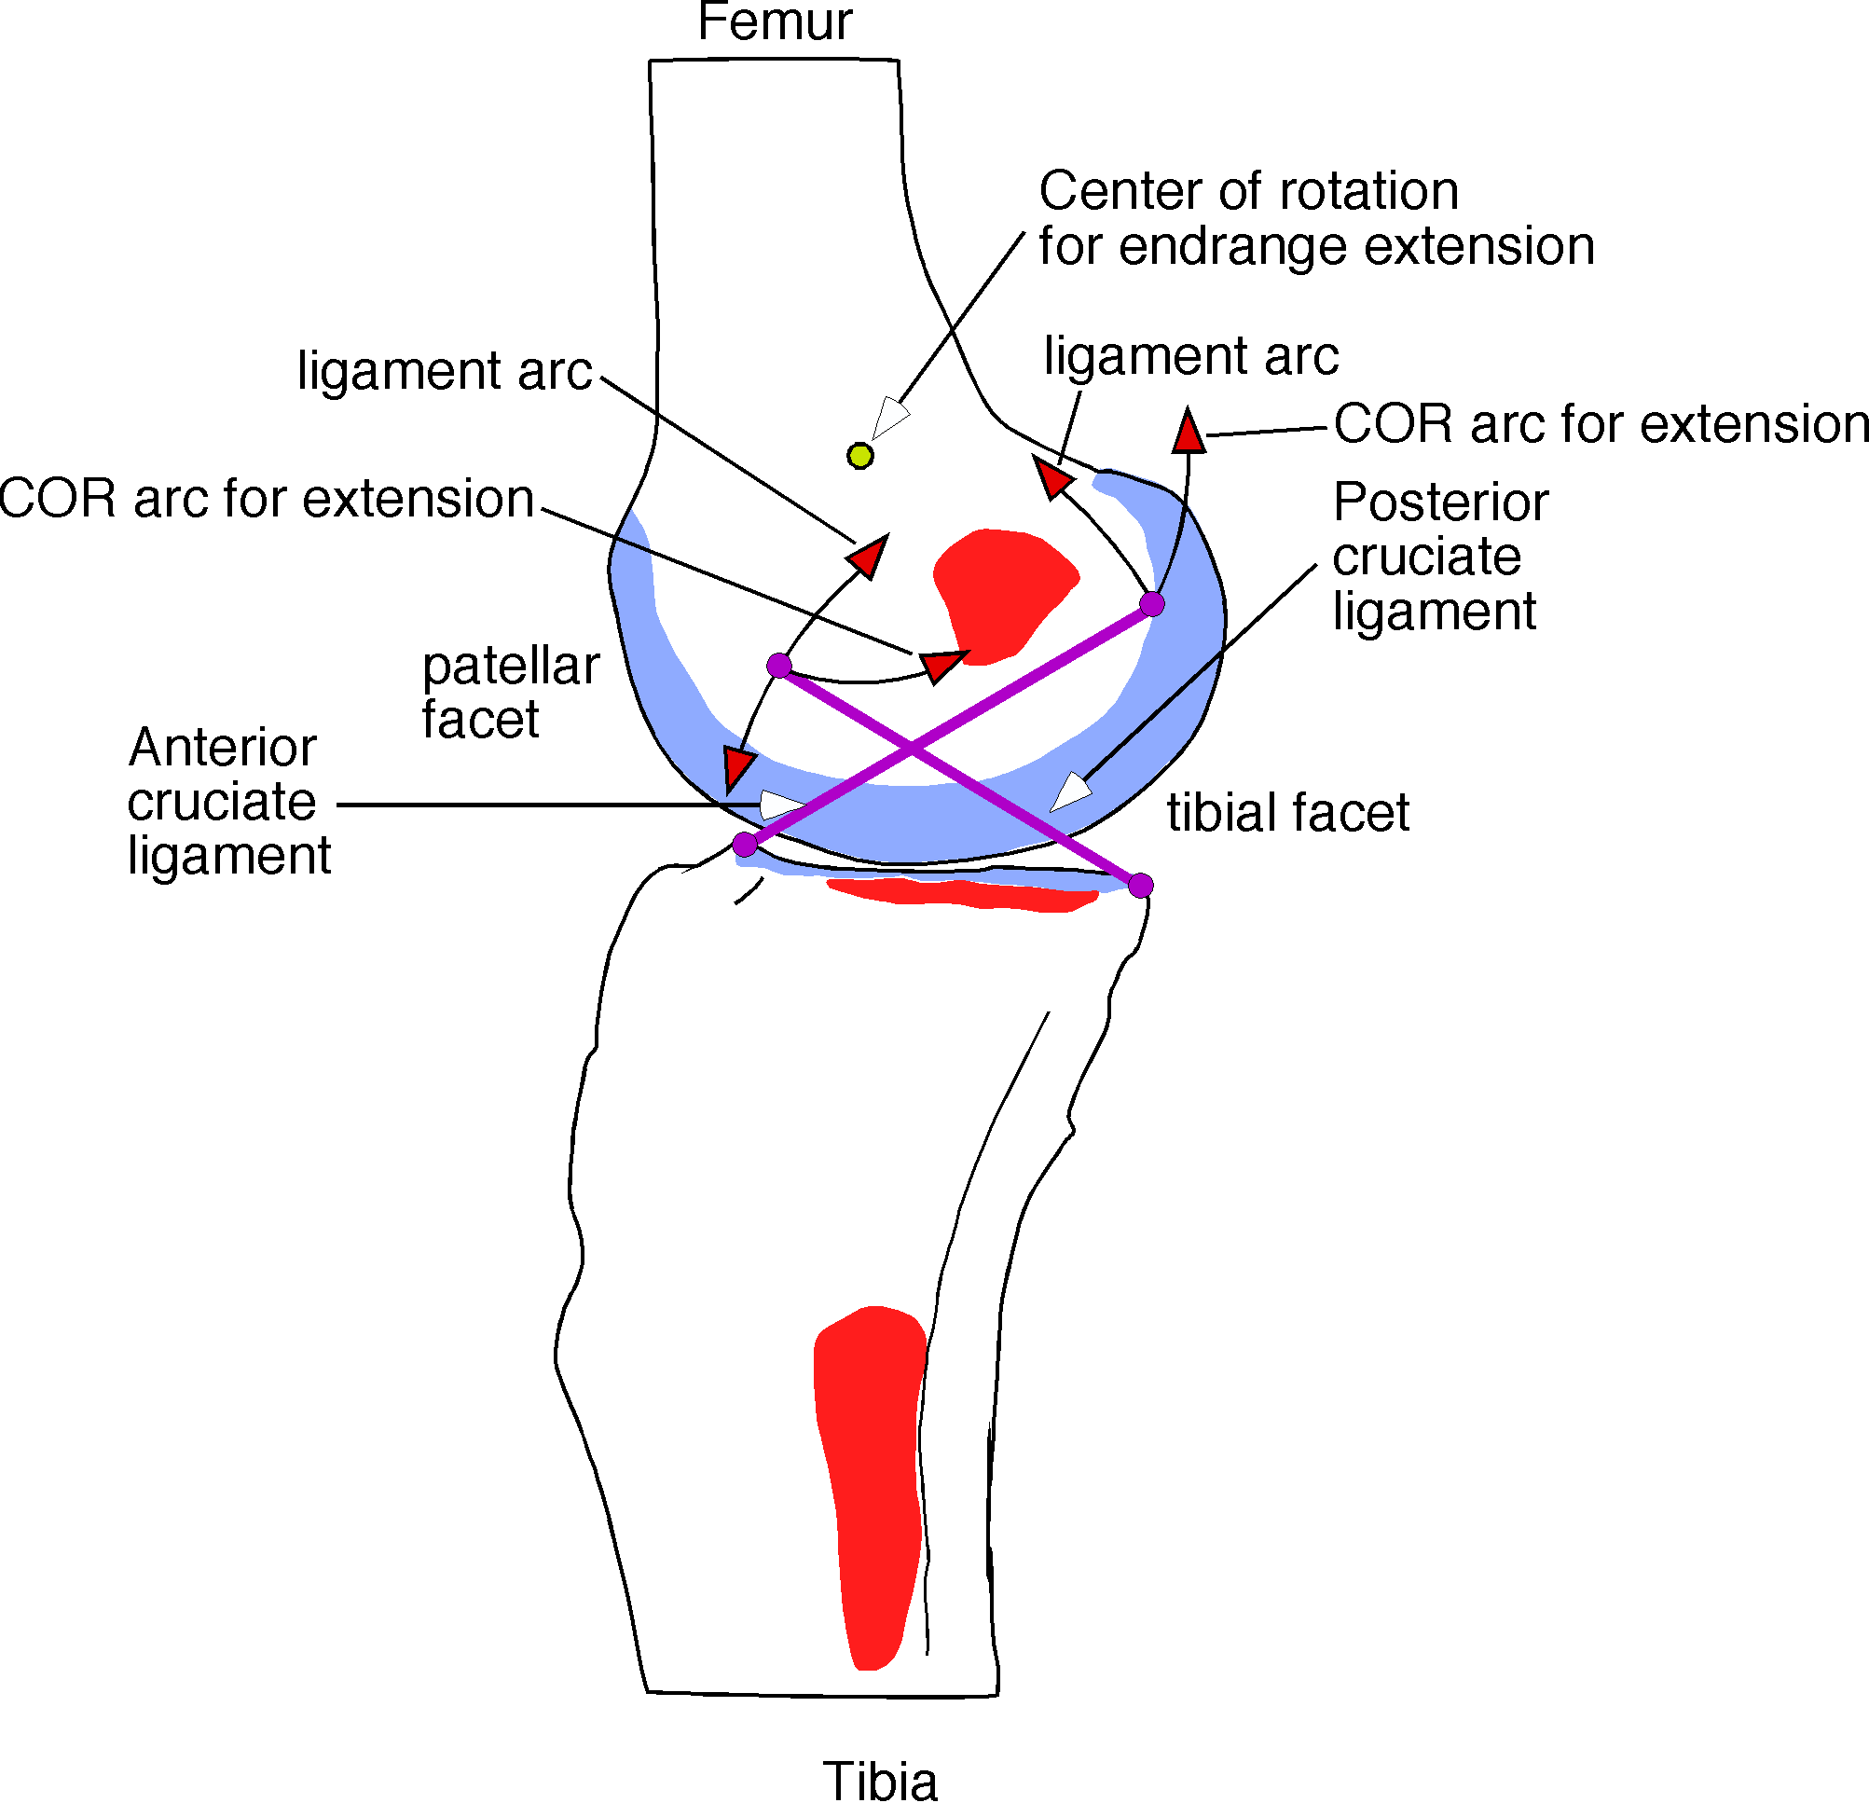
In endrange extension the anterior cruciate ligament is strained so that it draws the femur anteriorly and inferiorly on the tibial plateau. Extension tends to decrease the gap between the attachments of the posterior cruciate ligament so it is able to accommodate the anterior translation. Between the two cruciate ligaments, the femur is translated anteriorly and inferiorly as the joint enters terminal extension.
If both ligaments are tense, then the femoral attachments of both ligaments can be brought slightly closer to their tibial attachments by rotating the tibia laterally a few degrees. That is observed to happen as the knee joint enters the close-packed position in endrange extension.

Wrapping Up
The intent in this chapter has been to briefly introduce a number of ideas related to the manner in which ligaments shape movement in joints. This is a large subject to fully explore and this is not the place for an exhaustive examination. We tend to be impressed by the mass and force of the muscles and the wide excursions of the bones and to pay less attention to the many ligaments that do not actively move and, when they move, it is often for short distances. They are much less voluminous than either muscles or bones. And yet, they are central to the control of anatomical movement. As demonstrated here, they often set the direction and magnitude of the movement. In another forum, it might be interesting to systematically consider the many forms that ligaments take and how they perform their roles in different joints. Here we have considered only a couple of pairs of ligaments in the knee. To fully understand the knee, it is necessary to examine each ligament alone and in company with all the others.

