Constructing Equivalent Descriptions of a Rotation

We will consider a situation where a vector, v, is rotated about an axis of rotation, , through an angle of to generate the vector . If the angle between the axis of rotation and the rotating vector is a right angle than it is most efficient to use the definition of a quaternion to compute the value of the rotated vector. If the angle between the axis of rotation and the rotating vector is not a right angle, then a half angle formulation is required to compute the correct value. It may initially seem that these are two very different processes. If the tensor of the quaternion is unity, that is, the quaternion is a unit quaternion, then the two ways of computing the resultant are easily related in terms of each other. If is perpendicular to , then the expressions are as follows.

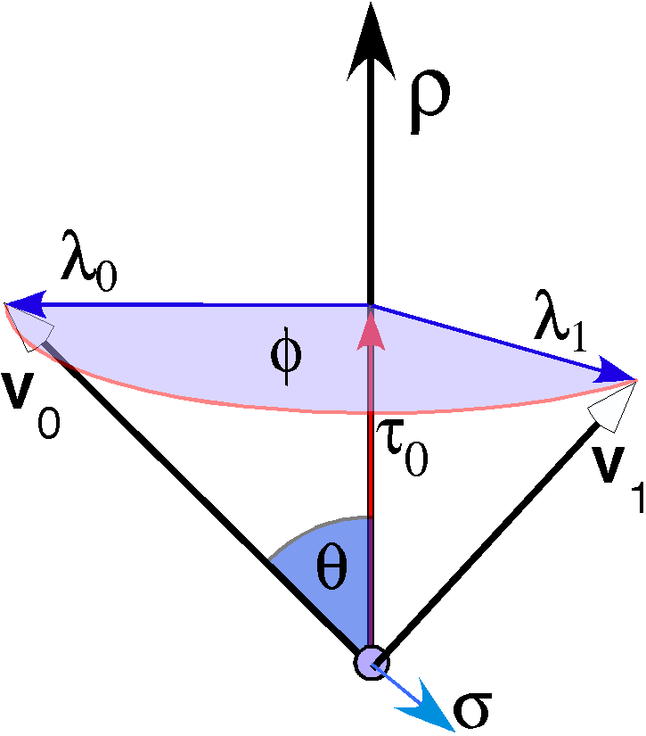
The vector v is rotated through an angle about an axis of rotation. It may also change length at the same time.
If is not perpendicular to , then more calculations are required. We define the unit vector in the direction of , , and take the ratio of it to a unit vector in the direction of the axis of rotation, , to obtain a quaternion that expresses the rotation of the axis of rotation into the original vector, . The angle of that quaternion is and we can express the sides of the triangle that has as its hypotenuse and a base, , aligned with the axis of rotation. The other side, , is perpendicular to the axis of rotation and it is the vector that is entered into the definition of a quaternion to obtain the vector in the direction of the transformed vector, . The derivation goes as follows.
If we have the vector, , perpendicular to the axis of rotation, then is and is zero. It follows that the full angle formulation gives the same result as the half angle formulation, which was stated above. Otherwise the must be replaced by and the result added to the offset translation, .
The full angle version applies only when the angle between the axis of rotation and the rotating vector is 90°. It is conceptually simpler in that it is rotation in a plane. The half-angle version is suitable for describing any rotation. Consequently, if you do not know that the angle between the rotating vector and the axis of rotation is a right angle, it is always best to use the half angle format. As indicated above, this simple equivalence applies only when the tensor is unity.
If the tensor of the quaternion is not unity, then the situation is more complex and the two processes yield fundamentally different results. However, each outcome can be converted into the other with little difficulty. In the next few paragraphs we will consider how.
Consider the two expressions. The first is based on the definition of a quaternion.
The second is based on the half angle formula that applies when the rotating vector is not perpendicular to the axis of rotation.
The second tensor is necessary because the half angle quaternions, which are computed from the full angle quaternion, cancel each other so that the expression inside the square brackets is effectively multiplication by a unit quaternion. The scalar, , is a rescaling of the vector v, a change in its length. As such, it serves the same role as the tensor in the first expression, which also changes the length of the rotating vector. The expression in the square brackets gives the new direction of the rotating vector and the tensor gives it its new length.

Movements with changes in scale
We need to consider these movements in a bit more detail. As far as I am aware, there is no terminology for the two movements expressed in the two equations above, so, I will introduce names for each. The intent is to simplify description by settling upon simple terms for expressing each action.
Paradoxically, there is a well established name for a similar but subtly more complex movement. When an object rotates about an axis as it advances in the direction of the axis, it is said to be making a screw motion (Weisstein 2003). This type of movement may also be called a twist, but that term has a very definite special meaning in differential geometry (Weisstein 2003). The force couple that produces a screw movement is called a wrench (Beer and Johnston Jr 1990). Such movements are well studied in mechanics, although they generally do not make it into elementary textbooks, since they are the results of systems of forces.

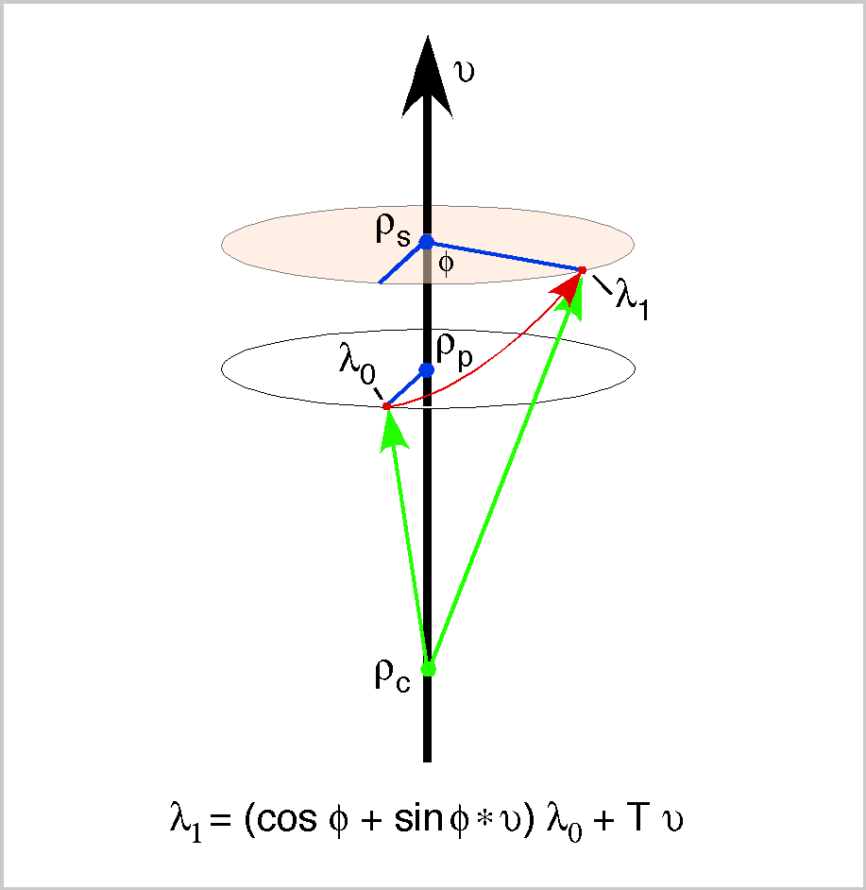

A screw is a combined rotation and translation with respect to the same axis

The above figure illustrates a screw. A point revolves about the axis , through an angular excursion of while traveling parallel with a distance of , which is a linear function of that is equal to zero when is equal to zero. If the location of the point at the start of the movement is and the location at the end of the movement is , then the movement is expressed as follows.
As used here, a screw can be oblique when the direction of the translation is not parallel with the axis of rotation. When the direction of the translation is parallel with the axis of rotation, then the screw will be an orthogonal screw, because the translation is perpendicular to the plane of the rotation. When unmodified, a screw will be taken to mean an orthogonal screw. All the screws considered here will be orthogonal screws. Wrenches are always, by definition, orthogonal. The screw theorem proves that all rigid body movements can be expressed as orthogonal screws (Weisstein 2003).
The second type of movement, the one described by the full angle formulation with a non-unity tensor, will be called a cast, as in casting seed away from oneself. This movement might also be called a twirl (Weisstein 2003). It is a movement that is confined to a plane in which the rotation vector changes length as it rotates. A cast is a unit cast when the rotating vector does not change length, that is, when its tensor is unity. If the tensor of a cast is not unity, that is when T = 1.0 + kφ, then the cast may be minifying (k < 0.0) or magnifying (k > 1.0).

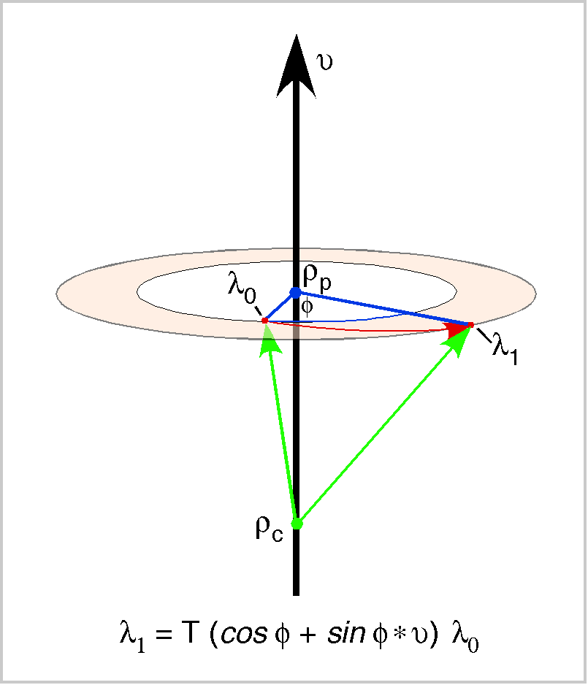

A cast is a planar rotation about an axis with a concurrent change in scale
An orthogonal screw is a unit cast plus a translation in the direction of the axis of rotation. Consequently, a screw is a more complex movement than a cast. The expression for a cast is as follows.
The tensor T_{c} is the magnification or minification factor for the cast. It operates in a different manner than the tensor for the screw, which translates the rotating vector.
The third type of movement, the one where the half angle formulation is used, will be called a coil, as it is a spiraling movement. It is a movement in which the rotating vector changes length as it rotates. It normally causes the rotating vector to move out of any plane of rotation that it occupies during an instant of the movement. The following figure illustrates the simplest example, where the angle between the axis of rotation and the rotating vector is constant. A coil is a unit cast when its tensor is unity.
The expression for a constant coil is given by the following expression.
The tensor is the relative length of the rotating vector, as it is in a cast, but, because we are multiplying a conical rotation, the effect is different. The rotating vector will spiral out or in as it moves relative to the axis of rotation. A coil looks rather like a screw, but one can never be an instance of the other, except when and , in which both are also a unit cast and all three are lacking the features that make them special.

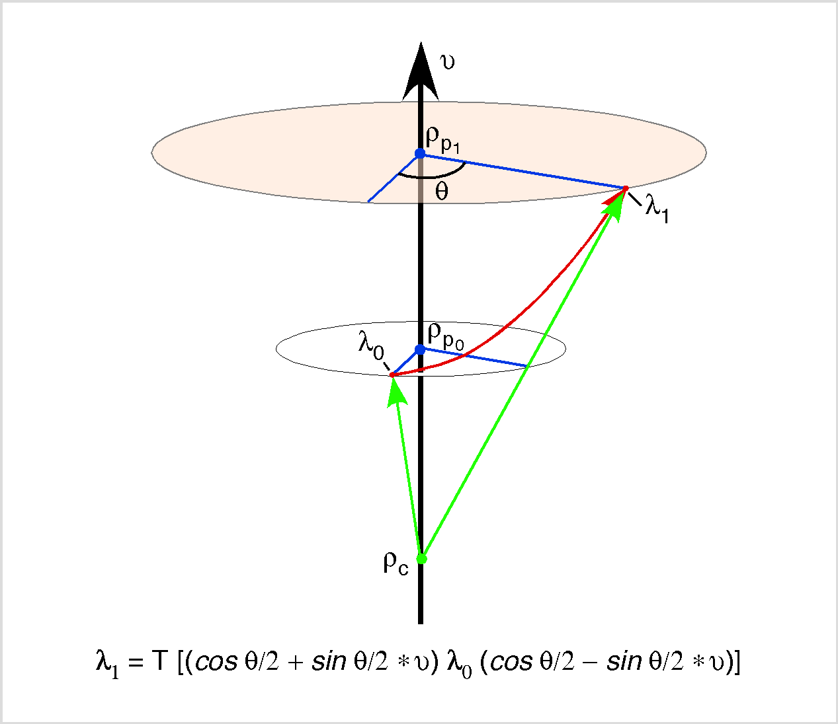
A coil is a conical rotation about an axis with a concurrent change in scale

Conversions Between Modes of Expression
Clearly, the expressions for screws and casts are quite similar in that both are written in terms of full angles. It is also clear that one can readily move between full angle and half angle expressions when the tensors are equal to one. It may not be immediately apparent that the half angle version of a coil can also always be written as a function of a full angle rotation. However, every unitary conical rotation can be viewed as a planar rotation, with the plane perpendicular to the axis of rotation and through the terminus of the rotating vector. That is the starting place for the following discussion.
One simply has to compute the location of the plane, a distance in the direction of the unit vector of the rotation quaternion, , from the origin of v. The plane is perpendicular to the axis of rotation, , and the distance between the axis of rotation and the rotating vector’s terminus in that plane is .
It turns out to be straightforward to compute those two vectors. In words, one computes the quaternion () that rotates the axis of rotation () into the rotating vector (v). Then, the axis of rotation is multiplied by that quaternion to obtain the location of the plane of the axis of rotation that contains the terminus of the rotating vector, , and the distance from the axis of rotation to the terminus of the rotating vector, .
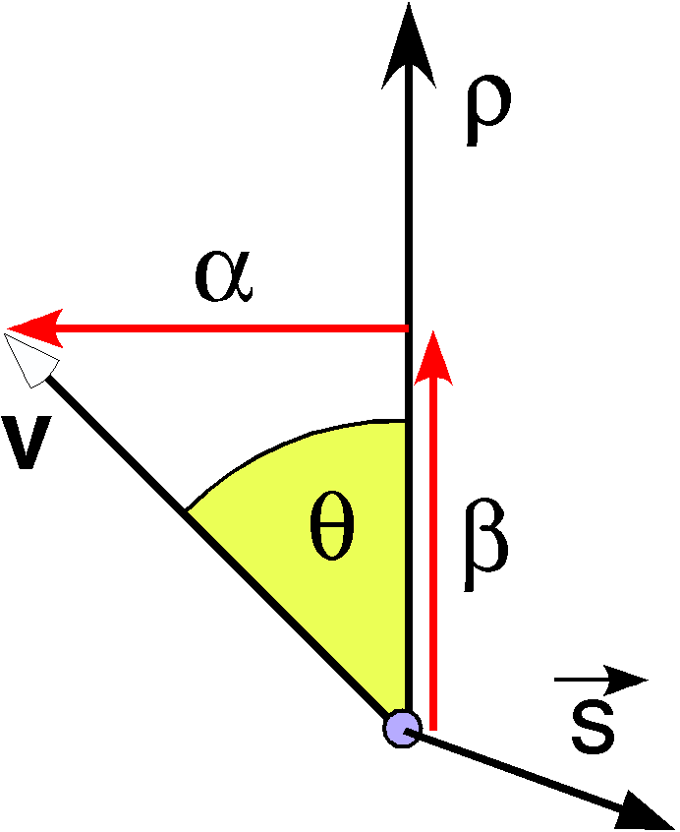

The components of the rotating vector relative to the axis of rotation may be readily computed from the ratio of the two vectors.
The ratio of the rotating vector to the axis of rotation is the quaternion , which has an angle and a tensor of . The vector of () is perpendicular to both v and .
Note that is defined slightly different than it was above. This relationship would not hold with that definition of .

Coil in Terms of Full Angle Expressions of Rotation
The last equation is the basis for the transformation from a half angle expression to a full angle expression. If the original expression was in terms of the half angle expression, then we can now write it in terms of the full angle of rotation.
If the tensor in the half-angle formulation is not equal to 1.0 then the rotating vector will trace a cone with a spiral edge. That is to say, the movement will be a constant coil. In the full angle formulation the rotation does not remain in a single plane. The plane that contains the terminus at the end of the rotation will be a distance from the center of rotation for the conical rotation.

Cast in Terms of Half Angle Expressions of Rotation
The origin of the rotation can be anywhere on the axis of rotation. Let us pick the point from the plane of rotation on the axis of rotation . The initial value of the rotating vector is . We can rescale the component first and then rotate the rescaled vector or rotate the vector and then rescale.

The vector is not changed by the operation, therefore we can readily compute the new value of the rotated vector.
So, it turns out that the location of the center of rotation is irrelevant except as an offset along the axis of rotation.
This can be expressed in the half angle format as follows.
The expression of a screw in half angle format is accomplished by simply adding the translation term to the last equation.

Conclusions
Clearly, and are rather different movements if the tensor is not unity. However, each can be expressed in the other format with comparatively simple adjustments.
The full angle expression is more intuitive, but it is generally easier to use the half angle expression in all situations that do not depend upon the definition of a quaternion as a rotation of one vector into another. On the other hand, there will be problems in which we need to compute the plane of the rotation and the distance from the axis of rotation to the rotating point and we will return to this imagery.

Computing the Equivalent Rotation for a Cast
A cast can always be reduced to a planar rotation by finding a center of rotation that is equidistant from the two locations. Sometimes all one is given is the locations at the beginning of the cast and at the end. This section considers how one finds a center of rotation given a cast. We start with two locations, and , which are the endpoints of a cast. That means that they have a common origin, O. We compute the midpoint between the two locations.
The ratio of the vector to the midpoint to the negative of one of the location vectors gives the angle between them. The angle is the angle of that quaternion.

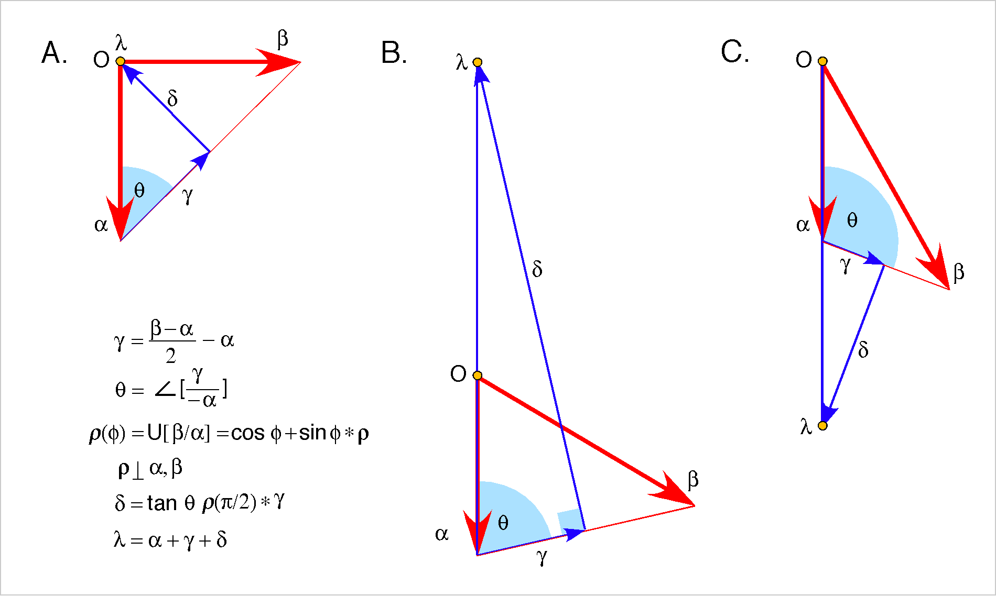
Three examples of casts and the construction of the center of rotation for the unitary rotation that is equivalent to the cast.
The cast is in a plane and we can compute the quaternion of that plane by taking the ratio of the two vectors of the cast or the quaternion of the ratio that was just computed. We will use the unit quaternion for the ratio and let the angle between the vectors, , be a variable.
The reason for computing that quaternion is it allows us to readily compute the vector that splits the angular excursion of the equivalent rotation, a vector that we will call the spine, . The direction of the spine is the quaternion of the plane of the rotation with an angular excursion of 90° times the direction of the vector to the midpoint and the length of the spine is the length of the vector to the midpoint times the tangent of the angle between the vector to the midpoint and the rotating vector. Putting those two facts together, we obtain the vector of the spine.
Now we can sum three vectors to obtain the center of rotation. The starting vector of the cast plus the vector to the midpoint between the two cast vectors plus the spine vector will bring one to the center of rotation for the equivalent unitary rotation or cast. Such a cast may also be called the isosceles cast, because the two rotating vectors are of equal length, the angle between them is , and the two base angles are equal.

With a unitary or isosceles cast, the center of rotation will be the origin of the cast. For non-unitary casts, the center of rotation lies on a line coincident with the starting vector. The location depends complexly upon the details of the cast, but the location may be both in the direction of the starting vector or in the opposite direction. The location is dependent upon the direction of the difference between the two cast vectors relative to the starting vector. If the direction of the difference is perpendicular to the starting vector, then the center of rotation is at plus or minus infinity. If it is tilted so as to form an acute angle with the starting vector, then the center of rotation will lie on the same side of the terminus at the origin of the starting vector and if it is obtuse then the center of rotation lies beyond the terminus of the starting vector. Which direction applies depends on the magnitude of the angular excursion of the cast and the extent to which it is magnifying or minifying. In fact, there are two solutions to the unitary rotation that is equivalent to a cast. They are mirror images across a line coincident with the difference between the two cast vectors.

The Loci of Casts
Given a starting location and a finishing location and an angular excursion that carries the first into the second, one has a wide selection of possible centers of rotation for a cast. In fact, it is not possible to determine a single solution to that situation. Such is apparent if you consider a simple arrangement. Take two stick-pins and stick them into a surface at some distance from each other. Now, take a plastic triangle and lay it on the surface so that two edges are against the shafts of the pins. The angle of the triangle between the pins remains the same, but you can move the triangle while keeping it in contact with both pins so that the apex traces out a curve that starts with it being near one pin, to it being equidistant from both pins, to it being close to the other pin. That is the set of loci that can be centers of rotation for casts that have an angular excursion to equal to the angle of the triangle. If you try different angles on the triangle, you see that the paths traced are different for different angles. Smaller angles trace larger excursions.

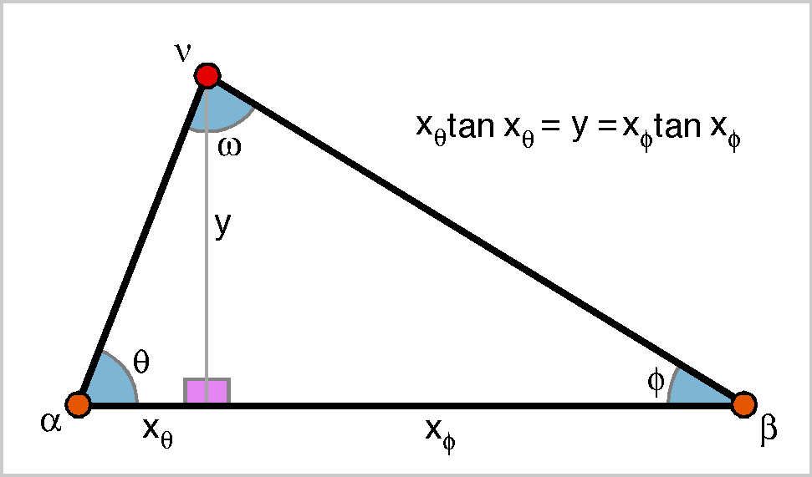

Let us first consider the shapes of the curves that trace the loci of possible casts with a particular angular excursion. Assume a unit distance between the two locations, , to simplify the calculations and since we are currently interested in the shapes of the curves, let the difference (x) be horizontal. The last thing that needs to be specified is the angular excursion of the cast, which will be designated by . We let the magnitudes of the other two angles vary between the maximal and minimal possible values. It is sufficient to set one, for instance , because the sum of all the angles must be 180° or radians ().
The problem is to find the location of the center of rotation for a cast that moves into through an angular excursion of . We begin by noting that a perpendicular to the difference that passes through the center of rotation node, , divides the cast into two right triangles with a common side, y. The difference, x, is divided into two segments, on the side of the angle and on the side of the angle. The length of the perpendicular, y, gives the vertical coordinate and either of the base segments will give a horizontal coordinate.
We build on the fact that the two right triangles have a common side. That means that it is possible to write an equation that involves four of the relevant variables.
Both y and x are scaled by , so for small angular excursions the curves are larger, but the shapes are the same because the ratio of y to x is . As the angular excursion, , increases, the curves are defined for a smaller range of values for . For small values of , the curves is roughly circular, as the following figure (A).
We can now go through and systematically compute the loci of the centers of rotation for a wide range of values of and . The result is illustrated in the following figure (B). The solutions are horizontally and vertically symmetrical because large corresponds to small and vice versa and positive rotation is symmetrical with negative rotation. However, since these curves are horizontally and vertically symmetrical, we can concentrate upon one quadrant when considering details.
A. 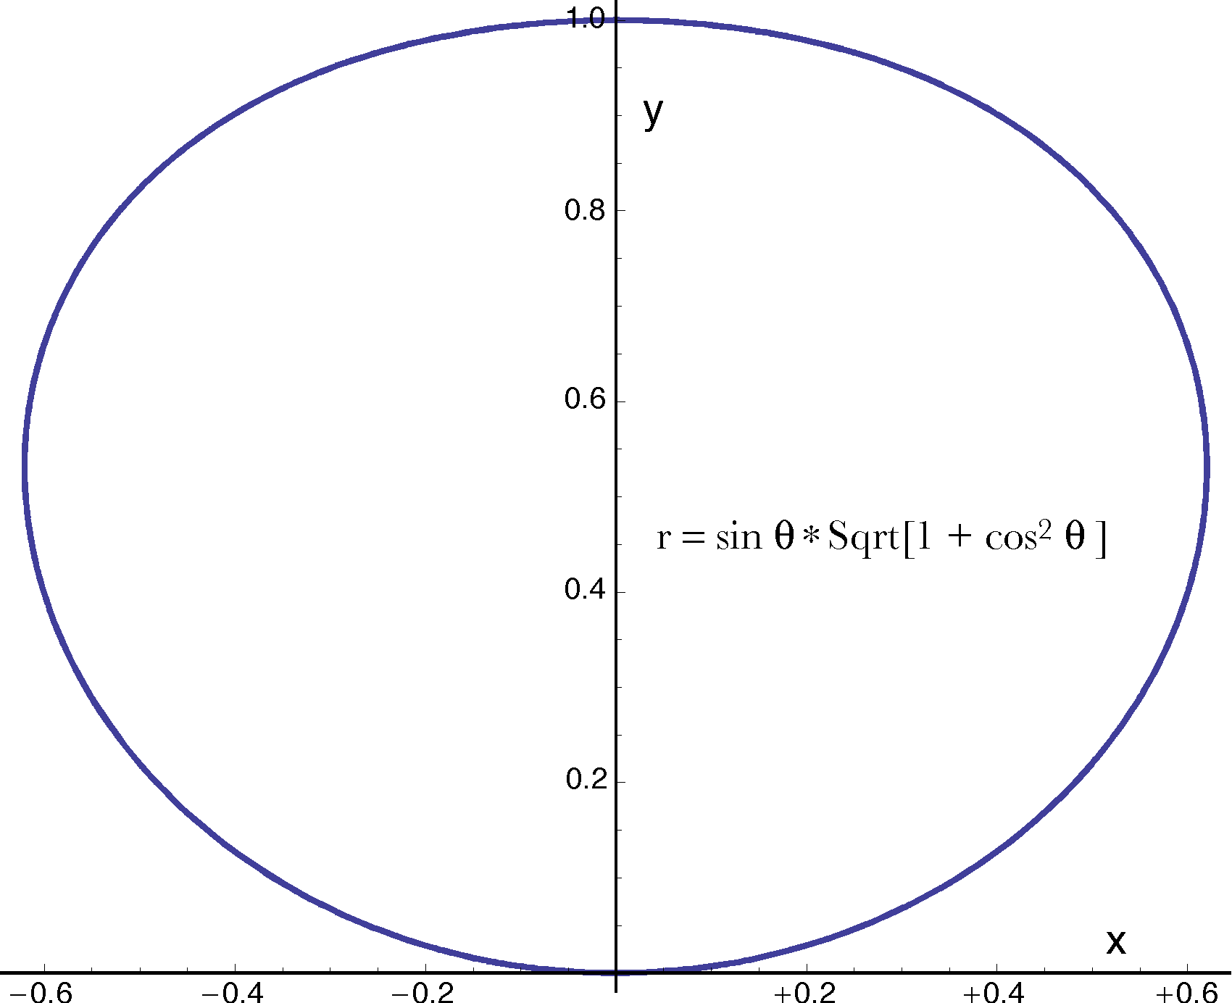 B. 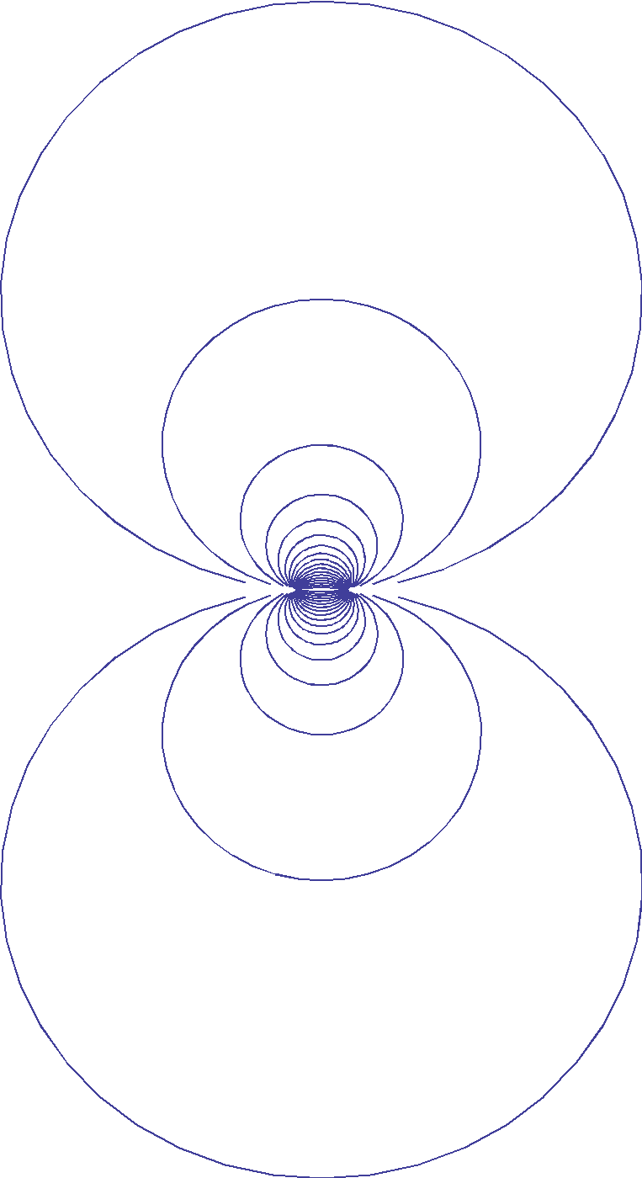

C. 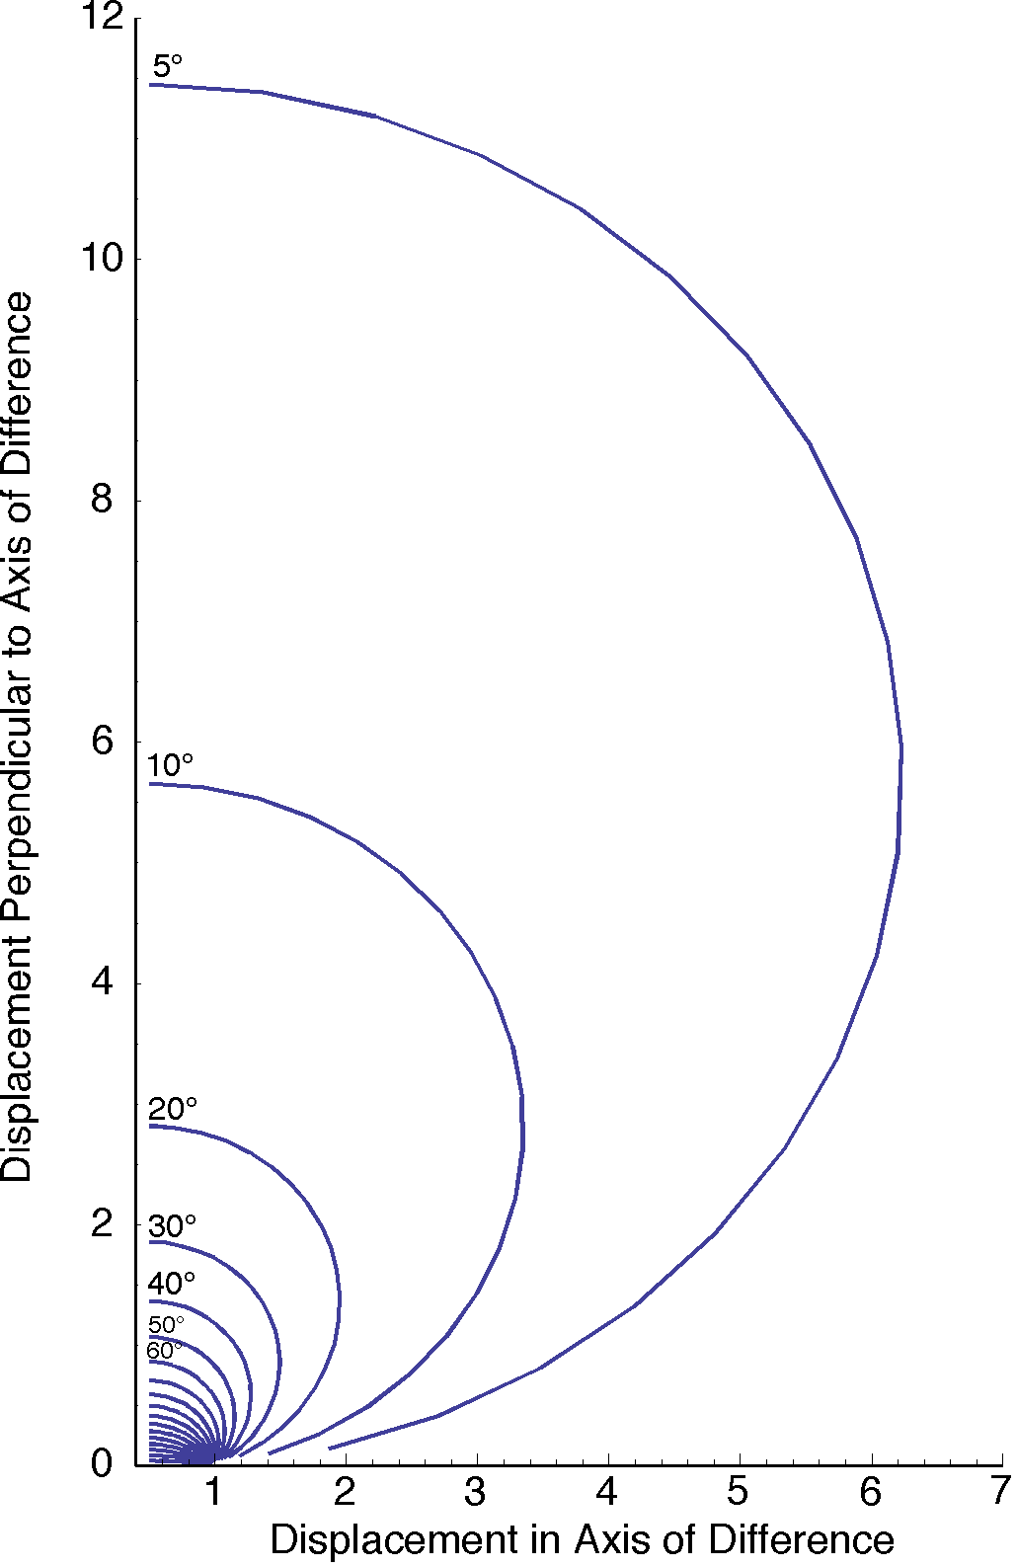 D.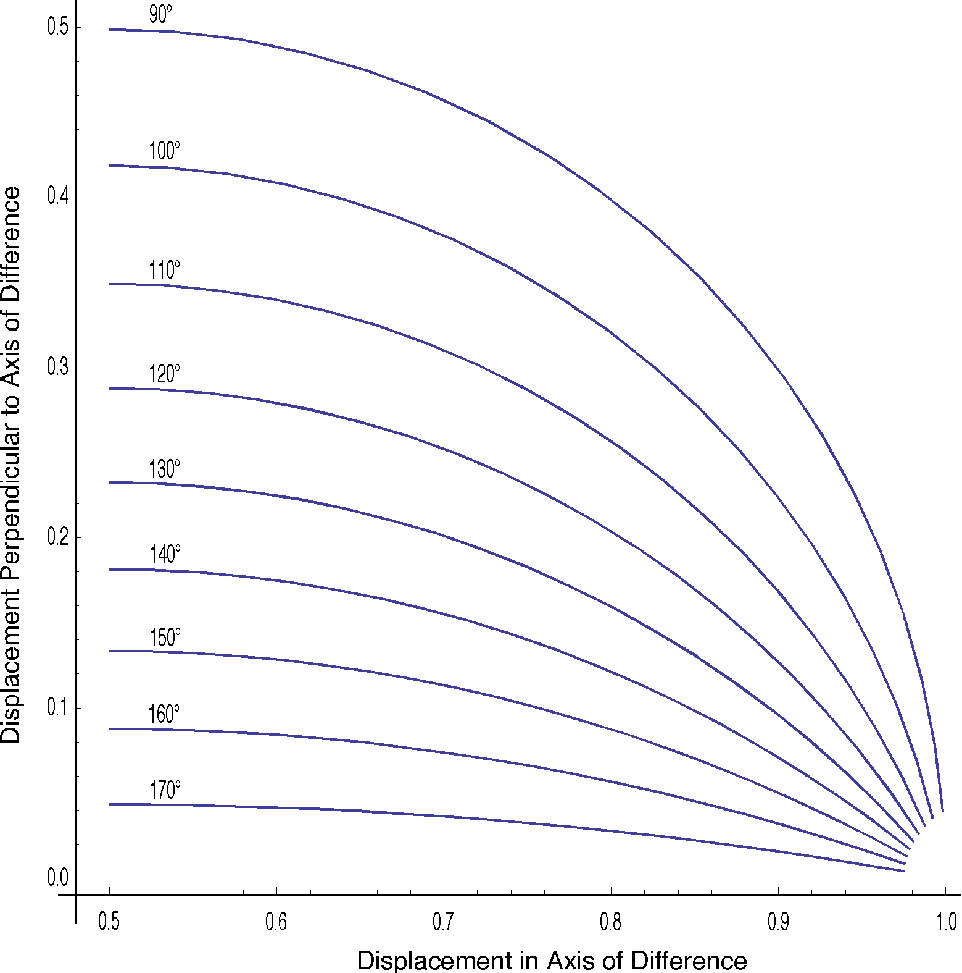

C. For small values of the angular excursion the loci of the centers of rotation are much more widely distributed than for larger angular excursions. The values of the base angle are equal for the most extreme left end of each curve. For this calculation, the difference between the locations of the two arms of the cast is set to 1.0. All measurements are relative to that difference.
D. The movement curves of centers of rotation for casts with excursions greater than or equal to 90°.
In the next figure (A), the curves are plotted for instances where the angular excursion is 5° to 170°. The smaller the angular excursion is, the wider the solution curve. If you think of our physical model, then it is apparent that this should be the case. The curves for are plotted separately (B) to illustrate them more clearly.
The isosceles solutions occur in the midline, when the displacement in the direction of the difference between and is 0.5. That is also when the distance from the difference vector is maximal. That maximal distance for isosceles casts is clearly a function of the angle of the cast. The following figure shows the shape of the curve for the distance from the difference to the center of rotation for isosceles casts.

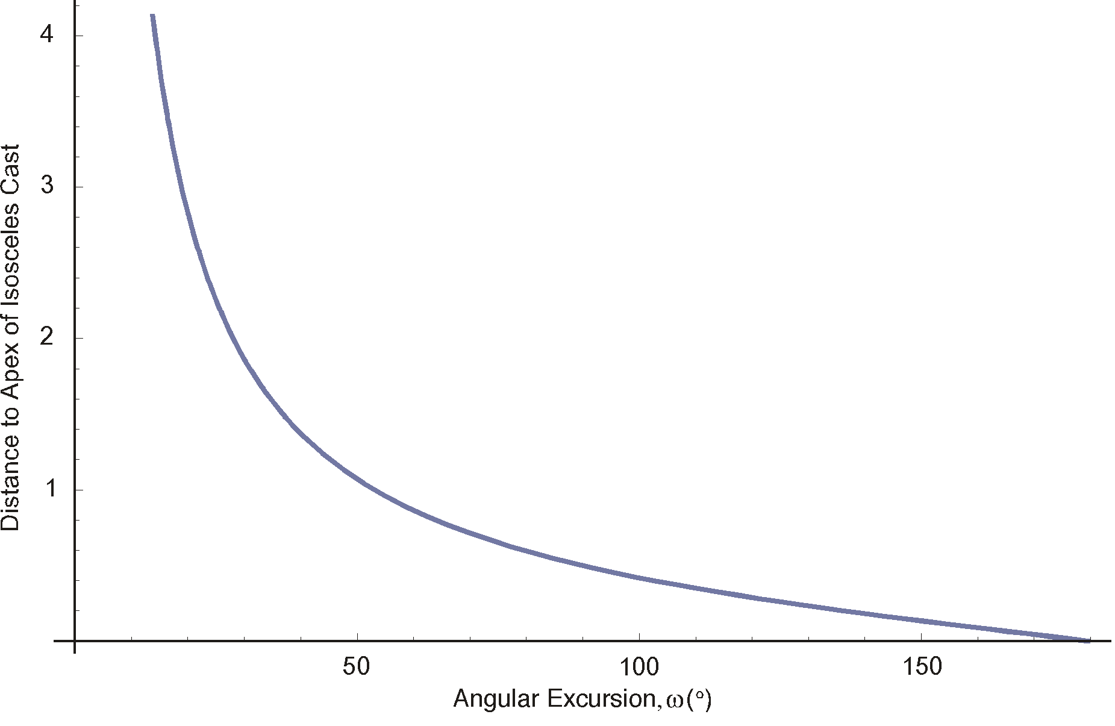
The distance from the difference between the location to the center of rotation for the isosceles cast, as a function of the angular excursion between the locations.
The center of rotation retreats indefinitely as the angular excursion approaches 0°. It lies on the difference when the angular excursion is 180°. For small values of the distance to the apex of the isosceles cast approximately doubles with each halving of .
If we mark the locations of the centers for a series of angles between the starting vector and the difference, the result shows that the points are approximately evenly distributed along the curve, as is shown for the curve in the following figure.
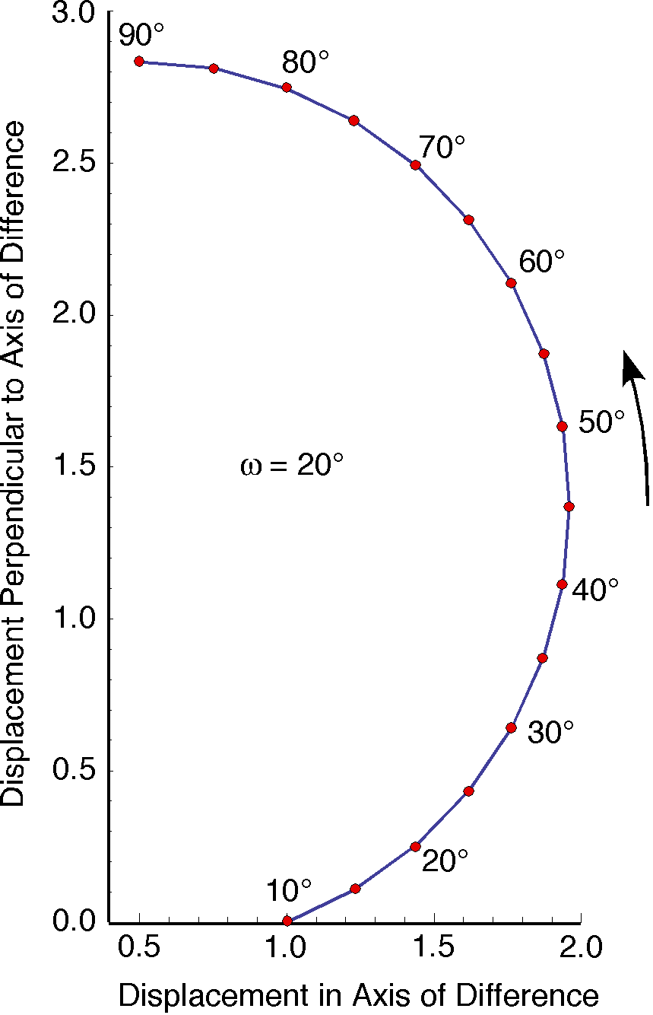
Note that the point for the isosceles cast (90°) is the furthest from the difference vector.

The Cast Center of Rotation Falls on a Line Coincident With the Starting Vector
When computing the equivalent isosceles cast for an arbitrary, but known , cast it was apparent that the centers of rotation were on the same line that was coincident with the starting vector. That raises the possibility that there is a logical necessity of that relationship. In this section, we will address that point in preparation for a construction of the centers of rotation for an unknown cast.

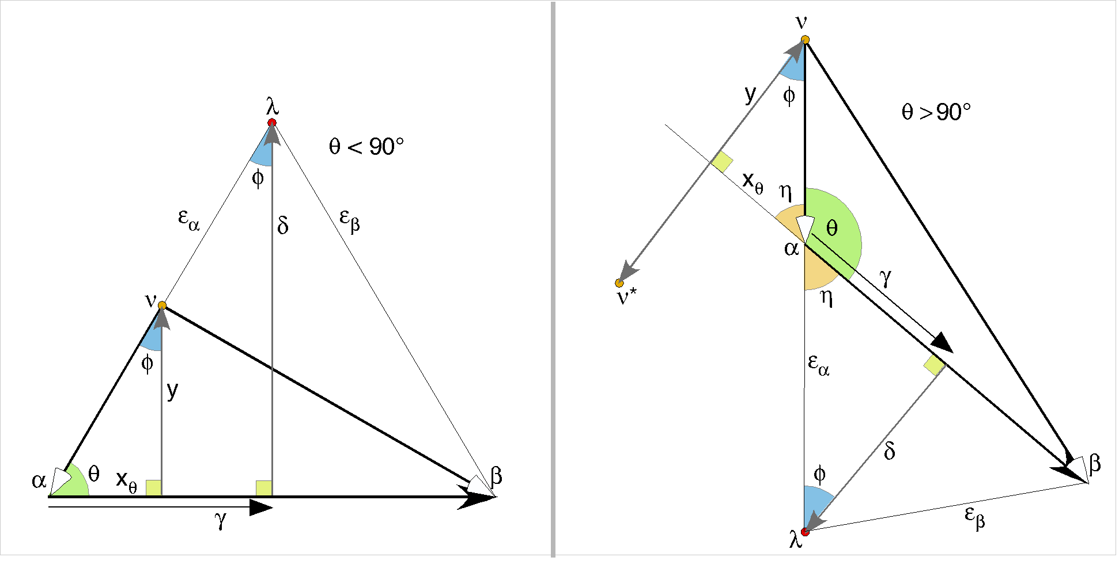

There are two patterns that may occur, depending upon the angle between the difference and the starting vector. If the angle is less than 90°, then the construction is like that shown above on the left, and, if it is more than 90°, then it is like the construction on the right. Similar arguments apply for both, but it is easier to take them as separate problems.
Consider the configuration when the angle is less than 90°. As argued above, the difference between and b is . We construct the perpendicular to the difference, , that gives the isosceles cast assuming an angle between the starting vector and the difference of. That center of rotation lies at . The vector from to will be called . We also found in a previous section that there is a center of rotation for a non-isosceles cast that has a center of rotation that lies at , which was computed by taking the perpendicular to the difference that passes through , y. The triangles formed by each of these calculations are similar in having all three angles equal and there is an alignment of the bases of the two triangles as parts of the difference between the starting and ending vectors. Therefore, the side that is not perpendicular to the difference must have the same slope and the apex that side forms with the difference is the same point in both cases, namely the terminus of . Consequently, the sloped sides of the triangles must be coincident with each other.
The second configuration is analyzed in much the same manner, as is indicated by using much the same labels in both figures. The main difference is that we need to introduce a new angle, the complement of , . The perpendiculars to the difference are constructed in the same manner, but the base angle is in both cases. The triangles are similar and the sloping sides are in opposite directions from the common point at the terminus of the starting vector. It follows that both and are on the same line.
Now we can consider a second way to compute the location of , which assumes that it lies on the line from the isosceles cast center to the terminus of the starting vector, which we will do in the next section. However, let us note again that the symmetries of the geometry mean that there are four solutions to the problem of finding the cast center. The other three may be found by reflecting the computed solution across the difference vector, across the spine of the isosceles cast or across both in succession. The other solutions can be computed directly by similar methods that use the finishing vector as the reference or reflecting the isosceles solution across the difference vector.

Computing the Center of Rotation for a Non-isosceles Cast
Usually when one needs to compute the center of rotation for a cast it is because the movement of an anatomical object has changed both the location and the orientation of the object. The ratio of the orientations tells one the angular excursion of the movement, , and the locations before and after the movement tells one the end points of the movement, . We also know the orientation of the plane that contains the cast. The ratio of the orientations is a quaternion. The angle of that quaternion is and its unit vector is . The orientation of the plane of the cast is . These are the parameters of the solution for the center of the cast.

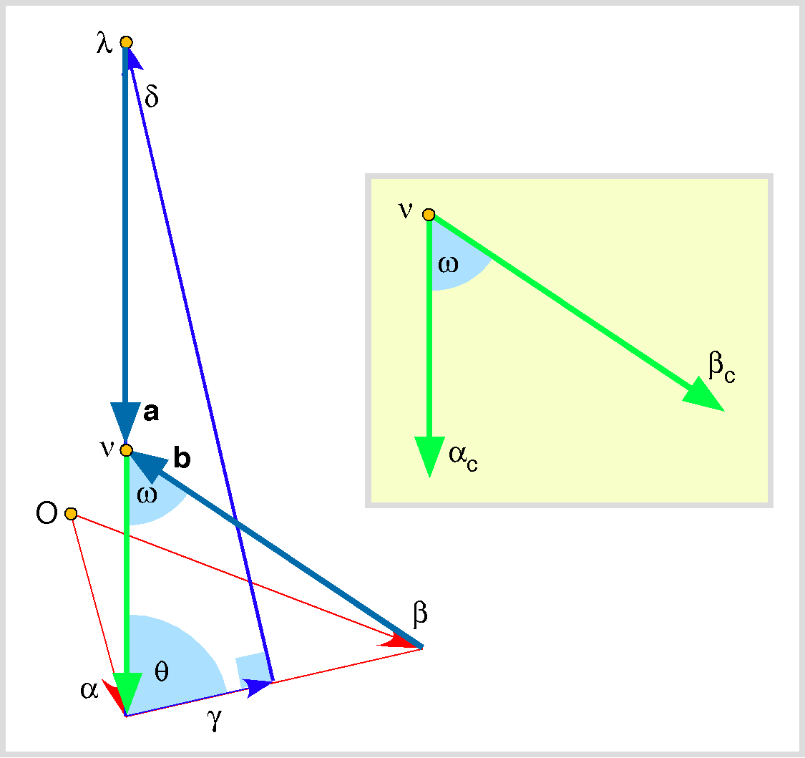

Construction for determining the center of rotation for a cast. The inset shows the cast in isolation.
The first steps of the calculation are similar to those that we used for the center of the unitary cast, with the difference that the origin of the location vectors is not necessarily the center of the cast. We start with the beginning and ending locations and compute the difference between them. Then we take half the difference, . We need to pick the angle between the difference and the starting vector, . We do not know at this point, but we can specify the angle that it must form with respect to the difference. That is the principal variable in computing the cast, the one that we choose.
We have to compute the quaternion of the plane of the cast, which is the unit quaternion of the ratio of the two orientations, , where is a free variable. That quaternion, which will be called the turning quaternion, is useful for rotating vectors in the plane of the cast. The vector of the turning quaternion, , the turning vector, is perpendicular to the plane of the cast.
It may be found that a single plane of the ratio of the orientations cannot contain both the starting and finishing locations. That is there is no rotation about an axis of rotation in the direction of that will carry into . In that case, we need to compute the offset translation of the finishing location relative to that plane which contains the starting location and subtract that offset from the finishing location to obtain a finishing location that does lie in the plane of the rotation. Since translation does not change orientation such an offset is perfectly acceptable, especially since there is not way to obtain the observed movement with a single rotation.
The offset is expeditiously computed by rotating the entire structure so that the plane of the cast in coincident with one of the cardinal planes. Let that reference plane be the i,j-plane. We compute the rotation that rotates the turning vector into a perpendicular to the reference plane, the quaternion . The structure is translated so that the terminus of the starting vector is at the origin of the system and the translated terminus of the finishing vector is rotated by . That yields a new location that may have a component in the k direction. The k component will be the offset from the plane of the cast. That offset, , is rotated back into the original orientation and subtracted from the original value of to yield a new value for the finishing vector, . The calculation is now performed with replacing . The offset will have to be added back when the calculations are completed.
With this information, it is possible to construct the spine and determine the location of the center of rotation for a unitary rotation, just was done above.
We can now compute a unit vector in the direction that connects to , which we will call a. The center of rotation for the cast lies along a line in that direction through . Also, we can compute a unit vector in the direction that connects the location with the center of rotation for the cast, which we will call b.
The center of rotation must also lie on the line in that direction. Consequently, the intersection of the two lines will be the location of the center of rotation for the cast.
We can solve the equation for x and/or y by resolving it into its components in the three cardinal directions.
We can see that this is true because the first line is simply a statement that traversing the three sides of a triangle brings you back to where you started.
We can solve for x and y. Only one is necessary, but both are readily computed.

If the center of rotation is , then the starting vector is and the finishing vector is , the angular excursion is and the tensor is the ratio of the magnitude of the finishing vector to the magnitude of the starting vector.
Consequently, the cast may be written as follows.
And the full movement is that plus the offset translation.
It should be noted that there are two solutions for each value of , which are mirror reflections across a line coincident with the difference between the two locations. Usually one or the other solution makes more anatomical sense than the other.

Computing the Center of Rotation for a Cast
With only one measurement of a rotatory movement, it is not possible to determine a unique value for the center of rotation for a cast. However, given two measurements, one can compute a unique center of rotation. Each measurement gives a curve like one of the ones illustrated above, but two measurements give two curves that will normally be tilted relative to each other and different magnitudes so there will be intersections between the curves and the intersections will be the loci of the center of rotation consistent with the two measurements. To illustrate this we need to dispense with the normalization that we have used here and get into the nitty-gritty of a full fledged calculation in three dimensions. To do that, we need to couch the problem in terms of quaternions, once more.
The center of rotation for an equivalent unitary rotation, the first parameter that we calculated above, is clearly not the only center of rotation for a cast. There are times when it may be sufficient, but most times one wishes to determine a physically appropriate center of rotation for a given cast. In anatomical situations the movements appear to rotate about a particular axis and while that axis may shift during the rotation it usually stays within reasonable bounds. It turns out that we need two samples of the movement to determine an appropriate axis of rotation.
In the last section we found that there is not a single unique solution for any single measurement of the rotation. For any angular excursion, there is an infinite set of centers that will give a cast for that particular angular excursion and pair of end points. However, given two measurements, it is possible to find a unique cast that satisfies both measurements. The solution is bound to be complex because the solution curves change with both angular excursion and the difference between the endpoints. Increasing the angular excursion makes the curves converge towards the difference, but increasing the difference makes them larger. In addition, a rotation will usually cause the difference between the endpoints to rotate in space, which will cause the solution curves to rotate as well. It is because of all of these factors that we would expect the solution curves of successive rotation states to intersect. We will now address the calculation of the solution curves for rotations in three-dimensions.
Usually when one needs to compute the center of rotation for a cast it is because the movement of an anatomical object has changed both its location and its orientation. The ratio of the orientations tells one the angular excursion of the movement, , and the locations before and after the movement tells one the end points of the movement, .
We also know the orientation of the plane that contains the cast. The ratio of the orientations is always a quaternion. The angle of that quaternion is and its unit vector is . The orientation of the plane of the cast is . That is, is normal to the plane that contains the cast. That means that we can use to rotate vectors in the plane of the cast, which is something that we are going to want to do. It also provides a handle for rotating the plane itself, which we will also want to do in the following derivation of the center of rotation for a pair of casts.
The first steps of the calculation are similar to those that we used for the center of the unitary or isosceles cast, with the difference that the origin of the location vectors is not necessarily the center of the cast. We start with the beginning and ending locations, , and compute the difference between them, . It is comparable to x in the last section, but it is a vector.
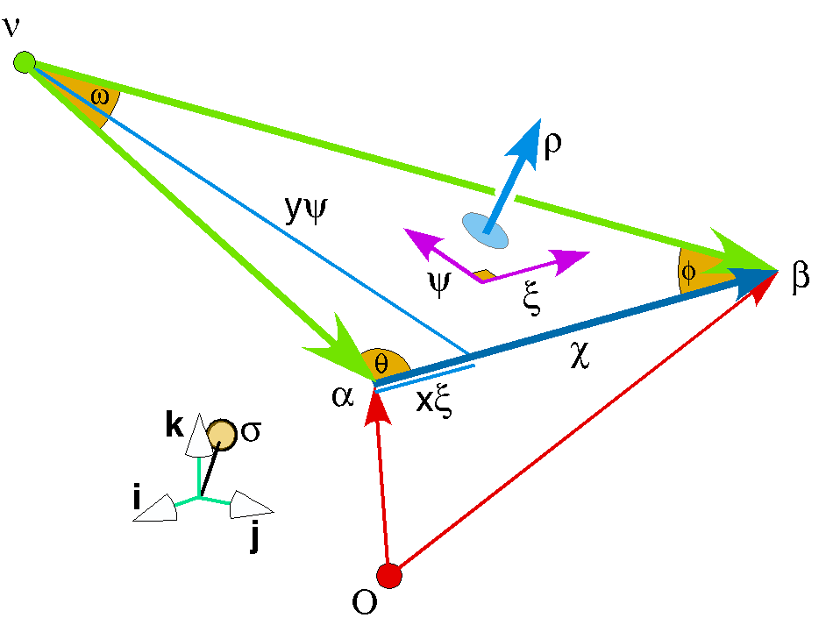

Construction for determining the center of rotation for a cast.
We have to compute the quaternion of the plane of the cast, which is the unit quaternion of the ratio of the two orientations, , where is a free variable. That quaternion, which will be called the turning quaternion, is useful for rotating vectors in the plane of the cast. The vector of the turning quaternion, , the turning vector, is perpendicular to the plane of the cast.
It may be found that a single plane of the ratio of the orientations cannot contain both the starting and finishing locations. That is, there is no rotation about an axis of rotation in the direction of that will carry into . In that case, we need to compute the offset translation of the finishing location relative to the plane that contains the starting location and subtract that offset from the finishing location to obtain a finishing location that does lie in the plane of the rotation. Since translation does not change orientation such an offset is perfectly acceptable, especially since there is no way to obtain the observed movement with just a single rotation.
As in the previous section, the offset is expeditiously computed by rotating the entire structure so that the plane of the cast in coincident with a cardinal plane, for instance the i,j-plane. We compute the rotation that rotates the turning vector into a perpendicular to the reference plane, expressed as the quaternion . The structure is translated so that the terminus of the starting vector is at the origin of the system and then translated terminus of the finishing vector is rotated by . That yields a new final location that may have a component in the k direction. The k component is the offset from the plane of the cast.
That offset, , is rotated back into the original orientation and subtracted from the original value of to yield a new value for the finishing vector, . The calculation is now performed with replacing . The offset will have to be added back when the calculations are completed.
We can perform all of the calculations of the center of the cast in the reference plane and then rotate the solution back into the original coordinates, but we will do the calculations in the original coordinates. The calculation is somewhat more complex, but more general.
The next task is to compute the center of rotations for the cast , which takes into through an angular excursion of in a plane with the normal vector . With this information, it is possible to construct the perpendicular to the difference in the plane by rotating the unit vector of , , through 90° about the vector . The resultant will be called.
Now, we can compute the intersection between and and the length of the vertical perpendicular, as we did in the last section.
The curve of solutions is given by adding the vector function to the starting location vector, .
If we carry out these calculations for two samples of the movement, then the curves of the two solutions can be equated to determine the loci that give solutions for both samples. The solution comes down to finding the values of or that give equality.
If the center of rotation is , then the starting vector is and the finishing vector is , the angular excursion is and the tensor is the ratio of the magnitude of the finishing vector to the magnitude of the starting vector.
Consequently, the cast may be written as follows.
The full movement is that plus the offset translation.
It should be noted that there are two solutions for each value of , which are mirror reflections across a line coincident with the difference between the two locations. Usually one or the other solution makes more anatomical sense than the other.

The Completeness of Cast Plus Translation Descriptions
All movements of an orientable object can be described as a change in location and a change in orientation. Since the analysis just considered is based on those two parameters, it can account for all rotations of an orientable object. For any single movement, there is not a unique solution, but a set of solutions contingent upon the angle of the ratio of to , or, more precisely, the value of . The solution may also include a translation, since the final location may not be in the plane of the cast for the starting position. However one can compute the offset that places a final location in the plane of the cast and therefore reduce the problem to finding the cast that carries the starting location into the final location minus the translation. There is always a cast since we guaranteed that both locations are in the plane of rotation dictated by the change in orientation. Consequently, all rotations of orientable objects can be described as a cast plus a translation. If we have two samples of the movement, then we can compute a unique center of rotation that satisfies both movements.
A cast may not be the most natural description in the sense that an anatomical object may be more naturally considered a coil or a screw or some other compound movement, based on the anatomy. If we have a reason to chose a particular center or rotation, then the solution is unique because we have a predetermined relationship between and .

References
Beer, F. P. and E. Johnston Jr, Russell (1990). Vector Mechanics for Engineers. Statics, Dynamics. New York, McGraw-Hill Book Company.
Weisstein, E. W. (2003). Concise Encyclopedia of Mathematics. Boca Raton, Fl., CRC Press.

