Parsing Movement Descriptions: Equivalent Movements

When dealing with simple unitary movements, that is, movement about a fixed center of rotation where the moving arm does not change length, it is generally straightforward to deduce a reasonable description of the movement from a series of measurements of its trajectory. In light of that, one might ask why it is necessary to develop methods to generate equivalent movement descriptions for movements. However, if we consider movements that involve several joints, then it becomes obvious that one needs simpler descriptions than the full set of generative equations for the movement.
Elsewhere, we examine movements of the cervical spine, where there may be seven joints working together to produce a movement of the head. The movements of the head are not simple swings or spins, but we find that they can be expressed fairly faithfully as paired rotations and translations. The difference is that the effective joints, that is, the centers of rotation, are usually not within the anatomical joints and they may not even be within the anatomical limits of the cervical spine. These compound movements often appear to occur about centers of rotation at some distance from the nearest anatomical joints. Even though we know that the equivalent movement description is not a true indication of the details of a movement, it is still useful, because it describes the movement that is occurring in a simple manner that is still a good indication of what is occurring at a particular cervical level.
In this chapter we will concentrate upon the theoretical aspects of computing equivalent movement descriptions, that is, finding a center of rotation for a segment of a complex movement. Our argument follows on the analysis of movement in the last chapter, where it was shown that any rotatory movement could be expressed as a combination of a cast and a translation, because any ratio of orientations can be expressed as a conical rotation about an axis of rotation and conical rotations can always be expressed as a cast. When the change in location dictated by this cast does not match the change in orientation, introduce a translation to bring the final location into alignment with the measured value, because translations change location without changing orientation.

The Description of Compound Movements
Let us start with a general movement. The object that we are monitoring starts with a particular location, , and orientation, , its initial placement, . These are presumably functions of time. Given at time t, the orientation will change in the next small interval of time according to a rotation quaternion, . At time t, the rotation is about the axis of rotation through an angular excursion of , where is an angular velocity. The new orientation is simply a conical rotation of the frame of reference.
The change in location is more complex in that there needs to be a center of rotation, , and then the rotation is applied to the vector from the center of rotation to the current location, .
Note that may be a constant, such as occurs in a single bony linkage, but the center of rotation may be changing with time as it is carried by other linkages, such as other joints. In this manner, a series of joints may be concatenated to give a compound movement that is unlike the movements in any of its constituent joints. There may also be a translation, , which does not change the orientation but does change the location. Pulling all these sources of location and change of location together, we obtain an expression in the form of the following equation.
When working with a set of concatenated joints, one introduces extension vectors, written in terms of the frame of reference vectors, to compute the new location of a center of rotation for a joint associated with that section of the assemblage of bones and joints. The joints may be expressed as the locations of the objects and the next joint and its orientation can be written as extension vectors that are functions of the new orientation of the moving object. We described a simple system of this nature in the chapter on swing and spin. It took a fair bit of concentration to follow the implications of the movements in that system with two simple joints; assemblages become much more difficult to understand with each additional joint.

A Simple Armature
Consider a simple armature with two links and two joints. The first joint is at the proximal end of the first link (at on link 1). The second joint is between the links ( at ). We are interested in the movements of the distal end of the second link ( at ). P has a location, , and an orientation, . The orientation of the first link is .

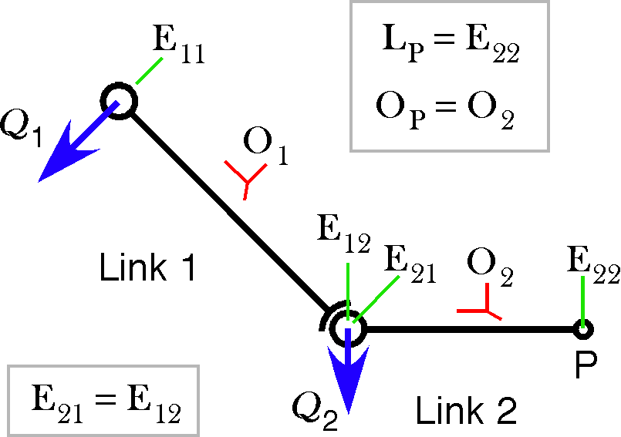
A simple armature with two links
The orientation is the orientation of the second link as modified by the movements of the two joints. Quaternions written in lower case are the corresponding uppercase quaternion with half the angle, as is the usual convention.
The location of the distal end of the first link is the location of the proximal end plus the rotated extension between the ends of the link.
The movement of the distal end of the second link because of the movement in the first joint is similarly expressed.
However, there is also movement in the second joint that moves the distal end relative to the proximal end. We can write that expression in the same format.
If we condense the last three equations into a single equation, then the description is definitely becoming complex. While each of the component equations is fairly easy to understand, the combination is far from obvious. Given a few more links, the descriptions become impenetrable to someone who does not know the components of the movement. Clearly, if we start writing the descriptions for an assemblage of several joined bones, the arithmetic soon becomes overwhelming and the results far from obvious. It becomes essential to find a simpler alternative description of the movements. That is when one considers cutting out the detail of the internal calculations and expressing the final movement in terms of an equivalent description. The detailed description computes the actual movements and we try to reduce those movements to a simpler, formally equivalent, description. How one might accomplish that simplification will be considered now.

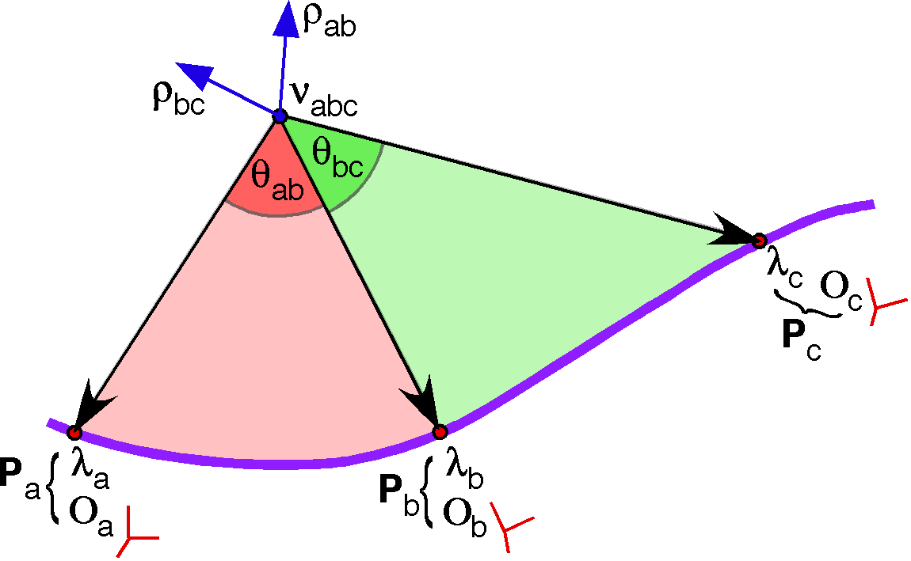

Computing the Cast Center of Rotation, Given the Movement
Suppose that we have computed a segment of movement for an anatomical object. We know its orientation and location at a series of points along its trajectory. Now, we want to find an equivalent compound movement that will give the observed values within an arbitrarily small error. Suppose that we have three samples placements along a segment of movement, . We can determine the angular excursions and axes of rotation for the rotations between the sample points by calculating the ratios of the orientations at those times. The angular excursion from to is and the axis of rotation is . Similarly for the interval between and , and .
It may often happen that a plane of rotation derived from a ratio of orientations is oriented so that there is no way for the initial and terminal sample points of the movement can both lie in the plane. In that case, there must be a concurrent translation. We will address the translation first, because it must be removed to make it possible to find the center of rotation for the rotation, which will be called the node and symbolized by for the remainder of this chapter.

Computing the Translation
For the movement segment , we compute the plane of rotation from the ratio of the orientations.
The unit vector of the quaternion, , is in the same direction or the direction opposite the translation, because the translation is perpendicular to the plane of the rotation.

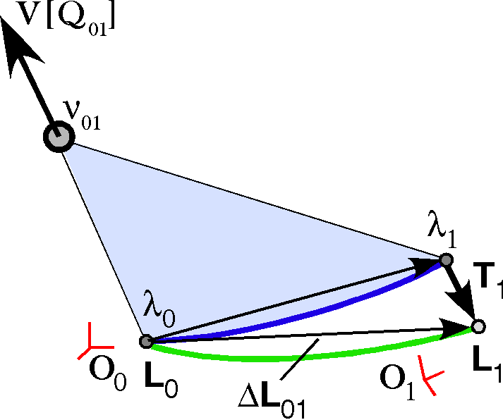
We know the beginning and ending locations, and , respectively. We know that is perpendicular to the line from to . We know that . Therefore, the translation is one side of a right triangle with a hypotenuse equal to . The angle between and the translation vector is the angle of their ratio.
The magnitude of can be computed directly.
Consequently, the translation is simply expressed.
Now, we know the end points of the arc of the rotation in the plane of the quaternion for the ratio of the orientations, . It is possible to compute the node of the rotation, because we know the angular excursion, which is the angle of the quaternion , . In fact, the solution is a double arc, symmetrical about the line segment between and . These arcs were computed in the last chapter. For small angular excursions, they are nearly circular.
The problem is now selecting a particular point on the arc. We can address this selection in a number of ways, depending on the relationship between the movement segment rotations. If the two movement segments have the same vector of rotation, that is, they lie in the same plane of rotation, then we can plot both arcs, suitably displaced relative to each other at the locations of the sample points and their intersection will be a node that gives the appropriate angular excursion for each movement. This solution is considered in detail in the next section.

Nodes for Movement Segments That Are Coplanar
Since all simple casts, coils and screws can be expressed as a cast plus a translation, many movement segments will be coplanar. That means that the two segments have the vector of their quaternion in the same direction. If , then we can use the derivations of the curves for nodes, from the last chapter, to find the common node for the two excursions. As argued there, for small offsets between the movement segments, the curves must intersect because they are spatially offset relative to each other. As the angular excursions become smaller, the nodal curves become more circular and the offsets become smaller. The segments are more apt to be similar in direction and curvature, so the intersections are more apt to be on a line orthogonal to the movement arc. Let us now consider the details of computing the common node of two movement segments.
We start with the triangle that has the node, , the initial locus of the movement, , and the final locus of the movement, , as its apices. The angle at the node will be called and the two base angles will be and . We note that this movement triangle can be divided into two right triangles with the right angles on the baseline between the initial and final loci. The base line is divided into a segment, , which is a side of the triangle with as one of its angles, and a segment, , which is the side of the triangle with as one of its angles. The perpendicular to the base through the node is called y.
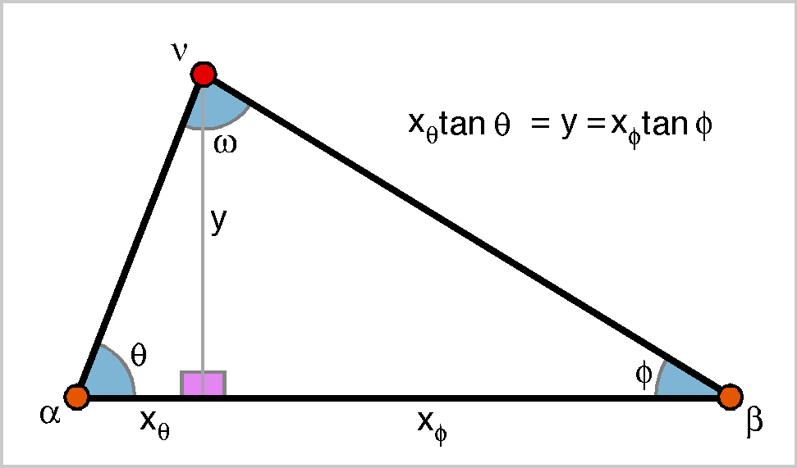
From the ratio of the initial and final orientations, we know the value of , because it is the angle of the ratio of the orientations. And, we know the initial and final loci of the movement segment, and . All of the other variables are subject to variation so there is not a unique solution for the node. Instead, there is a continuous curve that contains all the possible values of , given .
We described these curves in the previous chapter. We are able to compute a unique solution if we seek a common node that satisfies the constraints of two movement segments. Two possible arrangements are illustrated in the following figure.
We will deal with the disjoint movement segments, because the conjoint case may be obtained by setting . Because we were interested only in the shapes of the arcs in the last chapter, we assumed a constant length movement segment and computed the nodes for a variety of values of . Now, we need to consider expressions for the node when the location and orientation of the movement segment is pertinent. Consequently, we need to multiply the arcs by appropriate scaling and rotation factors.

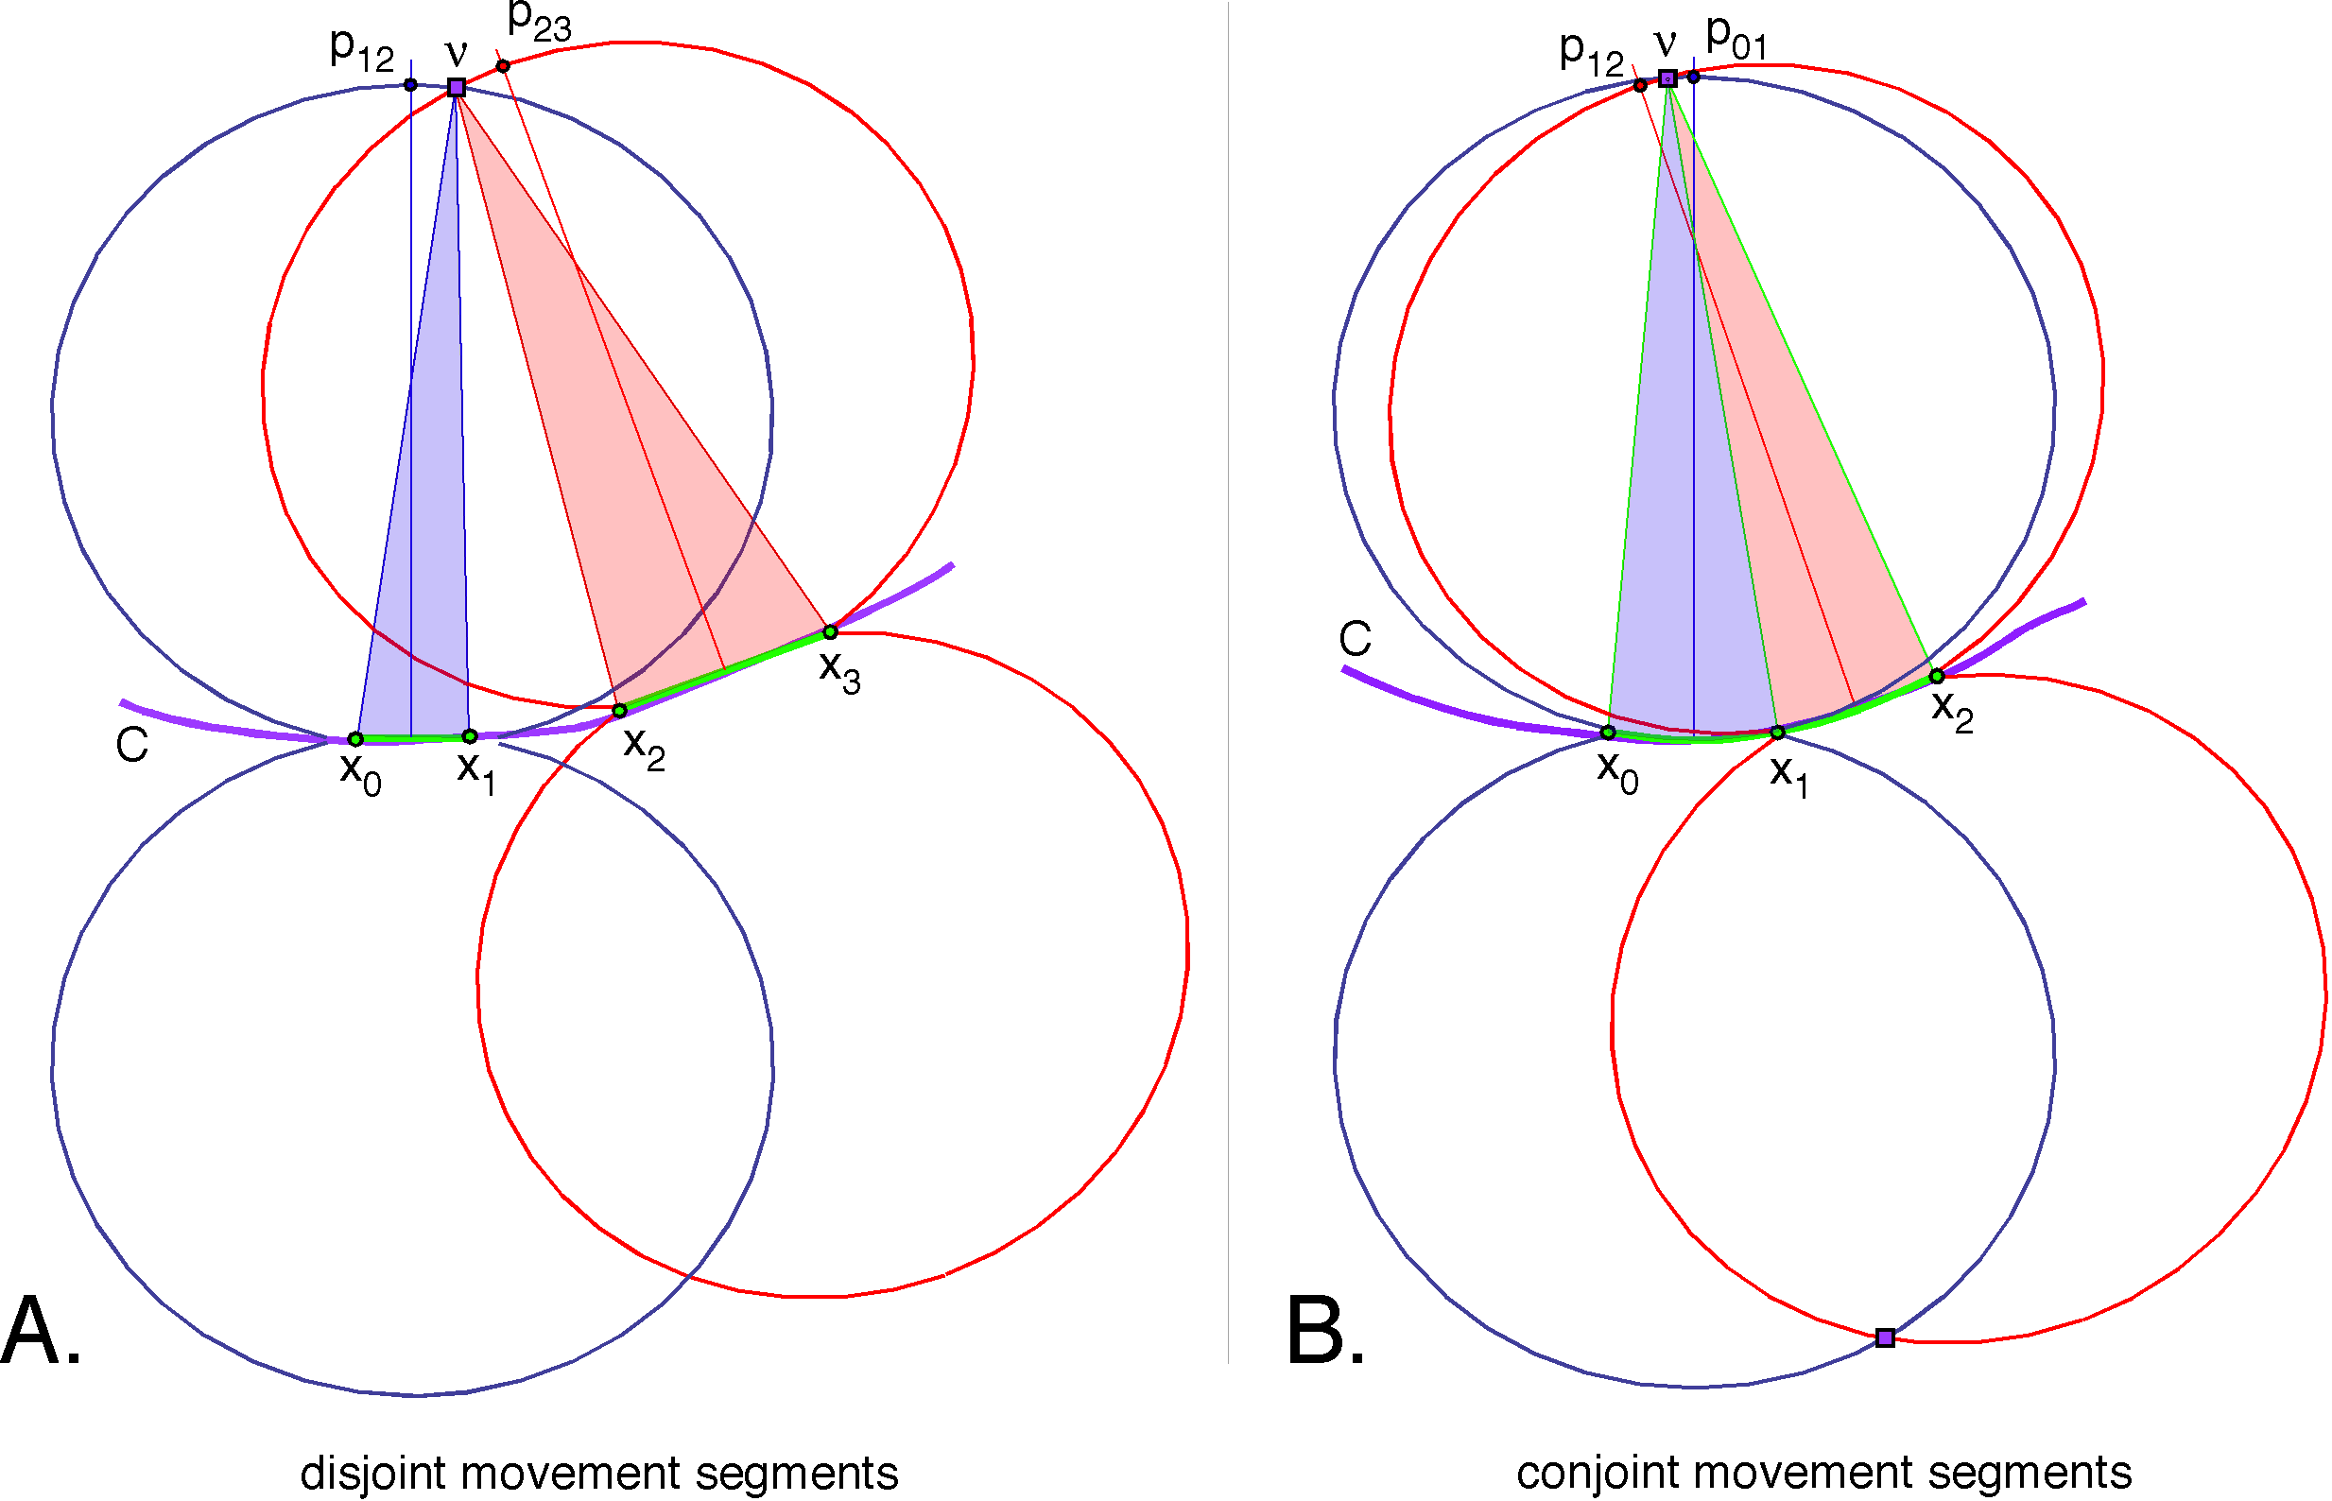
To simplify the language a little, let us call a curve of possible nodal loci a nodal loop. Such a loop is associated with a movement segment with terminal loci and that lies in a plane that has the normal vector . The line segment between the endpoints is the difference between them, , and the direction of that line is
The perpendicular to the movement segment is the direction rotated through a right angle about the normal to the plane. Let be the quaternion that turns into .

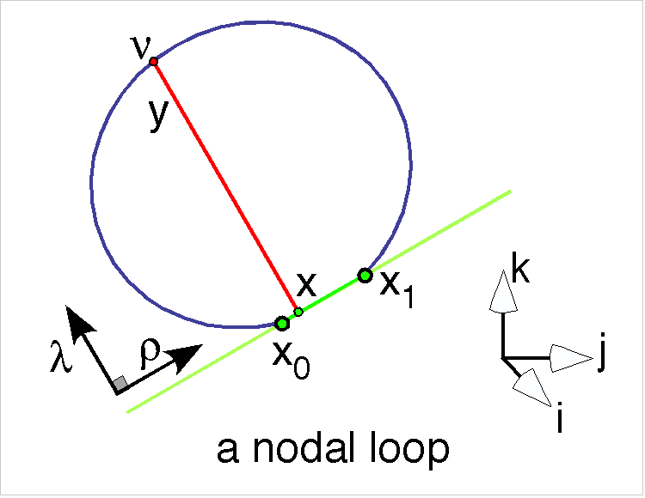
The location of the node is the sum of a position, , along a line coincident with the movement segment and a corresponding displacement, , perpendicular to that line in the plane of the movement. It also depends on the length of the segment and the location of the movement segment in space, which we take to be its initial locus, . The coordinates for the node when the movement segment is of unit length, , are functions of and .
If we take account of the orientation and the length of the movement segment, then the components can be written as follows.
If we return to the disjoint movement segments that are illustrated above, then we can write two expressions for the common node.
This equation looks complex, but it reduces to an expression in terms of the sine and cosine of theta. That equation can be rendered into three equations, one for the i components, one of the j components, and one for the k components. There are two unknowns and three equations, so it is largely a matter of algebra to solve for and , and from there to a value for . That value can be substituted in the equation for to find its location.

The Isosceles Solution
A second solution to finding the node of a movement is to assume an isosceles rotation and take the node that is on a line perpendicular to the difference between the loci, though the midpoint of that line. That solution has been developed elsewhere without having to calculate the arcs of the nodes. The solution does not require that the two arcs are in the same plane and it can be computed for a single movement segment, which makes it versatile. However, the isosceles solution may not be realistic in some situations. The isosceles solution will give a traveling center of rotation if the movement is not a unitary cast.
The isosceles solutions are illustrated by the lines to and , in the last figure. Generally the isosceles solutions will bracket the non-isosceles solution for coplanar movement segments.
In practice, in biological systems, the movement of the node may be comparatively small, especially if one breaks the movement into short segments. Consequently, the isosceles solution is often a useful and simple solution. However, the trajectory of the isosceles nodes may vary with the length of the movement segments. This phenomenon is explored in some detail in another chapter, which deals with the movements of the lower cervical spine.

Nodes for Movement Segments That Are Not Coplanar
Often, perhaps most of the time in real anatomical systems, two movement segments do not have a common axis of rotation and therefore do not lie in the same plane. We will now consider the situation where the axes of rotation are different for two segments of movement. In particular, we will consider two contiguous segments of movement although it is not necessary to the argument that they be contiguous.
We will also assume that the movement segment is convex in the sense that a line connecting to lies entirely to one side of the movement segment in the plane of rotation , and that the movement segment intersects its plane only at the ends of the movement, unless it is entirely in the plane of the rotation. We will also assume that this is true of any components of the movement segment. It may be noted that we are agnostic for any unmeasured placements, so the movement segment could be very erratic between measured placements. However, if we choose our measurements reasonably close together and the movement system is well behaved, then these exceptional cases are apt to be unusual and unlikely to occur.
The plane of the rotation is the vector of the quaternion , . We will now use a result that has not been derived here, but which is derived elsewhere [Quaternion Numbers]. The ratio of two planes is their intersection. We will actually turn this observation around and use the observation that the intersection of two planes is their ratio. So the line that lies in both planes is their intersection.
If the node for the rotations and must lie in the rotation planes for both and , then the node must lie on the intersection of those two planes, . So far we do not know where on the node is located. That is the central problem that must be solved. So, we need to gather the facts that we have and try to compute the value of the nodes, and .
At this point, a sketch of the situation is useful. We can draw the segment of movement, the sample points and the intersection of the planes of rotation. We also know the angular excursions for the two contiguous sections of the movement segment. The rest must be constructed.

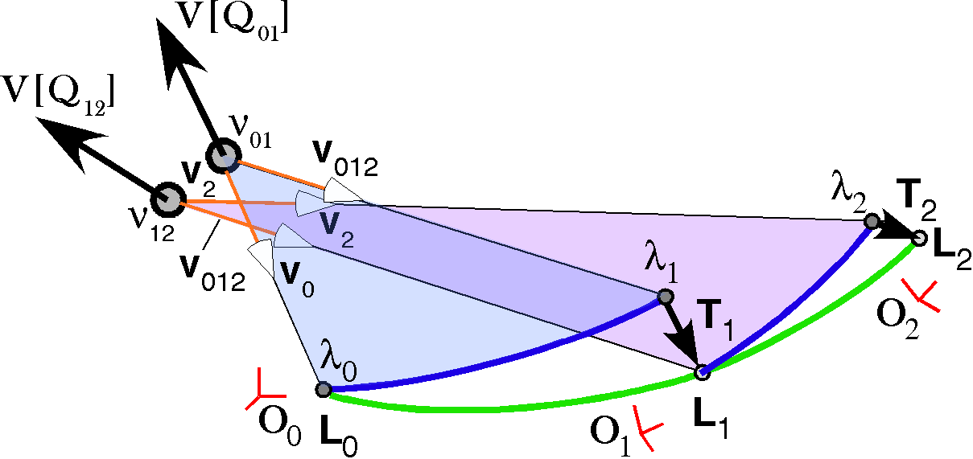
A general cast
To start with, we assume that we have two movement segments that have rotations in different planes. While it is not strictly necessary, we will assume that the segments are contiguous. So, the movement is from an initial placement of to a placement of and then to a placement of . For both movement segments, we compute the rotation quaternion for the change in orientation.
We are interested in the direction of the plane of rotation and the angular excursion .
The computed quaternions will be unit quaternions because orientations are constructed of unit vectors.
At this point it is necessary to compute the translation component and the terminal loci of the movement segments. The means for doing so were described above. We know the three placements , the initial and final loci of the two movement segments , the direction of the rotation planes , and the angular excursions for each rotation . What we need to know is the locations of the nodes for each rotation . The criterion that will shape our solution is that if the first translation is zero, then the nodes will occupy both planes of rotation. If the curvature of the movement segment is the same, the nodes will be coincident within that line.

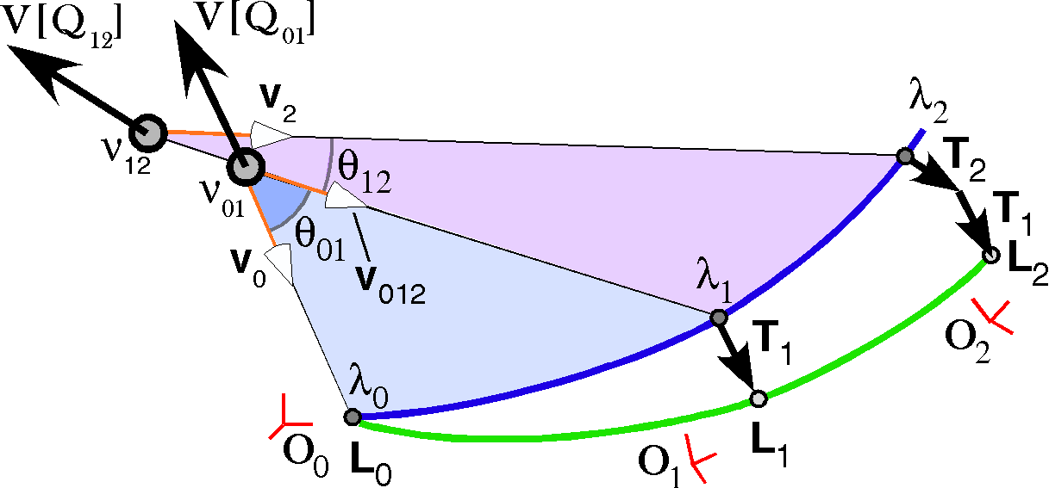
We have two planes, expressed by their normal vectors, and . The intersection of the two planes is given by their ratio.
If we rotate the intersection vector about the axis of the first quaternion, , through an angular excursion of , then we will have a unit vector that points from the node to the starting location.
We do not know the location of the node, as yet. That is the goal of this exercise. But, we do know that if we continue in the direction of from the node , then we will reach the initial location, .

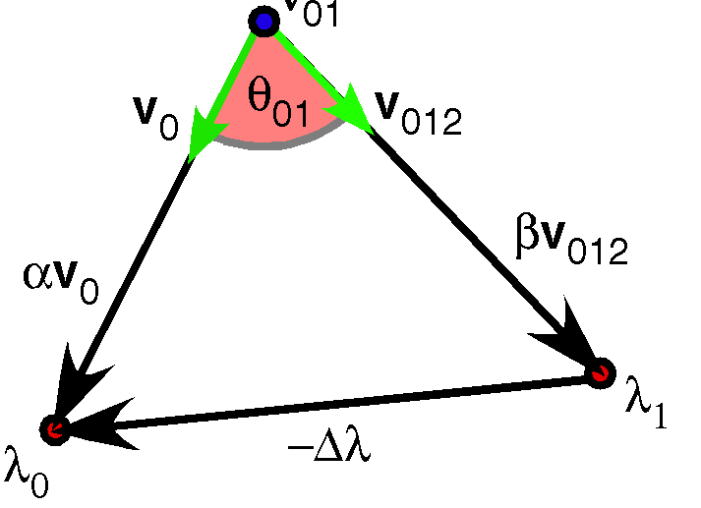
We also know that if we move in the direction of , we will intersect the other end of the movement segment, .
If we knew the value of and , then we could compute . With some simple algebraic juggling of the last two equations we can eliminate and have an equation in and .
If you sketch this expression it is apparent that it is simply a statement that if you pass successively around the three sides of triangle, you return to the starting place.
One’s first impression tends to be that though this is clearly a true statement, it is a single equation with two unknowns, therefore not adequate for finding those unknowns. However, it is actually three equations with two unknowns. If it is written in coordinate format, then there are three equations, one for each basis vector. All the displacements in each direction must total to zero. The solution falls out of some lengthy, but straightforward, algebra.
Once we know and , we know the location of the node, . Once we know , we know the cast that rotates into and the translation that brings the endpoint to . Consequently, the movement segment has been expressed as the sum of a cast and a translation.
Now consider the second movement segment. The analysis is basically the same, but with a few new features.
We know the starting and finishing locations, and . We know the plane of the rotation dictated by the ratio of the orientations.
We know the direction of the node from , because it is the same as for the first movement segment, . We obtain the unit vector that points in the direction of the final orientation, , by rotating the unit vector or the intersection in the positive direction about the normal to the plane of rotation for the second movement segment, , through the angular excursion .
Once again, we can solve for and by expressing the last equation in coordinate format and solving the three simultaneous equations.
Note that, in general, the two nodes are not coincident. They do both lie on a line in the direction of the intersection of the two planes. If there is no translation component, then they lie on the same line.

In the Limit
As we let the movement segments become smaller and smaller parts of the movement, they will approach the infinitesimal. It is of interest to consider what happens to the nodes of successive movement segments as the movement segments approach that limit.
If the movement occurs in a plane, then the common nodes for pairs of segments approach a smooth trajectory, perhaps a fixed point, in the plane of the movement. Assuming that the nodes do shift along such a trajectory, we expect that the trajectory of the nodes would be smooth as long as the movement is smooth.
The isosceles solution is essentially the radius of curvature for the movement segment. Consequently, the nodes will move along a trajectory as the curve flexes and extends. A flatter segment will have a greater radius of curvature and a more curved segment will have a shorter radius. The curve traced by these centers of rotation is called the evolute if the trajectory lies in a plane. The result for movements in three dimensions is much like the evolutus considered in another chapter [On Evolutes and Frames of Curves]. Physically, the nodes are much like the center for a weight whirling on the end of a string and the node is the momentary location of the fixation point of the string. As stated above, the isosceles solution is not in the plane of the curve unless the curve is confined to a plane. That is one of its advantages, in that it works equally well for all movements.
If the movement is not confined to a plane, then the intersections between successive movement planes rotates with the change in locus, so that it sweeps out a curvilinear surface. As the movement segments become shorter, the successive nodes move closer together, because the curvature of adjacent segments is nearly the same. In the limit, the nodes converge on a common node that shifts as the intersection moves. Once again, the node of the movements follows a smooth trajectory, but in three dimensions.
In general, the last two solutions do not yield the same trajectory. If the movement is a non-unitary cast, then the rays to the isosceles nodes will be perpendicular to the curve of the movement segment and the rays to the non-coplanar solution will be at obtuse angles to the curve.

Computation Examples

Confluent Movement Surfaces
Next, consider a computational example of a movement that is not a cast, although each segment may be expressed as a cast without translation. It is a conical rotation in which the rotation quaternion is a function of the angular excursion. It is also an example of what will be called a confluent movement surface. That term will be taken to mean that the rays from the center of rotation node to the loci sweeps out a smooth surface and the orientation changes in the same manner as location.
The movement starts at 0 and progresses to 18, where each segment is a 10° excursion. During the course of the movement the length of the armature increases from 1.0 to 1.5 units length and the armature sweeps down and out and then back up and in, so that it ends pointing in the opposite direction.

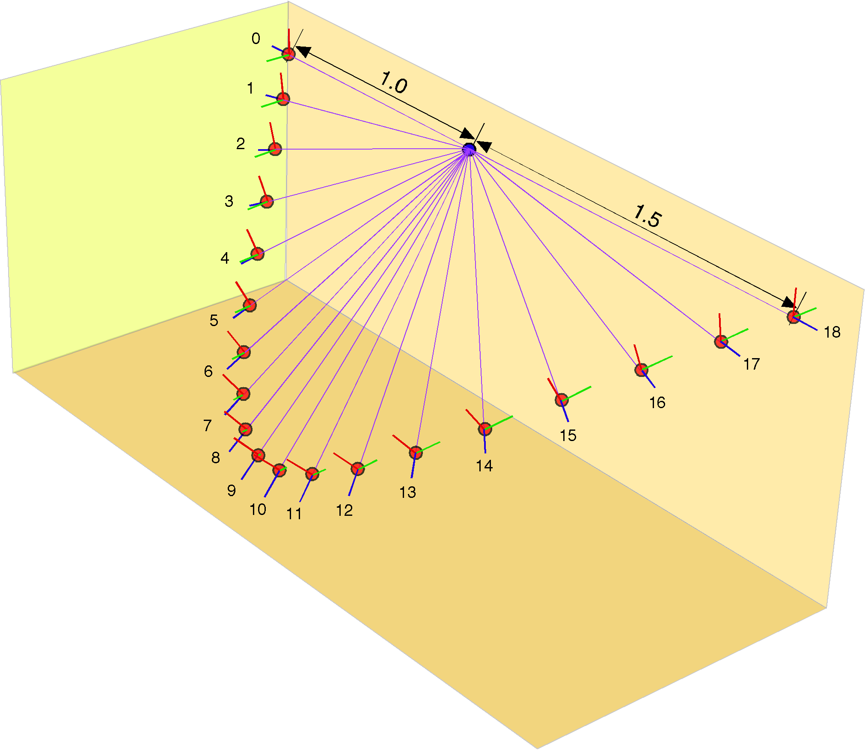
The actual parameters used for this illustration were a starting locus for the distal end of the armature of and an orientation aligned with the universal coordinates, . The rotation vector is a function of the angular excursion.
The locus is rotated by that quaternion and lengthened as follows.
The orientation is rotated by the same quaternion, consequently, there will be no translation.
This is a rather simple arrangement, but it will serve to illustrate most of the necessary points.
In this numerical example, one can easily see that the angular excursions of the movement segments are the ratios of the orientations and, because the loci are generated by the same rotation quaternion, there will be a convergence of the rays upon a common center of rotation node. The intersections between successive rotation planes are clearly the line that point to the common node.
What is not visually apparent is that the isosceles solution will give a different result. We know that to be the case because the rays become longer as we progress for locus 0 to locus 18. Therefore, the base angle on the lower numbered side must be slightly larger than the angle on the higher numbered side. Since the apical angle is 10°, by design, the two base angles must be 85° in the isosceles solution. When we take the ratios of the rays to the baseline, we find that the values are 86.1° and 83.9°.
Consequently, the isosceles node will tend to lie on the side towards the higher numbered locus, relative to the common node, and slightly further away from the baseline than the common node. The net effect will be that the isosceles nodes will follow a trajectory that circles the common node in the direction opposite to the trajectory of the loci.
As stated at the outset, this movement is an example of a confluent movement surface. The movement is such that the same rotation occurs for location and orientation. All movement is attributable to that rotation. Note that the movement is not a simple conical rotation in that the rotation quaternion is a function of the angular excursion, but it is momentarily a conical rotation at each point on its excursion. We would like to reduce all movements to such a confluent surface plus a translation vector that may also change with time or angular excursion. The next section deals with that process.

Reducing a Movement With Translation to a Confluent Surface and a Translation Vector
If an anatomical object moves through space, it must necessarily experience the same rotation for both location and orientation. However, location can also be changed by translation, without changing orientation, therefore the change in location may not correspond to the change in orientation. In the above example, there was no translation, therefore there was correspondence between location and orientation and the movement could be expressed as a confluent movement surface. Note that the frame of reference for orientation has a constant relationship to the rays from the common node. If a variable translation is added then the movement is still smooth, but there is no frame of reference that will stay aligned with the rays from the center of rotation to the loci along the movement’s trajectory. Still it is often of interest to separate such a movement into a rotation component and a translation component. We sketched how that might be done in the analysis given above, but now it is of interest to return to the process and examine it is more detail. The basic movement description has both a rotation and a translation and it can be written in the following form.
For instance, we might add a rotating translation to the movement illustrated above so that the movement leads and lags and rises above and falls below that trajectory. The orientation is not changed, but the location is altered as follows.
Movement from to may viewed as the sum of three components: a rotation, , an orthogonal translation, , and a translation in the plane of the rotation, .
Our mission is to extract R and T from the numerical description of the movement.
Although the translation component is added as a unit, it needs to be extracted in two steps. The first step is to compute the translation perpendicular to the rotation plane, , that is computed from the ratio of the orientations. That translation is subtracted from the movement to obtain an intermediary movement curve that is the projection of the movement curve into the planes of rotation based on orientation. To differentiate the three sets of locations on the three trajectories different symbols will be used for each set. In the original movement, the n’th location will be , in the intermediary trajectory, it will be , and in the rotation component, it will be .
The angular changes in location, , still do not match the angular excursions based on orientation, because we still have the translation components in the plane of rotation, . We can compute those translations by piecemeal calculation of the rotating armature for successive pairs of movement segments. The translation in the plane of the rotation is the difference between the intermediary location for the armature and the computed values on the assumption that the rotation has certain characteristics, . If we subtract that translation, the result will be a confluent surface that is the rotation component of the movement. Because of the appearance of the forms generated in computing the in-plane translations, the intermediary surface will be called the patchwork surface.
Let us now consider how one actually computes these entities. The first step is to start with two successive placements along the movement trajectory, and . From the orientations we can compute and angular excursion and a plane of rotation .
Given the locations and , one can construct the right triangle that has their difference as its hypotenuse and one side in the direction of the normal to the rotation plane as one of its sides. The angle between the hypotenuse and that side is the angle of their ratio.
The length of the translation side is and the length of the rotation excursion side is given by the following equation.
The first term on the right side is the length of the hypotenuse and the term in the brackets is the unit vector in the direction of the side, so the equation is essentially the same as the previous expression.
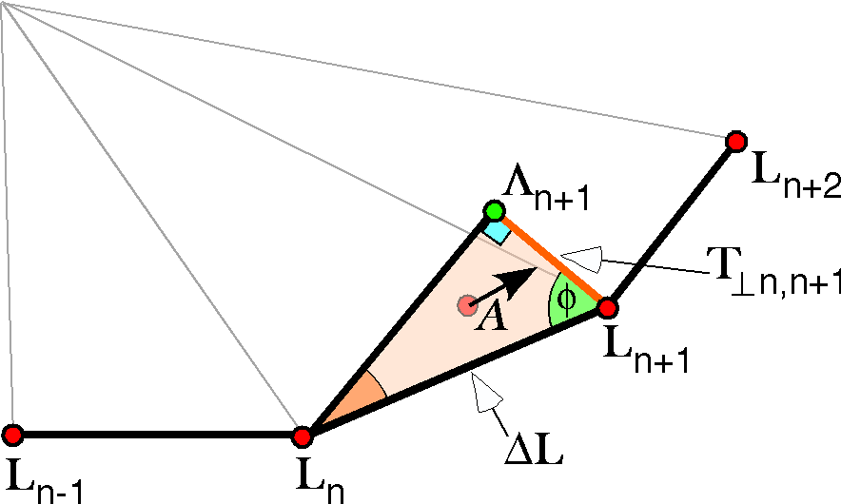
The excursion side extends from to , which is the movement segment when the orthogonal translation is subtracted. If we proceed in the same way for all the movement segments, then the result is a saw-tooth trajectory, which is the basis for the next step. The points along that trajectory are in a surface for which the movement segments are in the planes of rotation for the orientations. We can now start computing the rotation surface.
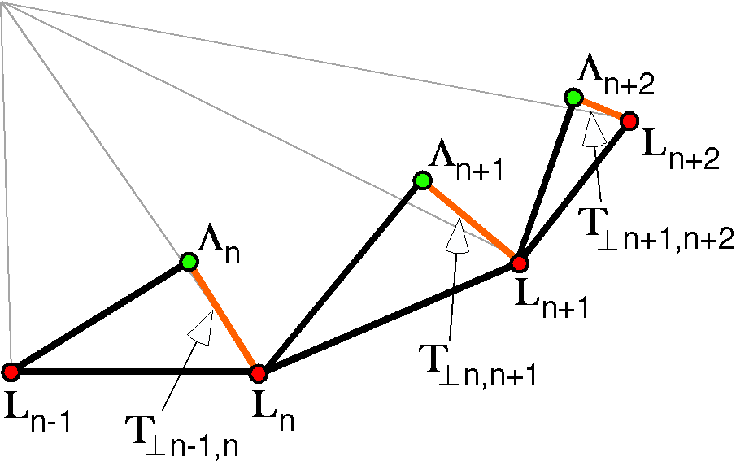
If we remove the orthogonal translations, the movement becomes a continuous trajectory of linear segments that join at the intermediary locations, . The next figure illustrates these as the green nodes. We know that the intermediary trajectory is the combination of a rotation and translation in the plane of the movement segment’s rotation.

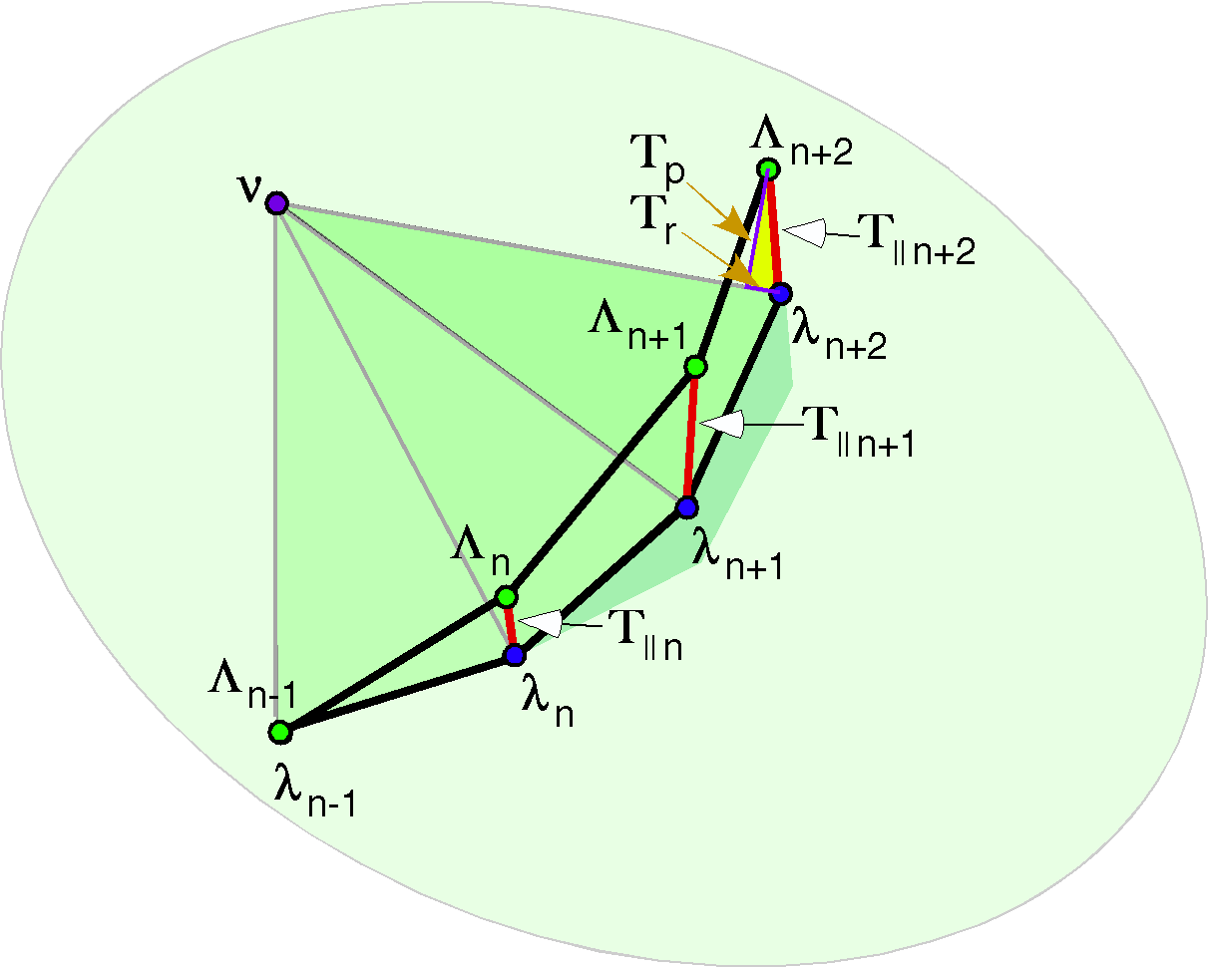
The genesis of a creased confluent surface for a rotation with translations in the plane of rotation
The rotation quaternion for the movement segment, , may be a non-unitary quaternion or a unitary quaternion. If it is a non-unitary quaternion, then the length of the moving armature will change as the armature moves. Here, we will use the term armature to indicate the link between the center of rotation and the rotating locus and symbolize it as .
There are two basic options in how one apportions the deviation from a unitary cast. The first option is to assume that any movement in the direction of the armature is part of the cast and any movement perpendicular to the armature is translation in the plane. This has the nice feature that translation is always in a plane perpendicular to the armature, but at the cost of a non-unitary cast. The second option is to assume that the cast is unitary and any movement in the plane of the rotation that deviates from that value is translation. Under the second option the rotation is simple, but translations may be in any direction.
There is obviously a third option, which is to combine the first two options and apportion some of the movement in the plane of rotation to a non-unitary cast and the rest to translation. However, this option depends on having some way to decide how the apportionment is to be handled. The choice is largely a matter or interpretation and there is no a priori basis for choosing one over the other unless one has additional information. If one plots the deviations from a unitary cast, then one may see that there is a linear or smoothly periodic pattern to the deviations and it is natural to choose the interpretation that best incorporates that regularity. One may also have reasons arising from the anatomy and physics of the system for choosing one option over another.
Setting that aside, let us consider how one might compute a set of loci for the rotation that generate a creased confluent surface that represents a rotation. To start, we need to know one armature that can be used as the basis for the calculation. Let us call that armature . The armature starts in a center of rotation, , and ends in a locus, .
These values constitute a boundary condition on the calculation of the surface.
We know the angular excursion of the segment of the surface that is associated with movement between two loci. It is the angle of the quaternion of the ratio of the orientations in the placements that bracket the movement segment, . The plane of the rotation is defined by the vector of that same quaternion, . If we write that rotation quaternion for the segment bounded by the creases and as , then we can write down a general formula for generating the next locus in the rotation.
If , then there must be a translation .
The in-plane translation may be resolved into a component that lies in the direction of the armature, , and a component that lies perpendicular to it, . These are illustrated for the last segment in the above figure.
We can determine the values of and from the following relationships, where the bar over a vector signifies that it is the unit vector in that direction and is the tensor of the quaternion .

