Geometrical Anatomy of the Eye and Eye Movements
In a Model with Restricted Extraocular Muscles

Thomas P. Langer

Introduction
In a companion paper, the geometrical anatomy of the eye and its implications for the eye’s movements were explored under the assumption that the eye muscles were free to follow their insertions as the eye moved. Comparatively recently it has been discovered that the eye’s extrinsic muscles are not free to follow their insertion (Demer, Miller et al. 1995; Clark, Miller et al. 1997; Demer, Poukens et al. 1997; Clark, Miller et al. 2000; Demer, Oh et al. 2000). Rather, they are constrained by fascial slings that act as pulleys. These pulleys are located a short distance posterior to the globe’s equator in neutral gaze, which might have profound consequences for the eye movements that they produce. The location and general anatomy of the relevant fascia has been known for some time (Duke-Elder and Wybar 1961; Williams, Bannister et al. 1995), but the role it plays in eye movements is only fairly recently appreciated. In this paper the same type of analysis will be done as was done in the free muscle model, but with the pulleys as part of the model.
It turns out that the formal differences between the two models are comparatively small. The only substantial difference is that the origins of the rectus muscles are no longer at the annulus of Zinn. While the muscles still take their anatomical origins from that common tendinous ring, their functional origins are a collection of fascial slings embedded in the fascia that encircles the globe near its equator and binds it to the orbital wall. These slings resist displacement of the muscles relative to the orbital wall, but allow the muscle’s tendons to freely follow their insertions as the eye moves. The model defines the origin to mean the functional origin, the point from which the muscle pulls, rather than the anatomical origin. Consequently, the origins move from the back of the orbit and medial to the eyeball to a series of slings near the transverse equator of the eyeball.
There is a great deal of detailed anatomy that relates to the orbital fascia, but the main points that we need to extract for the purposes of computing the eye movements is the locations of the pulleys for each of the recti. These are given in a recent paper that used MRI to monitor the eye muscles (Clark, Miller et al. 2000). As the eye was adducted and abducted the vertical recti flexed at their pulleys, and as the eye was elevated and depressed, the horizontal recti flexed at their pulleys. It was found that the locations of the pulleys were as summarized in the following table.

Normal Rectus Pulley Positions Relative to the Globe’s Center
Muscle | Anterior | Lateral | Superior
Medial Rectus | -3 ± 2 mm. | -14.2 ± 0.2 mm. | -0.3 ± 0.3 mm.
Lateral Rectus | -9 ± 2 mm. | 10.1 ± 0.1 mm. | -0.3 ± 0.2 mm.
Superior Rectus | -7 ± 2 mm. | -1.7 ± 0.3 mm. | 11.8 ± 0.2 mm.
Inferior Rectus | -6 ± 2 mm. | -4.3 ± 0.2 mm. | -12.9 ± 0.1 mm.
These measurements in millimeters translate into unit vectors originating from the center of the globe as follows.

Normal Rectus Pulley Positions Relative to the Globe’s Center
Muscle | i | j | k
Medial Rectus | -0.25 | 1.2 | -0.03.
Lateral Rectus | -0.25 | -0.84 | -0.03
Superior Rectus | -0.58 | 0.07 | 0.98
Inferior Rectus | -0.50 | 0.36 | -1.1
Once we have computed the locations of the rectus pulleys, we can plug them into the model developed for the freely moving eye muscles as the origins of the muscles. The calculations are otherwise the same as for that model.

Methods
The methods for this analysis are essentially as described in the companion paper. The principal differences are in the changes in the locations of the origins of the rectus muscles.
The calculations were done with the same model as for the analysis of free muscle anatomy, except for the changes in the muscle origins indicted above. All the calculations were done in Mathematica and most of the figures are taken from Mathematica with some labeling added in Canvas 9.

Results

Changes in Muscle Length with Changes in Gaze Direction

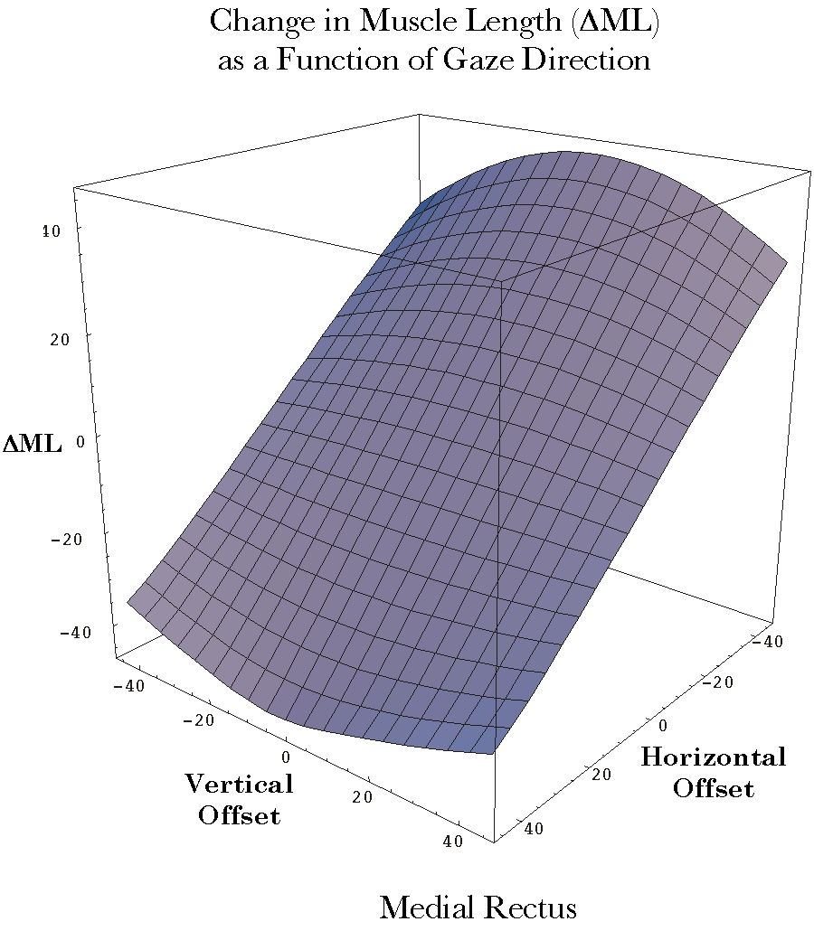
Figure 1. The distribution of the change in the medial rectus muscle’s length as a function of horizontal and vertical offset from neutral gaze: Restricted muscle model. The plotted variable is the difference between the muscle’s length in neutral gaze and its length in the offset gaze (ΔML). The vertical and horizontal offsets may run in different directions in the different plots, to best display the surface’s configuration. See the text for a description of the surface.
Gaze direction and orientation are completely determined by the set of muscle lengths of the six extraocular muscles. We have examined the distribution of the extraocular muscles as a function of gaze direction when the muscles are free the follow their insertions (Langer, 2004). It was found that the surface that represents this relationship is complex, but sections of the surface for each muscle is generally a fairly shallow hyperbolic, or saddle-shaped, surface tilted with respect to the coordinate plane for gaze direction. When the calculations are done with the pulleys acting as functional origins for the muscles, the results are similar.
The surfaces for the superior and inferior oblique muscles are the same because their origins and insertions are the same as in the free muscle model. The general differences for the four rectus muscles are that they are less curved than in the free muscle model. Despite the flatter surfaces the hyperbolic shape is sometimes more apparent.

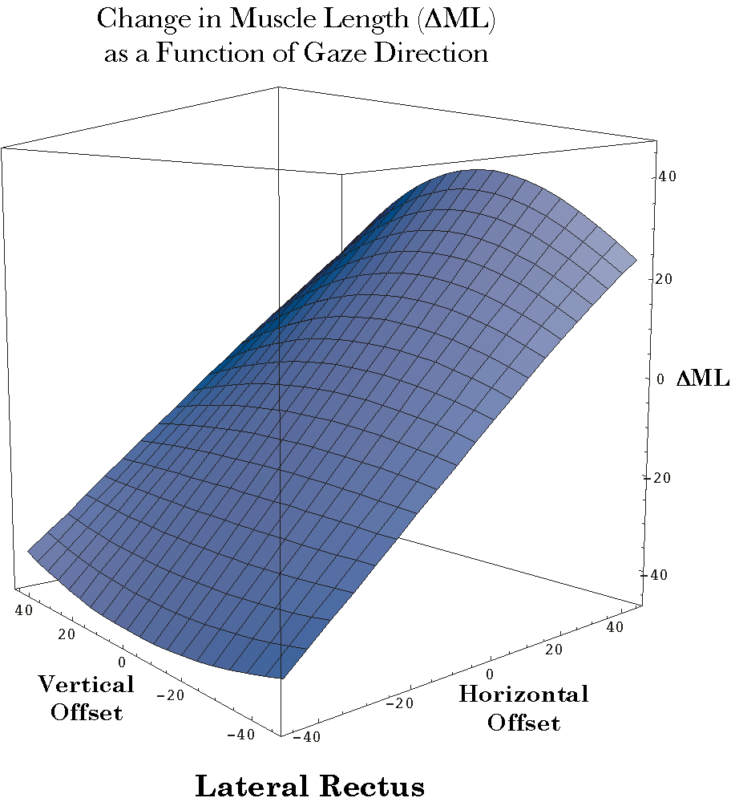
Figure 2. The distribution of the change in the lateral rectus muscle’s length as a function of horizontal and vertical offset from neutral gaze: Restricted muscle model. The conventions are the same as for the medial rectus muscle figure.

Medial Rectus
The surface for the medial rectus muscle is flatter in the restricted muscle model than in the free muscle model (Figure 1). This is most evident at the longer muscle lengths, where the curvature along the vertical axis substantially less. However, the edge of the surface for the most nasal gaze directions is more curved. It is curved in the opposite direction as for the temporal gaze directions. Consequently, the surface appears more hyperbolic. The shape of the surface in the restricted muscle model is like the shape of the most medial part of the surface in the free muscle model, as if the section being examined was shifted medially for the restricted model.

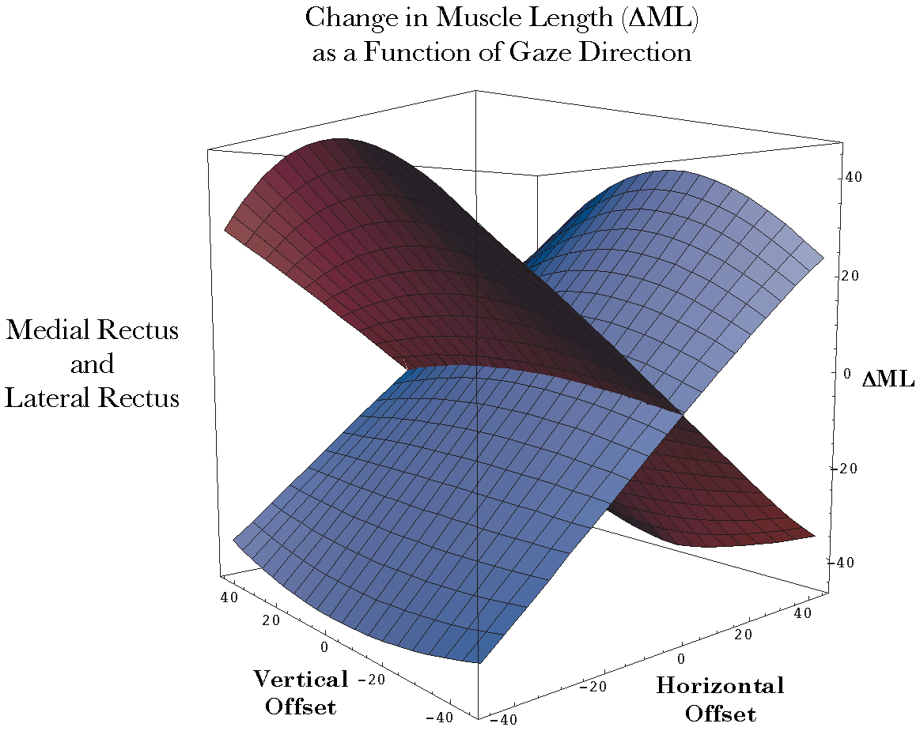
Figure 3. The distribution of the change in the medial and lateral rectus muscle lengths as a function of horizontal and vertical offset from neutral gaze: Restricted muscle model. The conventions are the same as for the medial rectus muscle figure.

Lateral Rectus
The differences between the muscle length surface for the free and restricted muscle models are in the same directions as for the medial rectus, but more so (Figure 2). There is more flattening of the surface for the longest muscle lengths (adduction) and more curvature in the opposite direction for the most temporal gazes. The restricted model surface is more curved overall than the surface for the medial rectus, which was true in the free muscle model as well. As with the medial rectus surface, the restricted surface for the lateral rectus looks like it is from the same surface as the free muscle surface, just shifted towards shorter muscle lengths.
When the two surfaces for the horizontal recti are plotted together (Figure 3), they are quite similar to the surfaces in the free muscle model, except less curvilinear, but more hyperbolic.

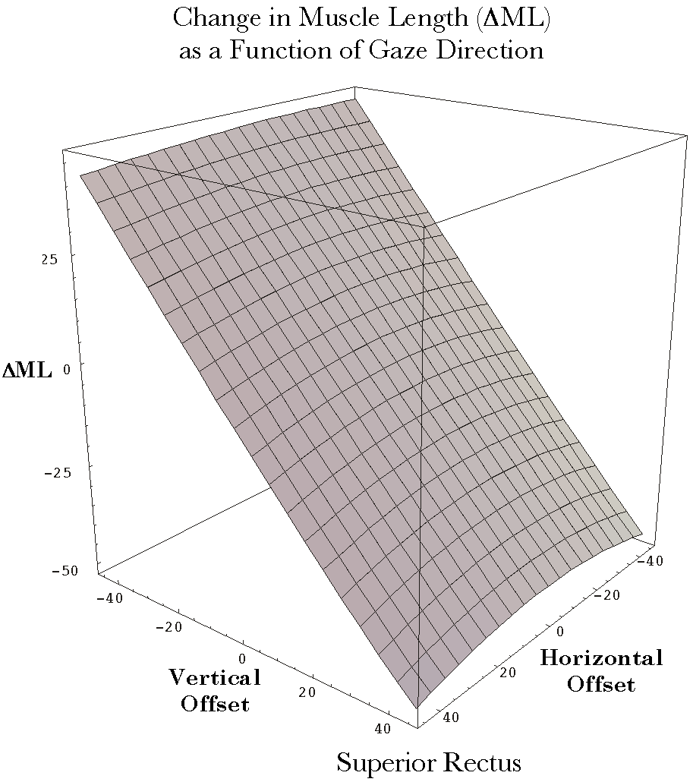
Figure 4. The distribution of the change in the superior rectus muscle’s length as a function of horizontal and vertical offset from neutral gaze: Restricted muscle model. The conventions are the same as for the medial rectus muscle figure.

Superior Rectus
The flattening of the muscle length surfaces is more pronounced for the vertical recti. This is especially true at the shorter muscle lengths. In the free muscle model, the surface is flexed at a gaze position about 23° lateral to neutral gaze and it is rounded in a roughly cylindrical fashion throughout its vertical extent. In the restricted model, the surface for the superior rectus is almost flat for the most depressed gazes and it becomes gently rounded for the most elevated gazes (Figure 4). If we were to extend the surface towards the most elevated gazes, the curvature would reverse and we would see that it is also hyperbolic.

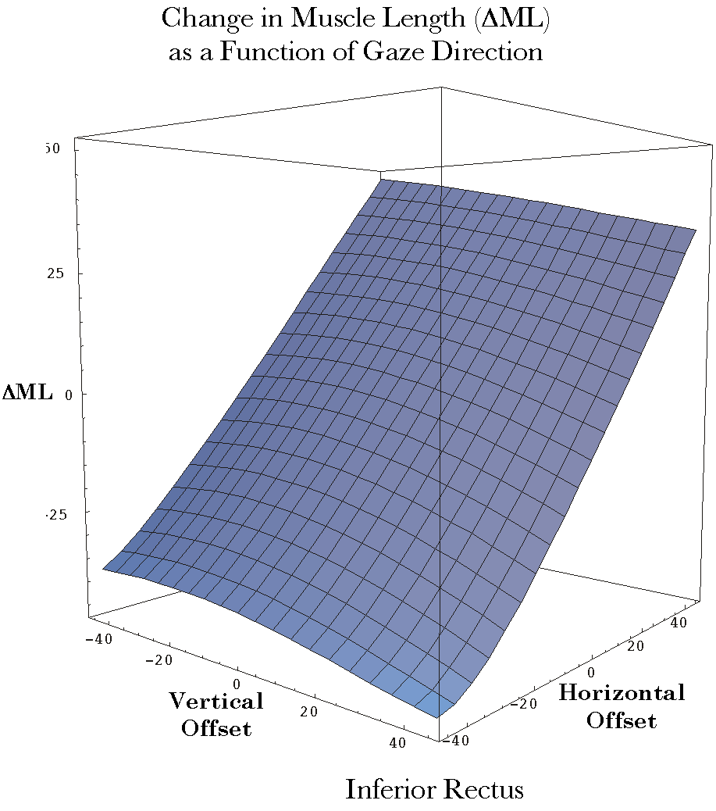
Figure 5. The distribution of the change in the inferior rectus muscle’s length as a function of horizontal and vertical offset from neutral gaze: Restricted muscle model. The conventions are the same as for the medial rectus muscle figure.

Inferior Rectus
The surface for the inferior rectus is nearly the mirror image of the surface for the superior rectus (Figure 5). It is nearly flat for the most elevated gaze positions and it becomes gently rounded at the most depressed gazes. There is a mild reversal of the curvature at the most laterally directed of the elevated gazes.
When we plot the surfaces for the two vertical recti together (Figure 6). It is possible to see that they are modestly tilted relative to each other. This is because the two muscle pulleys are not vertically aligned. Both surfaces are also slightly tilted relative to the vertical and horizontal axes of the orbit. This is because their muscle’s pulleys are placed medial to their insertions.

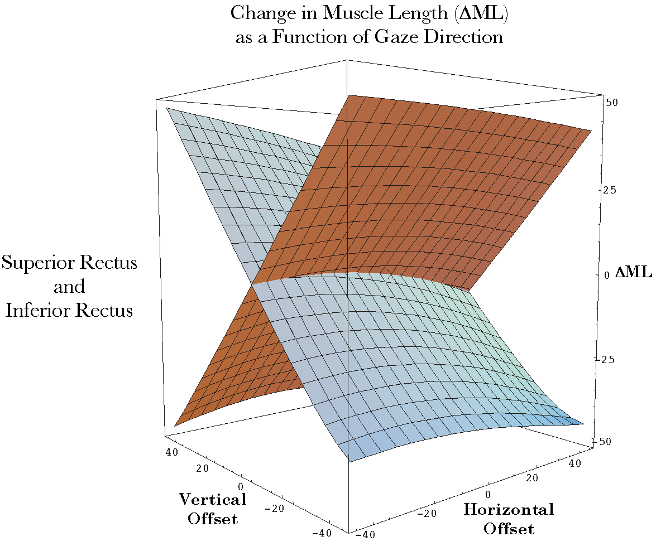
Figure 6. The distribution of the change in the superior and inferior rectus muscle lengths as a function of horizontal and vertical offset from neutral gaze: Restricted muscle model. The conventions are the same as for the medial rectus muscle figure.

All Extraocular Muscles
As with the free muscle model, the surfaces for all of the extraocular muscles have been plotted together to illustrate their general relationships (Figure 7). The complex surface generated is in most ways very like the surface in the free muscle model. One has to examine both surfaces closely to see the differences. The principal differences are due to the flattening of the surfaces for the recti.

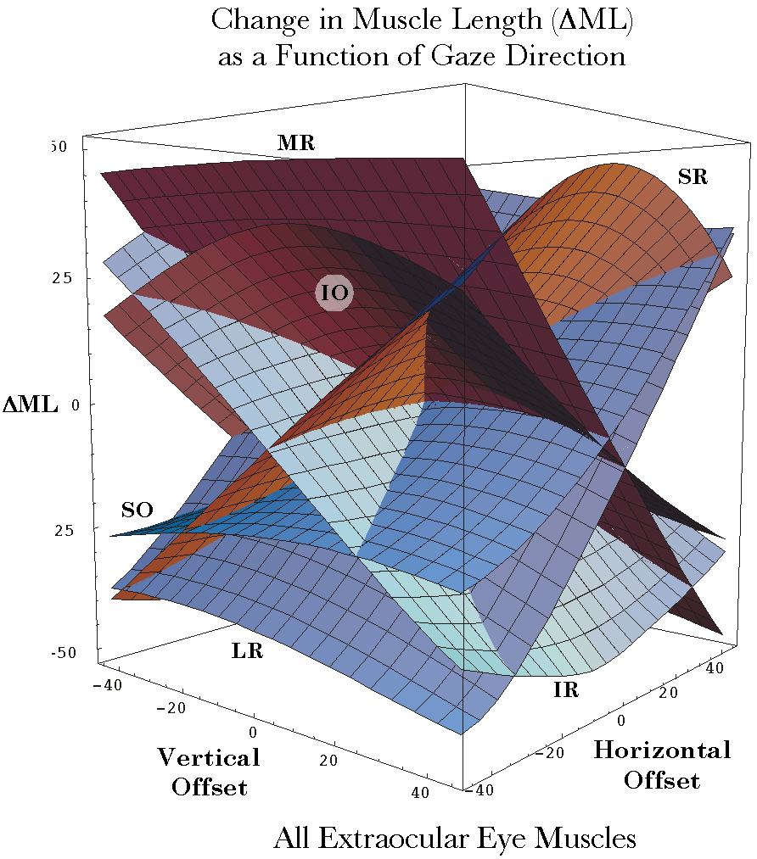
Figure 7. The distribution of the change in all of the extraocular muscle lengths as a function of horizontal and vertical offset from neutral gaze: Restricted muscle model. The conventions are the same as for the medial rectus muscle figure.

Pulling Directions
The most relevant differences between the two models are related to pulling directions as a function of gaze. As with the free muscle model, the gaze is entirely determined by the muscle lengths in the six extraocular muscles. The distribution of muscle lengths as a function of gaze direction is still a two-dimensional surface in an eight dimensional space. Once one has specified the gaze direction, then the gaze orientation is determined by the fact that it has to be spin neutral relative to neutral gaze.
As in the free muscle model, we move the eye radially from neutral gaze to an array of gaze directions that are spaced at 5° intervals as with latitude and longitude on a globe. The poles of the array are the vertical axes of the eye in neutral position. The array is chosen to extend from –45° to 45° both horizontally and vertically. This range far exceeds normal eye movements, which tend to extend 30° or less from neutral gaze (Williams, Bannister et al. 1995). The extreme of lateral gaze is 50°, but it is not a common excursion of the eye.

Medial Rectus

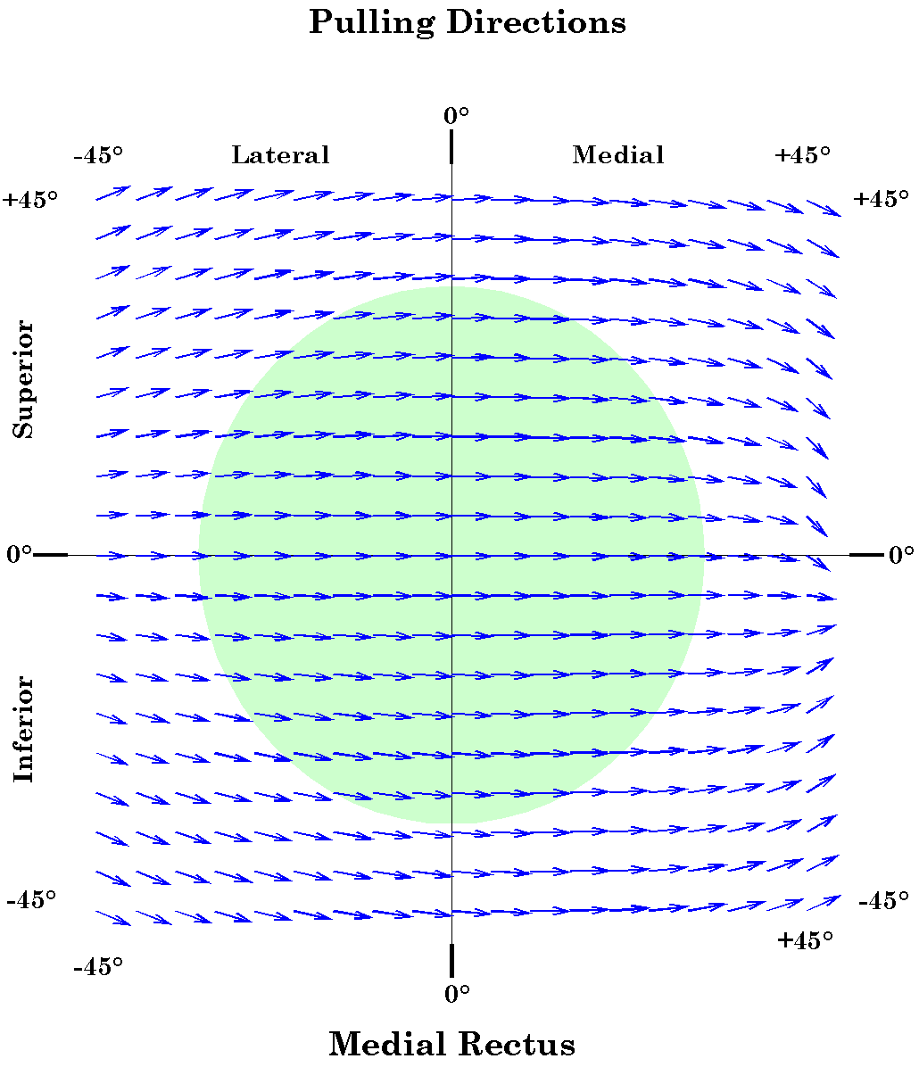
Figure 8. The distribution of the pulling direction of the medial rectus muscle as a function of horizontal and vertical offset from neutral gaze: Restricted muscle model. The direction of the vector is the direction of the muscle’s pull and the magnitude of its shaft is proportional to the magnitude of the swing component of the pull. The green circular area indicates the approximate range of normal eye movements. Nasal gaze directions and eye movements are considered to be in the positive horizontal direction. Temporal gaze and eye movements are negative. Elevation of the eye and elevated gaze are in the positive vertical direction and depressed gaze and movements are negative.

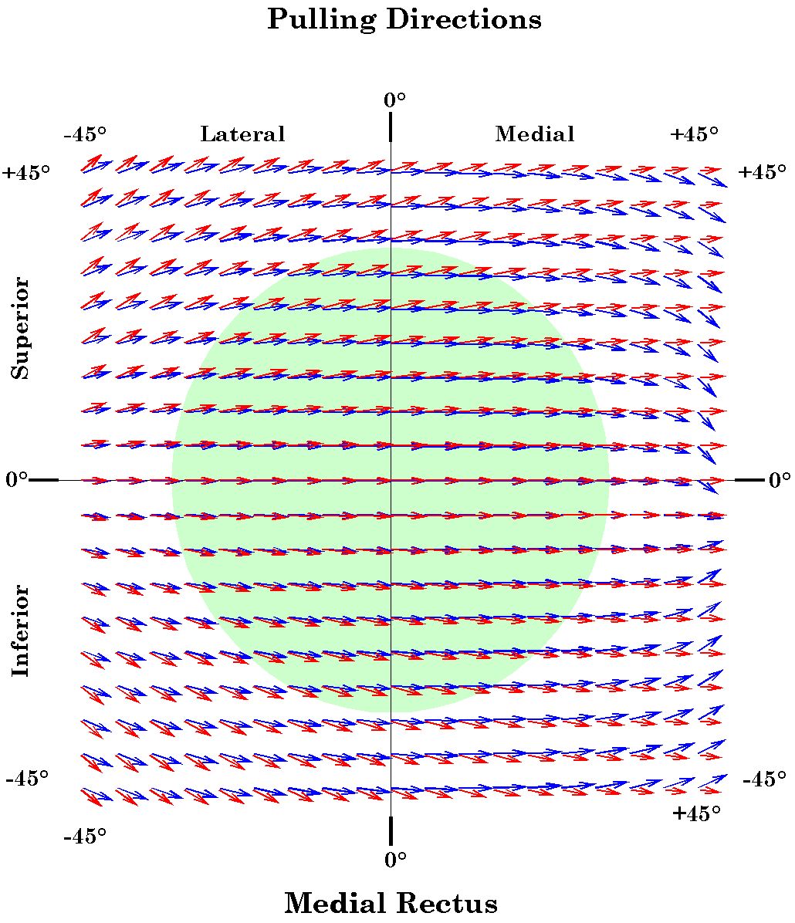
Figure 9. Comparison of the distributions of the pulling direction of the medial rectus muscle as a function of horizontal and vertical offset from neutral gaze: Restricted and free muscle models. The blue vectors are the vectors for the restricted model and the red vectors are the data from the free muscle model.
The moving of the functional origin forward has a modest influence upon the pulling directions of the medial rectus muscle (Figures 8 and 9), indeed on all of the rectus muscles. Within the range that is normally used for eye movements, the medial rectus pulls almost true horizontal. There is a small amount of vertical pull at the most lateral eye positions. This is in the same direction, but less developed than with the free muscle model. Unlike the free movement model, where the horizontal recti always tend to draw the eye away from the horizontal meridian when it is either elevated or depressed, the medial rectus has a slight tendency to draw the eye back towards the horizontal meridian when it is medially directed.
As the eye approaches the medial limit, medial to normal eye movements, the pull directions tend to converge. This is due the fact that the tendon has retracted almost into the pulley sling.

Lateral Rectus

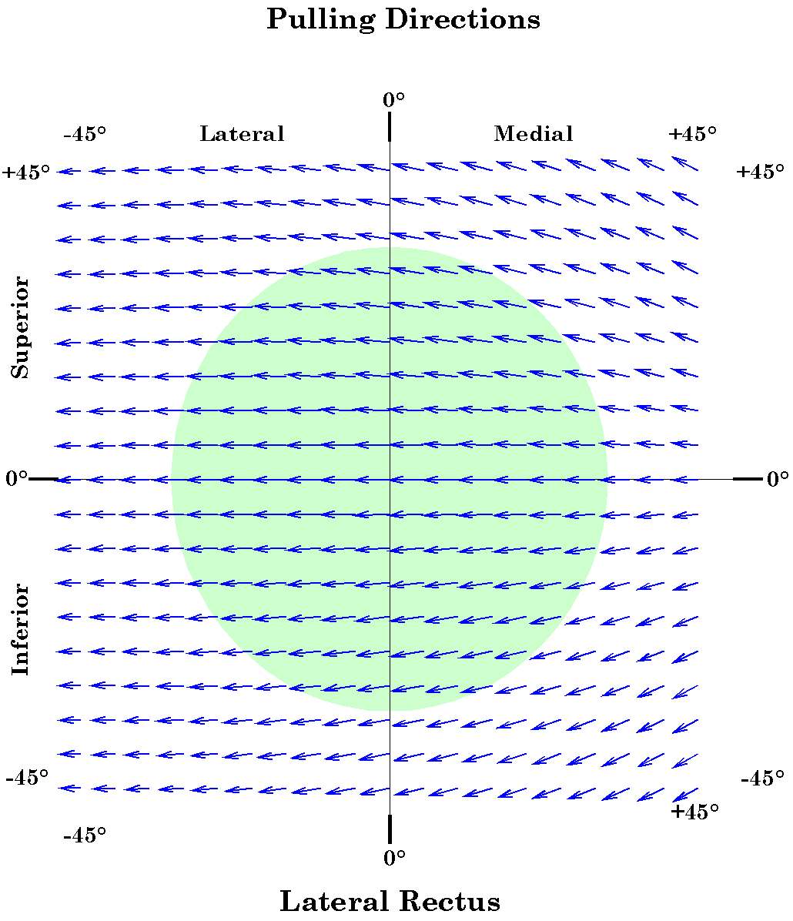
Figure 10. The distribution of the pulling direction of the lateral rectus muscle as a function of horizontal and vertical offset from neutral gaze: Restricted muscle model. The conventions are as given for the medial rectus figure.

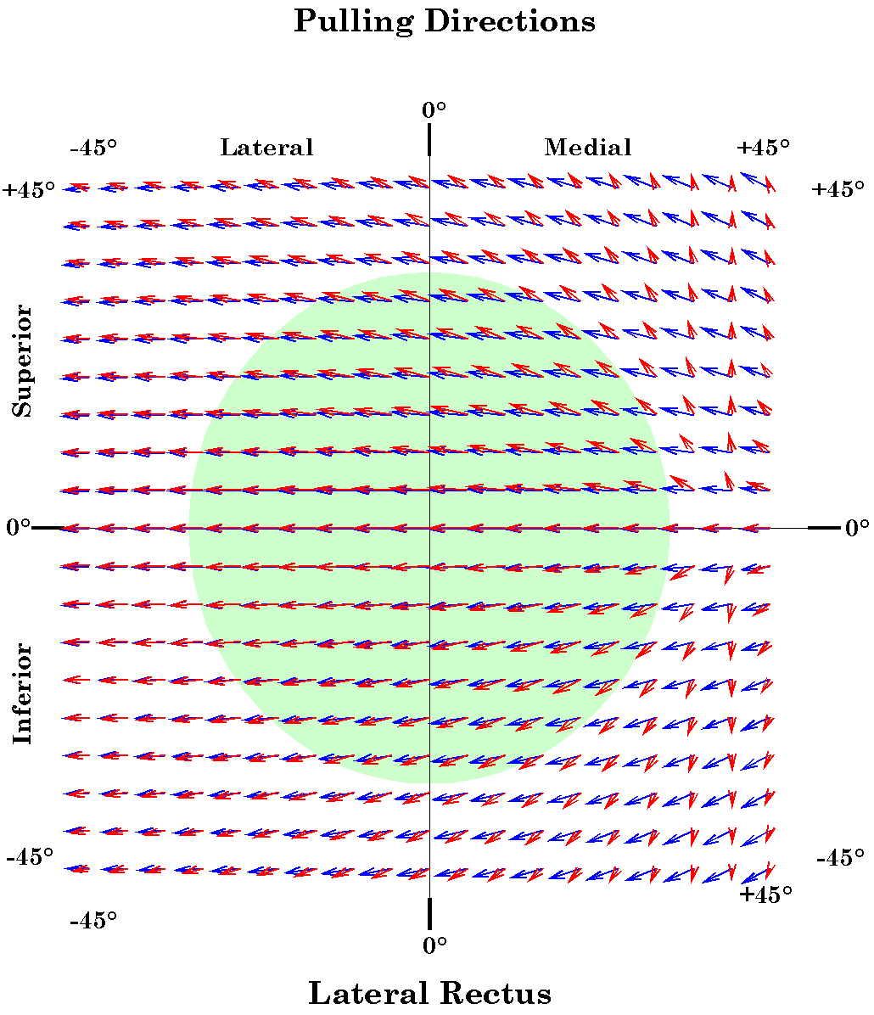
Figure 11. Comparison of the distributions of the pulling direction of the medial rectus muscle as a function of horizontal and vertical offset from neutral gaze: Restricted and free muscle models. The conventions are as given for the medial rectus figure.
The pulling directions of the lateral rectus are nearly a mirror image of the medial rectus (Figures 10 and 11). The muscle pulls nearly true horizontal except at the lateral extreme. There is still a slight tendency for the lateral rectus to draw the eye away from the horizontal meridian when it is either elevated or depressed, but it is less than in the free muscle model.
There is not the same convergence at the lateral limit, because the pulley sling is substantially more posteriorly placed. It was also noted that the lateral rectus sling seemed to travel a small distance posteriorly with the eye with abduction (Clark, Miller et al. 2000). This does not seem to be a necessary attribute since there is more than enough room for full abduction even if the sling does not move. Since the lateral rectus pulley also travels more than the others with elevation and depression, it may be that it is just more loosely bound to the lateral orbital wall by the fascia.

Superior Rectus

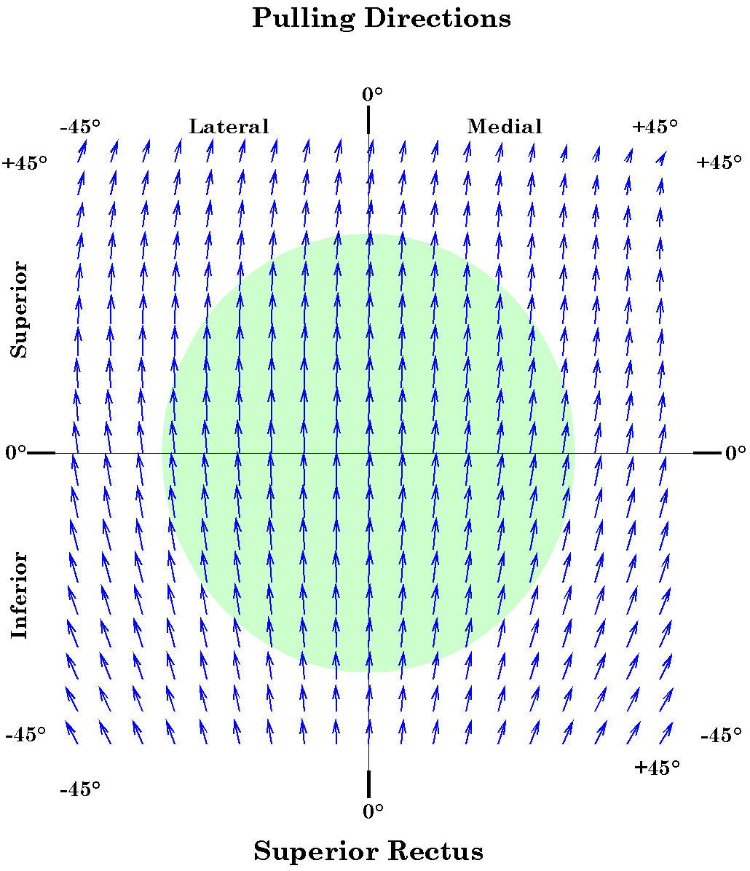
Figure 12. The distribution of the pulling direction of the superior rectus muscle as a function of horizontal and vertical offset from neutral gaze: Restricted muscle model. The conventions are as given for the medial rectus figure.
The pulling directions for the superior rectus are also more aligned than in the free movement model (Figures 12 and 13). Over most of the normal range the muscle pulls nearly true vertical. As with the horizontal recti, there is some convergence at the proximal extremes of the range and divergence at the distal extremes of the range.

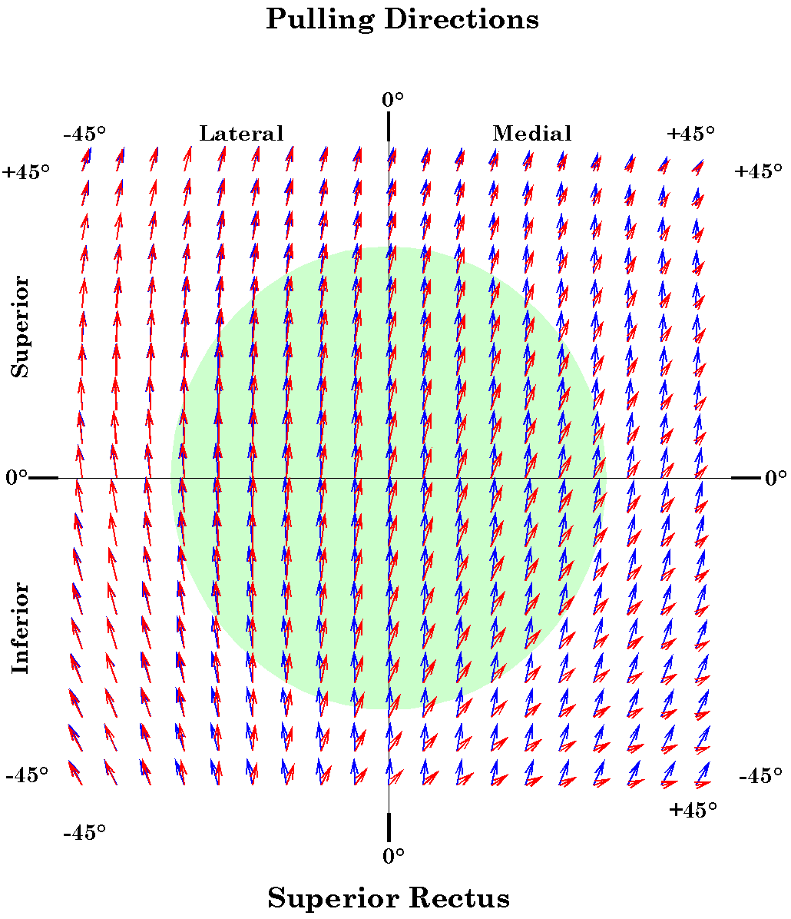
Figure 13. Comparison of the pulling directions for the superior rectus muscle in the free and restricted muscle models. The conventions are as for the medial rectus figure.
Another difference is that, in the free muscle model, there is a divergence of the pulling directions to either side of a longitudinal meridian that is 23° temporal to the vertical meridian. The results in the restricted muscle model are much as one would expect if the rectus muscle origins were directly posterior to the globe. The 23° nasal displacement of the annulus of Zinn is nullified by the anteriorly placed pulley.
There is a medial deviation of the pulling directions at the most elevated eye positions, but that is due to the pulley being located medial to the vertical meridian. It is similar to the convergence of the medial rectus muscle when the eye moves to its medial extreme.

Inferior Rectus
The pulling directions of the inferior rectus muscle are substantially less true vertical than the pulling directions for the superior rectus. The deviations are in the same direction as those with the muscles free to follow their insertions, but of lesser magnitude. This pattern is also due to the inferior rectus pulley being located more medial to the vertical meridian than its insertion.

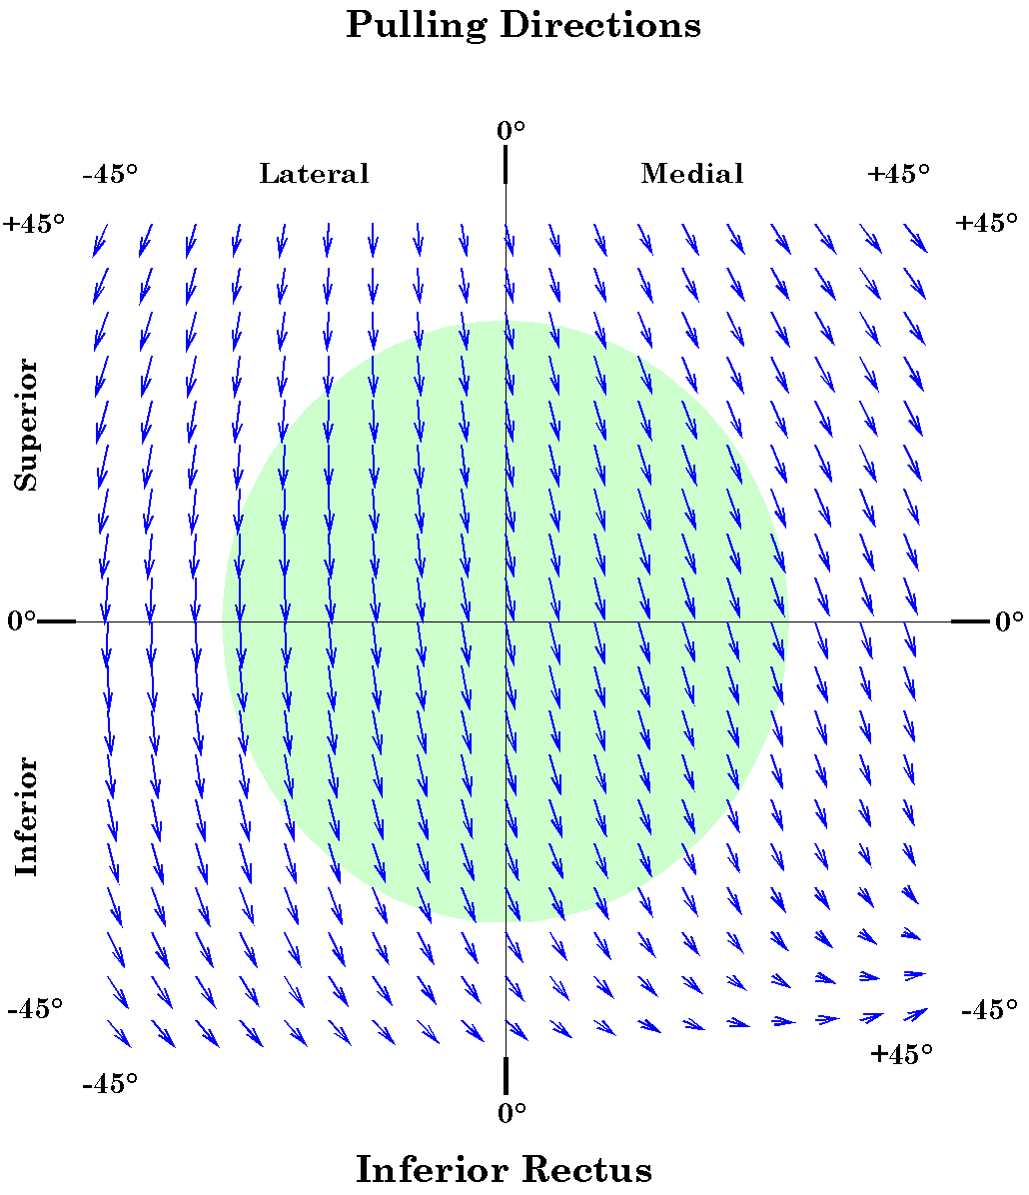
Figure 14. The distribution of the pulling direction of the inferior rectus muscle as a function of horizontal and vertical offset from neutral gaze: Restricted muscle model. The conventions are as given for the medial rectus figure.

Superior Oblique
The new anatomy does not reveal major differences in the anatomy of the oblique extraocular muscles. Of course, it has been known for a very long time that the superior oblique passes through a pulley that produces a major change in its pulling directions. The patterns for the obliques are included here for comparison.

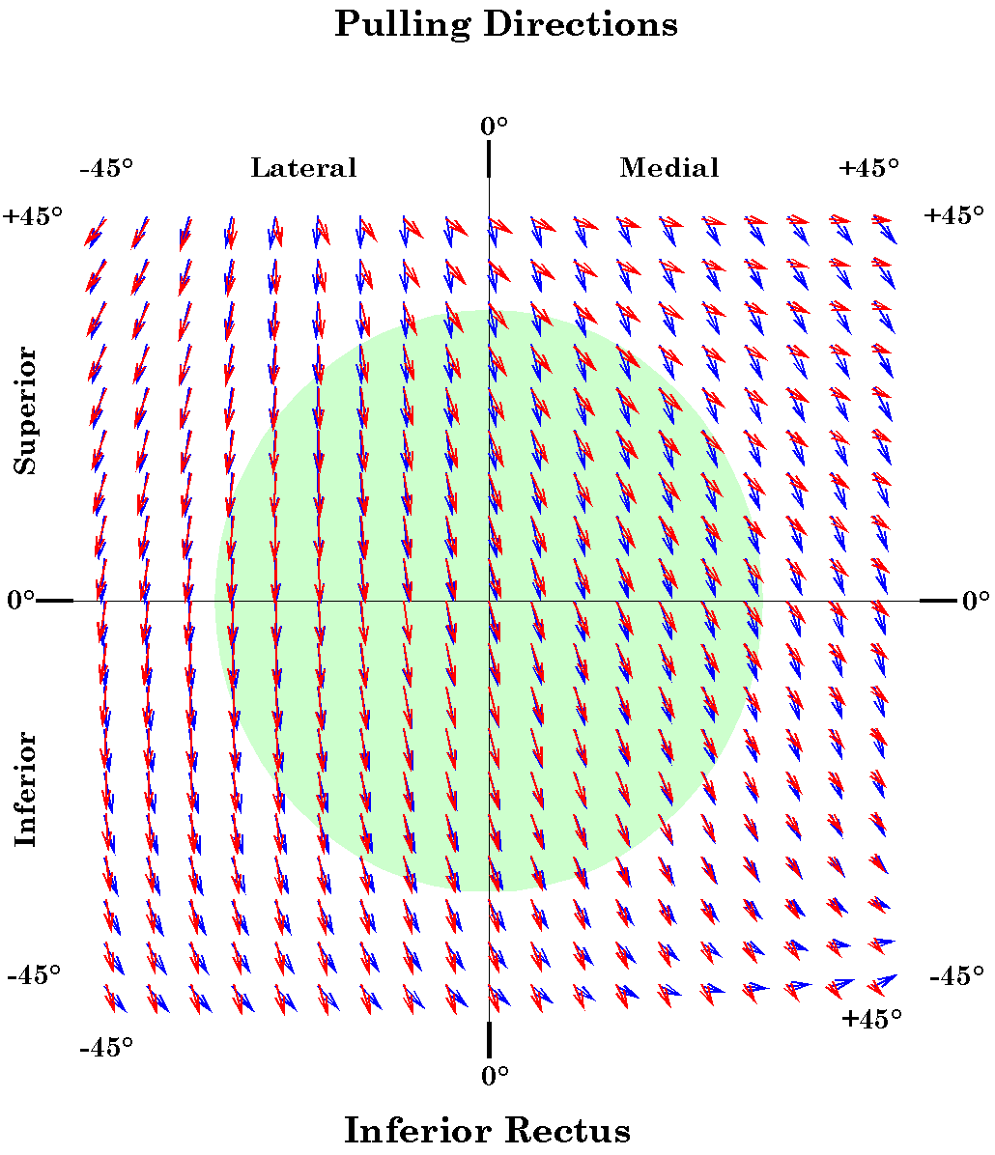
Figure 15. Comparison of the pulling directions for the inferior rectus muscle in the free and restricted muscle models. The conventions are as for the medial rectus figure.
The superior oblique continues to have a complex pattern of muscle pulls. When the eye is laterally directed, it causes the eye to spin in the direction of intorsion. When the eye is medially directed, it also acts as a depressor.

Inferior Oblique
The inferior oblique muscle is roughly the mirror image of the superior oblique, reflected across the horizontal meridian. With lateral eye deviation, it acts mostly as a torsional mover, but in the direction of extorsion. As the eye moves medially, more of its effort goes into elevation of the eye.

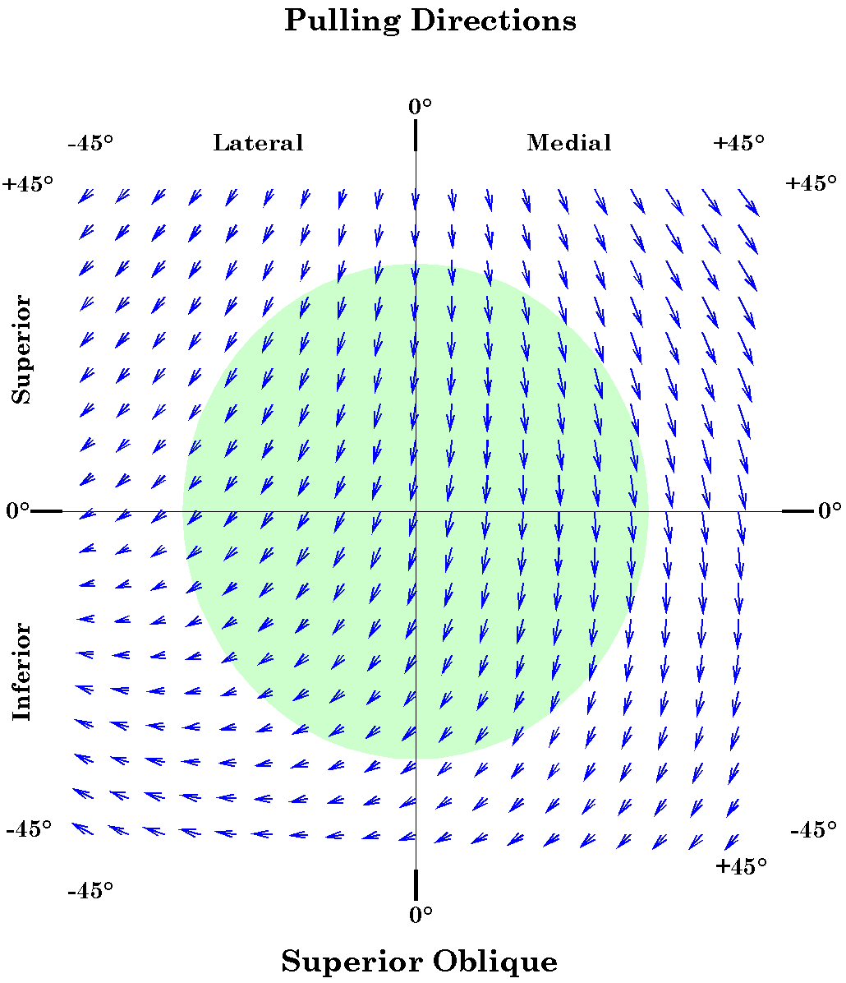
Figure 16. Comparison of the pulling directions for the superior oblique muscle in the free and restricted muscle models. The conventions are as for the medial rectus figure.
One of the advantages of constructing a model is that it allows us to ask “what if?” questions. For instance, we have been asking what eye movements would look like if the normal excursions were greater than those actually observed. By doing so, we are able to see that nice neat patterns start to beak down when the eye deviates more than a certain distance, which happens to be the actual normal limit in that direction.

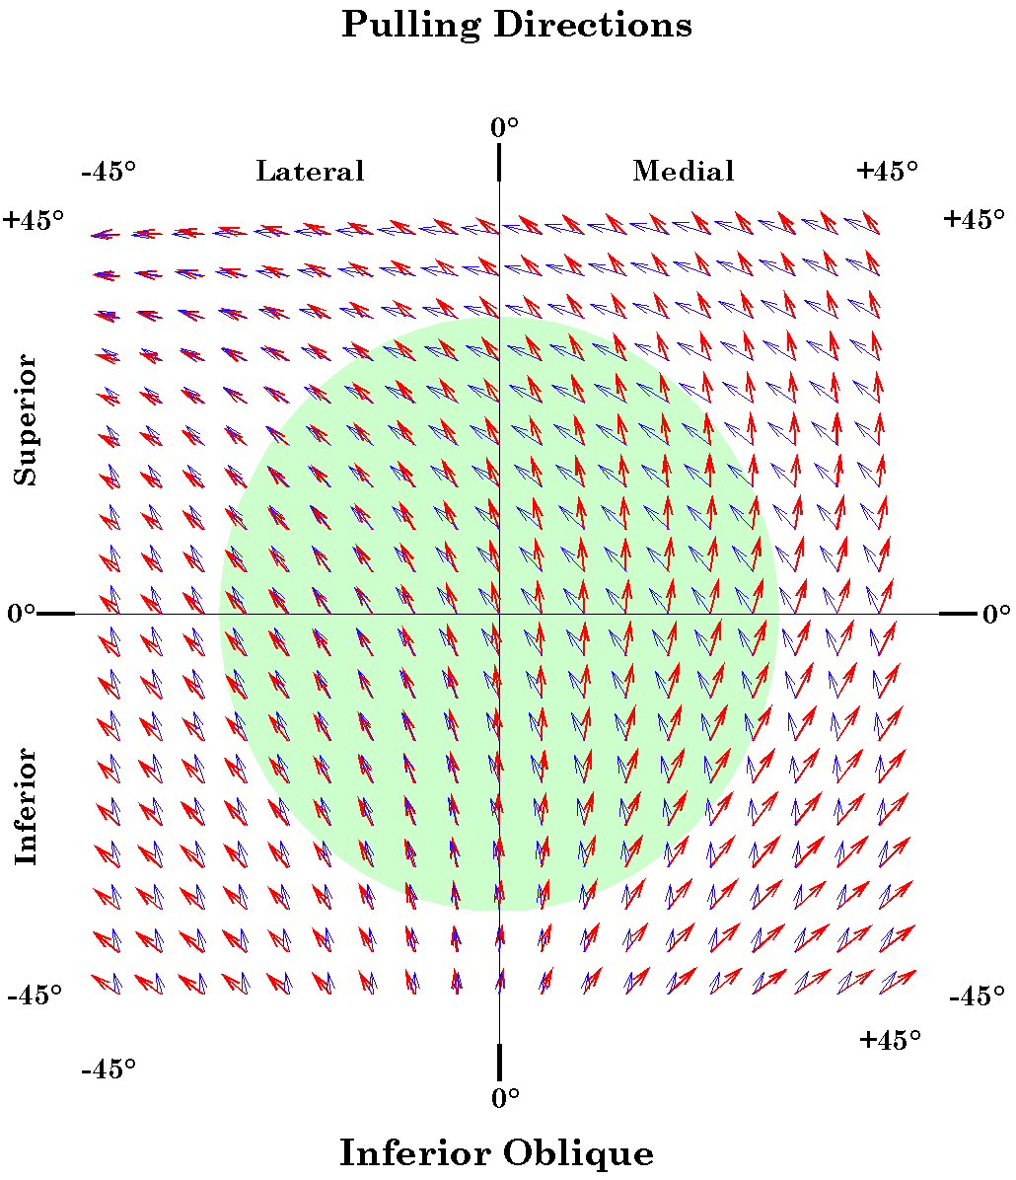
Figure 17. Comparison of the pulling directions for the inferior oblique muscle in the free (red) and restricted (blue) muscle models. The conventions are as for the medial rectus figure.
Another ‘what if’ question that arises is what would be the implications of having pulley slings for the oblique muscles. It does not appear to be the case that the superior oblique has a restrictive fascial sling that might redirect its action, other than the pulley from which its nerve takes its name. However, the inferior oblique muscle may have a partial restriction. As it passes posteriorly and laterally it sweeps inferior to the inferior rectus and is bound to it by fascial connective tissue. The sheaths of both muscles are continuous with a strong fascial ligament that passes inferior to the globe and supports it, the suspensory ligament of the eye or Lockwood’s ligament. Through the suspensory ligament these two muscles are mechanically linked with the fascial sheaths of the medial and lateral rectus muscles. The suspensory ligament also extends anteriorly, to fuse with the fascia of the lower eyelid. There is the possibility that the passage of the inferior oblique muscle through the fascial penumbra of the eyeball may act as a restriction on its movement, much as the other fascial slings restrict the recti. That brings us to the ‘what if’ question. How would the pulling directions of the inferior oblique muscle be changed if there were a restrictive sling at the point where it passed inferior to the inferior oblique? This scenario has been computed and the results are shown in the next figure 17.
It is apparent that the hypothetical restriction would center the gaze directions with the greatest spin in those gazes that are most inferior to neutral gaze. For gaze positions below neutral gaze the restricted inferior oblique muscle would be primarily an elevator. However, for those above neutral gaze it becomes more and more a lateral rotator. This because the fascial sling would lie a substantial distance medial to the midline of the eye.

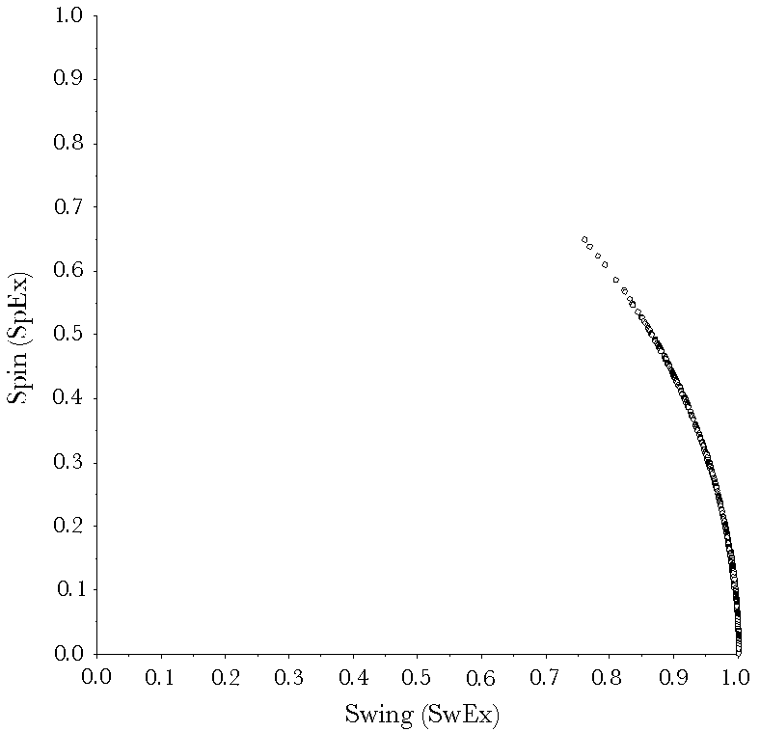
Figure 18. The distribution of spin (SpEx) as a function of swing (SwEx) for the horizontal rectus muscles. See the text for a description of the figure.

Spin versus Swing
The relationship between SpEx and SwEx for the restricted model is the same as in the free model, because the relationship is a property of rotations in three-dimensional space, not of any particular muscle system. The details of this relationship have been examined elsewhere.

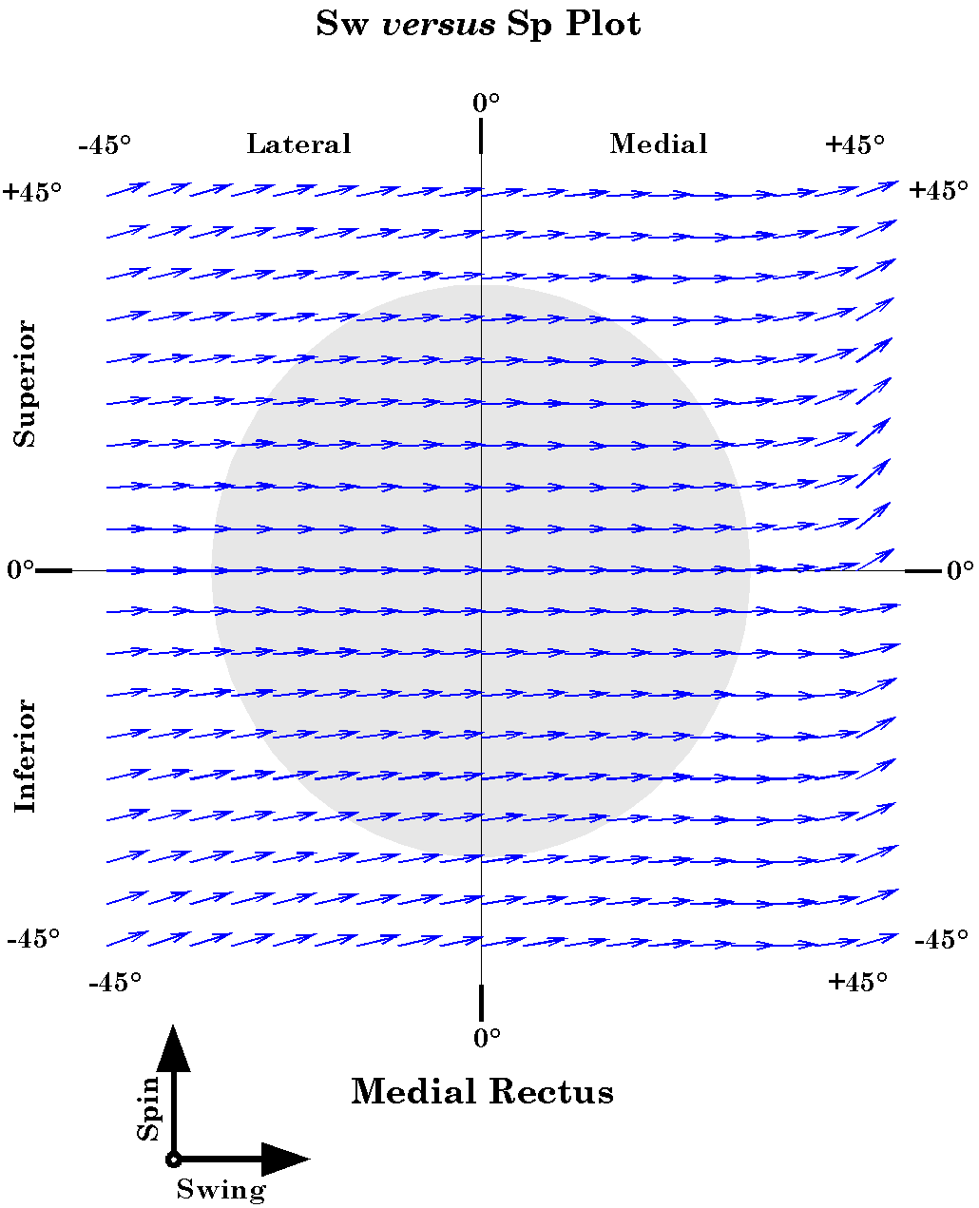
Figure 19. The distribution of swing (SwEx) and spin (SpEx) for the medial rectus muscle as a function of horizontal and vertical gaze: Restricted muscle model. The conventions are the same as for the muscle pull figures except that the vector is vector sum of the swing (SwEx: horizontal) and the spin (SpEx: vertical), multiplied by 5° to increase visibility.
The main difference that we note in the plots for the restricted muscles is that they do not extend to as small values of swing, therefore they do not have as much spin. Despite this general relationship, the vertical recti do produce movements with considerable spin, well over 50% of the muscle excursion.

Swing and Spin

Medial Rectus
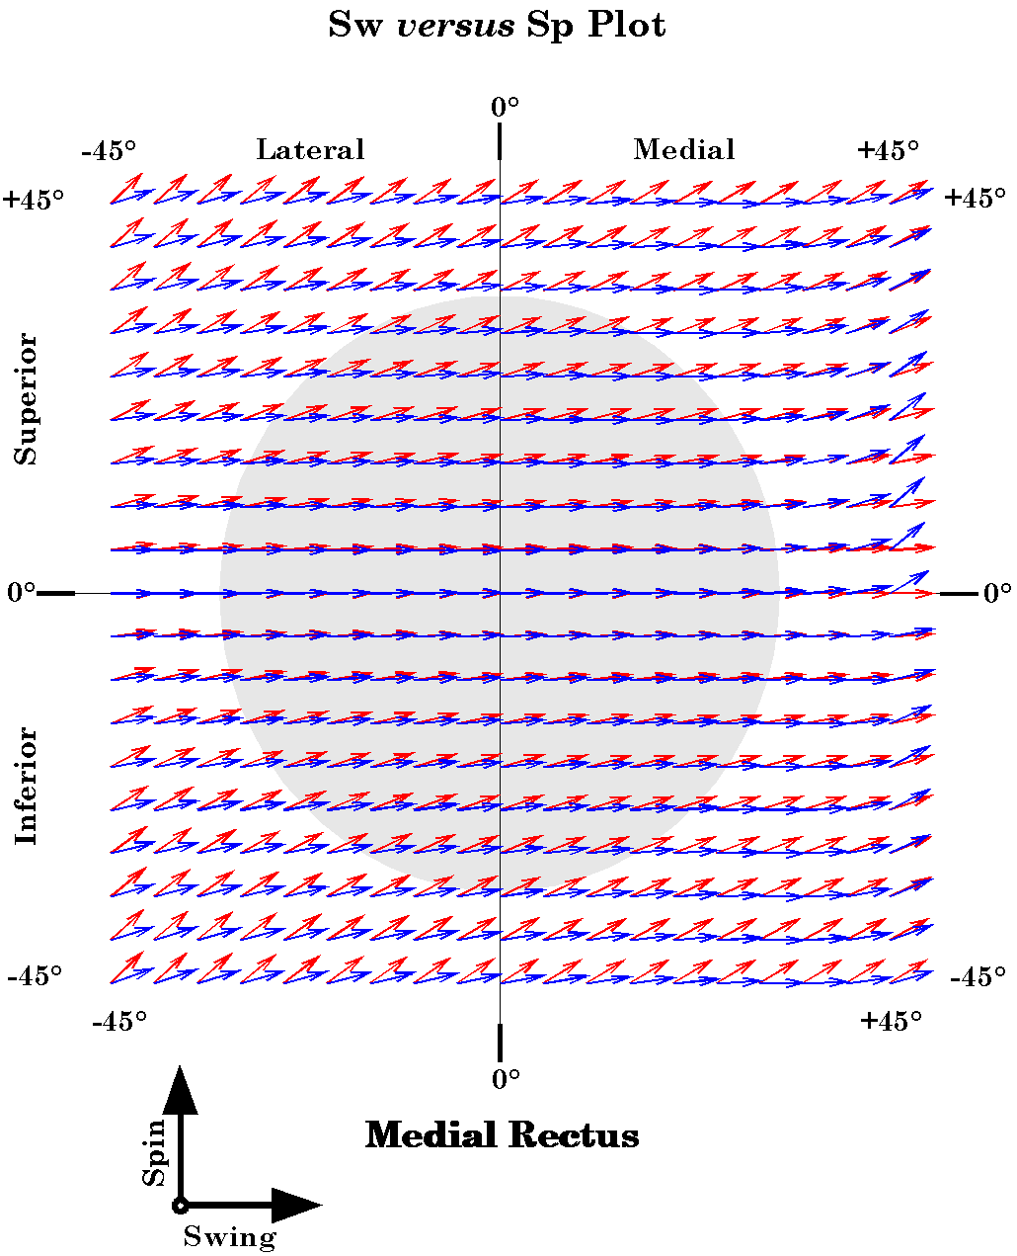
Figure 20. Comparison of the swing (SwEx) and spin (SpEx) for the lateral rectus muscle in the free and restricted muscle models. The blue vectors are the vectors for the restricted model and the red vectors are the data from the free muscle model.
Twitches of the medial rectus muscle produce almost pure swing at every gaze within the normal range of eye movements (figures 19 and 20). Even outside the normal range the pulls of the medial rectus muscle have very little spin. This is in accord with the pattern for the free muscles model, where the medial rectus generated comparatively little spin, however, the spin is substantially less with the restricted muscle.

Lateral Rectus

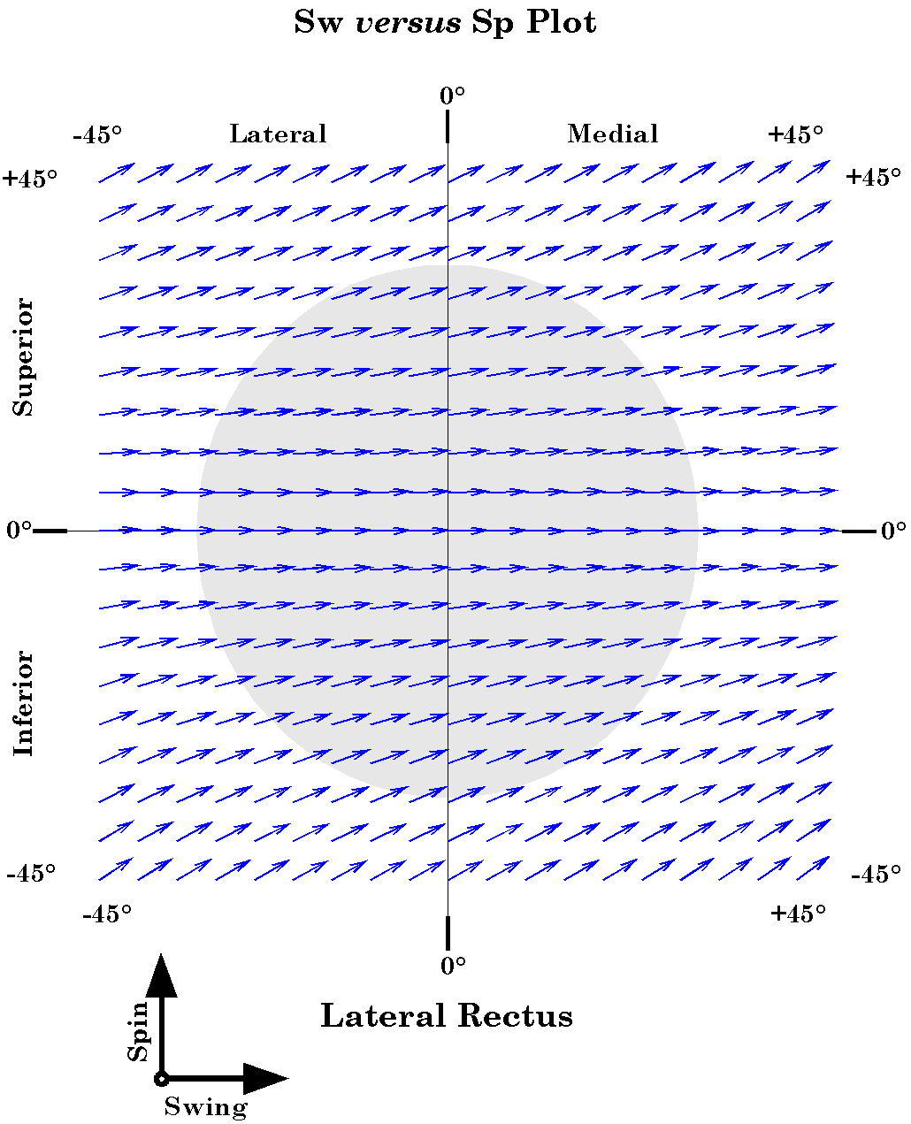
Figure 21. The distribution of the spin (SpEx) and swing (SwEx) of the lateral rectus muscle as a function of horizontal and vertical offset from neutral gaze: Restricted muscle model. The conventions are the same as for the medial rectus figures.
The pattern for the lateral rectus is much the same but there is much more spin than for the medial rectus muscle (Figures 21 and 22). It is noteworthy for the most elevated and depressed 15° of gaze. Still, as with the medial rectus, the amount of spin at any gaze is substantially less than for the free muscle model.
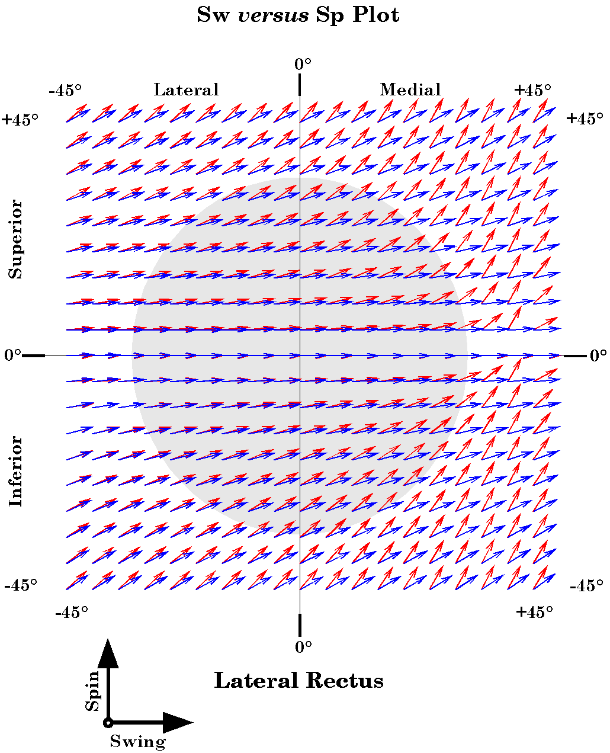
Figure 22. Comparison of the swing (SwEx) and spin (SpEx) for the lateral rectus muscle in the free and restricted muscle models. The conventions are the same as for the medial rectus figures.

Superior Rectus
The situation for the superior rectus is similar in that there is comparable spin in all gaze directions within the normal range of movements. There may be more or less spin in the more eccentric positions, depending on which direction the eye is looking (Figures 23 and 24). In the restricted muscle model there is more spin as the eye nears its nasal limit.
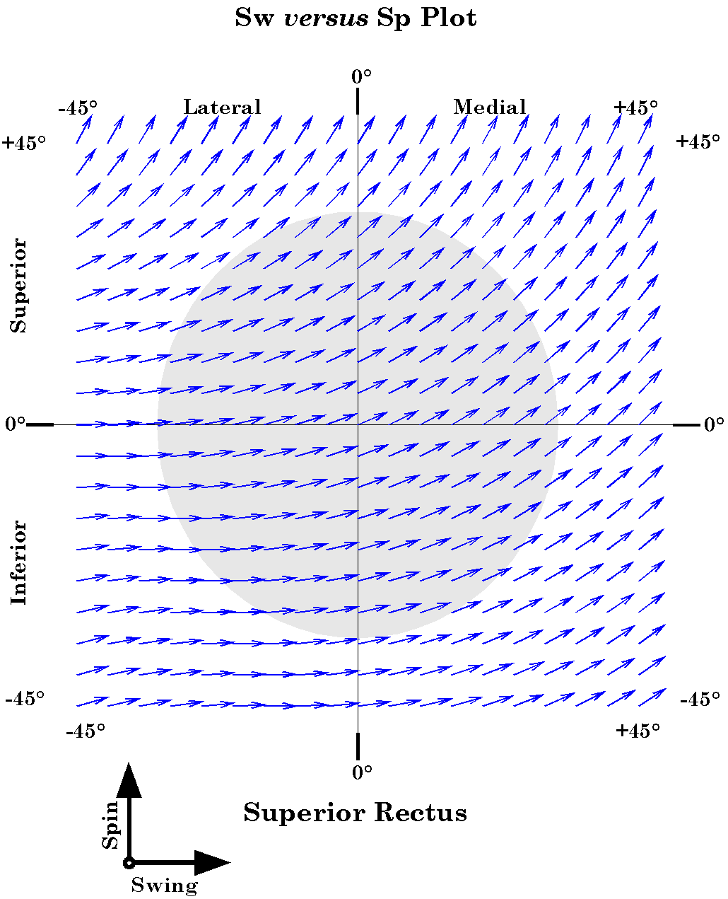
Figure 23. The distribution of the spin (SpEx) and swing (SwEx) of the superior rectus muscle as a function of horizontal and vertical offset from neutral gaze: Restricted muscle model. The conventions are the same as for the medial rectus figures.

Inferior Rectus
The pattern for the inferior rectus is similar to that for the superior rectus, except that there is less spin at all gazes where there is spin (Figures 25 and 26). There is substantially less spin than in the free muscle model. There is appreciable spin for all gaze directions medial to the vertical meridian.

The Obliques
The pattern for the obliques is the same as in the free muscle model because we have not restricted them in the current version of the restricted model.

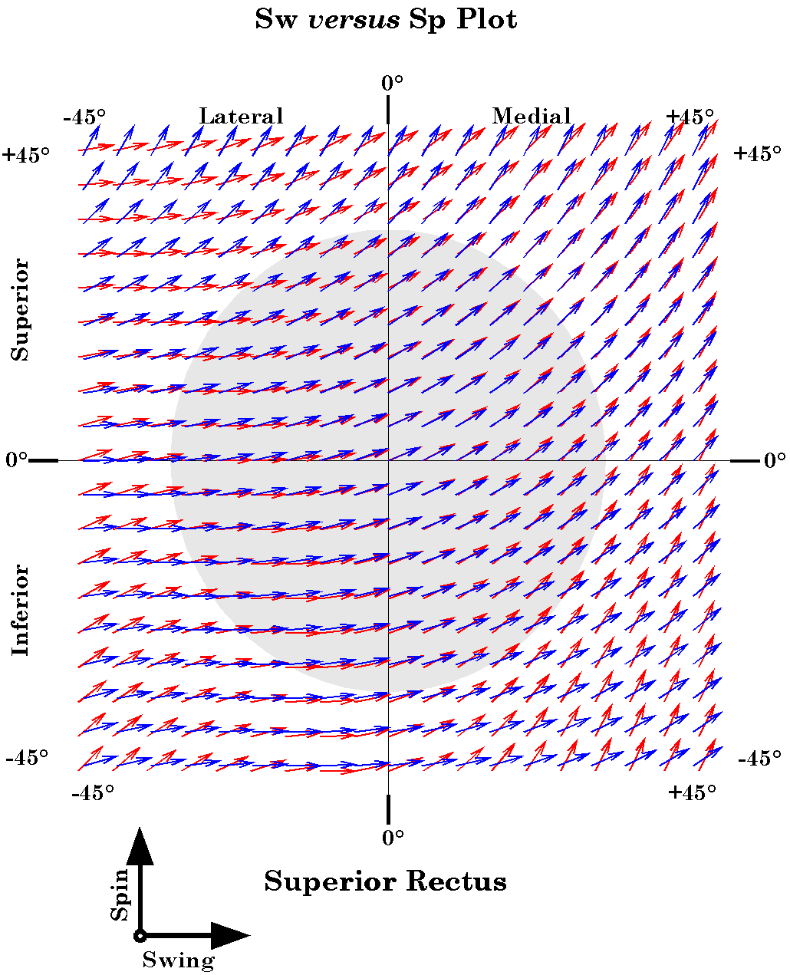
Figure 24. Comparison of the swing (SwEx) and spin (SpEx) for the superior rectus muscle in the free and restricted muscle models. The conventions are the same as for the medial rectus figures.

Summary
The recti, other than the superior rectus muscle, pull more consistently along the horizontal and vertical meridia in the restricted muscle model. The superior rectus is about the same in the range of normal eye movements. The great majority of the pull is directed into swing, that is moving the line of sight. There is less torsion except at the extreme limits of the normal range of eye movements. These observations probably mean that more of the responsibility for the automatic torsional compensation for eccentric gaze falls upon the oblique muscles.
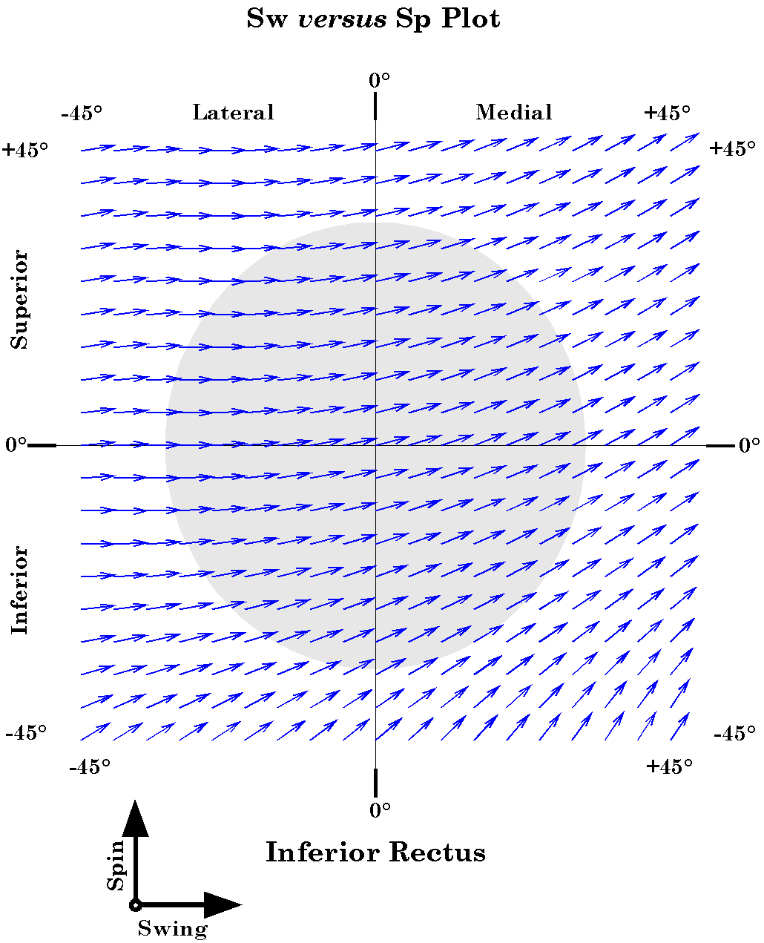
Figure 25. The distribution of the spin (SpEx) and swing (SwEx) of the inferior rectus muscle as a function of horizontal and vertical offset from neutral gaze: Restricted muscle model. The conventions are the same as for the medial rectus figures.

Discussion

Combined Muscle Pulls
Clearly, there are two orthogonal agonist-antagonist pairs of rectus muscles; the horizontal and vertical recti. These pairs pull nearly true horizontal or vertical in the normal range of eye movements. However, it is couplings between a horizontal rectus muscle and a vertical rectus muscle that will move the eye into most regions of the motor range. We should expect the truly interesting coordination in eye movement control to be those that exist between the vertical recti and the horizontal recti.
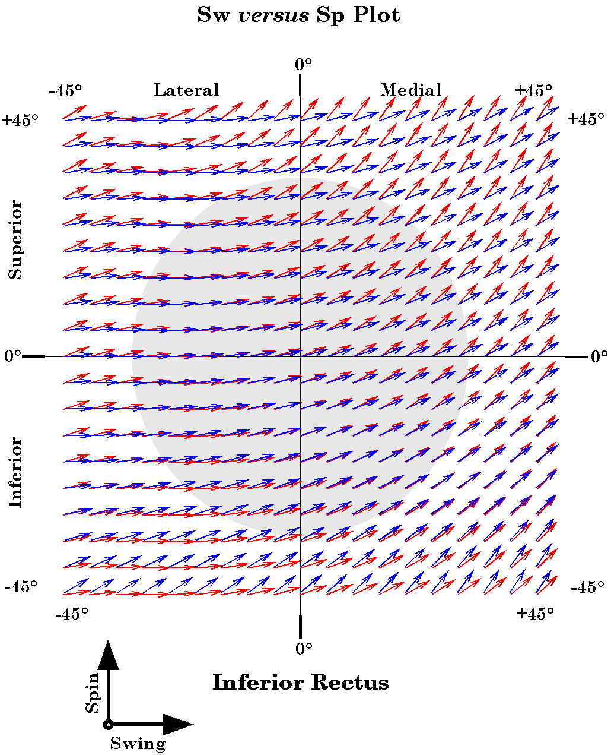
Figure 26. Comparison of the swing (SwEx) and spin (SpEx) for the inferior rectus muscle in the free and restricted muscle models. The conventions are the same as for the medial rectus figures.
Note that though we exert ourselves to assign roles to the various muscles, such as elevator/depressors, medial/lateral deviators, intorsion/extorsion, these are largely irrelevant in the final analysis. It is the muscle lengths that are the critical determinant of gaze. If the muscles are all of the appropriate length, then all the elevation/depression, medial and lateral deviation, and torsion will cancel out and the eye will be correctly directed and oriented. Every movement, be it as simple of abduction in the horizontal meridian or as complex as a diagonal saccade, requires that all the eye muscles change their length appropriately. It is easy to forget that all the other terminology and concepts are what we bring with our analysis, to help us understand the movements.
The greater parallelism in the pulling directions of given rectus muscles is neater to our eye, but it does not actually make a great deal of difference to our understanding of the eye movements. It does mean that the horizontal recti are horizontal deviators and the vertical recti are vertical deviators, to the first approximation. They do not introduce a great deal of torsion to the eye, except as normally happens because of the properties of rotations in three-dimensional space.

Physiological and Path-dependent Torsion
It is necessary to differentiate two different sources of torsion. The first is a physiological torsion. It is the type of torsion that might occur if we found the eye looking laterally and applied a small shock to one of the oblique muscles, causing it to twitch. Because the pulling direction of those muscles is roughly perpendicular to the line of sight, the eye would twist a short distance either into intorsion or extorsion, depending on which oblique was stimulated. That type of torsion is caused by the proper action of a muscle and one can choose to create it or not by greater or lesser activation of a muscle.
The second type of torque is pathway-induced torque. If we could cause the superior rectus to contract and draw the eye 10° superiorly and then cause the lateral rectus to contract and draw the eye 10° laterally, then the eye would be roughly 10° superior and 10° lateral to neutral gaze and it would be extorted relative to neutral gaze. If, on the other hand, we caused both muscles to contract the same amount, but together, so that the eye swung directly from neutral gaze to the gaze directed 10° up and 10° lateral, then the eye would be looking in the same direction, but it would not have any torsion relative to neutral gaze. The torsional difference between these two gazes is a property of three-dimensional space. It is the result of the differences in the different paths used to reach the same gaze position. It can not be changed, except by changing the path taken.
This second example is completely artificial in that it not how the eye movement system works. If one actually performed the sequence of movements, they would observe that the eye has zero torsion relative to neutral gaze independent of the path taken. That is because the eye movement system automatically corrects for the path dependent torsion. One of the most fascinating problems in understanding the control of eye movements in determining how it accomplishes this automatic path independence.
The role of the torsional muscles is not clear. It is clear that there is a need for torsional muscles, because it is necessary to have six independent muscles to control both gaze direction and gaze orientation. However, why is there so much more torsion in the lateral gaze quadrants than in the medial quadrants? Is it possible that in the lateral quadrants, the two torsions normally almost cancel each other out and that slight imbalance that is left over is used to cancel the torsion introduced by the recti. If so, the torsional properties of the oblique muscles may be no more relevant to gaze than the torsional properties that are intrinsic to the recti in off-center gaze.

Penumbral Fascial Tension: The Unseen Force
We have concentrated our analysis upon the movements induced by muscle contractions and steady state tensions. However, there is another source of forces that has not been analyzed, largely because it has not been appreciated as a potential eye mover. As was noted above, there is a penumbra of fascial membranes that encircle the globe and attach to the orbital wall (Duke-Elder and Wybar 1961; Demer, Miller et al. 1995; Williams, Bannister et al. 1995). These connections tend to hold the eyeball and the retrobulbar soft tissues suspended in the orbit. It has been noted that the penumbra attaches like a drumhead and therefore has the potential to passively drive the eye back towards neutral position
It would appear that the penumbral tensions are arranged so that the minimal overall tension in the penumbra occurs when the eye is in neutral position. In vegetative coma and in the recently dead the eyes are directed and oriented to lie near neutral gaze (Adams and Victor 1993). In both of these conditions the brainstem drive has been lost, so we are seeing the effects of the passive tensions in the eye muscles and the orbital penumbra.
Any deviation from neutral is going to stretch a portion of the penumbra and the portion of the penumbra that is most stretched is going to be the portion that will drive the eye directly towards neutral gaze. Beyond that, movements that move radially from neutral gaze will create tensions that are directed towards neutral gaze, but movements that are not spin null with respect to neural gaze will also produce an additional force component that will try to draw the gaze towards spin null gaze.
It should be mentioned that there may be another source of restorative rotatory force acting upon the eyeball. The retrobulbar space between the extrinsic eye muscles is occupied by considerable fat that is separated into sections by fascial partitions that extend inwards from the global surfaces of the eye muscles. Movements of the eye are going to change the distribution of forces in the fat pad, compressing some sectors and expanding others, thereby setting up a set of tensile forces that are acting towards returning all the sectors to their normal volume and the eye towards neural gaze.

Summary
While it has been well documented that the extraocular eye muscles are constrained by fascial slings as they pass through the penumbra that supports the eyeball in the orbit, it is not clear if this arrangement confers some advantage for the eye movement system or if it is simply a consequence of the muscles having to pass through the fascial barrier formed by the suspensory structures. By comparing the eye movements in both systems, we can begin to address this problem in a quantitative fashion. This comparison indicates that there are some comparatively minor differences when the functional origins of the recti are moved to positions just caudal to the equator of the eyeball. In general, there is some flattening of the muscle length surfaces and the pulling directions are rendered more true horizontal and vertical. These differences are correlated with a reduction in the amount of spin intrinsic to the rectus muscles pulls. This simplifies the system to our understanding, but it is not clear that it makes a great deal of difference to the eye control system. The torsional components of eye movements between off center eye movements are intrinsic to the geometry of the eye and space. They are compensated for by the eye movement control system by selecting the combinations of muscle lengths that will place the eyeball in the correct orientation for its current gaze direction. Any system that can determine that surface, presumably by learning, will be able to consistently produce the correct eye movement and static gaze irrespective of where the eye movement starts or ends. The order of eye movements is also irrelevant since the system will always produce the correct eye movement for the particular starting and ending position.
Since we can clearly learn the eye length surface and learn to adjust it when we put on distorting lenses, such as corrective glasses, it follows that independent of the detailed geometry of the eye, the system will work equally well if the muscles are free or restricted.

Bibliography
Adams, R. D. and M. Victor (1993). Principles of Neurology. New York, McGraw-Hill.
Clark, R. A., J. M. Miller, et al. (1997). “Location and stability of rectus muscle pulleys. Muscle paths as a function of gaze.” Invest Ophthalmol Vis Sci 38(1): 227-40.
Clark, R. A., J. M. Miller, et al. (2000). “Three-dimensional location of human rectus pulleys by path inflections in secondary gaze positions.” Invest Ophthalmol Vis Sci 41(12): 3787-97.
Demer, J. L., J. M. Miller, et al. (1995). “Evidence for fibromuscular pulleys of the recti extraocular muscles.” Invest Ophthalmol Vis Sci 36(6): 1125-36.
Demer, J. L., S. Y. Oh, et al. (2000). “Evidence for active control of rectus extraocular muscle pulleys.” Invest Ophthalmol Vis Sci 41(6): 1280-90.
Demer, J. L., V. Poukens, et al. (1997). “Innervation of extraocular pulley smooth muscle in monkeys and humans.” Invest Ophthalmol Vis Sci 38(9): 1774-85.
Duke-Elder, S. and K. C. Wybar (1961). System of Ophthalmology. London, Henry Klimpton.
Williams, P. L., L. H. Bannister, et al. (1995). Gray's Anatomy. The Anatomical Basis of Medicine and Surgery. New York, Churchill Livingstone.

