The Static Gaze Surface and Null Spin Saccades:
Spin Neutrality and Saccadic Trajectories

Thomas P. Langer

Spin Neutral Saccadic Eye Movements

Introduction

Donder’s Law and Listing’s Plane
As the eye scans the visual world the direction that it is looking, the line of sight, changes systematically. As the line of sight changes the orientation of the eye must also change. The line of sight and the orientation of the eye, together, will be called the gaze. The line of sight is the gaze direction and the orientation of the eye is the gaze orientation. In active vision, the visual world is projected upon the retina of an eye so that the horizontal and vertical axes of the visual world project as nearly as possible upon the horizontal and vertical meridia of the retina. This situation is observed experimentally and it has been called Donder’s Law. It turns out that the consequence of this functional restriction is that the orientation of the eye at all gaze directions is the orientation that would result from the eye moving away from neutral gaze along a great circle arc. Neutral gaze is the gaze when the eye is looking straightforward. A secondary consequence is that the axes of rotation for all such rotations would lie in a single plane perpendicular to the line of sight in neutral gaze. Such a plane is in fact experimentally observed and it has been called Listing’s Plane. It is also observed that all saccadic eye movements to, from, or through neutral gaze have an axis of rotation that lies in a plane perpendicular to the line of sight in neutral gaze,

Spin Neutrality
While the concepts are fairly complex when viewed closely, if we simplify, the rotatory movements generally change the orientation of the rotated object by imparting both swing and spin. In the instance of eye movements, spin is the rotation that occurs about the line of sight and swing is the rotation that occurs about an axis perpendicular to the line of sight. If the eye moves along a great circle trajectory, then there is no spin introduced by the eye movement. All other eye movement trajectories will introduce spin. For the purposes of this discussion we call a gaze that has no spin relative to neutral gaze a spin neutral gaze. A spin neutral gaze is a gaze that may be obtained by rotating the eye from neutral gaze along a great circle trajectory.
Gaze may be spin neutral relative to some other reference gaze if one chooses, but it is necessary to specify the reference gaze if it is not neutral gaze. If the reference gaze changes, the set of spin neutral gazes changes correspondingly. One can always tell if a gaze is spin neutral relative to another gaze by applying the great circle criterion. It is also possible to compute the amount of swing and spin that will transform one orientation into another.

Non-geodesic Eye Movements
Movements along great circles are geodesic movements, meaning that they are the trajectories between two points on a surface that will have minimal length. Surprisingly, most eye movements do not move along geodesics between their initial position and their final position. This is because such trajectories would cause spin of the visual world upon the retina. This is initially unexpected because it was just stated that normally static gaze is spin neutral relative to neutral gaze. So the starting position is spin neutral and it was just stated that great circle trajectories do not introduce any spin, so one would expect that the at the end of the movement the gaze would still be spin neutral. However it is easy to prove that while it will be spin neutral relative to the starting gaze and the starting gaze is spin neutral relative to neutral gaze, it will not be spin neutral relative to neutral gaze. The only exception is if the initial and final gazes are on a great circle that passes through neutral gaze. In brief, spin neutrality is not a transitive property of gaze.
This brings up the question of whether there is a trajectory that will translate the initial gaze into the final gaze with both being spin neutral relative to neutral gaze and, if so, what its properties might be. In particular, is there a smooth arc that will connect the two spin neutral gazes? This discussion will examine this question and find a solution in terms of conical rotations, that is rotations about an axis that at either an acute or an obtuse angle to the primary axis of the orientation. It will turn out that such trajectories have the very nice property that all the intermediate positions are also spin neutral, therefore the entire trajectory will move along the static gaze surface in a space of muscle lengths versus eye position.

Conical Rotations That Maintain Spin Neutrality
Geodesic trajectories do not maintain spin neutrality, but saccadic eye movements appear to follow fairly direct paths between the initial and final eye positions. The question arises as to how much the spin neutral trajectory deviates from the geodesic trajectory connecting the same two eye positions. Is it credible that the eye movement system might use conical rotations?
The greater the distance between the initial and final directions of gaze, the greater the deviation of the path from a geodesic. For small excursions the deviation of the spin neutral trajectory from the geodesic is comparatively small. For large excursions there is a substantial separation between the two paths. Most eye movements are fairly small. Trajectories that pass near neutral gaze will deviate less from the geodesic than pathways that connect gazes that are both far from neutral gaze in the same direction. Therefore, the real test will be for large saccadic eye movements that connect gazes that lie some distance from neutral gaze in the same direction.

The Calculation of Conical Rotations That Maintain Spin Neutrality
For the purposes of opening this analysis, we will take a saccade to be a single smooth rotational eye movement between an initial gaze position and a terminal gaze position with a fixed axis of rotation. It will be argued later that these are not the criteria that the nervous system used in determining the saccade, but they allow us to compute the trajectory with the appropriate characteristics. It is possible that the criteria used by the nervous system will produce the same result, but for different reasons.
A saccade that begins and ends with the gaze spin neutral with respect to neutral gaze will be called a spin neutral saccade. The relationship between the axis of rotation for a spin neutral saccade and the magnitude and direction of the eye movement is a very complex one. However, it can be expressed quite efficiently. If is the orientation frame for the line of sight at the origin of the movement and is the orientation frame at the terminus of the movement there is a rotation which will carry into , therefore is the ratio of to .

Both and are spin neutral relative to neutral gaze, therefore is completely determined. Note that, unless the origin and terminus are along the same great circle through neutral gaze, the two orientations will not be spin neutral relative to each other although, they are both spin neutral relative to a reference line of sight.
The ratio of the two orientations is a unit quaternion, which may be written as follows.
$$R=\text{cos}α+\text{sin}α∗v$$
The axis of rotation for the transformation will be the vector of the quaternion, v; the magnitude of the angular excursion will be the angle of the quaternion, . If the line of sight is represented by a unit vector, , aligned with it, taking its origin at the center of rotation for the eye, then the trajectory of the eye between the two gaze positions is given by the following expression.

$$\begin{aligned}λ\left(t\right)=R\left(t\right)∗λ\left(0\right)∗R^{−1}\left(t\right); \\ R\left(t\right)=\text{cos}t+\text{sin}t∗v; \\ 0≤t≤α,\text{ is a smooth monotonic function of time, t}\text{.}\end{aligned}$$

Methods
The model described below was translated into a Mathematica program that was run on a Power Mac G4. Some of the data figures were taken directly from the Mathematica output and some were processed through Excel spreadsheets.

Analytical Solutions for Special Cases

The Axis of Rotation for Spin Neutrality Depends on Initial and Terminal Gaze Directions and the Distance Between Them
If the eye moves between gaze directions that lie on a great circle through neutral gaze, then the vector of the rotation quaternion that introduces no spin is orthogonal to the plane of the movement. It lies in Listing’s plane because that is the definition of Listing’s plane. Listing’s plane is perpendicular to the line of sight in neutral gaze.

Figure 1. The movement starts at the lateral pole and swings to a position along the vertical meridian. The chessman at the lateral pole and the lower knight at the vertical pole are spin neutral relative to neutral position. The upper chessman at the vertical pole is correctly oriented for an excursion that carries the chessman at the lateral pole along the great circle to the vertical meridian. It can be seen that the upper chessman at the vertical pole is rotated relative to the lower chessman at the same position. The magnitude of the rotation is equal to the angle between the vertical meridian and the great circle trajectory.
The knight is transformed by rotation about a vertical axis to carry it to the lateral pole and about a horizontal axis to carry it to the vertical pole. The axis of rotation from 90° lateral to 90° superior is posteriorly directed. It leaves the knight rotated 90° relative to the knight that moved directly to the vertical pole. In order to bring it into the same orientation, it must be rotated about a vertical axis. See the text for details.
To facilitate visualization of the concepts discussed below, the eye has been replaced in the figures by a simple, but familiar orientable object, a knight chess piece. It is easier to appreciate the orientation of the chessman than a spherical object, like the eye, or a set of vectors, like an orientation frame. The convention will be that the knight is facing in the direction of the line of sight or the primary vector, x; a vector perpendicular to its left side will be the horizontal secondary vector, y; and a vector through the top of its head will be the vertical secondary vector, z. Together the vectors form a right-handed frame of reference.
If the initial gaze direction is some distance from neutral gaze and the eye moves to another position some distance from neutral gaze in a trajectory along a great circle that does not pass through neutral gaze, that trajectory will introduce a spin in the eye relative to neutral gaze. For instance, if we consider a non-anatomical, but easily visualized example, the geodesic trajectory that moves the eye from the lateral pole to the superior pole introduces 90° of spin (see above, Figure 1). The axis of rotation for that rotation lies on a line through the posterior pole of the eye.
The constant rotational trajectory that carries the eye between the same two points without introducing a spin is a circular arc about an axis centered in the posterior, superior, lateral, quadrant of the eye’s coordinate system at rest (see following figure). If the eye were moving in the opposite direction, from the superior pole to the lateral pole, the axis of the rotation would be in the opposite direction, but along the same axis.
If the trajectory were broken up into a series of smaller saccades, say each 10° of elevation, then the null spin trajectories would be closer to a great circle through the origin and terminus of the movement, therefore about an axes that exit the eye near its posterior pole. The axis of rotation varies not only with starting position and direction, but also magnitude of the movement.
Figure 2. A sphere with the axis of rotation and the conical swing surface illustrated. The intersection of the horizontal and vertical meridia is the neutral position. The excursion that carries a spin neutral orientable object at the lateral pole into the same object in a spin neutral orientation at the vertical pole will be the about the vector in the upper posterior lateral quadrant of the sphere, sweeping along the conical surface that is shown penetrating the sphere’s surface.
It is easily seen that the system is very non-linear. If one specifies only the beginning and end and the movement keeps the eye spin neutral relative to neutral gaze, then the rotation is expressed by a particular quaternion. However, if the movement is broken into a series of small steps, then the step’s rotation quaternions have axes that have very different directions. In a trajectory of many small steps the spin is being introduced in a very different manner than if there is a single step. Therefore there might be a considerable difference between the manner in which a saccadic eye movement and a smooth pursuit eye movement occur. A saccadic eye movement needs to be spin neutral only at its inception and conclusion. Smooth pursuit requires good vision throughout, therefore must be continuously spin neutral along its trajectory.

Special Case: Excursions from the Lateral Pole
We will start with a very simple, easily visualized situation and approach the fully general situation by a series of progressively more general situations. Along the way we can develop and practice the necessary mathematical tools.
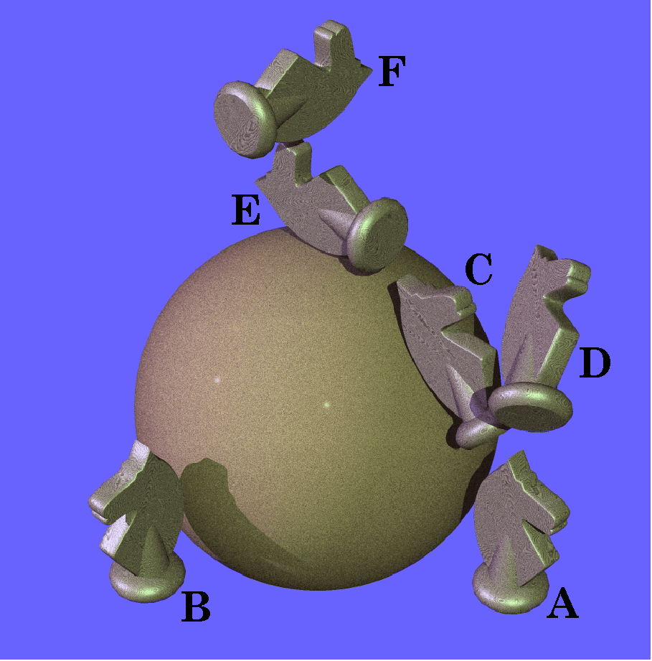
Figure 3. Movements from the lateral pole to the vertical meridian. The knight (A) is carried to the lateral pole (B) along a great circle trajectory and then along another great circle perpendicular to the horizontal meridian until it reaches the vertical meridian (F). Its orientation after that two step movement is compared with the orientation after a direct, great circle, trajectory from neutral position (E).
Let us first consider a special instance that is easy to visualize, but non-physiological for eye movements. Let the starting position for the movement be spin neutral gaze at the lateral pole of the globe (B) and consider the geodesic movements that carry the line of sight from the lateral pole to points along the vertical meridian. We wish to compare the orientation of the eye after the geodesic movement to its orientation if it had moved from neutral gaze (A) directly to its final position along the vertical meridian. All the geodesic movements from the lateral pole to the vertical meridian are the same size, 90° of excursion. The spin difference between the terminus of each geodesic movement and the gaze after moving along the vertical meridian from neutral gaze to the terminus is the elevation of the terminus relative to neutral gaze. For instance, if gaze moves from neutral gaze to the lateral pole (B) and then along the geodesic to a gaze direction 45° above neural gaze in the vertical meridian (D), then it will be rotated 45° about the line of sight relative to its the gaze if one started from neutral gaze and moved 45° directly up, in the vertical meridian (C). To an individual that experienced such a rotation the world would appear to have spun 45° in the direction opposite to the spin difference.
The simplest situation is a geodesic movement from a spin neutral gaze at the lateral pole (B), which will be obtained by rotation about the vertical axis of the globe. This situation was illustrated above in Figure 3. If a subsequent geodesic is taken from the lateral pole to the vertical pole (F) it will impart a spin of 90° to the orientation frame relative to the spin neutral gaze at the vertical pole (E). Such a rotation will have an axis of rotation aligned with the negative anterior/posterior axis of the orbit. The null spin trajectory that carries the eye from lateral gaze to vertical gaze will have a rotation axis centered in the posterior superior lateral quadrant of the orbit and an angular excursion of 120° (Figure 2).
For trajectories ending between neutral gaze and the vertical pole the axes of rotation for the spin neutral trajectory will lie between those two vectors. It remains to be verified computationally, but the trajectories probably lie in a plane at a 45° angle to Listing’s plane for movements to and from neutral gaze.

The Calculations:
To this point the argument has been mostly by hand-waving and appeals to intuition. We now consider how the results might be obtained by computation. The calculations are based upon simple quaternion algebra, therefore may appear strange, but it is a natural mathematical approach for analyzing rotations.

Rotation from lateral pole to superior pole:
Start with a simple example - the eye moving from the lateral pole to the superior pole. If the frame of reference in neutral gaze is with r along the line of sight, s directed medially, and t directed superiorly, then it may be represented as –

.
The i, j, and k are the universal coordinate axes for the space in which the rotations are occurring.

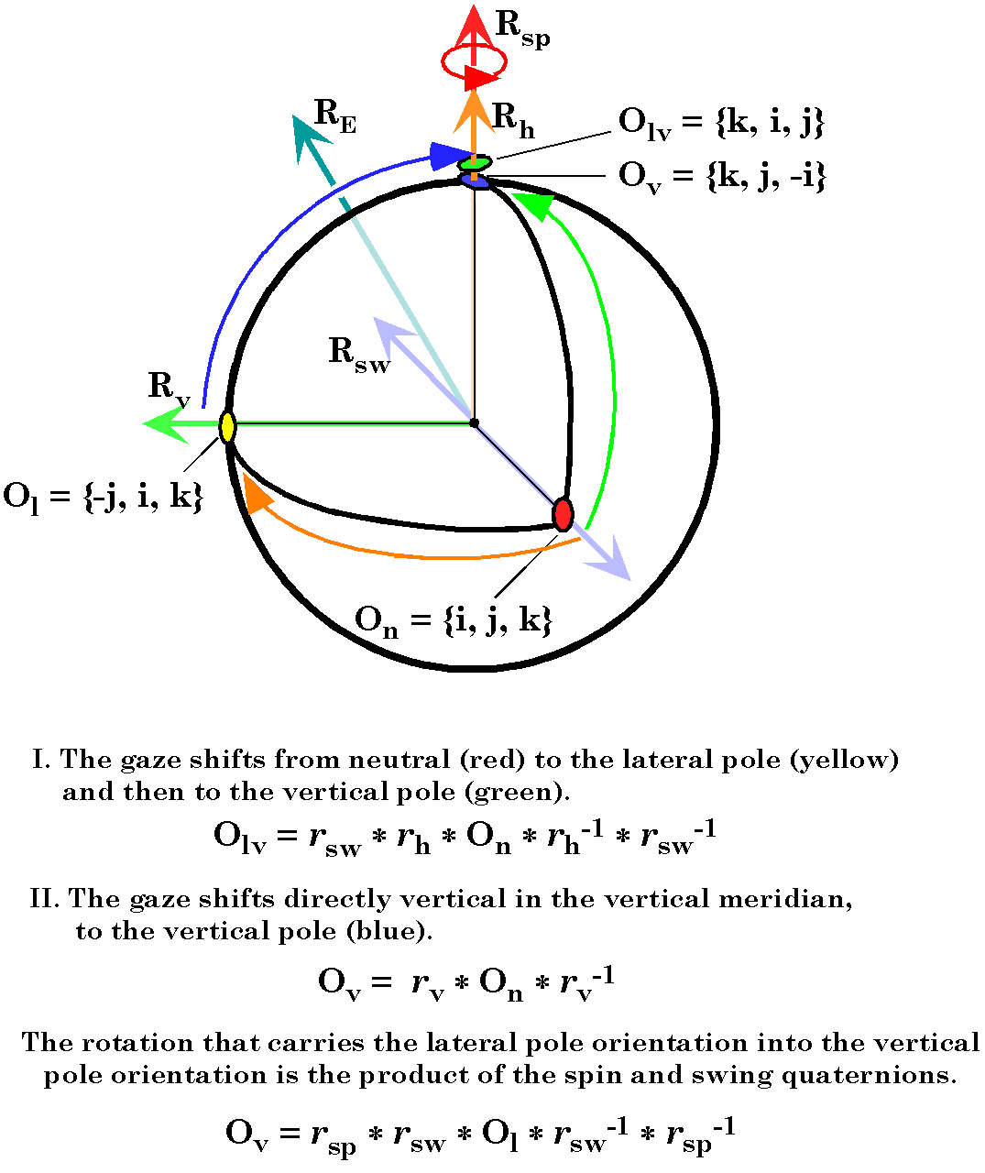
Figure 4. The movement starts at the lateral pole and swings to a position at the vertical pole. Two sets of movements are compared. The first carries an orientable object from neutral position to the lateral pole by swinging about a vertical axis of rotation ($R_{h}$) then to the superior pole by rotation about a posteriorly directed axis ($R_{\text{sw}}$). The second path is directly from neutral position to the superior pole, along a great circle trajectory, rotating about a laterally directed axis ($R_{v}$). The object does not have the same orientation at the end of the two trajectories. At the end of the first trajectory, it is rotated 90° relative to its orientation at the end of the second trajectory.
When the eye moves from neutral gaze to the superior pole along the geodesic path it rotates 90° about the negative j axis and the frame becomes

.
The half angle of the rotation quaternion is 45°, therefore the sine and cosine are both equal to the reciprocal of the square root of two. The result is as observed (Figure 4). The vertical axis is directed posteriorly (-i), the vector pointing to the left is still pointing to the left (j), and the anterior axis is pointing superiorly (k).
When the eye moves from neutral gaze to the lateral pole along the geodesic path the frame rotates 90° about the negative k axis and becomes

.
Again this is what is observed (Figure 4), the anterior axis is pointing to the right (-j), the left directed vector is now pointing anteriorly (i), and the vertical vector is still pointing superiorly (k).
If the eye swings from the lateral pole to the superior pole along the geodesic then it swings 90° about the negative i axis and the new frame coordinates are

.
As with the previous calculations this accords with observation of the rotation (Figure 4).
To bring the frame into alignment with the frame obtained by the direct path it is necessary to rotate the frame by 90° about the line of sight or the vertical or k axis.

.
The rotation from the lateral pole to the superior pole and then a 90° rotation about the vertical axis is expressed by a 90° rotation about the -i axis followed by a 90° rotation about the +k axis.

Note that the combination of the two successive rotations is equivalent to a single rotation about an axis centered in the superior posterolateral quadrant of the globe in neutral gaze Figure 4, R_{E}). The cosine of one-half the rotation is 0.5, which makes the excursion 2*60° = 120°.
These observations can be written down by inspection, because the geometry is very simple. However, it is necessary to develop a more general algebraic approach if the general solution is to be constructed.

Rotations from lateral pole to vertical meridian:
The next step is to generalize this approach to express the equivalent rotation axes for excursions of the eye from the lateral pole to points on the vertical meridian. This is still a very simple situation because the excursions are all 90° excursions along great circles through the medial and lateral poles.
The swing component occurs about an axis in the ik-plane. If $g$ is the angle of the plane containing the great circle with respect to the horizontal meridian, then the swing is expressed as a 90° rotation about the vector perpendicular to the plane of the great circle. The primary axis, x, prior to the rotation is $−j$ and after the rotation it is $i∗\text{cos}g+k∗\text{sin}g$. The ratio of the value after the rotation to that before the rotation is the swing quaternion.

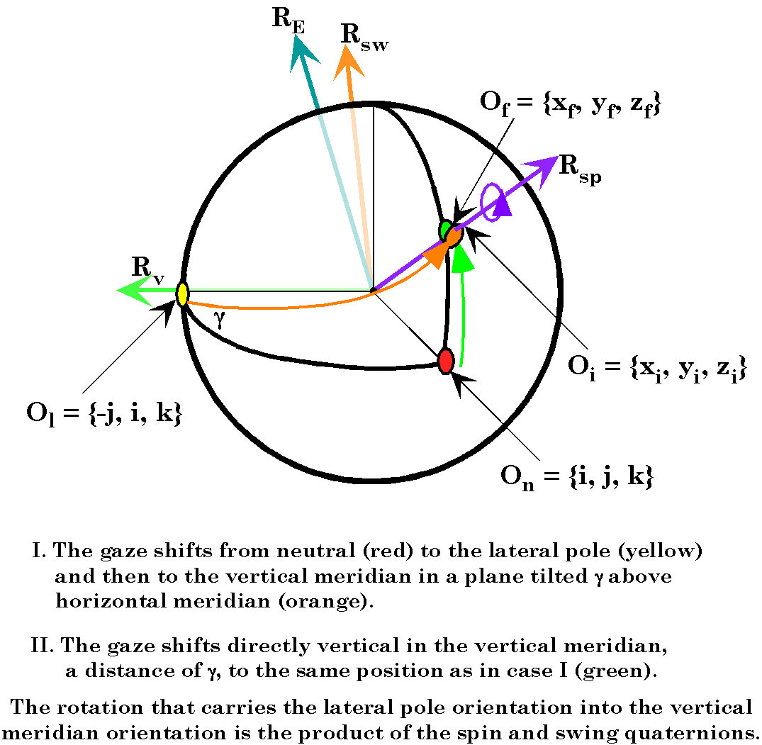
Figure 5. The movement starts at the lateral pole and swings to a position along the vertical meridian. Two sets of movements are compared. The first carries an orientable object from neutral position to the lateral pole by swinging about a vertical axis of rotation,$R_{h}$, as in Figure 4, then on a plane tilted at an angle γ to the horizontal meridian, to a position along the vertical meridian, by rotation about a posteriorly directed axis within the ik-plane.($R_{\text{sw}}$). The second path is directly from neutral position to the same position on the vertical meridian, along a great circle trajectory, rotating about a laterally directed axis ($R_{v}$). The object does not have the same orientation at the end of the two trajectories. At the end of the first trajectory, it is rotated through an angle γ relative to its orientation at the end of the second trajectory.
The spin component will be about the gaze direction, in the vertical meridian and of a magnitude of . It may be computed by computing the value of the secondary (y) axis after the swing and then the ratio of the final value of the secondary axis to that intermediate value. The secondary axis prior to rotation is $i$ and after applying the swing quaternion it is expressed as follows.

$$\begin{aligned}y_{i}=\frac{i∗\left(1−\text{cos}2g\right)+j∗2\text{cos}g−k∗\text{sin}2g}{2} \\ i∗{\text{sin}}^{2}g+j∗\text{cos}g−k∗\text{sin}g∗\text{cos}g\end{aligned}$$
The spin quaternion is the ratio of the final value, $j$, to this intermediate value, which is the following.

The sequential swing and then spin will be expressed as

where $r_{E}$ is the equivalent rotation quaternion. If we multiply the expressions and reduce, the expression for the equivalent quaternion is

One can see by inspection that the rotation axes are all in a single plane at a 45° angle to Listing’s plane that intersects Listing’s plane at the vertical pole. Also note that it gives the correct expression for the axis of the spin neutral movement from the lateral pole to the superior pole.
The amount of spin is determined by the angle between the secondary or horizontal tangential axis and the plane of the great circle. Since there is no spin when moving along a great circle the angle between the y component of the frame and the trajectory remains constant, in this case it is the angle at which the great circle leaves the lateral pole, .

Rotation from lateral pole to arbitrary gaze:
If the swing component in the last calculation were either more or less than a right angle then the spin would be correspondingly altered. Let be the swing relative to the vertical meridian, then the corresponding spin would be reduced by a factor of and about an axis through the new position.

The gaze is parallel with the unit vector given by the following expression.
$$λ_{G}=i∗\text{cos}β\text{cos}g+j∗\text{sin}β+k∗\text{cos}β\text{sin}g$$

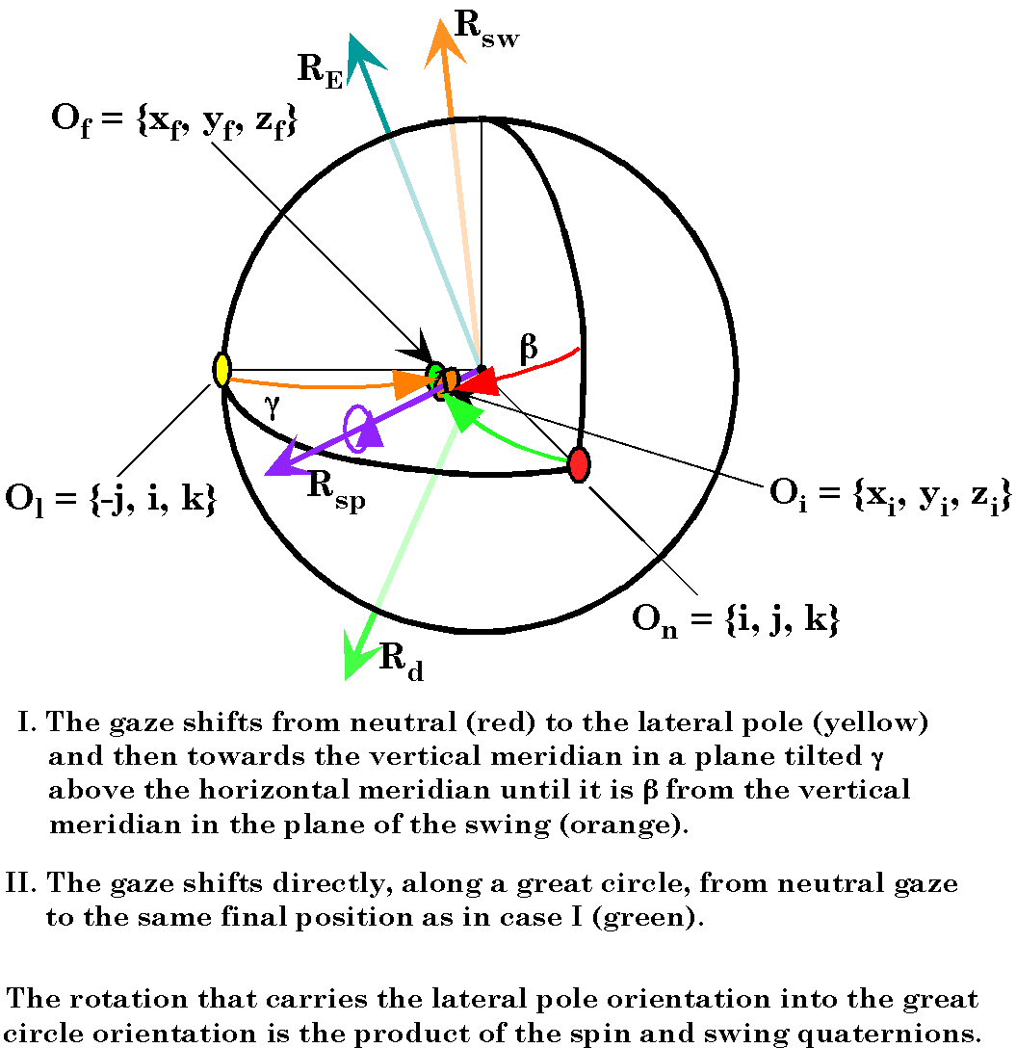
Figure 6. The movement starts at the lateral pole and swings to a position off the vertical meridian. Two sets of movements are compared. The first carries an orientable object from neutral position to the lateral pole by swinging about a vertical axis of rotation ($R_{h}$) then on a plane tilted at an angle γ to the horizontal meridian, to a position that is displaced from the vertical meridian by an angle β in the plane of the rotation, by rotation about a posteriorly directed axis in the ik-plane ($R_{\text{sw}}$). The second path is directly from neutral position to the same position, along a great circle trajectory, rotating about an axis in the jk -plane ($R_{v}$). The object does not have the same orientation at the end of the two trajectories.
The rotation quaternion that will turn neutral gaze to that gaze along a geodesic is the ratio of $λ_{G}$, the primary axis of the gaze frame, to $i$, the same entity in neutral gaze.
$$R_{G}=\text{cos}β\text{cos}g−j∗\text{cos}β\text{sin}g+k∗\text{sin}β$$
If we compute the value of the secondary axis of the frame of reference rotated from neutral gaze by $R_{G}$and from the lateral pole by$R_{\text{SW}}$, then the ratio of the two values will be the spin quaternion. The first calculation yields the following expression.
$$s_{G}=i∗\text{cos}β\text{sin}2g+j∗\text{cos}2β−k∗\text{sin}2β\text{sin}g$$
The second calculation yields the following expression.
$$\begin{aligned}s_{P}=i∗\text{cos}2β^{'}+j∗\text{sin}2β^{'}\text{cos}g−k∗{\text{sin}}^{2}β^{'}\text{sin}2g; \\ β^{'}=\frac{1}{2}\left[\frac{p}{2}+β\right]\text{.}\end{aligned}$$
However,
$${\text{sin \{}β}^{'}=\frac{\text{cos}\frac{β}{2}+\text{sin}\frac{β}{2}}{\sqrt{2}};\text{cos \{}β{}^{'}=\frac{\text{cos}\frac{β}{2}−\text{sin}\frac{β}{2}}{\sqrt{2}}$$
therefore
$$s_{P}=i∗\frac{\text{cos}β−\text{sin}β}{\sqrt{2}}+j∗\frac{\text{cos}β+\text{sin}β}{\sqrt{2}}∗\text{cos}g−k∗{\left(\frac{\text{cos}β+\text{sin}β}{\sqrt{2}}\right)}^{2}\text{sin}2g\text{.}$$
The ratio is given by the following quaternion.
$$\begin{aligned}R_{\text{SP}}=\frac{s_{G}}{s_{P}}=\frac{i∗\text{cos}β\text{sin}2g+j∗\text{cos}2β−k∗\text{sin}2β\text{sin}g}{i∗\frac{\text{cos}β−\text{sin}β}{\sqrt{2}}+j∗\frac{\text{cos}β+\text{sin}β}{\sqrt{2}}∗\text{cos}g−k∗{\left(\frac{\text{cos}β+\text{sin}β}{\sqrt{2}}\right)}^{2}\text{sin}2g} \\ \left(i∗\text{cos}β\text{sin}2g+j∗\text{cos}2β−k∗\text{sin}2β\text{sin}g\right)∗ \\ \left(−i∗\frac{\text{cos}β−\text{sin}β}{\sqrt{2}}−j∗\frac{\text{cos}β+\text{sin}β}{\sqrt{2}}∗\text{cos}g+k∗{\left(\frac{\text{cos}β+\text{sin}β}{\sqrt{2}}\right)}^{2}\text{sin}2g\right)\end{aligned}$$
The expansion of this product leads to an analytic solution that does not really help to understand the behavior of the system. It is not a simple, straight-forward, relationship, like that which was obtained in the previous two calculations. For instance, the magnitude of the spin, $j$, is given by the scalar term.

$$\text{cos}j=\text{cos}β\left[\text{sin}β\text{sin}g\text{sin}2g\left(\text{sin}2β+1\right)+\sqrt{2}\text{sin}g\text{cos}g\left(\text{cos}β−\text{sin}β\right)+\sqrt{2}\text{sin}β\left(\text{cos}β+\text{sin}β\right)\right]$$

As it stands, this does not help to see how the amount of spin depends on the angular excursion or the tilt of the plane of the geodesic. We would like to examine much more general situations than this, therefore it is sensible to forget the analytic solutions and create a computer model that will allow a much more detailed analysis, if not as clearly defined in it relationships.

A Model of Unitary Null Spin Saccades
It is possible to write down and analytically solve the general equations for the rotation axes of null spin saccades that carry the eye from one arbitrary gaze to another, the solution would be too complex to give a clear intuitive feeling for the nature of the solution. In lieu of such a solution it is possible to construct a computer model that allows one to examine the effects of various variables on the distribution of rotation axes as a function of initial and final line of sight for a saccade. The following is based on such a model.
The model is slightly different from that used above in the manner in which we choose gaze direction, but otherwise the same. It is assumed that both the initial gaze and the final gaze have null spin relative to neutral gaze. This is in accord with observation and has been codified as Donder’s Law. A null spin saccade is a single conical rotation about a particular axis of rotation that carries the initial gaze into the final gaze. Of particular importance is that it carries the initial orientation into the final orientation. Such saccades will cause the eye to both swing and spin, but the projection of the visual world will be appropriately oriented upon the retina at the beginning and end of the saccade.
The manner in which the model has been utilized is to select an initial gaze that is spin neutral relative to neutral gaze, then calculate the orientation of the eye for an array of other gazes that are spin neutral relative to neural gaze. The initial and final gaze directions are taken at intervals of five degrees from 45° depression to 45° elevation and from 45° medial rotation to 45° lateral rotation. These parameters probably exceed those for normal eye movements in all directions, with the possible exception of lateral rotation. For each element of the array, the model computes the null spin saccade that connects it to each of the other elements. By the null spin saccade we will mean the conical rotation that transforms the initial gaze into the final gaze, both of which are spin neutral relative to neutral gaze.
There are a number of ways that an array of gaze directions could be defined, each of which would give different sets of elements. Gaze direction will be defined as follows for the purposes of this analysis. First, look up or down in the vertical meridian of the eye through an angular excursion, $g$, the elevation relative to horizontal. Looking up is positive elevation and looking down is negative elevation. Second, from that elevated or depressed gaze, move medially or laterally an angular excursion, parallel with the horizon, $β$, called the medial or lateral turn. Turning medially is positive turn and turning laterally is negative turn. The advantage of this system of denoting gaze direction is the operations can be reversed and the same gaze direction is obtained. This is essentially the system used for longitude and latitude. For each gaze the line of sight is given by the following expression.
$$λ_{G}=i∗\text{cos}g\text{cos}β+j∗\text{cos}g\text{sin}β+k∗\text{sin}g$$
For each of these gazes the geodesic rotation is given by the rotation quaternion that is the ratio of the primary frame axis in the gaze to the same axis in neutral gaze.
$$\begin{aligned}R_{G}=\frac{λ_{G}}{i}=λ_{G}\text{*-}i \\ \left(i∗\text{cos}g\text{cos}β+j∗\text{cos}g\text{sin}β+k∗\text{sin}g\right)\text{*-}i \\ \text{cos}g\text{cos}β−j∗\text{sin}g+k∗\text{cos}g\text{sin}β\text{.}\end{aligned}$$
The elevation is $g$and the amount of medial or lateral turn is$β$. Note that the vector for all the rotation quaternions lies in the coronal plane, which is Listing’s plane. Note also that all the rotation quaternions are unit quaternions, but the vector of the quaternion is not a unit vector unless $β$ is zero.
For each of the array elements the conical rotation that will carry the initial gaze into the other array elements is computed as follows. First, calculate the pure swing that will carry the line of sight from the initial to the final gaze. Second, compute the orientation that will result if the initial gaze is carried through that swing. Then, third, compute the spin that will align the other two frame axes of the intermediate gaze with the same axes in the final gaze.
If the frame for the initial gaze is and the frame of the final gaze is , then the swing is -

The intermediate frame is

$r_{\text{sw}}$ is the quaternion with the same vector and magnitude, but half the angle of $R_{\text{sw}}\text{.}$
From that information we can compute the spin which is the ratio.

The rotation quaternion for the spin neutral saccade is the result of performing the swing and then the spin in sequence, therefore it is

and

The variable that is plotted in the following figures is the unit vector of the quaternion, . The unit vector of the rotation quaternion is the variable that lies in Listing’s plane when the initial gaze is neutral gaze. When the saccade starts with a gaze that is not neutral gaze, then the vector of the quaternion will generally not be in Listing’s plane. As will be demonstrated, for null spin saccadic excursions from an off-center gaze, the rotation quaternions have their vectors in a plane, but it is tilted relative to Listing’s plane for saccades to and from neutral gaze.
For convenience, let us call the vector of the rotation quaternion the rotation axis. For the circumstances of the eye model the rotation axis is always a unit vector. The angle of the rotation quaternion is its excursion. It is generally similar to the geodesic distance between the initial and final gaze positions, but not usually the same. For large saccades the two may be quite different.

The Distribution of Rotation Axes for a Fixed Initial Gaze

Saccades from Neutral Gaze
We expect the rotation axes for null saccades from neutral gaze to lie in a single plane orthogonal to the axis of neutral gaze. All the saccades will be geodesics since all the final orientations are spin neutral relative to neutral gaze. Since the null saccades are geodesics their excursions will be the distance from the initial gaze position to final gaze position.
The distribution of the axes of rotation can be analyzed from a number of perspectives. The first way that they will be viewed is as unit vectors arising from the sites of terminal gaze (Figure 7 . For each null spin saccade the unit vector of the quaternion that will carry the gaze from neutral gaze to the off center gaze is placed with its origin at the location of the terminal gaze direction. As can be easily seen, the vectors form a circular vector field centered upon neutral gaze. It is not perfectly circular, being slightly squared. In this particular instance all the rotation axes are confined to a single plane perpendicular to the line of sight. This will not be generally true.
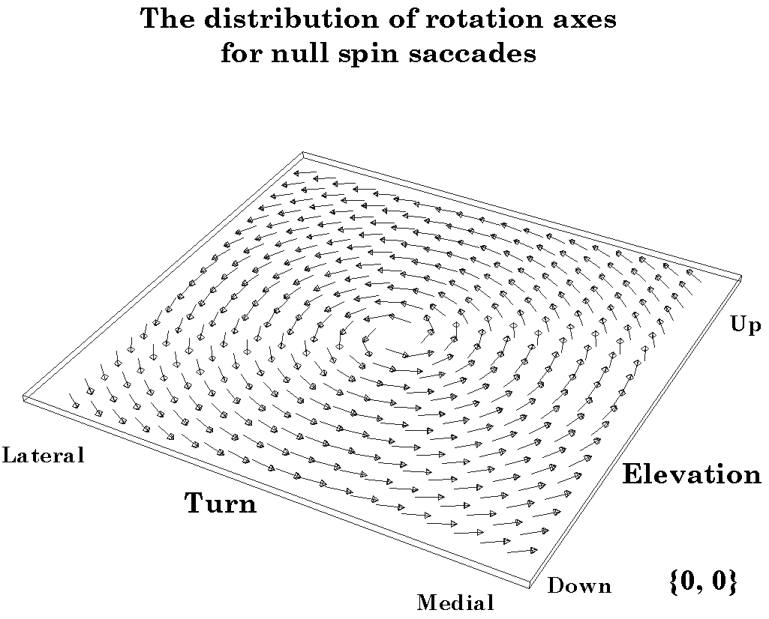
Figure 7. Axes of rotation for saccades from neutral gaze to an array of gaze positions. The arrow are unit vectors in the direction of the axis of rotation for a saccade from neutral gaze to the gaze at the origin of the vector. In this instance, all of the vectors lie in the same plane, perpendicular to the line of sight in neutral gaze.
The next figure illustrates the rotation axes of the null saccades as viewed from four points of view (Figure 8). The first view is a three dimensional image of the set of rotation axes, plotted so that they take their origin from a single point. It can be seen that the rotation axes are not uniformly distributed, but are grouped into four clusters with narrow gaps between. This due to sampling from a rectangular array. The second view is the projection of the vectors upon the back wall of the box that encloses the three-dimensional representation. It is the projection of the disc upon the coronal plane. In this instance, it is identical to the first representation except for being displaced posteriorly along the line of sight in neutral gaze. There are two more projections, but they are not obvious in this situation. The projection of the rotation vectors upon the floor (horizontal plane) and the side wall (sagittal plane) of the enclosing box are simply lines, because the rotation axes lie in a single plane, perpendicular to the line of sight.

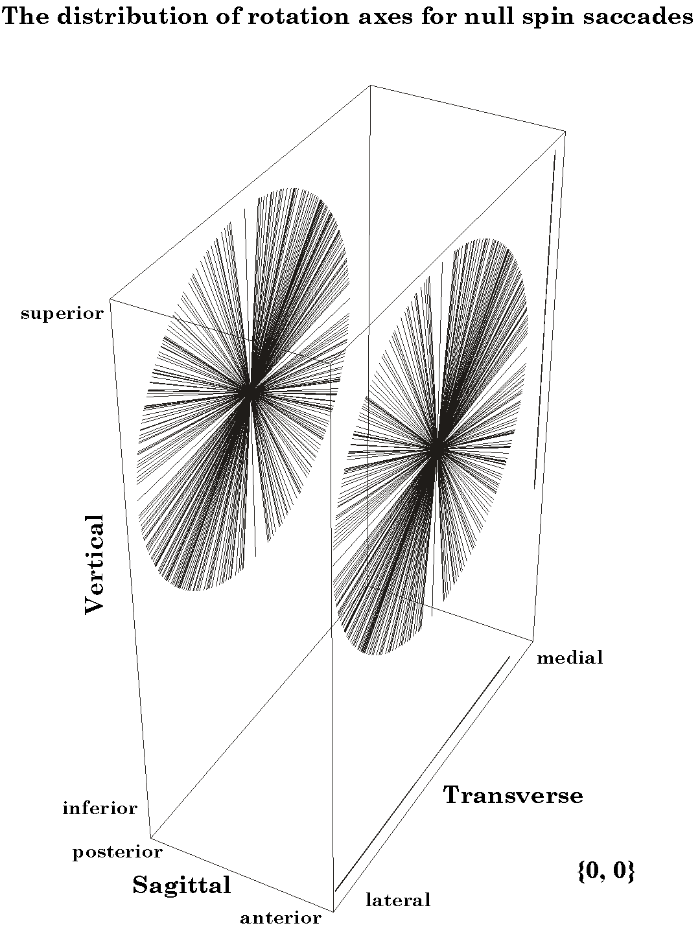
Figure 8. The axes of rotation for saccades from neutral gaze to an array of gazes are plotted with a common origin. The disc of radiating lines on the right shows the axes in three-dimensions. They are also shown as projections on a coronal plane (the disc to the left), a horizontal plane (line on the floor of the box), and a sagittal plane (line on the medial wall of the box). All the unit vectors lie in the same plane, perpendicular to the line of sight in neutral gaze. The plane that contains the rotation axes is called Listing’s plane.
These observations are not a surprise and they could have been arrived at by simply sitting and thinking about the geometry of the situation. We have simply described Listing plane. The situation becomes more interesting and complex as the initial gaze for the saccade is taken away from neutral gaze. These situations will be considered in stages.

Null Saccades from an Elevated Gaze
Consider the null spin saccades that arise from a gaze position elevated 20° above neutral gaze. The distribution of rotation axes with terminal gaze direction is given figure 9 . As with the saccades from neutral gaze, the distribution is a circular vector field centered upon the starting gaze direction. What is not so obvious from the figure is that the rotation axes are not confined to a plane. This can be appreciated by noting that the slab that contains the vectors is of some thickness. When the slab is rotated in the computer, it can be seen that the vectors extend above and below a plane perpendicular to the line of sight in neutral gaze. The degree to which they extend anterior or posterior varies systematically with terminal gaze direction.

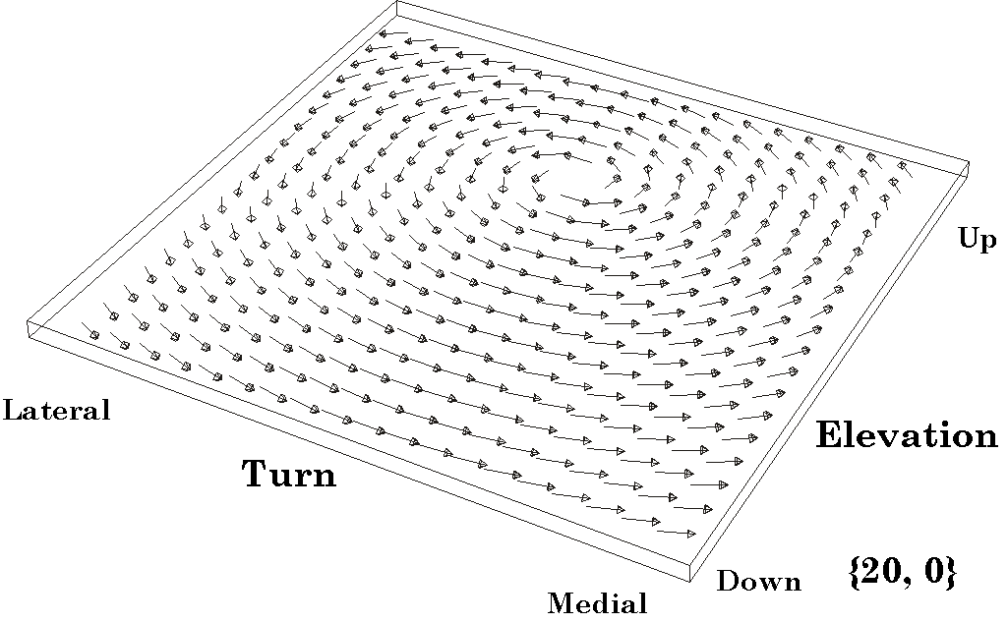
Figure 9. The distribution of axes of rotation for saccades from a gaze 20° superior to neutral gaze. The conventions are as in the figure 7, for neutral gaze. However, note that the vectors are tilted with respect to the plane, they occupy a slab.
In the three dimensional view of the rotation vectors arising from a common origin, the relationship is more apparent (Figure 10). The rotation vectors still lie in a single plane, but it is tilted so that it superior margin is tilted posteriorly. This can be seen by examining the projection on the side wall. It is still a line, but it is tilted so that its superior end is posterior to its inferior end. The projection on the floor of the box is elliptical, as one would expect. The projection on the back wall is foreshortened in the inferior/superior axis, but it is difficult to appreciate in this type of figure when the angle of tilt is so small.

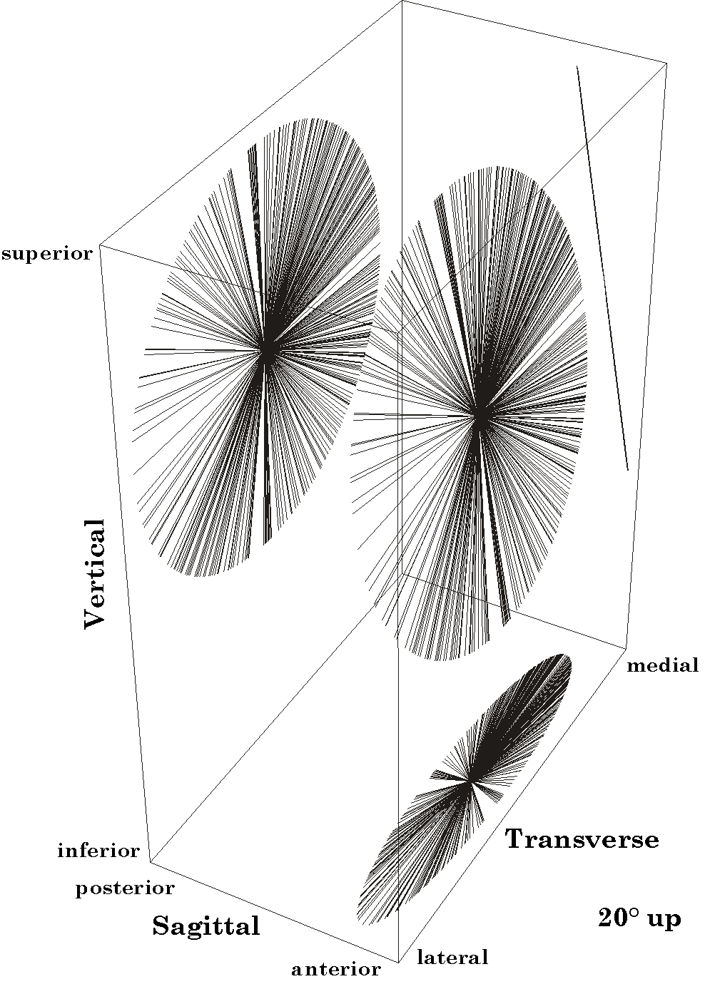
Figure 10. The axes of rotation for saccades to and from a gaze 20° elevated above neutral gaze. The conventions are as in the figure for neutral gaze. Note that the axes still lie in a plane, but it is tilted posteriorly, as can be seen in the projections upon the cardinal planes.
In order to obtain measurements of the amount of tilt, the projections have been plotted on a single surface that is orthogonal to the viewing angle (Figure 11). All three projections have been plotted together, but the one that is most interesting at this juncture is the side projection. If we measure the angle that it forms with the vertical plane it turns out to be 10° or half the magnitude of the elevation of the starting gaze direction. It turns out that if we perform the same calculations for a range of starting gazes that are elevated or depressed relative to the line of sight in neutral gaze, then the result is that the rotation vectors always lie in a single plane, tilted half the angle of the elevation, in the direction of the elevation.

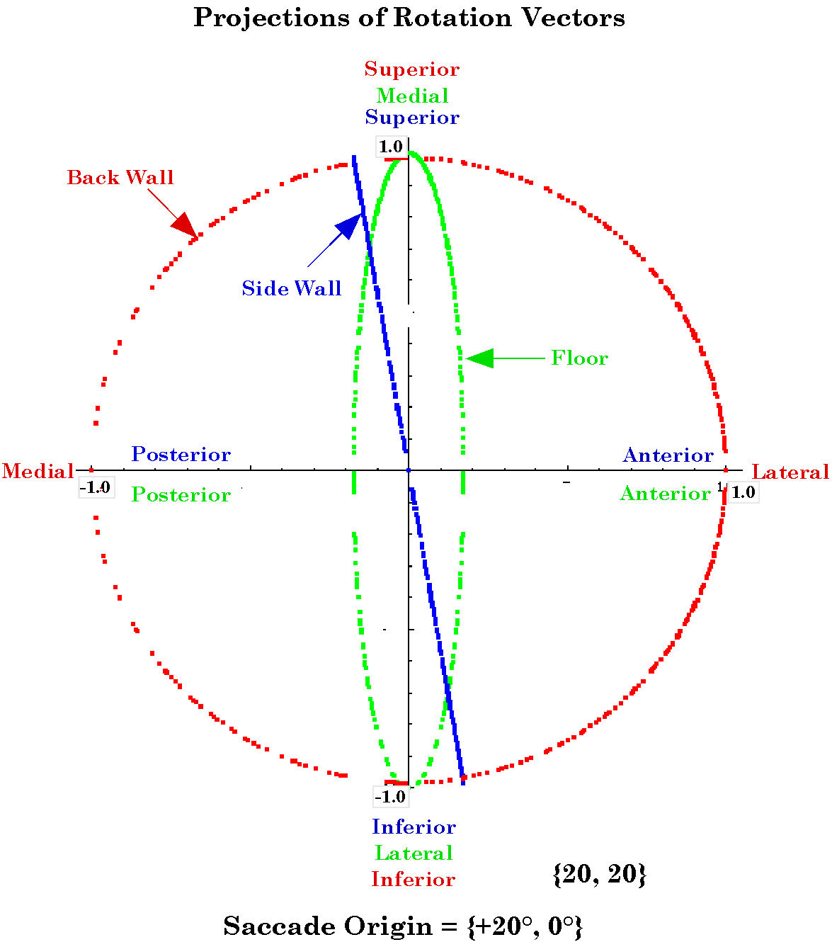
Figure 11. The projections of the disc of rotation axes upon the three cardinal planes of the eye. All three projections are superimposed on the same set of axes. The interpretation of the axes is indicated by the color-coded labels. So the right axis is lateral for the back wall projection, anterior for the sidewall projection, and also anterior for the floor projection. The side wall projection is most relevant here. It is tilted 10° posteriorly.
The same three views have been computed and plotted for the starting gaze depressed 20° below neutral gaze and they are much the same. The distribution with terminal gaze direction again form a circular vector field centered upon the starting gaze direction. The three dimensional array of rotation vectors with a common origin is tilted, but so that the superior margin is anterior. The projection on the side wall is tilted in the opposite direction from the same projection with 20° of elevation. Finally, measurements of the angle of tilt of the side wall projection show that the line is tilted 10° forward at the top.
If one gets very exact about the measurements, it will be seen that the measurements are not precisely half of the elevation or depression. They are always off by a fraction of a degree. This is apparently due to the manner in which we set up the gaze directions. The array of points is not an evenly spaced set of points on the unit sphere. Going up 10° and then out 10° parallel to the horizon will not place one at the same location as going away from neutral gaze at a 45° angle for a distance of the square root of two times 10°. The agreement is close for small angles, but it is not perfect. This problem will occur in other measurements as well.

Null Saccades From a Laterally Displaced Initial Gaze Position
The next figure illustrates a similar distribution of rotation axes for null saccades that start from a gaze position about 30° lateral to neutral gaze (Figure 12). The distribution of rotation axes with respect to terminal gaze direction is again a circular vector field centered upon the initial gaze direction. Where the rotation axes are plotted with a common origin they lie in a plane that is now tilted about the vertical axis about half the magnitude of the lateral deviation and in the direction of the initial gaze direction (Figure 13). The projection of the array of vectors upon the floor of the enclosing box is a single line rotated in the direction of the initial gaze. Once again, the tilt is not precisely half, deviating by a fraction of a degree, more for larger turns

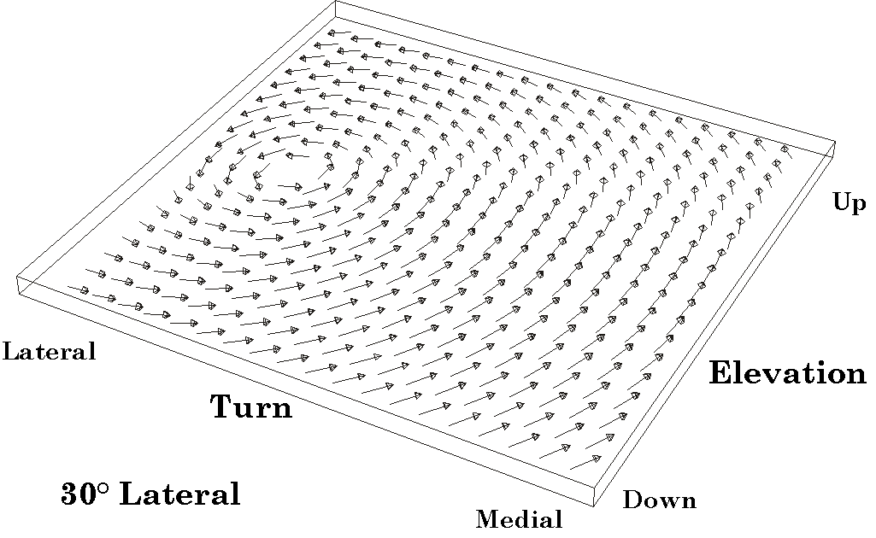
Figure 12. Distribution of axes of rotation for saccades to and from a gaze 30° lateral to neutral gaze. The conventions are as in previous figures. Note the vectors occupy a slab, therefore extend above and below the plane.

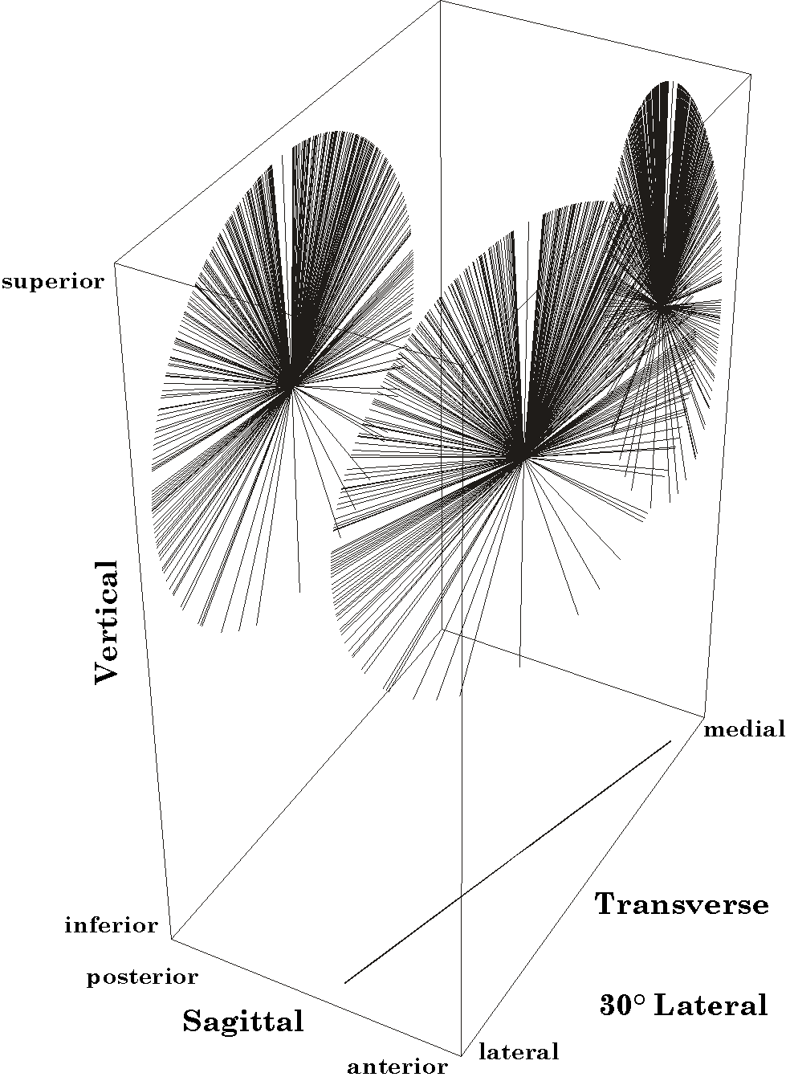
Figure 13. The disc of axes of rotation for saccades to and from a gaze 30° lateral to neutral gaze. All the axes lie in a plane that is tilted laterally about 15° from coronal.

Null Saccades from a General Gaze Position
The situation is symmetrical. If we choose a depressed or a laterally deviated initial gaze position, then the set of rotation axes is tilted accordingly, towards the initial gaze. The saccade that passes to neutral gaze will always lie in Listing’s plane and the maximal deviation from Listing’ s plane will occur for saccades perpendicular to the great circle through neutral gaze. Therefore, for a medially turned initial gaze, saccades towards or away from neutral gaze will have rotation axes that are vertical and lie in the coronal plane of the orbit. Saccades that are vertical will have rotation axes that are in the horizontal orbital plane and they will be directed anterior or posterior to the coronal orbital plane.
We now consider what happens if the initial gaze is offset in both horizontal and vertical directions. If the initial gaze position is both elevated or depressed and medially or laterally deviated, then the plane of the rotation axes for null spin saccades is tilted about both the vertical and the lateral axes, to an extent appropriate to the amount of the deviation in each direction from neutral gaze. In simpler terms, the plane of the axes of rotation was tilted towards the initial gaze by approximately half the angular displacement of the initial gaze from neutral gaze.
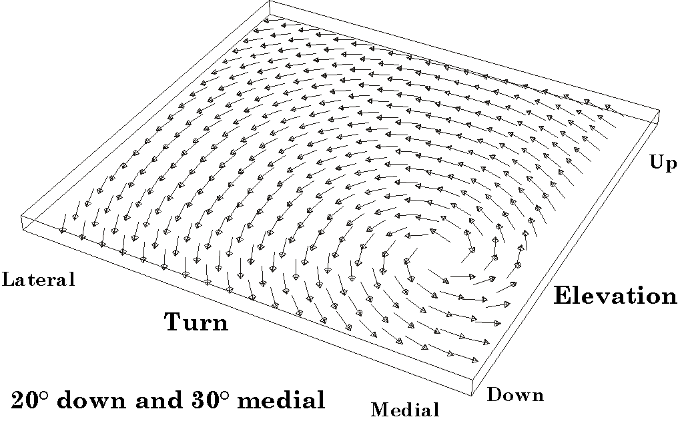
Figure 14. The distribution of axes of rotation for saccades to and from a gaze 20° below and 30° medial to neutral gaze. The conventions are the same as in previous figures.
In the next three figures the initial gaze is depressed 20° and medially rotated 30° (Figures 14, and 15). The null spin saccades again form a circular vector field centered upon the initial gaze direction. When the rotation axes are plotted with a common origin, they lie in a single plane, but its superior margin is tilted anteriorly and the lateral margin is tilted anteriorly. When the projections are laid flat it is possible to measure the amounts of each tilt and it is found that the anterior tilt of the superior margin is about 10° and the anterior tilt of the lateral margin is about 15°.
When the magnitudes of the elevation and turn are the same the side wall and floor projections overlap and they can be compared directly. In the illustrated case the elevation and medial turn are both 20° (Figure 16). The two ellipses overlap nearly exactly and both are tilted about 10° relative to the coronal plane of the orbit. As noted above, the overlap is never exact. This is also probably due to the way that the gaze positions are chosen. Reversing the horizontal and vertical swings reverses the direction of the discrepancy in the plots.
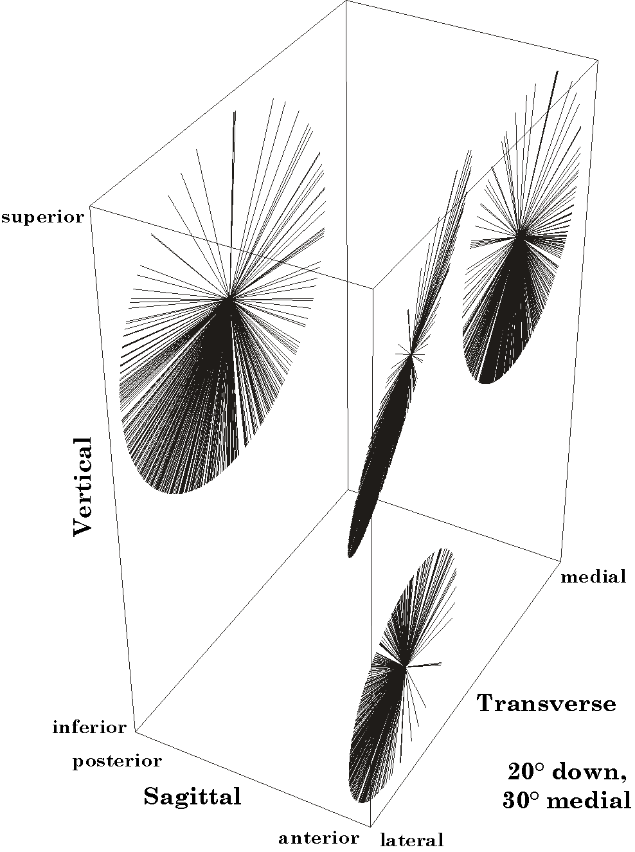
Figure 15. The rotation axes for saccades starting 20° down and 30° medial to neutral gaze. Note that the disc of rotation axes is tilted in two orthogonal planes.

The Distribution of Rotation Axes for a Fixed Final Gaze
Up to this point, we have considered the rotation axes of the saccades that start at a particular gaze and end in a variety of other gazes. What will be the properties of the saccades that converge upon a common final gaze? Actually, the distribution is very like the distributions just considered, because if the saccade that carries gaze 1 into gaze 2 is $R_{\text{12}}\left(T,v,α\right)$, then the saccade that carries gaze 2 into gaze 1 is $R_{\text{21}}\left(T,−v,α\right)$ or $R_{\text{21}}\left(T,v,−α\right)$. The two forms are formally the same. One can either move through the same angular excursion about the axis of rotation that points in the opposite direction or proceed in the opposite direction about the same axis of rotation. The primary difference between the saccades that diverge from an initial gaze position and saccades that converge on that gaze direction will be that while the rotation axes tend to cluster in one part of the unit circle, because there are more potential gaze targets in that direction if one is at an eccentric gaze, they will tend to cluster in the opposite side of the unit circle when we are looking at the saccades that converge upon a particular gaze. The tilt of the unit circle relative to the coronal plane will be the same as if we were looking at the set of saccades that originate at that gaze.

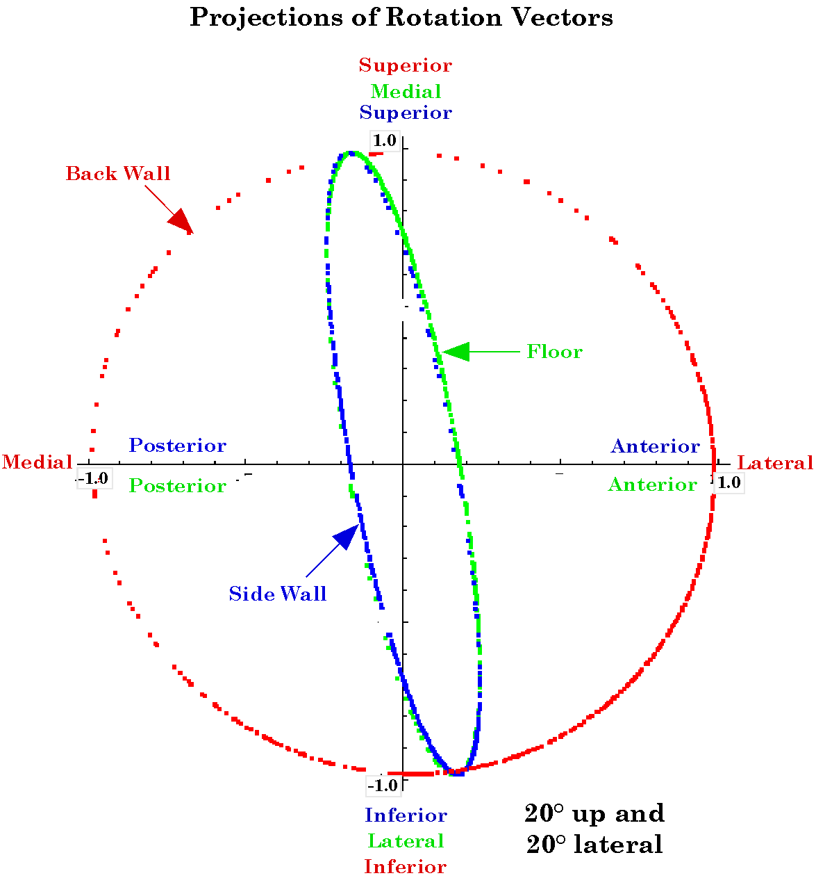
Figure 16. When the elevation and the lateral deviation are both 20°, the projections of the disc of rotation axes is the same in the horizontal (floor) and sagittal (side wall) planes. Both projections are tilted 10° from the coronal plane. The conventions are the same as previously.
For each gaze there will be a particular and unique unit circle of potential null spin saccades that diverge from that gaze and an almost identical unit circle of rotation axes for saccades that converge upon that gaze. The main difference will be that the unit vector of one unit circle will be the negative of those in the other. One unit circle will be the reflection of the other through the center of the circle. All of these unit circles for all the gazes will be great circles of a unit sphere. If we have a null spin saccade that starts at gaze #1 and ends in gaze #2, then the unit circle of potential rotation axes for gaze #1 will intersect the unit circle for gaze #2 at two points. One of those intersections will be the rotation axis for the saccade that carries gaze #1 into gaze #2 and the other will be the rotation vector for the saccade that carries gaze #2 into gaze #1.

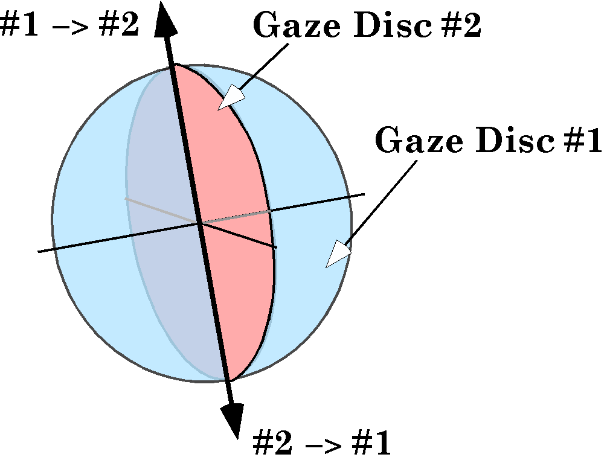
Figure 17. The rotation axes are equal and opposite vectors. Each gaze has it own disc and the intersection of the discs for the initial and final gazes is the rotation vector for the saccade between the two gazes.
In a formal sense the determination of the axis of rotation reduces to the intersection of geodesic unit circles of a unit sphere. Obviously this is not how the nervous system deals with the generation of the appropriate null spin saccades, but it helps to understand the formal structure of the problem, which can be very difficult to conceptualize if one is dealing with the gazes themselves.

The Spin of Null Spin Saccades
Null spin saccades are called null spin because the gazes at each end of the saccade have no spin relative to neutral gaze. It does not mean that they do not produce spin. In fact, they almost always will produce spin since they are conical rotations, which always have spin unless the axis of rotation is perpendicular to the rotating vector. In this section, we will briefly consider the distribution of spin with respect to gaze direction. The spin that we will be examining is the rotation of the second ratio of frames of reference in the calculation of the rotation quaternion for the null spin saccade.

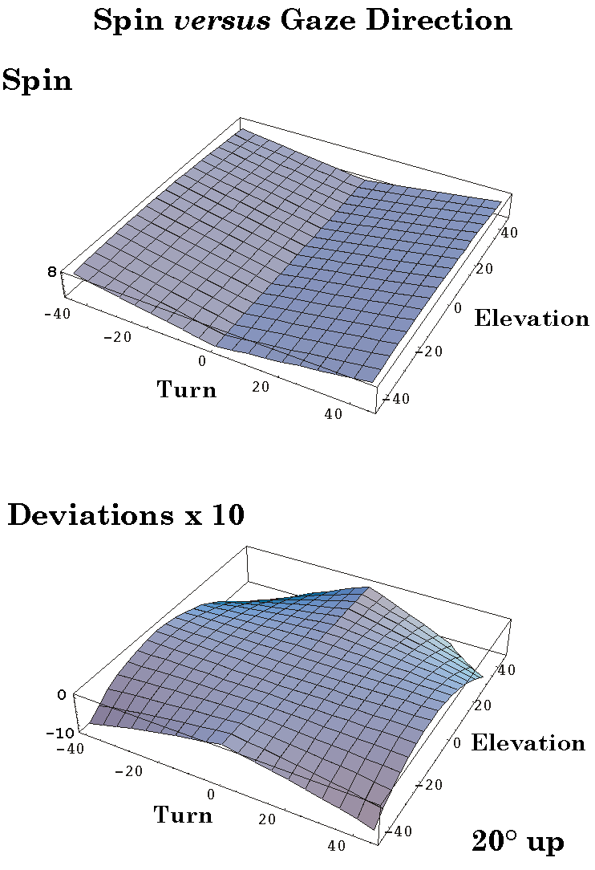
Figure 18. Spin is a function of the final gaze relative to the initial gaze. There is no spin for saccades that pass through neutral gaze. The further the final gaze is from that line, the greater the spin introduces by the saccade. By plotting the deviations from a simple folding of a plane, it is possible to see that the spin is not exactly linearly proportional to the distance from the no-spin line.
When we plot the magnitude of the spin versus gaze direction for saccades starting at a particular gaze, we find that it always has a characteristic shape. It is shaped like a piece of paper that has be folded in two and then incompletely opened so that it has two wings that meet at the crease and sweep up away from that line. The paper is resting on the crease and the wings sweep up symmetrically. The spin along the crease is zero. Some thought will reveal that this is precisely what one would expect. The crease corresponds to the set of gazes that lie on the great circle that passes through the initial gaze and neutral gaze. If the starting gaze is neutral gaze, then the sheet is flat, because there is no spin with geodesic saccades from neutral gaze, that being the reference gaze. As the initial gaze becomes more eccentric, the wings sweep up more steeply.
At first glance, the two wings appear flat, but closer examination will reveal that there is a gentle curvature to the surface, parallel to the crease. Also, one may note that the surface rises more at the gazes that are further from the initial gaze.
One aspect of the surface that has to be considered is that the calculation that produces the spin quaternion is arranged so that it will always produce a positive spin. If the spin is in the opposite direction, that will be indicated by the vector of the quaternion being in the opposite direction. Therefore it is possible that the surface is a single, almost flat surface that passes through the zero spin plane along the great circle that includes the initial gaze and neutral gaze. We can show that the surface is truly folded by a simple calculation.
To show that the surface is folded we will use a non-physiological saccade because the calculation is simplified considerably and it is easier to visualize the process, but the same logic would apply equally well for lesser saccades. Consider the situation where the eye is looking straight up and we bring it down to look directly medially or directly laterally. So we are comparing two saccades equidistant from the great circle through vertical gaze and neutral gaze. From the arguments given above we can write down a few relationships by inspection. The rotation vector that carries the eye from neutral gaze to vertical gaze is a 90° rotation about the secondary axis of the frame of reference, conventionally set to be j. However, the direction of the rotation is negative, so the axis of rotation is –j. Similarly, the saccades that carry the eye into medial and lateral gaze are +k and –k respectively. That leaves the saccades from vertical gaze to medial or lateral gaze. The geodesic trajectory from vertical gaze to medial gaze is 90° about the –i axis and to lateral gaze it is 90° about the +i axis. If we carry the eye into vertical gaze and then medial gaze, the quaternion for the composite rotation will be the following expression.
$$r_{\text{vm}}=\frac{1−i}{\sqrt{2}}∗\frac{1−j}{\sqrt{2}}=\frac{1}{2}∗\left(1−i−j+k\right)$$
The quaternion for the direct medial rotation will be given by the following expression.
$$r_{m}=\frac{1+k}{\sqrt{2}}$$
However, the orientation of the eye after the double saccade will be rotated relative to its orientation after the single medial saccade. We can determine the magnitude and the direction of the spin by dividing the double rotation by the single rotation.
$$\begin{aligned}r_{\text{Spin}}=\frac{\frac{1}{2}∗\left(1−i−j+k\right)}{\frac{1+k}{\sqrt{2}}}=\frac{1}{2}∗\left(1−i−j+k\right)∗\frac{1+k}{\sqrt{2}} \\ \frac{1−j}{\sqrt{2}} \\ R_{\text{Spin}}\text{=-}j\end{aligned}$$
The spin that must be introduced during the null spin saccade from vertical gaze to medial gaze is 90° of rotation about the –j axis.
We now perform the same calculation for the saccades from neutral to vertical to lateral gaze and directly to lateral.
$$\begin{aligned}r_{\text{vl}}=\frac{1+i}{\sqrt{2}}∗\frac{1−j}{\sqrt{2}}=\frac{1}{2}∗\left(1+i−j−k\right); \\ r_{l}=\frac{1−k}{\sqrt{2}}; \\ r_{\text{Spin}}=\frac{1}{2}∗\left(1+i−j−k\right)∗\frac{1+k}{\sqrt{2}} \\ \frac{1−j}{\sqrt{2}}; \\ R_{\text{Spin}}\text{=-}j\end{aligned}$$
The result is that the spin that needs to be introduced by the null spin saccade is 90° about the –j axis. Therefore, the spin is in the same direction for both saccades from vertical gaze. More generally, the spin versus gaze direction surface is folded.

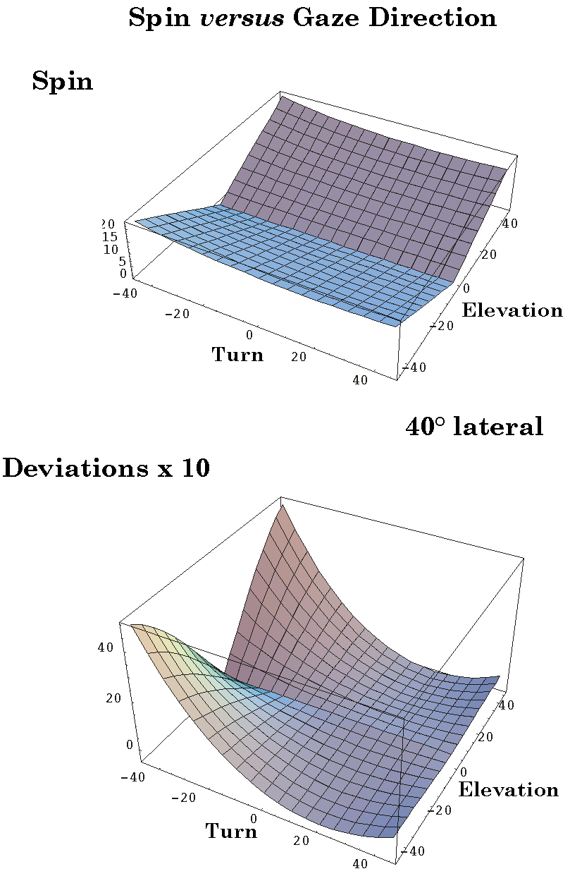
Figure 19. The spin introduced by saccades from a far lateral gaze is still like a partially folded sheet of paper with the line of no spin extending from the initial gaze to any gaze on a line through neutral gaze. The deviations from a flat folded sheet are greater than for an initial gaze 20° from neutral gaze.
As was noted above, the spin versus gaze surface is nearly flat except at the crease. However, it is not flat and one can see this by comparing the perpendicular cross-section through neutral gaze to other cross-sections. This has been done for several surfaces. When the initial gaze is elevated 20° above neutral gaze, then the deviations are all negative. That is, the surfaces are slightly convex up (see above). The deviations in the plot have been multiplied by ten to make it easier to appreciate the nature of the surface. Note that the maximal deviation is on the order of a degree in a surface that ascends about eight degrees. If the initial gaze is moved further from neutral gaze, like 40°, then the deviations increase. In the illustration, the maximal deviation is on the order of 4° in a surface that ascends about 15°.
In a situation where the initial gaze is displaced medially or laterally, the deviations are positive and the surfaces are slightly concave up. The shape of the surface is the same as for elevation except that it is rotated 90° and reflected in the horizontal plane. The differences between elevation and turning is unexpected, but it was found that reversing the order of the horizontal and vertical rotations in reaching the final gaze reversed the relationships between the surfaces for vertical and horizontal offsets. Therefore, the deviations are very sensitive to manner in which the gazes position array is chosen.
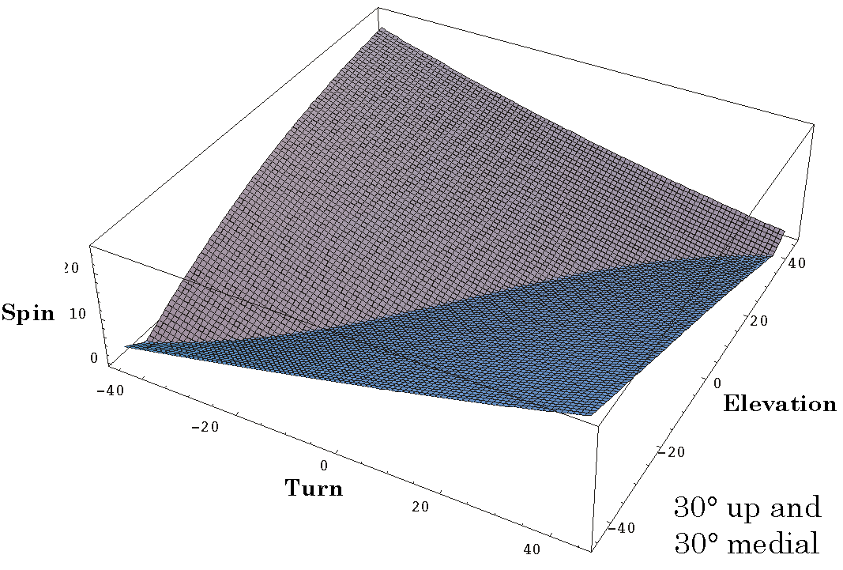
Figure 20. The distribution of spin produced by saccadic eye movements from a gaze 30° above and 30° medial to neutral gaze. The fold in this instance does not have a straight crease and the two wings are clearly not flat.
When the initial gaze is both elevated and turned the situation becomes more complex. The illustration is for the situation when the initial gaze is offset by 30° of elevation and 30° of medial turn. The surface has the same basic shape, but the crease is curved and the fine details of the contours of the folded surfaces are complex. It is not possible to find a cross-section that is straight. The deviations are computed relative to a cross-section that passes through neutral gaze, perpendicular to the crease. Using this cross-section as a reference may not be valid. However inspection of the surface itself indicates that it is complexly curved, which is what is illustrated in the figure.

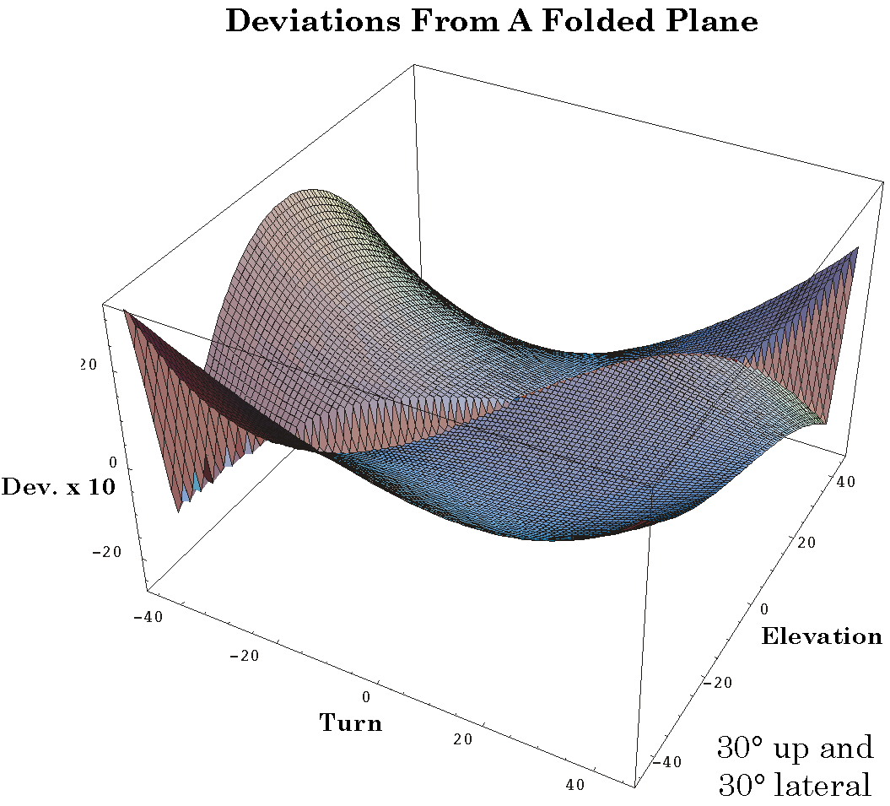
Figure 21. Deviations for a flat folded surface for saccades from an initial gaze 30° above and 30° medial to neutral gaze. The deviations have been multiplied by 10 to make the contours of the surface more apparent. Note that, unlike the saccades from the vertical and horizontal meridian, the surface is not symmetrical about the line through neutral gaze.

The Trajectories of Null Spin and Geodesic Saccades in Orbital Coordinates
Up to this point the null spin saccades have been considered as rotations about axes of rotation. Now we turn to a consideration of how they might appear on a plot of the saccade trajectory. We are primarily interested in how much curvature there is in the trajectory, how far it deviates from the geodesic trajectory. In the next set of figures the trajectories of the saccades as viewed from a number of points of view are plotted. Blue lines indicate the path followed by the geodesic saccades and the red lines are the same for the null spin saccades. The trajectories are sampled at 20 equally spaced points along the trajectory.

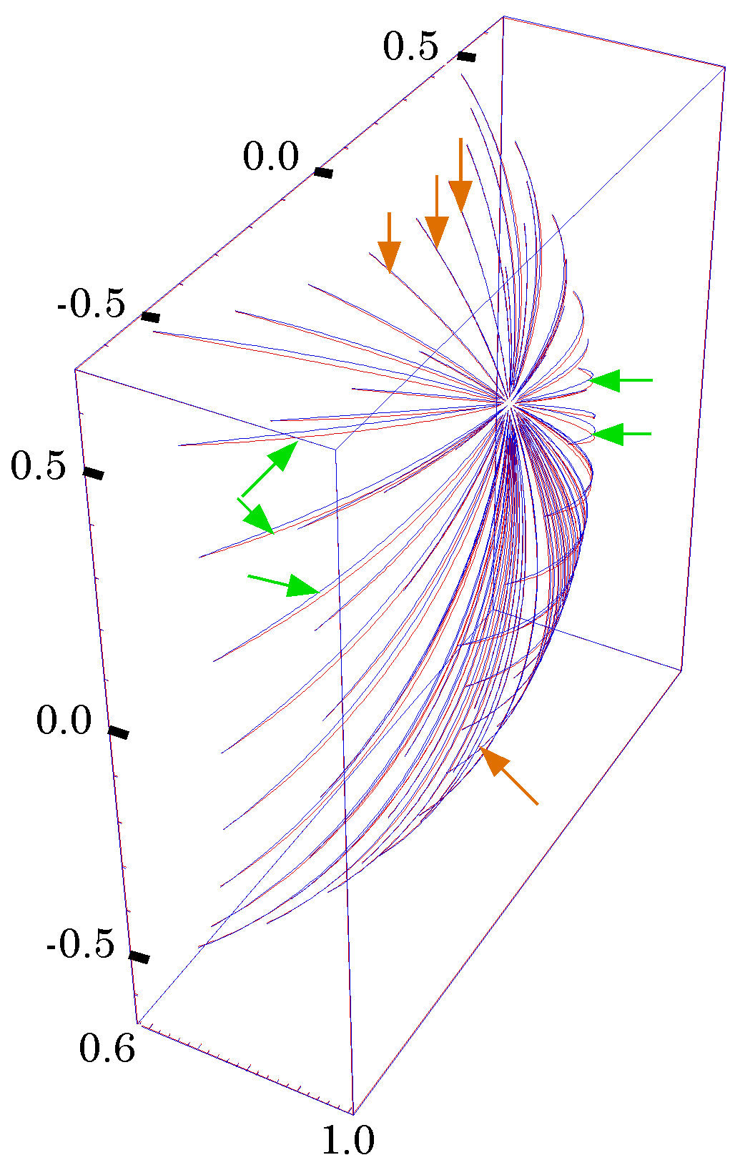
Figure 22. The set of saccades from +20° elevation in the vertical midline; oblique, superolateral anterior viewpoint. All the illustrated saccades start at the same point, {+20°, 0°}, and extend to an array of terminal gazes at 10° intervals, from –40° to +40° of turn and from –40° to +40° of elevation. The null spin saccades are red and the geodesic saccades are blue. The saccade pairs near the midline (orange arrows) have nearly the same trajectories. The saccade pairs approximately perpendicular to the midline (green arrows) have distinguishably different trajectories.
What is striking when one looks at the figures is the similarity of the two sets of traces (Figures 22, 23, and 24). This is partially because the saccades near neutral gaze are not markedly different and partially because of the foreshortening that occurs for more eccentric saccades. If we view the saccades from a medial or lateral view, then the difference is more apparent for more eccentric saccades. Ideally, one would view the two saccades in a three-dimensional image, where the difference is most apparent.

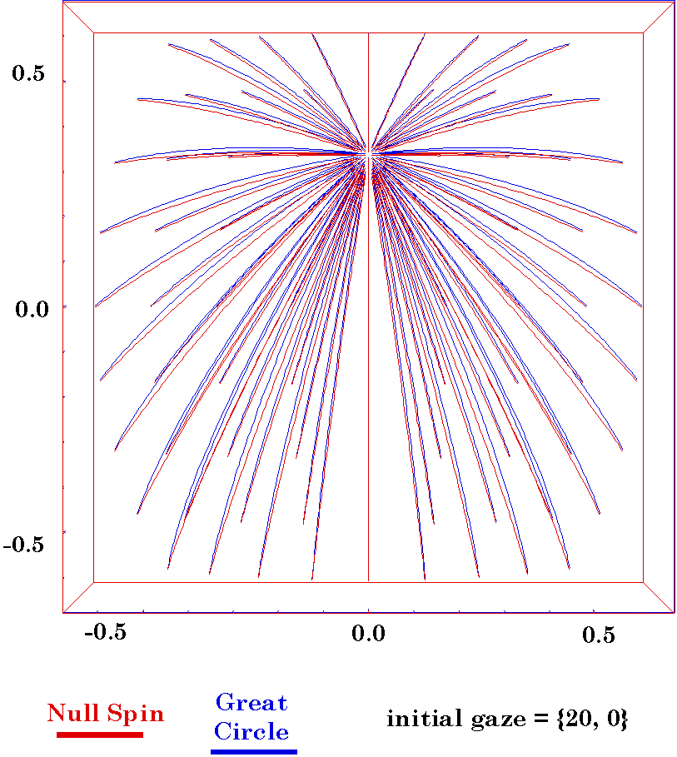
Figure 23. The set of saccades from +20° elevation in the vertical midline; medial viewpoint. The conventions are as in the previous figure.
When the initial gaze is more displaced from neutral gaze there tends to be more separation of the saccade pair (Figure 24). In this set of saccades, the initial gaze is turned 30° laterally and elevated 30°, which may be outside the range of normal eye movements. In this instance the separation is greatest when the saccades are directed away from the diagonal from the initial gaze through neutral gaze.
A curiosity of the two-dimensional presentation is that the geodesic saccade, which is the straightness and shortest saccade appears more curved and longer. This is again an artifact of compressing the three-dimensional path into two dimensions. It also indicates that “straight” saccades, meaning geodesic saccades on a sphere, will appear curved if mapped on a flat projection. Therefore curved saccadic traces are not necessarily indicative of indirect saccades.

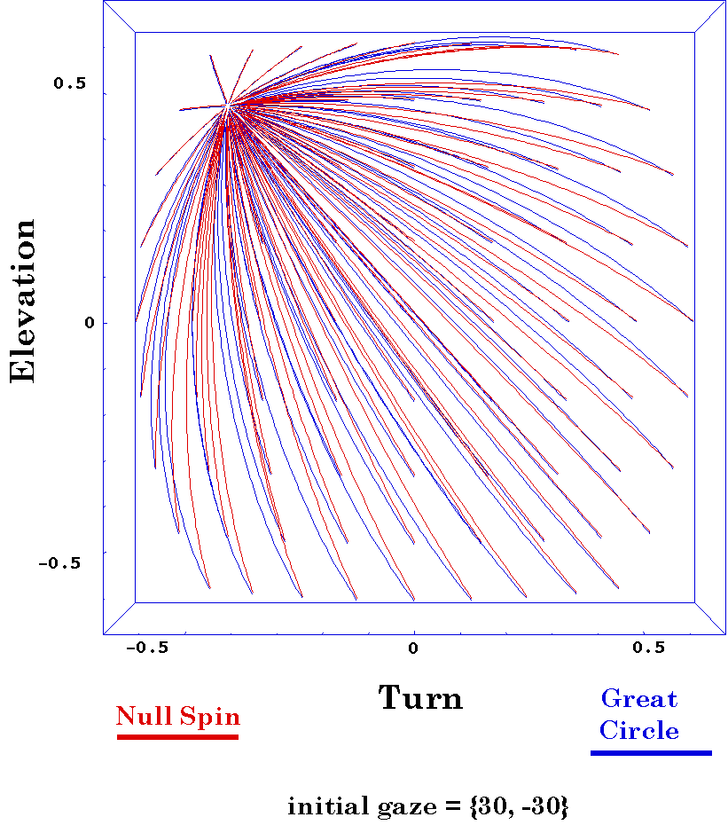
Figure 24. Trajectory paths from a gaze elevated 30° and laterally rotated 30°. Conventions as above.
These points aside, it is apparent that there is a difference between the geodesic and the null spin saccade. Viewed from in front, there is comparatively little curvature, especially for more radial saccades. The greatest discrepancies occur for saccades that are more circumferential, either vertical or horizontal. There is perfect registration of the geodesic and null saccades if the two ends of the saccade lie on a great circle through neutral gaze.
The distance between the two saccade trajectories in a pair changes with distance along the trajectory; first becoming greater, until the midpoint, and then becoming smaller. Therefore it is difficult to ascribe a single number to the separation and that would apply to the single point along the trajectories. The relative lengths of the two trajectories, their excursions, is a single number that applies to the entire saccade pair. It is striking how little difference there is in the lengths of the saccades in a pair. For an initial gaze direction with 20° of elevation in the vertical midline, the greatest discrepancies are less than a degree of difference between the two saccades for saccades that approach 90° of excursion. Saccades to terminal gazes near the vertical midline will show very little or no difference in saccade excursions (Figure 25).

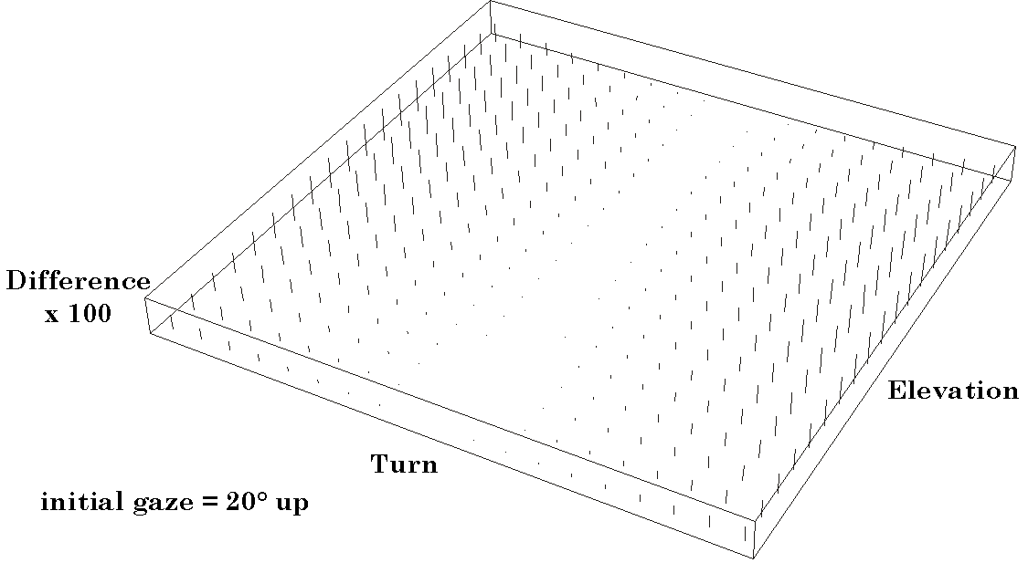
Figure 25. The differences in saccade trajectory length, excursion, for null spin saccades versus great circle saccades; initial gaze = 20° up. For each terminal saccade direction the difference in angular excursion between the null spin saccade and the geodesic saccade is plotted as a vertical line perpendicular to the gaze direction plane. Since the differences are generally small, the difference has been multiplied by 100 to make the dependence upon gaze direction more apparent. Notice that the differences are very small or zero for saccades in the vertical midline. They become larger for saccades to gaze directions further from the vertical midline. The largest difference is substantially less than a degree with 40° or larger saccades.
The situation is symmetrical in that if the initial gaze is along the horizontal meridian, then the saccade pairs are nearly identical for saccades that terminate near the horizontal meridian (Figure 26). As the terminal gaze direction shifts away from the horizontal meridian, the differences in excursion become greater. If the direction of the initial saccade gaze is moved away from neutral gaze, then the overall magnitude of the discrepancy between the members of the pair also increases.
The form of the relationship when the initial gaze is directed into a general direction is as one might expect (Figure 27). The smallest discrepancies occur when the saccade is near the diagonal through the initial gaze and neutral gaze. The greater distance between the initial gaze direction and neutral gaze, the greater the discrepancies between the elements of a saccade pair.

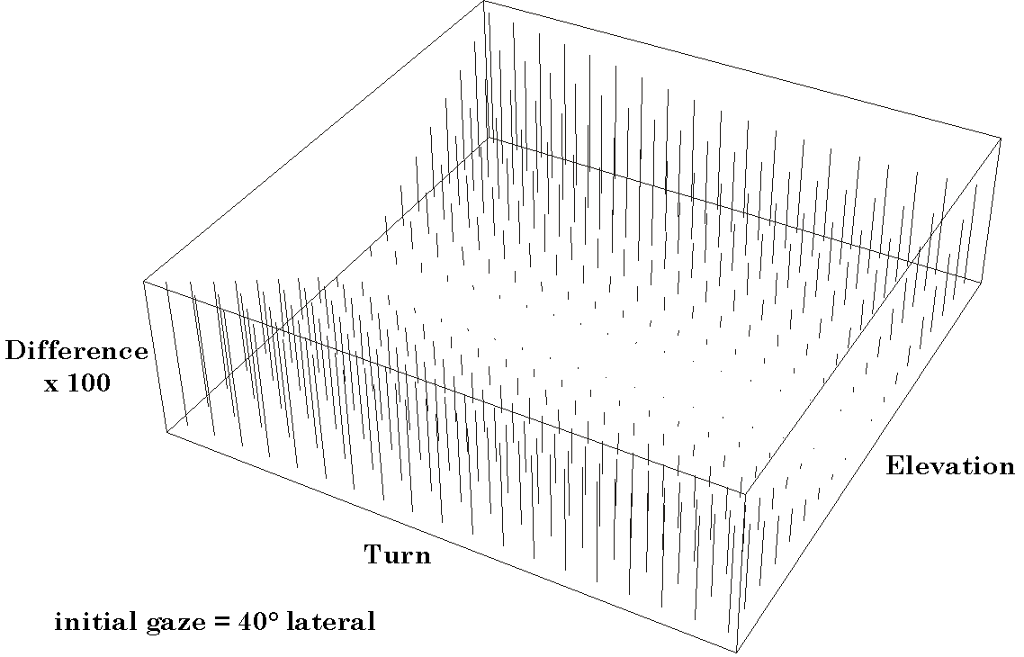
Figure 26. The differences in saccade trajectory length, excursion, for null spin saccades versus great circle saccades; initial gaze = {0, -40}. The conventions are as in the previous figure. Notice that the differences are very small or zero for saccades near the horizontal meridian. They become larger for saccades to gaze directions further from the vertical midline. The largest differences are substantially greater than in the previous figure. This is because the initial gaze for the saccades is more distant from neutral gaze.
Given the small apparent differences between the geodesic saccades and the null spin saccades, the question arises of how one might differentiate between the two alternatives in a physiological preparation. The great difference, if one can do the appropriate measurements, is that the axes of rotation for null spin saccades lie in a plane that is tilted midway between the coronal plane and the plane perpendicular to the vector from the center of the eye to the gaze position. For geodesic saccades the axis of rotation is perpendicular to the vectors that extend from the center of rotation to the initial and final gaze directions. Therefore, the rotation axes lie in a plane perpendicular to the vectors in the directions of the initial and final gaze directions.

Spin as a Function of Saccade Excursion
Possibly a minor point, but of some interest is to determine if the spin correction occurs uniformly along the null spin trajectory. For a few saccades the amount of spin relative to the initial gaze was plotted as a function of the distance along the saccade. It was found that the spin does not increase linearly with distance traveled. In the early part of the saccade the spin accumulates more slowly and in the latter part of the saccade it accumulates more quickly. Rough measurements taken from a null spin saccade between looking directly laterally and directly superiorly gave a rate of about two-thirds average for the initial part of the saccade. If we look at saccades in the physiological range, the differences are substantially less. For a saccade from 30° inferior to 30° superior to horizontal at 30° lateral the initial rate is about 90% of average rate over the entire saccade. It should be pointed out that this measurement is not a time rate of change, but an excursion rate of change. In any case, the effect would probably be small for most natural saccades.

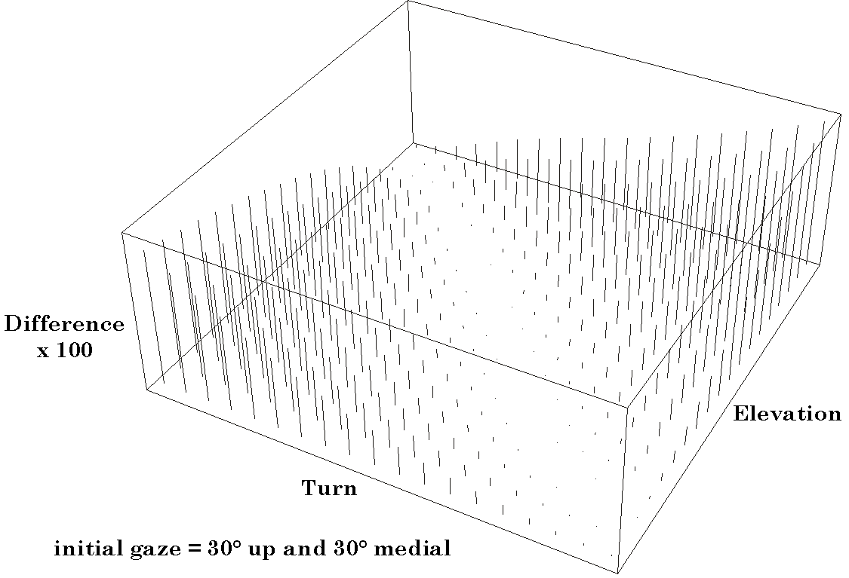
Figure 27. The differences in saccade trajectory length, excursion, for null spin saccades versus great circle saccades; initial gaze = 30° up and 30° lateral. The conventions are as in the previous figures. Notice that the differences are very small or zero for saccades near the diagonal that passes through the initial saccade gaze direction and neutral gaze. They become larger for saccades to gaze directions further from the diagonal. The largest differences are substantially greater than in the previous figures. This is because the initial gaze for the saccades is still more distant from neutral gaze.

Trajectories of Geodesic Saccades Compared to Static Gaze
In determining the geodesic saccade for a given shift of gaze we set the condition that the initial gaze is spin neutral relative to neutral gaze, and that the saccade is the shortest distance between the initial gaze direction and the final gaze direction. A question that naturally arises is how the gaze at intermediate positions along the arc of movement compares with the spin neutral gaze for that gaze direction. It is fairly easy to compute the spin neutral gaze, given a particular gaze direction.
For a series of 20 equally spaced intervals along the geodesic saccade the gaze was computed and the gaze direction was used to determine the rotation that would carry neutral gaze into the spin neutral gaze in that direction. The ratio of the gaze at that point along the geodesic trajectory and the spin neutral gaze for the same gaze direction was determined. Since the gaze directions will always be aligned, the only difference can be spin. It was found that spin relative to neutral gaze increases linearly as the geodesic saccade progresses. This was true for every saccade tested.
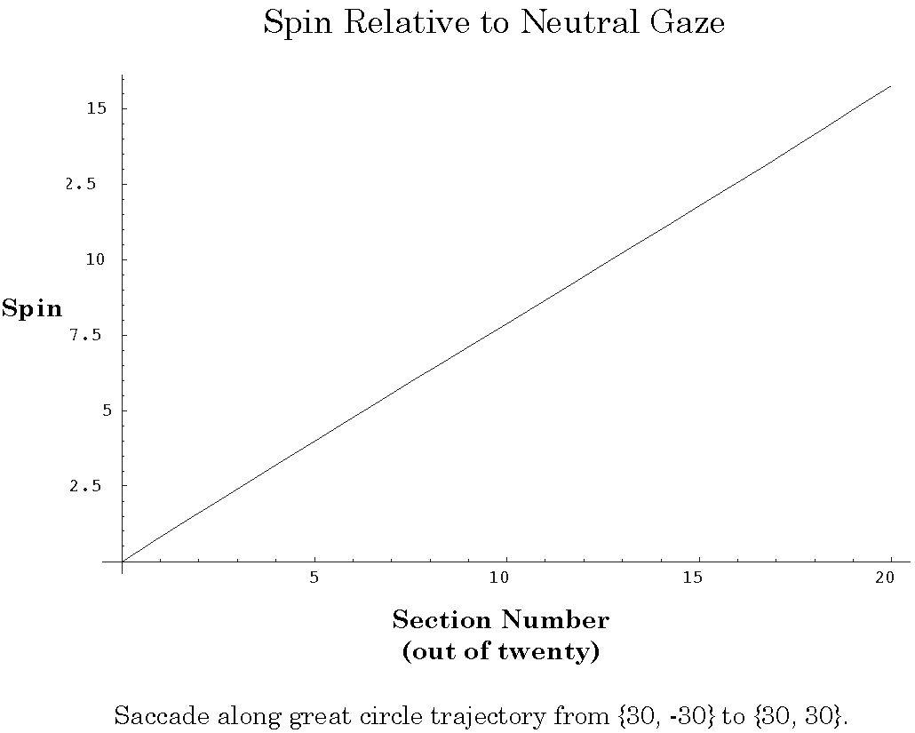
Figure 28. The change in spin relative to neutral gaze as a geodesic saccade progresses. The geodesic saccade is divided into 20 intervals and the gaze is computed at each interval. The spin neutral gaze for that gaze direction is computed and the spin of the geodesic trajectory relative to spin neutral gaze is computed. The difference is always a spin. The spin difference increases linearly with distance along the geodesic saccade.

Trajectories of Null Spin Saccades Compared to Static Gaze
In determining the null spin saccade for a given shift of gaze we set the condition that the gaze at both ends of the movement had to be spin neutral relative to neutral gaze, but placed no constraints upon the intermediate part of the movement other than it be a single circular arc. A question that naturally arises is how the gaze at intermediate positions along the arc of movement compares with the spin neutral gaze for that gaze direction. It is fairly easy to compute the spin neutral gaze, given a particular gaze direction. That is the substance of this section.
For a variety of gaze shifts, the trajectory of the null spin saccade was computed at 20 positions along its course. The gaze direction at each of those intermediate stages was computed. From the gaze direction it is easy to compute the spin neutral gaze for each of those positions. Because the calculation has been set up to make the primary axes have the same alignment, the only difference that could exist between the spin neutral gaze and the intermediate gaze along the null spin saccade is a difference in the alignment of the secondary and tertiary axes, that is, a spin. When the spin difference is computed for each of the points along the trajectory it is found to always be zero. In other words, the gaze at all points along the null spin saccade is precisely the gaze that would result from a geodesic saccade from neutral gaze. The eye is optimally oriented for vision throughout its course.

The Static Gaze Surface
The existence of Listing’s plane and Donder’s Law is consistent with and essentially equivalent to the observation that there is a unique orientation of the eye at each eye position and the visual image on the retina remains consistently oriented upon the retina. It has been shown that the line of sight for all resting gaze positions has the same orientation as neutral gaze when it is rotated to the gaze’s position along a great circle. Another way of expressing this relationship is that all resting gazes have null spin relative to neutral gaze.
It has also been argued that for each gaze direction and orientation there is a unique set of extrinsic eye muscle lengths. There are six degrees of freedom for gaze and there are six muscles, therefore the relationships between these variables occupy a twelve-dimensional space. However, since there is a one-to-one relationship between gaze direction and gaze orientation it is sufficient to specify gaze direction to also determine gaze orientation. Gaze direction can be specified by two variables because the radial component is constant. Therefore, the eye’s line of sight may be specified by two variables, say and . The relationship between line of sight and muscle lengths reduces to a two-dimensional surface in an eight dimensional space; two for eye position and six for the six extrinsic muscle lengths. If one specifies the direction of the eye’s line of sight, then the length of all the extrinsic eye muscles are also determined. Only those combinations of muscle lengths that correspond to a line of sight with null spin relative to neutral gaze will normally occur during fixed gaze. Let this surface be called the static gaze surface.
Smooth pursuit requires good vision as the eye moves, that is that the orientation of the eye is always appropriate for gaze direction, therefore during smooth pursuit the eye’s parameters should move along the static gaze surface. By specifying the direction of gaze during smooth pursuit one can effectively specify the lengths of all the eye muscles moving the eye. The changes in muscle length necessary to move the eye to a new position are determined by the differences encoded by the static gaze surface. As the eye moves, the corresponding locus in the static gaze surface moves in that surface. It can not jump to other points by leaving the surface and re-entering it at the new point, because the visual field would become rotated, about the visual axis, upon the retina. Vision would be compromised.
Saccades start and end in the static gaze surface because the line of sight is determined by the static gaze relationships that apply during fixed gaze or smooth pursuit. However, it is not necessary for the eye parameters to remain in the surface during the saccade, because vision is not as relevant while the eye is under-going a very rapid eye movement. Still, there is some evidence that one does perceive visual events while the eye is moving and that they may form the basis of subsequent eye movements, therefore it is possible that saccadic eye movements also obey the relationships implicit in the static gaze surface.
It has been repeatedly shown that saccadic eye movements that followed geodesics and that do not pass through neutral gaze will have net spin relative to neutral gaze and they will clearly pass out of the static gaze surface. In the model of saccades introduced above it is argued that saccades might follow circular arcs associated with conical swings. There are a number of lines of evidence that the null spin saccade is a reasonable approximation to the actual organization of natural, physiological, eccentric saccadic eye movements. We have just shown that null spin saccades will maintain the set of extrinsic eye muscle lengths in the static gaze surface. If such saccadic trajectories are indeed a good model of natural eye movements, then saccadic eye movements might use the same basic control mechanisms as smooth pursuit and static gaze eye movements. The orientation of the eye would then be automatically controlled by the direction of gaze.
Naturally, the static gaze surface does not completely explain saccadic eye movements. We have not dealt with the temporal dimension of saccades at all. Somehow, the eye control system has to learn what combinations of neural drives will achieve the correct set of muscle forces that will allow each of the muscles to have the appropriate length. That is a particularly knotty problem in that the length and direction of each muscle is a function of what each of the other muscles is doing. The length tension curves are all non-linear and the forces are acting at distributed points on a comparatively large three-dimensional body so we are dealing with sets of torques acting in a very complex manner. In mechanics, we are dealing with an analytical tool called wrenches that produce a type of movement called a screw (Beer and Johnston, 1990, pp. 104-105). There is both irreducible translation and rotation in a single movement, a force couple and a linear force. This is an area of mechanics that is seldom taught because of the complexity of the analysis. The non-linearity and the complex geometry of the forces present a very complex situation, without easy analytic reduction, therefore it is likely that the appropriate muscle drives for a given eye position are a learned pattern, something like a neural network in its formal structure. That tells us little about how the task is accomplished, but it must be accomplished, since Donder’s law is an experimental observation. What this analysis suggests is that having achieved this task, the neural circuits that regulate static gaze can be incorporated in a number of control systems, much as a software subroutine may be used by a diversity of program applications or other subroutines to handle a low level process.
There are a number of interesting questions that might be as asked about the static gaze surface. How does it virtually instantly switch between different surfaces, when we put on or take off a pair of glasses? Is it a process with a critical period for its acquisition, like stereo vision or language? What neural elements are involved in its operation? However, most of these are not going to be effectively addressed by geometrical anatomy, therefore are not going to be addressed here.

Summary
We started with the experimental observation that the orientation of the eye at eccentric gaze directions is such as to maintain the image of the visual world appropriately distributed upon the retina. It is not essential that this be true, but it is what one would expect if one were trying to set up a system to perform the functions of the eye. Organizing the visual system in this way simplifies the analysis of the visual input when the eye is allowed to scan its visual environment. It tends to optimize binocular vision and it allows one to assume that if the eye is looking in a particular direction, then the visual input is related in a consistent manner with what is being viewed. This fundamental observation is called Donder’s Law.
Given Donder’s law, it follows as a logical necessity that the axes of rotation that carry the eye from neutral gaze to any eccentric gaze is going to lie in a plane that is perpendicular to the line of sight in neutral gaze. The plane that is defined by the axes of rotation for all of these movements is called Listing’s plane. There is nothing magical about Listing’s plane. It follows logically from Donder’s Law and the geometry of the eye.
If we examine the geometry of rotations, then we observe that while rotations along a great circle or geodesic trajectory are the shortest paths between two gaze directions, they will also introduce a rotation of the visual image about the line of sight. If these are not avoided or corrected, the orientation of the visual image upon the retina will rapidly become unpredictable during series of scanning eye movements and certainly very inconsistently related to gaze direction, but Donder’s law says that such a thing does not occur. Therefore, there must be an automatic correction that occurs.
While there are several ways that this might be accomplished, it is proposed that a way that it might be done in the context of smooth circular eye movements is to not follow the geodesic trajectory, but to move about an oblique axis of rotation in a conical rotation. These saccades have been called null spin saccades, because the gaze orientations at both end of the saccade have null spin relative to neutral gaze. Null spin saccades do produce a spin of the eye, but it precisely the correct amount to bring the eye to the spin neutral orientation for the terminal gaze direction of the saccade. The distribution of the axes of rotation for such hypothetical saccades were computed for a variety of starting and ending gaze positions. It was found that they also lie in a plane, but it is tilted relative to Listing’s plane by an angular excursion approximately half that of the eccentric offset of the starting or the ending gaze direction and rotated about an axis perpendicular to the vector from neutral gaze to the eccentric gaze direction. The direction of the rotation is towards the eccentric gaze. For instance, if the gaze is elevated 30°, then the superior half of the plane is tilted approximately 15° posterior. If the gaze is 20° lateral, then the lateral half of the plane is tilted about 10° posterior. For comparison, if the saccades connecting eccentric gaze directions were geodesic or great circle trajectories, then the plane of the rotation axes would be tilted in the same direction , but the same amount as the elevation or turn.
Experimental studies are consistent with the null spin saccade hypothesis for eccentric saccades. In fact, the agreement is quite good. The problem is that while the approach apparently gives the correct saccade trajectories, it is not likely to explain the generation of saccades. One determines the appropriate axis of rotation by comparing the orientation of the eye prior to the saccade with the orientation after the saccade, both obtained by applying Donder’s Law. The ratio of those two orientations is the rotation quaternion for the saccade. We obtain the correct result, but by using global characteristics of the system. The control of the eye movement should depend upon local parameters of the system.
A possible means of linking the global parameters to local control may be the static gaze surface. It was determined that there is a unique set of muscle lengths for every gaze direction and that the set of those muscle lengths as a function of gaze direction is a two dimensional surface. Comparison of the orientation of the eye during a null spin saccade with the spin neutral gaze for the same gaze directions revealed that the eye’s orientation is identical for both calculations, at every point along the trajectory of the saccade. Therefore, during a null spin saccadic eye movement the eye still obeys the relationship that applies for static gaze and smooth pursuit eye movements. This indicates that the saccadic system need only specify the initial and final gaze directions and there are automatic systems that will control the spin so that the saccade ends with the eye correctly oriented, even if there is not good vision during the saccade. If true, this is an elegant example of evolutionary conservatism, using the same set of neural circuits to control eye orientation on a moment to moment basis independent of whether one is performing a visual fixation, smooth pursuit, or a saccade.
Bibliography
Beer, F. P. and E. R. Johnston Jr. (1990). Vector Mechanics for Engineers. Statics. New York, McGraw-Hill Book Company.

