Distortions in Media: Compressive and Tensile Strain
Let us start with a medium that is uniform and unstrained and look at how it is distorted by a number of types of strain. For each point in the medium we have a framed vector that specifies its location, a set of extension vectors, and an orientation. The extension vectors will be infinitesimals aligned with the frame of reference. Consequently, we will be concerned with a frame and a location, but will derive two different types of information from the strain frame.

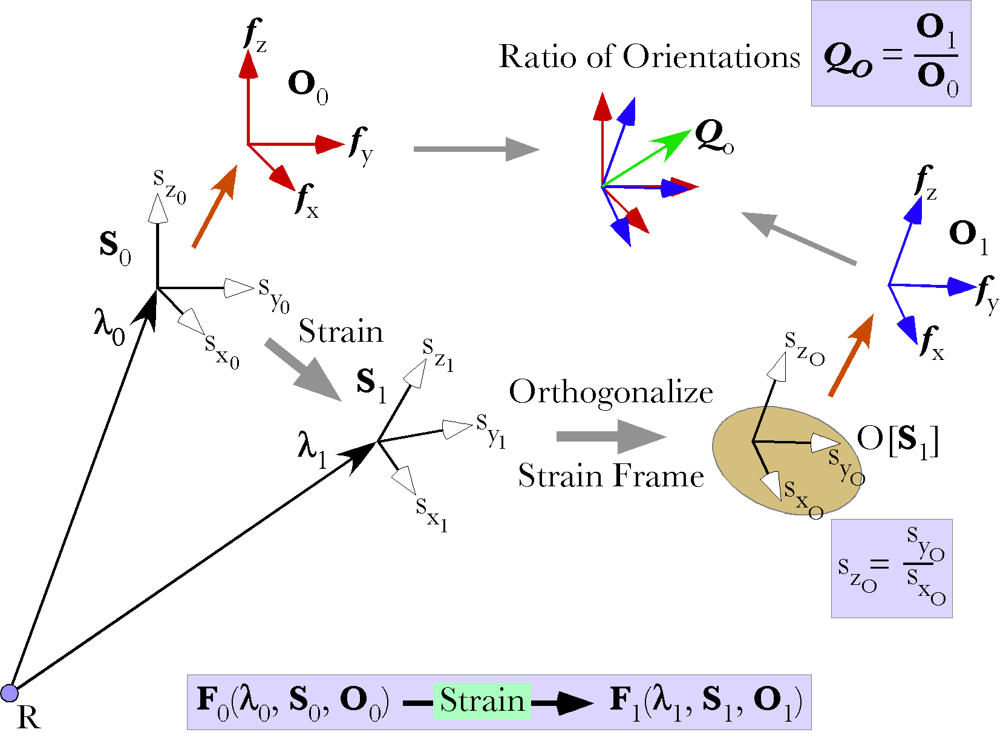
The basic procedure will be to describe the anatomy of a situation in terms of a strain and define a convenient framed vector for the calculations (F). First we will compute the new location after the strain (). That basic calculation is then repeated for a set of locations displaced an infinitesimal distance from the location along each of the frame axes, before and after the strain occurs. The extension vectors are computed by subtracting the location from each of those locations, giving a strained infinitesimal frame, . It is then a simple process to compute the strain quaternion for that distorted extension frame. The strain quaternion will give a substantial amount of information about the strain. We can compute the axes of rotation for the strain and from those axes compute the orthogonal frame associated with that strained frame (). Finally, we can compute the rotation quaternion () for the orthogonalized strained framed vector (). Orthogonalization involves computing a set of orthogonal vectors that express the orientation of the strained frame. A description of the procedure is given elsewhere (Langer 2006b). For present purposes, we will not need a sophisticated understanding. The appropriate orientation of the strained frame will be apparent.

Constrained Compression/Expansion
Let us start with a simple anatomy so that we can develop our tools before the mathematics becomes too complex. The medium is uniform and isotropic and there is no lateral movement. It may be visualized as a plunger compressing the medium in a rigid well or pulling it in one direction.
Let the initial distance between the two plates be $w_{0}$ and the displacement will be . If there is compression, then is negative and if there is expansion that is positive. Since the material cannot move laterally, it is restricted to the movement in the direction of the compression or expansion, that is, in the same direction as the displacement of the moving plate.
Location is measured relative to a point on the surface of the unmoving plate, A₀. The location before the compression is and, after the compression, it is . The difference between the locations is . This is expressed symbolically as .

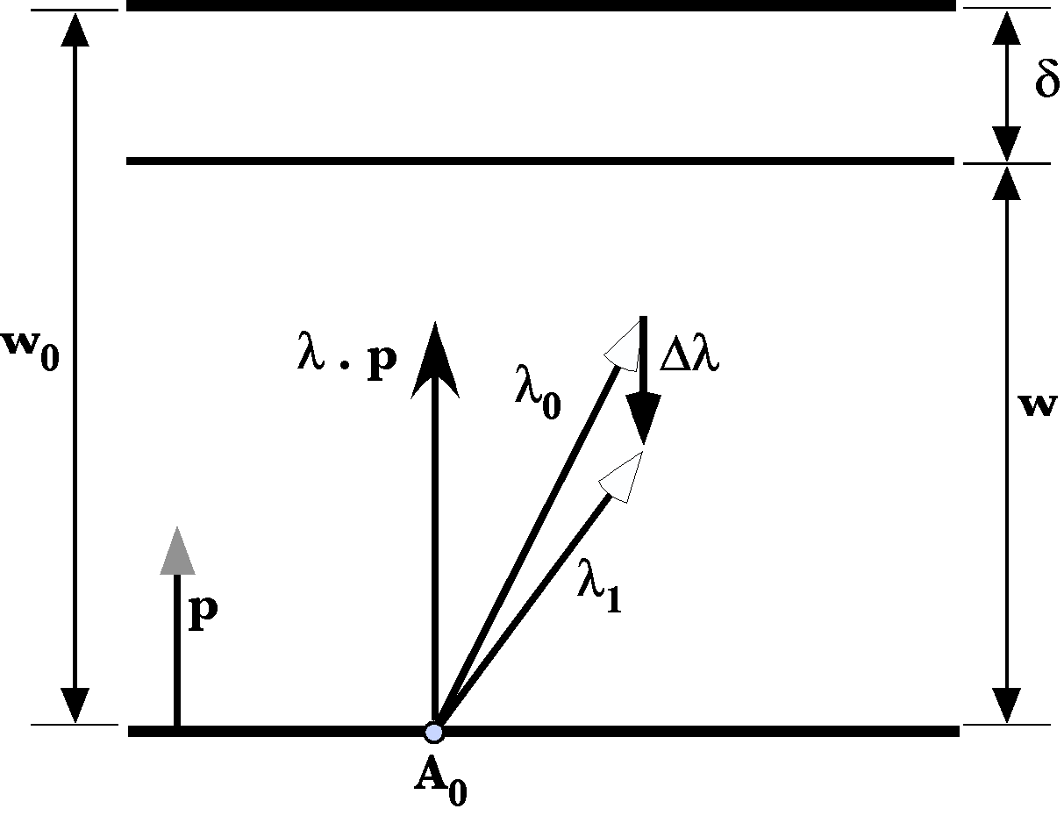
The problem comes down to writing an expression for the vector as a function of location, . In this situation the direction of the displacement is perpendicular to the two plates. Therefore, we construct a unit vector that is perpendicular to the bottom plate, $p$. The part of that is relevant to the compression, , is the projection of upon $p$, , that is, the component of the location vector that is perpendicular to the lower plate. Overall, the material between the plates must compress or expand a distance , but that change is evenly distributed over the distance of . The perpendicular component of , , is multiplied by the interval between the plates, divided by the original distance between the plates, , to give the amount of displacement of the location and that displacement is in the direction from the lower plate to the upper plate.
Normally, the compression is small, on the order of 5%, or less. Most biological materials are relatively incompressible and inextensible largely because they are mostly water in colloidal gels or they are mineralized, as in bone. When it is important that biological materials do not compress, they are usually provided with a ‘skeleton’ of some sort or they are confined in an inextensible cavity.
We now consider the extension vectors. Let the first and second vectors of the frame be parallel with the lower plate and the third vector be perpendicular.
If we look at the extension vectors, the vertical axis changes an amount proportional to the compression or expansion, while the horizontal axes remain the same, so that there is a slight stretching or flattening of the test cube. The test cube is a unit cube so we may replace the infinitesimals with unity. If the vertical direction is the k axis, then the strain quaternion is a scalar.
The flattening is the same everywhere in the medium, therefore the extension strain is uniform.
The orientation frame for the test box is equal to the orientation frame for the framed vector so the ratio of the two frames is unity.

Unconstrained Expansion/Contraction
The constrained case is in many ways trivial, but it illustrates the basic approach. We now move on to a more complex situation, similar to the first, but without a constraint upon lateral movement. As the plates are brought together the medium may bulge laterally and as they are separated it may be drawn centrally. Consequently, points in the medium may move vertically and laterally and they usually do so.
The constrained case of compression is simple and a bit boring, but it gives us a start on the unconstrained case, which is neither simple nor boring. In the unconstrained situation, we also assume an incompressible, or minimally compressible, amorphous matrix between two flat plates, but with room to move laterally, parallel with the plates. The gel will be assumed to be a circular mass, to simplify the calculations and because it is the lowest energy state for an unconstrained gel capable of flow, because it minimizes surface tension. The shape of the slab of gel is irrelevant to the basic physics.
First, the movement of the plates by distance $\left|d\right|$ will cause a volume, ${DV}_{\text{circle}}={pr}_{0}^{2}∗d$, of material to flow laterally from a circular region of radius $r_{0}$ about the center of the mass. The outer radius of the circular ring that contains the material that was inside the circular slab of radius $r_{0}$. is given by a simple expression.
The volume of displaced material is equal to the volume of the ring that it occupies, so, we can set these two expressions equal and solve for the outer margin of the ring in terms of the vertical shift and the radius of the original circular slab.

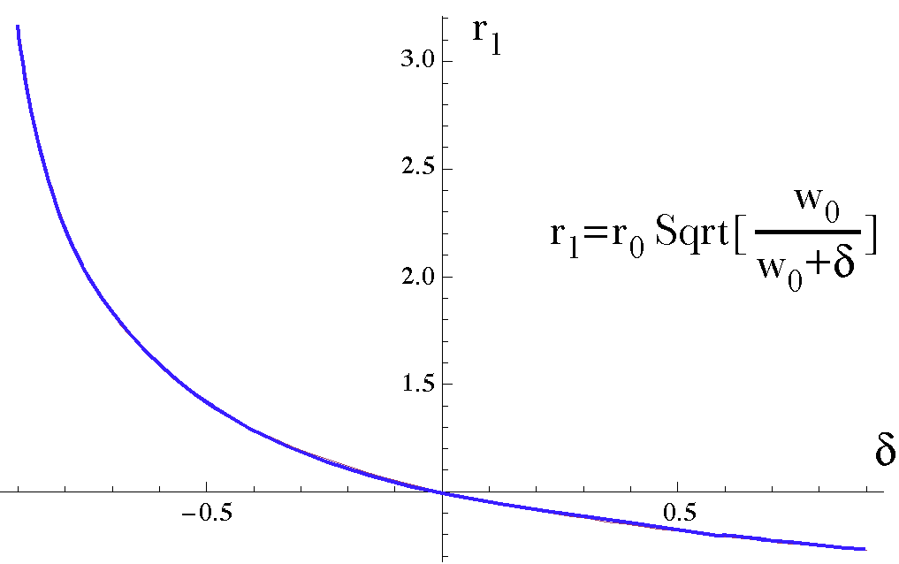
For an initial slab thickness of = 1.0 and radius of = 1.0 the radius of the slab, , is plotted versus the amount of compression or expansion, .
Consequently, the central circular slab of radius $r_{0}$ now occupies a circular slab of radius $r_{1}$, where $r_{1}$ is given by the formula that was just derived. For small amounts of compression, the percentage increase in radius is about half the percentage decrease in height between the plates. For large compressions the new radius increases rapidly for small increments of compression.
However, this is not a correct analysis, because the medium does not move as a vertically flat surface. Rather it bulges. The middle parts move out more that the parts that impinge on the bounding plates. Let us consider how that might occur.
First we need to determine how much material there is that is moving. The volume of material prior to the compression or expansion () is the volume of a circular disc with a radius of and a thickness of . If the plates are moved, then the volume inside the initial radius is decreased (compression) or increased (expansion). That capacity, , is easily computed and thus the amount of material that has to shift, , is readily computed.
If the excess material were to flow uniformly peripherally, then the material a distance $r_{0}$ from the center of the disc would end up lying at a distance of $r_{1}$ from the center of the disc. However, flow is not uniform. It is most likely to occur as described by the Navier-Stokes equation of hydrodynamics, that is, laminar flow. If that is a reasonable approximation to the flow, then the rate of flow is proportional to the square of the distance from the fixed walls. Close to the wall there is very little flow and, in a horizontal plane midway between the two plates, the flow would be maximal and proportional to the square of the distance to the nearest wall.
Even if the flow is not laminar, it will often have a similar profile. For instance, a muscle is often attached to a rigid substrate like bone at its ends and that attachment does not shrink or expand as the muscle contracts or lengthens.
The lateral flow would be given by an expression like the following, where is taken to be the middle plane, half way between the two endplates.
$$d\left(x\right)=d_{\text{Max}}−{\text{kx}}^{2}\text{.}$$
The variable ‘d(x)’ is the displacement of the material parallel to the plates and, ‘x’, is the distance from the middle plane. The constant $d_{\text{Max}}$ is the displacement of the material in the middle horizontal plane, at . We do not know $d_{\text{Max}}$ or k, therefore we must solve for them in terms of the variables that we do know.
At the upper and lower plates the horizontal displacement is zero, which allows us to express the constant in terms of the maximal displacement.
Let $d_{\text{Max}}=m$ and , to simplify the notation a bit for calculation. Envision the flow as a stack of thin circular sheets that are expanding or contracting peripherally from the radius $r_{0}$ to the radius $r_{0}+d\left(x\right)$, where d(x) is the diameter given by the expression for the displacement, and each sheet has a thickness of $Dx$. The volume of the expansion is the sum of those sheets, where each sheet has a volume that is proportional to the thickness of the sheet times its width.
Passing to the limit for section thickness, dx, the expression can be written as an integral.
The term within the integral can be expanded into the following expression.
The integral of this expression turns out to be much simpler than one might expect.

This expression can be set equal to the volume of material between the plates and, with suitable rearrangement of the terms, it can be solved for the maximal displacement.
The maximal displacement is a function of the radius of the circular slab, the amount of compression or expansion, and the distance between the plates. With values for the maximal displacement, , and the coefficient of the squared distance from the center horizontal plane, k, it is possible to calculate the profiles of the material for a series of compressions and expansions. That has been done for an initial disc one unit thick with radius of one unit, and the results are illustrated in the following figure.
For small compressions, there is a small bulging of the matrix, approximately 8/10^{ths} the percentage of the compression, so that a 10% compression causes the maximal lateral displacement to be about 108% of the radius of the slab. When the compression is 50%, the maximal displacement is about 160% of the slab radius. Finally, when the compression is large, like 90%, then the maximal displacement is large, 400% of the slab radius. For large compressions it is likely that the matrix spreads to adhere to the endplates, so this is clearly an idealization.
When stretching the medium, the center of the slab dips in, making the middle thinner, much as a rubber band becomes thinner in the middle when it is stretched. The minimal thickness when the medium is twice its original thickness is 0.54 of the original radius. The minimal thickness becomes zero when the distance between the endplates is five times the original. Clearly, that is an idealization as well.
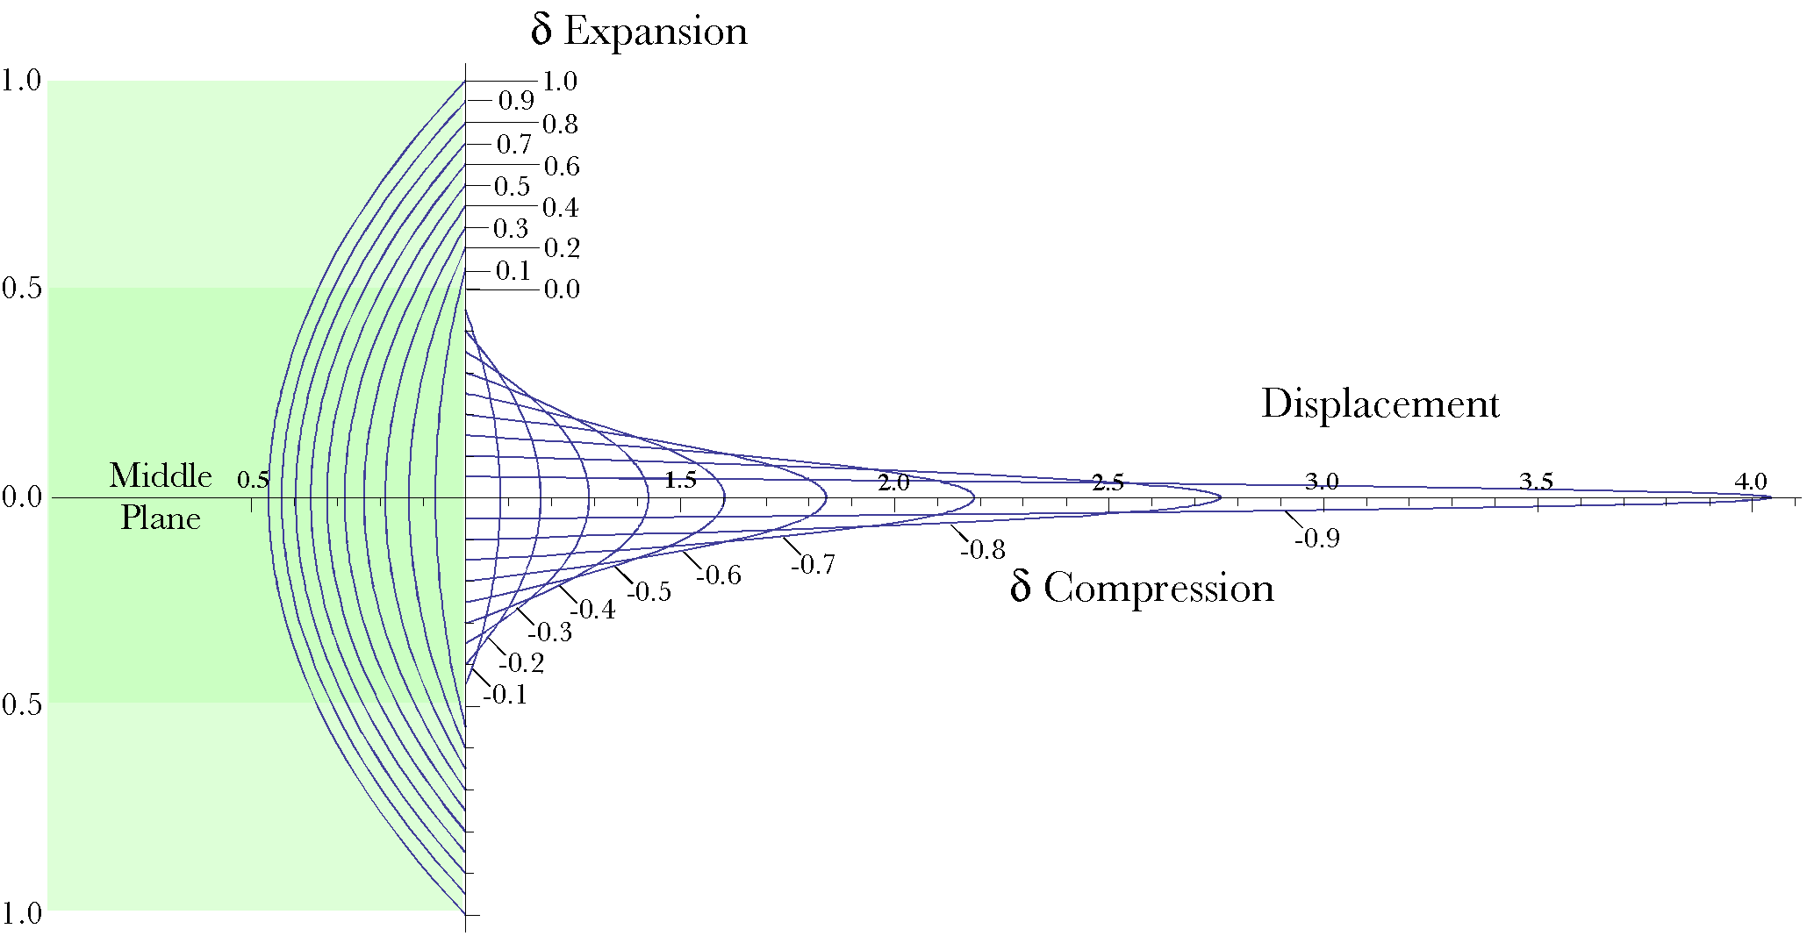
The displacement profiles for different amounts of compression and expansion. The slab is compressed or expanded from 0.1 to 0.9 of its height (δ). This causes the material in the slab to be displaced laterally. The volume of the displaced material is the displacement profile rotated in a circle about the center of the slab. The denser green area indicates the original profile.

Distortions of framed vectors in an unconstrained compressed/stretched medium
We now turn to the calculation of the components of framed vectors in the gel. To start, the framed vector will have a location relative to the center of the disc of strained material, in the horizontal plane midway between the two moving plates, on the central axis. The extension and orientation frames will be aligned with the vertical and horizontal axes of the anatomy, with the first two axes parallel with the horizon and the third vector parallel with the vertical axis.
The displacement vectors for compression vary in obliquity as a function of the depth of the location and the distance from the center of the slab. If we take the middle horizontal plane as our reference plane, then the locations in that plane are carried directly laterally a distance equal to the maximal displacement. At the bounding planes, the displacement is entirely vertical. Between those two extreme locations, the displacement is the sum of a vertical displacement () similar to that computed in the first example and a horizontal lateral displacement ().
The lateral displacement in the horizontal plane is computed as follows. First, compute the horizontal expansion or contraction at the new horizontal level of the location. To do that, it is necessary to compute the horizontal component of the location, , and the new horizontal level, x. The contraction or expansion at that level, , is the parameter that we just finished computing in the previous section.
Once we know the amount of change at the level of the location, then it is simply a matter of scaling the horizontal component of the location by multiplying it by the ratio of the dilated radius to the original radius. The change in the horizontal component is the new horizontal location minus the original horizontal location. The total change in locations is the change in vertical position plus the change in horizontal position and the new location is the original location plus the change in location.

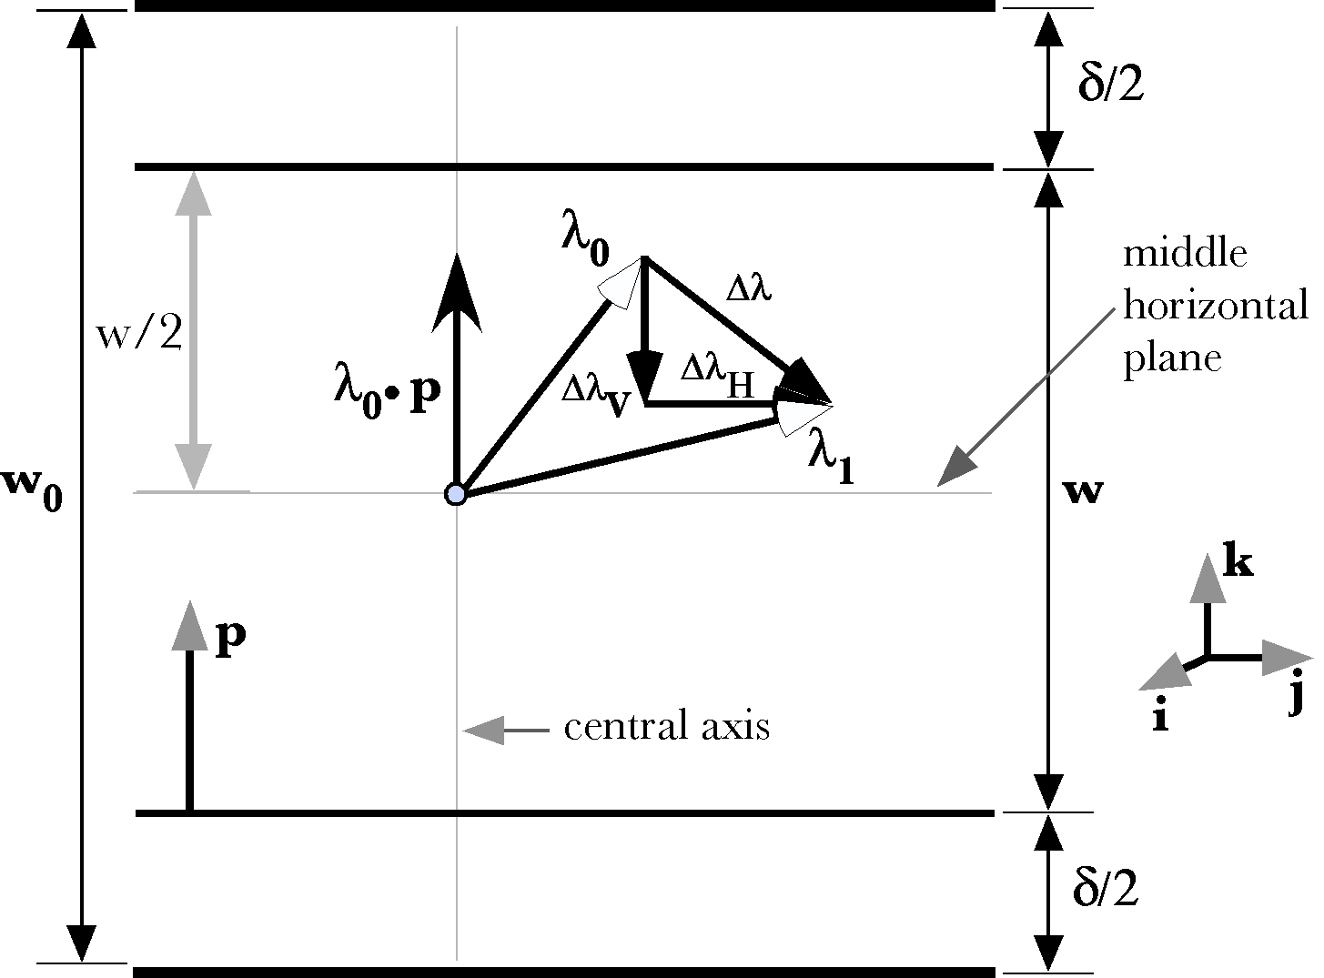
Compression without lateral constraint causes the matrix to move vertically and laterally. The vertical movement is greatest near the moving plates and the lateral movement is greatest near the middle horizontal plane.
Many of these relationships are illustrated in the above figure. This is a situation where the order of the vectors in the vector sum is important. The magnitude of the horizontal change in location is a function of depth in the slab. Therefore, it is necessary to determine the depth by subtracting the vertical change in location from the initial location before computing the horizontal change in location.
If the origin of the coordinate system is in the middle horizontal plane at the center of the slab and the initial location is , then, assuming that the plates are parallel to the i,j-plane and equal distances above and below, that the compression brings them symmetrically towards the plane, and that the center of the slab is at the origin of the coordinate system, then the displacement vector is given by the following expression.
where
If we plug the value for ‘x’ into the expression for the change in location, the result is complex, but almost all of the symbols stand for constant parameters of the anatomy.
The anatomy of this system is symmetrical about the central axis, so it is possible to examine most of the behavior of the system in a radial slice through the slab of material. If we examine the positive j,k-plane, then the above expression reduces to the following equation.
We can use this formula to calculate the amount of movement at any point in the slab of material for any amount of compression or extension. The next couple figures are examples of the results of such calculations in a slab of unit radius and thickness when it is compressed or stretched by a factor of 0.30.
The greater the distance to the middle horizontal plane the more vertical the flowlines. For points on the upper or lower surface of the slab, the flowlines are vertical and for points in the middle plane they are horizontal. The greater the distance from the central axis, the longer the flowlines, particularly for points in the middle of the slab.
For small amounts of compression, the lateral component is small. However, if the matrix is loosely constrained, like the nucleus pulposus of an intervertebral disc within the ligamentous sheath of the annulus fibrosus, then the lateral displacement may be the limiting parameter upon compression.

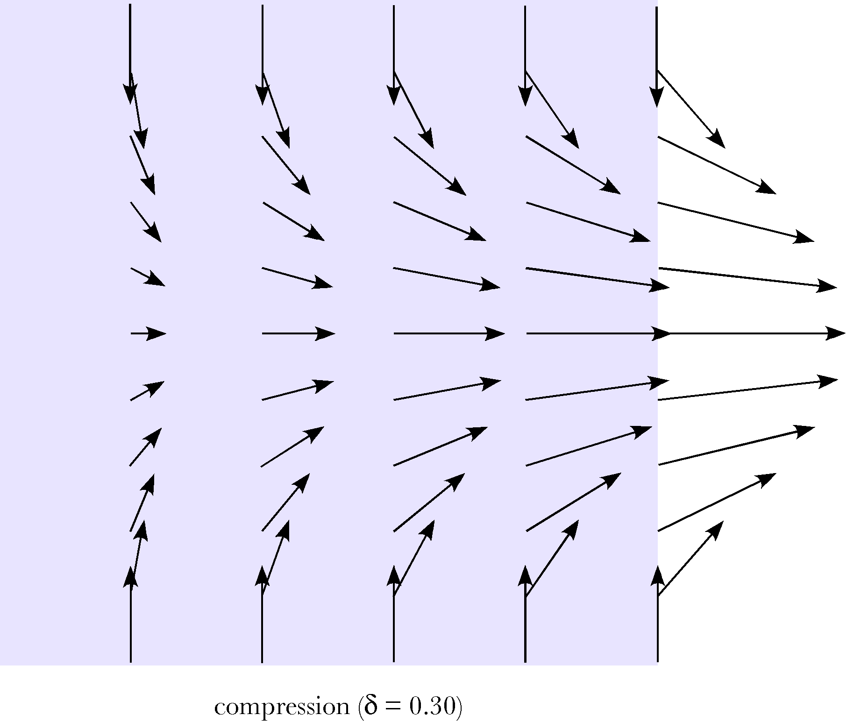
The flow vectors for compression between parallel plates are greater and more horizontal for middle levels and greater radii. The illustration is for a compression that is 0.3 times the distance between the plates.

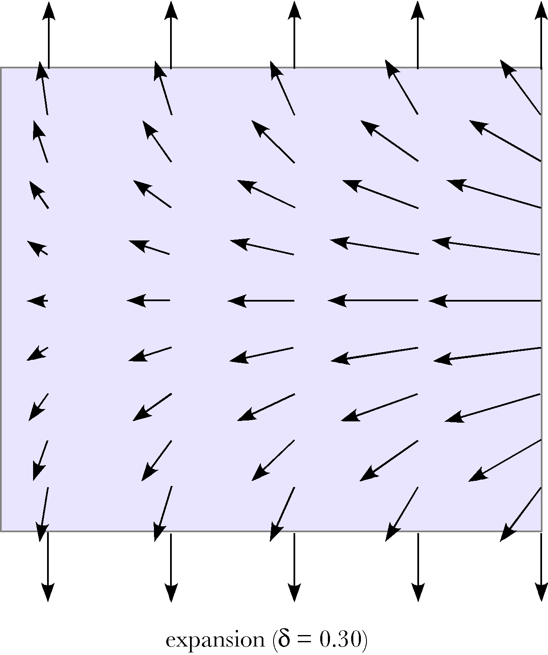
The flow vectors for stretching between parallel plates are greater and more horizontal for middle levels and greater radii. The illustration is for an expansion that is 0.3 times the distance between the plates. Flowlines are drawn for vertical lines at 0.2, 0.4, 0.6, 0.8, and 1.0 times the horizontal distance from the central axis to the outer surface.
In general, biological structures are not as neat as the computed examples considered here, but, these examples do give reasonable models for the consideration of biological situations. While exact solutions of the biological geometry may not be possible, it is possible to generate order of magnitude solutions that support or deny particular interpretations.

The extension frame
Now, we turn to a consideration of the extension frame. As before, the unstrained frame is a set of infinitesimals. Unlike before, the strained frame is a function of the location of the sampled point.

We can simplify the problem by noting the radial symmetry and looking at the extension frame in the j,k-plane (α=0.0).

The fractional change in the extension vectors is obtained by dividing by the unstrained frame.
The rate of stretching in the horizontal plane becomes greater as one moves to more peripheral locations. That is because the area of a ring of a given width increases in proportion to the square of the radius of the ring. In the present situation the matrix has more volume to occupy, for a given increase in radius, as it spreads peripherally. The proportional change in the vertical component of the ratio of the stretched or compressed matrix to the unstressed matrix is not a function of the radial offset, but the further from the middle horizontal plane one moves the greater the tilt in the direction of j.
The following figures show how the medium is strained by compression () and stretching (). Two types of strain are examined, volume strain (V) and strain in a plane parallel with the end plates (A). The vertical strain is uniform throughout the depth of the slab, because it was assumed to be so as one of the initial conditions of the anatomy. However, the resulting distortion of the medium causes the strain in the perpendicular plane to vary as a function of depth in the slab ().
In fact, the direction of the volume strain reverses so that stretching the medium causes the material near the endplates to experience a net increase in local volume and the material midway between the plates to decrease in volume. That is also implicit in the illustrations of the flow lines. With stretching, material flows from the middle towards the upper and lower surfaces and during compression the flow is towards the middle and laterally.
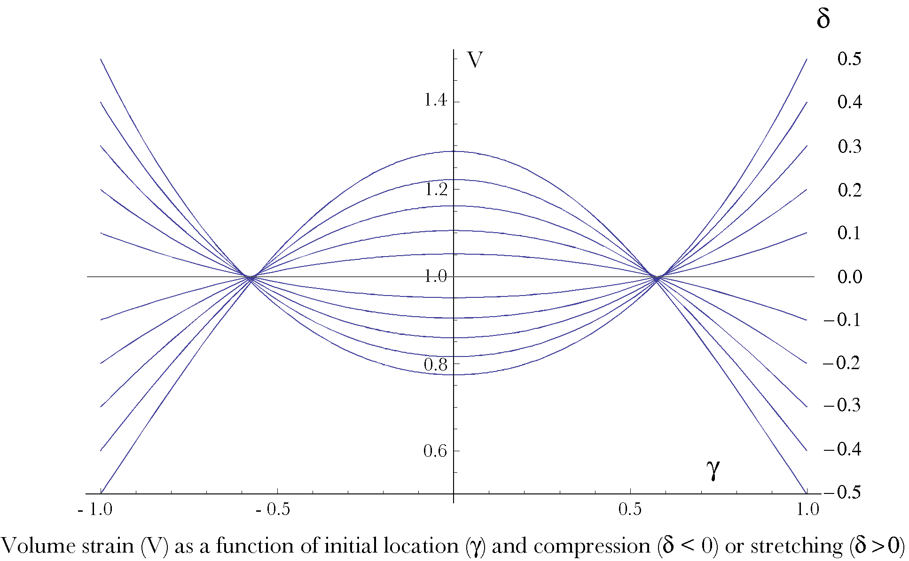
The local volume strain is computed for different amounts of compression and stretching of a slab between parallel endplates. The amount of strain upon the slab is given by the relative change in the distance between the plates (). The depth in the slab is . There is a reversal in the direction of the local volumetric strain so that material tends to flow from the center of the slab to towards the endplates (stretching) or vice versa (compression).
Since the amount of vertical strain is constant throughout the depth of the slab, the flow must be largely due to spreading or contraction in the perpendicular plane. As the material is forced centrally and laterally during compression, the only available direction for compensation is to cause the lateral walls of the strain box to move laterally. Consequently, there is an area strain (A). Conversely, as the slab is stretched and its center is drawn medially, the walls of local strain boxes are drawn in and the area diminishes. Unlike the volume strain, the area strain is in a consistent direction for all depths in the slab, but is becomes greatest or least in the middle plane. As noted above, there is no dependence upon the radial distance in the slab, so the area strain is uniform in a plane parallel to the endplates.
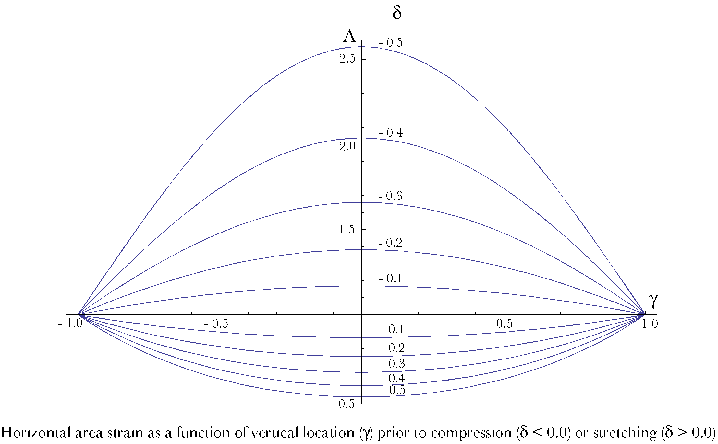
The local area strain in a plane parallel with the endplates depends upon depth in the slab or material. The direction of the strain is consistent for all depths, but the amount of strain is maximal in the middle plane parallel to the endplates. The magnitudes of area strain are greater than the amount of volume strain.
The maximal amount of areal strain is greater than the amount of volume strain. For instance, a compression of 0.5, that is rendering the slab half as thick, causes the area in the middle plane to expand to more than 2.5 times its initial value. Consequently, all other things being equal in this model, we would expect damage to the material in the slab to occur most often near the middle of the slab.
The horizontal components of the strain frame are identical, therefore the frame does not rotate in the i,j – plane. The third component, the vertical component, does rotate, about the - i axis. In this instance, a slice in the j,k-plane, the i axis is the tangent to the circumference of the slab, so, the vertical axis generally tilts radially. The angular excursion of the tilt is the ratio of the new direction to the original direction.
The tilt angle is computed for compressions from -0.9 to -0.1 and expansions from 0.1 to 0.9. The curves are symmetrical about the middle horizontal plane. Tilt is less for locations near the middle horizontal plane and greater as one approaches the upper and lower faces of the slab.
There is also a dependence upon the radial distance from the central axis of the slab (β). As one moves away from the central axis, the amount of tilt at a given vertical position in the slab increases for any given amount of compression or stretching.
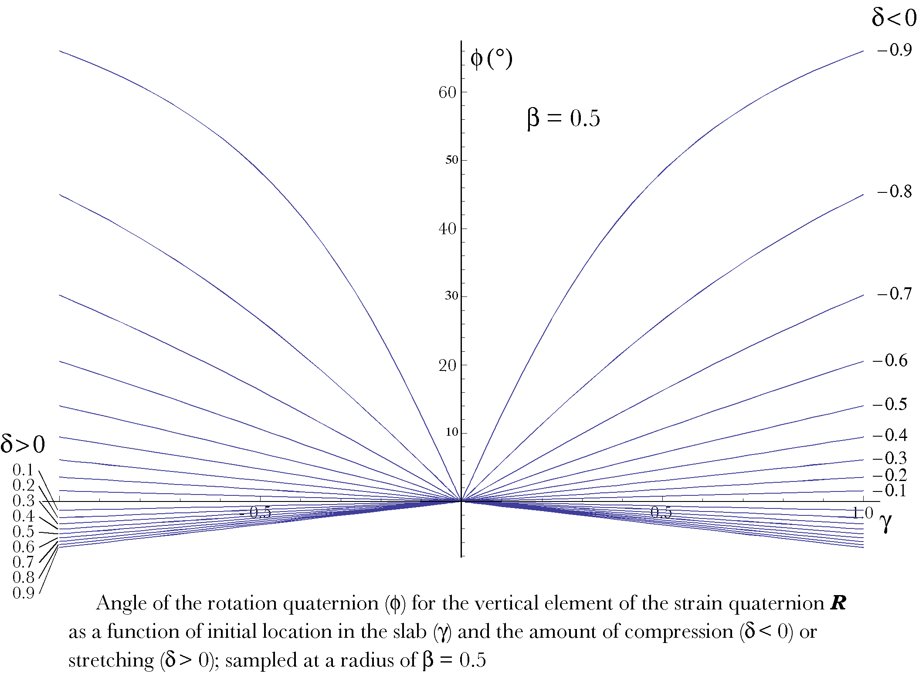
The tilt angle is about the i axis if the slice is in the j,k plane. For stretching (), the vertical axis tilts peripherally. With compression, the vertical axis of the strained box tilts centrally. The magnitudes of tilt are more affected by compression. The amount of tilt is greater at larger distances from the center of the slab.
When compression occurs, the vertical axis of the strained box tilts towards the central axis of the slab and when stretching occurs the tilt is away from the central axis. The tilt is least near the central axis and greatest at the peripheral boundary. At the central axis the material either expands or contracts along the vertical axis. Peripherally the material further from the middle horizontal plane is dragged relative to the material that is slightly closer. If the gel is bulging (compression) then the vertical axis is dragged centrally and if the gel is sucking in (stretching) the vertical axis is dragged peripherally. This may also be expressed by noting that the axis of rotation for compression is in the direction of i and for stretching it is in the direction of – i.
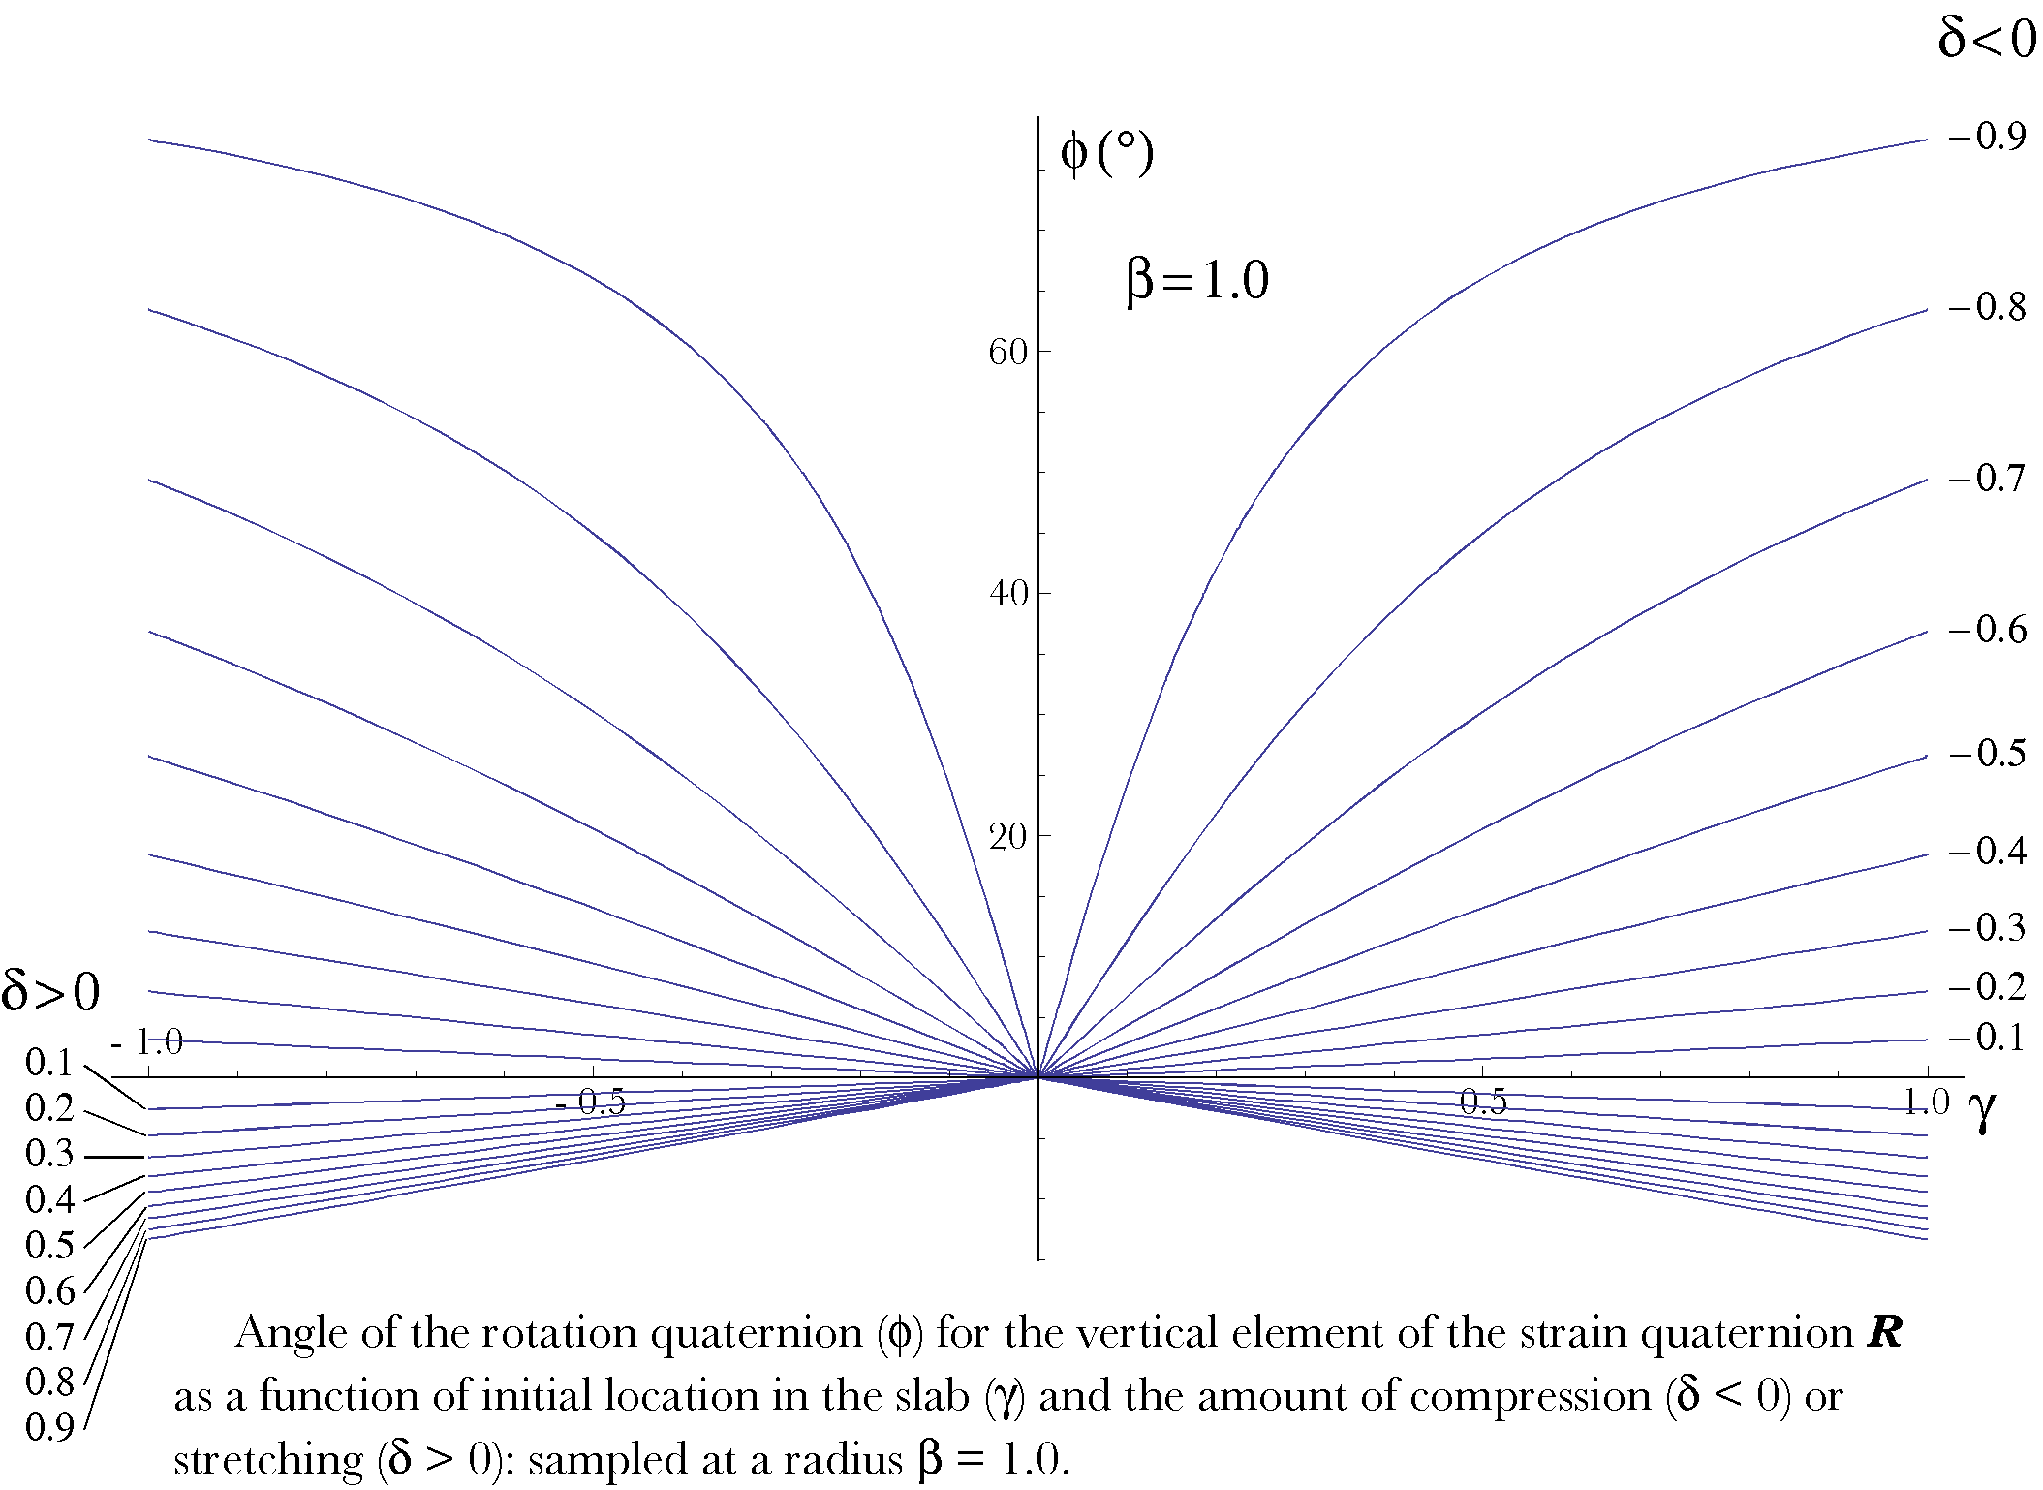
At greater distances from the center of the slab the magnitude of the tilts of the vertical axis of the strained box increase. Compare this plot, sampled at the outer boundary, with the previous figure, which is sampled midway between the center of the slab and its outer boundary. The vertical distances () in both figures are in the unstrained slab.

The orientation frame
We may now consider the orientation of the frame vector for this type of strain. Since the first two vectors of the strain frame do not rotate, that is, the frame moves peripherally along a radial trajectory, one can orthogonalize the strain frame by computing the vector that is the ratio of the first two vectors, which is obviously a vector in the direction of the k axis. Consequently the orientation frame does not rotate. That agrees with our intuition that the material moves radially in or out, but it does not rotate.

Summary
Compressive or tensile strain is intuitively a simple distortion. The material simply expands or contracts without twisting. That is clearly the case when the material is constrained. If the constraints are removed and the material is allowed to flow, then the situation becomes somewhat more complex. Most of this chapter was taken up in defining the distortion that occurs in a relatively simple anatomy.
In order to obtain a definite solution, it was necessary to assume some basic flow characteristics, namely laminar flow. In unconstrained materials, it is natural to assume constant volume and equal forces throughout the medium. Flow under those circumstances will tend to be laminar. Those assumptions may or may not be valid in any particular situation, but the computed deformations are consistent with observations of changes in elastic media that are compressed or stretched. When pinched between two surfaces they bulge laterally and when stretched they narrow in the middle.
The intent of this analysis was not to describe any particular instance of this type of strain, but to demonstrate how one might go about analyzing the distortions in terms of strains as characterized by strain boxes. This is not the usual approach of elasticity theory, but the intent was not to describe flows per se, but to express the anatomical movements implicit in particular types of distortions. If better or alternate descriptions of the flow become available, then the same methodology may be used to explore the implications of that flow to the anatomical movements within the medium.
There are a number of anatomical situations that might be explored with this approach. The movements of the annulus fibrosus of the intervertebral disc might be interesting as a case of compressive strain. Strains in muscles, tendons, and ligaments might be examined as instances of tensile strain.

