Distortions in Media: Shear Strain
The compressive/tensile strain that was considered in the last chapter was uniformly distributed within the medium. When lateral movement was not constrained, the strain led to a flow that was not uniform. In this chapter, we will consider strain that is, as it were, across the medium, without compression or expansion. It also causes a differential flow, which shears the medium. We will consider two types of shear, linear shear and rotational shear. Linear shear is in a single direction throughout the medium. Rotational shear is generated when one parallel end plate rotates relative to the other.

Linear Strain

Linear Strain in Crystalline Materials
In a crystalline material a shearing force is distributed evenly over the layers of the crystal, so the displacement is a linear function of the distance from the fixed plane. Consequently, if the two surfaces are separated by a distance ‘w’ and the moving layer is displaced a distance $s$, then the shift at a location, $λ$, is proportional to its relative distance from the fixed plate to the moving plate, measured perpendicular to the fixed plate.
We might expect substances like bone to shear in this manner. It is a very simple anatomy.

Linear Strain in Amorphous Materials
Amorphous media will tend to flow when sheared and the distribution of the displacement will not be uniform. Material near a fixed surface will not move as readily as material at some distance from the endplates. We will encounter a situation approximating laminar flow. In laminar flow, the velocity of flow is proportional to the square of the distance from the fixed surface.

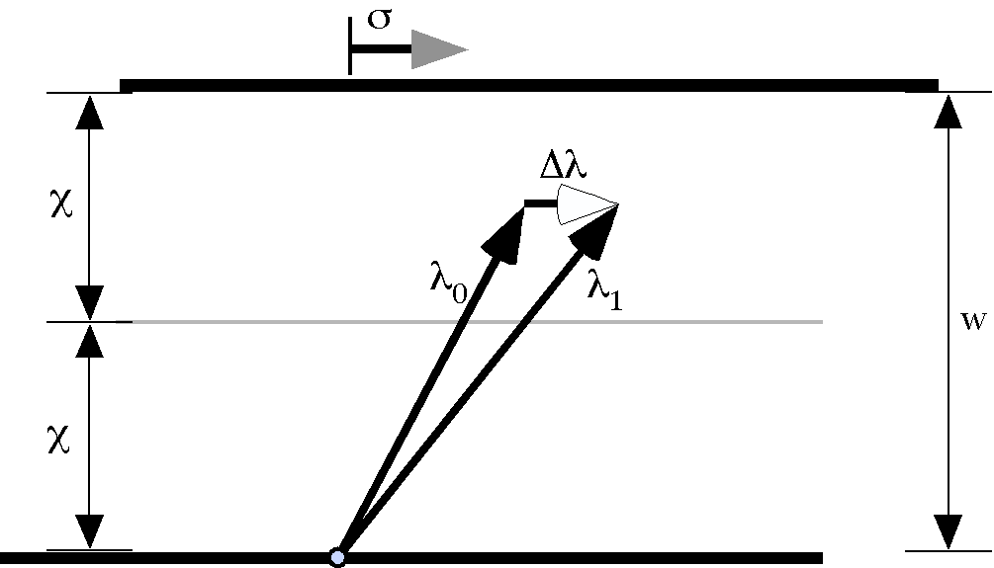

The shear of one plate relative to another while preserving the distance between them. The two parallel plates are separated by w and the shear is σ.
It is computationally easiest to assume flat upper and lower boundaries for the matrix, which will be assumed parallel to the direction of shear. For definiteness, assume that the plates are separated by a distance w, the bottom plate is fixed and upper plate moves a distance $s=\left|s\right|$ in the direction of the shear, $s/\left|s\right|$, and that the two plates are parallel and horizontal. The amount of shear in any horizontal plane, between the two plates is given by a second order polynomial.
We specify that the displacement is zero adjacent to the plates. Consequently, we can evaluate the expression for the local displacement at those two locations and obtain the value of k as a function of the maximal displacement and the distance between the two plates.
We do not know the value of the maximal local displacement, $d_{\text{Max}}$, but we do know the magnitude of the shear displacement and the shear is the summation of all the local displacements. From that, it is possible to compute the value of maximal local displacement.
The maximal local displacement is readily computed from this result by noting that the total displacement is $\left|s\right|=s$.
We can now write the expression for the local displacement and the expression for the shear.
and
For any location $λ_{0}$, the shear will move it to a new location that is the same distance from the plates, but moved parallel with the shear vector an amount that depends upon its location relative to the fixed plate.
The shear profile is not a linear function of the distance of the location from the plates, but there is not a strong curvature to the leading edge of the displaced matrix. The shear profiles are the same throughout the matrix between the plates.

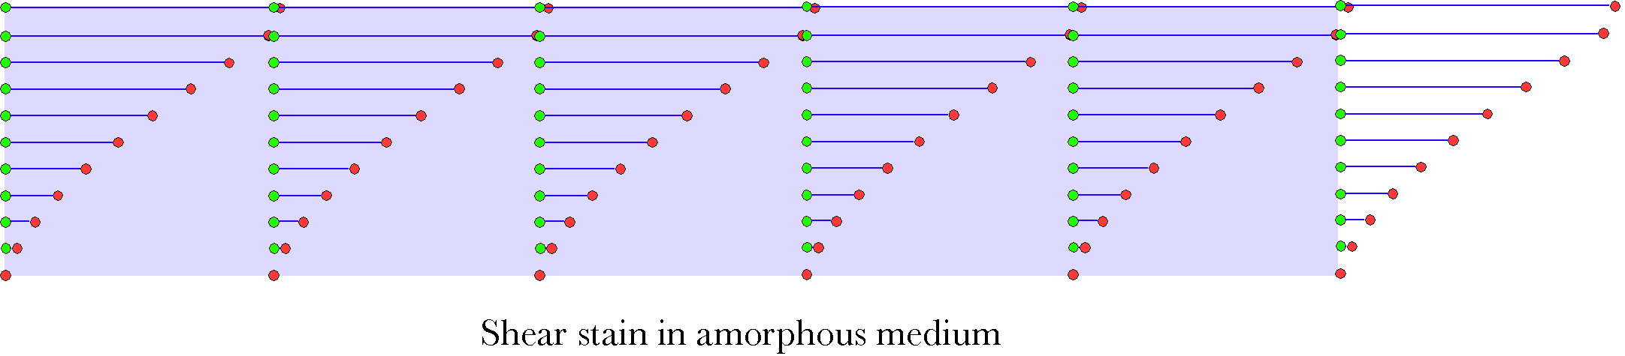
The shear is symmetrical about the middle horizontal plane midway between the plates. Consequently, it will look the same whether the upper plate alone or the lower plate alone is moving or both are moving as long as the relative movement between the plates is the same.

Extension Frame
Let us construct an infinitesimal extension frame at the location . Also, let the strain be in the direction of the y axis. The change in the frame as the medium experiences the shear strain described above will be given by the changes in all the infinitesimal extension vectors

We subtract the strained location vector from each of the stained combination location and extension vectors to obtain the strained extension frame.

Since is an infinitesimal, we can set all terms with higher powers of equal to zero.

If we compute the strain quaternion, it is much as expected.

There is no change in volume, because the scalar of the strain quaternion is unity, but the vertical axis is rotated about the axis that is mutually perpendicular to the vertical axis and the axis in the direction of the shear. The rotation of the vertical axis is nil when the vertical component is at the upper or lower boundary of the slab of material, meaning that there is no shear at the boundaries of the slab. The angle of the strain quaternion () is plotted versus the depth () in a 2 unit thick slab in the following figure.
The assumed shears range from modest () to very large () in steps of 0.1 times the thickness of the slab. Most biological shears would be near to the low end of this range. However, between the surfaces in a joint, the shears might become quite large.

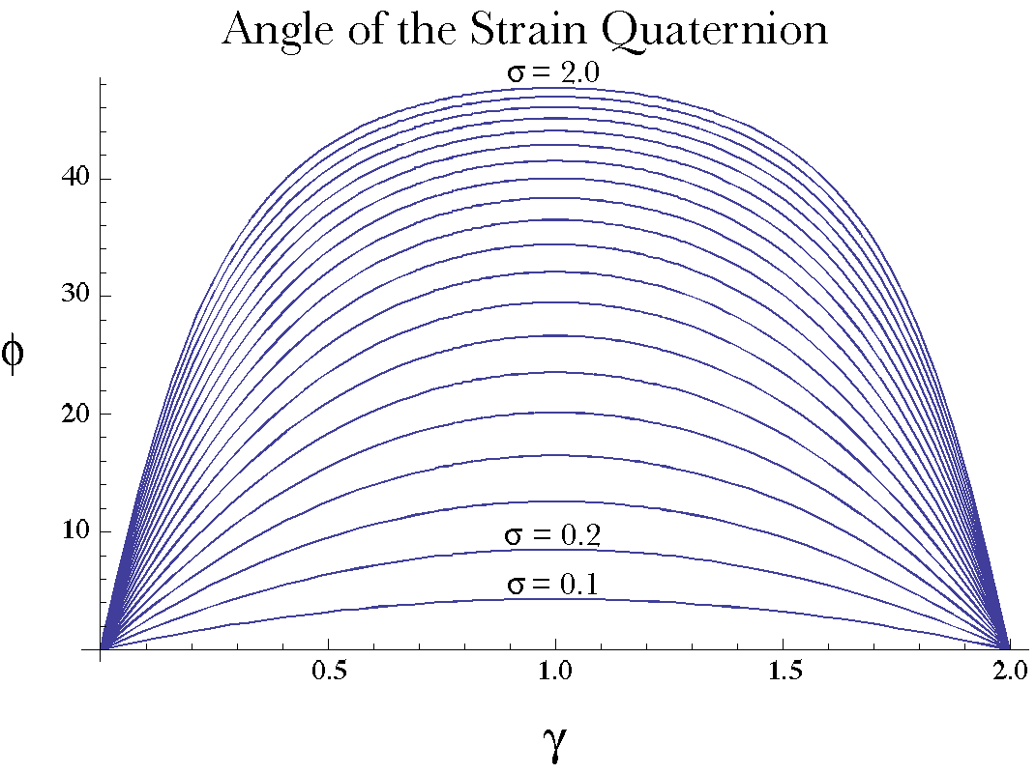

The orientation frame
As with the compressive/tensile strain, orthogonalizing the frame leads to a frame that is aligned with the original orientation frame. Consequently, the orientation is not changed by linear shear.

Rotational Strain
Another way that a shear strain may occur is if the medium is subjected to a rotational force applied to its upper face that causes its upper surface to rotate relative to its lower face. This type of force causes a rotational strain.
Let us assume a circular slab that lies between two plates and let the lower plate be fixed while the upper plate rotates about an axis through the center of the slab. A location (r) is designated by its distance from the center of the slab (r) and its height above the lower plate (h). The locus r is rotated about the axis of rotation () through an angle when the upper plate is rotated through the angle . We have to determine the magnitude of from the anatomy of the system. As before, the original locus is labeled by and the new locus is . The change in location is . The rotation of the upper rim of the slab is given by a simple quaternion expression.
It is assumed that all r move in the same manner, tracing a circular trajectory in the slab. Upon that assumption we can reduce the problem to two dimensions in which the movement occurs in circular band concentric with the axis of rotation. We essentially peel away that band and lay it flat for many of the calculations.
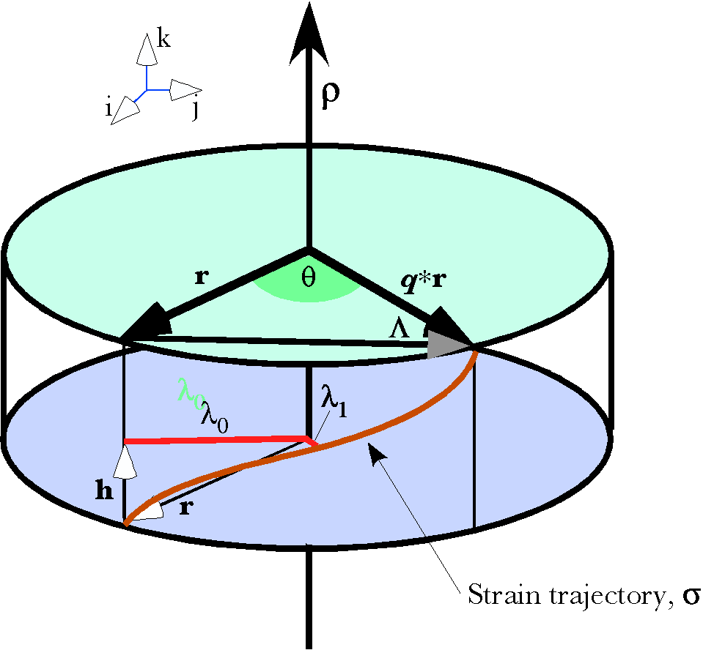
The upper (green) plate is rotated through an angular excursion of θ about an axis of rotation, ρ. Producing a rotational shear between the two plates. For locations between the plates, λ₀, the flow of the matrix is in a ring concentric with the axis of rotation to an extent that depends upon the distance from the location to the fixed plate (blue) and the separation between the two plates, 2χ.

The initial location vector () is resolved into two component vectors, one parallel to the perpendicular, h, and one perpendicular to it, r.
We will also need to designate a tangential unit vector, , that is perpendicular to r and h.
The maximal shear, the movement at the interface between the slab of material and the moving plate is the angular excursion, in radians, times the radial distance, concentric with the axis of rotation.
However, the shear is along a circular trajectory, therefore net distance traveled is the final location minus the initial location.
Since , there is a tendency for the sheared matrix to move centrally, however, that space is already occupied by the more central rings, so the matrix must flow in its own concentric ring. Still, there is a centrally directed tendency to compress the matrix. If the matrix contains vertical fibers that link the two bounding surfaces, then the fibers will tend to pass directly between their attachment sites. The surface generated by a circle of such fibers will be concave in its middle, giving the matrix a more hourglass-like shape. This anatomy has been developed in some detail elsewhere (Langer 2005n; Langer 2005o), where the strains in the vertebral artery are computed from its anatomy.
Since a cylindrical ring is topologically a flat surface we can, as it were, peel it away to treat the flow as we did in linear shear and lay it back into its original position to see how that flow, f, appears in situ.
We have already derived the expression for , given , when the shear is linear.
With several simple changes, a similar expression describes rotational strain. The total shear is an angular excursion, , and the perpendicular offset is . The change in location, , in radians, is also expressed as angular excursion.
The distance is the distance within the ring, rather than the chord that connects the initial and final locations. Consequently, the expression relating the initial and final locations may be written as follows.
With rotational shear, the final location is more concisely expressed as a quaternion product with the initial location. Note that the angular excursion can be reduced to a scalar factor times the total angular shear. This means that the angular excursion of the flow is independent of the distance from the axis of rotation, which is in accord with our expectations. This is of physical importance, because it means that the strain is uniform throughout the radius of the matrix.
The distribution of shear is basically taking the linear shear and wrapping it on to a cylindrical surface. The general shape of the distribution was sketched in the introductory figure for this section and it is plotted from detailed calculations in the following figure.
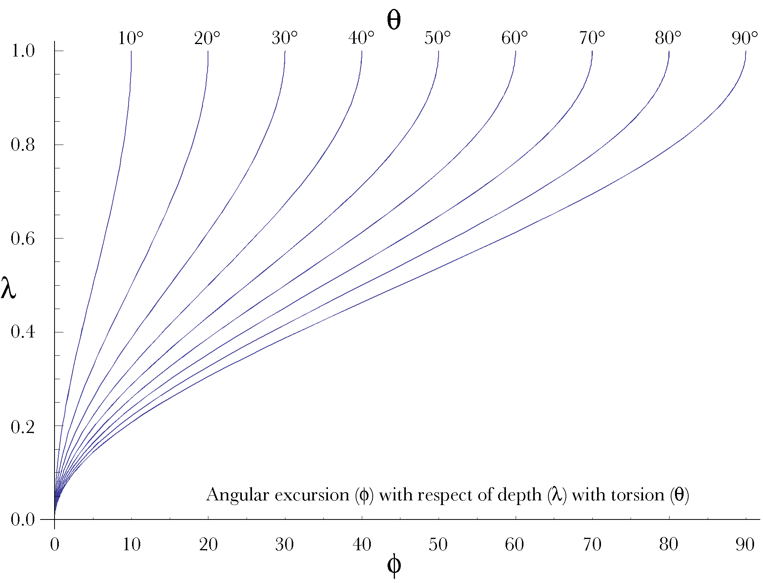

Torsional Shear
There is a type of torsion in which the strain is not uniform radially. If the torque force is applied to the outer surface of the matrix, as in unscrewing a jar lid, then the strain differential is between the outer surface and the axis of rotation. If the tangential force is assumed to be uniform over the outer surface, then the strain is greatest at the outer surface and it is attenuated as one moves centrally. However, unless the center is fixed, the mass will begin to rotate as a unit and the strain will be resolved. A variant of this scenario that is potentially more interesting is when the mass is fixed or retarded by other forces and a torque force is applied to a portion of the outer surface. For instance, when the mass is a bone shaft and the torque is due to the pull at a muscle attachment. That problem is far more difficult and therefore will be deferred until we have more experience with strain.

Extension frames for rotatory shear
A convenient and logical frame for extension is a unit vector in the direction of r, the unit tangent at , and a vertical unit vector. The manner in which the radial and tangent vectors have been defined ensures that if they form the first and second extension vectors respectively, then the extension frame will be right-handed if the vertical vector points in the direction of the axis of rotation.
The original location moves to a new location given by the expression given above.
The transformation of the first component of the extension frame is given by the following expression.
If , then –
The second component, the tangent vector, transforms in much the same manner, but we must use the rotation for conical rotation, because the differential vector is not in the same direction as the location vector.

In both cases the infinitesimal extension axis is rotated around a vertical axis to the same extent as the location. That is essentially what one would expect from the anatomy of the situation. If we orthogonalize by constructing the third axis of the extension frame as the ratio of the second axis to the first axis, then the orientation changes as if multiplied by a unit quaternion with its vector in the vertical direction and its angle equal to the angular excursion of the location vector.
The last component of the extension frame transforms much as the vertical component of the linear shear transformed. The calculations are a bit more complex. We must use the expression for conical rotations, but we may use or as the location vector. The angular excursion of the rotation of the compound vector is a function of the infinitesimal extension vector.

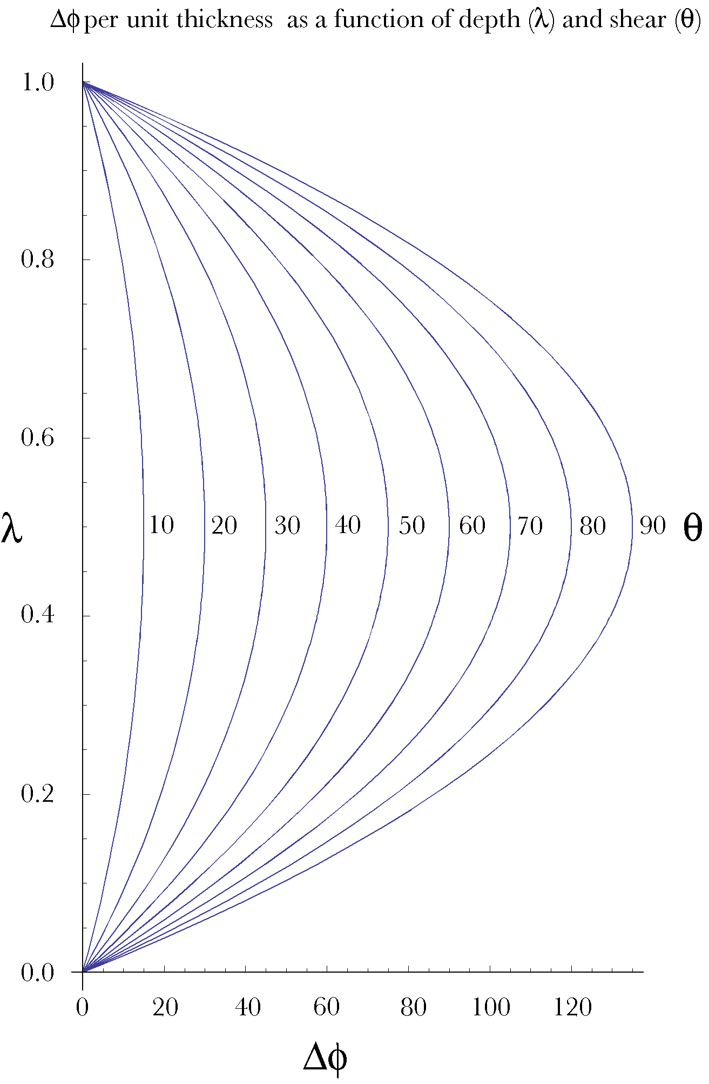
The first term is the expression for in , so may be expressed as , the excursion of the location plus an additional excursion . The ratio of to is the tilt of the vertical axis in the tangent plane to the ring at the new location. The tangent plane rotates with the location, so, the actual tilt is the tilt rotated through the angular excursion of the location, .
The vector rotates horizontally, so the vertical magnitude of the vertical component does not change with the rotation so the strain quaternion has a scalar of unity. The volume does not change. That is what one expects with a shear strain.

Orientation Frame
The first two components of the strain frame remain mutually orthogonal and they rotate in the horizontal plane through an angle equal to the change in location. If we orthogonalize the strain frame by setting the third component equal to the ratio of the first two components, then the resulting orientation frame rotates through the angle about the axis of rotation for the slab,. Consequently, in this instance, the orientation does change with the strain, but the change is relatively simple, being the same for all points in the matrix.

Summary
In many ways shear strain is simpler than compressive/tensile strain. There is a uniformity and simplicity in the distributions of strain that was not present with the unconstrained compressive/tensile strain.
As with the compressive/tensile strain it is not necessarily the case that the distribution of strain is a second order function of the distance from a moving plate. However, it is impossible to gain much insight if we do not assume some distribution and the second order distribution yields reasonable outcomes that accord, at least qualitatively, with common observation. It might be interesting to assume distributions of strain other than linear or second order functions and explore their implications for the overall distribution of shear.
While the rotational and linear shear cases are very similar, it was interesting to explore the rotational case because of the greater use of quaternion analysis in the rotational model. Quaternions make the analysis very straightforward, basically as easy as with the linear shear anatomy. The rotational shear anatomy allowed us to generate a model where there is a change in orientation in the medium, all be it very simple.
We have not explored all the possibilities for shear anatomies. As alluded to earlier in the chapter, we might explore the consequences of a shear applied to the lateral wall of the slab or we might consider a matrix in which there are fibrous elements that make the strain anisotropic or force the strain to be in the most direct line between two moving points.
We might also combine compressive/tensile strain with shear strain as with a wrenching movement that screws surfaces together while rotating them with respect to each other. We might consider situations in which one end plate tilts relative the other as when a vertebra tilts forward and backward upon another. We might consider the combination of strained elements as with the gelatinous nucleus pulposus confined within the fibrous annulus fibrosus in a lumbar intervertebral disc. However, the intent here was to illustrate the application of the tools that have been developed to a few simple anatomies, therefore, these more complex situations will be deferred to another time and place.

