Orthogonalized Strained Boxes

Strain
It was argued above that strain in a medium may be assessed by examining the manner in which a cube of the unstrained material is distorted by forces within and outside the medium. It has also been argued that strain takes two basic forms called volume strain and vector or rotational strain. The volume strain is a scalar and the vector strain is a vector. Volume strain means the volume has changed and vector strain means the angles between the edges of the cube have changed. These two elements together are components of a strain quaternion.

The vector triple product
It was noted that if three vectors {α, β, γ} form three edges of a parallelepiped, then the scalar part of their product is equal to the volume of the parallelepiped.
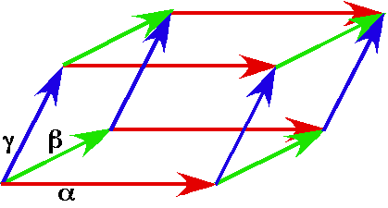
The cube with edges α, β, and γ is strained into a parallelepiped in which the edges are rotated relative to each other and possibly compressed or lengthened, but they still enclose the same matrix, after the strain.
When the edge vectors are mutually orthogonal, the vector triple product is always a scalar. If we change the order of the vectors, the scalar may be either 1 or –1. The order used here is a right-handed coordinate system in which the earlier listed vectors act upon the later listed vectors. In , $α$ is multiplied by $β$ and the product is multiplied by $g$. It is equally valid to choose the cyclic permutations or and there are situations when these permutations are more appropriate choices (see below). All these triple vector products are equal to 1.0. The complementary set of permutations in which the order is reversed, , , and , will yield triple vector products of -1.
Since the choice of the vectors is arbitrary, except that they are mutually perpendicular unit vectors, this result is applicable to any three mutually perpendicular unit vectors. We will generally choose orderings that reflects a right hand coordinate system, so that the volume will be positive.

Definition of Box
When we place a hypothetical unit cube in a medium and allow it to be strained along with the medium, we are effectively placing a frame at a point in the medium. The edge vectors extending from one corner of the cube form a unit frame. Such a frame is called a box. A box is actually a set of extension vectors, because it has location and the lengths and directions of the vectors may change with the anatomical motion of the strain. Unlike a frame of reference, the edge vectors may move relative to each other. The box does have orientation and it makes sense to consider changes in its orientation, but a box is not a frame of reference.
The central concept of this chapter will be is strain frames. A strain frame is a way of finding a set of mutually orthogonal vectors that meaningfully represent the orientation of a strained box. It also turns out that they also form the elements of a frame that may serve as the basis of an anatomical description of the internal rotations between the edge vectors of a strained box.
When a box is placed at a point in a medium to measure strain it is said to be a test box. In general, we will be concerned with the configuration of the box after a strain has occurred. That configuration will give us an index of the strain. The distortion of a test box serves as a means of expressing the nature of a strain. In later chapters, we will use test boxes as a tool in studying the consequences of particular types of strain for flow in the strained medium.

Volume Strain and Diagonal Strain
It is readily seen that if the orthogonal edge vectors are not unit vectors, then the scalar of the product is the product of the lengths. This is what one would expect of an index of volume, . If a unit box is distorted so that the edges remain perpendicular, but change in length, then the box experiences a strain. This is intuitive if we consider a box that is stretched so that one edge vector, say$α$, doubles in length while the others, $β\text{ and }g$, remain unit vectors.
The volume of the box doubles which is certainly a strain. Such a strain will be called a volumetric strain, symbolized by $V$. Volume is clearly a scalar quantity.
The strain in this scenario is actually more complex than a volumetric strain. To see this, consider the following scenario. Suppose that one edge increases by a factor of 2.0, but the other two edges are reduced by a factor of $1/\sqrt{2}»0\text{.}\text{707}$.
The volume does not change, therefore there is no volumetric strain, but the box is clearly strained, because it is distorted relative to the original cubic box. In order to capture this strain we look at another relation between the three edge vectors, a feature reflected in the diagonal vector of the box, the sum of its edge vectors, $d=α+β+g$.
The diagonal of the vector of the elongated box rotates 28.171° about an axis that is in the direction of relative to the diagonal vector of the original cubic box. This strain that changes the shape of the cube will be called diagonal strain. There was also diagonal strain in the example where one edge doubled in length without the others changing, but it was combined with a volumetric strain.

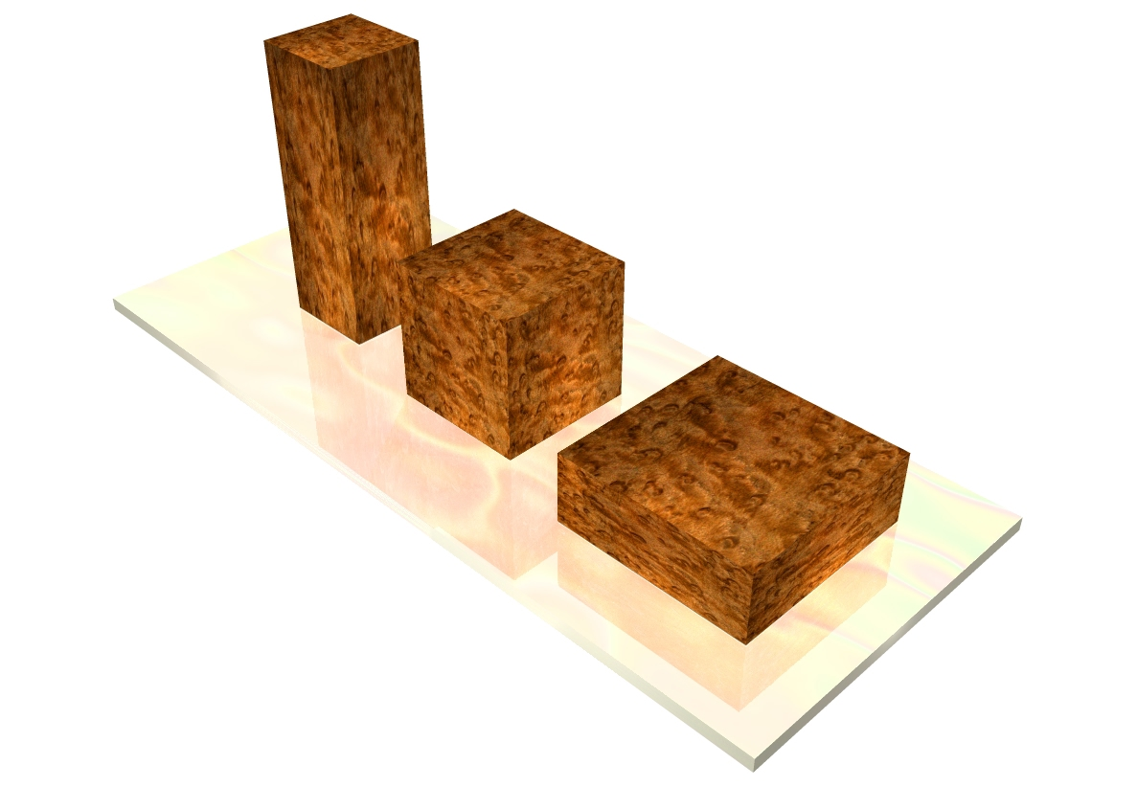
These three boxes have the same volume, therefore there is no volumetric strain in moving from one to the other. Their edges remain mutually perpendicular, so there is not a vector strain. However, there is a clearly a strain in moving from one to the other, which maybe being expressed by a change in the direction of the diagonal for the boxes.
There are many ways in which a bit of a medium may be strained, such as changing its location, its shape or its orientation. In this chapter the focus will be on the changes in shape that may be measured at a point in the medium. In particular, we will concentrate on the distortions of test boxes and mostly upon compressive/tensile strain and shear strain and their effects upon the strain quaternion. Diagonal strain will be considered elsewhere.
A third example illustrates that volumetric strain can also occur in isolation. One can have a volumetric strain without changing the shape of the box. The diagonal of the box increases or decreases, but does not change direction. Consider a box in which all three edge vectors double in length.
The volume increases eight-fold and the diagonal becomes twice as long, but the shape of the box is not changed because the diagonal of the enlarged box is parallel with the diagonal of the original, unstrained, box. This type of strain is not common and it is less interesting than the more common types where the relationships between the edge vectors change.

Rotational or Vector Strain
When the edge vectors rotate relative to each other, so that they are no longer mutually orthogonal the strain quaternion has a vector component and the strain is a rotational or vector strain. Most test boxes placed with random orientation will experience vector strain. In fact, it takes a certain amount of care to place a test box so that it does not experience vector strain and often it is not possible to find such a placement.
Unlike volume strain, which does not depend on the orientation of the test box, vector strain is highly dependent upon the orientation of the box relative to the strain. The last chapter addressed some of the properties of vector strain by computing the distortion in a small spherical bubble of material centered upon a given location and submitted to a particular strain. It gave some insights into the relationships between the strain and the distortions experienced by test boxes with different orientations. In this chapter, we will examine another side of the strained test box and the strain quaternion.

Uniform and Directional Strain
The first example above was an instance of a directional strain and the last example is an instance of uniform or isomorphic strain. Fundamentally, the difference between the uniform expansion and directional expansion is that with uniform expansion or contraction, no matter how we choose the box edges, they remain orthogonal after the strain. If we are following a spherical bubble of material, it remains spherical although it may increase or decrease in diameter. As a consequence, any three orthogonal points remain orthogonal.
With directional expansion, the box edges remain orthogonal only if we choose them to lie parallel with the directions of expansion or contraction. A spherical bubble of material becomes an ellipsoidal bubble and it is only if we chose mutually orthogonal points on the initial sphere that become major or minor axes of the ellipse that the axes remain mutually perpendicular.
If the triple vector product, that is, the strain quaternion, is a scalar quaternion after the strain, then the axes are aligned with the directions of expansion and contraction. Any other choice of box edges will experience a rotational or vector strain. That is, their triple vector product will have a vector component, therefore, it will be a full blown quaternion, with both scalar and vector components.
In the first example considered, we got a nil rotation component because we happened to choose an arrangement of edge vectors that did not change direction with the strain. The relationships between the directions of the edge vectors were unchanged by the strain, they remained mutually orthogonal. Almost any other choice of edge vectors, other than a permutation of those edge vectors, will yield a squashed box after the strain. That can be demonstrated by choosing the following mutually orthogonal edge vectors.
$$α=\frac{i+k}{\sqrt{2}},β=j,g=\frac{−i+k}{\sqrt{2}}\text{.}$$
Multiplying the i components by 2 and leaving the other components alone and then multiplying out in the vector triple product yields the following.
Clearly, the first and last components of the product are not mutually perpendicular after the strain and that is reflected in the vector component of the strain quaternion, which indicates that they have rotated about an axis of rotation in the negative j direction. If we compute the angle of the strain quaternion, it is -36.87°. The strain of the two axes that each lie at a 45° angle to the axis of elongation is an opening of 36.87°, so that after the strain they have an angle of 90° + 36.87° = 126.87° between them. That can be checked by taking the ratio of the two strained axes.
We can find a box that experiences only volumetric strain when the strain is compressive or tensile, by choosing one edge so that it lies parallel with the direction of expansion or contraction and a second edge parallel with any other possible orthogonal strain(s). Such a box is conceptually straightforward to construct. In the situation that we have just been considering, there is only the one strain, the stretching along the i axis. Any test box that has one axis along the i axis will experience a volume strain with nil vector strain.
Because of the symmetry of the α and γ axes relative to the axis of strain their distortions happen to cancel out in this particular instance and the diagonal is the same as for the unstrained box, namely {1, 1, 1}. However, if we choose a unstrained box that is the original cubic box rotated 45° about the diagonal of the box, then the diagonal of the strained box is not the same as for the unstrained box.
The unstrained box is given by the following edge vectors.
$$\begin{aligned}α=0\text{.}\text{804738}i\text{+0}\text{.}\text{505879}j\text{ -}0\text{.}\text{310617}k, \\ β=−0\text{.}\text{310617}i\text{ +0}\text{.}\text{804738}j\text{ +0}\text{.}\text{505879}k, \\ g=0\text{.}\text{505879}i\text{ -}0\text{.}\text{310617}j\text{ + 0}\text{.}\text{804738}k\text{.}\end{aligned}$$
The strained box is given by the following edge vectors, in which the i components are doubled.
$$\begin{aligned}α=1\text{.}\text{60948}i\text{ + 0}\text{.}\text{505879}j\text{ -}0\text{.}\text{310617}k, \\ β=−0\text{.}\text{621234}i\text{ + 0}\text{.}\text{804738}j\text{ + 0}\text{.}\text{505879}k, \\ g=1\text{.}\text{01176}i\text{ -}0\text{.}\text{310617}j\text{ + 0}\text{.}\text{804738}k\text{.}\end{aligned}$$
The diagonal of the unstrained box is {1, 1, 1} and the diagonal of the strained box is {2, 1, 1}. The difference between the diagonals is in the i direction. So, one axis should be in the i direction. In this case, we can see that the other two axes may be in any direction that is orthogonal to the i axis, since there is neither expansion nor contraction in any other direction.

Boxes With Non-Orthogonal Edge Vectors
If the edge vectors are not mutually orthogonal, then the vector triple product is always a quaternion, the scalar of that quaternion is the volume of the parallelepiped, S(α, β, γ), and the vector of the quaternion is an index of the changed relationships between the edge vectors. One can easily confirm this by substitution of non-orthogonal edge vectors into the expression for the vector triple product. From here on, we will consider the implications of triple vector products of non-orthogonal vectors. This means that we will be considering non-uniform contractions and/or expansions or shear.

Example 1.
Let $α=i$, $β=j$ and . The third edge vector is the direction of the diagonal of the unit cubic box. This is an example of a pure shear strain in which the upper face of the cube moves in the direction of the diagonal between the first and second axes.
The strain quaternion is as follows.
The new volume, , is 1.0 and the vertical vector, , is tilted forward 54.7356° relative to the perpendicular to the plane about a unit vector axis of rotation that is in the direction of .

The Strain Frame
It is possible to construct a set of mutually orthogonal unit vectors that are associated with the strained box, which give a definite orientation to the box. The construction is as follows.
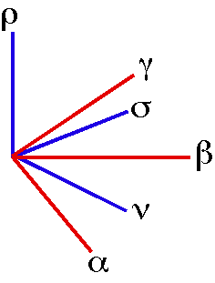
The non-orthogonal strained vector set {α, β, γ} is resolved into the orthogonal strain frame {ν, σ, ρ}.
The unit vector perpendicular to the plane is designated by the symbol and the axis of rotation for the component relative to is the unit vector designated by the symbol . The vectors are perpendicular to each other because $ρ$ is perpendicular to the and is perpendicular to the plane determined by and . Consequently, lies in the plane.
We can complete the frame by computing the perpendicular to the plane determined by .
$ρ$, is the unit vector parallel to the axis of rotation that turns $α$ into $β$. $s$, is parallel to the axis of rotation that turns $ρ$ into $g$ and it is always in the plane determined by $α$ and $β$. Consequently, these two vectors and their right-handed mutual perpendicular, $ν$, form an orientation frame, , for the vector triplet, $\left[α,β,g\right]$. If we take the two vectors $s$ and $ρ$ in that order, then the right hand mutually orthogonal vector is the ratio of $ρ$ to $s$.
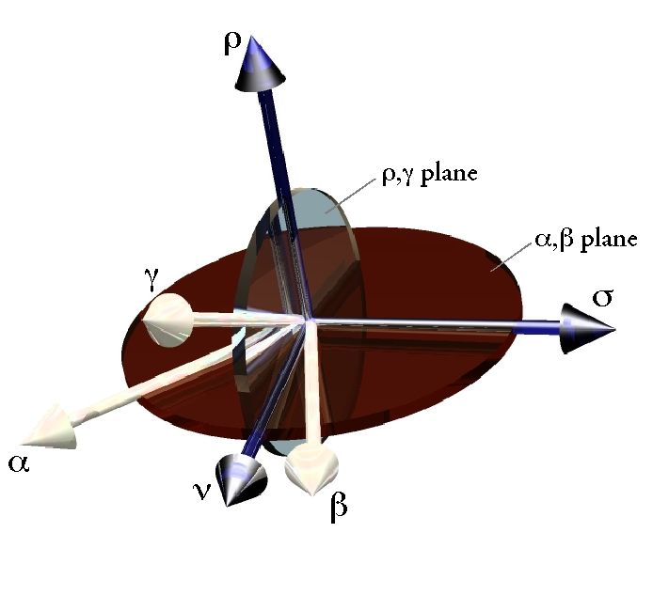
The strain frame. The vector set {α, β, γ} is distorted by strain. The rotation axis for α into β is ρ, which is perpendicular to the αβ plane (red disc) and the rotation axis for ρ into γ is σ, which is perpendicular to the ργ plane (transparent). The frame is completed by the rotation axis for σ into ρ about the vector ν.

We can readily compute , for the present situation, where the edge vectors are , and .
The strain frame is not symmetric in that it gives a special value to the $α,β−\text{plane}$and its perpendicular or normal vector, . Still, it can be viewed as an orientation frame in that it generally gives a unique orthogonal frame to a set of strained vectors.
The strain frame of an unstrained box is not uniquely defined by this protocol, since and therefore and may be any two mutually orthogonal vectors in the plane. It will be convenient to leave the strain frame for an unstrained frame undetermined until it is compared with a strained frame at which time it takes on the nearest value to the strained frame. In the example just considered the ratio of the strained to the unstrained frame is 1.0 because we chose the value of the unstrained frame in which the and axes are equal to those of the strained frame and the axis is equal to k in both the strained and unstrained frames. There is not a change in orientation. That result conforms with our intuition that pure shear does not change the orientation of the medium.

The case of
Let us consider the general situation where the α and β vectors are unit vectors that remain perpendicular, but the unit vector γ is tilted with respect to their plane. The product of α and β is the vector perpendicular to the $α,β−\text{plane}$that turns $α$ into $β$, that is ρ. The vector product of the three unit vectors is .
The angle $f$ is the angle between the vectors. If α, β, and γ are not unit vectors, then the general formula is as follows.
In the formalism of vector analysis and with arbitrary length vectors, is given by the following expression.
is obviously a quaternion. The scalar of that quaternion, when α, β, and γ are unit vectors, is . The unit vector is perpendicular to both γ and ρ; consequently, it lies in the plane of α and β, perpendicular to the plane of γ and ρ. The angle $f$ is the angle between γ and ρ in their plane. This is largely a recapitulation of the logic of the strain frame, which it should be, for we will find that the strain frame is a function of the changes in the relationships between the edge vectors (see below).
The vector σ is the unit vector of the axis of rotation for the shear that rotates the perpendicular to the base ($ρ$) relative to the base (the $α,β−\text{plane}$). Therefore, in the instance of shear in one plane, the vector component of the triple vector product quaternion, , gives one the axis of rotation of the shear, σ.
If we return to the example above and retain α and β as i and j, respectively, and change γ to , then the strain quaternion is readily computed.
The perpendicular to the $α,β−\text{plane}$ is ρ = k and the vector of the shear rotation quaternion is σ = $\frac{−i+j}{\sqrt{2}}$. One can tell by inspection that these are the correct values for the two vectors. If we take the value of the sine from the expression, it is possible to compute the angle of the shear.
We find that the unitary strain quaternion in this scenario () is composed of a volumetric strain and a shear strain.

The case of
The case where $α$ is not perpendicular to $β$, but $g$ is perpendicular to their plane is another interesting case to consider. The third edge vector is perpendicular to $α$ and $β$, therefore $f=0\text{.}0$ and it is aligned with the vector $ρ$. The principal factor in the shear is that the perpendicular is reduced by a factor of $\text{sin}q$, where $q$ is the angle between and when is turned into .
The product of and is easily written.
The product is a quaternion with its vector in the direction of the perpendicular to the first two axes. The magnitude of the quaternion is the negative of the ratio of the length of to the length of and the angle of the quaternion is the angle between them.
The third edge vector, , is aligned with the perpendicular, $ρ$, therefore the triple vector product may be written down.
The volumetric strain is proportional to the sine of the angle between and and the shear strain is proportional to the cosine of the angle times the negative perpendicular to the .
It is notable that the strain quaternion is the same if we use the form or the form for the triple vector product. That means that when we use the first triple vector product in the next section, it will reduce to each of the results that have already been considered when one or the other rotation is reduced to zero.
We can illustrate this strain by allowing the strained box to have the edge vectors , , and . The volume quaternion is readily calculated.
The vector of the rotation is directed in the negative k direction, which means that the angle between the and axes is reduced by 45° from its angular excursion in the unstrained test box.
Note that the $s$ and $ν$ vectors are undefined in this situation, because there are an infinity of possible candidates. Any vector in the $α,β−\text{plane}$ is valid $s$ since $g$ is aligned with $ρ$ and therefore there is no specific rotation that rotates one into the other. The solution is in fact the null vector. Since $s$ is the null vector, $ν$ is also undefined. Consequently, we cannot define a strain frame in the usual way. However, if we reassign the vectors, so that the $β$ edge is viewed as tilted relative to the $α,g\text{plane}$ plane, then it is possible to construct a frame using the same analysis as in the previous section. In that scenario, . Changing the angle between the first and second axes does not change the orientation of the box.

No mutually orthogonal edges
In each of these first two situations, there is a single axis of rotation and the strain quaternion could be expressed in terms of that axis of rotation. We now consider the situation in which none of the edge vectors is perpendicular to any of the other edge vectors.
It has already been established that can be written in terms of .
The third edge, , can be written in terms of .
These expressions can be combined to give the triple vector product.
The vector was defined to be a unit vector that completed the right-handed strain frame with and , in that order, so that .
This expression for the strain quaternion reduces to the previous two expressions for the strain quaternion when or . That is what we would expect since they are extreme examples of this situation.
If we are primarily interested in the form of the solution, then it is more convenient to use the unit strain quaternion.
We can use trigonometric identities to rewrite the strain quaternion in terms of the internal angles. Since
it follows that
The strain quaternion has been expressed as a function of the basis vectors of the strain frame and the angular excursions of two strains. The volumetric strain is the product of the two component strains, which is what one would expect. The approximation of the and vectors changes the volume in proportion to the sine of the angle between them and the tilting of the vertical vector changes the volume in proportion to the cosine of the angle it forms with the vertical unit vector.
The axis of rotation for the vector component is dependent upon the relative magnitudes of the angular excursions. When and are near a right angle , that is the test box is only slightly distorted by the strain, the vector of the strain quaternion lies near the . As either angle moves away from a right angle the strain vector shifts towards the axis. This can be more easily appreciated if we normalize on the $ν$ component and replace the tilt of $g$ relative to the vertical with the interior angle, . The more the edges converge, the proportionately greater the $ν$ component becomes. For small amounts of convergence (θ and $\bar{f}$ approximately at right angles), the component is relatively small.

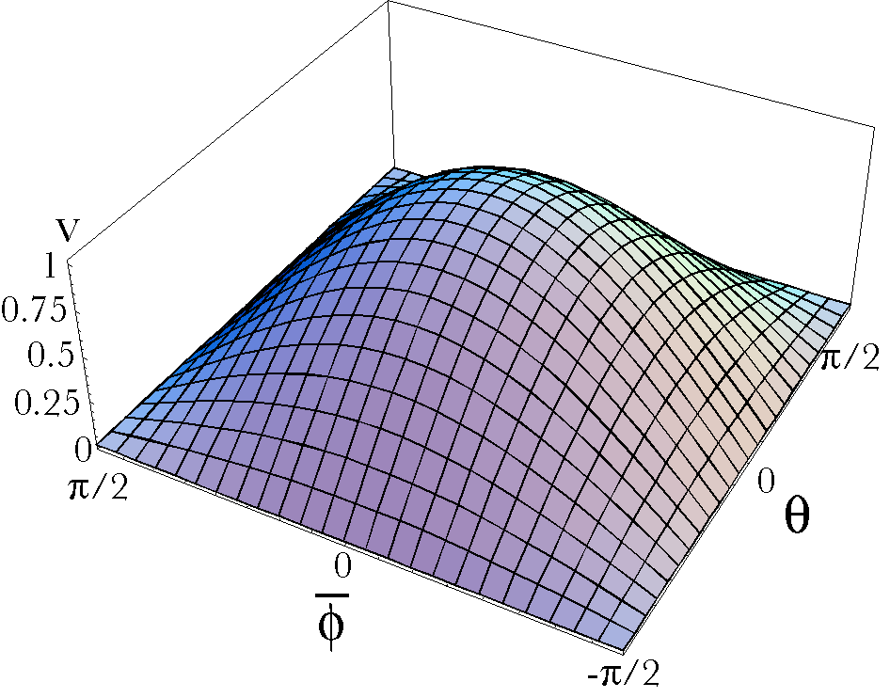
The volumetric strain is a function of both interior angles.

Put in other words, as the test box becomes more distorted the volume shrinks and the component in the direction of the vector becomes longer. The components in the directions of the and vectors become shorter.
Given the strain rotations of a cubic box , one can write down the strain quaternion, . The strain quaternion allows one to compute the relations between the edges of the distorted box.

The Inversion of the Generalized Strain Quaternion
We have explored the calculation of the strain quaternion in the case where 1.) all the edge vectors are orthogonal, 2.) the case when the first and second edge vectors are not orthogonal, 3.) the case where the third component is not orthogonal to the first two, and 4.) the case where none of the vectors are orthogonal to any other edge vectors . The strain vector for the first case is the null vector. The second and third cases give and , respectively, as their strain vectors. In those cases it is straightforward to determine the axis of rotation and the angular excursion between the edge vectors.
The expression for the strain quaternion in the fourth case is more difficult in that there is interaction between the angular excursions between the vectors, so that all components of the vector component of the strain quaternion are functions of both angles and it is necessary to introduce a third basis vector to the frame.
When the strain quaternion is computed for the fourth case the expression is going to be in terms of $\left\{\text{i,}\text{j,}k\right\}$, instead of . However, once we have computed the three orientation frame vectors, it is simply a matter of computing the projection of the strain vector upon each frame vector.
Then, we can write the strain quaternion as follows.
Given this quaternion, we can write down four equations that allow one to determine the values of $q$ and $f$.
These equations lead directly to the values of $q$ and $f$.
$$\begin{aligned}\text{tan}q=\frac{c_{s}}{c_{ρ}}⇒q={\text{tan}}^{−1}\frac{c_{s}}{c_{ρ}}, \\ \text{tan \{}\bar{f}\end{aligned}=\frac{c_{s}}{c_{s}}⇒\bar{f}={\text{tan}}^{−1}\frac{c_{s}}{c_{s}}\text{.}$$
Consequently, the angular excursion about the $ρ$ axis that carries into is $q$ and the angular excursion about the axis that carries into the is $\bar{f}$. The angle between and is $\frac{p}{2}−\bar{f}=f$. Therefore, there is a fairly direct calculation that allows one to extract the angular excursions for both distortions, given the strain quaternion for the generalized distortion.

An Example
Let us consider an example that utilizes these observations. The box is distorted into the box . The strain quaternion is readily computed.
We loose no generality in substituting i, j, and k for the cube’s edge vectors, because any cube can be rotated and translated to bring it into alignment with the basis vectors. Rotation and translation do not change strain.
The vector is obviously $k$ in this situation.
The vector is the unit vector of the ratio of to $k$.
The component is the ratio of to .
We can compute the projections of the vector component of the strain quaternion upon these frame vectors. We start with the equations from above.
Again, we write the equations from above for the angular excursions of the rotations and substitute into the equations.
It is easily confirmed that the volume of the unit cube is reduced to $\sqrt{6^{−1}}=0\text{.}\text{408248}$, that the edge vector is rotated –45° relative to the edge vector about the axis, and that the edge vector is at an angle of 35.2644° to the .

Another Example
In the last example all the edge vectors remained unit vectors after the strain. If the matrix is incompressible, then the unit vectors will become longer. Let the distorted box have the edge vectors . Then the strain quaternion is the product of the three edge vectors.
This is very like the result that was obtained with the unit vectors, differing only in that there is not a $\sqrt{6^{−1}}$ term. Some thought will show that the final results are not changed by that multiplier, except that the volume remains unity, therefore the analysis works as well for non-unit edge vectors as with unit edge vectors.

Summary:
We began this section on strain with the consideration of an interesting mathematical relationship, namely, that the scalar of three vectors is the volume occupied by the parallelepiped that has those vectors as its edge vectors. For a given strain, the change in volume of a test box is independent of the orientation of the test box, even though the box may be distorted in very different ways depending upon its initial orientation.
The same strain may create rather different appearing strained boxes depending upon the orientation of the test box. We found that the vector of the strain quaternion is related to the shape of the strained box in that it expresses the rotations of the edges relative to each other as one progresses from a unit cube into a squashed box. The value of the vector strain is a sensitive function of the orientation of the test box.
In the last chapter, we saw how the dependence of the vector strain upon the test box orientation is a function of the set of mutually orthogonal test box axes that one chooses from a unit sphere surrounding the location. The distortions of such spherical bubbles into strain ellipsoids explain the changes in the test box axes with strain.
In this chapter, we returned to a consideration of strained boxes and defined a new concept, the strain frame. It was shown that the strain quaternion can be expressed a function of the components of the strain frame and that one can invert the strain quaternion to obtain the rotations of the test box axes. If no two edge vectors are mutually orthogonal, then the vector component of the strain quaternion is not obviously indicative of the internal rotations. It is necessary to project the vector upon the component axes of the orientation frame for the strained box. However, doing so leads directly to the desired excursions about the and axes. There is an interaction component, which is projected upon the axis. As the edge vectors become more nearly orthogonal, the projection becomes smaller.

