Quaternions and the Description of Anatomical Movements

Thomas P. Langer, Ph.D.

Department of Anatomy and Cell Biology
University of Saskatchewan

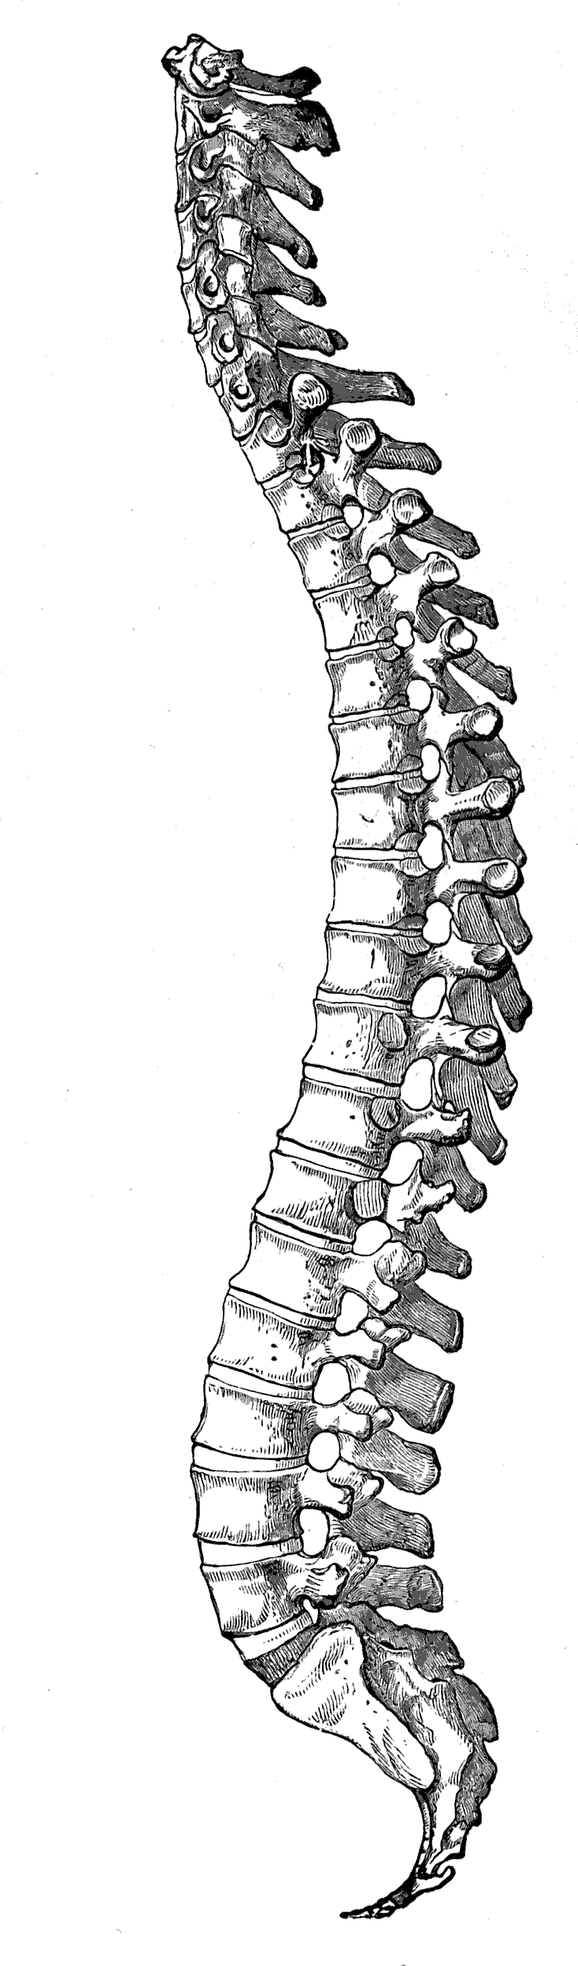

2007

