Analysis of Strain
Imagine a cube of material within a larger mass of the same material. It is continuous with its surroundings on all sides. A stress is applied to the entire mass that causes a strain that extends throughout the mass. That strain is reflected in the distortion of the cube.
There are basically two types of distortion that may occur, separately or together. These are linear and rotational strain. The first is a linear displacement in which one or more faces of the cube move parallel with its initial position. One face translates relative to another, without rotation.
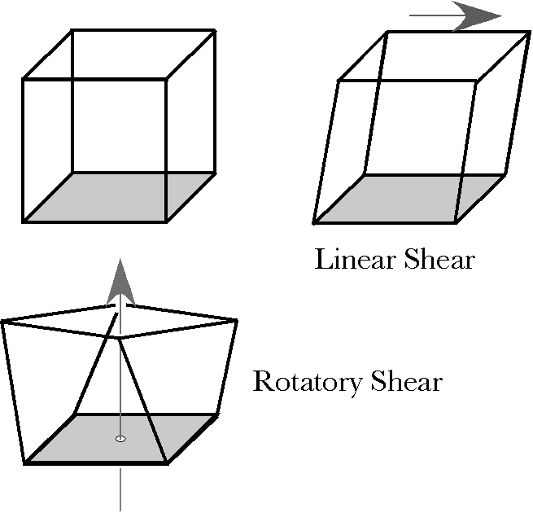
In rotational strain, there is a twisting of one face relative to an opposing face. In this type of strain there is a axis about which the rotation occurs. Points on that axis do not move during the strain. All other points swing about the axis. Note that the axis of rotation does not necessarily pass through the imaginary cube. Also, note that the rotation requires a frame of reference.
Let us consider linear shear first. The imaginary cube is a framework that allows one to visualize the movement within the mass. It is convenient to let the cube be a unit cube, but without specifying what the unit of measurement may be. Sometimes it may correspond to a cube microns on a side and sometimes to a cube millimeters or centimeters on a side. To start with, assume that the cube is aligned with a coordinate system, so that it can be specified by three orthogonal unit vectors at one corner of the cube. Let those vectors be {{1. 0, 0}, {0, 1, 0}, {0, 0, 1}} or i, j, and k in a three-dimensional vector space. Also, let $d=x+y+z=i+j+k$ be the diagonal of the cube from the origin corner to the furthest corner from the origin. Let us call that furthest corner, the apex of the cube.

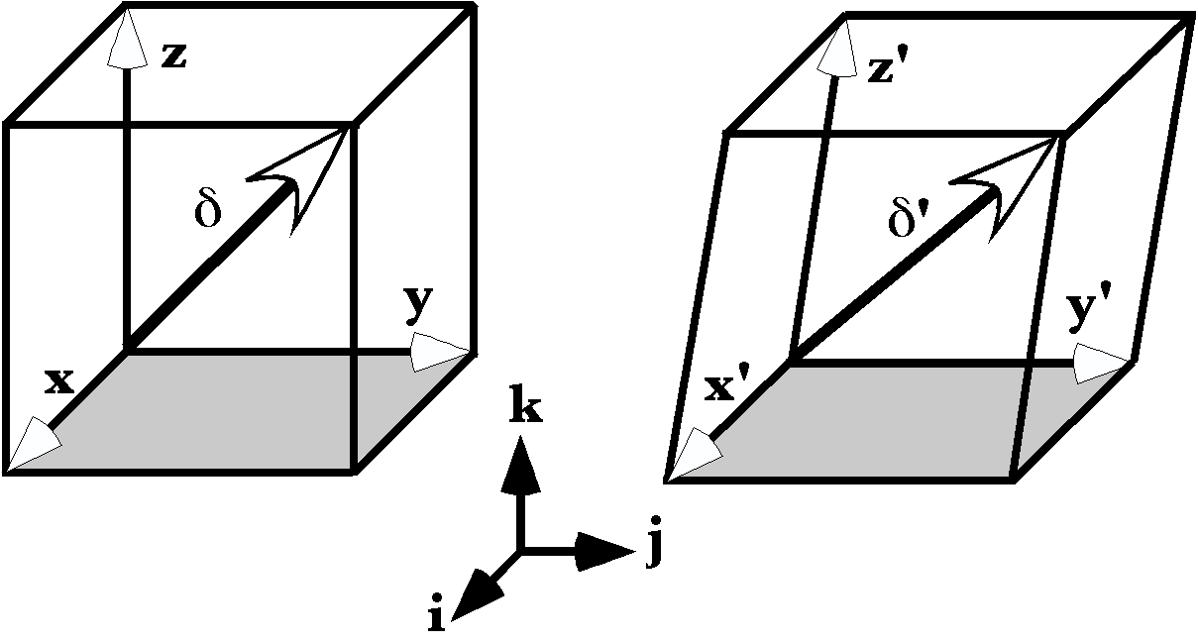
If the cube translates as a whole, without internal change, there is no strain.
With linear shear, the diagonal vector is changed as the shear carries the cube’s apex along all three axes. The new diagonal may be resolved into three components with the same origin, but inclined relative to the initial coordinate axes.
$d^{'}=x^{'}+y^{'}+z^{'}$
The primed coordinate vectors are functions of more than one of the three universal coordinates. Each is the result of rotating one of the initial coordinate axes.
$$\begin{aligned}x^{'}=q_{x}∗x, \\ y^{'}=q_{y}∗y, \\ z^{'}=q_{z}∗z\text{.}\end{aligned}$$
Consider what happens when the diagonal becomes longer, but does not change direction. Each coordinate axis is rotated towards the diagonal. The rotation axis for the x coordinate is
$$ρ_{x}=\frac{d}{x}=\frac{d}{i}=\left(i+j+k\right)\text{*-}i=1−j+k,$$
Similarly for the other two axes.
$$\begin{aligned}ρ_{y}=\frac{d}{y}=\frac{d}{j}=\left(i+j+k\right)\text{*-}j=1+i−k\text{ and} \\ ρ_{z}=\frac{d}{z}=\frac{d}{k}=\left(i+j+k\right)\text{*-}k=1−i+j\text{.}\end{aligned}$$
The three vectors for the rotations of the coordinates are given by the following matrix.
$$\left[\begin{matrix}0 & −1 & 1 \\ 1 & 0 & −1 \\ −1 & 1 & 0\end{matrix}\right]∗\left[\begin{matrix}i \\ j \\ k\end{matrix}\right]=\left[\begin{matrix}−j+k \\ i−k \\ −i+j\end{matrix}\right]$$
The determinant of the matrix is 0.0, therefore the three rotation axes lie in the same plane. This can be checked by taking the ratio of any two vectors. The vector of the quaternion is always $i+j+k$ or its negative$−i−j−k$. All three rotation axes for rotating the coordinate axes into the diagonal lie in the same plane, which is perpendicular to the diagonal vector.
If the diagonal is changed by the shear, then the situation is as in the following example. The sheared diagonal is $d_{S}=α_{x}i+α_{y}j+α_{z}k$. The shear moves the upper face a distance $\text{sin}q$ in the positive y direction.
$$\begin{aligned}\text{x©}=i, \\ \text{y©}=j, \\ \text{z©}=\text{sin}q∗j+k\text{.}\end{aligned}$$
Consequently, the diagonal’s coefficients are given by the following expressions.
$$\begin{aligned}α_{x}=1, \\ α_{y}=1+\text{sin}q=1+V, \\ α_{z}=1\text{.}\end{aligned}$$
The rotation quaternions for rotating the coordinate axes into the diagonal are as follows.
$$\begin{aligned}ρ_{x^{'}}=\frac{i+\left(1+V\right)j+k}{i}=\left(i+\left(1+V\right)j+k\right)\text{*-}i=1−j+\left(1+V\right)k, \\ ρ_{y'}=\frac{i+\left(1+V\right)j+k}{j}=\left(i+\left(1+V\right)j+k\right)\text{*-}j=\left(1+V\right)+i−k, \\ ρ_{z'}=\frac{i+\left(1+V\right)j+k}{k}=\left(i+\left(1+V\right)j+k\right)\text{*-}k=1−\left(1+V\right)i+j\text{.}\end{aligned}$$
These vectors form a matrix that is singular and therefore they are all in a single plane.
$$\left[\begin{matrix}0 & −1 & \left(1+V\right) \\ 1 & 0 & −1 \\ −\left(1+V\right) & 1 & 0\end{matrix}\right]∗\left[\begin{matrix}i \\ j \\ k\end{matrix}\right]=\left[\begin{matrix}−j+\left(1+V\right)k \\ i−k \\ −\left(1+V\right)i+j\end{matrix}\right]$$
All the vectors are perpendicular to the diagonal, therefore the plane that contains the rotation axes is perpendicular to the diagonal. The plane is tilted differently from the one for the first example, because the diagonal vector is tilted differently.
If we perform the same calculations, except using the strained coordinates, then the results are as follows.
$$\begin{aligned}ρ_{x^{'}}=\frac{i+\left(1+V\right)j+k}{i}=\left(i+\left(1+V\right)j+k\right)\text{*-}i=1−j+\left(1+V\right)k, \\ ρ_{y'}=\frac{i+\left(1+V\right)j+k}{j}=\left(i+\left(1+V\right)j+k\right)\text{*-}j=\left(1+V\right)+i−k, \\ ρ_{z'}=\frac{i+\left(1+V\right)j+k}{Vj+k}=\left(i+\left(1+V\right)j+k\right)\text{*-}Vj−k=\left[1+V\left(1+V\right)\right]−i+j−Vk\text{.}\end{aligned}$$
The rotation vector matrix is altered, but the three vectors still lie in the same plane, because the determinant of the matrix is 0.0.
$$\left[\begin{matrix}0 & −1 & \left(1+V\right) \\ 1 & 0 & −1 \\ −1 & 1 & −V\end{matrix}\right]∗\left[\begin{matrix}i \\ j \\ k\end{matrix}\right]=\left[\begin{matrix}−j+\left(1+V\right)k \\ i−k \\ −i+j−Vk\end{matrix}\right]$$
The three rotation axes lie in a plane, but they are not the same length. Three points determine an ellipse with its center at the origin, so it should be possible to calculate an ellipse that lies in the plane of the diagonal.

