Point and Linear Depressions
If a probe is pressed against an elastic, incompressible, matrix then the displacement that the probe produces must be absorbed by the matrix causing distortion. In this section, we consider the nature of the distortion that is produced under such circumstances. For a point-like depression, the distortion spreads uniformly from the depression. It this situation that means radially.
If the depression occurs at the point $λ_{d}$, then the radial vector from the depression to the location $λ_{0}$ is $r=λ_{0}−λ_{d}$. The strain is going to be a function of location, but radially directed, . The magnitude of the strain is going to be proportional to the thickness of the concentric shell equal to the displaced volume. Assuming a hemispherical depression of radius $n=\left|ν\right|$ and a distance from the center of the depression of $r=\left|r\right|$, the hemispherical shell with the same volume can be computed by computing the difference in volume between the sphere of radius $r$and the sphere of radius $r+d$.
$$\begin{aligned}V=\frac{1}{2}∗\frac{4}{3}{pn}^{3}+\frac{1}{2}∗\frac{4}{3}{pr}^{3}=\frac{1}{2}∗\frac{4}{3}p{\left(r+d\right)}^{3}, \\ n^{3}={\left(r+d\right)}^{3}−r^{3}, \\ \text{d=}\sqrt[3]{\left(r^{3}+n^{3}\right)}−r\text{.}\end{aligned}$$
Consequently, at distance $\left|r\right|$ from the center of the depression the matrix must move a distance $d$, radially to accommodate the displaced material.
$${Dλ}_{P}=d_{P}=\left[{\left(r^{3}+n^{3}\right)}^{1/3}−r\right]∗\frac{r}{\left|r\right|}\text{.}$$
The amount of strain to compensate for a small depression is remarkably small once one moves any distance from the depression. In the following figure, the depression has been set at 0.1 units radius and the strain has been calculated and plotted for points from 0.1 to 3.1 units from the center of the depression. Even at 0.1 units beyond the depression, the strain is less than 0.01 units.
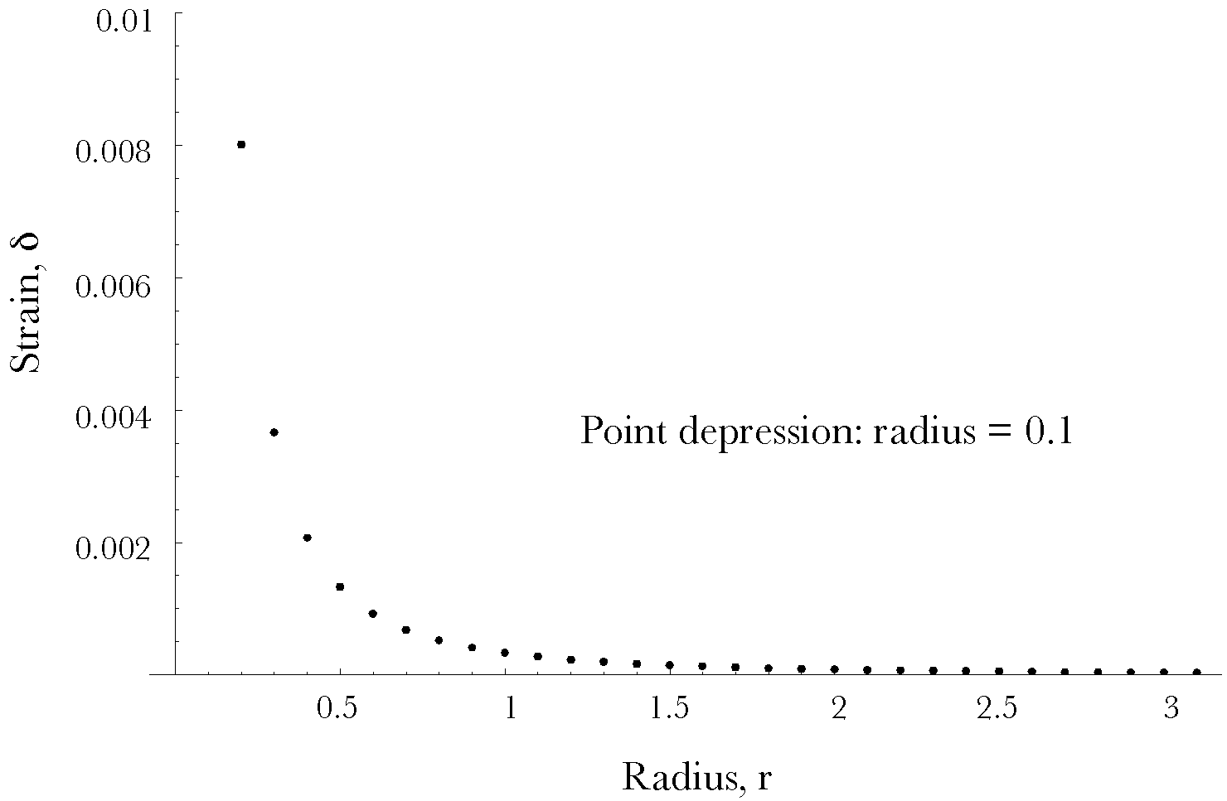
If the depression is linear, as in a edge pressing into the matrix, then the distribution of strain is going to be related to the square of the distance from the line of displacement. The line of depression, D, is characterized by a point that lies upon it, $λ_{C}$, and the set of scalar multiples of a unit vector, $α$, that is parallel with the depression.
$$D=λ_{C}+kα$$
The argument is similar to that for a point depression except the relevant radius is the shortest distance from the line to the location.
$$r=λ_{0}−\left[λ_{C}+\left(α·β\right)\frac{α}{\left|α\right|}\right],β=λ_{0}−λ_{C}\text{.}$$
The depression is cylindrical with a radius $n=\left|ν\right|$. The symmetry if the situation is cylindrical, therefore, the cylindrical shell with inner radius r that has the same volume as the depression is given by the following expression.
$$\begin{aligned}V=\frac{1}{2}{pr}^{2}l+\frac{1}{2}{pn}^{2}l=\frac{1}{2}p{\left(r+d\right)}^{2}l, \\ n^{2}={\left(r+d\right)}^{2}−r^{2}, \\ \text{d=}\sqrt{r^{2}+n^{2}}−r\text{.}\end{aligned}$$
As with the point depression, the strain can be written in terms of the radial vector from the linear depression to the initial location and the depth of the depression.
$${Dλ}_{L}=d_{L}=\left[{\left(r^{2}+n^{2}\right)}^{1/2}−r\right]∗\frac{r}{\left|r\right|}\text{.}$$
The decrease in strain is less steep than with point depressions, but still remarkably steep. By 10 times the depth of the depression, the strain is about 0.05 times the depth of the depression.
