The Diagonal Vector
It can be shown that, given the three differently directed edges of a parallelepiped box, $\left\{α,β,g\right\}$, their product, $y=αβg$, gives useful information about the volume of the box and the relationships between the sides or edges of the box (Strained Boxes and Products of Three Vectors). The sum of the three edges, $D=α+β+g$, is the diagonal and it may also tell us interesting things about the box. The diagonal alone is not particularly interesting, except in giving some indication of the size of the box in terms of its linear dimensions. If we know that the box is cubic, then we may compute the length of the sides, $S=\frac{1}{3}\left|D\right|$, but not their directions, except the conical surface that they occupy.
$\begin{aligned}V=d∗u∗d^{−1}; \\ d=\text{cos}J+\text{sin}J∗\frac{D}{\left|D\right|},J=0→2p; \\ u=z\left(t\right)∗\frac{D}{3},z=\frac{i}{\text{UV}\left(D\right)},t=\text{54}\text{.}\text{7356}°\text{.}\end{aligned}$

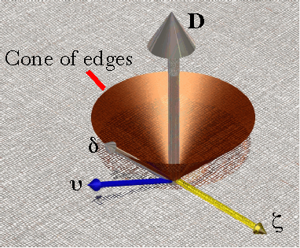
However, if we know the diagonal of a box before and after it is stretched then we know the direction and magnitude of the strain even though we do not know the shapes of the boxes before or after the strain. That difference between the diagonals prior to and after the distortion will be called the directional strain, κ.
$$k=DD=D_{1}−D_{0}\text{.}$$
Another situation in which the diagonal of a box is useful is in finding a reasonable cubic unit box for computing strain when we know only the current box edges. If we are given a set of edge vectors that specify a box, and we need a box that could reasonably be the unit cube that gave rise to that box , then we can construct such a box, by computing the unit vectors in the directions of the edge vectors and computing the diagonal of their box. That diagonal gives equal weighting to each edge vector and we can use it to create a box that is symmetrical about the diagonal, but aligned with the directions of the edge vectors. If the edge vectors are orthogonal, then the unit vectors of the edge vectors are the edge vectors of the unit cube for those edge vectors. If the edge vectors are not orthogonal, then the cubic box is aligned with the prime edge vector, the vector that is taken to be the anchor for the orientation. Generally, we are interested in constructing such a unit cube when we want to study the orientation of a box. There are other ways of getting unit boxes aligned with a strained box. Some will be discussed here and some will be discussed elsewhere (Finding the Transformation of a Cubic Box: the orientation of strained boxes).

The prime diagonal of the unit cube and other boxes, its difference, and its direction
Given a unit cubic box aligned with the universal coordinate axes, $\left\{α,β,g\right\}=\left\{\text{i,}\text{j,}k\right\}$, one can readily write down the diagonal of the box.
$$D_{\left[\text{1,1,1}\right]}=α+β+g=i+j+k\text{.}$$
If the box is stretched by making the j edge vector twice as long, then the new diagonal is again easily written down.
$$D_{\left[\text{1,2,1}\right]}=α+β+g=i+2j+k$$

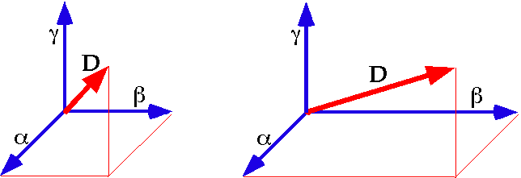

The diagonal of a box is the sum of its edge vectors, thus it reflects changes to the shape of the box.
The difference between the two vectors is j, the difference from the unit cubic box. The deviation of the second box from the unit cubic box is the difference in the diagonal vectors. More generally, if the box has the edge vectors $\left\{0\text{.}5i,2j,3k\right\}$, then its diagonal is given as follows.
$$D_{\left[0\text{.}\text{5,2,3}\right]}=0\text{.}5i+2j+3k$$
The transformation of the diagonal vector is given by the difference between the vectors.
$$D{\text{D=D}}_{\left[0\text{.}\text{5,2,3}\right]}−D_{\left[\text{1,1,1}\right]}\text{=-}0\text{.}5i+j+2k\text{.}$$
So far, the diagonal vector has been straight-forwardly related to the three edge vectors and the basis vectors. Consider if the box is rotated 90° about the k axis.
$$\begin{aligned}D_{2}=α+β+g=j+\left(−i\right)+k\text{=-}i+j+k; \\ DD=\left(−i+j+k\right)−\left(i+j+k\right)\text{=-}2i\text{.}\end{aligned}$$
Even less straight-forward is the situation where the edge vectors are not orthogonal.
$$\begin{aligned}\left\{α,β,g\right\}=\left\{\text{i,}i+\text{j,}i+j+k\right\}⇒D_{S}=3i+2j+k; \\ DD=2i+j\text{.}\end{aligned}$$
The $DD$ is in effect the stretch that occurs when the unit cube box is strained into the current configuration. The direction of the strain is the unit vector of that strain.
$$Dd=\frac{DD}{\left|DD\right|}\text{.}$$
So, for the last difference vector the direction is easily computed. It is a unit vector in the direction of the difference in box diagonals.
$$Dd=\frac{2i+j}{\sqrt{5}}\text{.}$$
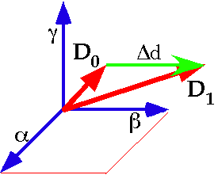

Changes in the shape of a box are reflected in the shift in the diagonal of the box.

Projecting the diagonal upon its plane
If we have a diagonal and a set of edge vectors that sum to it, then it is possible to compute a set of three mutually orthogonal vectors that give a orientation frame for the system, which will be called the diagonal plane. The vector of the plane is the unit diagonal vector, $\tilde{D}$. It points in the direction of the diagonal and its plane is perpendicular to it. There are an infinite set of possible vectors that define the plane, but the ones chosen are the projections of the coordinate axes into the plane. To compute these vectors, we must first compute the unit vectors in the directions of the edge vectors. The tilde indicates that the variable is a unit vector.
$$\tilde{α}=\frac{α}{\left|α\right|},\tilde{β}=\frac{β}{\left|β\right|},\tilde{g}=\frac{g}{\left|g\right|}\text{.}$$
In the last example the unit edge vectors are as follows.
$$\tilde{α}=i,\tilde{β}=\frac{i+j}{\sqrt{2}},\tilde{g}=\frac{i+j+k}{\sqrt{3}}\text{.}$$
The next step is to compute the rotation quaternion that rotates the unit diagonal into each of the edge vector directions.
$$\begin{aligned}R_{α}=\frac{\tilde{α}}{Dd}=\frac{i}{\frac{3i+2j+k}{\sqrt{\text{14}}}}=i∗\frac{1}{\sqrt{\text{14}}}\left(−3i−2j−k\right)=\frac{3−2k+j}{\sqrt{\text{14}}} \\ \text{cos}\left(\text{36}\text{.}\text{6992}°\right)+\text{sin}\left(\text{36}\text{.}\text{6992}°\right)∗\frac{j−2k}{\sqrt{5}}\text{.}\end{aligned}$$
$$\begin{aligned}R_{β}=\frac{\tilde{β}}{Dd}=\frac{\frac{i+j}{\sqrt{2}}}{\frac{3i+2j+k}{\sqrt{\text{14}}}}=\frac{1}{\sqrt{2}}\left(i+j\right)∗\frac{1}{\sqrt{\text{14}}}\left(−3i−2j−k\right)=\frac{1}{\sqrt{\text{28}}}\left(5−i+j+k\right) \\ \text{cos}\left(\text{19}\text{.}\text{1066}°\right)+\text{sin}\left(\text{19}\text{.}\text{1066}°\right)∗\frac{−i+j+k}{\sqrt{3}}\text{.}\end{aligned}$$
$$\begin{aligned}R_{g}=\frac{\tilde{g}}{Dd}=\frac{\frac{i+j+k}{\sqrt{3}}}{\frac{3i+2j+k}{\sqrt{\text{14}}}}=\frac{1}{\sqrt{3}}\left(i+j+k\right)∗\frac{1}{\sqrt{\text{14}}}\left(−3i−2j−k\right)=\frac{1}{\sqrt{\text{42}}}\left(6+i−2j+k\right) \\ \text{cos}\left(\text{22}\text{.}\text{2077}°\right)+\text{sin}\left(\text{22}\text{.}\text{2077}°\right)∗\frac{i−2j+k}{\sqrt{6}}\text{.}\end{aligned}$$
We now know the axis of rotation that will carry the diagonal into each edge vector, but we want to carry the diagonal into the plane of diagonal where the plane containing the diagonal and the edge vector intersects the plane of the diagonal. Since the plane of the diagonal is perpendicular to the diagonal, the rotation’s angular excursion is in each case a right angle. Since the cosine of 90° is zero and the sine is unity, the expressions for the rotation quaternions simplify considerably.
$$\begin{aligned}R_{α}\left(\frac{p}{2}\right)=\frac{j−2k}{\sqrt{5}}\text{.} \\ R_{β}\left(\frac{p}{2}\right)=\frac{−i+j+k}{\sqrt{3}}\text{.} \\ R_{g}\left(\frac{p}{2}\right)=\frac{i−2j+k}{\sqrt{6}}\text{.}\end{aligned}$$
Each of these is used to rotate the unit diagonal vector though a right angle, to obtain the projection of the edge vectors into the plane of the diagonal.
$$\begin{aligned}P_{α}=\frac{j−2k}{\sqrt{5}}∗\frac{3i+2j+k}{\sqrt{\text{14}}}=\frac{1}{\sqrt{\text{70}}}\left(5i−6j−3k\right), \\ P_{β}=\frac{−i+j+k}{\sqrt{3}}∗\frac{3i+2j+k}{\sqrt{\text{14}}}=\frac{1}{\sqrt{\text{42}}}\left(−i+4j−5k\right), \\ P_{g}=\frac{i−2j+k}{\sqrt{6}}∗\frac{3i+2j+k}{\sqrt{\text{14}}}=\frac{1}{\sqrt{\text{84}}}\left(−4i+2j+8k\right),\end{aligned}$$
Each of the projection vectors is a unit vector and they all lie in the plane perpendicular to the diagonal vector. The diagonal vector and the diagonal plane form an orientable characterization of the three edge vectors that have been considered here.
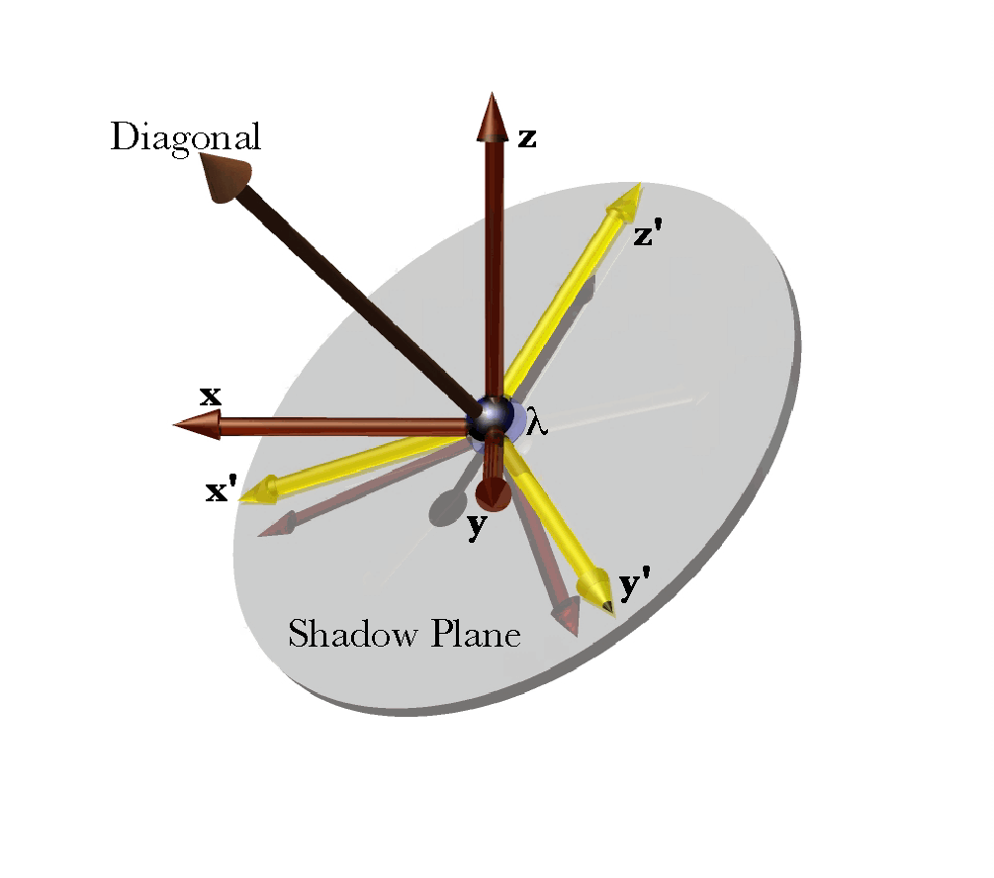
If three vectors $\left\{\text{x,y,z}\right\}$ are the edge vectors of a box, then one can construct their projection upon the plane of the diagonal vector $\left\{x^{'},y^{'},z^{'}\right\}$. The diagonal and its shadow plane can be used as indicators of the orientation of a box. To fully determine orientation, one must also specify one of the projection vectors in the shadow plane.
To review the procedure, the three edge vectors are added to obtain the diagonal vector. Diagonal vectors can be compared to determine the transformation that separates two different vector systems. The three edge vectors can be replaced by the diagonal vector and its plane by computing the directions of the edge vectors and the rotation quaternions that turn the unit diagonal vector into each unit edge vector. The unit vector of each rotation quaternion can be used to rotate the diagonal into the plane of the diagonal, aligned with the edge vectors.

The unit frame for a diagonal vector
The diagonal vector is the sum of the three edge vectors and its deviation from the diagonal of a unit cube tells us the direction in which the box is being stretched or compressed. The strain quaternion is the product of the three edge vectors. It has a scalar component that is the volume enclosed by a parallelepiped with the three edge vectors and a vector component that encodes the rotations of the edge vectors relative to each other. It expresses the internal strain of the box bounded by the edge vectors.
Since the box may be translated, rotated, and/or strained and we would like to evaluate each of these transformations independently it is useful to abstract each from the common transformation. Translation is not a function of the edge vectors and they contain no information about location, therefore we do not have to worry about translation at this time. Orientation shift is the relationship between a base orientation frame and the current orientation frame. An orientation frame is a set of three mutually perpendicular unit vectors. When there is no strain, the change in orientation is the ratio of the current orientation frame to the base orientation frame. If there is concurrent strain then, the edge vectors are not orthogonal or they have lengths other than unity or both forms of strain are present. When the distortion is only the lengthening or contraction of an axis, then one may obtain an orientation frame by computing the directions (unit vectors) of the edge vectors and using them as the orientation frame. If the edge vectors are not orthogonal, then it is necessary to compute a set of mutually perpendicular unit vectors that have the same orientation as the edge vectors. That set of edge vectors also act as the base for computing the strain due to internal shifts in the matrix.
The problem with changes of orientation involving non-orthogonal edge vectors is creating a useful definition of their orientation frame and devising means to compute it. That is where the diagonal vector may be useful. If we compute the directions of the edge vectors, that is their unit vectors, then compute the unit diagonal vector of that set of vectors, we can build a frame on those vectors. In computing a base orientation frame one assumes that the standard of comparison is a cubic box that is aligned with the current box, that is has the same orientation. If the strain is only changing the lengths of the unit edge vectors, then the cubic box is just the unit vectors of the current box’s edge vectors. If there is rotation of the edge vectors relative to each other, then the best guess of the original cubic box is one that is symmetrical about the diagonal of the unit box of the edge vectors.
When the edge vectors are mutually orthogonal, then the calculation is relatively straight-forward. Let the edge vectors be $\left\{α,β,g\right\}$, which are mutually orthogonal, but not necessarily of equal length. The unit edge vectors are obtained by dividing by their length.
$$\tilde{α}=\frac{α}{\left|α\right|},\tilde{β}=\frac{β}{\left|β\right|},\tilde{g}=\frac{g}{\left|g\right|}\text{.}$$
The diagonal vector is the sum of the unit edge vectors.
$$D=\tilde{α}+\tilde{β}+\tilde{g}⇒\tilde{D}=\frac{\tilde{α}+\tilde{β}+\tilde{g}}{\sqrt{3}}$$
The rotation quaternion for turning the unit diagonal into the unit edge vector is the ratio of the unit edge vector to the unit diagonal vector. Assuming that $\left\{α,β,g\right\}$ is a right–handed system -
$$\begin{aligned}R_{α}=\frac{\tilde{α}}{\tilde{D}}\text{=-}\frac{1}{\sqrt{3}}\tilde{α}∗\left(\tilde{α}+\tilde{β}+\tilde{g}\right) \\ \text{=-}\frac{{\tilde{α}}^{2}+\tilde{α}\tilde{β}+\tilde{α}\tilde{g}}{\sqrt{3}}=\frac{1+\tilde{β}−\tilde{g}}{\sqrt{3}} \\ \frac{1}{\sqrt{3}}+\frac{\tilde{β}−\tilde{g}}{\sqrt{3}}=\frac{−1}{\sqrt{3}}+\frac{\sqrt{2}}{\sqrt{3}}\frac{\tilde{β}−\tilde{g}}{\sqrt{2}} \\ \text{cos}t+\text{sin}t∗\frac{\tilde{β}−\tilde{g}}{\sqrt{2}},t=\text{54}\text{.}\text{7356}°\text{.}\end{aligned}$$
$$\begin{aligned}R_{β}=\frac{\tilde{β}}{\tilde{D}}=\frac{−1}{\sqrt{3}}\tilde{β}∗\left(\tilde{α}+\tilde{β}+\tilde{g}\right) \\ \text{=-}\frac{\tilde{β}\tilde{α}+\tilde{β}\tilde{β}+\tilde{β}\tilde{g}}{\sqrt{3}}=\frac{\tilde{g}+1−\tilde{α}}{\sqrt{3}} \\ \frac{1}{\sqrt{3}}+\frac{\tilde{g}−\tilde{α}}{\sqrt{3}}=\frac{1}{\sqrt{3}}+\frac{\sqrt{2}}{\sqrt{3}}\frac{\tilde{g}−\tilde{α}}{\sqrt{2}} \\ \text{cos}t+\text{sin}t∗\frac{\tilde{g}−\tilde{α}}{\sqrt{2}},t=\text{54}\text{.}\text{7356}°\text{.}\end{aligned}$$
$$\begin{aligned}R_{g}=\frac{\tilde{α}}{\tilde{D}}=\frac{−1}{\sqrt{3}}\tilde{g}∗\left(\tilde{α}+\tilde{β}+\tilde{g}\right) \\ \text{=-}\frac{\tilde{g}\tilde{α}+\tilde{g}\tilde{β}+\tilde{g}\tilde{g}}{\sqrt{3}}=\frac{\tilde{α}−\tilde{β}+1}{\sqrt{3}} \\ \frac{1}{\sqrt{3}}+\frac{\tilde{α}−\tilde{β}}{\sqrt{3}}=\frac{1}{\sqrt{3}}+\frac{\sqrt{2}}{\sqrt{3}}\frac{\tilde{α}−\tilde{β}}{\sqrt{2}} \\ \text{cos}t+\text{sin}t∗\frac{\tilde{α}−\tilde{β}}{\sqrt{2}},t=\text{54}\text{.}\text{7356}°\text{.}\end{aligned}$$
In this case, the calculation of the frame is particularly easy because frame vectors are the unit vectors that result from rotating the diagonal though an angle of $t$ about the unit vector of each of the above rotation quaternions. That is precisely what we have just computed so the frame vectors are the unit vectors of the edge vectors, $\left\{\tilde{α},\tilde{β},\tilde{g}\right\}$.
$$\begin{aligned}R_{α}∗\tilde{D}=\tilde{α}, \\ R_{β}∗\tilde{D}=\tilde{β}, \\ R_{g}∗\tilde{D}=\tilde{g}\text{.}\end{aligned}$$
In the derivation of the formulae for the rotation quaternions, there was no reference made to the unit edge vectors being orthogonal, so the same argument applies to non-orthogonal unit edge vectors. However, if one is going to construct an orientation frame from the diagonal vector, we can not rotate the diagonal vector through an angular excursion of $t$ for each axis.

Orientation for boxes that do not have mutually orthogonal edge vectors
Orientation is not uniquely determined for non-orthogonal edge vectors. It is necessary to chose a prime vector and a secondary vector. Let the prime unit edge vector be $α$ and the secondary edge vector be $β$. Any two successive vectors in ring permutations of the vector set would be satisfactory, $\left(\left\{α,β\right\},\left\{β,g\right\},\left\{g,α\right\}\right)$.
There are several options for orientation frames, depending on how one interprets orientation. The first is to take the diagonal vector as the principal index of orientation and construct a frame symmetrically about it. One turns the diagonal through the prime vector to form an angular excursion of τ, then rotates that vector through two successive 120° rotations about the diagonal vector, to obtain the other two orientation vectors. In this construction the orientation frame is symmetric about the diagonal vector. Any of the edge vectors can be the anchor for such a symmetrical orientation frame.
Another approach is to take the prime vector and it’s relationship to the secondary vector as the principal index of orientation. The vector of the quaternion that turns the prime vector into the secondary vector is taken to be the tertiary orientation vector and the vector of the quaternion that turns the tertiary vector into the primary vector is taken to be the secondary orientation vector. We consider each of these approaches in turn in the following sections.

Symmetrical Orientation Frame
The diagonal might be the sum of the edge vectors, $D=α+β+g$, or the sum of the unit edge vectors, $\tilde{D}=\tilde{α}+\tilde{β}+\tilde{g}$. The unit diagonal vector, $\tilde{D}$, is computed. The unit diagonal vector is turned through an angular excursion of $t$ towards the prime unit edge vector, to obtain the prime vector of the orientation frame. The prime vector may be any of the three edge vectors; we will use $α$, for the present.
$$\begin{aligned}R_{α}=\frac{\tilde{α}}{\tilde{D}}, \\ \hat{α}=R_{α}\left(t\right)∗\tilde{D}=\text{UV}\left(R_{α}\right)∗\tilde{D}, \\ \hat{β}=R_{α}\left(\frac{p}{3}\right)∗\hat{α}∗R_{α}{\left(\frac{p}{3}\right)}^{−1},\hat{g}=R_{α}\left(\frac{2p}{3}\right)∗\hat{α}∗R_{α}{\left(\frac{2p}{3}\right)}^{−1}\text{.}\end{aligned}$$
Once the prime vector is calculated, the other two orientation frame vectors are obtained by rotating it through 120° and 240° about the unit diagonal vector. Because the $\hat{α}$ axis is not orthogonal to the diagonal vector, it is necessary to use Euler’s formula to obtain the other frame axes. In Euler’s formula the quaternion angle is half the angular excursion, therefore we use 60° and 120° of rotation, rather than 120° and 240°
Note that the results will be different depending upon which diagonal vector is used as the basis for the unit diagonal vector. The first option is a function of the directions and the lengths of the edge vectors. The second option depends only on the directions. In either case the orientation frame is symmetrical about the unit diagonal vector. However, the first option will prove unsatisfactory as an index of orientation (see below). Note that the orientation frame will also depend upon the edge vector chosen as the basis of the frame.

Orientation Frame based on the prime plane
It might be argued that the critical factor in orientation is the relationship between two of the edge vectors, for instance, $α\text{ and }β$. The first orientation vector is taken to be the unit vector of $α$ and we compute the perpendicular to the plane determined by $α\text{ and }β$, which is the tertiary frame vector, then the ratio of the primary vector to the tertiary to find the secondary orientation frame vector.
$$\hat{α}=\frac{α}{\left|α\right|},\hat{g}=\frac{\frac{β}{\left|β\right|}}{\hat{α}},\hat{β}=\frac{\hat{α}}{\hat{g}}\text{.}$$

Consideration of representative cases
Consider the situation in which the box becomes twice as long in one direction and unchanged otherwise. It is reasonable that one would consider that there has been no change in orientation and that the strain is directional and volumetric. The diagonal of the box is $D=α+2β+g$, which has a unit vector $\tilde{D}=\frac{α+2β+g}{\sqrt{6}}$. The diagonal of the box with unit vectors in the directions of the edge vectors is $D_{d}=α+β+g$, which has a unit vector of $\tilde{D}=\frac{α+β+g}{\sqrt{3}}$. Without calculation, one knows that the frame vectors for the symmetrical orientation frame associated with the diagonal is $\left\{α,β,g\right\}$. The symmetrical orientation frame for the first diagonal is different, because the direction of the diagonal is different. We can see that is true, if we set $\left\{α,β,g\right\}=\left\{\text{i,}2\text{j,}k\right\}$.
$$\begin{aligned}R_{α}=\frac{\tilde{α}}{\tilde{D}}=\frac{i}{\frac{i+2j+k}{\sqrt{6}}}=\frac{−1}{\sqrt{6}}i∗\left(i+2j+k\right)=\frac{1+j−2k}{\sqrt{6}} \\ \frac{1}{\sqrt{6}}+\frac{\sqrt{5}}{\sqrt{6}}\frac{j−2k}{\sqrt{5}}=\text{cos}\text{65}\text{.}\text{9052}\text{°+}\text{sin}\text{65}\text{.}\text{9052}\text{°*}\frac{j−2k}{\sqrt{5}}\end{aligned}$$
$$\begin{aligned}\hat{α}=R_{α}\left(t\right)∗\tilde{D}=\text{UV}\left(R_{α}\right)∗\tilde{D}=\left(\text{cos}t+\text{sin}t∗\frac{j−2k}{\sqrt{5}}\right)∗\frac{i+2j+k}{\sqrt{6}} \\ \left(\frac{1}{\sqrt{3}}+\frac{\sqrt{2}}{\sqrt{3}}∗\frac{j−2k}{\sqrt{5}}\right)∗\frac{i+2j+k}{\sqrt{6}}=0\text{.}\text{9811}i+0\text{.}\text{1733}j+0\text{.}\text{0866}k, \\ \hat{β}=\tilde{D}\left(\frac{p}{3}\right)∗\hat{α}∗\tilde{D}{\left(\frac{p}{3}\right)}^{−1}=\left(\frac{1}{2}+\frac{\sqrt{3}}{2}\frac{i+2j+k}{\sqrt{6}}\right)∗\hat{α}∗\left(\frac{1}{2}−\frac{\sqrt{3}}{2}\frac{i+2j+k}{\sqrt{6}}\right) \\ \text{=-}0\text{.}\text{1370}i+0\text{.}\text{9367}j−0\text{.}\text{3222}k, \\ \hat{g}=\tilde{D}\left(\frac{2p}{3}\right)∗\hat{α}∗\tilde{D}{\left(\frac{2p}{3}\right)}^{−1}=\left(−\frac{1}{2}+\frac{\sqrt{3}}{2}\frac{i+2j+k}{\sqrt{6}}\right)∗\hat{α}∗\left(−\frac{1}{2}−\frac{\sqrt{3}}{2}\frac{i+2j+k}{\sqrt{6}}\right) \\ \text{=-}0\text{.}\text{1370}i−0\text{.}\text{3042}j+0\text{.}\text{9427}k\text{.}\end{aligned}$$
The symmetrical orientation frame based on the diagonal vector of the stretched box is not aligned with the axes of the box prior to the stretch. Consequently, simply stretching the box is sufficient to appear to rotate the box when using that approach. Therefore, it is not desirable to define orientation in such a way. We can discard that interpretation of orientation as not being compatible with our intuition with how orientation behaves.
So far, the symmetrical orientation frame based on the directions of the edge vectors appears to be satisfactory, because it does not indicate an orientation change with stretching alone and our intuition is that stretching a region of the matrix does not change its orientation.
The prime plane approach will also indicate that there was no change in orientation, because the relationship between the $α$ and $β$ edge vectors and their relations with the universal coordinates are not changed by the stretching alone.
$$\frac{β}{α}=g;\frac{α}{g}=β⇒α\hat{β}\hat{g}\hat{α}\text{.}$$
Now, let us consider a slightly more distorted box, one in which there is shear. Assume that the upper surface of the box moves parallel with the lower surface, so that the $g$ edge vector is tilted with respect to the perpendicular of the $α,β−\text{plane}$. Let the edge vectors be $\left\{α,β,g+0\text{.}1∗β\right\}$. The strain quaternion is readily computed. It is the product of the three edge vectors in the right hand order. In the unit cubic box the three edge vectors are $\left\{α,β,g\right\}$ and the volume, $S\left(\text{αβg}\right)$, is 1.0. In the sheared box the volume remains 1.0, because the width, depth, and height are the same. There is a vector component that encodes the shift in the third edge vector relative to the $α,β−\text{plane}$. It is a rotation about the axis of $α$.
$\begin{aligned}y=α∗β∗\left(0\text{.}1β+g\right)=α∗0\text{.}1β^{2}+\text{αβg}\text{=-}0\text{.}1α+\text{αβg}, \\ \text{αβg}=1\text{.}0,\text{ thus -} \\ y=1\text{.}0−0\text{.}1α\text{.}\end{aligned}$
The vector portion of the strain quaternion gives the rotation of the third component of the edge vectors relative to the perpendicular to the $α,β−\text{plane}$.
$$\text{sin}f=0\text{.}1⇒\text{f=5}\text{.}\text{74}°\text{.}$$
The rotation is about the $α$ unit vector.

