Properties of a Distorted Box

Distortion
Spatial distortion is potentially complex. It may encompass squeezing or stretching, linear and rotational shear, twisting and wrenching, and many other movements. However, at its simplest, spatial distortion is the systematic movement of locations within a physical matrix to other locations. By systematic we will mean that there is a formula, algorithm, or set of rules that describe how the locations in the matrix move to their new locations. In general, we assume a smooth transition so that locations that are close before the distortion are close after the distortion. Normally, the distance between locations changes during the distortion, but volume remains nearly constant. So, if we imagine a test box, defined by a set of locations at its corners, embedded in the physical matrix prior to the distortion, then the box is distorted as the matrix is distorted. Even if the box is complexly re-shaped by the distortion, it is assumed that its volume is the same as prior to the distortion. The matrix is fluid, but incompressible.
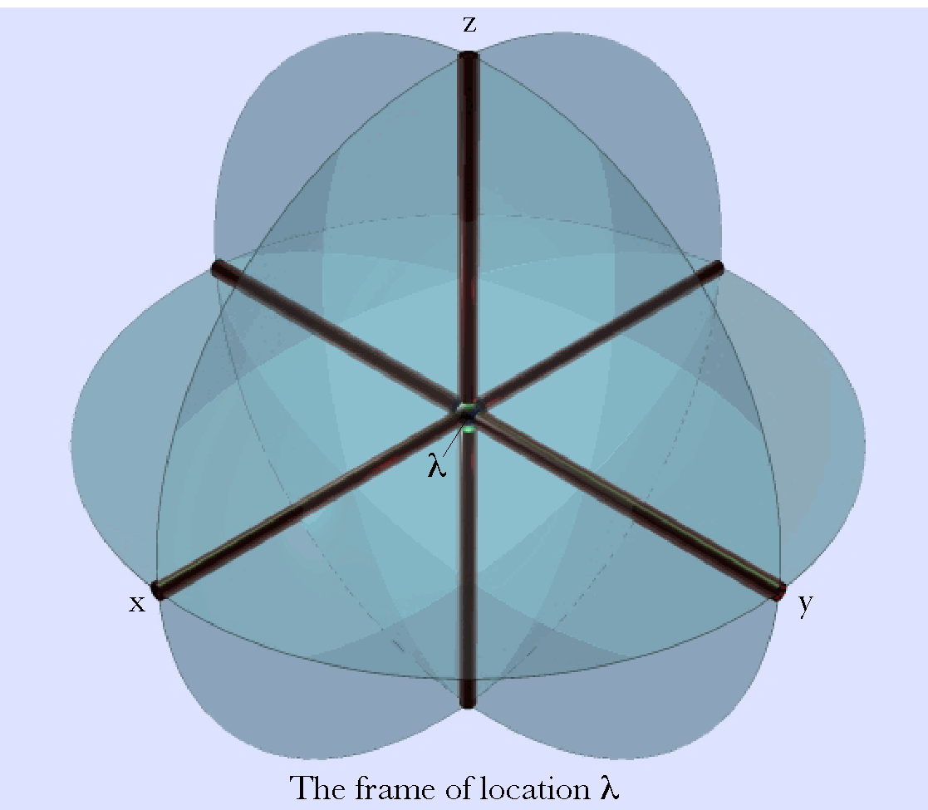
Every location, λ, is the intersection of three mutually orthogonal planes and particularly the intersection of their intersections, which form three mutually orthogonal lines {x, y, z}. The location may be viewed as a corner of a box.

Location may be viewed as the intersection of the faces or edges of a box
We will simplify the indicial structure from a box to a set of three mutually orthogonal axes associated with each location. Every location is a corner of a cubic box, with its participating edges and faces, which intersect at the location. A face is the plane determined by two edges and an edge is the line of intersection of two faces. Such a structure will be called a frame of reference. The point of common intersection of the edges and faces, a location, is a corner of a box. The three lines that contain the point are the edges and the three faces are the sides of the box in the vicinity of the point. Prior to the imposed strain in the matrix, the edges are mutually orthogonal and of unit length. The unit of length is assumed to be small relative to the scale of the distortion, so that linear axes are reasonable approximations of the local structure.
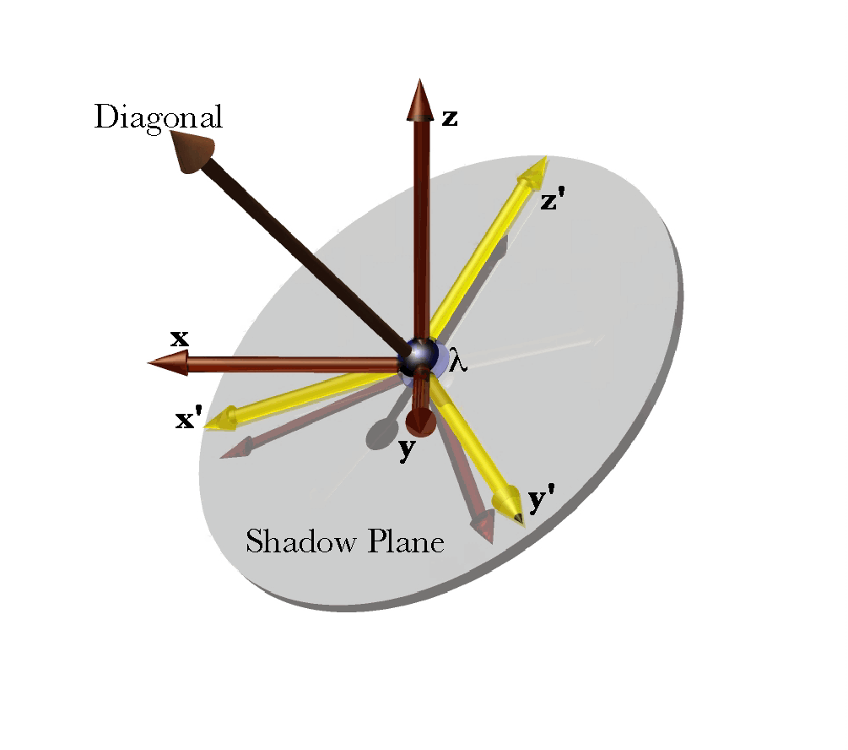
A frame of reference at location λ with basis vectors {x, y, z}, its shadow plane, and shadow vectors {x’, y’, z’}. The shadow plane is orthogonal to the diagonal and the shadow vectors are the result of rotating the basis vectors into the shadow.

The diagonal of a frame of reference and its shadow plane
If the three edges (axes) are added together then we obtain the diagonal of the frame of reference that would result from the completion of the box by adding parallel edges. The diagonal may be viewed as a vector. The rotation quaternions that carry the edges into the diagonal all lie is a plane that is perpendicular to the diagonal vector. The plane that contains the rotation quaternions will be called the shadow plane. It is perpendicular to the diagonal vector.
Let there be an universal coordinate system with the basis vectors {i, j, k}, which are mutually orthogonal unit vectors. Any location can be written as a sum of multiples of the three basis vectors.
$$λ=ai+bj+ck\text{.}$$
For simplicity, let the basis vectors of the frame of reference be the universal coordinate system’s basis vectors.
$$\left\{\text{x,}\text{y,}z\right\}=\left\{\text{i,}\text{j,}k\right\}\text{.}$$
The diagonal is then simply the sum of the basis vectors of the frame of reference.
$$d=i+j+k$$
The rotation quaternions that rotate the basis vectors into the diagonal are the ratios of the diagonal to each basis vector.
$$\begin{aligned}R_{x}=\frac{i+j+k}{i}=\left(i+j+k\right)\text{*-}i=1−j+k; \\ R_{y}=\frac{i+j+k}{j}=\left(i+j+k\right)\text{*-}j=1+i−k; \\ R_{z}=\frac{i+j+k}{k}=\left(i+j+k\right)\text{*-}k=1−i+j\text{.}\end{aligned}$$
Each quaternion has an angle of 54.7356° and it may not be apparent at this point, but all three rotations quaternion vectors are in the same plane.
The ratio of any two different vectors of the rotation quaternions is a quaternion with a vector equal to the diagonal and an angle of 120°. Consequently, the three rotation quaternions for the basis vectors into the diagonal all lie in the same plane separated from each other by 120°.
$$\begin{aligned}R_{\text{y/x}}=\frac{i−k}{−j+k}=\left(i−k\right)∗\left(j−k\right)\text{=-}1+i+j+k; \\ R_{\text{z/y}}=\frac{−i+j}{i−k}=\left(−i+j\right)∗\left(−i+k\right)\text{=-}1+i+j+k; \\ R_{\text{x/z}}=\frac{−j+k}{−i+j}=\left(−j+k\right)∗\left(i−j\right)\text{=-}1+i+j+k\text{.}\end{aligned}$$
The plane that contains the rotation quaternions will be called the shadow plane for the frame of reference. The basis vectors are projected upon the shadow plane by rotating each basis vector in the plane of the basis vector and the diagonal until it lies in the shadow plane. This is equivalent to rotating a vector of the length of the basis vector and the direction of the diagonal through 90°, about the vector of the rotation quaternion, in the direction opposite to the sense of the rotation quaternion. The length of the basis vectors, prior to a distortion, is 1.0. However we will use the variable, $ν$, for greater generality. Consequently, if the diagonal vector is $d=ai+bj+gk$, then the rotating vector is $ρ$.
The rotation quaternion is R, which has the unit vector, $R$.
$\begin{aligned}R=J+ai+bj+ck; \\ q={\text{cos}}^{−1}\left[\frac{J}{\sqrt{J^{2}+a^{2}+b^{2}+c^{2}}}\right]; \\ \text{sin}\text{q=}\frac{\sqrt{a^{2}+b^{2}+c^{2}}}{\sqrt{J^{2}+a^{2}+b^{2}+c^{2}}}; \\ R=\text{UV}\left(R\right)=\frac{ai+bj+ck}{\sqrt{a^{2}+b^{2}+c^{2}}}; \\ R=\sqrt{J^{2}+a^{2}+b^{2}+c^{2}}∗\left[\frac{J}{\sqrt{J^{2}+a^{2}+b^{2}+c^{2}}}+\frac{\sqrt{a^{2}+b^{2}+c^{2}}}{\sqrt{J^{2}+a^{2}+b^{2}+c^{2}}}∗\frac{ai+bj+ck}{\sqrt{a^{2}+b^{2}+c^{2}}}\right] \\ T\left[\text{cos}q+\text{sin}q∗R\right]\text{.}\end{aligned}$
The rotation quaternion that rotates the diagonal into the shadow plane is given by the following expression.
$$R\left(−\frac{p}{2}\right)=\text{cos}\left(−\frac{p}{2}\right)+\text{sin}\left(−\frac{p}{2}\right)∗R\text{=-}R\text{.}$$
We have constructed the problem so that $ρ$ is perpendicular to the shadow plane and the vector of $R$ lies in the shadow plane, so they are mutually perpendicular and we can write their product as follows.
$$\begin{aligned}ρ^{'}=R\left(−\frac{p}{2}\right)∗ρ\text{=-}R∗ρ \\ =\frac{−R}{−ρ}=\frac{R}{ρ} \\ =n∗\frac{\text{UV}\left(R\right)}{\text{UV}\left(d\right)}=n∗\frac{\bar{R}}{\bar{d}}\text{.}\end{aligned}$$
The projection of the basis vector is the ratio of the diagonal vector of the same length to the unit vector of the rotation quaternion for that basis vector into the diagonal. It lies in the shadow plane and it is orthogonal to the vector of the rotation quaternion. Consequently, the projections of the basis vectors are rotated 90°couterclockwise relative to their rotation vectors.
For the basis vectors examined above $a,b,g=1\text{.}0$, therefore $ρ=\frac{i+j+k}{\sqrt{3}}$. We computed the rotation quaternions for the three basis vectors therefore can write down $R$ for each basis vector.
$$\begin{aligned}R_{x}=1−j+k⇒R_{x}=\frac{−j+k}{\sqrt{2}}⇒\frac{j−k}{\sqrt{2}}∗\frac{i+j+k}{\sqrt{3}}=\frac{2i−j−k}{\sqrt{6}}=ρ_{x}^{'}; \\ R_{y}=1+i−k⇒R_{y}=\frac{i−k}{\sqrt{2}}⇒\frac{−i+k}{\sqrt{2}}∗\frac{i+j+k}{\sqrt{3}}=\frac{−i+2j−k}{\sqrt{6}}=ρ_{y}^{'}; \\ R_{z}=1−i+j⇒R_{z}=\frac{−i+j}{\sqrt{2}}⇒\frac{i−j}{\sqrt{2}}∗\frac{i+j+k}{\sqrt{3}}=\frac{−i−j+2k}{\sqrt{6}}=ρ_{z}^{'}\text{.}\end{aligned}$$

Extension Shadows and Orientation Shadows.
In the instance of the frame of reference, $\left\{\text{x,}\text{y,}z\right\}$, that was the basis vectors, $\left\{\text{i,}\text{j,}k\right\}$, the shadow of the frame of reference is the same for the extension frame of reference and for the orientation frame of reference, since they are the same. In general, this will not be the case. When there has been a strain, the location usually changes and there is a distortion of the frame of reference. If we are concerned with extension, the arms of the frame of reference may well have been rotated and stretched or contracted and these changes are relevant to the extension so they are retained when the shadow is computed. However, when considering orientation, the lengths of the arms of the frame are not part of the definition of orientation, therefore we replace the arms with unit vectors with the same direction. Clearly the diagonal is not going to be the same in the two situations, therefore the shadow planes are going to be different. The projections of the axes are going to be different as well, except in special cases.

Uniform Translation
A uniform translation is one in which every location is moved the same distance in some direction. Location changes, but neither extension or orientation is changed, because the basis vectors of the frames of reference are not altered. The post-translation frames of reference will be the same as the pre-translation frames.
$$\begin{aligned}{\left\{x^{'},y^{'},z^{'}\right\}}_{E}={\left\{\text{x,}\text{y,}z\right\}}_{E} \\ {\left\{x^{'},y^{'},z^{'}\right\}}_{O}={\left\{\text{x,}\text{y,}z\right\}}_{O}\end{aligned}$$

Non-uniform Translation
In non-uniform translation, all locations move, but not necessarily in the same direction or the same distance. There is no rotation. Because there may be compression and/or rarefaction of the locations in a small locale, the lengths of the arms of the frames of reference may change. This means that the extension shadow plane will change, because the diagonal vectors for the frames are different. The arms of the frames continue to point in the same directions.
To start with, let us assume that there is a stretching of the matrix in the direction of the i axis. Consequently, the frame of reference $\left\{\text{x,}\text{y,}z\right\}=\left\{\text{i,}\text{j,}k\right\}⇒\text{Translation}⇒\left\{a\text{i,}\text{j,}k\right\}$. This means that the diagonal goes from $i+j+k⇒ai+j+k$. The change is obviously $\left(\text{a-1}\right)i$. In the orientation frame, the x axis is replaced by a unit vector in the same direction, thus there is no change in orientation.
$$\left\{x^{'},y^{'},z^{'}\right\}=\left\{\text{i,}\text{j,}k\right\}=\left\{\text{x,}y,z\right\}\text{.}$$
If the x arm is stretched to twice its original length, and the y arm is contracted to half of its original length, then the resulting frame will be as follows.
$$\left\{x^{'},y^{'},z^{'}\right\}=\left\{2\text{i,}\frac{j}{2},k\right\}\text{.}$$
The change in the extension is the strained diagonal minus the unstrained diagonal.
$$\left[2\text{.}0i+0\text{.}5j+k\right]−\left[i+j+k\right]=\left[i−0\text{.}5j\right]\text{.}$$
We may also notice that the diagonal has rotated, as has its shadow plane.
$$\begin{aligned}\frac{d^{'}}{d}=\frac{2\text{.}0i+0\text{.}5j+k}{i+j+k}=3\text{.}5+0\text{.}5i+1\text{.}0j−1\text{.}5k; \\ q=\text{28}\text{.}\text{1255}°,v=0\text{.}\text{267}i+0\text{.}\text{535}j−0\text{.}\text{802}k,T=2\text{.}\text{290}\text{.}\end{aligned}$$
The diagonal rotates 28.126° about the unit vector $0\text{.}\text{267}i+0\text{.}\text{535}j−0\text{.}\text{802}k$ while it becomes 2.29 times as long.
We can see that that this is not a rotation, by noting that the orientation diagonal and shadow plane have not changed.

Rotation about a location
Suppose that the location is on the axis of rotation for the matrix. Then each arm of the frame is transformed by the same rotation quaternion. We will also assume for now that there is no expansion or contraction.
$$h^{'}=r∗h∗r^{−1},h=\text{x,}\text{y,}z\text{.}$$
Let the rotation be a 120• rotation about the vector $\frac{i+j+k}{\sqrt{3}}$.
$$\begin{aligned}r=\text{cos}\frac{p}{3}+\text{sin}\frac{p}{3}∗\frac{i+j+k}{\sqrt{3}}=\frac{1}{2}+\frac{\sqrt{3}}{2}∗\frac{i+j+k}{\sqrt{3}}=\frac{1}{2}\left(1+i+j+k\right), \\ r^{−1}=\frac{1}{2}\left(1−i−j−k\right), \\ x^{'}=\frac{1}{2}\left(1+i+j+k\right)∗i∗\frac{1}{2}\left(1−i−j−k\right)=j; \\ y^{'}=\frac{1}{2}\left(1+i+j+k\right)∗j∗\frac{1}{2}\left(1−i−j−k\right)=k; \\ z^{'}=\frac{1}{2}\left(1+i+j+k\right)∗k∗\frac{1}{2}\left(1−i−j−k\right)=i\text{.}\end{aligned}$$
Clearly, there is no way that the new orientation frame can be obtained from the old orientation frame by multiplying the components of the old orientation frame by scalars.
$$f_{O}=\left\{\text{i,}\text{j,}k\right\},f_{O}^{'}=\left\{\text{j,}\text{k,}i\right\}\text{.}$$
Curiously, the diagonal of the frame of reference is identical with the original frame of reference, however, the projections of the arms of the frame are different, so one can readily show a difference between the original and final frames.
The projections are computed by determining the axes of rotation that carry the arms of the frame of reference into the diagonal. These are nearly the same as those computed above.
$$\begin{aligned}R_{x}=\frac{i+j+k}{j}=\left(i+j+k\right)\text{*-}j=1+i−k; \\ R_{y}=\frac{i+j+k}{k}=\left(i+j+k\right)\text{*-}k=1−i+j; \\ R_{z}=\frac{i+j+k}{i}=\left(i+j+k\right)\text{*-}i=1−j+k\text{.}\end{aligned}$$
The diagonal is the same as before.
$$ρ=\frac{i+j+k}{\sqrt{3}}$$
The projections are the same as before, except for being rotated 120°
$$\begin{aligned}R_{x}=1+i−k⇒R_{x}=\frac{i−k}{\sqrt{2}}⇒\frac{−i+k}{\sqrt{2}}∗\frac{i+j+k}{\sqrt{3}}=\frac{−i+2j−k}{\sqrt{6}}=ρ_{x}^{'}; \\ R_{y}=1−i+j⇒R_{y}=\frac{−i+j}{\sqrt{2}}⇒\frac{i−j}{\sqrt{2}}∗\frac{i+j+k}{\sqrt{3}}=\frac{−i−j+2k}{\sqrt{6}}=ρ_{y}^{'}; \\ R_{z}=1−j+k⇒R_{z}=\frac{−j+k}{\sqrt{2}}⇒\frac{j−k}{\sqrt{2}}∗\frac{i+j+k}{\sqrt{3}}=\frac{2i−j−k}{\sqrt{6}}=ρ_{z}^{'}\text{.}\end{aligned}$$
We can determine the rotation by computing the ratio of the x arm in the final frame to its value in the original frame.
$$\frac{\frac{−i+2j−k}{\sqrt{6}}}{\frac{2i−j−k}{\sqrt{6}}}=\frac{−i+2j−k}{2i−j−k}=\frac{1}{2}\left(−1+i+j+k\right)\text{.}$$
This is a rotation of 120° about the unit vector $\frac{i+j+k}{\sqrt{3}}$.
Since the extension and orientation frames are not contingent upon the location of the axis of rotation, but only upon its direction, the analysis for rotation about an axis through the origin of the frame is equally valid for rotation that do not pass through the origin.

Shear
Up to this point the frames of reference have been rigid in the sense that the relations between the arms of the frame of reference are unchanged by the transformation. They remain mutually orthogonal. Translation alone does not alter either frame, expansion or contraction change the lengths of the arms, therefore change the extension frame, but not the orientation frame. Rotation moves all the arms in the same manner, so it changes the orientation frame, but not the extension frame In all of these transformations the arms stay mutually orthogonal. In shear, the relationships between the arms of the frames change in that at least one pair of arms are no longer orthogonal.
Consider a simple example in which the z arm is inclined relative to the x arm. Let the z arm be inclined 45° relative to the x arm.
$$\left\{\text{x,}\text{y,}z\right\}=\left\{\text{i,}\text{j,}\frac{i+k}{\sqrt{2}}\right\}\text{.}$$
The diagonal is the sum of the arms.
$$d=\frac{\left(1+\sqrt{2}\right)i+2j+\sqrt{2}k}{2}$$

