Shear Displacement Between Parallel Plates
In a crystalline material a shearing force is distributed evenly over the layers of the crystal, so the displacement is a linear function of the distance from the fixed plane. Consequently, if the two plates are separated by a distance w and the moving layer is displaced $s$, then the shift at a location, $λ$, is proportional to the relative distances from the fixed plate to $λ$ and to the moving plate, measured perpendicular to the fixed plate.
$$Dλ=s∗\frac{λ·p}{w}\text{.}$$
We might expect substances like bone to shear in this manner. In amorphous elastic media there is a flow that occurs which is approximately linear. This means the displacement near the moving plates is very small or nil and the flow in the middle of the matrix is greatest. Assuming a Navier-Stokes type of flow, the local displacement is proportional to the square of the distance from a plate. This same type of flow occurs in compression, but with somewhat different results. It is easiest to assume a flat boundary in the matrix, which will be assumed perpendicular to the direction of shear. For definiteness, assume that the bottom plate is fixed and upper plate moves a distance $s=\left|s\right|$ in the direction of the shear, $s/\left|s\right|$, which we will assume is in the plane of the upper plate and that the two plates are parallel and horizontal. The amount of shear in any horizontal plane, between the two plates is given by a second order polynomial.
$$DD=d_{\text{Max}}−k{\left(x−c\right)}^{2},c=w/2\text{.}$$
We specify that the displacement is zero adjacent to the plates. Consequently, we can evaluate the expression for the local displacement at those two locations and obtain the value of k as a function of the maximal displacement and the distance between the two plates.
$$\begin{aligned}x=w⇒D\text{D=0}\text{.}\text{0=}d_{\text{Max}}−k{\left(w−c\right)}^{2} \\ d_{\text{Max}}−k{\left(\text{2c}−c\right)}^{2} \\ d_{\text{Max}}−{kc}^{2} \\ k=\frac{d_{\text{Max}}}{c^{2}}\end{aligned}$$
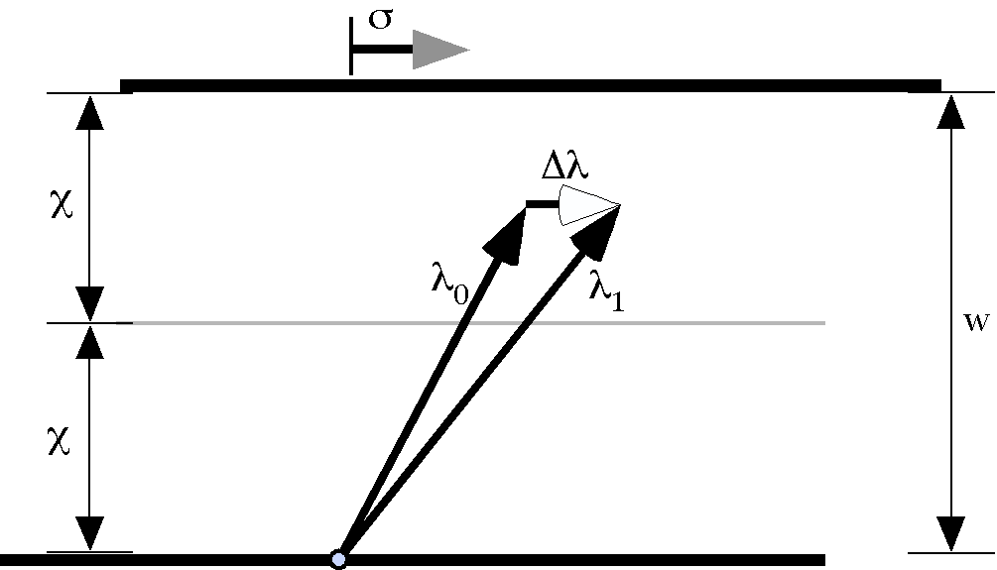
The shear of one plate relative to another while preserving the distance between them. The two parallel plates are separated by w and the shear is σ.
We do not know the value of the maximal local displacement, $d_{\text{Max}}$, but we do know the magnitude of the shear displacement and the shear is the summation of all the local displacements. From that, it is possible to compute the value of maximal local displacement.
$$\begin{aligned}\int_{0}^{w}{DD}\text{ dx}=\int_{0}^{w}{d_{\text{Max}}−k{\left(x−c\right)}^{2}\text{dx}} \\ d_{\text{Max}}\int_{0}^{w}{\text{dx}}−k\int_{0}^{w}{{\left(x−c\right)}^{2}\text{dx}}=d_{\text{Max}}\int_{0}^{w}{\text{dx}}−\frac{d_{\text{Max}}}{c^{2}}\int_{0}^{w}{\left(x^{2}−2x{\text{c+c}}^{2}\right)\text{dx}} \\ d_{\text{Max}}{\left[x\right]}_{0}^{w}−\frac{d_{\text{Max}}}{c^{2}}{\left[\frac{x^{3}}{3}−x^{2}\text{c+}{xc}^{2}\right]}_{0}^{w} \\ d_{\text{Max}}w−\frac{d_{\text{Max}}}{c^{2}}\left(\frac{w^{3}}{3}−w^{2}\text{c+}{wc}^{2}\right) \\ {\text{=2cd}}_{\text{Max}}−\frac{d_{\text{Max}}}{c^{2}}\left(\frac{8c^{3}}{3}−4c^{3}+2c^{3}\right) \\ {\text{2cd}}_{\text{Max}}−\frac{{\text{2cd}}_{\text{Max}}}{3}=\frac{4}{3}{\text{cd}}_{\text{Max}}\end{aligned}$$
The maximal local displacement is readily computed from this result by noting that the total displacement is $\left|s\right|=s$.
$$\frac{4}{3}{\text{cd}}_{\text{Max}}={sÛd}_{\text{Max}}=\frac{3}{4}\frac{s}{c}\text{.}$$
We can now write the expression for the local displacement and the expression for the shear.
$$\begin{aligned}DD=d_{\text{Max}}−k{\left(x−c\right)}^{2} \\ \frac{3}{4}\frac{s}{c}\left(1−\frac{1}{c^{2}}{\left(x−c\right)}^{2}\right)\end{aligned}$$
and
$$Dλ=\int{DD\text{.}\text{dx}=}\frac{3}{4}\frac{s}{c}\left[x−\frac{1}{c^{2}}\left(\frac{x^{3}}{3}−x^{2}\text{c+}{xc}^{2}\right)\right]\text{.}$$
For any location $λ_{0}$, the shear will move it to a new location that is the same distance from the plates, but moved parallel with the shear vector an amount that depends upon its location relative to the fixed plate.
$$\begin{aligned}λ_{1}=λ_{0}+Dλ, \\ λ_{1}=λ_{0}+\frac{3}{4}\frac{s}{c}\left[x−\frac{1}{c^{2}}\left(\frac{x^{3}}{3}−\frac{2x^{2}c}{2}+{xc}^{2}\right)\right]∗\frac{s}{\left|s\right|}, \\ x=λ_{0}·p\text{.}\end{aligned}$$
The shear profile is not a linear function of the distance of the location from the plates, but there is not a strong curvature to the leading edge of the displaced matrix. The shear profiles are the same throughout the matrix between the plates.
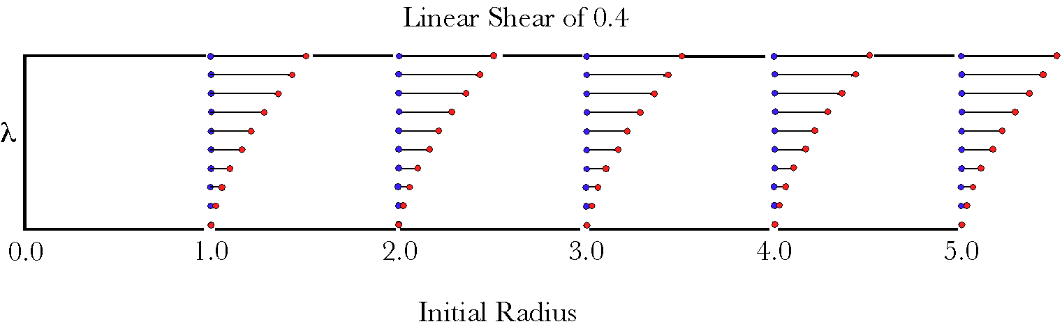
Linear shear is the same at all perpendiculars to the plates that extend through the matrix. The amount of displacement depends upon the distance of the location from the plates. If there is flow, then the amount of shear is not a linear function of the distance from the plates. The blue circles indicate the original locations of the material and the red balls mark its final location, after the shear.

The Extension Matrix
Clearly, the only dimension in which the shear varies is the axis perpendicular to the plates, so, if we make the x axis point in the direction of the shear, the y axis points in the perpendicular direction parallel to the plates, and the z axis is perpendicular to the plates. Adding an increment in the direction of either the x axis or the y axis does not change the displacement.
$$\begin{aligned}Dλ\left(λ_{0}+e\right)=Dλ\left(λ_{0}\right)\text{, if }e\text{=a}x\text{+b}y, \\ Dλ\left(λ_{0}+e\right)−Dλ\left(λ_{0}\right)=0\text{.}0\text{.}\end{aligned}$$
Adding or subtracting a small vertical distance to the location will change the shear.
$$\begin{aligned}λ_{1}\left(λ_{0}+ek\right)=λ_{0}+ek+\frac{3}{4}\frac{s}{c}\left[\left(x+e\right)−\frac{1}{c^{2}}\left(\frac{{\left(x+e\right)}^{3}}{3}−{\left(x+e\right)}^{2}\text{c+}\left(x+e\right)c^{2}\right)\right]∗i, \\ λ_{1}\left(λ_{0}−ek\right)=λ_{0}−ek+\frac{3}{4}\frac{s}{c}\left[\left(x−e\right)−\frac{1}{c^{2}}\left(\frac{{\left(x−e\right)}^{3}}{3}−{\left(x−e\right)}^{2}\text{c+}\left(x−e\right)c^{2}\right)\right]∗i, \\ λ_{1}\left(λ_{0}+ek\right)−λ_{1}\left(λ_{0}−ek\right)=\frac{3}{4}\frac{s}{c^{3}}∗2e\left[−x^{2}+\text{2x}\text{c-}\frac{e^{2}}{3}\right]i+2ek, \\ x=λ_{0}·p\text{.}\end{aligned}$$
The ratio of the transformation of the vertical increment to the vertical increment is a rotation quaternion.
$$\begin{aligned}q_{z}=\frac{\frac{3}{4}\frac{s}{c^{3}}∗2e\left[−x^{2}+\text{2x}\text{c-}\frac{e^{2}}{3}\right]i+2ek}{2ek}, \\ \left\{\frac{3}{4}\frac{s}{c^{3}}∗\left[−x^{2}+\text{2x}\text{c-}\frac{e^{2}}{3}\right]i+k\right\}\text{*-}k, \\ 1+\frac{3}{4}\frac{s}{c^{3}}\left[−x^{2}+\text{2x}\text{c-}\frac{e^{2}}{3}\right]j\text{.}\end{aligned}$$
Note that the axis of rotation is parallel to the j axis.
Let
$$d=\sqrt{1+\frac{3}{4}\frac{s}{c^{3}}{\left[−x^{2}+\text{2x}\text{c-}\frac{e^{2}}{3}\right]}^{2}}$$
then the angle of the rotation is $q$.
$$q={\text{cos}}^{−1}\left(\frac{1}{d}\right)\text{.}$$
We can rewrite the rotation quaternion as follows.
$$q_{z}=\text{cos}q+\text{sin}q∗j\text{.}$$
The extension matrix is the three rotation quaternions; actually two scalars and a quaternion.
$$E=\left[q_{x},q_{y},q_{z}\right]=\left[1\text{.}0,1\text{.}0,\text{cos}q+\text{sin}q∗j\right]\text{.}$$

Orientation Matrix
As the extension matrix indicates, the change in is mostly a bending of the vertical axis in the direction of the shear. We would expect the i and j components to remain unchanged the z axis to tilt. The difference between the transforms of two locations with the same vertical level is the separation between the two locations.
$$\begin{aligned}λ_{1}\left(λ_{0}+e\right)=λ\left(λ_{0}+e\right)+Dλ\left(λ_{0}+e\right)=λ\left(λ_{0}\right)+e+Dλ\left(λ_{0}\right)\text{, if }e\text{=a}x\text{+b}y, \\ λ_{1}\left(λ_{0}+e\right)−λ_{1}\left(λ_{0}\right)=e\text{.}\end{aligned}$$
This leads directly to the quaternion for the $\bar{x}$ orientation.
$$Q_{\bar{x}}=1\text{.}0\text{.}$$
To compute the other two orientation matrix elements, we need to know the transformed z axis.
$$\begin{aligned}λ_{1}\left(λ_{0}+ek\right)=λ_{0}+ek+\frac{3}{4}\frac{s}{c}\left[\left(x+e\right)−\frac{1}{c^{2}}\left(\frac{{\left(x+e\right)}^{3}}{3}−{\left(x+e\right)}^{2}\text{c+}\left(x+e\right)c^{2}\right)\right]∗i, \\ λ_{1}\left(λ_{0}+ek\right)−λ_{1}\left(λ_{0}\right)=\frac{3}{4}\frac{s}{c^{3}}∗e\left[−x^{2}+2x\text{c-}x\text{e-}\frac{e^{2}}{3}+\text{ce}\right]i+ek\text{.}\end{aligned}$$
Consequently, the three transformed basis vectors are given by the following matrix.
$$\left\{\text{i,}\text{j,}\frac{3}{4}\frac{s}{c^{3}}∗e\left[−x^{2}+2x\text{c-}x\text{e-}\frac{e^{2}}{3}+\text{ce}\right]i+ek\right\}=\left\{\text{i,}\text{j, \{}\hat{a} | | i+\hat{b}k\right\}\text{.}$$
The transform of the y axis is the same as before the transform so there is no swing needed to carry the pre-strain basis into the $\bar{y}$ basis. A spin about the y axis is needed to bring the pre-strain z axis into the projection of the transformed z ($\tilde{z}$) axis into the plane of the $\bar{y}$ axis.
First we must calculate the z axis projection into the plane of the $\bar{y}$ vector. That is done by finding the quaternion that carries $\bar{y}$ into $\bar{z}$ and then calculate the vector obtained by rotating the $\bar{y}$ axis 90° about the vector of the rotation quaternion. The rotation quaternion is the ratio of the $\bar{z}$ axis to the $\bar{y}$ axis.
$$\frac{\bar{z}}{\bar{y}}=\frac{\hat{a}i+\hat{b}k}{j}=\left(\hat{a}i+\hat{b}k\right)\text{*-}j=\hat{b}i−\hat{a}k\text{.}$$
Since the scalar is zero, the two vectors are already perpendicular, which one can also deduce from the observation that $\bar{z}$ is in the i,k-plane and $\bar{y}$ is perpendicular to that plane. Therefore, the third basis vector in the transformed basis is simply $\bar{z}$, divided by its norm or length.
$${\bar{z}}^{'}=\frac{\hat{a}i+\hat{b}k}{\left|\hat{a}i+\hat{b}k\right|}$$
The ratio of the post-strain z axis to the pre-strain z axis is the orientation transform for the $\bar{y}$ frame of reference.
$$\begin{aligned}\frac{{\bar{z}}^{'}}{z}=\frac{\frac{\hat{a}i+\hat{b}k}{\left|\hat{a}i+\hat{b}k\right|}}{k}=\frac{\hat{a}i+\hat{b}k}{\left|\hat{a}i+\hat{b}k\right|}\text{*-}k=\frac{\hat{b}+\hat{a}j}{\left|\hat{a}i+\hat{b}k\right|}, \\ Q_{\bar{y}}=\frac{\hat{b}+\hat{a}j}{\left|\hat{a}i+\hat{b}k\right|}\text{.}\end{aligned}$$
This expression tells us that the transform is a rotation of the pre-strain frame of reference about the y axis through an angle if $q$, where $q$ is given by the following expression.
$$q_{\bar{y}\bar{z}}={\text{cos}}^{−1}\left(\frac{\hat{b}}{\left|\hat{a}i+\hat{b}k\right|}\right)={\text{cos}}^{−1}\left(\frac{\hat{b}}{\sqrt{{\hat{a}}^{2}+{\hat{b}}^{2}}}\right)\text{.}$$
The last component of the orientation matrix is the rotation that carries the pre-strain frame of reference into the $\bar{z}$ frame of reference. To compute that quaternion, we need to know the projection of the $\bar{x}=i$ axis into the plane of the $\bar{z}$ vector. As in the previous calculation we compute the projection and then the ratio of the $\bar{z},{\bar{x}}^{'}$-plane to the z, x-plane.
$$Q_{\bar{z}}\left(\bar{z}→\bar{x}\right)=\frac{i}{\hat{a}i+\hat{b}k}=i∗\left(−\hat{a}i−\hat{b}k\right)=\hat{a}+\hat{b}j\text{.}$$
From this expression, one can readily see that the rotation quaternion is a rotation about the y axis through an angular excursion given by the following formula.
$$q_{\bar{z}\bar{x}}={\text{cos}}^{−1}\left(\frac{\hat{a}}{\left|\hat{a}+\hat{b}j\right|}\right)={\text{cos}}^{−1}\left(\frac{\hat{a}}{\sqrt{{\hat{a}}^{2}+{\hat{b}}^{2}}}\right)\text{.}$$
The projection of the $\bar{x}$ axis into the plane of the $\bar{z}$ vector is thus the rotation quaternion with an angle of 90° times the $\bar{z}$ axis.
$$\hat{x}=j∗\left(\hat{a}i+\hat{b}k\right)=\hat{b}i−\hat{a}k\text{.}$$
Thus, the frame of reference for the $\bar{z}$ axis is the following triplet.
$$f_{\bar{z}}=\left\{\frac{\hat{b}i−\hat{a}k}{\left|\hat{b}i−\hat{a}k\right|},\frac{\hat{b}j}{\left|\hat{b}j\right|},\frac{\hat{a}i+\hat{b}k}{\left|\hat{a}i+\hat{b}k\right|}\right\}=\left\{\frac{\hat{b}i−\hat{a}k}{m_{\text{ab}}},j,\frac{\hat{a}i+\hat{b}k}{m_{\text{ab}}}\right\};m_{\text{ab}}=\sqrt{{\hat{a}}^{2}+{\hat{b}}^{2}}\text{.}$$
We can take advantage of the fact that the ${\bar{y}}^{'}$ axis is unchanged by the rotation of the frame of reference, leaving only a spin to align the two frames of reference. That spin is the ratio of the x axes or the y axes.
$$\begin{aligned}Q_{\bar{z}}\left(x→{\bar{x}}^{'}\right)=\frac{\frac{\hat{b}i−\hat{a}k}{m_{\text{ab}}}}{i}=\frac{\hat{b}i−\hat{a}k}{m_{\text{ab}}}\text{*-}i=\frac{\hat{b}+\hat{a}j}{m_{\text{ab}}}, \\ Q_{\bar{z}}\left(z→{\bar{z}}^{'}\right)=\frac{\frac{\hat{a}i+\hat{b}k}{m_{\text{ab}}}}{k}=\frac{\hat{a}i+\hat{b}k}{m_{\text{ab}}}\text{*-}k=\frac{\hat{b}+\hat{a}j}{m_{\text{ab}}}\text{.}\end{aligned}$$
Pulling these results together, the orientation matrix for linear shear is given in the following expression.
$$O_{\text{shear}}=\left\{Q_{\bar{x}},Q_{\bar{y}},Q_{\bar{z}}\right\}=\left\{1\text{.}0,\frac{\hat{b}+\hat{a}j}{m_{\text{ab}}},\frac{\hat{b}+\hat{a}j}{m_{\text{ab}}}\right\}\text{.}$$

