Finding the Transformation of a Cubic Box:
the orientation of strained boxes
Assume that we are given the set of three edge vectors for a parallelepiped that we know was a unit cubic box before the box was possibly transported, rotated, and/or strained. The original values of the edge vectors were $\left\{α_{0},β_{0},g_{0}\right\}$ and their current values are $\left\{α_{1},β_{1},g_{1}\right\}$. To what extent can we determine the transformation that the original unit cubic box experienced to yield the current edge vectors?
Let us start by defining a few terms implicit to this question. Translation is the physical movement of the box as a whole without rotation, as in carrying it forward in a straight line. Translation does not change orientation. Orientation is the placement of the box with respect to a universal coordinate system, for instance, the directions of the edge vectors of the box relative to a standard coordinate system. Orientation is changed when the box, as a unit, rotates about an axis of rotation. Most anatomical movements are a combination of translations and rotations. Strain is the internal distortion of the box either by changing its shape, its volume, and/or rotating an edge vector relative to the other edge vectors.
Translation or change of location is expressed as a vector, $Dλ=λ_{1}−λ_{0},\text{where }λ_{0}$ is the original location and $λ_{1}$ is the current location. Change in orientation is expressed as a quaternion, $R_{O}$, which codes the axis of rotation and the angular excursion that carries the original orientation into the current orientation. It is the ratio of sets of mutually orthogonal vectors. There are several types of strain, which are expressed in different forms. Linear strain may expressed as a vector, $k$, that connects the diagonal of the box in the original configuration to the current diagonal of the box. Volume strain and rotational strain are expressed in the quaternion that is the product of the three edge vectors. This strain quaternion, $y$. codes the volume of the box, as its scalar and internal rotations of the edge vectors relative to each other as a vector that depends upon the angles between the edge vectors.
We will not be considering translation or change in orientation in any depth here. They are treated in other essays. The issues that will be considered revolve around the concept of strain. In particular, how to determine the strain quaternion from the configuration of the edge vectors.

On the Nature of Boxes
We are using the concept of distorting a box as a metaphor for the strain at a point in a matrix. The actual objects used for computation are triads of vectors that are envisioned as being the corner of a parallelepiped. Since they form the edges of the imaginary box, they are called edge vectors. However, the triad is defined at a point in the matrix and thus strain is defined on points of three dimensional space.
The null or starting condition in a relaxed matrix is a set of three mutually orthogonal unit vectors of arbitrary orientation. These may be expanded into a cubic box with edges of unit length. While the orientation of the box is arbitrary, it makes sense to choose it so as to make computation as easy and intuitive as possible. Usually the initial edge vectors are chosen to be $\left\{α,β,g\right\}=\left\{\text{i,j,k}\right\}$. This is permissible and perfectly general because one can always rotate a box to be in alignment with the universal coordinate system without changing the strain. Therefore, observations made on this aligned box can be readily extended to all other boxes.
Changes is the alignments of the edge vectors are usually interpreted in terms of changes in the shape of their box. However, it is important to remember that strain is defined on points and not extended structures. Boxes are always parallelepipeds, even though an actual box of material in the matrix might well be twisted or truncated by the flow of the matrix.

Orthogonality
To determine if three vectors are orthogonal one computes their unit vector, that is, their direction, for each edge vector and then their strain quaternion is the product of the three direction unit vectors.
$$\begin{aligned}\tilde{α}=\frac{α}{\left|α\right|};\tilde{β}=\frac{β}{\left|β\right|};\tilde{g}=\frac{g}{\left|g\right|}; \\ \tilde{y}=\tilde{g}∗\tilde{β}∗\tilde{α}=u+w\end{aligned}$$
The unit strain function ($\tilde{y}$) is a quaternion with two components, a scalar volume strain (υ) and a vector rotational strain component ($w$). If $\tilde{y}=u=1\text{.}0$, then the three vectors are orthogonal and there is no volumetric or rotational strain. Volumetric strain is a change of the scalar component from 1.0. $\tilde{y}$ is a unit quaternion, because it is the product of three unit vectors, therefore has a magnitude of unity. Orthogonal vectors have a scalar component of 1.0, therefore can have no vector strain.
$$\tilde{y}=u+w=1\text{.}0⇒w=0\text{.}0\text{.}$$
Given a set of edge vectors, we can determine if they are orthogonal. If they are orthogonal, then we can determine the orientation shift between them by simply dividing the current edge vector frame by the original edge vector frame. If the edge vectors are not orthogonal, then there was an internal rotational strain and we need to compute an orientation frame for that set of edge vectors before it is possible to compute any possible change in orientation.

Directional Strain
Directional strain may be detected by computing the diagonal vector for the unit vectors of the current edge vectors, $\tilde{m}$, and the unit diagonal vector for the current box, $\text{UV}\left(m\right)$, and comparing their directions. The diagonal of a box is the sum of its edge vectors, $m=α+β+g$.
If $\tilde{m}$ and $\text{UV}\left(m\right)$ have different directions, then there has been a relative lengthening or contraction of one or more of the edge vectors. If the length of the diagonal of the current box, $m$, is not equal to $\sqrt{3}$, then the box has grown or shrunk.
Sometimes we have a set of edge vectors that are obviously not the edge vectors of a cube, but we wish to determine how their box is distorted from a cubic shape. It is necessary to construct an appropriate cubic box to which they can be compared. It should be a box that is aligned in the same manner. If the current box has orthogonal edges then one need only substitute the unit vectors of the edge vectors to obtain a unit cube that is oriented in the same direction. If the edge vectors are not mutually orthogonal, then one can construct a box that has edge vectors that are aligned with the directions of the strained box’s unit vectors. One reduces the current edge vectors to unit vectors, calculates the diagonal of the box that they form, computes the unit cubic box that lies about that diagonal in the same manner as the directions of the current edge vectors. There is not a unique solution to finding the cubic box associated with a strained box, but this solution does yield a symmetrical solution that seems reasonable in most situations.
One can construct a mutually orthogonal set of unit vectors, $\left\{\overset{˘}{α},\overset{˘}{β},\overset{˘}{g}\right\}$, that are aligned with the current set of edge vectors, $\left\{α,β,g\right\}$, by a simple calculation. Calculate the unit vectors in the directions of the edge vectors, as was done above, $\left\{\tilde{α},\tilde{β},\tilde{g}\right\}$. Then calculate the diagonal for those vectors, $\tilde{m}=\tilde{α}+\tilde{β}+\tilde{g}$. For each unit edge vector compute the rotation quaternion, $h$, that turns the diagonal into the unit edge vector. Write the rotation quaternion for a rotation of $t$, where $t$ = 54.7356° is the angular excursion of the rotation from the diagonal of a cube to one edge, $h\left(t\right)$. Finally rotate the diagonal by each of the rotation quaternions to obtain the edge vectors of the cube, $\left\{\overset{˘}{α},\overset{˘}{β},\overset{˘}{g}\right\}$. The diagonal of that cube, $\overset{˘}{m}$, is compared with the diagonal of the current box, $m$. This calculation guarantees that the diagonal vector of the unit box for the current edge vectors, $\tilde{m}$, has the same direction as the diagonal vector of the unit cube built upon that vector, $\tilde{m}$. We can make the comparison by computing the unit box on the diagonal. The calculation is as follows.
$$\begin{aligned}\tilde{m}=\frac{\tilde{α}+\tilde{β}+\tilde{g}}{\sqrt{{\tilde{α}}^{2}+{\tilde{β}}^{2}+{\tilde{g}}^{2}}}⇒ \\ h_{α}=\frac{\tilde{α}}{\tilde{m}};\overset{˘}{α}=h_{α}\left(t\right)∗\tilde{m},t=\text{54}\text{.}\text{7356}, \\ h_{α}\left(t\right)=\text{cos}t+\text{sin}t∗\text{UV}\left(h_{α}\right), \\ h_{β}=\frac{\tilde{β}}{\tilde{m}};\overset{˘}{β}=h_{β}\left(t\right)∗\tilde{m}, \\ h_{β}\left(t\right)=\text{cos}t+\text{sin}t∗\text{UV}\left(h_{β}\right),\end{aligned}$$
$$\begin{aligned}h_{g}=\frac{\tilde{g}}{\tilde{m}};\overset{˘}{g}=h_{g}\left(t\right)∗\tilde{m}, \\ h_{g}\left(t\right)=\text{cos}t+\text{sin}t∗\text{UV}\left(h_{g}\right), \\ \overset{˘}{m}=\frac{\overset{˘}{α}+\overset{˘}{β}+\overset{˘}{g}}{\sqrt{3}}=\tilde{m}, \\ U\left(m\right)=\frac{α+β+g}{\sqrt{α^{2}+β^{2}+g^{2}}}=\frac{α+β+g}{\left|m\right|}\text{.}\end{aligned}$$
The linear strain is the difference between the diagonal of the strained box and the diagonal of the unit box constructed on $\tilde{m}$.
$$k=m−\overset{˘}{m}\text{.}$$
If $k$ is zero, or the null vector, then there is no directional strain. If $k$ is non-zero, then the vector points in the direction of the change of shape in the box. Directional strain is mostly about the shape of the box. Note, however, that it is easy to envision boxes that have directional strain, but no volumetric or rotational strain (see the figure below).

Volumetric Strain and Incompressibility
A unit cubic box has a volume of 1.0 $\left(y_{0}=u=1\text{.}0\right)$. The volume of the current box is given by the scalar of the strain quaternion ($S\left(y_{1}\right)$), which may no longer be unity, even if the box’s edges remain mutually orthogonal. The distorted box may have edge vectors that have elongated or contracted. If there are no additional constraints on these changes, then the volume of the box may well have changed. However, the changes often occur in a compensatory fashion, so that the product of the edge vector lengths remains 1.0 (see below). As long as the volume remains unity, there is no volumetric strain, even though the shape of the box has changed.
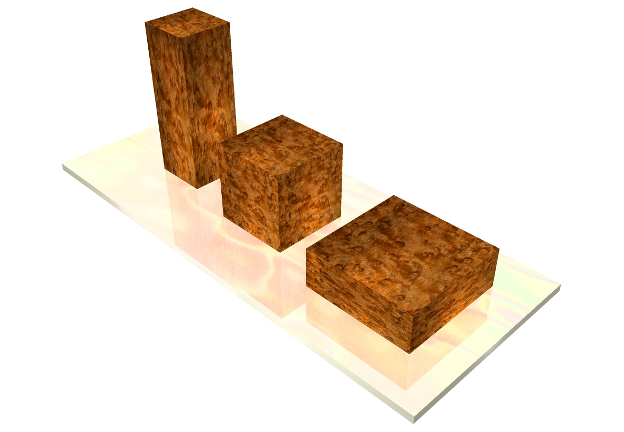
These three boxes have the same volume, therefore there is no volume strain in moving from one to the other. There is certainly strain, as is illustrated by the stretching and compression of the patterns on the sides of the front and back boxes, but it is another type of strain, linear strain.
If ${\tilde{y}}_{1}=1\text{.}0$$(\text{that is, the edges mutually perpendicular})\text{ and}$ $y_{1}$$\text{is a scalar not equal to unity}$(the volume is not equal to 1.0), then there is a volumetric strain without rotational strain. One or more of the edge vectors has been stretched or compressed. Since the lengths of the edge vectors ($\left|α_{1}\right|,\left|β_{1}\right|,\left|g_{1}\right|$) are simply multiplicative when they are mutually orthogonal, the relationship between the edge vectors is comparatively simple.
$$S\left(y_{1}\right)=\left|α_{1}\right|∗\left|β_{1}\right|∗\left|g_{1}\right|\text{.}$$

Skewed Boxes
The scalar of the strain quaternion, that is the volume of the box, may also be unity when the edge vectors are not mutually orthogonal. Such a situation will occur if the matrix is incompressible, but fluid. In that situation, there will be a vector strain.
$$y_{1}=g_{1}∗β_{1}∗α_{1}=u_{1}+w_{1};u_{1}=1\text{.}0\text{ and }w_{1}¹0\text{.}$$
The box is sheared, but the edges increase in length to compensate.

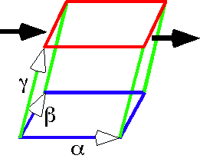
The unit cube is strained by moving the upper face relative to the lower face. This causes the γ edge vector to rotate with respect to the vertical to the αβ-plane.
Consider a situation like that illustrated above. The edge vectors are $\left\{\text{i,j},0\text{.}2i+k\right\}$, so the strain quaternion is the triple product .
$$y=gβα=1\text{.}0+0\text{.}2j=\text{cos}\text{11}\text{.}\text{3099}\text{°+}\text{sin}\text{11}\text{.}\text{3099}\text{°*}j$$
The $g$ vector become slightly longer, 1.02 units long, and the volume of the box remains 1.0. The axis of rotation for the $g$ vector is the $β$ edge vector’s unit vector (j) and it rotates through 11.31° of angular excursion towards the $α$ axis.

Biological systems are approximately isovolumetric
This isovolumetric property combined with shear is approximately true of many biological structures that contain water and/or fat confined to the tissue (cartilage, ligaments, tendons, fascia, muscles, fat pads). The fibrous elements in many of these tissues are arranged so as to restrain shear or change in shape of the box. The water can flow, but is nearly incompressible at the pressures present in biological tissues. This is usually the situation when there is a rapid change in the strain in the tissue, but may be less true with sustained compression or distraction, because water can move into and out of the tissues when pressure gradients occur. For instance, cartilage is nearly rigid when forces are rapidly imposed, but it will bleed synovial fluid when under sustained compression and imbibe fluid when it is not compressed.

In iso-volumetric systems, strain in one directions changes their extension in other directions
If the material’s matrix is incompressible, then it is always observed that $S\left(y_{1}\right)=1\text{.}0$. It does not follow that the edge vectors are equally long. For instance, compression of a uniform incompressible matrix along one axis will cause the edge vectors in the orthogonal directions to expand a corresponding amount.
$$\begin{aligned}\left|α\right|∗\left|β\right|∗\left|g\right|=1\text{.}0=\left|\text{dα}\right|∗\left|e_{β}β\right|∗\left|e_{g}g\right|,\left|e_{β}\right|=\left|e_{g}\right|\text{.} \\ \left|α\right|,\left|β\right|,\left|g\right|=1\text{.}0⇒{\text{de}}^{2}=1⇒e=d^{−\frac{1}{2}}\text{.}\end{aligned}$$
Consequently, doubling the length of $α$ forces the lengths of $β\text{ and }g$ to be reduced by $1/\sqrt{2}$ and reducing the length of $α$ by half forces the other two axes to expand by the $\sqrt{2}$. When a tendon is stretched, it becomes thinner; when a muscle is contracted, it becomes fatter.

The Volumetric Scalar Component of the Strain Quaternion
The strain quaternion of the current set of edge vectors tells us something of the nature of the transformation, even at a glance. If $S\left(y_{1}\right)=1\text{.}0$ and $S\left({\tilde{y}}_{1}\right)<1\text{.}0$, then the distortion is isovolumetric and the matrix is incompressible. If $S\left(y_{1}\right)<1\text{.}0$, then the matrix is compressible and the compression ratio is $S\left(y_{1}\right)$. If $S\left(y_{1}\right)>1\text{.}0$, then the matrix is expanded and the expansion ratio is $S\left(y_{1}\right)$.

Arbitrary Transformations
Assume a unitary cubic box, $\left\{α_{0},β_{0},g_{0}\right\}$, in a matrix that is transformed by a distortion to form a skewed parallelepiped $\left\{α_{1},β_{1},g_{1}\right\}$. The box may have experienced changes in location, extension, orientation and/or strain.
The location of the box, $λ$, as a whole may be changed. The magnitude of the translation is the difference of the location vectors, $λ_{1}−λ_{0}$. That transformation, although interesting, is not under consideration here. The edge vectors may be considered to be extension or orientation vectors, which lack locality, therefore code differences of location, but not location itself.
The box may be rotated, changing its orientation ($O$), and the box may be strained, generating a strain quaternion ($Y$). Both of those transformations are embedded in the frame of the box,$\left\{α,β,g\right\}$. In this essay we are differentiating between orientation frame vectors and edge vectors, for reasons that will become apparent as we proceed. Consequently, we will interpret the edge vectors as a triad of extension vectors.
To characterize a strained box, the framed vector is a set of at least seven vectors: the location vector $\left(λ\right)$, the three edge vectors $\left(α,β,g\right)$, and the three orientation vectors $\left(\text{r,}\text{s,}t\right)$. There may be additional extension vectors to express a particular locus relative to the location of the box.
In a distorted box, there is not an unique orientation frame and the orientation frame vectors may be functions of the extension frame vectors. Most of what follows is related to determining the orientation frame for a general box, which may be strained.
Basically, the new terminology is because orientation frames are sets of mutually orthogonal unit vectors that may be viewed as being rotated through a particular angular excursion about a single axis, that is by a single rotation quaternion, $R_{O:\left\{α,β,g\right\}}$.
Edge vectors are often rotated relative to each other, as described by their transformation, so that they are no longer mutually orthogonal, therefore not orientation frames.
We need to retain the concept of orientation in these types of distortions, but it turns out that there is not a single possible orientation when the edge vectors are no longer mutually orthogonal. To deal with this multiplicity of valid orientations it is necessary to select one of the original orientation vectors, for instance $α$, to be the prime orientation vector. That vector plus a second orientation vector, for instance $β$, define a plane, the $αβ−\text{plane}$. That plane will be called the prime plane and it should be chosen so that it reflects some relevant attribute of the matrix, such as being horizontal in the unstressed matrix.
When computing a change in orientation, one computes the ratio of the orientation frame after the transformation to the orientation frame before the transformation. However, it necessary to use only two of the three orientation vectors in the calculation. Here, $α$ and $β$, in that order, are the two vectors that are chosen. Note, however, that one can chose any two vectors and will obtain a definite orientation. It is convenient to chose the vectors consistently, so that the prime plane for orientation is consistent and relevant.
If $α$ and $β$ are not mutually perpendicular in the strained matrix, then it is necessary to compute a $β$ that is perpendicular to $α$ in the prime plane. This is done by constructing the perpendicular to the prime plane, $ρ$, and making the orthogonal $β$ the ratio of the $α$ to $ρ$. This new $β$ will be indicated by the use of a hat, $\hat{β}$.
$$\begin{aligned}ρ\left(α,β\right)=UV\left(\frac{β}{α}\right)=UV\left(\frac{β∗α^{−1}}{T{\left(α\right)}^{2}}\right)=UV\left(β∗α^{−1}\right), \\ \hat{β}=\frac{α}{ρ}=\frac{α∗ρ^{−1}}{T{\left(ρ\right)}^{2}}=α∗UV{\left(β∗α^{−1}\right)}^{−1}, \\ α∗UV\left(α∗β^{−1}\right)\text{.}\end{aligned}$$
The vector $ρ$ is the unit vector of the ratio of $β$ to $α$. The vector $\hat{β}$ is the unit vector of the ratio of $α$ to $ρ$. The three vectors $\left\{α,\hat{β},ρ\right\}$ form a mutually orthogonal set of vectors aligned with the prime orientation vector and the prime orientation plane.
Now we can write down the orientation frame for the edge vectors, $f_{O:α_{1},β_{1},g_{1}}=\left\{α,\hat{β},ρ\right\}$. The orientation frame for the current edge vectors is the vectors $α,\hat{β},\text{ and }ρ$, in that order. The frame for the initial unit cube box is $\left\{α_{0},β_{0},g_{0}\right\}$. Consequently, the shift in orientation is the ratio of the current orientation frame to the initial orientation frame.
$$R_{O:α,\hat{β},ρ}=\frac{f\left(\left\{α,\hat{β},ρ\right\}\right)}{f\left(\left\{α_{0},β_{0},g_{0}\right\}\right)}$$
The $R_{O}$rotation quaternion describes the orientation transformation that turns the initial box into the current box. The rotation can be inverted to obtain the frame for the current box after the shift in orientation has been removed, $f\left(\left\{α_{1},β_{1},g_{1}\right\}\right)$. The $r_{O}$ rotation quaternion is the $R_{O}$ rotation quaternion with an angle of the quaternion that is half the angular excursion for$R_{O}$.
$$f\left(\left\{α,\hat{β},ρ\right\}\right)=r_{O}∗f\left(\left\{α_{0},β_{0},g_{0}\right\}\right)∗r_{O^{−1}}⇒f\left(\left\{α_{1},β_{1},g_{1}\right\}\right)=r_{O^{−1}}∗f\left(\left\{α_{1},β_{1},ρ_{1}\right\}\right)∗r_{O}$$
$$f\left(\left\{α_{1},{\hat{β}}_{1},ρ_{1}\right\}\right)=r_{O^{−1}}∗f\left(\left\{α_{1},{\hat{β}}_{1},ρ_{1}\right\}\right)∗r_{O}$$
We can now compute the strain quaternion as has been outlined above. The current edge vectors have been rotated so that their $α$ component is aligned with the original $α_{0}$ and the $β$ component is in the $αβ−\text{plane}$. The volume strain is the scalar of the triple product, $y_{1}=S\left(gβα\right)$. The vertical rotation quaternion is the ratio of $β$ to $α$.
$\frac{β}{α}=\frac{β∗α^{−1}}{T{\left(α\right)}^{2}}=\text{cos}q+\text{sin}q∗ρ\text{.}$
The second rotation quaternion is the ratio of $g$ to $ρ$.
$$\frac{g}{ρ}=\frac{g∗ρ^{−1}}{T{\left(ρ\right)}^{2}}=\text{sin}f+\text{cos}f∗s\text{.}$$

Summary
It turns out that one can compute the translation, change in orientation and strain in a cubic box that has experienced all three. To do that. It is necessary to know the location of the box before and after the transformation and the edge vectors of the strained box. This is a general solution that applies to all strained boxes.
It should be noted that, as stated above, the concept of a box does not refer to a definite box. In fact, we are actually examining the strain at a point in the matrix. That strain is encoded in the three edge vectors. The box comes from completing the imaginary box by generating the parallelepiped that would result from all combinations of the edge vectors. Consequently, though we use the metaphor of a box, the actual object being studied is a set of three vectors that emanate from a single point and define the local distortion of the coordinates. Most of the time this distinction seems like a bit of sophistry, but when there is a divergence or convergence of the matrix, as in a spreading flow, then boxes would be larger or smaller at one end than at the other, thus not parallelepipeds. This is not a problem with edge vectors.

