The Geometrical Anatomy of Compound Movements

Thomas Langer
In this essay, we will consider the analysis of movements that are composed of a rotation and a translation. Such movements are called compound movements. Most multi-joint assemblies will produce compound movements, even if all the component joints allow only pure rotations. The actual movements within a multiarticular chain of elements may be very complex, but all movements of a moving element can be reduced to a rotation, a translation, or a combination of the two.
A rotation is a movement that carries an element around a fixed point, the center of rotation. Rotations generally cause the element to change its location and its orientation in space. They almost always cause a change in orientation. The only exception is a rotation of zero angular excursion or a complete great circle of rotation. A rotation of an element about its center will change its orientation without changing its location.
A translation is a movement that changes the element’s location without changing its orientation. While they may follow complex trajectories, the essence of a translation is that the total effect is equivalent to moving the element from its initial position to its final position along a straight line between the two locations.
Any movement of an element is equivalent to a combination of a translation and a rotation. In this essay we try to determine how one can compute equivalent movements, given the initial and final states of an orientable element. Equivalent movements are compound movements that carry the object from its initial state to its final state. The actual trajectory may not be an equivalent movement; it will generally be more complex.
Introduction to the Mathematical Concepts

Geometrical Anatomy
Geometrical anatomy, in the sense used here, is the mathematical study of the movements of an animal’s body, based upon the anatomy of their bones, joints, and muscles. It considers joint movements in isolation and in multi-jointed assemblies. For instance, the movement of the upper limb in reaching or the eye in looking. The anatomy of the moving parts largely determines the nature of their movements; it certainly constrains movement.
Mathematical constructs are used in describing the anatomy and the rules for movements and possible movements are computed by the manipulation of the mathematical constructs according to the rules. Expressing the anatomical relationships in sufficient detail to allow computation of the movements by a computer forces one to think through the anatomy and the movements at a level that is rarely achieved in more qualitative analysis. The results are generally more exact than can be obtained by qualitative analysis and one can analyze much more complex joint assemblies in a quantitative manner.

Orientability
One of the most fundamental attributes of human and other animal bodies is that they are orientable. They can be uniquely oriented in space. This means that body parts are so constructed that one can clearly differentiate left and right. Given a right hand one can readily tell that it is a right hand with a dorsal and palmar surface, a thumb side and a pinkie side, a wrist and fingers.
Orientability is so much a part of our bodies that we take it for granted, as we do the blueness of the sky or the fact that it is dark at night. Like the blueness of the sky and the darkness of night, the orientability of the body and its parts has surprisingly deep implications. Some of these implications will be examined below.
If we wish to describe body movements, then we must consider their orientations as well as their locations. In order for a movement to be effective, as in catching a ball or putting a letter through a slot, it must not only place the hand in the correct location, but it must do so with the correct orientation. Much of what follows is concerned with the description and manipulation of orientation.

Orientation
One of the first meanings of orientation was to face towards the east or orient. That was generalized to include placing a structure relative to the points of the compass and we further generalize the concept to mean the placement of a structure relative to a coordinate system.
It turns out to be necessary and sufficient to define three independent vectors attached to a structure to specify its orientation relative to three-dimensional space. These vectors are called a frame of reference. By attaching a frame of reference we mean to associate it with the structure, not to actually fix it to the structure. A frame of reference has no location, therefore cannot be fastened to a three-dimensional structure. By independent, we will mean that you cannot obtain one of the vectors of the frame of reference by adding multiples of the other two. Usually it is most convenient to choose three orthogonal vectors, to simplify the calculations, but orthogonality is not necessary.
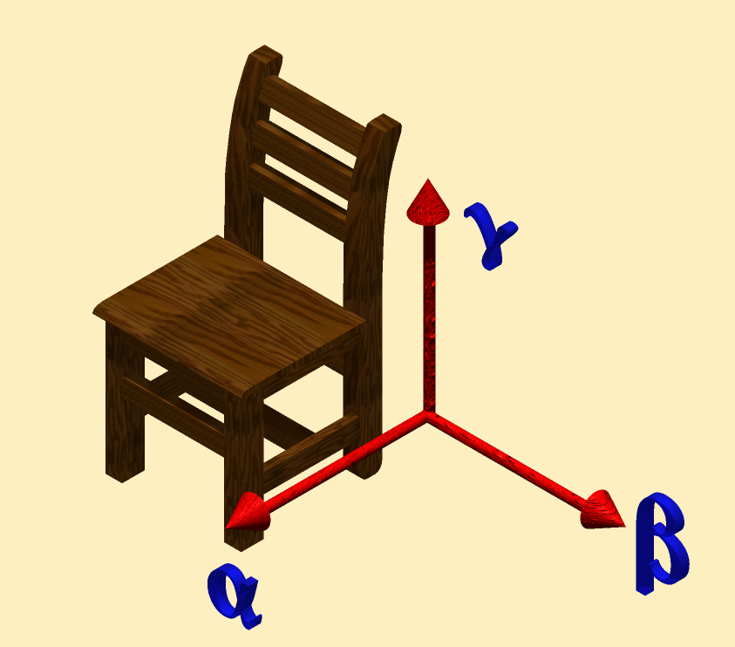
A chair is orientable. It has a front and back, a top and bottom, and a left and right side. A frame of reference {α, β, γ} has been attached to the chair in the illustration. The vector α points in the direction of the front, β points to the left, and γ points up. This is a right-handed coordinate system. If any one of the vectors had the opposite direction or the order of two of the vectors is reversed, then the coordinate system would be left-handed.
A frame of reference (f) and the component vectors of a frame of reference {α, β, γ} can be expressed as the sum of multiples of the unit vectors of a coordinate system {x, y, z}.
$$\begin{aligned}f=\left\{α,β,g\right\}; \\ α=a_{1}x+a_{2}y+a_{3}z, \\ β=b_{1}x+b_{2}y+b_{3}z, \\ g=c_{1}x+c_{2}y+c_{3}z\text{.}\end{aligned}$$
It will be common practice to use three orthogonal vector axes called i, j, and k, rather than x, y, and z. This is for reasons that we will now consider.

Change in Orientation
Changes in orientation may be expressed as transformations of the frame of reference for the object. In particular, the transformation from a frame of reference f₀ to the frame of reference f₁ is the ratio of the two frames.
$$Q_{0:1}=\frac{f_{1}}{f_{0}}$$
One can readily see that $f_{1}=Q_{0:1}∗f_{0}$, therefore $Q_{0:1}$ is an operation that when applied to the three vectors of the frame of reference $f_{0}$ transform it into the frame of reference$f_{1}$. This transformation is a rotation about a particular axis of rotation, through a particular angular excursion. If $f_{0}$ and $f_{1}$ are both right –handed or both left-handed coordinate systems, then there is always a rotation that will convert $f_{0}$ into $f_{1}$.
Actually computing such a transformation is a somewhat involved process (see Appendix A), but conceptually such a transformation is simply the quaternion that rotates f₀ into f₁, a comparatively simple idea. In this situation, a quaternion is just an axis of rotation, v, and an angular excursion, θ. It is written in a form rather like a complex number, except that the imaginary term is a weighted sum of three imaginary numbers (i, j, k).
$$\begin{aligned}Q=\text{cos}q+v∗\text{sin}q; \\ v=r∗i+s∗j+t∗k\text{.}\end{aligned}$$
θ is the angle of the quaternion and v is the vector of the quaternion. The $\text{cos}q$ term is clearly a real number. It is called the scalar component of the quaternion. The $v∗\text{sin}q$ term is the vector of the quaternion. A quaternion with a scalar component equal to zero is clearly a vector.
Quaternions turn out to be ideal for describing rotation in three-dimensional space, because they combine and transform in the same ways that rotations combine and transform orientable objects.

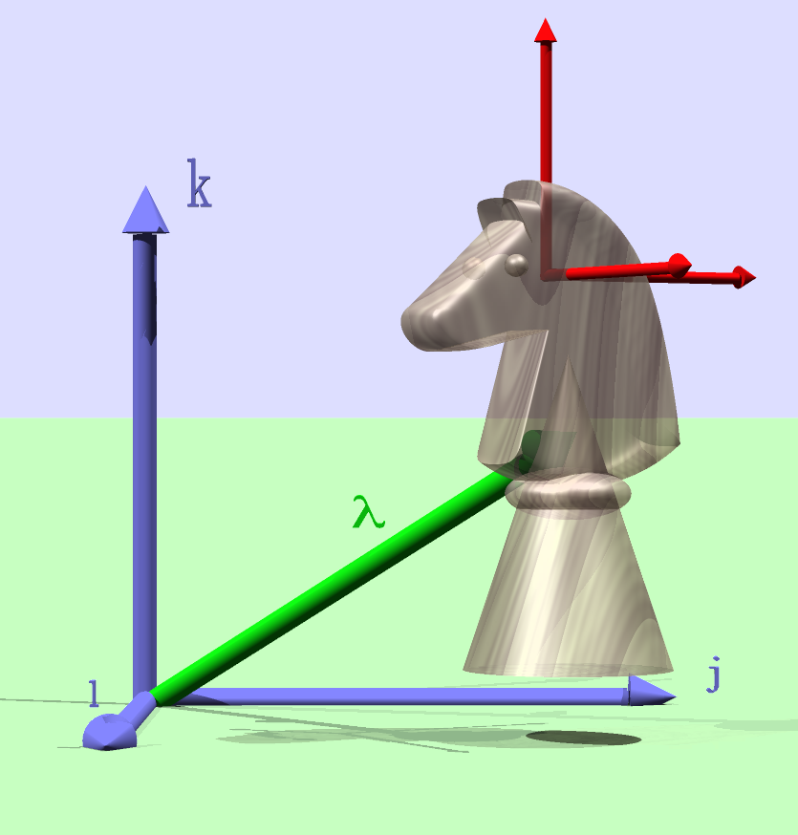
The knight is an orientable object and a frame of reference has been attached to it. The blue coordinates are the universal coordinates {i, j, k}. The green vector, λ, is the location of the knight relative to the origin of the universal coordinates and the red vectors are a frame of reference for the knight.

Quaternions
The three imaginary numbers of a quaternion are interpreted as the orthogonal unit vectors of a universal coordinate system in which the structure is embedded. In the example of the chair, we can align the unit vectors with the $α$, $β$, and $g$ vectors, so that $α=i$, $β=j$, and $g=k$. In the case of the knight, the frame of reference is not aligned with the basis vectors, because the knight has rotated 45° about its vertical axis. Therefore, $α=ai+bj$, $β\text{=-}bi+aj$, and $g=k$. Specifically, in this instance, $a=\text{cos}q$ and $b=\text{sin}q$, where θ is the angular excursion about the vertical axis.
There is a peculiarity of quaternions that is of great importance to the analysis of movement. The order of multiplication is important. If Q₁ and Q₂ are two quaternions, then, in general,
$$Q_{1}∗Q_{2}¹Q_{2}∗Q_{1}$$
and, in particular, if $i$ indicates a rotation of 90° or $p/2$ radians about the i axis in the direction that aligns the j axis with the k axis and similarly for j and k, then the following rules hold.
$$\begin{aligned}\text{ij}=k,\text{jk}=i,\text{ki}=\text{j,} \\ \text{ji}\text{=-}k,\text{kj}\text{=-}i,\text{ik}\text{=-}\text{j,} \\ \text{ii}=\text{jj}=\text{kk}\text{=-}1\text{.}\end{aligned}$$
Since $\text{ii}=\text{jj}=\text{kk}\text{=-}1$, it follows that i, j, and k are imaginary numbers, as in complex numbers, since they are all square roots of –1. However, they are different imaginary numbers since the product of any two is not –1, but the third imaginary number or its negative.

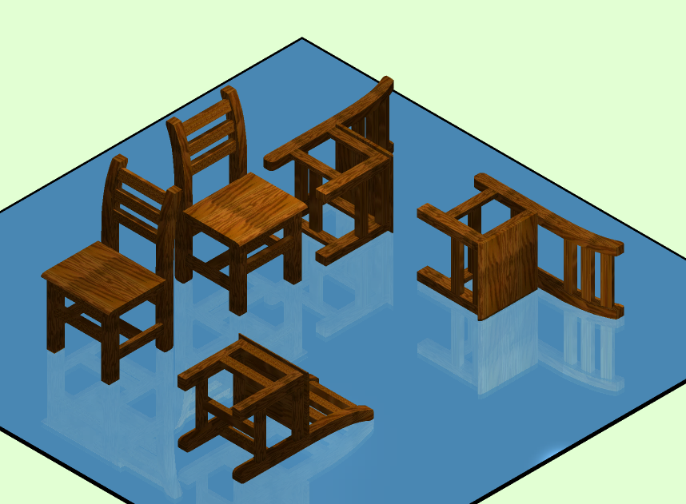
The chair in the center of the back row is the starting position for two successive rotations, but in different orders. The chair to the left has been rotated 90° about an horizontal axis that points towards the back of the chair and then that transformed chair has been rotated 90° about a vertical axis that points down. The chair to the right of the original chair has been first rotated 90° about the vertical axis and then 90° about the backward pointing axis. Clearly, reversing the order of the rotations leads to a different outcome. This will generally be true of rotations in three-dimensional space.
We will use quaternions as a metaphor for rotations. In particular, the rotation $Q_{1}$ followed by the rotation $Q_{2}$ will be expressed as the product $Q_{2}∗Q_{1}$. If $Q_{1}$ is a 90° rotation to the right about a vertical axis (counterclockwise when viewed from above) and $Q_{2}$ is a 90° rotation laterally to the right about a transverse axis (clockwise when viewed from the observer’s position) and the object being rotated is a book standing on its bottom end with its spine towards you, then $Q_{2}∗Q_{1}$will leave it with its spine down, with the top edge of the book to the right. On the other hand $Q_{1}∗Q_{2}$will leave it lying on its front cover with its spine directed to your right. The two outcomes are very different, but different exactly in the manner that one would predict by multiplying the quaternions for the rotation. In general, quaternions exactly model the behavior of rotations in three-dimensional space.


In practice, the multiplication of quaternions is exactly like the algebraic multiplication of polynomials, except one must be careful to keep the order of the imaginary variables in the correct order.
(a + bi + cj + dk) ∗ (e + fi + gj + hk) =
(a e - b f - c g - d h) + (b e + a f - d g + c h)i,
+ (c e + d f + a g - b h)j + (d e - c f + b g + a h)k
Keeping all the multiplication products in the correct order and reducing the products of the imaginary numbers requires vigilance. In extended calculations, it is easy to reverse imaginary terms and thus end up with the wrong result. However, it is relatively easy to create a quaternion calculator with simple programming and the computer has no trouble with consistently producing the correct product.
Using the identities given above, multiplication of quaternions always reduces to a quaternion. Unlike the vectors in vector analysis, which have both scalar and vector multiplication, there is only one way to multiply quaternions and division of quaternions has a meaning. In fact, the division of quaternions is one of their most useful attributes in movement analysis.

The Interpretation of Quaternions as Rotations
If we have two vectors, then we can move them so that they have a common origin without changing their value. We can transform one vector, v₁, into the other, v₂, by rotation about an axis perpendicular to the plane that contains both vectors and multiplying the length of the first vector by a real number to obtain the length of the second vector. If the vector that is the axis of rotation is v and the angular excursion of the rotation is θ and the ratio of the length of the second vector to the length of the first vector is T, then the transformation may be expressed as a quaternion equation.
$$v_{2}=T\left(\text{cos}q+v\text{sin}q\right)∗v_{1}=R∗v_{1}$$
The vector of the quaternion R is v, its angle is θ, and its magnitude or tensor is T.
Note that vectors are quaternions in the same sense as imaginary numbers are complex numbers. A vector is a quaternion with an angle of 90° or π/2 radians. As will be introduced below, vectors can be considered as formally equivalent to planes, because they are the ratio of two orthogonal vectors, which form the basis of the plane that is perpendicular to the vector.
The quaternion, R, represents the ratio of two vectors.
$$R=\frac{v_{2}}{v_{1}}\text{.}$$
If $\left|v_{1}\right|=\left|v_{2}\right|$, that is, the initial and final vectors are equally long, then this relationship effectively describes the rotation of a vector about a vector perpendicular to itself. The vector component of the quaternion (v) is the axis of rotation and the angle of the quaternion (θ) is the angular excursion.
$$v_{1}=R∗v_{0}=1\text{.}0\left(\text{cos}q+v\text{sin}q\right)∗v_{0}$$
The rotation quaternion is called an unit quaternion, because it has a magnitude of 1.0. This also means that its vector also has a magnitude of 1.0.
A quaternion may be represented by a simple hand gesture. If you extend the thumb of your right hand and curl your fingers, then the direction of your thumb indicates the direction of the vector of the quaternion and the curled fingers indicate the direction of a positive rotation. You are expressing a right-handed quaternion. If you use your left hand, then the quaternion is left-handed. You can use either convention, as long as you use it consistently.

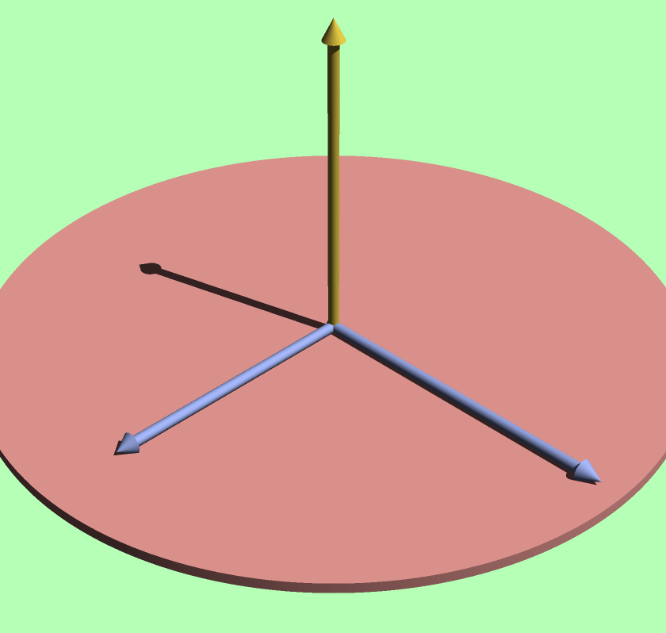
If the shorter blue vector is the starting vector and the longer blue vector is the final vector, then the two blue vectors define a plane and the vector perpendicular to that plane is the vector of the quaternion that is the ratio of the two blue vectors. The length of the gold vector is the tensor of the quaternion and it is proportional to the relative lengths of the blue vectors, and the angle between the two blue vectors is the angle of the quaternion.

Conical Rotations
We frequently wish to express the transformation when the rotating vector is not perpendicular to the axis of rotation. Since the rotating vector sweeps out a conical surface when it is at an acute or obtuse angle to the axis of rotation, these are called conical rotations. It turns out that we need to use a slightly more complex formulation to describe this situation. If the axis of rotation is v and the angular excursion is θ, the initial vector, v₀, is transformed into the final vector, v₁, according to the following expression, where R is the rotation quaternion.
$$v_{1}=r∗v_{0}∗r^{−1};R=\text{cos}q+v\text{sin}q\text{; }r=\text{cos}\frac{q}{2}+v\text{sin}\frac{q}{2}\text{.}$$
We use the rotation quaternion with half the angle because the transformation moves the vector v₀ through an excursion that is twice the angle of the quaternion.

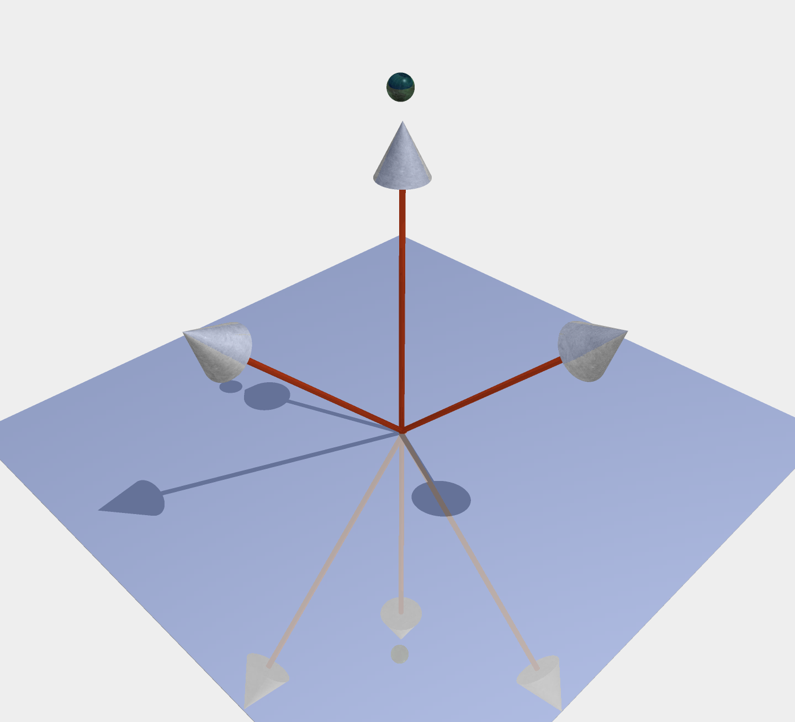
The vector designated by the sphere is the vector of a quaternion that expresses the rotation of the oblique vector that is pointing to the left into the vector that is pointing to the right. Since the rotation is not in a plane the rotation is a conical rotation.
The quaternion $r^{−1}$ is the inverse of r. Operationally, it is the rotation that reverses the transformation r. If q is a general quaternion, $q\text{=T}\left(\text{cos}q+v\text{sin}q\right)$, then q⁻¹ is given by the expression
$$q^{−1}=\frac{\text{cos}q−v\text{sin}q}{T^{2}}$$
Since the tensor, T, is 1.0 for rotations that do not change the length of the rotating vector, the expression reduces to multiplying the vector component of the quaternion by minus one.
$$q^{−1}=\text{cos}q−v\text{sin}q\text{.}$$
The principle difference is that the vector of the quaternion points in the opposite direction. If you compute the product of a unit quaternion and its inverse the result is 1.0.
$$q∗q^{−1}=1\text{.}0$$
The expression for a conical rotation reduces to the expression for rotations in a plane when the angle between the axis of rotation and the vector is $\frac{p}{2}$ radians.
$$\begin{aligned}v_{1}=r∗v_{0}∗r^{−1}{Ûv}_{1}=R∗v_{0},\text{ when }v\hat{v_{0}},v_{1}; \\ r=\text{cos}\frac{q}{2}+v\text{sin}\frac{q}{2}\text{ and }R=\text{cos}q+v\text{sin}q\text{.}\end{aligned}$$
When rotating vectors, it is best practice to use the second transformation, the one for conical rotation, unless you know that the vector of the quaternion is perpendicular to the vector that is being rotated. If you use the first transformation and the two vectors are not perpendicular, the result will have a scalar component. Rotating vectors, which have a scalar part equal to zero, never turns them into full quaternions, with both vector and scalar parts not equal to zero.
The Description of Compound Movements

Compound Movements
If the location of a structure is given by a location vector, λ, then the change in its location, $s=λ_{1}−λ_{0}$, may be expressed as the sum of a translation and a rotation about a particular axis of rotation. A translation does not change the orientation of the structure, so, any change in orientation must be due to a rotation. A rotation occurs about a particular line, called the axis of rotation. In the axis of rotation, one point can always be found that will allow the rotation to occur in a plane perpendicular to the axis of rotation. That point will be the center of rotation.
If T is the translational shift, R is the rotation quaternion, and λ_{c} the location of the center of rotation, then
$$λ_{1}=T+R∗\left(λ_{0}−λ_{c}\right)+λ_{c}$$
The second term reflects the fact that the rotation is always relative to the axis of rotation. The coordinate system is moved to the center of rotation, the rotation is performed, and the coordinate system is moved back to it original location for the translation.
Since the location and orientation of a structure change together when the structure rotates, we know that the rotation that moves the structure is the same move that changes its orientation
$R=Q_{0:1}=\frac{f_{1}}{f_{0}}$.
Therefore, we may rewrite the expression as
$$\begin{aligned}λ_{1}=T+Q_{0:1}∗\left(λ_{0}−λ_{c}\right)+λ_{c}, \\ T+\frac{f_{1}}{f_{0}}∗\left(λ_{0}−λ_{c}\right)+λ_{c}\text{.}\end{aligned}$$
In the last expression, it is clear that the change in orientation determines the rotation.
We can use the planar transformation because we defined the center of rotation to lie in the plane perpendicular to the axis of rotation that contains the initial location,$λ_{0}$. Therefore, the rotation is always in a plane perpendicular to the axis of rotation.
Note, however, that the vectors of the frame of reference need not be in that plane. In fact, at least one of them must be directed out of the plane. Consequently, the conical transformation is essential when computing the new orientation.
$$f_{1}=q_{0:1}∗f_{0}∗q_{0:1}^{−1};q_{0:1}=Q\left(\frac{q}{2}\right)\text{.}$$
Bunny A is rotated about the center of rotation C_{R} through an angle of θ to give bunny B. Bunny B has changed its orientation and its location, compared to bunny A. That is typical of rotations. Bunny B is then translated a distance T_{P} in the plane of the rotation and a distance T_{A} in the direction perpendicular to the plane, for a total translation of T = T_{A}+T_{P}. Bunny C has the same orientation as bunny B, but a different location. Translations never change orientation.
We can always create a compound movement that will move the orientable object from one location and orientation to another location and orientation. In fact there are an infinite number of compound movements that can satisfy the boundary conditions. The next section examines how one might find such a solution, particularly if there are additional boundary conditions that allow one to find an unique solution.
Analysis

Determining the Rotation Quaternion
When one describes a movement as above, then there is definite movement that is composed of a particular translation and a particular rotation about a particular center of rotation. A natural question is whether one can reverse this process. If we have a framed vector, $f_{0}$, that is transformed into another framed vector, $f_{1}$, can we determine the rotation and translation that were responsible for the transformation? The short answer is no, however, it is still interesting to see what can be determined and what cannot. In some situations an unique solution is possible.

The knight is an orientable object that can be codified by a framed vector. The basis vectors are indicated by the green mutually orthogonal vectors labeled {I, J, K}. They lie at the origin of the coordinate system. The gold vector is the location of the knight relative to the origin. The red vector in the vertical axis of the knight is an extension vector. The three silver vectors are the frame of reference. This set of five vectors can stand in for the knight when one wishes to compute the consequences of its movements.
A framed vector is composed of a location vector, $l$, an extension vector, $e$, and a frame of reference, $O=\left\{a,b,g\right\}$. The same movement must move the object from $l_{0}$ to $l_{1}$ and change the orientation from $O_{0}$ to $O_{1}$. Therefore, the rotation quaternion is the ratio of the orientations.
$$R=\frac{O_{1}}{O_{0}}$$
From the rotation quaternion we know the axis of rotation, $ρ_{R}=ν\left(R\right)$, and the angular excursion of the rotation, $j_{R}\text{=Ð}\left(R\right)$, but do not know the center of rotation, $c_{R}$. In general, we will represent the vector of a quaternion $q$by the symbol $ν\left(q\right)$ and the angle of a quaternion by $Ðq$.
A plane perpendicular to the rotation quaternion’s vector, $y_{R}$, is called the plane of the quaternion $R$. There are many $y_{R}$’s, because all planes parallel to $y_{R}$ are examples of $y_{R}$. It is possible that there is no $y_{R}$ that includes both the locations,$λ_{0}$ and $λ_{1}$. Another way of stating this is that if $s_{0,1}=λ_{1}−λ_{0}$, then $s_{0,1}$ may not lie within any $y_{R}$. The vector $s_{0,1}$ will be called the separation vector.

Computing the Frame of Reference for the Plane of the Quaternion
If there is no plane that includes both locations, then there is a translation in the direction of the vector of the quaternion, $ρ_{R}$. It is the distance between the $y_{R}$’s that contain the initial and final locations and it will be called the axial translation,$T_{A}$. One can determine the distance between the $y_{R}$ planes that include $λ_{0}$ and $λ_{1}$, respectively.
Briefly, we calculate the axial translation by first computing the plane $y_{R}$ that contains $λ_{0}$, rotating it and the separation vector to a horizontal orientation, extracting the vertical component of the separation vector, $s_{1,0}$, and then rotating the remaining horizontal and vertical components of the movement back into the original orientation of the plane of the quaternion. The transformed horizontal component is the projection of the separation vector into the plane of the quaternion and the transformed vertical component is the axial translation. The rest of this section describes this process in detail.
Let k be the vertical unit vector in the universal coordinate system. Since the perpendicular to the plane is the vector of the rotation quaternion, $ρ_{R}$, we can compute the horizontal axis of the plane by taking the ratio of the vector of the quaternion to the universal vertical.
$$H=\frac{ρ_{R}}{k}=ρ_{R}∗k^{−1}\text{=-}ρ_{R}∗k$$
The horizontal vector of the plane is the vector $h=ν\left(H\right)$. We can see this is the case by noting that H is the quaternion that rotates the vertical axis into the perpendicular to the plane. It’s vector has a horizontal orientation and there can be only one horizontal axis if the plane is not itself horizontal. If it is horizontal, then we can choose any horizontal line that is convenient. Let there be a convention that, if the vector of the plane is aligned with the vertical axis, then the horizontal vector of the plane is the i axis.
$$ν\left(H:ν\left(R\right)=k\right)=i$$
Since k and $ν\left(R\right)$are both unit vectors, $h$ is also a unit vector.
Now we can determine the line of steepest ascent for the plane, the tilt vector of the plane, because it is the horizontal vector of the plane rotated through a right angle about the quaternion of the plane.
$$t=R\left(\frac{p}{2}\right)∗ν\left(H\right)=R\left(\frac{p}{2}\right)∗h$$
$t$ is a unit vector, because it is the horizontal unit vector rotated through a right angle.
The three vectors $\left\{ρ,h,t\right\}$form an orthogonal frame of reference for the plane $y_{R}$. We will call the process that was just described ‘framing the plane’, because it attaches a unique frame of reference to any plane of a quaternion.

Computing the Axial Translation and the Planar Separation
Now we want to rotate the plane $y_{R}$about $h$, so that its $\left\{h,t\right\}$plane is in the horizontal $\left\{\text{i,j}\right\}$ plane of the universal coordinates. This is accomplished by rotating the vector of the rotation quaternion into the k axis. We already know the rotation that swings the {i, j} plane into the {$h,t$} plane. It is H. We can transform the separation vector, $s_{0,1}$, by rotating it about the horizontal vector of the $y_{R}$plane, $ν\left(H\right)$, but in the opposite direction. The hatted variables indicate that the object is being described after the rotation.
$$\begin{aligned}{\hat{s}}_{0,1}=H^{−1}∗s_{0\text{.}1}∗H \\ \hat{a}i+\hat{b}j+\hat{c}k\end{aligned}$$
The axial translation, that is, the offset relative to $y_{R}\left(λ_{0}\right)$, is the coefficient of the k component of the transformed separation vector, ${\hat{T}}_{A}=\hat{c}k$. The i and k components are the planar offset vector, ${\hat{s}}_{R}=\hat{a}i+\hat{b}j$, that is the separation between the initial and final locations in the plane of the rotation quaternion. In effect, it is the projection of the separation vector into the plane of the quaternion.
We can work back to the axial translation and the planar separation in the original coordinates by inverting the transformation.
$$\begin{aligned}T_{A}=H∗{\hat{T}}_{A}∗H^{−1} \\ a_{A}i+b_{A}j+c_{A}k\end{aligned}$$
$$\begin{aligned}s_{R}=H∗{\hat{s}}_{R}∗H^{−1} \\ a_{P}i+b_{P}j+c_{P}k\end{aligned}$$
The projection of the location of the final position into the $y_{R}$ plane that contains $λ_{0}$ is
$\begin{aligned}λ_{1}^{'}=λ_{1}−T_{A} \\ λ_{0}+s_{R}\end{aligned}$.
From this point on, we will be primarily concerned with the analysis of the offset in the plane of the quaternion, $s_{R}$.

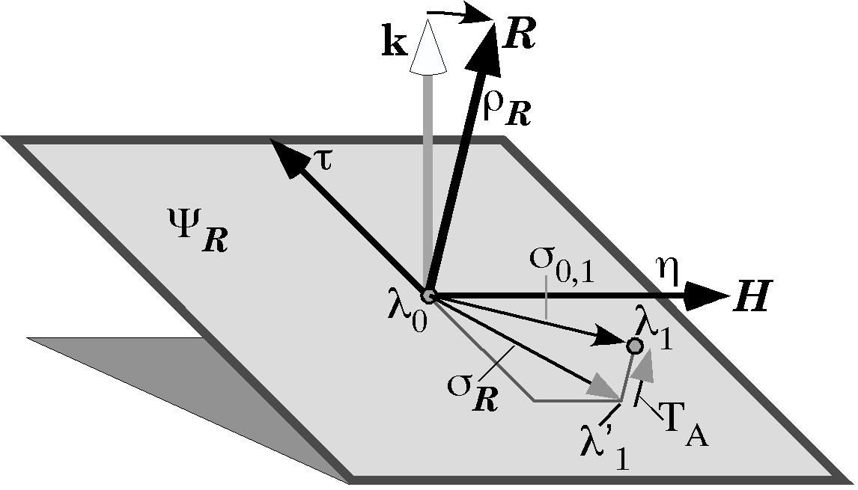

Possible Solutions
The planar separation, $s_{R}$, is the basis for computing the center of rotation and planar translation. The planar movement is a combination of a rotation of $j_{R}$ and a translation $T_{P}$, but there is not an unique solution. This can be seen by considering two extreme cases. First, the entire offset can be considered translation ($T_{P}=s_{R}$ ) and the center of rotation is at $λ_{0}$, $λ_{1}$, or anywhere between. This is not a very satisfying solution in that it is not very realistic or interesting. Second, the entire offset can be considered rotation, that is $T_{P}=0\text{.}0$. This is more interesting in that it gives a unique solution. The center of rotation is on the perpendicular bisector of the offset vector at a point where the angle between the two locations is equal to $j_{R}$, the angle of the quaternion R. This is an interesting solution in that it gives a definite solution and it may be a realistic description of the movement. It may also be seen as a step to a more satisfying solution, which is to see the movement as a rotation about a point that makes anatomical sense, plus a translation.

The Case of a Partially Determined Center of Rotation
We will return to the rotation-only solution shortly, but let us take a minute to develop a third solution. Often there is an anatomical reason for placing the center of rotation in a particular plane or on a particular line, but one may not know where in that plane or on that line the point lies. For instance, we know that a movement starts in the midline and occurs about a point in the mid-sagittal plane. In such a situation one can specify that the center lies in the midsagittal plane, in which case one can rotate the vector that extends from the center of rotation to the initial location, $e_{0}=λ_{0}−c_{R}$, as determined by the rotation-only solution, about the center of rotation, $c_{R}$, until it is aligned with the line of intersection and re-compute the location of the final location after that rotation, by applying the same transformation to $e_{1}=λ_{1}−c_{R}$. The difference between the final location after the rotation and the final location before the rotation will be the translation in the plane of the rotation quaternion, $T_{P}$. Consequently, computing the center of rotation assuming that the movement is totally due to rotation is a first step to finding the center of rotation and translation in a partially determined situation.

Finding the Center of Rotation
If we have an initial $\left(λ_{0}\right)$ and final $\left(λ_{1}\right)$ location and a rotation quaternion $\left(R\right)$ that is the ratio of the final orientation to the initial orientation and both locations are in a single plane of the rotation quaternion $\left(y_{R}\right)$, it is possible to determine the center of rotation $\left(c_{R}\right)$ that will rotate the initial location into the final location. Let the radial vectors from the center of rotation to the initial and final locations be $e_{0}$ and $e_{1}$, respectively. One of the consequences of making the movement totally rotation is that the two vectors are of equal length, $\left|e_{1}\right|=\left|e_{0}\right|$. If the separation between the two locations is $s$, then the midpoint of the separation is $d$.
$$d=λ_{0}+\frac{λ_{1}−λ_{0}}{2}\text{.}$$
The separation between the initial location and the midpoint of the separation vector is
$m=\frac{λ_{1}−λ_{0}}{2}$
A unit vector in the direction of $s$ will be
$$V=\frac{s}{\left|s\right|}=\frac{m}{\left|m\right|}\text{.}$$
Therefore, a unit vector in the direction of the perpendicular bisector of $s$ is obtained by rotating $V$ through an angular excursion of $\frac{p}{2}$ radians, using the rotation quaternion of the plane, R.
$$w=R\left(\frac{p}{2}\right)∗V\text{.}$$
The center of rotation must lie on the perpendicular bisector of the separation vector because the radial vectors must be equal length. Let $k$ be the distance from the midpoint of the separation vector to the center of rotation. The angle between the radial vectors is $j_{R}$ and the vectors $m$ and $kw$ form a right triangle with the radial vector ($e_{0}\text{ or }e_{1}$) as the hypotenuse. We know the length of $m$ and the half angle $\frac{j_{R}}{2}$, therefore we can compute the value of $k$.
$$\text{tan}\frac{j_{R}}{2}=\frac{\left|m\right|}{k}Ûk=\frac{\left|m\right|}{\text{tan}\frac{j_{R}}{2}}\text{.}$$
We can now compute the center of rotation by stepping off $kw$ from $d$.
$$c_{R}=d+kw$$
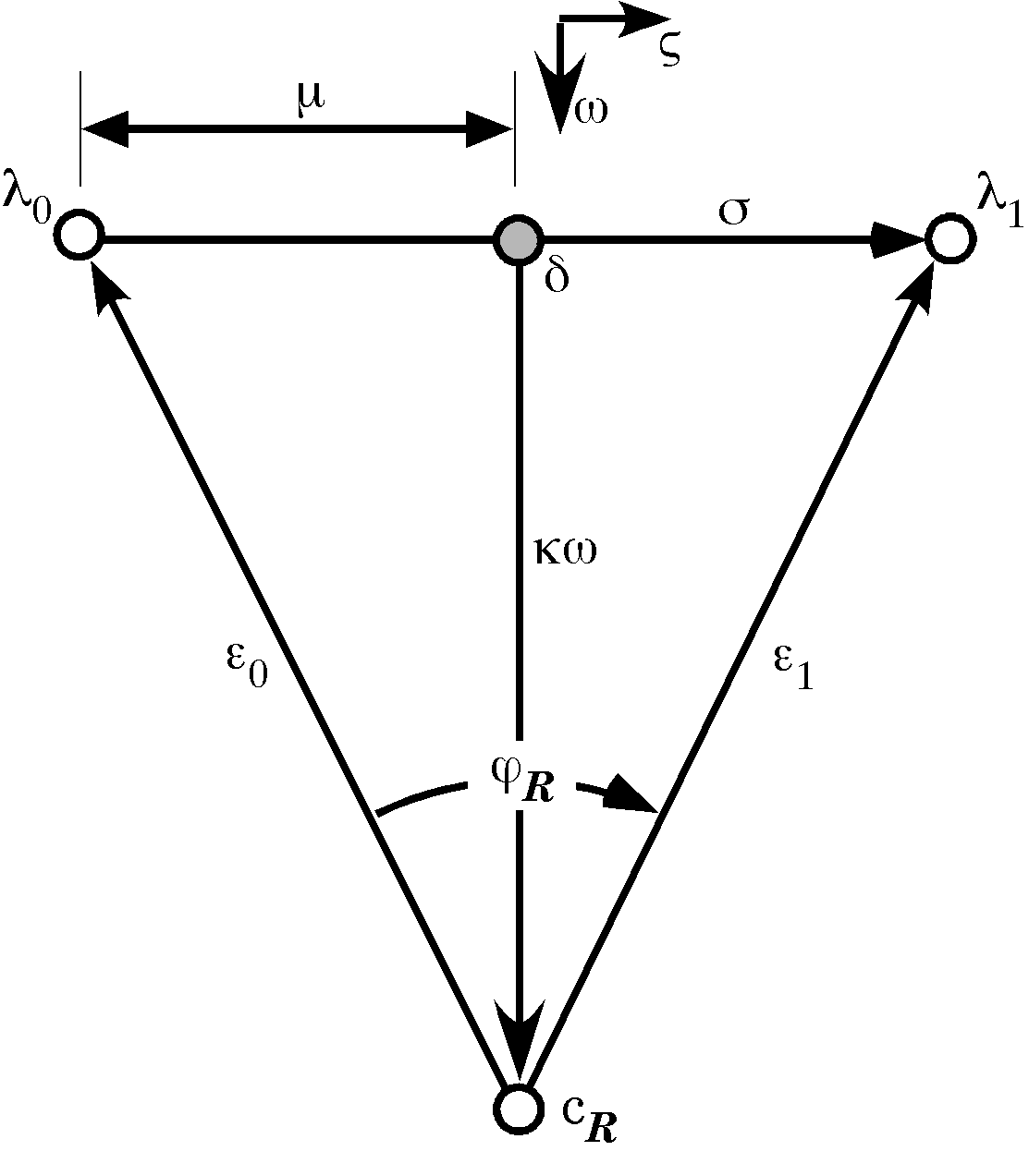

Finding the Line of Intersection
We have found the solution if the movement is entirely due to rotation. This rotation-only solution is often a satisfactory answer when we have inadequate information to choose a particular center of rotation, but there are many situations where we know something about the center of rotation while not knowing exactly where it lies. For instance, we may know that the movement started in neutral position, with the center of rotation in the midsagittal plane. Consequently, we have reason to suspect that the center of rotation is somewhere in the midsagittal plane, at least initially. One solution is to allow that the effective center of rotation shifts during the movement. In that case we might compute the center of rotation for successively longer segments of the movement or we might compute the center of rotation for a succession of short segments of the movement. Both are reasonable and potentially informative analyses of the movement. In many situations, they are the best description of the movement.
We have just developed the tools for such calculations. However, another interpretation might be that the movement is a combination of a rotation about the original center of rotation plus a translation. To find this solution we need to compute the solution for rotation-only, in the manner that has just been demonstrated, then we rotate $−e_{0}$ until it is aligned with the line of intersection, which will place the center of rotation in the appropriate plane. The same transformation is applied to$s$, to obtain the terminal location after the rotation, $λ_{1}^{'}$. The difference between the terminal location after the rotation and the final location is the translation in the plane of the quaternion,$T_{y_{R}}=λ_{1}−λ_{1^{¢}}=T_{P}\text{.}$
The central problem becomes finding the line, $L_{I}$, that lies in both the plane of the rotation and the plane that contains the starting position and the center of rotation. This section will deal with finding that line of intersection, $L_{I}$. We start with two planes, $y_{R}$, the plane of the rotation quaternion, and, $y_{S}$, the plane that contains the starting position and the center of rotation. Each is defined by the vector of the quaternion that is perpendicular to it, R and S, respectively. It turns out that there is a remarkably elegant solution of the line of intersection between the two planes. The line of intersection is perpendicular to both planar quaternions, therefore it lies in both planes. If it is perpendicular to both planar quaternions, then a quaternion that has the line of intersection as its vector may be expressed as the ratio of the vectors of the two planes. The ratio of two planes is their intersection.
$$I=\frac{ν\left(S\right)}{ν\left(R\right)}$$

Their intersection is a quaternion with the line of intersection as its vector, $ν\left(I\right)$, and the angle between the two planes as its angle, $ÐI$. Since the two planar quaternions are unit quaternions, the tensor of the intersection is also 1.0 and the intersection is a unit quaternion.
$$L_{I}=ν\left(\frac{ν\left(S\right)}{ν\left(R\right)}\right)=ν\left(I\right)$$
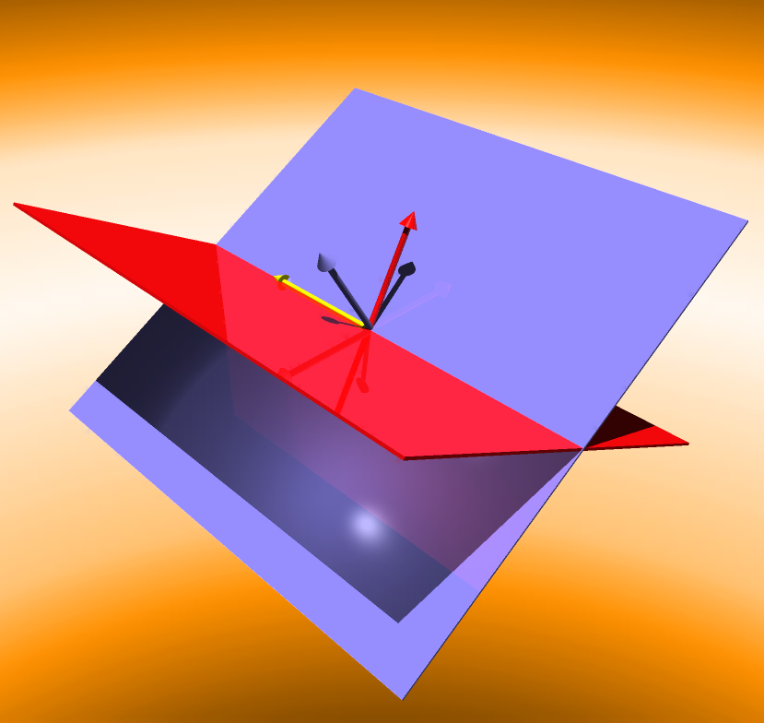
The two intersecting planes (red and blue) are formally equivalent to the vectors that are perpendicular to them (red and blue). The ratio of the vectors is the quaternion that is the intersection of the planes. The line of intersection is the vector of the intersection quaternion (yellow).
Since the planes of the quaternions are not any particular plane, but an infinite set of parallel planes for each planar quaternion, the line of intersection is not a particular vector. Any vector with the appropriate direction and a length of 1.0 is an instance of $L_{I}$. In order to select a particular line of intersection, we must pick an origin for the intersection vector. In our present situation, the origin lies at the initial location.
$$i=\left(λ_{0}+L_{I}\right)−λ_{0}$$

Computing the Partially Determined Case
We know the following:
$λ_{0}$ is the initial location,
$λ_{1}$ is the final location in the plane of the quaternion $R$, $y_{R}$,
$q$ is the angular excursion between $λ_{0}$ and $λ_{1}$,
$c_{R}$ is the center of rotation for the planar rotation,
$−e_{0}=c_{R}−λ_{0}$ and $s_{0,1}=λ_{1}−λ_{0}$, and
$i_{S,R}=ν\left(I\right)=ν\left(\frac{ν\left(S\right)}{ν\left(R\right)}\right)\text{ and }f=Ð\left(\frac{i_{S,R}}{e_{0}}\right)$.
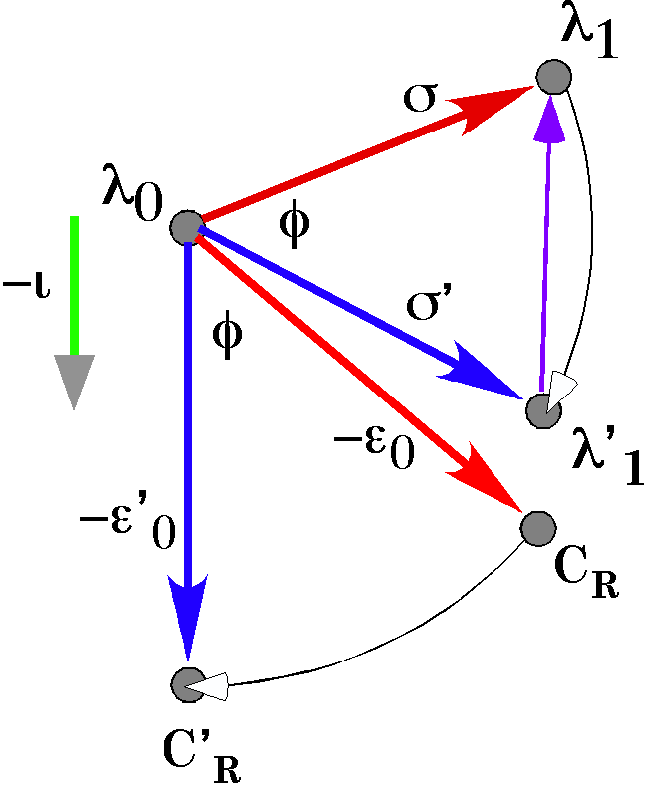
The original $λ_{0}$and $λ_{1}$ are used to compute the center of gravity assuming rotation only, C_{R}. The line of intersection, ι, is computed and the angle between it and the initial armature is computed, φ. In the diagram the negative of both vectors is used, but the result is the same. The new center of rotation, C’_{R}, is computed by swinging $−e_{0}$through the angle φ and the new final location, $λ_{1}^{'}$, is computed by swinging σ through the same angular excursion. The translation in the plane of the rotation quaternion, T_{P}, is$λ_{1}−λ_{1}^{'}$.
We may deduce the partially determined center of rotation by rotating the vector from the initial position to the center of rotation for rotation-only, $−e_{0}$, to the negative of the vector of the quaternion I, $−i_{S,R}$.
$$c_{R}^{'}=λ_{0}+R\left(f\right)\text{*-}e_{0}=λ_{0}−R\left(f\right)∗e_{0}\text{.}$$
Similarly, the final position after the rotation about $c_{R}^{'}$ is obtained by rotating the separation vector between the initial and final locations, $s_{0\text{.}1}$, through the same angular excursion about the initial location.
$$λ_{1^{¢}}=λ_{0}+R\left(f\right)∗s_{0\text{.}1}$$
Finally we can compute the translation in the plane $y_{R}$, assuming that the center of rotation lies in the plane $y_{S}$ by subtracting the final position after rotation from the final position in the $y_{R}$ plane before rotation.
$$T_{P}=λ_{1}−λ_{1^{¢}}$$
We now know the center of rotation, $c_{R}^{'}$, the translation in the plane of rotation, $T_{P}$, and the translation in the direction of the vector of the rotation quaternion, $T_{A}$. Therefore we have an unique, fully determined solution to the problem, subject to certain constraints upon the location of the center of rotation.
Summary
It is important to understand compound movements because any actual movement may be formally reduced to a compound movement. A compound movement is a combination of a rotation, which must change the orientation of a moving orientable object and may change its location, and a translation, that changes its location without changing its orientation. Given only the initial and final states of the object, it is not possible to say anything of its actual trajectory other than what is contained in the definition of its equivalent compound movement.
The compound movement is not a single solution, but a set of solutions that meet certain constraints. There are certain members of the solution set that are more interesting than others. Among these is the rotation-only solution. In many situations it is the optimal solution in that it defines a virtual joint that is able to generate the movement. If we know intermediate points on the object’s trajectory, then we can examine how a movement in a multiarticular chain may be reduced to the actions of a singe virtual joint that moves in time and space.
Sometimes, the optimal solution incorporates additional information that may come from our knowledge of the anatomy of the movement. For instance, if we know that the movement started from the midsagittal plane, then we can make that an additional condition on the solution. Including the additional information may often yield a single solution

Applications
Movements that occur in a single joint are generally a rotation without translation, therefore the analysis of single joint motions is usually straight-forward. There are situations in multi-joint assemblages where it is clear that, while all the movements in the component joints are rotations, the most relevant characteristic of the movement is a translation. For instance, when reaching forward from a fully flexed elbow, with the shoulder in neutral position, to upper extremity fully extended with the hand on level with the shoulder and the elbow straight, the movements in the shoulder and elbow joints are rotations, but the overall reaching movement is fundamentally a translation. Walking is basically about translating the body from one location to another and yet all the joint movements for propelling the body are rotations. In other assemblages, such as the neck, the movement is largely about rotation, but the movement involves complex interactions between many non-orthogonal axes of rotation. In all of these movements, overall movement is fairly straight-forward, although far from simple. The overall movement may be quite different than the component movements.
To understand these complex movements it is often convenient to reduce them to equivalent compound movements. Which equivalent movements are chosen depends upon what aspects of the movement one is interested in and what one knows about the anatomy of the movement. It is possible that one might develop two or more different types of compound movements in the analysis of a single system, to examine different aspects of the movement.
The analytic tools developed in this essay will provide the means for analysis of the movements of multi-joint assemblies in terms of compound movements, that is, in terms of pairs of rotations and translations.

