Commentary on Joly’s Manual of Quaternions

Chapter 1. The Addition and Subtraction of Vectors
In this commentary the text of Joly’s Manual of Quaternions is summarized and developed in several parts to elaborate on his themes and fill in where the need seemed to be present. In addition, a number of figures have been created to illustrate points that are not illustrated in the text. The progression and themes of the text are followed, for the most part.

Art. 1.

A vector is a directed magnitude.
We take as intuitive the concepts of points in space and straight lines. We start by defining what will be called a standard vector. These are the vectors of vector analysis, essentially directed magnitudes, without locality. However, we start with particular instances of a vector, which do have locality.
A vector is the portion of a straight line that connects a point, A, to another point, B. For the moment let that directed line segment be called AB. It has direction in that it passes from an origin, A, to a terminus, B, and not in the opposite direction. The line segment that passes in the opposite direction, from B to A, is called the opposite of AB and is written as BA. The opposite of a vector may be written by placing a negative sign in front of its designation.
BA = - AB
The vector AB has locality, because both A and B are definite points in space. When we mean the particular vector that extends from A to B, then the vector is a fixed or localized vector. When we mean a vector that has the same length and direction as AB, but which may be anywhere in space, then the vector is a free or non-localized vector. Free vectors may be moved without changing their value, as long as the maintain the same length and direction. Such movements are called translations. Translation of a fixed vector changes its value, because its location is a part of its value.
The magnitude of a vector is the distance between its origin and its terminus. We have not defined how one might measure the distance between points, but for the moment assume that we have straight line segment of a particular length, which we will designate as being unity. Given the straight line between A and B, we lay this ruler along the line and move it to measure how many times it can be laid end to end between A and B. The number of times one can do so is the distance between the two points. It is apparent that one can extend this operation to include lengths that are real numbers, when the number of ruler lengths is not an integer. A vector that has a length of 1.0 is called a unit vector.
All free vectors that are of equal length and have the same direction are equivalent. Fixed vectors that are of equal length and have the same direction are equal. Any two points, A’ and B’, that lie in the same relation to each other as B lies with respect to A will be the origin and terminus of an equivalent vector to AB. Therefore, moving a vector without rotating it will allow one to align the vector with all vectors to which it is equivalent.
A’B’ = AB
Sometimes we wish to designate a particular member of the set of equivalent vectors, in which case we chose a particular origin or terminus. The points A and B define a particular vector. When we wish to indicate a vector without a definite location, it is common practice to use a single letter, often a Greek letter, for instance, a, b, c, . . . , α, β, γ.
Vectors that have a definite location are localizable. While it is not necessary, they are often defined relative to a coordinate system. The location of A is defined relative to a universal origin, which will be symbolized by O in this discussion. So the location of A is given by the vector OA. The vector OA is a particular localized vector.

Art. 2.
Since we can translate a vector and not change its value, it is always possible to move vectors so that the terminus of one is the origin of another. If this is done with two vectors AB and BC, where B is the terminus of AB and the origin of BC, then the vector that extends between A and C, AC, is said to be the sum of AB and BC. If we move the vector BC so that its origin is at A, then its terminus will be at another point, D, and we would write it as AD. If we now move the vector AB so that it has its origin at D, then it will have its terminus at a point E. The second vector will be written as DE. It turns out that if we carry out the construction that E is also C, therefore, the sum of AD and DE is AE = AC. This relationship can be seen if we construct the parallelogram that correspond to the description. If we replace the specific vectors with single letters that designate the whole sets of equivalent vectors (α = AB and DE, β = BC and AD, γ = AC and AE), then one can write the general relationship.
AB + BC = α + β = AC = γ = AE = β + α = AD +DE
The order in which vectors are added will not change the sum.

Art. 3.
This may be extended by straightforward argument to multiple vectors. If we have another vector, δ, then we can examine all the possible combinations of the four vectors and verify that any order of addition of the four vectors yields the same sum, ε.
$$α+β+d=β+α+d=g+d=d+g=d+α+β=d+β+α=e$$

Any path that traverses from A to E will give the same sum, namely ε. This means that the addition of vectors is both associative and commutative; associative in that we may group them as we choose and commutative in that we can add them in any order.

Art. 4.
We can also add the negative of vectors, so any pathway that traverses the connections in the above array, starting with A and ending at E, will give the same sum, AE. Any sub-pathway is an equally valid vector sum.
$$a+b+\text{d+}\left(−e\right)=0$$
Any pathway that forms a closed polygon will have a sum of 0. The vector 0 is the null vector, it has a length of 0.0 and indefinite direction. Adding 0 to any other vector will not change the vector.

Art. 5.
The addition of negative vectors is equivalent to subtraction and it is possible to simplify the notation.
$$a+\left(−b\right)ºa−b$$

Art. 6.
When a vector is added to itself n times, then we can express the result as n times the vector.
$$\begin{aligned}a+a=2a; \\ a+a+a=3a; \\ a+a+a+L+a=na\end{aligned}$$
This may be extended to situations where n is any real number, much as the integers are extended to the rational and irrational numbers. Such numbers as n are called scalars. They have magnitude but not direction. It is straight-forward to extend the range of scalars to negative numbers.
The expression $na$ is read as meaning a vector in the same direction as α , but with n times the length. It is straight-forward to show that expressions like the following make sense.
$$3α+2β=5g$$
If two vectors are parallel, then it makes sense to write expressions that express one as a scalar multiple of the other.
$$\text{If }a‖b\text{, then}b=ma\text{.}$$
In fact, if the ratio of two vectors is a scalar, then they are parallel.
It is straight-forward to interpret expressions such as the following, which demonstrates the distributive character of scalar multiplication.
$$c\left[aa+bb\right]=c\text{g=}aca+bcb;g=aa+bb\text{.}$$

Art. 7.
In quaternion analysis, the tensor of a vector is its length. It is a signless magnitude. Therefore, the tensors of a vector and its negative are the same.
$$T\left(a\right)=T\left(−a\right)$$
The vector that has the same direction as α, but a tensor of 1.0 is called the versor of the vector α. It may be expressed as the ratio of a vector to its tensor. The versor is a unit vector.
$$U\left(a\right)=\frac{a}{T\left(a\right)}$$
If the scalar n is a real number then the following relations hold.
$$T\left(na\right)=\begin{matrix}nT\left(a\right) & \text{if }n>0 \\ −nT\left(a\right) & \text{if }n<0\end{matrix}$$

$$U\left(na\right)=\begin{matrix}U\left(a\right) & \text{if }n\text{>0} \\ −U\left(a\right) & \text{if }n\text{<0}\end{matrix}$$
A vector may be decomposed into the product of its tensor and its versor, its magnitude times its direction.
$α=T\left(α\right)⋅U\left(α\right)$.

Art. 8.
It is convenient to be able to resolve an arbitrary vector into component vectors that are parallel to the basis vectors of a coordinate system. The basis vectors of a three-dimensional coordinate system are three non-coplanar vectors that occupy the space. It is usual to make the vectors mutually orthogonal unit vectors, but it is sufficient to ensure that they are independent, in the sense that none of the vectors can be expressed as a combination of multiples of the other two vectors. This means that there is no plane the contains all three vectors. Each pair of basis vectors defines a plane.
There is one and only one way that an arbitrary vector may be resolved into the sum of three component vectors in a given coordinate system if the following procedure is followed.

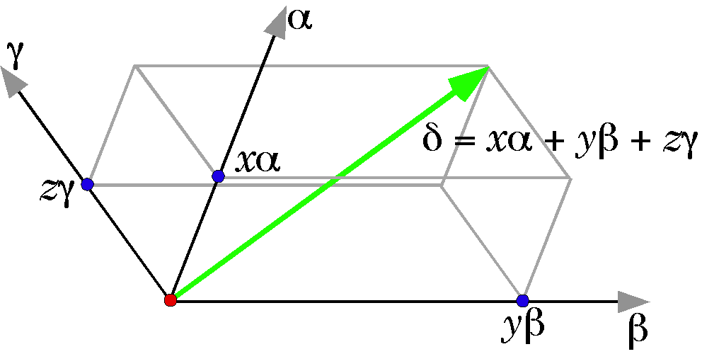
If the basis vectors are α, β, and γ and the vector is δ, then one constructs a parallelepiped by moving the planes defined by each of the pairs of vectors so that they contain the terminal point to the vector δ. Where they intersect the basis vectors are the terminal points of three vectors, xα, yβ, and zγ. 
$$d=xα+yβ+zg$$
There is one and only one set of intersects for any particular set of basis vectors. However, note that if a different set of basis vectors is chosen then the vector can be expressed as a different sum of component vectors.

Chapter 2. The Multiplication and Division of Vectors and of Quaternions

Art. 9.
In the last chapter it was noted that if two vectors were parallel, then ratio of the two vectors meant something, namely the ratio of their tensors.
$$\frac{α}{β}=\frac{T\left(α\right)⋅U\left(α\right)}{T\left(β\right)⋅U\left(β\right)}=\frac{T\left(α\right)⋅U\left(α\right)}{T\left(β\right)⋅U\left(α\right)}=\frac{T\left(α\right)}{T\left(β\right)}=n_{\text{αβ}}$$
In this chapter, the meaning of the ratio of two vectors is explored for those situations in which the two vectors are not parallel. We start by defining some types of multiplication of vectors.

Scalar Multiplication
The first type of multiplication is the projection of one vector, α, into another vector, β. It is the length of β times the projection of α into β, where a projection is constructed by drawing a perpendicular to β that intersects the terminus of α.
First, we define a product that will be called the scalar product, SP, it is the product of the tensor of one vector times the tensor of the projection of the other vector upon the first vector. As the figure shows, the order is not important, because the product is the same in either case. The scalar product is a positive number, because it is the product of two tensors and tensors are always positive numbers. The scalar product is a type of multiplication that is used frequently in vector analysis. It is so named since the product is always a scalar. It may also be called a dot product because it is generally written using the dot symbol as the multiplication symbol.
$$\text{SP}\left(\text{αβ}\right)=αoβ$$
In this essay, we will use a slightly different function for the relationship that corresponds to the scalar product. It is called the scalar of the product of the two vectors α and β  and it is written as S(αβ) . It is the negative of the scalar product, for reasons that will become apparent as we progress.

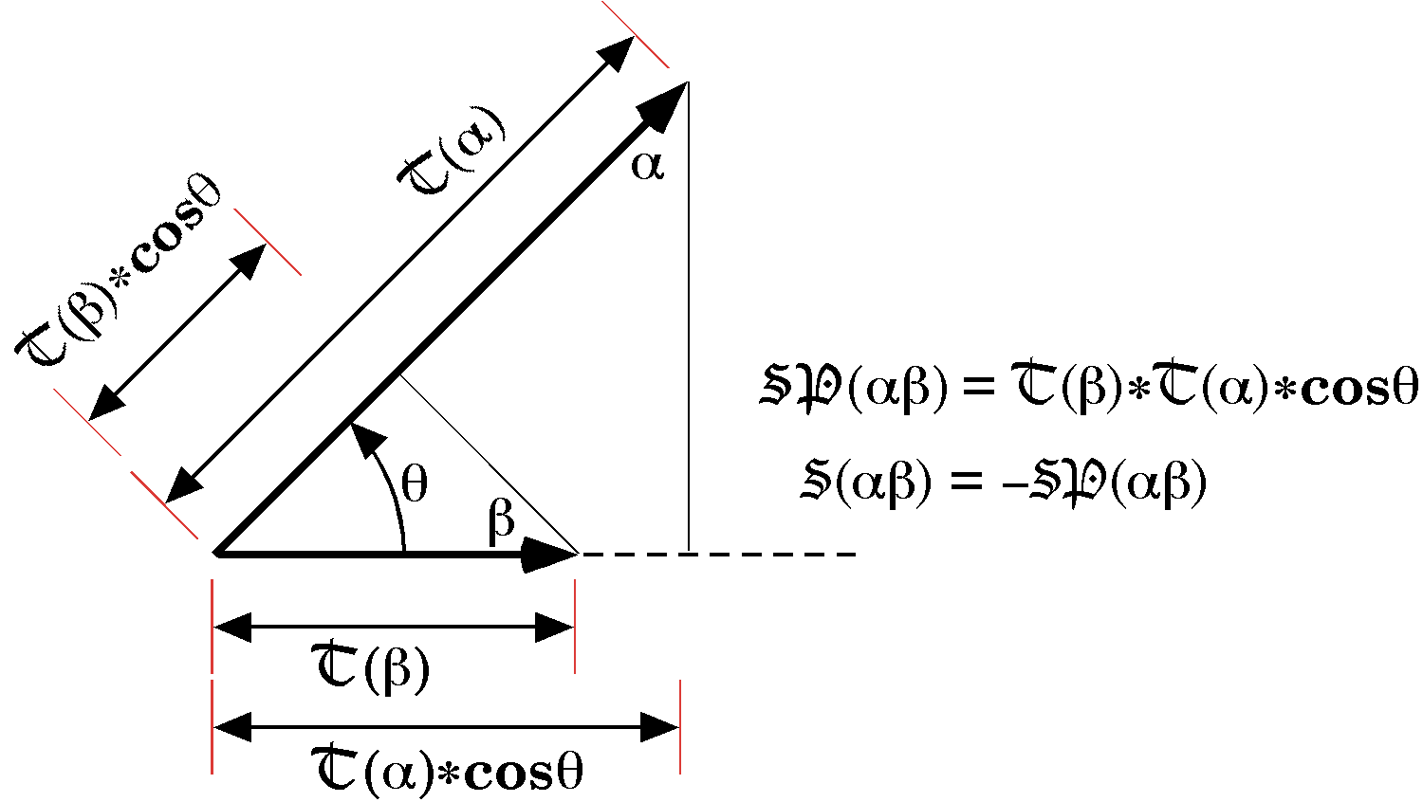
The scalar (S) and the scalar product (SP) of the vectors α and β.
Historical Note: Since quaternion analysis preceded vector analysis, the scalar of a vector product is an older concept than the scalar product. The scalar product is useful in mechanics in that the work done by a force acting over distance can be modeled as the scalar product of the force and the change in location of the point of application.
$$W=FoDr$$

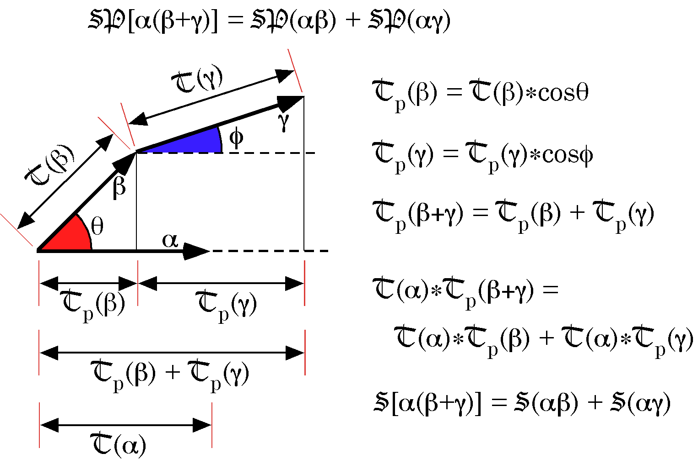
We can combine the scalars of vector products to obtain simpler expressions. This depends upon noting that the projection of a sum of vectors is the sum of their projections. This is illustrated in the figure above. We can extend this observation to a general expression that relates the scalars of a sum to the sum of scalars.
$$S\left[\sum_{n}{α_{n}}∗\sum_{m}{β_{m}}\right]=\sum_{m}{\sum_{n}{S\left(α_{n}∗β_{m}\right)}}$$
This readily converts to the expression for scalar products.
$$\begin{aligned}\text{SP}\left[\sum_{n}{α_{n}}\sum_{m}{β_{m}}\right]=\sum_{m}{\sum_{n}{\text{SP}\left(α_{n}β_{m}\right)}}, \\ \sum_{n}{α_{n}}o\sum_{m}{β_{m}}=\sum_{m}{\sum_{n}{\left(α_{n}{oβ}_{m}\right)}}\text{.}\end{aligned}$$
Note that if α and β are mutually perpendicular, then their projections upon each other are nil, and if the scalar of a vector product is nil then the vectors are mutually perpendicular.
$$α\hat{βÛS}\left(\text{αβ}\right)=0\text{.}$$
If the scalar of a vector product is known, there is no way of knowing the vectors in the product, even if we know one of the vectors. Consequently, the division of scalars or scalar products by vectors does not have a unique solution. Asking for the inverse of taking the scalar of a vector product (S) or of a scalar product (SP) has no meaning.

Art. 10.
In vector analysis, there is a second way of multiplying vectors, which yields a vector, therefore these products are called vector or cross products. Like dot products, the term comes from the type of multiplication symbol used. Cross-products are used to model moments of forces or torques, T, where the location vector for the point of application of a force, r, is multiplied by the vector for the force, F.
$$T=r´F\text{.}$$
The rationale for the form of the cross-product is generally not given. It is argued that that the format works for modeling the relations between forces and the tendency to rotate, therefore it is appropriate. The rationale derives from quaternion analysis as will be developed below.
Given two vectors, α and β, they can always be translated so that they have a common origin and therefore define a plane. Erect a third vector, γ, perpendicular to that plane that has a length equal to the area of the parallelogram formed by the two vectors. That vector is the cross product of the two vectors. In quaternion analysis it is written as V(αβ) and read as the vector of the vector product αβ.
$$\begin{aligned}g=α´β=V\left(\text{αβ}\right); \\ T\left(g\right)=T\left(α\right)⋅T\left(β\right)⋅\text{sin}q, \\ g\hat{α},β\text{.}\end{aligned}$$
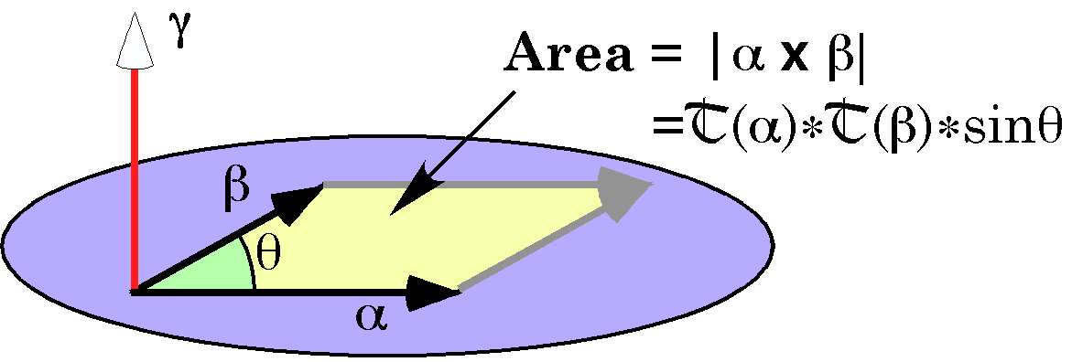
There are actually two vectors that meet these constraints, they point in opposite directions, perpendicular to the plane of the multiplied vectors. Either perpendicular vector works equally well as long as one consistently chooses it. The one that is normally used is the vector that completes a right-handed coordinate system. If the fingers on one’s right hand are curled so that they extend from the first vector in the product to the second vector, then the thumb points in the direction of the vector product. If one curls one’s fingers from the second vector to the first vector, then the product vector points in the opposite direction, which leads to the following relationship.
$$V\left(\text{αβ}\right)\text{=-}V\left(\text{βα}\right)\text{.}$$
This expression indicates that this type of multiplication is not commutative. The order in which the vectors are multiplied is critical to the final result. This turns out to be of great importance in the analysis of systems that are modeled with vectors.
As with the scalar of a vector product, it does not make sense to ask for the inverse of the vector of a vector product since there is not a unique solution. If two vector products are equal, then the two pairs of vectors must lie in the same plane, they must form parallelograms of equal areas, and the sense of the rotation from the first element of each pair to the second element is the same.
$$\begin{aligned}V\left(\text{αβ}\right)=V\left(\text{gd}\right)⇒ \\ α\text{ and }β\text{ lie in the same plane as }g\text{ and }d\text{ and} \\ T\left(α\right)∗T\left(β\right)∗\text{sin}q=T\left(g\right)∗T\left(d\right)∗\text{sin}f\text{ and} \\ α\text{ lies respect to }β\text{ as }g\text{ lies in respect to }d\text{.}\end{aligned}$$
However, if two vectors α and β are mutually perpendicular then the their vector product is the same as for any other pair in which the orthogonal components have the same values. Clearly, there are not unique solutions for the inverse of the vector product, even if we know one of the component vectors.
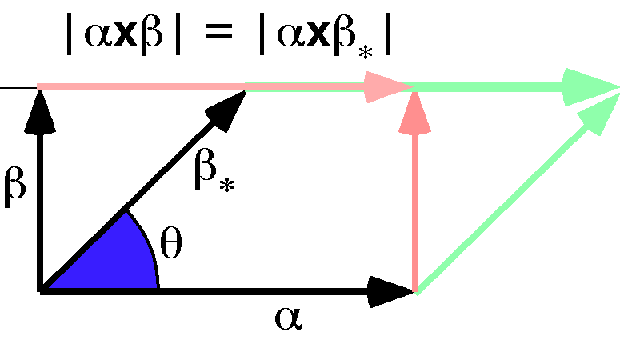
The vector product is the same for all pairs of vectors in a plane that have the same orthogonal dimensions.
This means that we can replace a vector in the cross product with its projection upon a line perpendicular to the other vector.
$$α´β_{}=α´\left(\frac{β_{}\text{sin}q}{\left|β_{}\right|}\right)=α´β$$

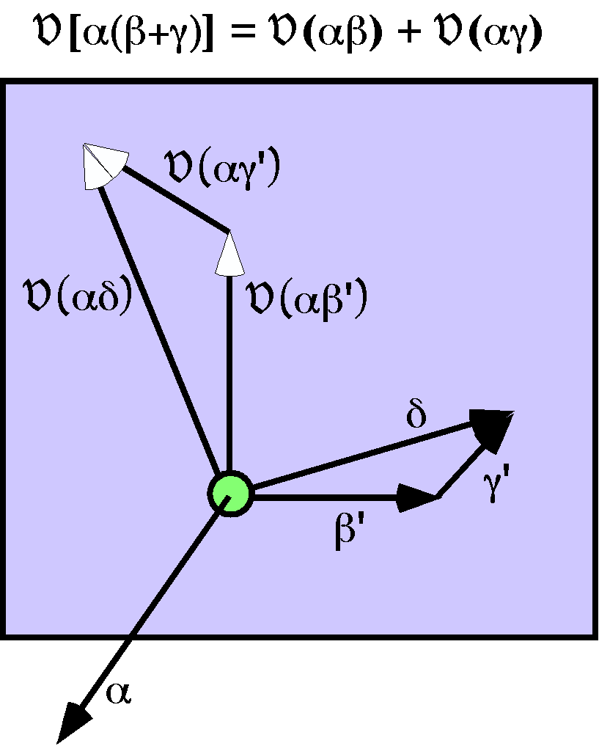

We can use this property to examine the distributive law for cross products. There is a vector α that is to be multiplied times the combined vector β+γ, V[α(β + γ)]. For both β and γ, we replace the vector by the equivalent vector that is orthogonal to α, β’ and γ’, respectively. Since both β’ and γ’ lie in the plane perpendicular to α, their sum lies in the same plane. Since the cross product is perpendicular to both of its components, it must lie in the same plane, but rotated 90° relative to the β’ or γ’ vector and T(α) times as long. Since β’ + γ’ = δ it follows that V(αβ’) + V(αγ’) =V(αδ). Because the β and γ may replace their projections orthogonal to α without changing the product, we may also write the expression as follows.

$$\begin{aligned}V\left[α\left(β^{'}+g^{'}\right)\right]=V\left(αβ^{'}\right)+V\left(αg^{'}\right), \\ V\left[α\left(β+g\right)\right]=V\left(\text{αβ}\right)+V\left(\text{αg}\right)\text{.}\end{aligned}$$
This result can be generalized to the following expression.
$$V\left[\sum_{n}{α_{n}\sum_{m}{β_{m}}}\right]=\sum_{m}{\sum_{n}{V\left(α_{n}β_{m}\right)}}$$
Finally, note that if V(αβ) = 0, then the vectors α and β must be parallel or one of them must equal 0, because that is the only way that the area of their parallelogram, T(α)∗T(β)∗sin θ, could be 0.0. The vector product is the nil vector, 0, because it is a vector with a tensor of 0.0 and indefinite direction.

Art. 11.
In quaternion analysis the product of the vector α into the vector β is the sum of the scalar and the vector of the vector product.
$$\text{αβ}=S\left(\text{αβ}\right)+V\left(\text{αβ}\right)\text{.}$$
Because both of its components are doubly distributive and they are summed, it follows that the vector product is doubly distributive.
$$\begin{aligned}\sum_{n}{α_{n}}\sum_{m}{β_{m}}=\sum_{n}{\sum_{m}{α_{n}}}β_{m},\text{ which expands as follows -} \\ \left(α_{1}+α_{2}+α_{3}+L+α_{n}\right)∗\left(β_{1}+β_{2}+β_{3}+L+β_{m}\right)= \\ α_{1}β_{1}+α_{1}β_{2}+α_{1}β_{3}+α_{1}β_{4}+L+α_{1}β_{m}+α_{2}β_{1}+α_{2}β_{2} \\ +α_{2}β_{3}+α_{2}β_{4}+L+α_{n}β_{1}+α_{n}β_{2}+α_{n}β_{3}+α_{n}β_{4}+L+α_{n}β_{m}\text{.}\end{aligned}$$
Since the vector of the vector product is not commutative, the vector product is not commutative.
$$\begin{aligned}\text{αβ}=S\left(\text{αβ}\right)+V\left(\text{αβ}\right)\text{ and }\text{βα}=S\left(\text{βα}\right)+V\left(\text{βα}\right), \\ S\left(\text{αβ}\right)=S\left(\text{βα}\right),\text{but }V\left(\text{βα}\right)=−V\left(\text{αβ}\right)\text{.}\end{aligned}$$
We can write the scalar and vector components of the product as sums and differences between the products.
$$\begin{aligned}S\left(\text{αβ}\right)=S\left(\text{βα}\right)=\frac{\text{αβ}+\text{βα}}{2} \\ V\left(\text{αβ}\right)\text{=-}V\left(\text{βα}\right)=\frac{\text{αβ}−\text{βα}}{2}\end{aligned}$$

Art.12.
Vector products are the sum of a scalar and a vector, so that they have four parts when the vector is resolved into its components. For that reason they are quaternions.

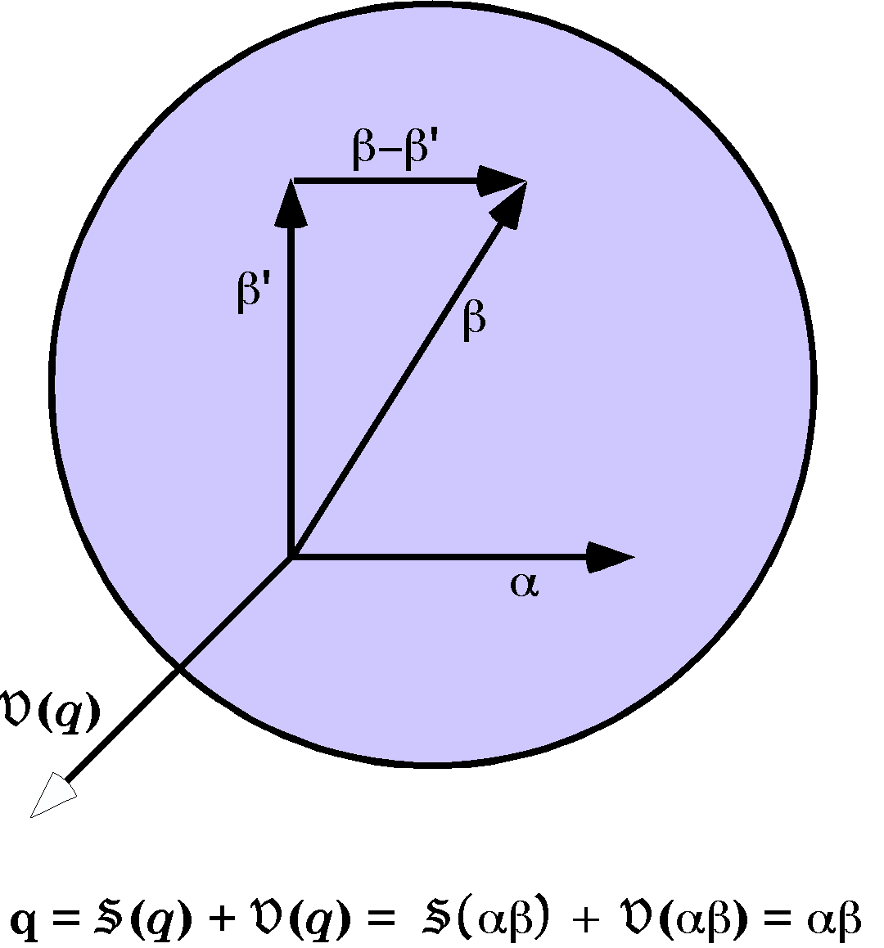
If q is a quaternion and it is written as $q=S\left(q\right)+V\left(q\right)$and $α$and $β^{'}$ are two vectors that are mutually perpendicular to each other and to so that $V\left(αβ^{'}\right)=V\left(q\right)$ and if $β−β^{'}‖α$ such that $S\left[α\left(β−β^{'}\right)\right]=S\left(q\right)$, then $V\left(q\right)=V\left(\text{αβ}\right)$, since $V\left[α\left(β−β^{'}\right)\right]=0$, and $S\left(q\right)=S\left(\text{αβ}\right)$ because $S\left(αβ^{'}\right)=0$, therefore
$q=\text{αβ}$.
The quaternion $q$ has been reduced to the product of two vectors and the procedure was general, so, any quaternion may be expressed as the product of two vectors.
Now we may consider scalars and vectors to be special instances of a more general class of number, quaternions, much as real and imaginary numbers are special subsets of complex numbers.
Quaternions are added by adding like parts. Their scalars sum and their vectors sum. Since both sums are associative and commutative, it follows that the addition of quaternions is associative and commutative.
$$\begin{aligned}q_{1}=S\left(q_{1}\right)+V\left(q_{1}\right), \\ q_{2}=S\left(q_{2}\right)+V\left(q_{2}\right), \\ q_{3}=S\left(q_{3}\right)+V\left(q_{3}\right), \\ \\ q_{1}+q_{2}=\left[S\left(q_{1}\right)+S\left(q_{2}\right)\right]+\left[V\left(q_{1}\right)+V\left(q_{2}\right)\right] \\ \left[S\left(q_{2}\right)+S\left(q_{1}\right)\right]+\left[V\left(q_{2}\right)+V\left(q_{1}\right)\right] \\ q_{2}+q_{1} \\ \\ \left(q_{1}+q_{2}\right)+q_{3}=\left[S\left(q_{1}\right)+S\left(q_{2}\right)\right]\text{+S}\left(q_{3}\right)+\left[V\left(q_{1}\right)+V\left(q_{2}\right)\right]+V\left(q_{3}\right) \\ S\left(q_{1}\right)+\left[S\left(q_{2}\right)+S\left(q_{3}\right)\right]+V\left(q_{1}\right)+\left[V\left(q_{2}\right)+V\left(q_{3}\right)\right] \\ q_{1}+\left(q_{2}+q_{3}\right)\end{aligned}$$

Art.13.
We can now write down the consequences of multiplying quaternions by scalars or vectors. Multiplication by a scalar is straight-forward.
$$n∗q=n∗S\left(q\right)+n∗V\left(q\right)=q∗n\text{.}$$
Multiplication by a vector depends upon the order of the elements.
$$\begin{aligned}α∗q=α∗S\left(q\right)+α∗V\left(q\right), \\ q∗α=S\left(q\right)∗α+V\left(q\right)∗α, \\ α∗S\left(q\right)=S\left(q\right)∗α,\text{ but} \\ α∗V\left(q\right)¹V\left(q\right)∗α\text{.}\end{aligned}$$
The quaternions that are the product of a vector and the vector part of a vector product are different, depending upon the order of the vectors in the product. Note that the product of two vectors is a quaternion and not a vector as with a cross-product.

Art. 14.
If we set up a right-handed coordinate system with the three, mutually orthogonal, basis vectors being {i, j, k}, arranged so that rotating i into j gives k. We can write down the following relations from inspection.
$$\begin{aligned}S\left(\text{ij}\right)=S\left(\text{jk}\right)=S\left(\text{ki}\right)=0 \\ S\left(i^{2}\right)=S\left(j^{2}\right)=S\left(k^{2}\right)\text{=-}1 \\ V\left(\text{ij}\right)=k;V\left(\text{jk}\right)=i;V\left(\text{ki}\right)=j; \\ V\left(\text{ji}\right)\text{=-}k;V\left(\text{kj}\right)\text{=-}i;V\left(\text{ki}\right)\text{=-}j;\end{aligned}$$
All these relationships are implied by a single statement, which is famous since Hamilton carved it in the stonework of a bridge in Dublin when he discovered it.
$$i^{2}=j^{2}=k^{2}=\text{ijk}\text{=-}1$$
To illustrate, multiply both sides by the same vector leads to various relationships.
$$\begin{aligned}\text{ijk}∗k\text{=-}kÛ\text{ij}=\text{k,} \\ \text{ij}∗j=\text{kj}\text{Û-}i=\text{kj,} \\ \text{i*ijk}\text{=-}iÛ\text{jk}=i,\text{ etc}\text{.}\end{aligned}$$
These relationships lead to several curious attributes of quaternion systems. The basis vectors are all square roots of –1, therefore imaginary numbers, and yet they are different square roots, because multiplying two different vectors together does gives not –1, but the third vector. In fact, all quaternion vectors of length 1.0 are square roots of –1. Consequently, in quaternion analysis, there are an infinite number of square roots of –1.
It helps to have an aide memoire for the relations given above and the following diagram is perhaps the easiest way to remember the relationships. Going clock-wise around the circle give positive results and going counter-clockwise give negative results. Thus, ij = k, but ji =- k. Any value times itself is –1.
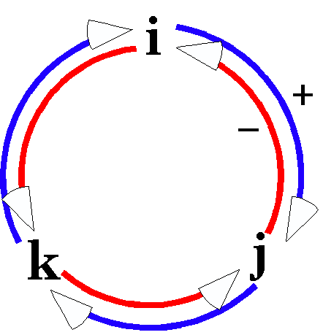
It is permitted to multiply adjacent vectors in the order in which they lie, but one can not skip over intervening elements in a product.
$$i∗\text{ijk}\text{=-}1⋅\text{jk}\text{=-}\text{jk}=i\text{, but }\text{ijk}∗i=\text{kki}\text{=-}i\text{.}$$
We cannot multiply the two i’s in the second expression to get –1. Basically, one can multiply only adjacent vectors.

Art. 15.
Since the product of any two vectors is a quaternion and the product of any two quaternions is a quaternion, quaternions are closed under multiplication and associative.

Art. 16.
This is perhaps the central finding of the elements of quaternions. It is the division of vectors that was a large factor in their discovery and use. It is the concept that sets quaternion analysis apart from vector analysis.
If we square a vector, α, the product is the negative of the magnitude of the vector squared. This allows us to calculate the inverse of α.
$$\begin{aligned}α∗α=S\left(α∗α\right)+V\left(α∗α\right)=S\left(α∗α\right)\text{=-}T^{2}\left(α\right); \\ \frac{α∗α}{−T^{2}\left(α\right)}=1⇒α∗\frac{−α}{T^{2}\left(α\right)}=1; \\ α^{−1}=\frac{−α}{T^{2}\left(α\right)}\text{.}\end{aligned}$$
The inverse of a vector is a vector in the opposite direction with a magnitude that is the inverse of the magnitude of the vector.
The power of this observation lies in the analysis of the following situation. Assume two vectors, α and β, that have been translated so that they have a common origin. We know that β has been generated out of α by a transformation. We wish to determine what that transformation might be. Therefore, we take the ratio of β to α.
$$R=\frac{β}{α}=β∗α^{−1}$$
R is the product of two vectors, thus a quaternion. The ratio of two vectors is a quaternion.
There is one point that has to be addressed at this point. We might interpret a fraction in two ways, but the two expressions are not equivalent. In fact they are almost always different.
$$\frac{β}{α}=β∗α^{−1}\text{ or }\frac{β}{α}=α^{−1}∗β\text{, but }β∗α^{−1}¹α^{−1}∗β\text{.}$$
It turns out that either will work, as long as one is consistent in interpreting the meaning of a fraction. Usual practice is to use the first option above. Best practice is to write the expressions in the format to the right of the equal sign. Then there is no ambiguity.
The reciprocal of a product is the product of reciprocals in the reverse order. This can be seen because the products cancel out in succession as one moves from the middle of their product.
$$\begin{aligned}Q=\text{αβgd}{ÛQ}^{−1}=d^{−1}g^{−1}β^{−1}α^{−1}, \\ {\text{QQ}}^{−1}={\text{αβgdd}}^{−1}g^{−1}β^{−1}α^{−1}=1\text{.}\end{aligned}$$
This has even deeper significance. The reciprocal of the product of quaternions is the product of their reciprocals in reverse order. Consequently, any combination of quaternions, by addition, subtraction, multiplication, or division is a quaternion. Quaternions are closed to all the arithmetical operations.

Art. 17.
We define a function of a quaternion called its conjugate. The conjugate of a quaternion is the quaternion with its vector component equal to the negative of the quaternion’s vector component.
$$K\left(q\right)=S\left(q\right)−V\left(q\right)\text{.}$$
If the quaternion is written as the product of two vectors, then we may write the conjugate as the product of those vectors in reverse order.
$$q=\text{αβ}ÛK\left(q\right)=\text{βα}\text{.}$$
If we multiply a quaternion by its conjugate then the result is a tensor equal to the product of their component vectors’ tensors squared. It turns out that the order of multiplication is not relevant.
$$\begin{aligned}q∗K\left(q\right)=\text{αββα}=α⋅T\left(β^{2}\right)⋅α=T\left(α^{2}\right)⋅T\left(β^{2}\right), \\ K\left(q\right)∗q=\text{βααβ}=β⋅T\left(α^{2}\right)⋅β=T\left(α^{2}\right)⋅T\left(β^{2}\right)\text{.}\end{aligned}$$
We can express this relationship in an alternative form, which gives a different result.
$$\begin{aligned}q∗K\left(q\right)=\left[S\left(q\right)+V\left(q\right)\right]∗\left[S\left(q\right)−V\left(q\right)\right]=S^{2}\left(q\right)−V^{2}\left(q\right)=T^{2}\left(q\right), \\ K\left(q\right)∗q=\left[S\left(q\right)−V\left(q\right)\right]∗\left[S\left(q\right)+V\left(q\right)\right]=S^{2}\left(q\right)−V^{2}\left(q\right)=T^{2}\left(q\right)\text{.}\end{aligned}$$
Combining both results, we can write down a relationship between the tensors of the component vectors and the tensor of the quaternion.
$$T^{2}\left(q\right)=T\left(α^{2}\right)⋅T\left(β^{2}\right)\text{.}$$
The format of a quaternion may be written in terms of tensors and unit vectors.
$$q=\text{αβ}=U\left(α\right)⋅T\left(α\right)⋅T\left(β\right)⋅U\left(β\right)=T\left(α\right)⋅T\left(β\right)⋅U\left(α\right)⋅U\left(β\right)=T\left(q\right)⋅U\left(q\right)\text{.}$$
The U(q) = U (α) U (β) is the versor of the quaternion and the T(q) = T(α)T(β) is the tensor of the quaternion.
If the angle of the quaternion is θ, where π − θ is the angle between the vectors, then we can expand the tensor and versor of the quaternion into a trigonometric format that is very useful in many contexts.
$$S\left(q\right)=T\left(q\right)⋅\text{cos}q\text{ and }V\left(q\right)=T\left(q\right)⋅\text{sin}q⋅U\left(q\right)\text{.}$$
We can now write the expression for a quaternion in trigonometric form.
$$q=S\left(q\right)+V\left(q\right)=T\left(q\right)\left[\text{cos}q+\text{sin}q⋅U\left(q\right)\right]\text{.}$$

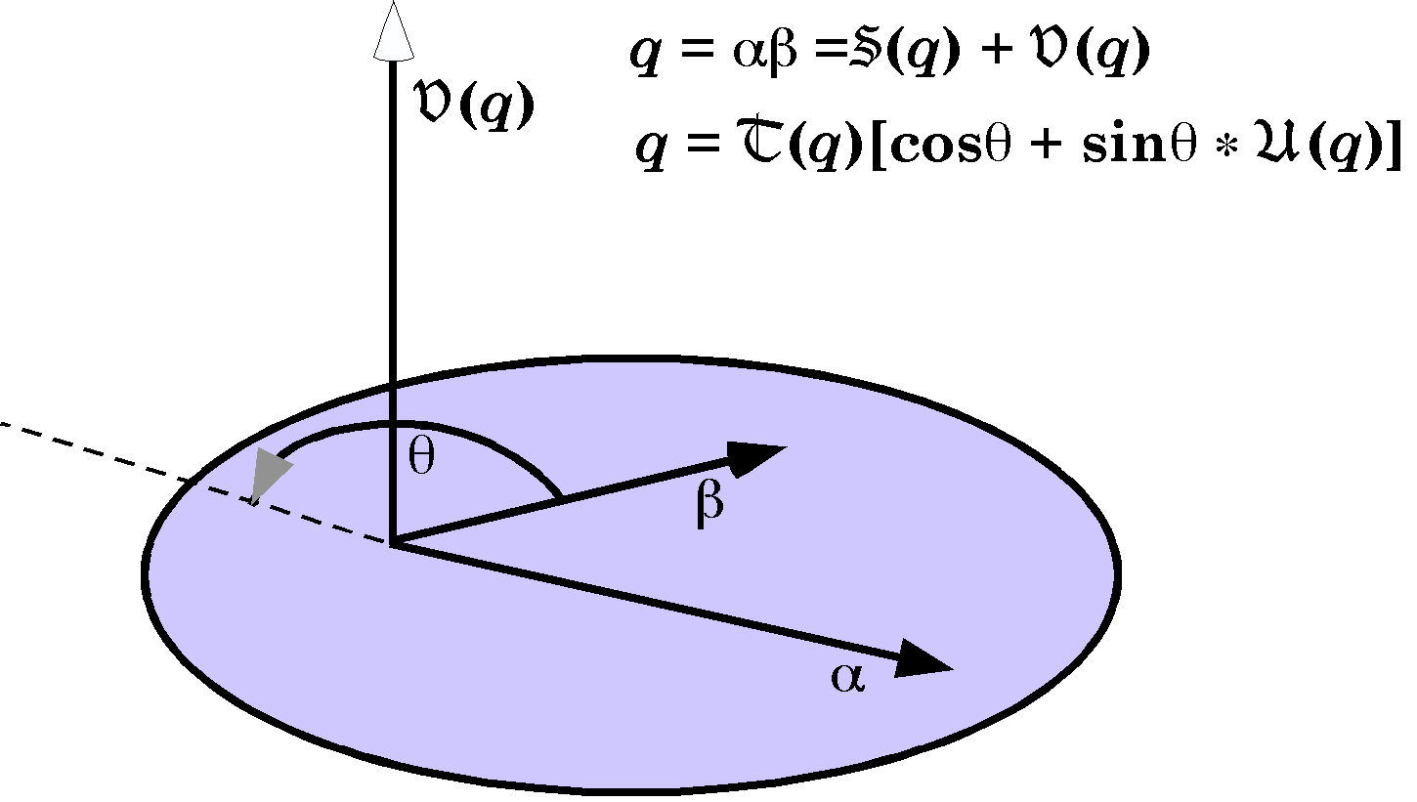

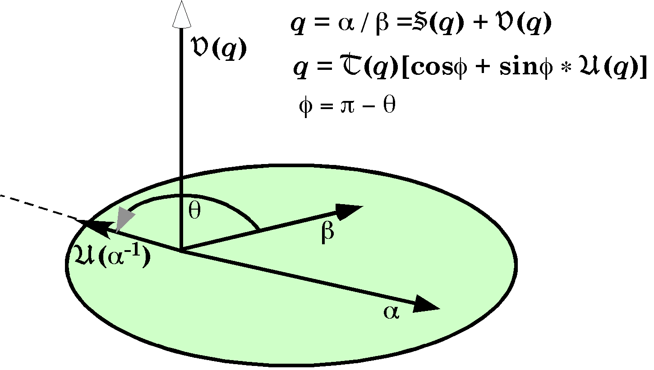
The vectors α and β define a plane, which is called the plane of the quaternion. The quaternion is composed of a scalar that is proportional to the cosine of the angle of the quaternion, the angle outside the angle between α and β, that completes a straight angle, and a vector that is perpendicular to the plane of the quaternion. The vector of the quaternion is the tensor of the quaternion times the sine of the angle of the quaternion times a unit vector perpendicular to the plane of the quaternion.
The definition of the angle of the quaternion is a bit clumsy, but is perfect for the other way of defining a quaternion, as a ratio of vectors. If α and β are vectors and α is transformed into β, then the transform is a quaternion. The inverse of α has the opposite direction to α, therefore it makes a straight angle with α and the angle of the quaternion is the angle between α and β.

Up to this point the functions of a quaternion or a vector have been written as functions of the quaternion or vector, but the symbolism becomes burdensome when one starts write more complex expressions and yet the symbolism used by Joly is difficult to read because the functions and quaternions have equal visual value, except for the quaternions and vectors being lower case and the functions being uppercase Roman or Greek characters. To try to reach an effective compromise, the following symbolism is introduced.
$$\begin{aligned}Q_{Q}\text{ is the quaternion }Q, \\ S_{Q}\text{ is the scalar of }Q, \\ V_{Q}\text{ is the vector of }Q, \\ T_{Q}\text{ is the tensor of }Q, \\ U_{Q}\text{ is the unit vector of }Q, \\ K_{Q}\text{ is the conjugate of }Q, \\ P_{Q}\text{ is the plane of }Q, \\ A_{Q}\text{ or }ÐQ\text{ is the angle of }Q\text{.}\end{aligned}$$
As elsewhere, scalars are written in plain text or italics, vectors in bold, and quaternions in both bold and italic. Where the quaternion or vector that is meant is obvious the subscript may be omitted. Usually the vector or the quaternion will be written without a functional symbol. Using this symbolism the following may be written
$$\begin{aligned}q=αβ=S\left(q\right)+V\left(q\right),q=T\left(q\right)\left[\text{cos}q+\text{sin}q∗U\left(q\right)\right] \\ \text{becomes} \\ q=αβ=S_{q}+V_{q},q=T_{q}\left[\text{cos}q+\text{sin}q∗U_{q}\right]\text{.}\end{aligned}$$

Art. 18.
A quaternion can always be expressed as the ratio of two vectors. So we write the quaternion in that format.
$$q=\frac{β}{α}={\text{βα}}^{−1}$$

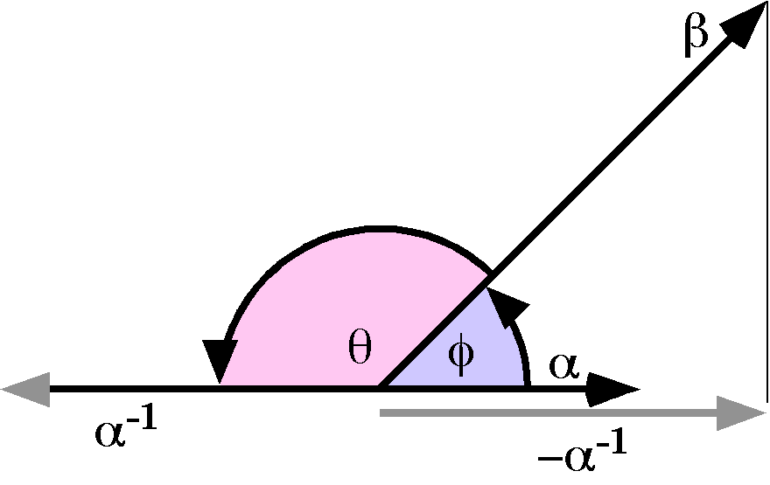
Write the quaternion in the canonical trigonometric form.
$q=T\left[\text{cos}f+\text{sin}f⋅U\right]$´
The angle of the quaternion is θ = π − φ, therefore the angle between α and β vectors is φ and the angle between α⁻¹ and β is θ. The tensor of the quaternion is T.
$$T_{q}^{2}=T_{α^{−1}}^{2}T_{β}^{2}{ÛT}_{α^{−1}}^{2}=\frac{T_{q}^{2}}{T_{β}^{2}}⇒T_{α}^{2}=\frac{T_{β}^{2}}{T_{q}^{2}}$$
Both vectors are in the plane of the quaternion, q. While we do not know what that plane is, we know it exists, therefore we know that the quaternion q can be written as a ratio of vectors.

$$\begin{aligned}K_{q}=S_{q}−V_{q}\text{ and }q=S_{q}+V_{q}\text{, therefore} \\ q+K_{q}=2S_{q}\text{ and }q−K_{q}=2V_{q}\text{.}\end{aligned}$$

Art. 19.
Since a quaternion may be interpreted as the ratio of two vectors. It may be viewed as a transform that rotates vectors in its plane through an angular excursion equal to its angle while lengthening them according to its length.
$$\begin{aligned}q=T\left(\text{cos}q+\text{sin}q⋅U\right), \\ q=\frac{β}{α}⇒β=q∗α\end{aligned}$$
Both α and β are perpendicular to the vector of q, U. They are separated by an angle of θ and β is T times as long as α.

Art. 20.
The multiplication of two quaternion may visualized as follows. Let the quaternions be q and r. choose a vector in the plane of q and in the plane of r, β. The vector β is an intersection between the two quaternion planes. Construct the vector that is rotated into β by q.
$$\begin{aligned}q∗α=β, \\ α^{−1}=β^{−1}∗q, \\ α={\left(β^{−1}∗q\right)}^{−1}\text{.}\end{aligned}$$
Construct the vector that β is rotated into by r.
$$g=r∗β\text{.}$$
Now the ratio of γ to α is the product of rq.
$$\begin{aligned}g=r∗β, \\ β=q∗α, \\ g=r∗q∗α, \\ \text{rq}=g∗α^{−1}=\frac{g}{α}\text{.}\end{aligned}$$

Art. 21.
If the tensors of the quaternions are 1.0, then quaternion products may be interpreted as great circle arcs in a unit spherical surface. Unitary quaternions of this sort are called versors.
If the center of the sphere is O, then a ray from the center to the point A on the sphere is OA. A great circle arc, r, that passes from A to B would carry the vector OA into OB therefore the arc can be characterized as the ratio of OB to OA.
$$U_{r}=\frac{\text{OB}}{\text{OA}}$$
If there is a second arc, q, to the point C, then the combination of the two arcs will be the product of the quaternions.
$$U_{\text{rq}}=\frac{\text{OC}}{\text{OB}}⋅\frac{\text{OB}}{\text{OA}}=\frac{\text{OC}}{\text{OA}}=U_{r}∗U_{q}$$

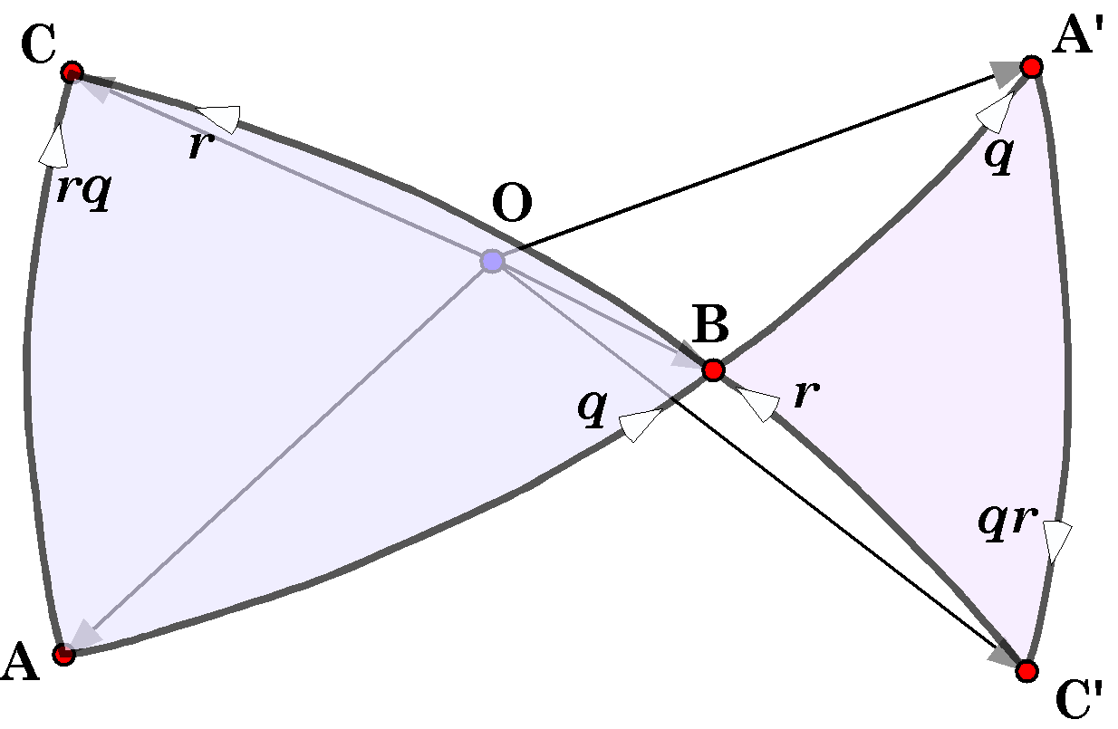

In the following expression, it initially looks like the result should be the same, if we cancel out the OB’s, but if we write out the middle expression, it is clear that cancellation is not possible and we have to choose arcs that have a common point for the terminus for the first arc and the origin of the second arc.
$${{\begin{aligned}U_{\text{qr}}=\frac{\text{OB}}{\text{OA}}⋅\frac{\text{OC}}{\text{OB}}=U_{q}∗U_{r}? \\ U_{\text{qr}}=\text{OB}⋅{\text{OA}}^{−1}⋅\text{OC}⋅{\text{OB}}^{−1} \\ \text{OB}⋅−\text{OA}⋅\text{OC}⋅−\text{OB}¹U_{q}∗U_{r}\text{.} \\ \text{Let }B\text{ be the terminus of arc }r\text{ and the origin of arc }q\text{, } \\ \text{then there are points \{}A\end{aligned}}^{'}\text{ and \{}C}^{'}\text{, such that -}U_{\text{qr}}=\frac{OC^{'}}{\text{OB}}⋅\frac{\text{OB}}{OA^{'}}=\frac{OC^{'}}{OA^{'}}=U_{r}^{−1}∗U_{q}^{−1}=U_{q}∗U_{r}\text{.}$$
In general, $C^{'}A^{'}$will not equal AC, but the triangle ABC will be inversely symmetrical with the triangle $A^{'}BC^{'}$.
The only time that two versors are commutative is if they are coplanar, that is to say only when they are segments of that same great circle. If both AC and $A^{'}C^{'}$ are on the same great circle and B is not coplanar with the great circle, then it must be a pole to the great circle and $A^{'}C^{'}\text{=-}\text{AC}$. Consequently, B must be on the great circle if $A^{'}C^{'}=\text{AC}$.
If we perform a right versor and then do it again, then we are squaring the right versor and the result is –1.
$${\left(\frac{\text{OB}}{\text{OA}}\right)}^{2}=\frac{OA^{'}}{\text{OB}}⋅\frac{\text{OB}}{\text{OA}}=\frac{OA^{'}}{\text{OA}}=\frac{{\text{OA}}^{−1}}{\text{OA}}={\text{OA}}^{−1}⋅−{\text{OA}}^{−1}\text{=-}T^{2}\left({\text{OA}}^{−1}\right)\text{=-}1$$

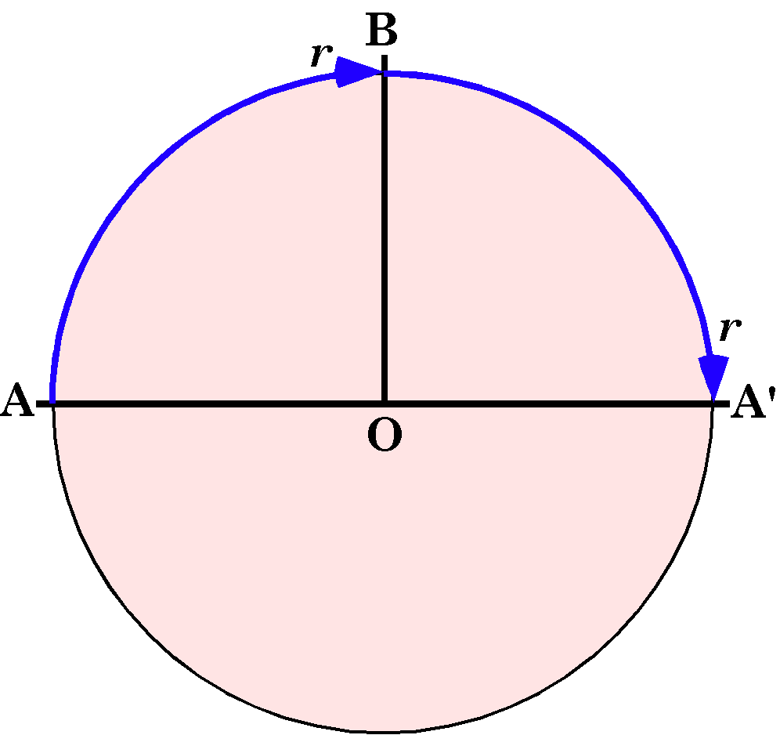
One of the most important relationships of quaternion analysis is the rotation of an arbitrary vector about an axis of rotation. The following develops the concept from the analysis that started this section.

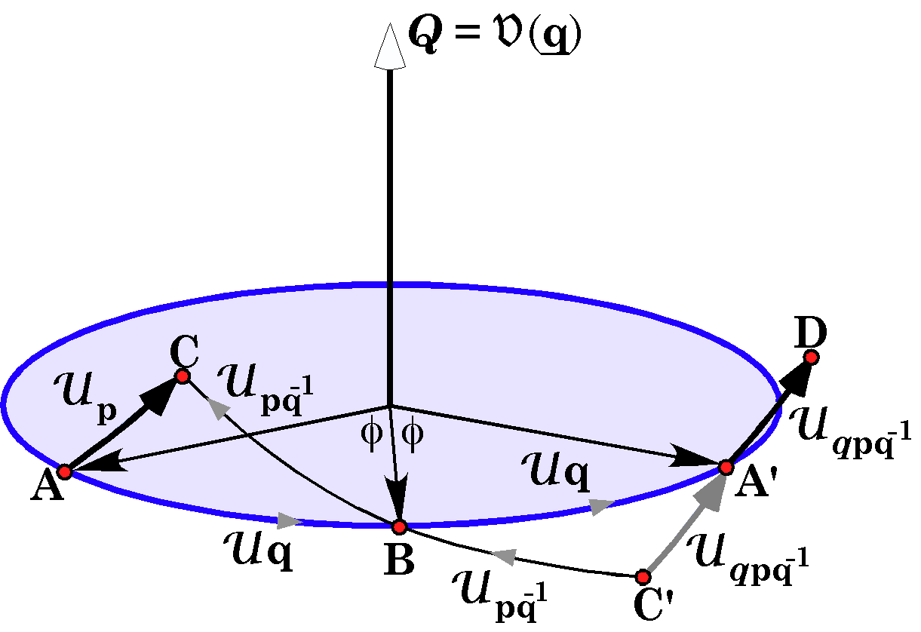
We start with a vector $\text{AC}=U_{p}$. Then we note that it is equivalent to swinging from A to B and then to C. A to B is $q$ and A to C is $p$, therefore A to B to C must be ${\text{pq}}^{−1}$.
$${\text{pq}}^{−1}⋅q=p$$
The arc $C^{'}A^{'}$ may also be written as the excursion form $C^{'}$ to B to$A^{'}$. From $C^{'}$ to B is ${\text{pq}}^{−1}$ and B to $A^{'}$ is q, therefore the excursion $C^{'}A^{'}$ must be ${\text{qpq}}^{−1}$.
$$q∗{\text{pq}}^{−1}={\text{qpq}}^{−1}$$
Since the triangle $A^{'}BC^{'}$ is inversely symmetrical to triangle ABC, it follows that the arc $A^{'}D$ has the same relationship to the great circle as AC, but rotated about Q, through twice its angle, φ. Consequently, we may write down a general formula for obtaining the vector that results when an arbitrary vector, ρ, is rotated about an axis of rotation, $V_{q}$, through twice the angle of the quaternion, $f$, an angle of 2φ.
$$ρ^{'}={qρq}^{−1},\text{where }q=\text{cos}f+\text{sin}f⋅V_{q}\text{.}$$

Art. 22.
We have created a number of functions of quaternions, such a the scalar (S) and vector (V) of the quaternion, the tensor of a quaternion (T), conjugates of quaternions (K) and unit quaternions (U). These can be combined to obtain compound functions. The dual functions are summarized in the following table.

 | S | V | K | T | U
S | S | 0 | S | T | SU
V | 0 | V | -V | 0 | VU
K | S | -V | 1 | T | KU
T | ±S | TV | T | T | 1
U | ±1 | UV | UK | - | U

This ends the introductory chapters of the book. The remaining chapters develop these ideas in a number of directions.

