Structural Ratios:
The comparison of structures and their parts

Thomas Langer

When comparing objects or collections of objects it is commonly found that the ratio of the objects is a useful measure for comparison. In this essay the concept of ratio will be explored as it pertains to structure. First, we will consider the simple ratios that every school child knows, then work our way through increasing generalization of the concept to some very abstract, but elegant and useful structural ratios that provide the basis of a deep analysis of structure.

A ratio is the division of one number by another
Perhaps the simplest ratio is the ratio of integers. One has 12 cookies and 6 children. If 2 cookies are given to each child, then the supply of cookies is exhausted and the children are all treated equally. To solve the problem, we took the ratio of the number of cookies to the number of children. We might solve the problem by giving a cookie to each child, then giving a second cookie to each child. In the second case we took the ratio of the set of cookies to the set of children.

Ratios of integers may be fractions
As is often the case with such concepts, there is a fly in the ointment. If we had 15 cookies, then we would give each child two cookies and find ourselves with extra cookies but not as many as there are children. It is for just such situations that fractions were created. We have enough cookies for 3 out of 6 children or we must divide our 3 cookies into 2 parts and give each child 1/2 of a cookie. In either case there is a fraction of 1/2. We need to give each child 15/6 or 5/2 of a cookie. While very young children have difficulty with fractional objects, most have acquired the operational concept by the time they reach elementary school.

Distance is expressed as ratios to a standard unit
The first generalization of the concept of ratio occurs when we switch from discrete sets of objects to indefinitely subdivisible objects. Length is such a concept. Generally length is expressed as a ratio of a distance to a standard interval. The boy is 6 feet tall means that we could, in principle, take a piece of wood 1 foot long and lay it end to end until we had done so 6 times and the marked off interval would be the same as that from the top of the boy’s head to the ground.
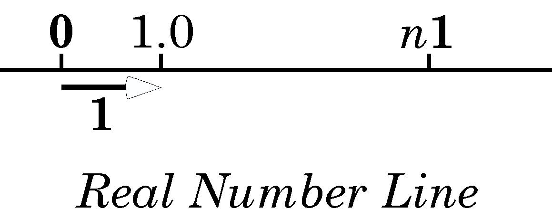
The real numbers, the rational and the irrational numbers, may be put in one to one correspondence with the points of a line. The line is called the real number line.
One rapidly learns that few things are integer numbers of a standard distance. That is why we use rulers that are marked off in standard divisions. We cans say that boy is 6 feet + 2 inches + 3/10 of an inch. Our system for writing numbers is organized so that we can continue indefinitely to smaller and smaller subdivisions. So it is possible to say that light takes 1/299,792,458 of a second to travel 1 meter in a vacuum. To 100 places that is 3.335640951981520495755767144749185117925815198459729096987489925447023754013184681250386892654917957 * 10⁻⁹ seconds and we could go on to 200 or 1,000 decimal places. All numbers that can be expressed as a ratio of two integers are instances of rational numbers. In practice, any distance or time interval can be expressed with arbitrary precision as a ratio to a standard measure.

Not all distances are rational ratios of standard measures
It would appear that one could express any distance as a rational number. Quite unexpectedly it turns out that there are pairs of distances that can not be expressed as a ratio of integers. In fact it is quite easy to find such a pair. If we take a square that is 1 unit long on a side, then the diagonal of that square can not be expressed as a rational number times the length of the side. Since it was considered irrational for such numbers to exist, they were called irrational numbers. To make things worse there are infinitely more irrational numbers than there are rational numbers and there is an infinity of rational numbers. There are a countable infinity of rational numbers, meaning that we could in principle put them in one-to one correspondence with the set of integers. That is, there are as many integers as there are rational numbers, which also should come as a shock. There is an uncountable infinity of irrational numbers, meaning that there is no way that one can find a one-to-one correspondence between the integers and the irrational numbers.

Rational + irrational numbers = real numbers
The rational and irrational numbers can be conceptualized as points on a line. If we include all the rational numbers and irrational numbers, then we have accounted for every point on the line. There is no room for any others. These numbers are called the real numbers and the line is called the real number line. The real number line has a point from which all others are measured (0) and a standard distance with which all other distances are compared, unity or 1. All real numbers are multiples of 1, that is n1.

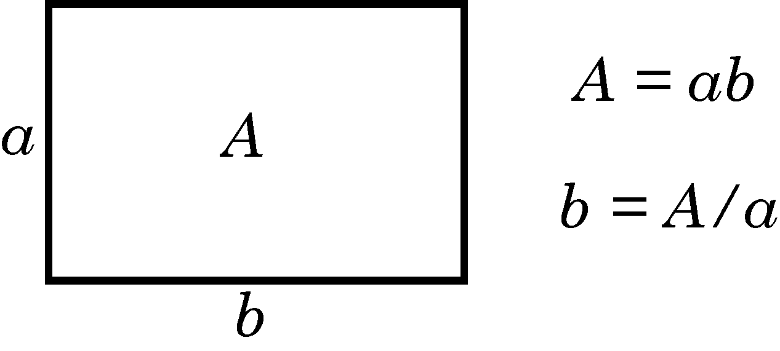
The ratio of a rectangle’s area to a side is its other side

The ratio of a square’s area to its side is its side
The area of a rectangle, A, is the product of its sides, $\text{ab}=A$. Therefore, the ratio of the rectangle’s area to the length of one side of the rectangle, $A/a$, is the other side, orthogonal, side of the rectangle, b. When the rectangle is a square, the ratio of its area to a side is the side, because all of the sides are equal. We call the ratio of a square’s area to its side, its square root. It turns out that for squares with integer areas, generally the square root is an irrational number.

Squares with negative areas
We have considered a number of situations in which a reasonable, ordinary, problem led to strange consequences. At this point we need to consider a problem that seems ridiculous, but turns out to have quite reasonable and useful consequences. Consider a square that has a negative area. Such a thing is counter-intuitive, but there are many real world problems in which the solution depends upon finding the side of a square with negative area. The simplest is solving the equation
$$x^{2}\text{=-}1\text{.}$$
The product of two positive numbers is a positive number and the product of two negative numbers is a positive number, so there is apparently no number that will give a negative number when multiplied by itself. Yet there are problems that derive from real physical situations in which the solution involves a multiple of the square root of –1. It turns out that if we allow that such numbers exist and that they can be expressed as ni, where n is a real number and i is equal to the square root of negative one, then we can express many relationships that are useful models of the real world. Such numbers were called the imaginary numbers, because they did not seem real, like the real numbers. It turns they are just as real as the real numbers, but the name has stuck.
If the real number line is full with the real numbers, where do we put the imaginary numbers. Since the n part of ni is a real number, the imaginary numbers can also be conceptualized as points on a line, much like the real number line. The number 0 is both an imaginary number and a real number, therefore it must lie on both lines. That is, the real number line and the imaginary number line intersect at 0. It is logical to make the two lines mutually orthogonal, that is perpendicular to each other, and straight. However, when we do that, it becomes apparent that there are a great many other possible numbers that are the combination of a real number and an imaginary number. Such numbers are called complex numbers and they are written as a1 + bi, where a and b are real numbers and i is the square root of minus one. It is common practice to suppress the 1.
$$a+bi=a+b∗\sqrt{−1}$$

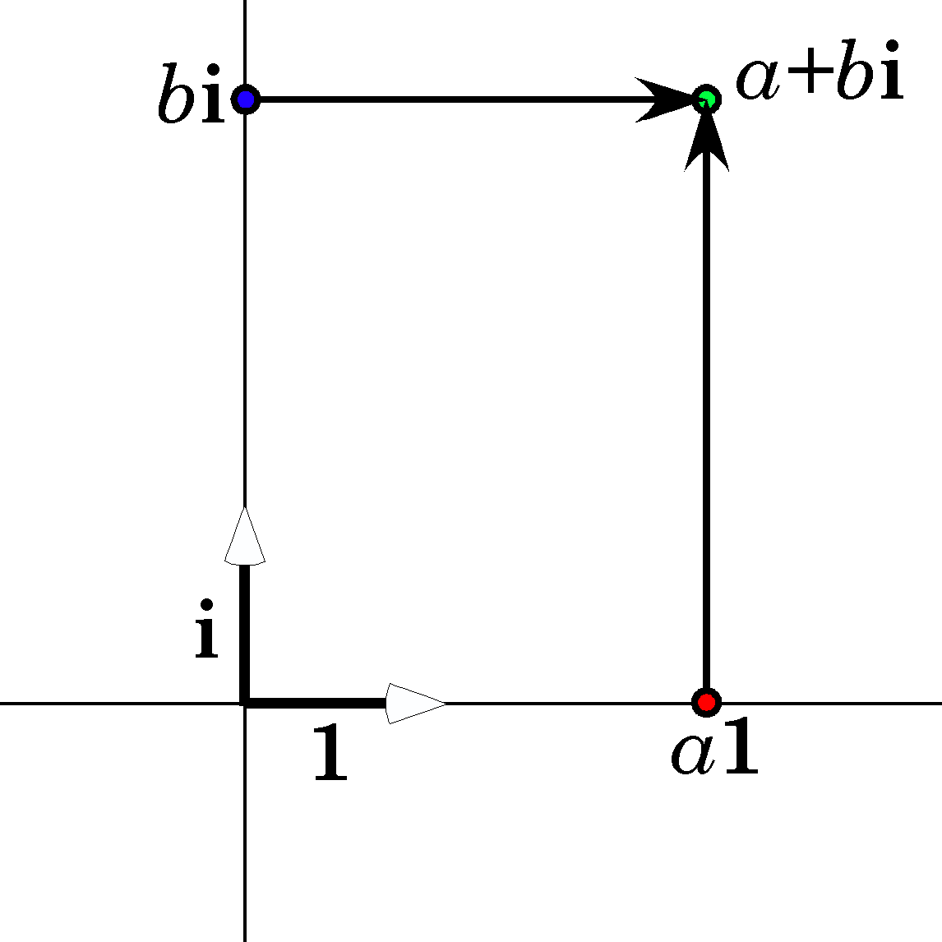
Complex numbers are a combination of a real number and an imaginary number.
Complex numbers are represented as points in the plane defined by the real and imaginary number lines. The complex number a + bi is located by moving out a units on the real number line and then b units parallel to the imaginary number line or b units up the imaginary number line and a units parallel to the real number line. The result is the same either way. Complex numbers add by adding the real parts together and the imaginary parts together.
$$\left(a_{1}+b_{1}i\right)+\left(a_{2}+b_{2}i\right)=\left(a_{1}+a_{2}\right)+\left(b_{1}+b_{2}\right)∗i\text{.}$$
Multiplication is algebraic, except for remembering that the square of i is –1.
$$\begin{aligned}\left(a_{1}+b_{1}i\right)∗\left(a_{2}+b_{2}i\right)=a_{1}a_{2}+a_{1}b_{2}i+a_{2}b_{1}i+b_{1}b_{2}i^{2} \\ \left(a_{1}a_{2}−b_{1}b_{2}\right)+\left(a_{1}b_{2}+a_{2}b_{1}\right)i\text{.}\end{aligned}$$
While this is a correct and often useful, way of expressing the multiplication of complex numbers, there is an alternative formulation that gives a better sense of what is occurring when two complex numbers are multiplied. Note that a complex number, a + bi, is equally well described by specifying the angle between the positive real axis and the line segment from the origin (0, 0) to the point that represents the number and the length of the line segment. The conversion between formats is very straightforward.
$$\begin{aligned}z=a+biÛz=r\left(\text{cos}q+i\text{sin}q\right)\text{, where} \\ r=\sqrt{a^{2}+b^{2}}\text{ and }q\text{=arctan}\left(\frac{b}{a}\right),\text{ or} \\ \text{a=r}∗\text{cos}q\text{ and }\text{b=r}∗\text{sin}q\text{.}\end{aligned}$$

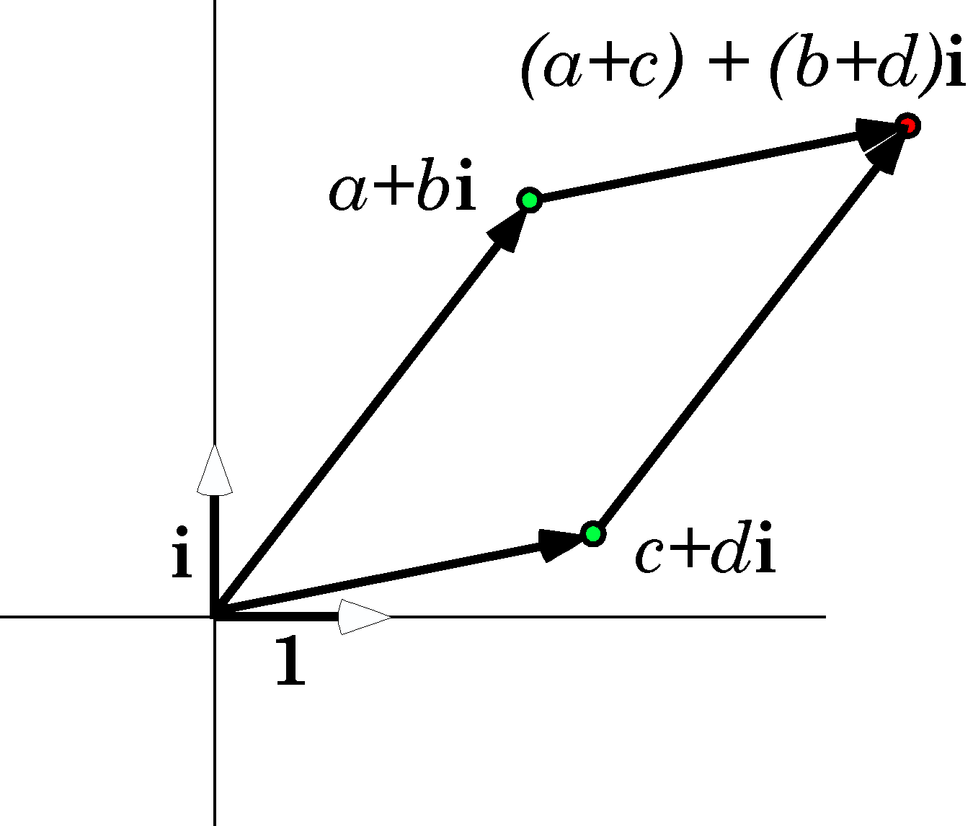Complex numbers add by the parallelogram rule.
We can express multiplication in the trigonometric form as follows.
$$z_{1}∗z_{2}=r_{1}r_{2}\left[\text{cos}\left(q_{1}+q_{2}\right)+i\text{sin}\left(q_{1}+q_{2}\right)\right]$$
The product of two complex numbers is the product of the lengths of their rays and the sum of their angles.

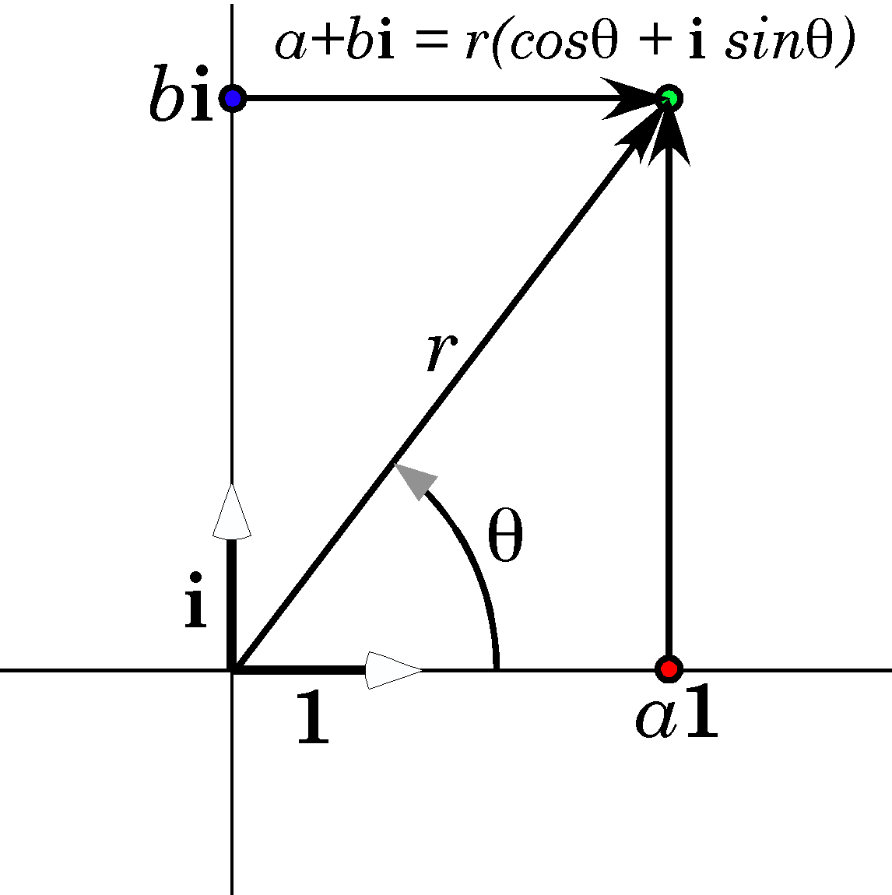
Complex numbers may be expressed in rectilinear and trigonometric forms.
The magnitude or norm of a complex number is the length of its ray, r. Therefore, if one of the complex numbers has a magnitude of 1.0, then the effect of multiplying it times another complex number is the rotate the second complex number through the angle of the unitary complex number.
$$\begin{aligned}\text{If }ρ\text{=1}\text{.}0\left(\text{cos}f+i\text{sin}f\right)\text{ and }z=r\left(\text{cos}q+i\text{sin}q\right), \\ \text{then }ρ∗z=r\left[\text{cos}\left(q+f\right)+i\text{sin}\left(q+f\right)\right]\text{.}\end{aligned}$$
By this means we have constructed a means of rotating a vector z in a plane.
Notice that it makes sense to divide a complex number by another complex number and there is a unique solution.
$$\frac{z_{2}}{z_{1}}=\frac{r_{2}}{r_{1}}\left[\text{cos}\left(q_{2}−q_{1}\right)+i∗\text{sin}\left(q_{2}−q_{1}\right)\right]\text{.}$$

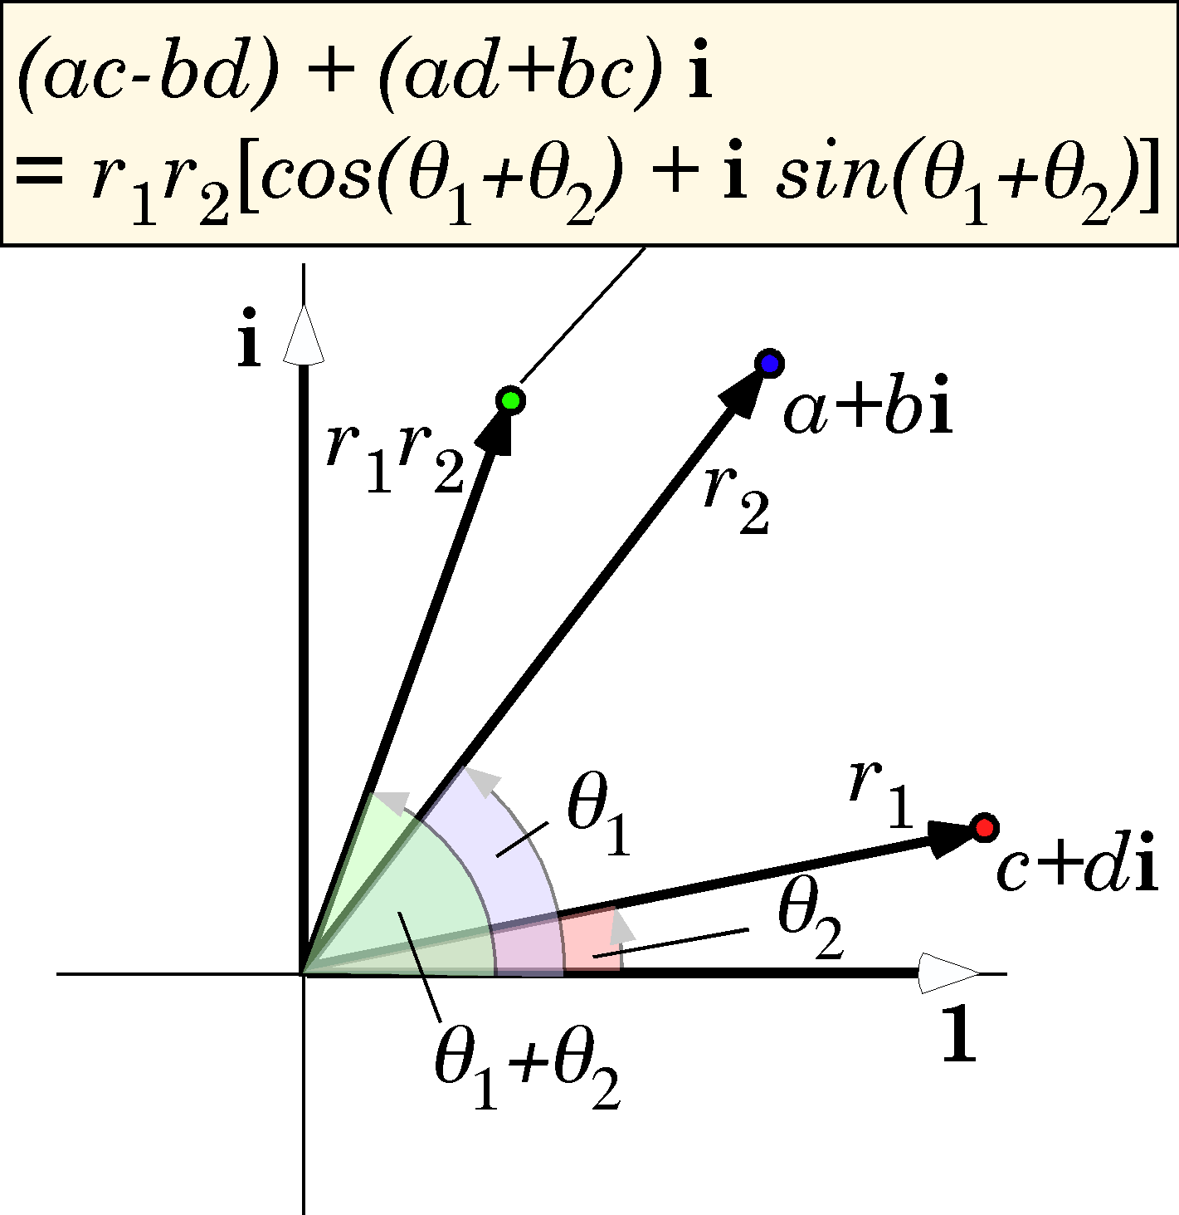The product of two complex numbers is the product of the lengths of their rays and the sum of their angles.
This is not the case in vector analysis. In vector analysis, we are dealing with vectors in three dimensions. There are two ways to multiply vectors: scalar multiplication and vector multiplication. In scalar multiplication, the product is a real number or scalar.
$$\begin{aligned}\text{If }v_{1}=a_{1}x+b_{1}y+c_{1}z\text{ and }v_{2}=a_{2}x+b_{2}y+c_{2}z\text{, then } \\ v_{1}{ov}_{2}=r_{1}r_{2}\text{cos}f,\text{ where }f\text{ is the angle between the vectors and} \\ r_{1}r_{2}=\left|r_{1}\right|∗\left|r_{2}\right|=a_{1}a_{2}+b_{1}b_{2}+c_{1}c_{2}\text{.}\end{aligned}$$
If the angle between the vectors is a right angle, then the scalar or dot product is 0.0, if the angle is 0.0, then the scalar product is the product of the lengths of the vectors. In general, the dot product or scalar product is the product of the lengths of the vectors times the cosine of the angle between them. Scalar products turn up in physics in the description of work as the dot product of a force and the distance that it operates over.
$$W=For$$

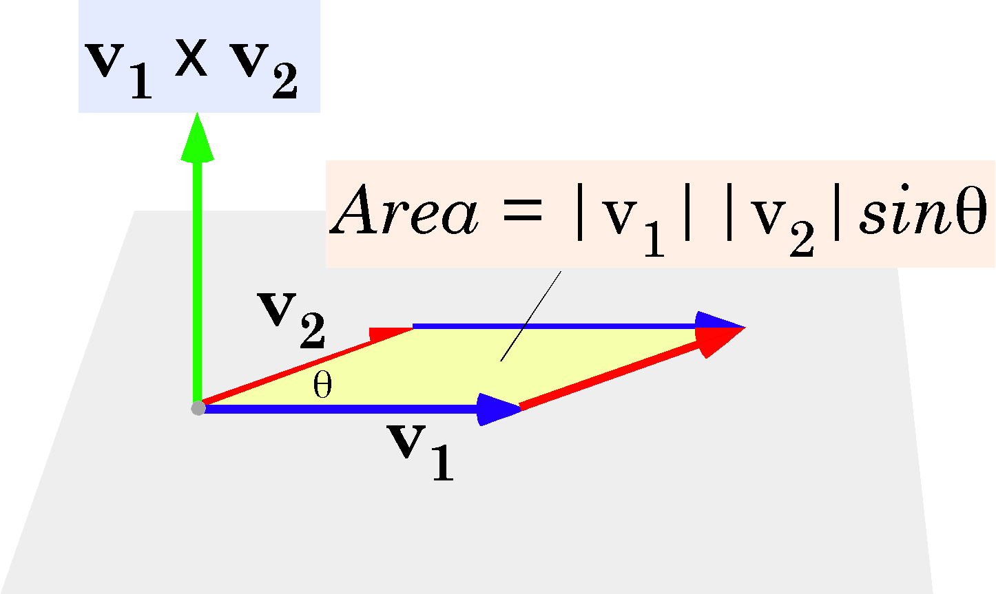The vector or cross product of two vectors is a vector perpendicular to the plane of the multiplied vectors with a length proportional to the area of the parallelogram formed by the two vectors.
The vector or cross product is a vector that is perpendicular to the plane of the two vectors and which has a length that is equal to the product of the their lengths times the sine of the angle between them. In other terms, the cross-product is the area in the parallelogram formed by the two vectors, projected perpendicular to the plane of the vectors.

$$\begin{aligned}v_{1}´v_{2}=r_{1}r_{2}\text{sin}f∗u_{\text{12}},\text{where }f\text{ is the angle between the two vectors, the length of a vector, } \\ v_{n}{\text{, is r}}_{n}=\left|v_{n}\right|\text{ ,}\text{and }u_{\text{12}}\text{ is the unit vector perpendicular to the plane determined by the two } \\ \text{vectors, }(v_{1}\text{ and}{\text{ v}}_{2})\text{,that is, in the direction of the thumb of the right hand when its fingers curl } \\ \text{from }v_{1}\text{ to }v_{2}\text{.}\end{aligned}$$
Cross products are used to model torques or moments, T, where a vector force, F, acts at a distance, r, from the center of rotation to cause rotation, $T=r´F$. The direction of the vector T specifies the plane in which the rotation occurs and the magnitude of T is proportional to the momentum of the rotation.
While both types of vector multiplication have uses in the modeling of forces, neither of these types of multiplication can be inverted to give a division that yields a unique solution. This consistent with their use to model forces since, given a resultant work or torque, there is no way to know which forces generated it, even if you know one of the components.

The ratio of two vectors is a quaternion
The excursion into complex numbers is a bit of a side path, but it gave us a system in which it made sense to divide vectors and it illustrates one way rotation may be modeled. There turns out to be a generalization of complex numbers that applies to vectors in three-dimensional space, called quaternions, because they have four parts. In quaternion analysis it also makes sense to divide vectors and doing so gives a unique solution. It turns out that the ratio of vectors is a very powerful concept in understanding structure and movement.

A quaternion is the ratio of two vectors. The vectors v₁ and v₂ define a plane, which will be called the plane of the quaternion, indicated by the red glass disc. The plane is expressed by the vector that is perpendicular to it, here indicated by the gold vector, Q, called the vector of the quaternion. The length of the vector of the quaternion is the tensor of the quaternion and it is proportional to the ratio of the lengths of the vectors. The angle of the quaternion is the angle between the two vectors.
Although vector analysis is a subset of quaternion analysis, in simplifying quaternion analysis the ability to divide vectors by vectors was lost. A similar loss of power occurs in real analysis relative to complex analysis. Often there is a trade-off between power and difficulty and, while quaternion analysis is more difficult, it does have more power than vector analysis. Having said that, quaternion analysis is not that difficult at the fundamental level.
We will approach quaternions through vectors. A vector will initially be assumed to be a directed magnitude in three-dimensional space. We will find that vectors are more complex objects in quaternion analysis, than they are in vector analysis. Vectors will be expressed as the sum of three components, like the traditional {x, y, z}, but in terms of the three orthogonal vector components {i, j, k}. So a vector might be written in the following format.

$$\begin{aligned}v=ai+bj+ck\text{, where }a\text{, }b\text{, and }c\text{ are real numbers } \\ \text{and }i\text{, }j\text{, and }k\text{ are orthogonal unit vectors}\text{.}\end{aligned}$$
If one has two vectors, $v_{1}$ and$v_{2}$, does it make sense to speak of the ratio of $v_{2}$ to $v_{1}$? If so, what could be meant by such a ratio? One solution is to move the two vectors so that they have a common origin, which is permitted because vectors do not have locality, and then note that the two vectors define a plane. In order to transform $v_{1}$ into $v_{2}$ it is necessary to rotate $v_{1}$ about an axis perpendicular to the plane that contains the vectors. The plane that contains the vectors will be called the plane of the quaternion. The vector that is perpendicular to the plane of the quaternion, $v_{1,2}$, is called the vector of the quaternion. The rotation has an angular excursion, θ called the angle of the quaternion. Finally, if the two vectors are of different lengths, there must be a multiplicative factor equal to their ratio,$T=\left|v_{2}\right|/\left|v_{1}\right|$, called the tensor of the quaternion. So a transformation that turns $v_{1}$into $v_{2}$might involve these three variables.
$$v_{2}=Q\left[v_{1,2},q,T\right]∗v_{1}$$
It turns out that the transformation may be effected if the transform takes a form similar to a complex number. The key is how the basis vectors multiply. A vector is written as a sum of three orthogonal vectors that are multiples of the basis vectors.
$v_{1}=b_{1}i+c_{1}j+d_{1}k$ .

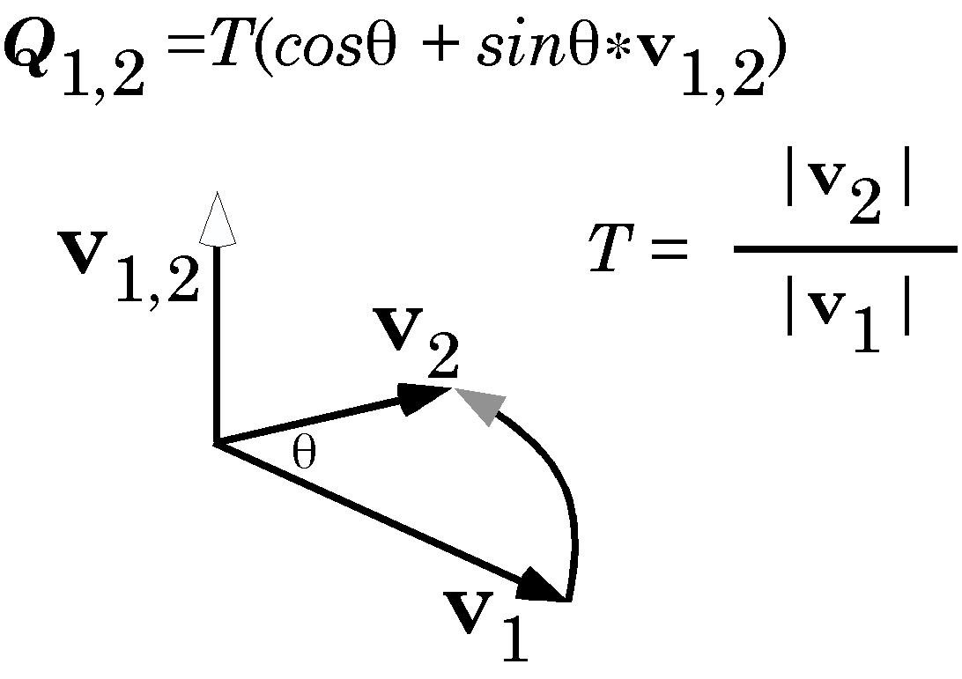
A quaternion may be viewed as the ratio of two vectors. As such it must indicate the plane in which they lie, the angular excursion between them, and their relative magnitudes.
The transform is written as the sum of a scalar and a vector.
$$Q=T\left(\text{cos}q+\text{sin}q∗v_{1,2}\right)=a_{1,2}+b_{1,2}i+c_{1,2}j+d_{1,2}k$$
When written in the trigonometric form, it is assumed that the vector of the quaternion, $v_{1,2}$, is a unit vector.
The power of this formulation occurs in the multiplication of the basis vectors. They are treated as three different imaginary numbers. This is embedded in the rules for their multiplication.
$$\begin{aligned}i∗j=kj∗k=ik∗i=j \\ j∗i\text{=-}kk∗j\text{=-}1i∗k\text{=-}j \\ i∗i=j∗j=k∗k\text{=-}1\end{aligned}$$
The last line indicates that all three unit vectors are imaginary numbers in that they are square roots of –1. The first two lines indicate that they are different imaginary numbers in that the product of any two is the third. The middle line shows that the order of multiplication is important. Reversing the order reverses the sign of the result. In brief, multiplication is not commutative.
The results of the order of multiplication may be remembered with a simple diagram. Going clockwise around the circle, the product is positive, and going counter-clockwise, the product is negative.
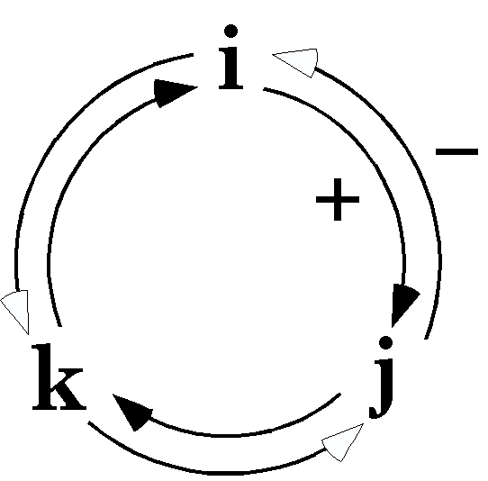
The following formula is a very compact version of the rules for multiplying the basis vectors.
$$i^{2}=j^{2}=k^{2}=\text{ijk}\text{=-}1\text{.}$$
It may help to see how such a transformation might occur. Consider a vector aligned with the j axis that has a length of 2 and it is rotated about the i axis through 90° of rotation and made twice as long. The vector of the quaternion is i, the angular excursion is 90°, and the tensor of the quaternion is 2.0. The rotation quaternion may be written down from this information.
$$R=2\left(\text{cos}\frac{p}{2}+\text{sin}\frac{p}{2}\left(1i+0j+0k\right)\right)=2\left(0+1\text{.}0\left(i\right)\right)=2i$$
The product is then straight-forward.
$$v_{2}=R∗v_{1}=2i∗2j=4k$$
The answer is deliberately trivial, namely a vector of length 4, aligned with the k axis. One can write down the result of the transformation by inspection. However, when the transformed vector is arbitrary and the axis of rotation is also arbitrary, the consequence of the rotation may be far from obvious. Tat is when quaternions prove themselves.
This analysis has demonstrated a remarkable relationship. If s and t are any two vectors, then there exists a number R, that is their ratio.
$$t=R∗sÛR=\frac{t}{s}\text{.}$$
This brings us to one of the most important concepts in this analysis of structure, the ratio of two vectors is a quaternion.
There is an ambiguity in the last expression. Since $\frac{t}{s}$ may be interpreted as $t∗s^{−1}$ or $s^{−1}∗t$ and $t∗s^{−1}$is different from $s^{−1}∗t$, we have to settle on a convention for how to interpret a ratio when it is written as a fraction. Either interpretation will be satisfactory as long as one is consistent. In this essay, the first interpretation, that the denominator follows the numerator, is the interpretation used.

A quaternion is the sum of a scalar and a vector
A quaternion is a strange number in that it is the sum of a scalar and vector, but it is not unlike a complex number. In complex numbers, the number was the sum of two different types of number a real number and an imaginary number. The imaginary number is written as b*i meaning a scalar, b, which is a real number is multiplied by the unit of measure along the imaginary number line, i. The real component is also a product, like the imaginary number. The real component should be written as a*1, where 1 is the unit of measure along the real number line. It is common practice to suppress the 1, but it is there. Similarly, a quaternion may be written as the sum of four types of numbers.
$$Q=a1+bi+cj+dk\text{.}$$
The first component operates differently from the other three in that the product of 1 and any of the other numbers is the number. Thus we should add the following line to the listing of products given above.
$$1∗1=11∗i=i∗1=i1∗j=j∗1=j\text{1*k}=k∗1=k\text{.}$$
Because the first term acts so differently from the last three terms it is considered different and called a scalar, whereas the last three terms are collectively a vector. Much the same thing happens when considering space-time. Time is handled differently than space, even though they are both components of the same entity. The last three terms in a quaternion act like a vector, so vectors are a subset of quaternions. However, note that the product of two vectors in quaternion analysis is different from the products in vector analysis. In fact, it is the sum of the two types of vector products in vector analysis.
$$\begin{aligned}s∗t=\left(bi+cj+dk\right)∗\left(fi+gj+hk\right) \\ =\text{bf}i^{2}+\text{bg}\text{ij}+\text{bh}\text{ik}+\text{cf}\text{ji}+\text{cg}j^{2}+\text{ch}\text{jk}+\text{df}\text{ki}+\text{dg}\text{kj}+\text{dh}k^{2} \\ \text{=-}\text{bf}1+\text{bg}k−\text{bh}j−\text{cf}k−\text{cg}1+\text{ch}i+\text{df}j−\text{dg}i−\text{dh}1 \\ \text{=-}\left(\text{bf}+\text{cg}+\text{dh}\right)1+\left[\left(\text{ch}−\text{dg}\right)i+\left(\text{df}−\text{bh}\right)j+\left(\text{bg}−\text{cf}\right)k\right] \\ \text{=-}sot+s´t\end{aligned}$$
The product of two vectors is a quaternion. This follows from the fact that a quaternion is the ratio of two vectors.
This brings us to an interesting point. In the last section, the expression $s^{−1}$ appeared as if it was obvious what was meant. We are now in a position to say what that term means. What was obviously implied was that there was a vector, $s^{−1}$, that when multiplied by s would give the identity 1.
$$s∗s^{−1}=1\text{.}$$
The expression for vector products that we just wrote out says that if t is the inverse of s, then their cross product must be equal to 0.0 and their dot product must be equal to -1.0.
$$\sqrt{b^{2}+c^{2}+d^{2}}=T\left(s\right)$$
Therefore, the dot product is equal to –1.0, if and only if the following holds.
$$f=\frac{−b}{T{\left(s\right)}^{2}};g=\frac{−c}{T{\left(s\right)}^{2}};h=\frac{−d}{T{\left(s\right)}^{2}}$$
Consequently, the inverse of s is a vector with the opposite direction and a magnitude equal to the inverse of the tensor.
$$s^{−1}=\frac{−s}{T{\left(s\right)}^{2}}\text{.}$$
Another point to take from the basic relation, $t=R∗s$, is that a quaternion acting on a vector produces another vector. A vector is a quaternion in which the scalar is 0.0. It may be seen as the perpendicular to a plane that is defined by two vectors at right angles to each other. It is in effect a set of orthogonal vectors that define a space that is a plane and the vector perpendicular to it. In this sense, a quaternion vector is different than a standard vector, as is used in vector analysis. This may be seen in a simple thought experiment.

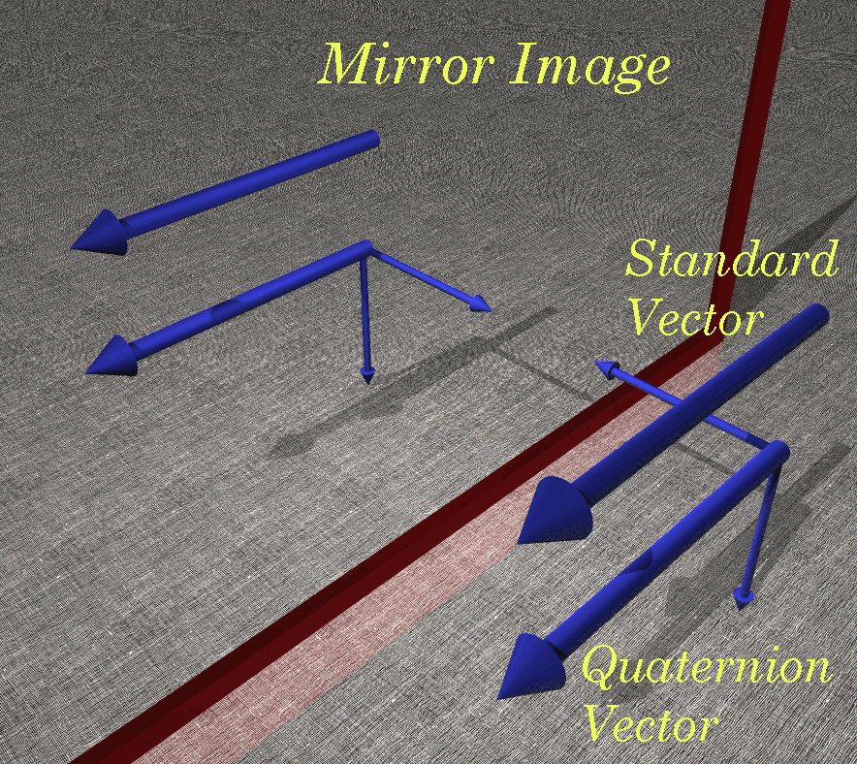
The vectors of quaternion analysis differ in subtle ways from those of vector analysis. The standard vector of vector analysis is a directed magnitude and therefore is not changed by translation or reflection in a plane parallel with its axis. Vectors in quaternion analysis look the same, but actually also carry an orientation with them so that reflection in a mirror parallel with their axis will change their rotational sense. The smaller vectors attached to the quaternion vector are not actually present. They are used here to indicate the rotational sense of the vector. Any two mutually orthogonal vectors in the same plane would be equally appropriate.
Imagine a vector of each type lying in front of a mirror that is parallel to their axis. The reflection of a standard vector will be equivalent to the original vector. They differ only by a translation. The reflection of a quaternion vector is not the same as the original vector. It has the opposite sense of rotation. It points in the same direction, but it is left-handed, if the original vector was right-handed.
In a formal sense, the quaternion vector and its reflection are like right and left gloves. You can turn a right hand glove into a left hand glove by turning it inside-out, which is equivalent to reflecting it in a mirror, but short of doing so, there is no way to make the right hand glove fit the left hand. Interestingly, the commercial solution to this situation is to eliminate the dorsal/ventral axis of the glove. Latex examination gloves are made flat, so that either hand can be gloved. However, as anyone who has used such gloves knows, the solution, while acceptable, is not very good for either hand.
The standard vectors are used to model forces and quaternion vectors are like those used to model torques. It is appropriate that quaternion vectors should be used to model torque, because torque is actually defined in a plane, the vector of a torque or moment indicates the orientation of the plane in which the force tends to rotate a set of points. Although we commonly use torque as if it were a force, it is not a force and the difference is fundamental.

Unit vectors are formally equivalent to the planes to which they are perpendicular
Given a vector, it is possible to compute the plane that is perpendicular to it and vice versa. For any vector, S, one can compute the direction of the vector, which is the unit vector in the same direction.
$$\bar{S}=\frac{S}{\left|S\right|}\text{.}$$
We can compute the horizontal vector of the plane, $\bar{H}$, by noting that it is the vector of the quaternion that turns $\bar{S}$into the vertical axis of the coordinate system, k. For reasons that will become apparent as we proceed, the actual calculation will be the quaternion that turns k into $\bar{S}$.
$$H=\frac{\bar{S}}{k}⇒\bar{H}\text{ is the vector of the quaternion }H\text{.}$$
The other vector that will be computed is the line of steepest ascent in the plane, $\bar{F}$. It is perpendicular to the horizontal vector of the plane, which is, by definition, in the direction of the line of minimal change in altitude. There are at least three ways to compute $\bar{F}$. One may note that the line of steepest ascent is obtained by rotating the horizontal vector about the vector of the plane through an angular excursion of 90°.
$$\bar{F}=\bar{S}\left(\frac{p}{2}\right)∗\bar{H},\text{ where \{}\bar{S}\left(\frac{p}{2}\right)\text{ is a rotation of }\frac{p}{2}\text{radians about the unit vector of }S\text{.}$$
Alternatively, one might note that the line of steepest ascent is the vector that results if one rotates the perpendicular to the plane 90° about the horizontal vector in the direction of the vertical of the coordinate system.
$${\bar{F}={\bar{H}}^{−1}\left(\frac{p}{2}\right)∗\bar{S}\text{, where \{}\bar{H}}^{−1}=\frac{k}{\bar{S}}\text{.}$$
Finally, one might note that the vector of steepest ascent is perpendicular to both $\bar{S}$ and $\bar{H}$, therefore it is the ratio of those two unit vectors.
$$\bar{F}=\frac{\bar{H}}{\bar{S}}\text{.}$$
This process of finding two mutually orthogonal vectors in the plane of a quaternion vector will be called framing the vector. What is being done is to erect an orientable framework that has a particular handedness so that it codes for the orientation of the plane. The frame is the set of three unit vectors$\left\{\bar{S},\bar{H},\bar{F}\right\}$. In this case the vectors are the perpendicular to the plane, the horizontal vector of the plane, and the vector of steepest ascent in the plane. Any three mutually perpendicular vectors that are associated with the plane would work equally well, but these are fairly intuitive and easy to compute.

The ratio of two planes is their intersection
The formal equivalence between planes and their vectors, leads to an elegant result that seems very strange when stated like this sections heading, but which is true. If we have two planes that are not parallel, then they must intersect, sometimes we need to know what the intersection is. Clearly it is a straight line so it may be represented by a vector. The vector of each plane is perpendicular to the plane, so, if we bring the vectors together at the intersection, then the vectors must stand to each other as the planes stand to each other. The line of intersection is an element of both planes, therefore, it must be perpendicular to each of the planar vectors. The orthogonal to the line of intersection and the plane’s vector will also stand in the same relation as that between the planes. Consequently, the ratio of the planes’ vectors will be a quaternion that has its vector aligned with the line of intersection and its angle equal to the angle between the planes. This means that the quaternion is the intersection of the planes.
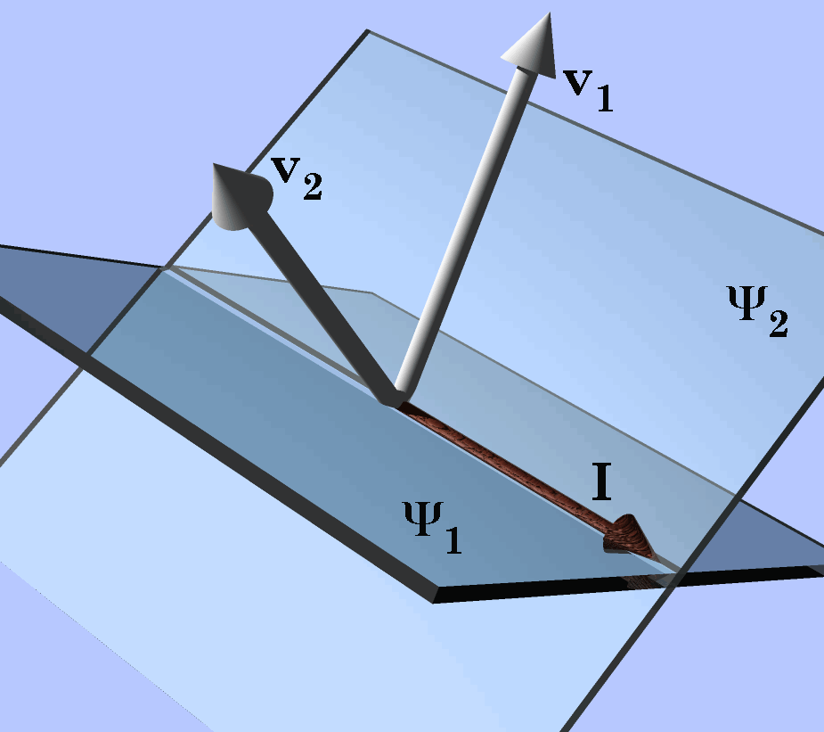
The ratio of two planes is the ratio of their vectors, their intersection. The planes ₁ and ₂ are shown with the vectors of their quaternions, v₁ and v₂, respectively. The ratio of the planes is equivalent to the ratio of their vectors, which the intersection of the planes,.
Note that the intersection is a richer concept than the line of intersection that we started out with. It is a direction, the direction of the line of intersection, and the direction depends on which plane is turned into the other. It is the angular excursion of that rotation. It is possible for it to have magnitude other than 1.0, if there is a difference in the scale of the two planes.
Parallel planes do not intersect and their ratio is a scalar. If they have the same sense, then the scalar is positive, if they have opposite sense then the scalar is negative. When a rotation quaternion is a scalar, it means that there is not a unique axis of rotation that will produce the transformation.

Most rotations are conical rotations
Up to this point all rotations have involved vectors in a plane perpendicular to the axis of rotation. However, many, if not most rotations of vector quantities occur about axes that lie at an angle to the vector, such that the vector sweeps out a conical surface. This brings up the question of whether there is a similar relationship for such arrangements.
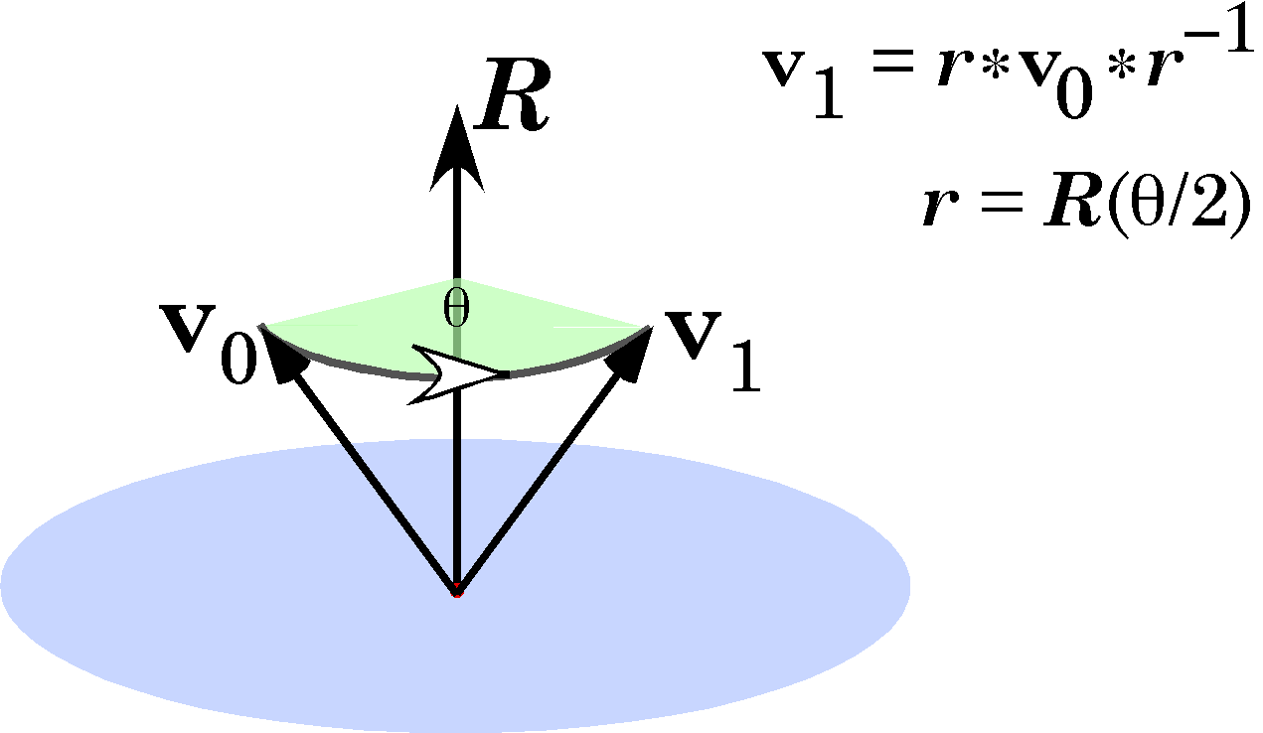
Conical rotation occurs when the vector does not rotate in the plane of the quaternion. The expression for the transformation is slightly more complex.
There is and it is only slightly more complex that the basic rule for rotation in a plane. If the vector that is being rotated is v and the quaternion that describes the rotation is R, then the new vector is given by the following expression.
$$v^{'}=R∗v∗R^{−1}\text{.}$$
There is one quirk that has to be dealt with. If the angle of the quaternion is θ, then the new vector, v’, is the result of rotating v through 2θ of angular excursion. Therefore, we want to use the quaternion R with its angular excursion set to θ/2. To designate such half-angle quaternions, it will common to write the equation as follow.
$$v^{'}=r∗v∗r^{−1},\text{ where }r=R\left(\frac{q}{2}\right)\text{.}$$
When it is not known that the vector that is being rotated is perpendicular to the vector of the rotation quaternion, it is wise to use this form of quaternion rotation. You will be able to tell that the rotation is conical if the result of using the planar rotation formulation yields a quaternion with a non-zero scalar.
$$\begin{aligned}{\text{If }R∗v\text{ gives a \{}v}^{'}\text{ with scalar components }¹\text{ 0}\text{.}\text{0, }\end{aligned}{\text{then the rotation is conical and you must use \{}v}^{'}=r∗v∗r^{\text{-1}\text{.}}\text{.}$$
When rotating arbitrary vectors, always use conical rotation.
Conical rotation is a very powerful concept when dealing with rotation of structures in space. Since structures can be expressed as arrays of vectors, one can rotate a structure by applying the same rotation to all the component vectors.

Orientation is a fundamental property of orientable objects
When one has computed a frame for a vector and its plane, it is possible to specify the orientation of the plane in an unambiguous manner that lends itself to computation. We will use this concept more generally to specify the orientation of objects such as bones that are allowed to move in space by rotation, translation, or a combination of both types of movement.
Most parts of the body are orientable in the sense that we can determine how they sit in space and how they are moved by rotations and translations. For instance, one can tell a right hand from a left hand, because they have definite dorsal and ventral surfaces, a finger end and a wrist end, and a thumb side and pinkie side. Consequently, it is straight-forward to attach a frame, $\left\{\text{r,}\text{s,}t\right\}$, to a hand. One might set the r axis to point down the axis of the middle digit, the s axis to point in the direction of the thumb, and the t axis to point in the dorsal direction. These coordinate systems are called frames of reference because they allow us to reference the orientation of the object to a universal coordinate system {i, j, k}. Having attached such a frame of reference to the hand, one can write expressions that model the movements of the hand as rotation quaternions acting upon its frame of reference.
When we speak of attaching the frame of reference, we mean to associate it with the object. Since orientation is not localized, there is no attachment in the physical sense, but it often helps to visualize the frame of reference as a small frame attached to a part of the object and traveling with it. Note that the frame of reference for the right hand has been set up to be a right-handed coordinate system and the frame of reference for the left hand is a left-handed coordinate system.
When the three orthogonal vectors of the frame of reference for an object are multiplied by a quaternion, they are all rotated in the same manner about an axis of rotation that is aligned with the vector of the quaternion. The result of the rotation can be referred back to the new orientation of the hand by reversing the associations that were made when creating the frame of reference.
Consider a very simple example of the use of orientation to characterize rotations of an orientable object. If we take the associations for the hand given above and start with the hand oriented so that the r axis is aligned with the i axis, the s axis with the j axis, and the t axis with the k axis, then the orientation of the hand can be written as an array.
$$\left[\begin{matrix}r \\ s \\ t\end{matrix}\right]=\left[\begin{matrix}i \\ j \\ k\end{matrix}\right]$$
If the rotation is 90° about the i axis, then the new orientation can be computed. It is necessary to use the equation for conical rotation when transforming orientation frames of reference, because at least one of the axes must be at an angle other than 90° to the axis of rotation. Since the angular excursion is 90°, the half angle is 45° and the sine and cosine are both $1/\sqrt{2}$. The rotation quaternion is a unit quaternion (T = 0.0), since we do not want to change the length of the vectors.
$$\begin{aligned}\left[\begin{matrix}r^{'} \\ s^{'} \\ t^{'}\end{matrix}\right]=\left(\frac{1}{\sqrt{2}}+\frac{i}{\sqrt{2}}\right)∗\left[\begin{matrix}i \\ j \\ k\end{matrix}\right]∗\left(\frac{1}{\sqrt{2}}−\frac{i}{\sqrt{2}}\right) \\ =\left[\begin{matrix}\frac{i}{\sqrt{2}}−\frac{1}{\sqrt{2}} \\ \frac{j}{\sqrt{2}}+\frac{k}{\sqrt{2}} \\ \frac{k}{\sqrt{2}}−\frac{j}{\sqrt{2}}\end{matrix}\right]∗\left(\frac{1}{\sqrt{2}}−\frac{i}{\sqrt{2}}\right) \\ =\left[\begin{matrix}i \\ k \\ −j\end{matrix}\right]\end{aligned}$$
If i was ventral, j was to the left, and k was rostral, then the hand started out palm down. After 90° rotation about an dorsal-ventral axis, it ended with the thumb up and the palmar surface facing medially. Again, the calculation is very simple to allow the results to be checked by visualization. Quaternion analysis becomes indispensable when the orientation, the axis of rotation, and/or angular excursion are arbitrary.

The ratio of two frames of reference is a quaternion in a conical rotation operator.
It is relatively common to have the orientation of an orientable object in two stages of a movement and a need to determine what rotation would produce the change. Much as one can describe the difference between two vectors by the transformation that would convert one into the other, one can characterize the difference between two orientations by determining the rotation that would transform one orientation into the other. This means finding the quaternion for a conical rotation operator ($R$) which would transform the initial orientation ($O_{i}$) into the final orientation ($O_{f}$).
$$O_{f}=R∗O_{i}∗R^{−1}$$
With a few exceptions, it is almost impossible to guess the correct quaternion, therefore, we need a strategy for computing the quaternion that is the conical rotation operator. One way to compute the conical rotation quaternion is to break the rotation into two planar rotations. To start with, orientation has no locality, so, we can move the two frames of reference so that they have a common origin. Then we can choose one of the axes of the frame and compute the quaternion that rotates it from its initial direction to its final direction. Any axis will do, but, to have something definite, let it be the r axis. Then the quaternion that rotates $r_{i}$into $r_{f}$can be computed.
$$G_{r}=\frac{r_{f}}{r_{i}}$$
The initial orientation ($O_{i}$) is multiplied be $G_{r}$to give an intermediate orientation ($O_{t}$) in which the r axis, $r_{t}$, is coincident with the final r axis,$r_{f}$.
$$O_{t}=G_{r}\left(\frac{j_{r}}{2}\right)∗O_{i}∗G_{r}^{−1}\left(\frac{j_{r}}{2}\right),\text{ where }j_{r}\text{ is the angle of }G_{r}\text{.}$$
At that point the other two axes are in the same plane as their final vectors, so, a rotation about the r axis will bring the intermediate frame of reference into alignment with the final frame of reference. Either of the remaining axes will suffice for computing the second quaternion. Here, we will use the s axis.
$$G_{s}=\frac{s_{f}}{s_{t}}$$
The combination of these two planar rotations transforms the initial frame of reference into the final frame of reference. This can be expressed by applying the second transformation to the first transformation.
$$\begin{aligned}O_{f}=G_{s}\left(\frac{j_{s}}{2}\right)∗G_{r}\left(\frac{j_{r}}{2}\right)∗O_{i}∗G_{r}^{−1}\left(\frac{j_{r}}{2}\right)∗G_{s}^{−1}\left(\frac{j_{s}}{2}\right)=g_{O}∗O_{i}∗g_{O}^{−1}; \\ g_{O}=G_{s}\left(\frac{j_{s}}{2}\right)∗G_{r}\left(\frac{j_{r}}{2}\right)\end{aligned}$$
If one chooses other combinations of axes for the calculation, then the component quaternions will be different, but the overall quaternion, $g_{O}$, will be the same.

Orientable objects may be represented by framed vectors
Orientation is not localized, meaning that it does not have a physical location in space. It is not changed by translations and its changes with rotation do not depend upon the location of the axis of rotation, only on its direction and the angular excursion. There are however, attributes of an orientable object that do depend upon where the axis of rotation is located. These properties involve its location in space. An object’s location is its displacement relative to a particular point in space. It is a vector quantity.
Translation changes location. Rotation also changes location, but in a way that is contingent upon the spatial relationship between the object’s location and the location of the axis of rotation. Consequently, location and orientation are different types of properties, because they change differently with translation and rotation. When characterizing an object it is necessary to specify its location and its orientation.

A framed vector is a collection of three types of vectors, location, extension, and orientation vectors. Location (gold vector) is the position of the object relative to a standard reference system (green vectors, {i, j, k}). Extension (red vector) is a spatial attribute of the object, as in height, depth, location of ears relative to center of knight. Orientation (silver vectors) is coded by a set of three non-coplanar vectors that point in particular directions. Generally the this set of vectors, called a frame of reference, is a set of three, mutually orthogonal, unit vectors. The order of the vectors is important, because it determines the handedness of the system.
A third structural property of an object is its extension. Extension is the spatial relationships between the objects parts.. It is the distance between the center of a vertebra and its superior, inferior, ventral and dorsal faces, between its center and the tip of its spine, between the tips of its articular facets. Extension is the difference between two locations, so one would expect it to transform like location, but it lacks locality, therefore is not changed by translation of the object as a whole. It is changed by rotation in the same manner as orientation. Therefore, extension can often be expressed in terms of the orientation frame and added to location to compute a structure’s location in space. For instance, if the location of an articular facet is described relative to the vertebral body’s center in terms of the frame of reference for that vertebra, then the location of the facet after a movement can be computed by computing the new vertebra location and the change in orientation, expressing the facet location in term so the new orientation vectors, and adding it to the new vertebra location. The description of extension is a vector and an integral part of the description of the vertebra, therefore it might as well be included as a part of the vertebra’s descriptor. While, one can usually generate the extension from orientation, it is still a third property of an object that is useful to incorporate in a description of objects. Extension vectors may be single, as when expressing the location of the vertebral spine, or there may be hundreds or thousands of them in a framed vector, when describing a surface.
The one place where extension may differ from location and orientation is in its response to expansion or contraction, that is, rescaling. Location may be changed by expansion of contraction, depending upon whether the expansion is relative to the location of the object or relative to another point. Extension is always changed by rescaling, unless the scaling is unitary, that is, a factor of 1.0. Orientation is changed by rescaling if the change in metric is non-isotropic, that is it is growing more in some directions than others or the direction of expansion is different in different regions of space. The direction of expansion is the difference between the reference vector prior to the rescaling and the same vector after rescaling.
If we start with a vector $\left\{a,b,c\right\}$ and after the rescaling it is the vector $\left\{α,β,g\right\}$, where $α,β,\text{ and }g$ are functions or a, b, and c and of a particular reference point $\left\{a_{0},b_{0},c_{0}\right\}$, so that $α=f\left(a−a_{0}\right)$, $β=f\left(b−b_{0}\right)$, and $g=f\left(c−c_{0}\right)$. The ratio of the two vectors is computed as follows.

$$\begin{aligned}v_{0}=\left(a−a_{0}\right)i+\left(b−b_{0}\right)j+\left(c−c_{0}\right)k \\ \hat{a}i+\hat{b}j+\hat{c}k; \\ v_{1}=αi+βj+gk; \\ Q_{e}=\frac{v_{1}}{v_{0}}=\frac{αi+βj+gk}{\hat{a}i+\hat{b}j+\hat{c}k}=\frac{\left(αi+βj+gk\right)\text{*-}\left(\hat{a}i+\hat{b}j+\hat{c}k\right)}{{\hat{a}}^{2}+{\hat{b}}^{2}+{\hat{c}}^{2}} \\ \frac{\left(α\hat{a}+β\hat{b}+g\hat{c}\right)+\left(g\hat{b}−β\hat{c}\right)i+\left(α\hat{c}−g\hat{a}\right)j+\left(β\hat{a}−α\hat{b}\right)k}{{\hat{a}}^{2}+{\hat{b}}^{2}+{\hat{c}}^{2}}\text{.}\end{aligned}$$
If the expansion is uniform and isotropic about a central point, $\left\{a_{0},b_{0},c_{0}\right\}$, then $α=β=g=k\left(d−d_{0}\right),d=\text{a,}\text{b,}c$. Under those conditions the expansion quaternion may be reduced to a scalar.

$$\begin{aligned}Q_{e}=\frac{k\left({\hat{a}}^{2}+{\hat{b}}^{2}+{\hat{c}}^{2}\right)+\left(k\hat{c}\hat{b}−k\hat{b}\hat{c}\right)i+\left(k\hat{a}\hat{c}−k\hat{c}\hat{a}\right)j+\left(k\hat{b}\hat{a}−k\hat{a}\hat{b}\right)k}{{\hat{a}}^{2}+{\hat{b}}^{2}+{\hat{c}}^{2}} \\ k\text{.}\end{aligned}$$
If the expansion is uniform, but anisotropic, about a central point $\left\{a_{0},b_{0},c_{0}\right\}$, then $α=e_{α}\left(a−a_{0}\right),β=e_{β}\left(b−b_{0}\right),\text{ and}g=e_{g}\left(c−c_{0)}\right)$. Substituting the functions into the equation for the expansion quaternion give the following result.

$$\begin{aligned}v_{0}=\left(a−a_{0}\right)i+\left(b−b_{0}\right)j+\left(c−c_{0}\right)k \\ \hat{a}i+\hat{b}j+\hat{c}k; \\ v_{1}=e_{α}\hat{a}i+e_{β}\hat{b}j+e_{g}\hat{c}k; \\ Q_{e}=\frac{v_{1}}{v_{0}}=\frac{\left(e_{α}\hat{a}i+e_{β}\hat{b}j+e_{g}\hat{c}k\right)\text{*-}\left(\hat{a}i+\hat{b}j+\hat{c}k\right)}{{\hat{a}}^{2}+{\hat{b}}^{2}+{\hat{c}}^{2}} \\ \frac{\left(e_{α}{\hat{a}}^{2}+e_{β}{\hat{b}}^{2}+e_{g}{\hat{c}}^{2}\right)+\left(e_{g}\hat{c}\hat{b}−e_{β}\hat{b}\hat{c}\right)i+\left(e_{α}\hat{a}\hat{c}−e_{g}\hat{c}\hat{a}\right)j+\left(e_{β}\hat{b}\hat{a}−e_{α}\hat{a}\hat{b}\right)k}{{\hat{a}}^{2}+{\hat{b}}^{2}+{\hat{c}}^{2}} \\ \frac{\left(e_{α}{\hat{a}}^{2}+e_{β}{\hat{b}}^{2}+e_{g}{\hat{c}}^{2}\right)+\left(e_{g}−e_{β}\right)\hat{b}\hat{c}i+\left(e_{α}−e_{g}\right)\hat{a}\hat{c}j+\left(e_{β}−e_{α}\right)\hat{a}\hat{b}k}{{\hat{a}}^{2}+{\hat{b}}^{2}+{\hat{c}}^{2}}\text{.}\end{aligned}$$
If we use the diagonal of a unit cube with its origin at the center of the expansion as the test vector, then the expression simplifies considerably.

$$\begin{aligned}Q_{e}=\frac{\left(e_{α}{\hat{a}}^{2}+e_{β}{\hat{b}}^{2}+e_{g}{\hat{c}}^{2}\right)+\left(e_{g}−e_{β}\right)\hat{b}\hat{c}i+\left(e_{α}−e_{g}\right)\hat{a}\hat{c}j+\left(e_{β}−e_{α}\right)\hat{a}\hat{b}k}{{\hat{a}}^{2}+{\hat{b}}^{2}+{\hat{c}}^{2}} \\ \frac{\left(e_{α}+e_{β}+e_{g}\right)}{3}+\frac{\left(e_{g}−e_{β}\right)i+\left(e_{α}−e_{g}\right)j+\left(e_{β}−e_{α}\right)k}{3}\text{.}\end{aligned}$$
The tensor of the quaternion is $\frac{e_{α}^{2}+e_{β}^{2}+e_{g}^{2}}{3}$, therefore, we can rewrite it.

$$\begin{aligned}Q_{e}=\frac{e_{α}^{2}+e_{β}^{2}+e_{g}^{2}}{3}\left[\frac{e_{α}+e_{β}+e_{g}}{e_{α}^{2}+e_{β}^{2}+e_{g}^{2}}+\frac{1}{e_{α}^{2}+e_{β}^{2}+e_{g}^{2}}\left[\left(e_{g}−e_{β}\right)i+\left(e_{α}−e_{g}\right)j+\left(e_{β}−e_{α}\right)k\right]\right] \\ ⇒\text{cos}j=\frac{e_{α}+e_{β}+e_{g}}{e_{α}^{2}+e_{β}^{2}+e_{g}^{2}}\text{.}\end{aligned}$$

If there is two-fold elongation along the i axis and no change along the other two axes, then the elongation quaternion would be as follows.

$$\begin{aligned}Q_{e}=2\left[\frac{2}{3}+\frac{1}{6}\left[j−k\right]\right]=\frac{4}{3}+\frac{1}{3}\left[j−k\right] \\ ⇒\text{cos}j=\frac{2}{3}⇒j=\text{48}\text{.}\text{12}°\text{.}\end{aligned}$$
Frames of reference are not changed by uniform expansion or contraction because the vectors of a frame are unit vectors. Applying a rescaling transformation to the frame vectors may make them longer, but they are divided by their new length to make them unit directional vectors once more. It is not strictly necessary to have unit vectors in the frame, but it simplifies computation if we can rely on the frame being unit vectors.
When describing an orientable object it is straight-forward to create data structures, which will be called framed vectors. The simplest complete framed vector has a location vector, an extension vector and an orientation frame.
The location vector places the object relative to some external reference point and coordinate system. The location is generally the center of the object or a significant point in or on the object. Usually there is a single location vector.
The extension vector or vectors give the locations of significant points on the object, relative to its location. If the location vector points to the center of a vertebral body, then there may be extension vectors to the centers of the articular facets, the dorsal and ventral surfaces of the vertebral body, the vertebral spine, or any of the other relevant loci on the vertebra.
There is generally a single frame of reference in a framed vector. Since all frames of reference travel with the object to which they are attached, it is simple to compute any other attached frame, by specifying the conical rotation transform that rotates one into the other. Therefore, it would be more economical of space to add the transform quaternion to the framed vector.
It is feasible to add transform quaternion to the framed vector, because the vectors that are used in this analysis are actually quaternion vectors. The framed vector is an array of quaternions because it is simpler to keep all the calculations in quaternion analysis and the purpose of framed vectors is to describe anatomy in a format that can be operated upon by quaternions.
Framed vectors are of variable size, depending upon the number of extension vectors. Sometimes, there are none or there may be hundreds or thousands in some applications. The important feature of framed vectors is that the three types of vectors are transformed differently by translations, rotations, and rescaling.

Rotation about eccentric axes of rotation
All the rotations considered so far are about axes that are centered at the origin of the rotating vector or rotations of vectors that do not have locality, such as orientation frames. When there is locality, such as with location vectors, then the relationship between the vector and the axis of rotation is critical. For instance, whether we flex our elbow or our shoulder 90° makes a considerable difference in the location of our hand.
The following figure illustrates the effect of rotation about an axis that does not pass through the origin of the vector. The center of rotation is at $g$, which is not in the plane of the quaternion R.
$$\begin{aligned}λ^{'}=λ−g; \\ λ^{''}=r∗λ^{'}∗r^{−1}; \\ λ^{'''}=λ^{''}+g\text{.}\end{aligned}$$

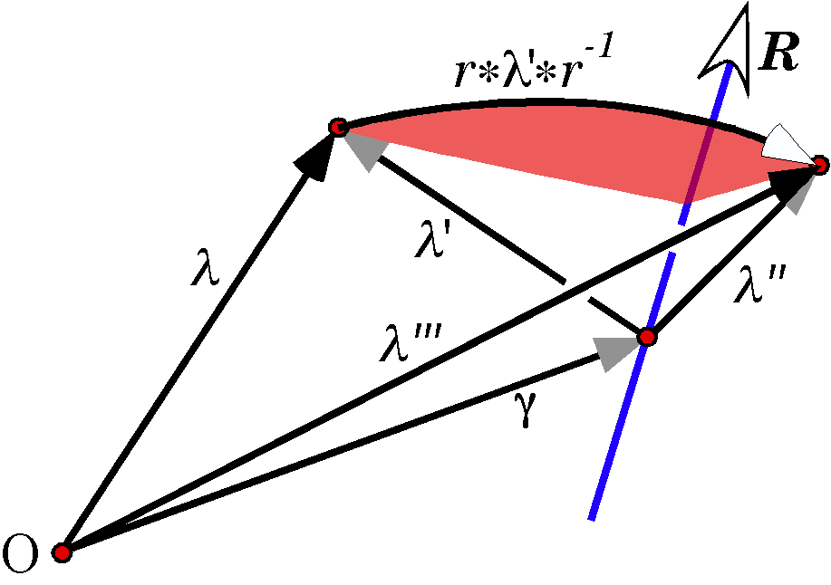
Rotation of location vectors is dependent upon the location the center of rotation. When rotating, $R$, a location, $λ$, about an axis of rotation that does not pass through the origin of the coordinate system, it is necessary to shift the origin of the coordinate system, $O$, to the center of rotation, $g$, perform the rotation upon the location ($r∗λ^{'}∗r^{−1}$) and shift the coordinate system back to the original origin to obtain the new location, $λ^{'''}$.
When a location vector, $λ$, rotates about an axis, $R$, that does not go through its origin, $O$, it is necessary to compute the location relative to a point on the axis of rotation,$g$. Rotate the new location vector, $λ^{'}$, appropriately about the axis of rotation, $λ^{''}$, then compute the final location, $λ^{'''}$, relative to the original origin. This can be written as a single expression for calculation.
$$λ_{\text{rotation}}=r∗\left(λ−g\right)∗r^{−1}+g$$

Ratios of location relative to an axis of rotation
The ratio of two locations is the quaternion that transforms one location vector into the other. If we do not have a particular origin for the location vectors, we cannot compute an unique quaternion solution, since any arc that connects the locations is a possible solution. If we know the rotation does not change the radius of rotation, then the quaternions must lie in a plane that is perpendicular to the line connecting the two locations, midway between the two locations. If the unit vector in the direction of the line is$d$, then the solutions are of the following form.

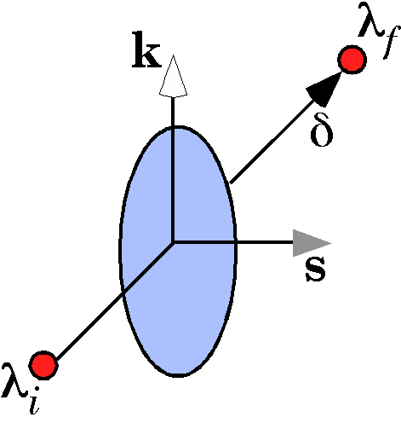
$$\begin{aligned}s=ρ∗s+\left(λ_{i}+\frac{λ_{f}−λ_{i}}{2}\right)\text{, where } \\ ρ=r\left(\text{cos}f+\text{sin}f∗d\right),f=0⇒2p, \\ s=V\left(\frac{k}{d}\right),V\left(\right)\text{ is }thevectorof\text{ function,} \\ d=\frac{λ_{f}−λ_{i}}{\left|λ_{f}−λ_{i}\right|}\text{, } \\ \text{and }k\text{ is the vertical axis}\text{.}\end{aligned}$$
The vector s can be any vector in the plane perpendicular to the connecting line. In this formulation we computed the horizontal vector. All other solutions may be obtained by rotating s about the axis of the connecting line, $d$.
If we know the direction of the axis of rotation, then we can reduce the set of possible solutions to those a single direction. Note, however, that the axis of rotation must lie in the perpendicular bisector plane. If does not, then there must have been a translation or at least two rotations that were not in the same plane. That situation is considered below.

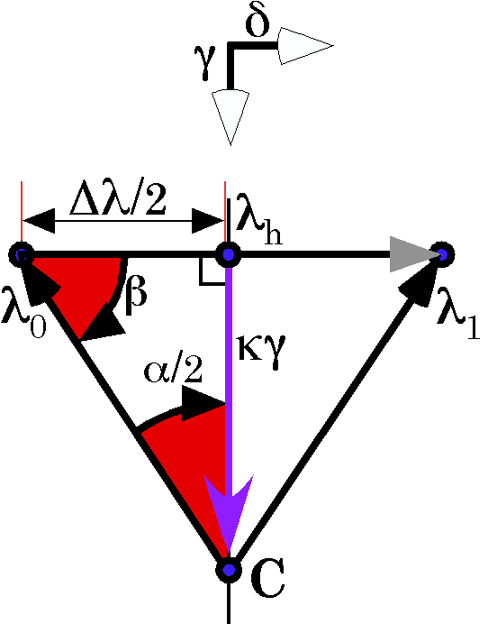
The relationships between locations and the center of rotation for a rotation about a known axis of rotation of unknown location. The view is looking directly down on the plane of the rotation. The axis of rotation perpendicular to the page.
If we know the angular excursion of the rotation, then we can specify a center of rotation. The axis of rotation specifies the plane in which it lies, that is the plane that is perpendicular to the axis of rotation and which contains both locations. If there is no such plane, then there was a translation parallel to the axis of rotation or at least two non-coplanar rotations.
Given the two locations, $λ_{0}\text{ and }λ_{1}$ and the axis of rotation, and angular excursion of the rotation, $α$, it is possible to compute the center of rotation, C. It is straight–forward to compute the difference between the two locations, the directional vector for that line, $d$, and the midpoint of the line, $λ_{h}$. The center of rotation lies on the perpendicular bisector of the connecting line, an unknown distance from the midpoint.

Ratios of orientations determine axis of rotation and angular excursion
Since orientation does not have locality, it is convenient to visualize orientation frames as being distributed in a unit sphere with one axis, say the r axis chosen to be the principal axis vector, then the other axes may be in any orientation in the plane perpendicular to the radial vector. The movement that carries the initial orientation into the final orientation is the product of the movements that carry the pre-movement principal vector into the post-movement principal vector, $q_{\text{Sw}}$, and the rotation about the post-movement principal vector that aligns the other two axes with the final orientation frame, $q_{\text{Sp}}$. The first movement is called a swing movement because the principal axis sweeps through space and the second movement is called a spin movement because the motion involves a spinning of the secondary axes about the principal axis.
The movement that moves the orientation frame from the pre-movement configuration to the post-movement configuration is a curvilinear trajectory of the principal axis in the surface of the unit sphere, an arc about an axis that is the product of the swing and spin quaternions.
$$\begin{aligned}O_{\text{Post}}=q_{\text{Sp}}∗q_{\text{Sw}}∗O_{\text{Pre}}∗q_{\text{Sw}}^{−1}∗q_{\text{Sp}}^{−1} \\ q_{\text{Ex}}∗O_{\text{Pre}}∗q_{\text{Ex}}^{−1}\end{aligned}$$
The excursion quaternion, $q_{\text{Ex}}$, has an angle, $j_{\text{Ex}}$, and a vector, $v_{\text{Ex}}$. It is a unit quaternion, therefore its tensor is unity. The center of rotation is the center of the sphere. The unit sphere is a convenient visualization tool, however, the location of the axis of rotation is not actually known in general. In order to determine the location the center of rotation, we need to have information about the locations of the object prior to and following the movement. This considered below.

Swing, spin and sweep movements
In the previous section, it was stated that the first movement was a swinging movement and the second a spinning movement. Most people have a reasonable intuitive sense of what we mean by those terms, but they are worth deeper consideration, because they are more subtle than they appear at first.
To be exact, the first movement is a pure swing, because the principal axis remains in a single plane. It follows a great circle trajectory on the unit sphere. The second is spin, because the secondary axes rotate about the principal axis. Spin in its strictest sense is movement that occurs about the principal axis. Generally, the principal axis is an extension vector, that is a line that connects two landmarks on the structure or aligns with an axis of the structure. For instance, the anteriorly directed axis of a vertebra or a line connecting the center of the humeral head with the elbow joint. When the movement of the principal vector is neither aligned with the axis of rotation (spin) or perpendicular to the axis of rotation (pure swing), then it is generally called swing. There is, however, considerable room for ambiguity, since pure swing is often also called swing, without the qualifier. It would be preferable to reserve the term swing for pure swing, where the principal vector is perpendicular to the axis of rotation, use spin for movements where the principal vector is aligned with the axis of rotation, and use another term, such as sweep, for the remainder of movements, where the principal vector is neither parallel or perpendicular to the axis of rotation. Sweeping movements would be conical rotations where the angle between the principal vector and the axis of rotation is neither 0° or 90°.
Framed vectors were invented to deal with just this problem. To characterize a movement, one needs a location or extension vector and an orientation frame. Generally when we speak of spin and swing we implicitly assume a standard orientation and/or standard axes. When considering movement of the humerus in the glenohumeral joint, we assume anatomical position and the axis of the humerus is often taken to be a line from the elbow joint to the center of the humeral head. The axis of the humerus, in this instance, does not follow the shaft of the humerus. It is an extension vector. The center of rotation is assumed to be the center of the humeral head, since it is nearly spherical. While frames of reference are not explicitly defined, the implicit assumption is that there are anterior, lateral, and superior axes.
Abduction is a lateral swing movement in which the axis of the humerus moves directly laterally and superiorly in a single plane. Adduction is movement in the opposite direction, about the same axis of rotation. Lateral spin is a movement in which the humerus rotates about the axis of the humerus to turn the anterior aspect of the elbow laterally. Medial rotation is movement in the opposite direction about the axis of the humerus. Flexion and extension are swing movements perpendicular to abduction/adduction, which move the axis of the humerus anteriorly or posteriorly and superiorly.
There are reasons to be both more strict and less strict with the swing/spin nomenclature. On the side of more strict is that pure swing and spin have special attributes. In pure spin, the framed vector changes orientation, but not location. A standard vector is not changed by spin about its axis. In the instance of the humerus, the extension vector is the axis of the humerus. It does not move, but the orientation of the humerus is changed.
Pure swing is special in the way that orientation changes with location. It is difficult to capture exactly what is happening in words, but one can specify exactly what is meant, by saying that great circle trajectories, which are pure swing, change orientation is a manner so that the spin component is zero when the ratio of the orientation after the movement to the orientation before the movement is computed. Basically the secondary axes rotate about the principal axis at a rate exactly equal to the angular excursion of the principal axis. Trajectories that do not follow great circle trajectories introduce a spin into the orientation of the moving frame of reference, so there is a concomitant twisting with the angular excursion. The difference is subtle. But important in the analysis of movements.
On the spinning earth, the north and south poles experience pure spin, points on the equator experience pure swing, and all other points experience swing, or what we are calling sweeping movements. This illustration points up the another aspect of these movements. The rotation of the earth is a single movement, which is experienced differently at different locations on its surface. Consequently, swing and spin do not describe a movement per se, but a relationship between the center of rotation and a moving framed vector. Choosing a different center of rotation will change the nature of the movement. For instance, on the rotating earth, a location at 45° north latitude will experience a sweeping movement if we consider the center of rotation to be the center of the earth. However, any point on the axis of rotation is an equally valid choice for a center of rotation, so, if we choose the center of rotation to lie 0.707 times the distance from the equatorial plane to the north pole, then the points at 45° north latitude will be experiencing pure swing and the points at the equator will be experiencing conical swing.
In conclusion, spin and swing are much more subtle concepts than they appear to be at first. They always assume a principal axis, a frame of reference, and a center of rotation. Changing any of these attributes may change the type of movement, without changing the fundamental movement.

Ratios of framed vectors
It is common to have an orientable object in one location and orientation and after a series of translations and rotations it finishes in another location and orientation. We wish to express this change as an equivalent simple movement. A similar situation might be if one picked up a book off a table, carried it into another room, used it, and brought it back and put it on a shelf in the bookcase. One might be interested in the entire trajectory from table to bookcase, but often it is sufficient to know the overall change, irrespective of the actual path followed. The net effect was to move it from the table to the bookcase, as distance of 3 feet along the most direct path between its two locations.
The difference between bunny A and bunny C is a rotation of θ about the center of rotation C_{R} and a translation of T_{P} + T_{A}. Given only bunny A and bunny C, there are many possible compound movements that might produce the change.
It turns out that any movement may be expressed as a combination of a translation and a rotation. Such a movement will be called a compound movement. A little thought will reveal that there is not a unique solution to the description of a movement as a compound movement. However, there are some solutions that are often of greater interest than others. In the case of the book it makes most sense to say that it changed location by a translation equal to the distance and direction between its original location and its final location and that it rotated as given by the ratio of its final orientation to its original orientation. There are other situations in which it makes sense to consider the entire movement a single rotation. One might use that type of equivalent movement when the movement appears to be a smooth sweep of movement, rather than a set of disjointed movements. Such rotation-only solutions are often useful for representing joint movements.

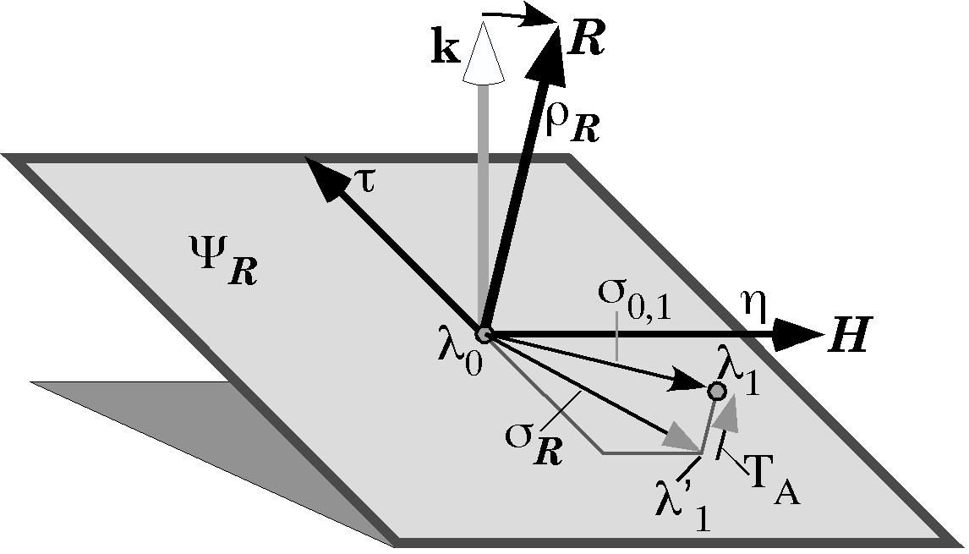
A framed vector with location $λ_{0}$ is transformed into a framed vector with location$λ_{1}$, while the ratio of the orientations is the quaternion R. The illustration shows a situation where the two locations lie in different planes of the quaternion, so there is an axial translation, T_{A}. See the text for further description.
One often has additional knowledge or constraints upon the solution, such as, it occurs about a center of rotation in the midsagittal plane. In such cases, the constraints may force a unique solution in which there is a definite, non-zero, rotation and a definite, non-zero, translation.
We will now consider the procedure for computing the center of rotation, axis of rotation, and angular excursion for a rotation and the translations in the plane of the rotation quaternion and perpendicular to the plane.
The starting point is the framed vectors of the object prior to the movement and immediately after. The ratio of the frames of reference gives us the axis of rotation and the angular excursion as components of the quaternion R. We still need to know the center of rotation and the translations.
Given two arbitrary framed vectors, $f_{0}\text{ and }f_{1}$, there is no guarantee that they represent opposite ends of a single rotation, so, one must first determine what part of the difference cannot be due to rotation. That is determined as follows.
The ratio of the orientations will give the axis of rotation, R, and the angular excursion of the rotation that transforms the first into the second framed vector, $f$. Those are components of the rotation quaternion. If there is no change in orientation (R is a scalar), then there is only translation, because that is the definition of a translation, a movement without change of orientation.
Once the axis of rotation is known, one can use the first location, $λ_{0}$, and the axis of rotation, R, to compute the plane, $y_{R}$, that is perpendicular to the axis of rotation and that contains the initial location,. If the second location, $λ_{1}$, is not in that plane, then the perpendicular distance from the $λ_{1}$ to the plane will be the component of the translation that is parallel to the axis of rotation, the axial translation, T_{A}. We can determine the perpendicular distance between a point and a plane, when we know the vector of the plane by framing the plane (see above) and rotating the plane and the point so that the plane is coincident with the horizontal plane through the origin. The vertical height of the point above the plane after that rotation is the magnitude of the axial translation. The axial translation can be transformed back into the original coordinates by reversing the multiplication, using the inverse of the horizontal quaternion of the plane. The axial translation can be subtracted from the final location to give the projection of the final location into the plane of the rotation ($y_{R}$) that contains the initial location, $s_{R}$. The orientation of the framed vector at $λ_{1^{¢}}$ is the same as the orientation at $λ_{1}$, since translation does not change orientation.
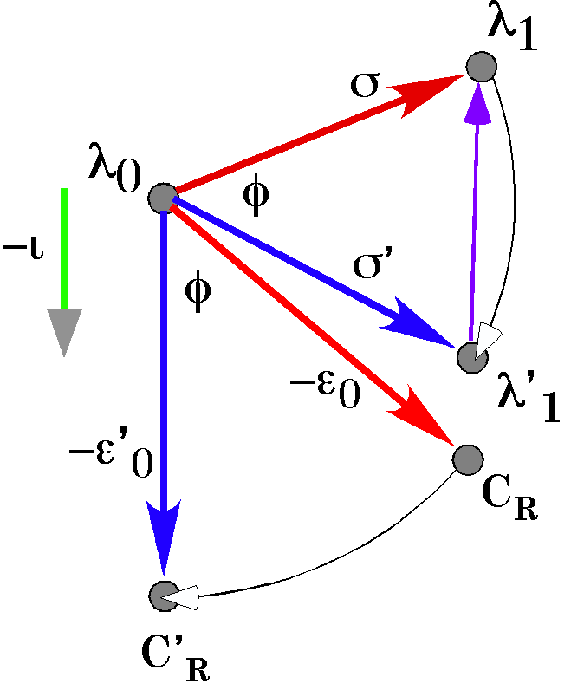
If the location of the center of rotation is known, then one can transform the rotation-only solution into the appropriate center of rotation, $C_{R}^{'}$. and a translation in the plane of the quaternion.
At this point the problem becomes the one that was solved above for the ratio of locations relative to an axis of rotation. The axis of rotation is known, the angular excursion is known and the initial and final locations are known. Using the methods described, it is possible to compute the center of rotation. That center of rotation is the center for a rotation-only solution in the plane of the quaternion.
If one has reason to know that the center of rotation is actually in a particular plane, such as the midsagittal plane, then one can take the ratio of the plane of the rotation quaternion to the plane of the center of rotation to obtain their intersection. A vector from $λ_{0}$ to the center of rotation, $e_{0}$, may be rotated into the line of intersection to give the center of rotation in the plane of the centers of rotation. If the same transformation is applied to the second location in the plane, $λ_{1^{¢}}$, then it will move to a new location, $λ_{1^{¢¢}}$, and the difference between the new and old locations is the translation in the plane of the rotation quaternion, the planar translation, T_{P}. The sum of the planar and axial translations is the total translation, T.

Ratios of structures are often measurements of differences
In this essay, we have defined structure in terms of framed vectors, therefore it is natural that we describe changes in term of relations between the framed vectors that are used in the descriptions. When we are interested only in location, it makes sense to compare the locations by computing the by subtracting the initial location from the final location.
$$Dλ=λ_{1}−λ_{0}$$
One could and often does characterize the difference in two locations as a rotation about a center of rotation. Rotation changes orientation, therefore, it is necessary to have an expression for the orientation of the object if there is to be a unique solution of the center of rotation. When there is a rotation, there is a change in orientation. Rotation is not adequately characterized by a subtraction. It is a more complex type of difference. In fact, it turns out that quaternions are precisely what is needed to compare steps in a rotation and to compare orientations. They form a large component of the description of differences between framed vectors. When comparing framed vectors one must use a combination of translations and rotations. Wherever there are changes in orientation, there are quaternions and almost any anatomical movement involves a change in orientation.

